Supporting information
1. Overview of historical sample plots in the study area
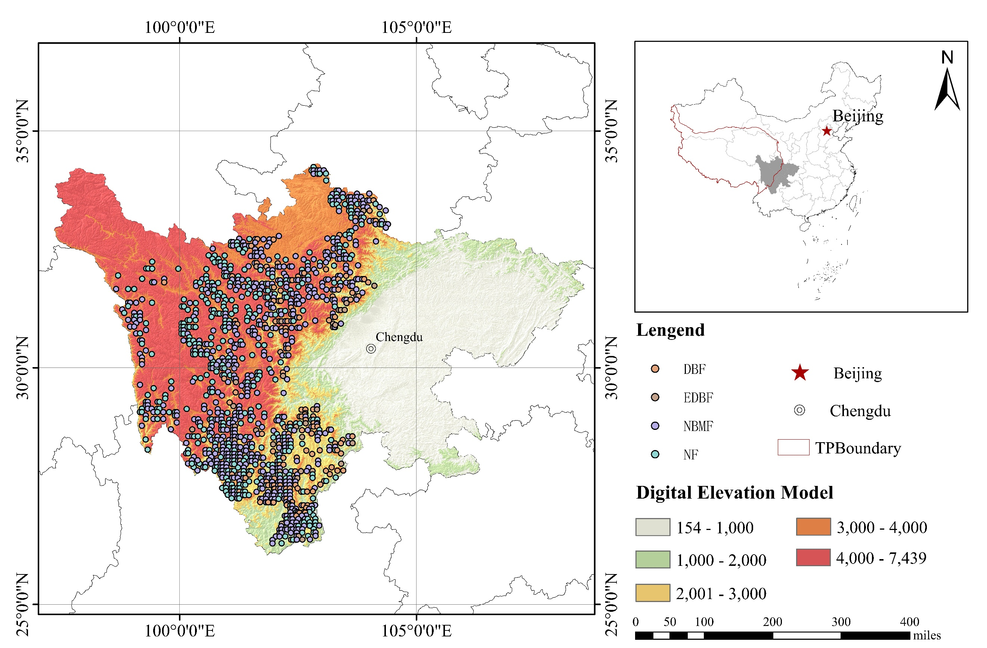
Fig. S1 Distribution of sampling plots of the four forest biomes in the study area. The forests on the Tibetan Plateau are mainly distributed in the southeast, while the northern part is dominated by grasslands. The forest sampling sites in our study cover over half of the forested area on the Plateau. The study area, a transitional zone from the Sichuan Basin to the Plateau, features large altitudinal differences and complex terrain. Evergreen and deciduous broad-leaved mixed forests (EDBF), deciduous broadleaved forests (DBF), needle-broad leaved mixed forests (NBMF), and needleleaf forests (NF).

Table S1 Meta-data (mean + SD) used this study are shown for the different forest biomes: Evergreen and deciduous broad-leaved mixed forests (EDBF), deciduous broad-leaved forests (DBF), needle-broad leaved mixed forests (NBMF), and needleleaf forests (NF).
Items | EDBF | DBF | NBMF | NF
Number of plots | 42 | 115 | 592 | 499
Measurement times | 3.53±1.34 | 3.71±1.83 | 4.46±2.40 | 4.10±1.80
Measurement interval | 5.04±2.90 | 5.42±2.64 | 5.07±3.35 | 5.16±2.06
Carbon stocks (Mg ha⁻¹) | 235.14±45.60 | 234.51±54.05 | 232.40±47.86 | 144.70±13.32
Canopy (%) | 51.60±21.01 | 50.37±18.12 | 55.65±17.97 | 49.73±19.17
Canopy height(m) | 10.85±5.45 | 8.39±4.31 | 13.35±6.25 | 12.08±7.15
Richness | 3.35±1.13 | 2.78±0.50 | 3.78±1.45 | 2.30±0.35
Basal area (m²/ha) | 16.48±5.40 | 12.24±4.90 | 23.22±5.03 | 18.39±4.95
Altitude (m) | 2700±560.45 | 2967±564 | 3219±602 | 3606±538
Precipitation (mm) | 867.8±157.06 | 864.1±159.74 | 843±158.47 | 820.3±160.21
Mean Monthly Temperature (°C) | 16.5±2.51 | 15.4±2.49 | 13.67±2.74 | 11.10±2.69
the Precipitation and Mean Monthly Temperature are the value of growing season (4-10).
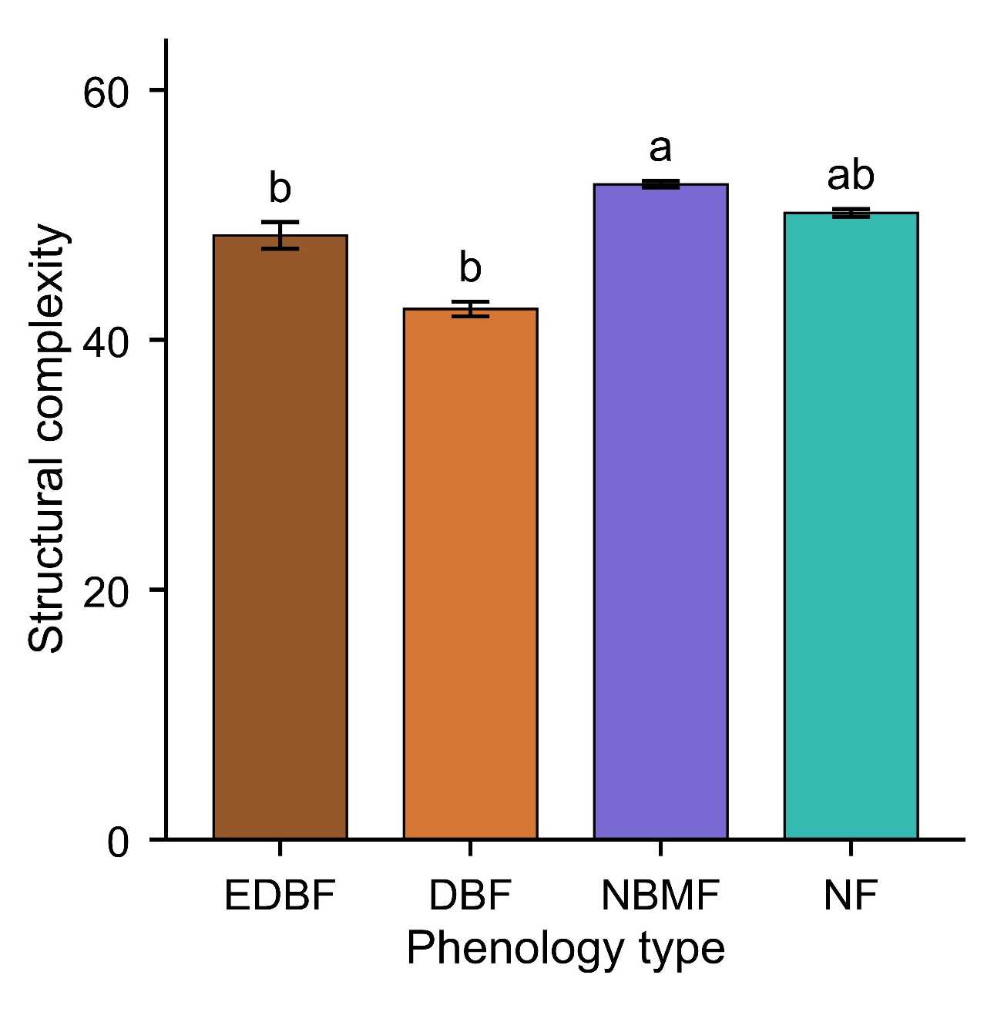
Fig. S2 Comparison of structural complexity in the four forest biomes. NBMF exhibit significantly higher structural complexity than other forest types (*** P<0.001). The DBF has the lowest complexity of structure. Data are presented as mean ± standard error.
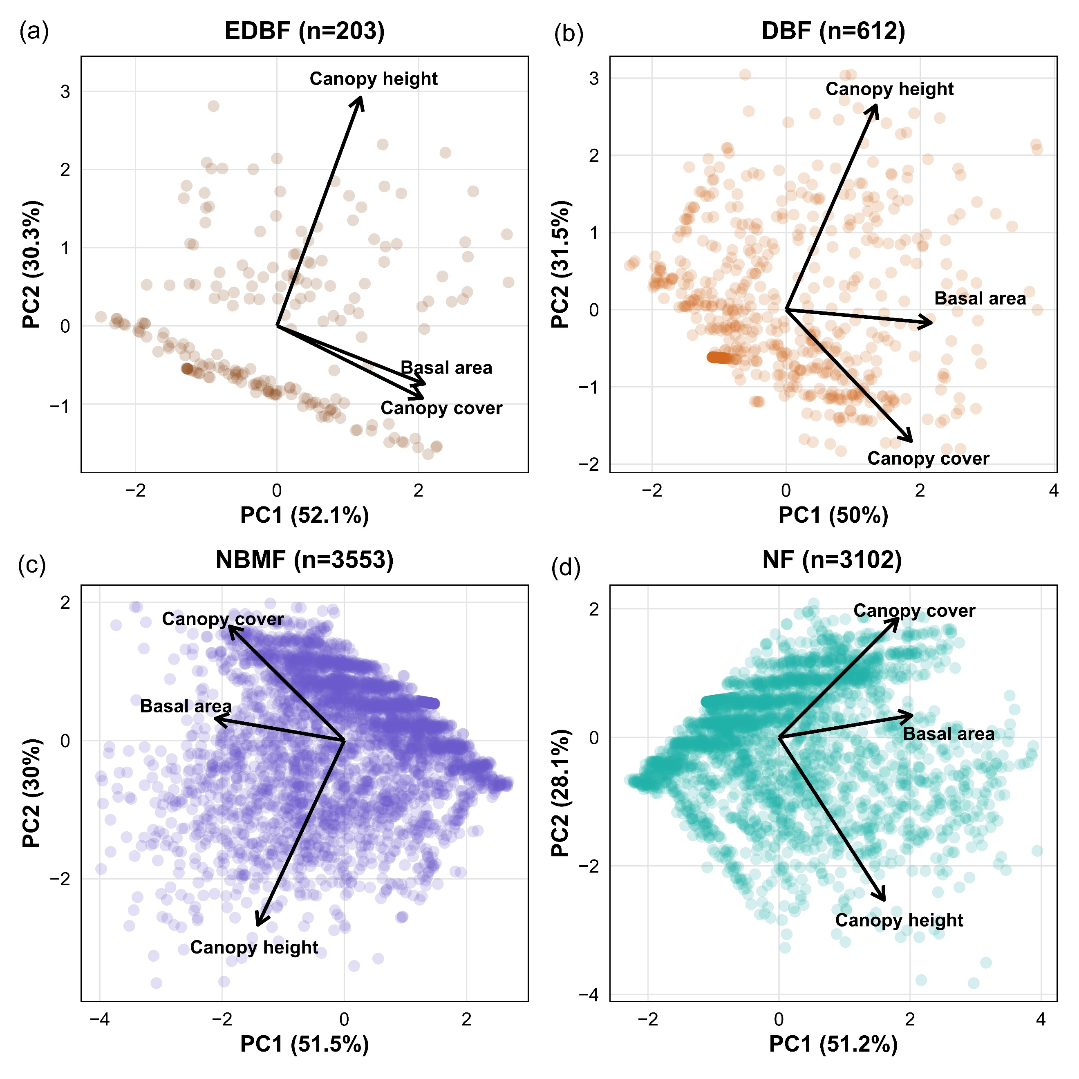
Fig. S3 Principal component analysis (PCA) of forest structural variables across different forest biomes. Panels show (a) evergreen deciduous broadleaf forest (EDBF), (b) deciduous broadleaf forest (DBF), (c) needleleaf and broadleaf mixed forest (NBMF), and (d) needleleaf forest (NF). Points represent individual plots, and arrows indicate the direction and relative contribution (loadings) of structural variables, including canopy height, canopy cover, and basal area (BA). PC1 summarizes a coordinated gradient of stand structural attributes, primarily associated with canopy cover, basal area and canopy height, reflecting variation in overall stand structure. PC2 captures variation in vertical versus horizontal stand structure, as indicated by contrasting loadings of tree height and canopy attributes. The proportion of variance explained by each axis is indicated in parentheses. Note that PCA scores are standardized and unitless, representing relative positions of plots along multivariate gradients. The orientation (sign) of PCA axes is arbitrary; therefore, interpretation focuses on the relative alignment and contribution of variables rather than absolute increases or decreases along the axes.
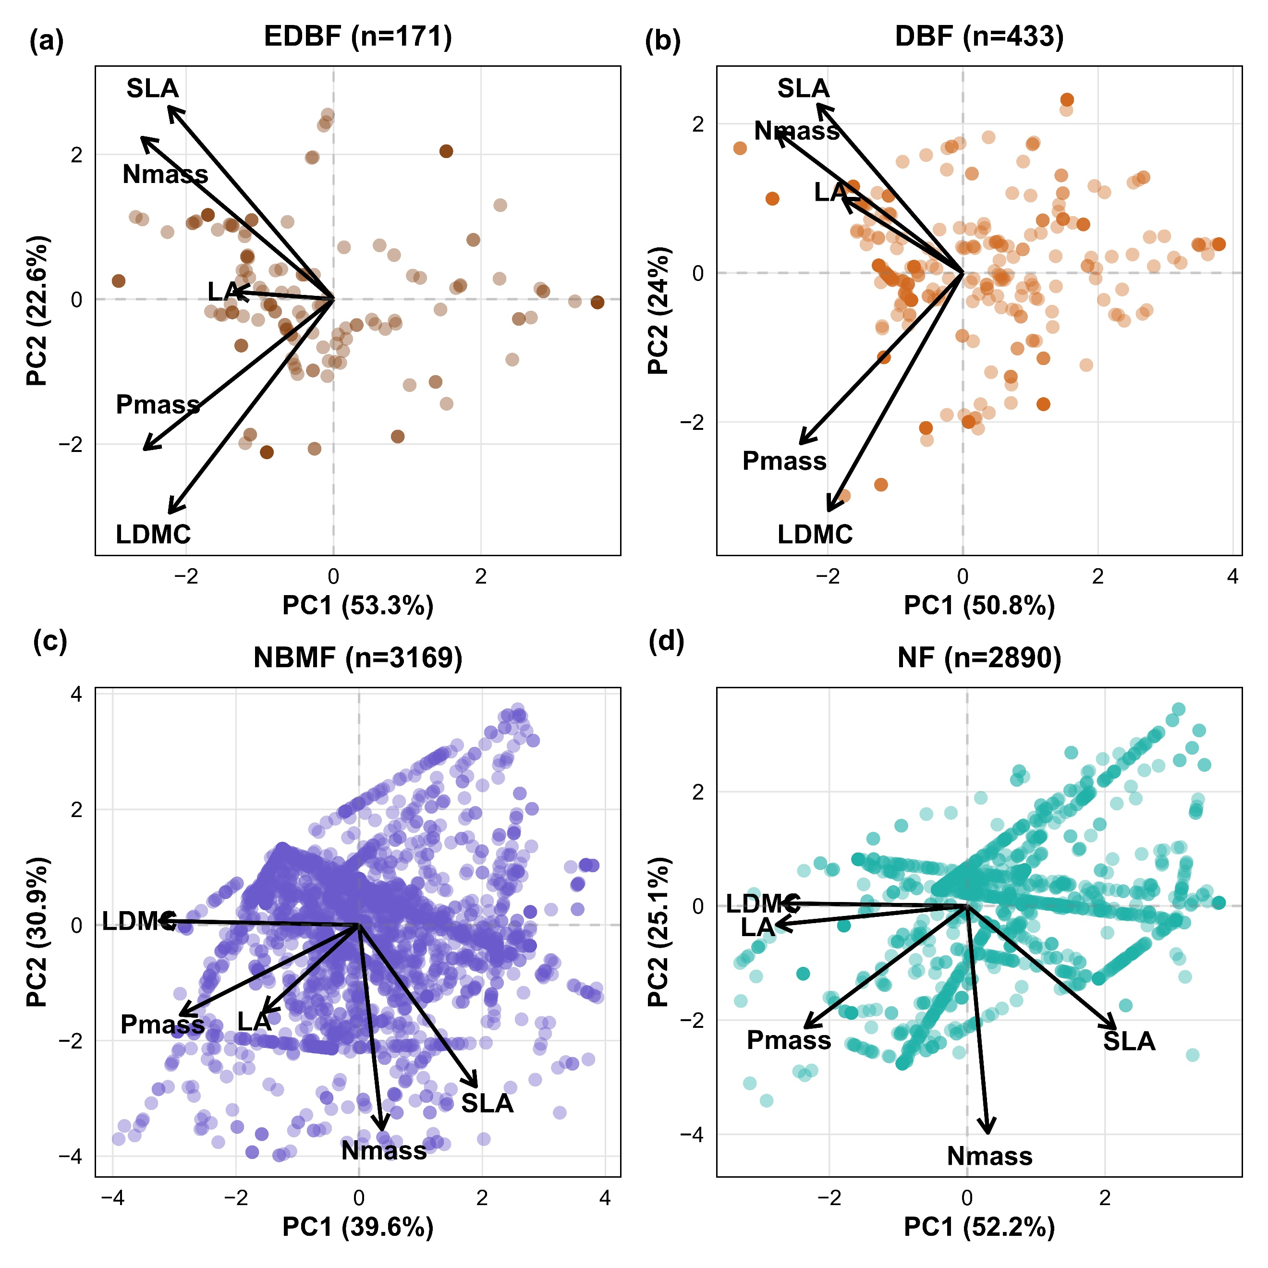
Fig. S4 Principal component analysis (PCA) of leaf functional traits in (a) evergreen broadleaf forests (EDBF), (b) deciduous broadleaf forests (DBF), (c) needleleaf–broadleaf mixed forests (NBMF), and (d) needleleaf forests (NF). Points represent individual plots, and arrows indicate the direction and relative contribution (loadings) of leaf functional traits, including specific leaf area (SLA), leaf area (LA), leaf dry matter content (LDMC), leaf nitrogen concentration (Nmass), leaf phosphorus concentration (Pmass). The orientation (sign) of PCA axes is arbitrary; therefore, interpretation focuses on the relative alignment and contribution of traits rather than absolute increases or decreases along each axis.

In EDBF, Trait PC1 explained 53.3% of total trait variation and was associated with coordinated variation in SLA, LA, LDMC, Nmass, and Pmass. Because all traits loaded in a similar direction, TraitPC1 primarily reflected overall variation in leaf structural and nutrient investment rather than a clear acquisitive–conservative trade-off. TraitPC2 explained 22.6% of total variation and separated SLA and Nmass from LDMC and Pmass, representing a classical leaf economics spectrum (LES) gradient ranging from conservative to acquisitive resource-use strategies.
Similarly, in DBF, TraitPC1 explained 50.8% of total trait variation and was associated with coordinated variation among leaf size, nutrient concentration, and tissue investment traits, indicating a dominant axis of overall trait covariation. TraitPC2 explained 24.0% of total variation and contrasted SLA and Nmass with LDMC and Pmass, reflecting a classical acquisitive–conservative resource-use spectrum. Along this axis, positive values corresponded to acquisitive strategies characterized by high SLA and nutrient concentrations, whereas negative values represented conservative strategies associated with high LDMC.
In contrast, NBMF and NF exhibited clearer trait trade-offs along the primary PCA axis (Fig. S4). In NBMF, TraitPC1 explained 39.6% of total trait variation and contrasted SLA with LDMC and Pmass, indicating a classical leaf economics spectrum ranging from conservative to acquisitive strategies. Positive TraitPC1 values were associated with acquisitive traits, whereas negative values reflected conservative resource-use strategies. TraitPC2 explained 30.9% of total variation and was associated primarily with variation in Nmass and leaf size relative to other leaf traits, representing an additional axis of nutrient allocation and leaf structural differentiation independent of the primary resource-use spectrum.
Similarly, in NF, TraitPC1 explained 52.2% of total trait variation and represented the dominant acquisitive–conservative trade-off axis. Positive values were associated with acquisitive traits, particularly high SLA, whereas negative values corresponded to conservative strategies characterized by greater LDMC. TraitPC2 explained 25.1% of total variation and was mainly associated with variation in Nmass relative to leaf structural traits, indicating an independent axis of nutrient allocation strategy.
Overall, broadleaf forests (EDBF and DBF) exhibited the classical acquisitive–conservative resource-use spectrum along TraitPC2, whereas needleleaf-associated forests (NBMF and NF) expressed this trade-off primarily along TraitPC1. Thus, the functional strategy axes governing resource acquisition and conservation differed fundamentally among forest types. Positive values of the acquisitive–conservative axis consistently represented acquisitive strategies characterized by higher SLA and nutrient acquisition, whereas negative values represented conservative strategies associated with greater tissue investment and resource retention. These contrasting patterns of trait coordination suggest that the mechanisms linking functional strategies to stand structural development and structural complexity may differ among forest types.
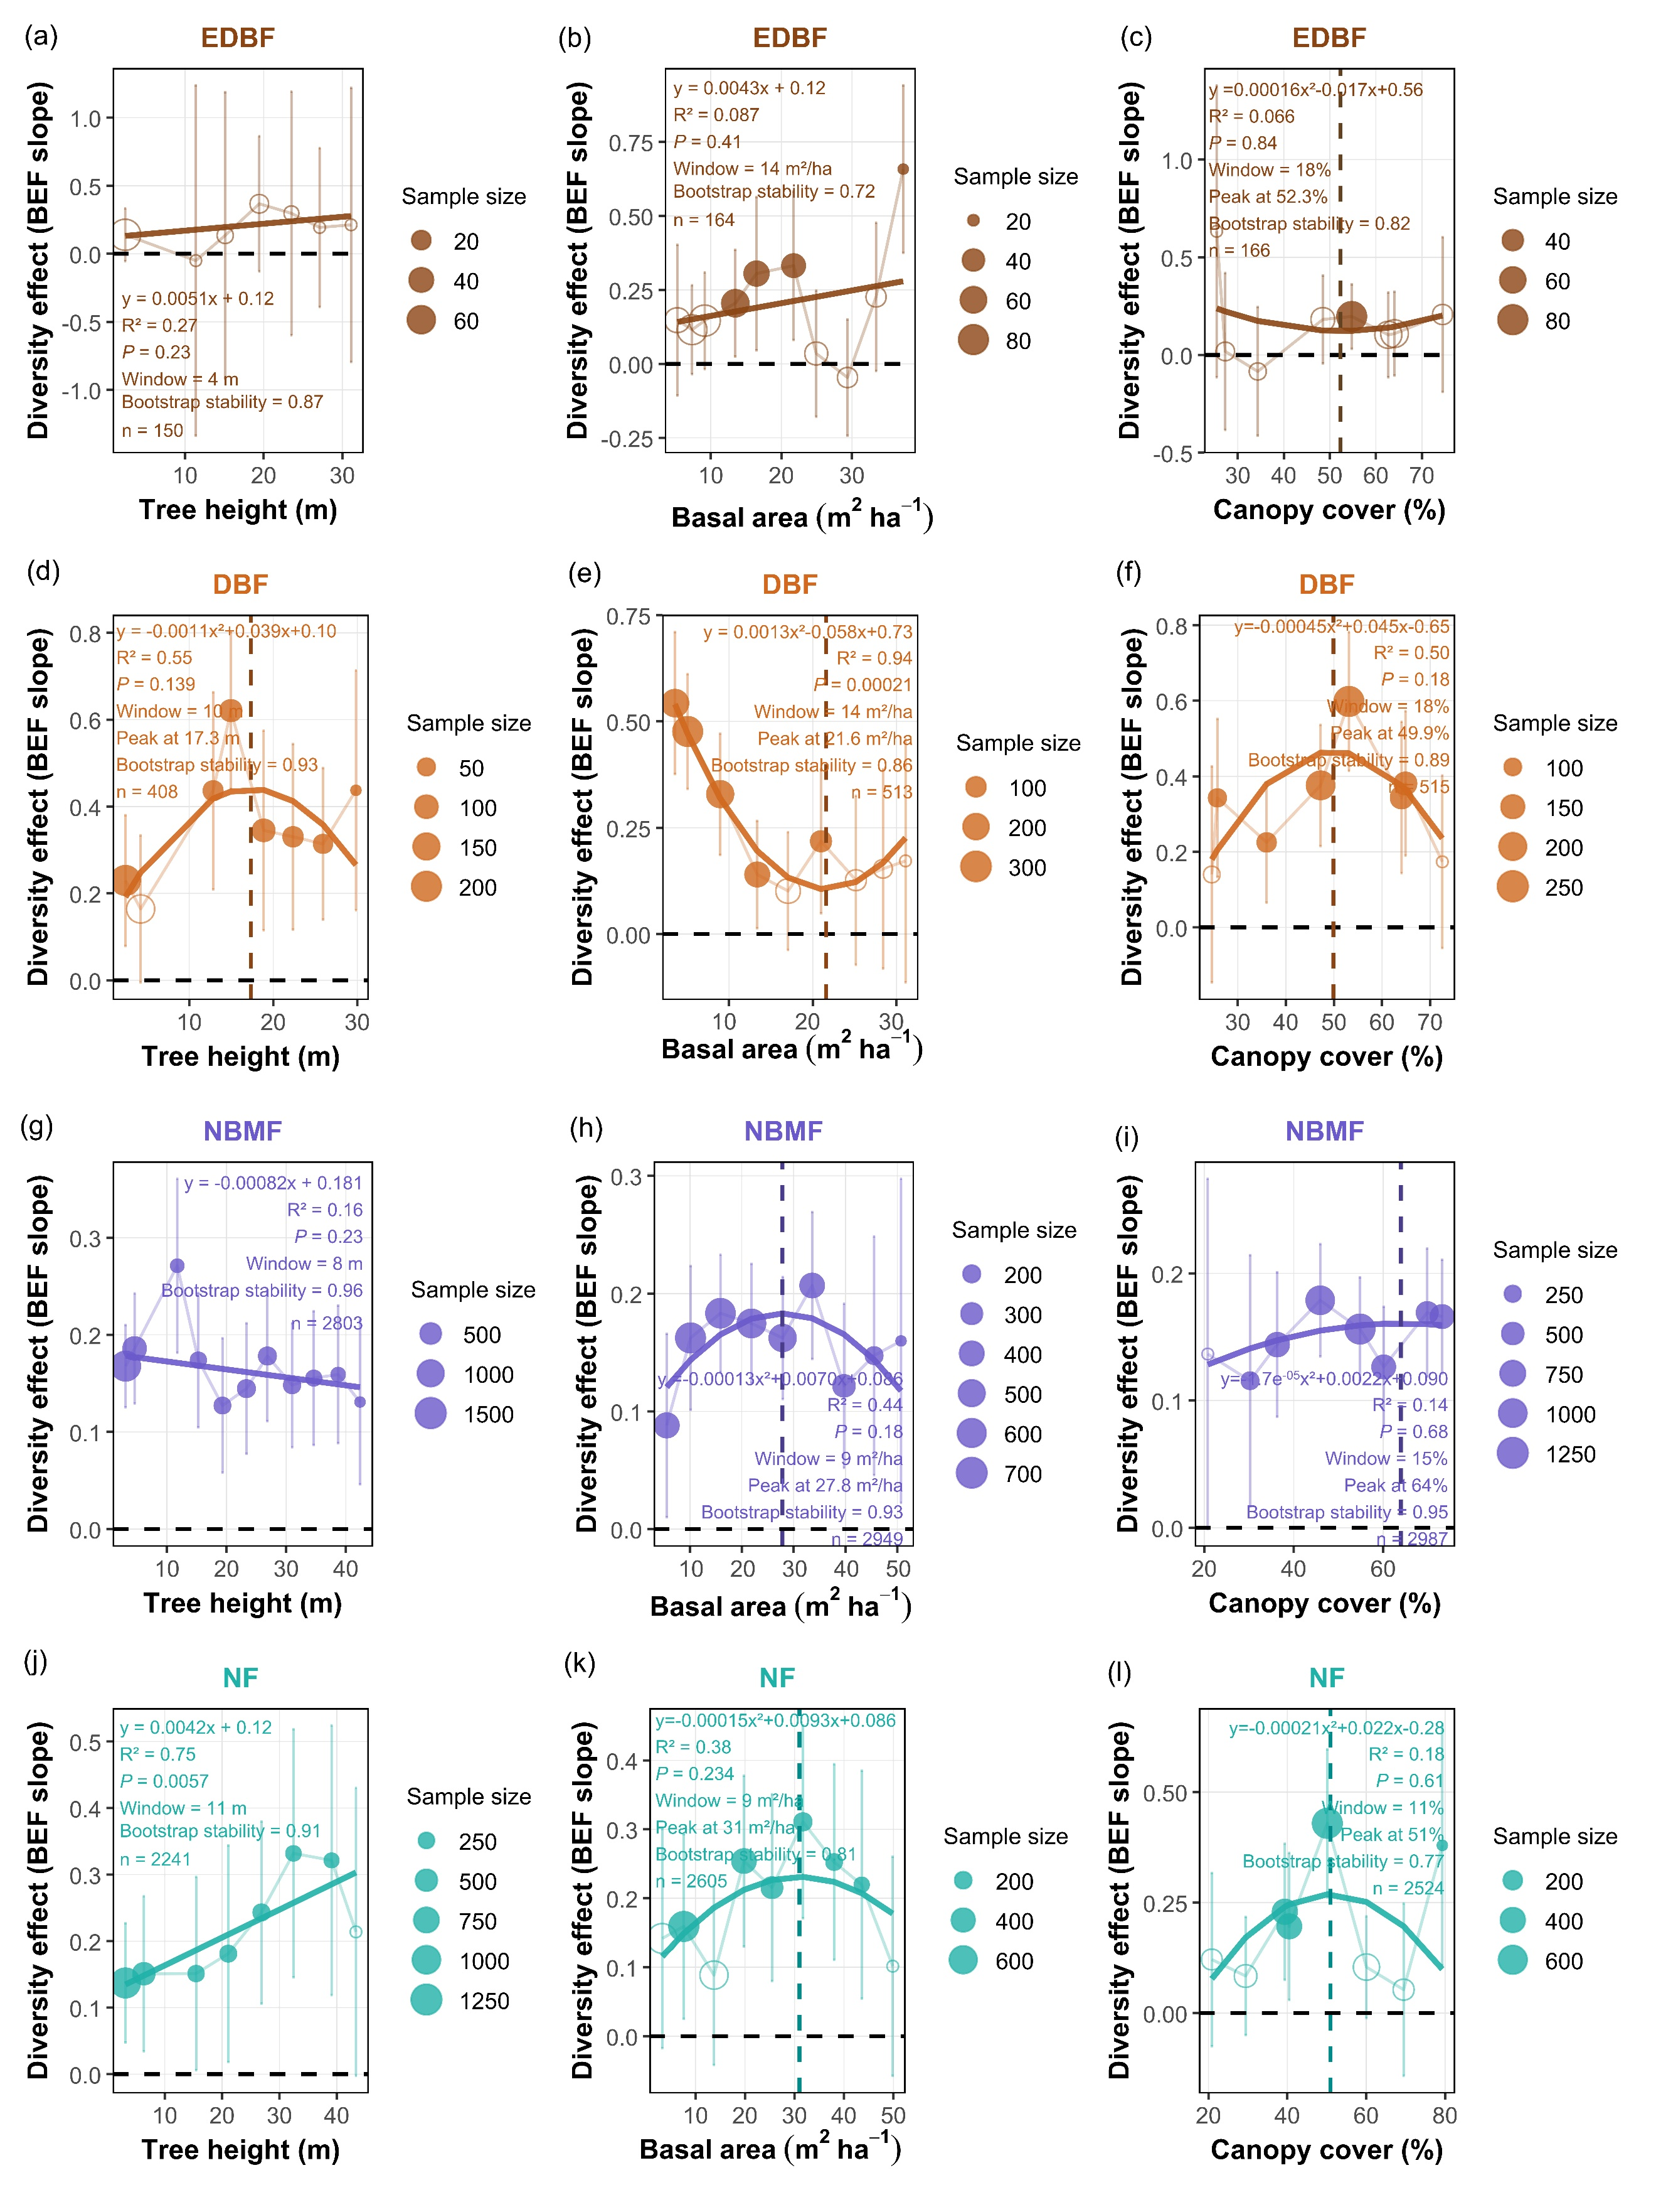
Fig. S5. Effects of tree species diversity on forest biomass carbon stocks along gradients of canopy cover, basal area, canopy height across the four forest biomes. Panels correspond to forest types: EDBF (evergreen–deciduous broad-leaf mixed forests), DBF (deciduous broad-leaf forests), NBMF (needle–broadleaf mixed forests), and NF (needleleaf forest). Each point represents the fixed‑effect slope of the diversity–biomass carbon relationship from linear mixed‑effects models. Quadratic curves depict variation in effect size (slope) along each gradient, with accompanying R² values indicating goodness of fit. Peaks of the curves indicate the moderator values at which the diversity effect is strongest or weakest within each forest type. Filled circles denote statistically significant effects (P < 0.05), open circles denote nonsignificant effects (P > 0.05), and vertical bars represent standard errors (SE). Sample size denotes the number of observations underlying each regression slope of diversity effects on biomass carbon storage.
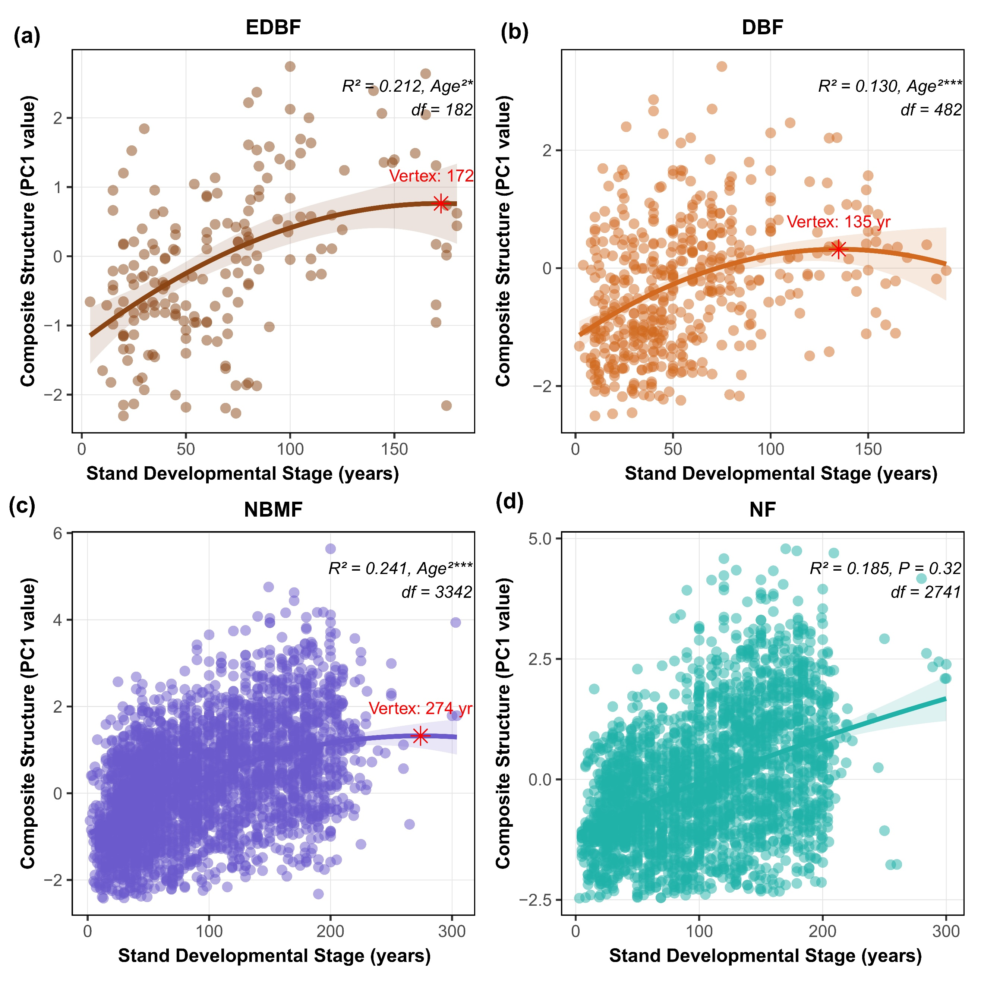
Fig S6 Developmental stage-dependent trajectories of forest structural attributes across four forest biomes. Generalized additive model (GAM) predictions showing the effects of stand developmental stage on the forest composite structure gradient (a) in four forest types: evergreen deciduous broadleaf forest (EDBF), deciduous broadleaf forest (DBF), needle–broadleaf mixed forest (NBMF) and needleleaf forest (NF). Lines represent model predictions; shaded areas indicate 95% confidence intervals. The composite structure gradient integrates canopy height, canopy cover and basal area (BA). Red stars indicate the estimated structural development thresholds (vertex ages) derived from quadratic models.
Stand structural development increased significantly with stand developmental stage across all forest types except NF, although the magnitude and temporal trajectories differed markedly among forest types (Fig. S6). Overall, mixed and broadleaf forests exhibited clear nonlinear increases in structural development with stand developmental stage, whereas NF showed a weaker and more gradual developmental trajectory. Stand structural development generally increased with stand developmental stage, but the developmental trajectories and structural thresholds differed substantially among forest types. Broadleaf forests reached structural maturity at relatively younger stand developmental stages, whereas mixed forests exhibited prolonged structural accumulation over much longer developmental periods. In contrast, needleleaf forests showed comparatively weak age-related structural differentiation. These results indicate that forest type strongly mediates the temporal dynamics and developmental thresholds of stand structural organization.
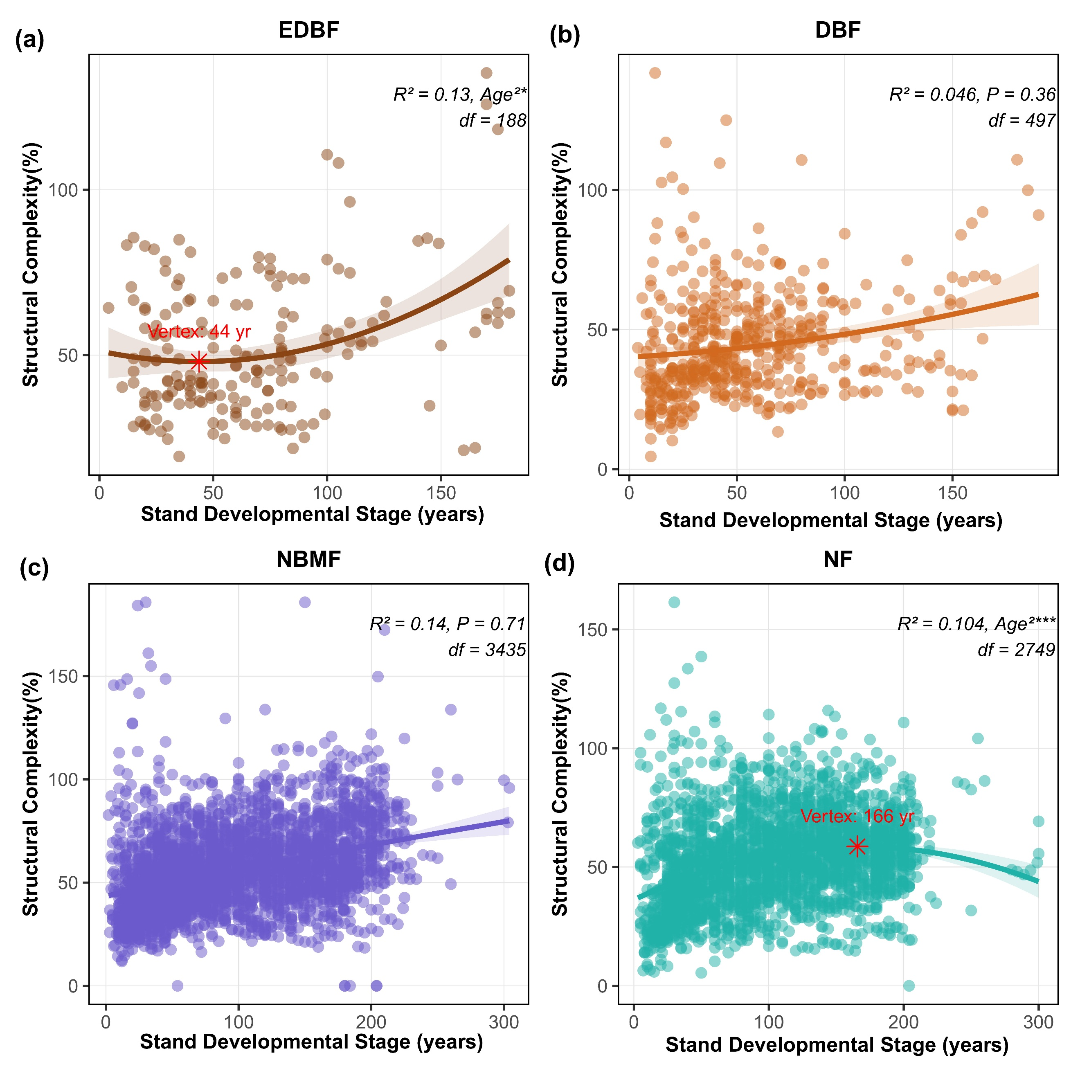
Fig. S7 Age-dependent trajectories of forest structural attributes across four forest biomes. Generalized additive model (GAM) predictions showing the effects of stand developmental stage on the forest structural complexity in four forest biomes: evergreen deciduous broadleaf forest (EDBF), deciduous broadleaf forest (DBF), needle–broadleaf mixed forest (NBMF) and needleleaf forest (NF). Lines represent model predictions; shaded areas indicate 95% confidence intervals. The composite structure gradient integrates canopy height, canopy cover and basal area (BA). Red stars indicate the estimated structural complexity thresholds (vertex ages) derived from quadratic models.
Relationships between stand structural complexity and stand developmental stage differed substantially among forest biomes (Fig. S7). Overall, EDBF and NF exhibited significant nonlinear relationships between structural complexity and stand developmental stage, whereas DBF and NBMF showed comparatively weak age-related variation in structural complexity. Age-related trajectories of stand structural complexity differed fundamentally from those observed for stand structural development. Whereas structural development generally increased with stand developmental stage, structural complexity showed weaker and more nonlinear successional dynamics. Broadleaf and needleleaf forests exhibited clear structural reorganization processes across stand development, while mixed forests maintained relatively stable structural complexity over time. These results suggest that stand developmental stage regulates structural development and structural complexity through distinct ecological pathways across forest biomes.
3. Path analysis of the coupled effects of forest stand structure and diversity on the biomass carbon of different forests biomes
Prior to model fitting, we formulated a conceptual framework to describe the hypothesized relationships among forest structure, diversity, functional traits and forest biomass carbon. Specifically, Richness, structure complexity and development were modeled as function of stand developmental stage. And biomass carbon was modeled as a function of richness, structure complexity and development and stand developmental stage. During the model fitting process, non-significant pathways were systematically removed in order to improve model parsimony and ensure that only statistically supported relationships were retained. This trimming approach allowed for a more interpretable and robust model by focusing on the most influential and empirically supported interactions among variables.
Table S2 The results of the final SEMs in EDBF forest
Response | Predictor | Estimate | Std.Err | P value
Structural development | Stand developmental stage | 0.50 | 0.10 | <0.001***
Structural complexity | Stand developmental stage | 0.21 | 0.10 | 0.045*
Richness | Structural complexity | 0.044 | 0.12 | 0.72
Biomass Carbon | Structural development | 0.27 | 0.12 | 0.027*
Biomass Carbon | Structural complexity | -0.0096 | 0.10 | 0.93
Biomass Carbon | Richness | 0.36 | 0.10 | <0.001***
Biomass Carbon | Stand developmental stage | 0.21 | 0.11 | 0.054
Structural development | Structural complexity | 0.11 |  | 0.19

Table S3 The results of the final SEMs in DBF forest
Response | Predictor | Estimate | Std.Err | P value
Structural development | Stand developmental stage | 0.39 | 0.061 | <0.001***
Structural complexity | Stand developmental stage | 0.19 | 0.071 | 0.0066**
Richness | Structural complexity | 0.18 | 0.068 | 0.0075**
Biomass Carbon | Structural development | 0.29 | 0.070 | <0.001***
Biomass Carbon | Structural complexity | -0.016 | 0.061 | 0.79
Biomass Carbon | Richness | 0.17 | 0.068 | 0.013*
Biomass Carbon | Stand developmental stage | 0.31 | 0.061 | <0.001***
Structural development | Structural complexity | 0.19 |  | 0.0085**

Table S4 The results of the final SEMs in NBMF forest
Response | Predictor | Estimate | Std.Err | P value
Structural development | Stand developmental stage | 0.59 | 0.036 | <0.001***
Structural complexity | Stand developmental stage | 0.33 | 0.034 | <0.001***
Richness | Structural complexity | 0.070 | 0.033 | 0.035*
Biomass Carbon | Structural development | 0.30 | 0.032 | <0.001***
Biomass Carbon | Structural complexity | -0.20 | 0.034 | <0.001***
Biomass Carbon | Richness | 0.25 | 0.035 | <0.001***
Biomass Carbon | Stand developmental stage | 0.15 | 0.038 | <0.001***
Structural development | Structural complexity | 0.088 |  | 0.0078**

Table S5 The results of the final SEMs in NF forest
Response | Predictor | Estimate | Std.Err | P value
Structural development | Stand developmental stage | 0.52 | 0.041 | <0.0001***
Structural complexity | Stand developmental stage | 0.25 | 0.036 | <0.0001***
Richness | Structural complexity | 0.14 | 0.043 | 0.0011**
Biomass Carbon | Structural development | 0.28 | 0.035 | <0.001***
Biomass Carbon | Structural complexity | -0.023 | 0.038 | 0.55
Biomass Carbon | Richness | 0.10 | 0.035 | 0.0038**
Biomass Carbon | Stand developmental stage | 0.33 | 0.038 | <0.001***
Structural development | Structural complexity | 0.092 |  | 0.013*

Table S6 Direct, indirect, and total effect of structures development and complexity, richness, and stand developmental stage on forest biomass carbon in the four forests biomes based on standardized values of statistically significant (P<0.05) Structural Equation Model (SEM) paths.
Dominant effect | EDBF | DBF | NBMF | NF

Stand developmental stage
Direct | 0.21 | 0.39 | 0.59 | 0.52
Indirect | Stand developmental stage, PC1[(0.50)*(0.27)]; Stand developmental stage, Structural complexity [(0.21)*(-0.0096)]; Stand developmental stage, structural complexity, Richness [0.21*0.044*0.36] | Stand developmental stage, PC1 [(0.39)*(0.29)]; Stand developmental stage, complexity [(0.19)*(-0.016)]; Stand developmental stage, complexity, richness [0.19*0.18*0.17] | Stand developmental stage, PC1 [(0.59)*(0.30)]; Stand developmental stage, complexity [(0.33)*(-0.20)]; Stand developmental stage, complexity, richness[0.33*0.07*0.25] | Stand developmental stage, PC1 [(0.52)*(0.28)]; Stand developmental stage, complexity [(0.25)*(-0.023)]; Stand developmental stage, complexity, richness [(0.25)*(0.14)*(0.10)]
Total | 0.35 | 0.28 | 0.20 | 0.47
Stand development
Direct | 0.27 | 0.29 | 0.27 | 0.28
Indirect | / | / | / | /
Total | 0.27 | 0.29 | 0.27 | 0.28

Stand complexity
Direct | -0.0096 | -0.016 | -0.20 | -0.023
Indirect | Stand complexity, Richness [0.044* 0.36] | Stand complexity, Richness [0.18* 0.17] | Stand complexity, Richness [0.07* 0.29] | Stand complexity, Richness [0.14* 0.10]
Total | 0.0062 | -0.057 | -0.18 | 0.0049
Richness
Direct | 0.36 | 0.17 | 0.25 | 0.10
Indirect | / | / | / | /
Total | 0.36 | 0.17 | 0.25 | 0.10
Direct and indirect effects of stand development and complexity, stand developmental stage, richness on biomass carbon in different forests types are shown separately. Total effects represent the sum of direct and indirect pathways. In the “Indirect” column, terms such as Stand developmental stage→ PC1 (0.45) × (0.34) indicate the indirect effect of stand developmental stage on biomass carbon stocks mediated through composite structure (PC1 value), calculated as the product of the corresponding path coefficients. Indirect effects via other pathways are computed in the same manner. “/” denotes the absence of a given causal pathway.

