Supplemental Figure 1: Bray-Curtis NMDS for Genus through Phylum. (A) Genus, (B) Family, (C) Order, (D) Class, and (E) Phylum-level NMDS plots with PERMANOVA and β-dispersion p-values shown at the top. An R² value is also indicated for PERMANOVA testing. Asterisks indicate significant results.

Supplemental Figure 2: Mean Group Composition for NAFLD-positive and negative Groups. (A) Species and (B) phylum bar plots with the average relative abundance of each group displayed.

Supplemental Figure 3: Boxplots of Differentially Abundant Species. Relative abundances are plotted along the y-axis. Note that scales change for each taxon displayed.

Supplemental Figure 4: Boxplots of Differentially Abundant Genera. Relative abundances are plotted along the y-axis. Note that scales change for each taxon displayed.

Supplemental Figure 5: Boxplots of Differentially Abundant Families. Relative abundances are plotted along the y-axis. Note that scales change for each taxon displayed.

Supplemental Figure 6: Boxplots of Differentially Abundant Orders. Relative abundances are plotted along the y-axis.
Supplemental Figure 7: Boxplots of Differentially Abundant Classes. Relative abundances are plotted along the y-axis. Note that scales change for each taxon displayed.
Supplemental Figure 8: Boxplots of the Four Most Abundant Phyla. Bacteroidetes was the only phylum found to be differentially abundant by ANCOM-BC. Relative abundances are plotted along the y-axis. Note that scales change for each taxon displayed.

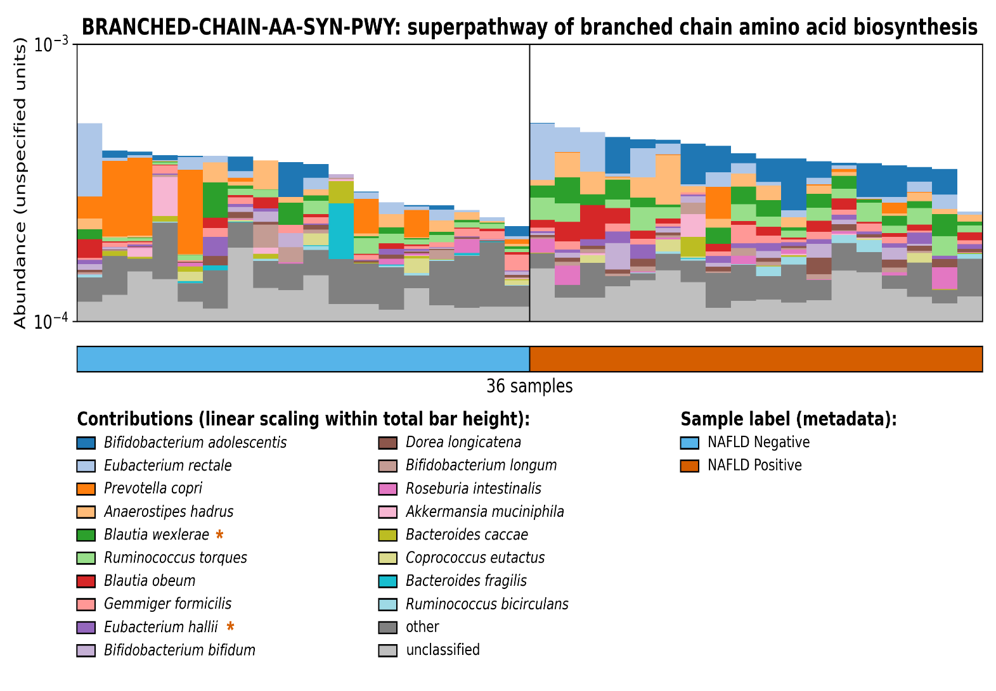
Supplemental Figure 9: Barplots Showing Relative Contribution of Individual Species to Total MetaCyc Pathway Abundance Per Sample. Samples are grouped and color coded based on NAFLD-status. Species contributions found to be statistically significantly different are marked with an asterisk and colored based on which group the species is elevated in. Bacteroides ovatus, Bacteroides stercoris, Bacteroiedes thetaiotamicron, and Parabacteroides distasonis are grouped into the “other” category but were found to be significantly elevated in the NAFLD negative group.

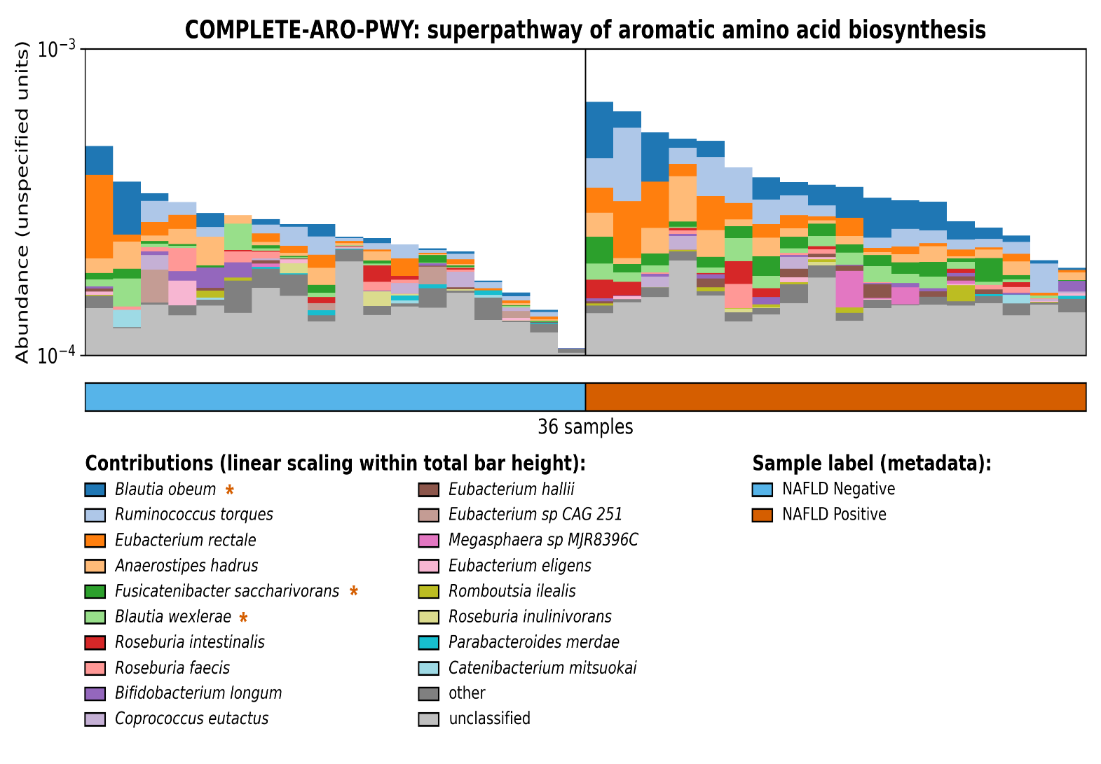 Supplemental Figure 10: Barplots Showing Relative Contribution of Individual Species to Total MetaCyc Pathway Abundance Per Sample. Samples are grouped and color coded based on NAFLD-status. Species contributions found to be statistically significantly different are marked with an asterisk and colored based on which group the species is elevated in.

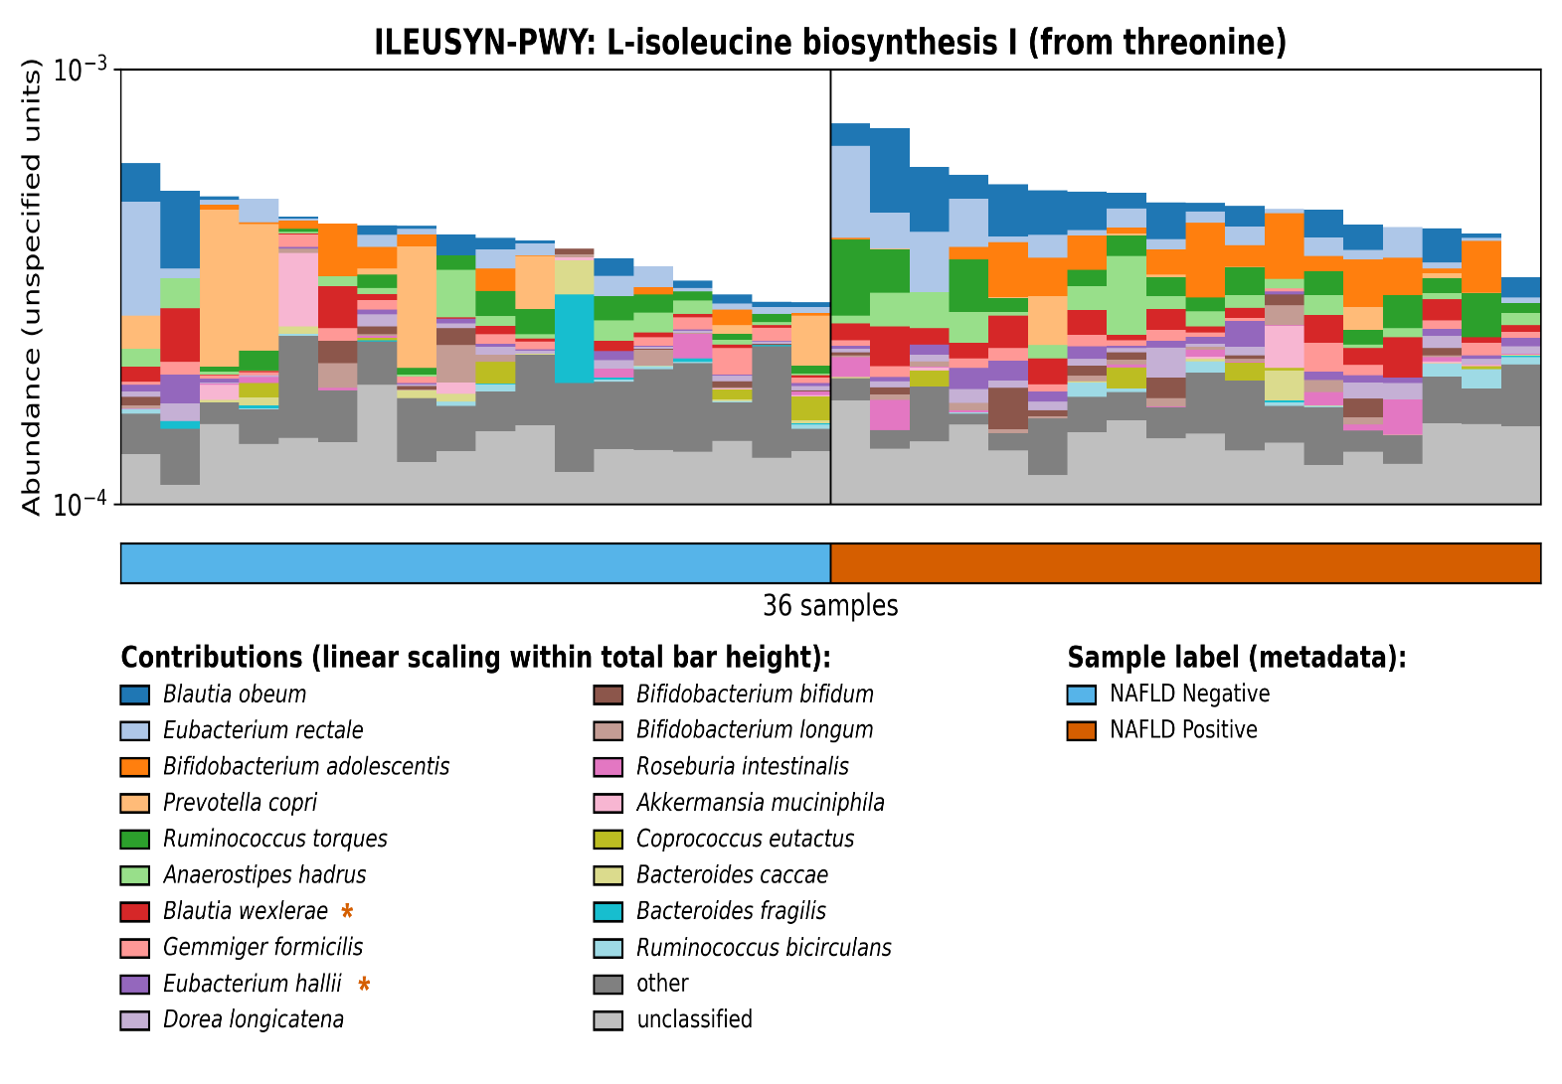
Supplemental Figure 11: Barplots Showing Relative Contribution of Individual Species to Total MetaCyc Pathway Abundance Per Sample. Samples are grouped and color coded based on NAFLD-status. Species contributions found to be statistically significantly different are marked with an asterisk and colored based on which group the species is elevated in. Bacteroides ovatus, Bacteroides stercoris, Bacteroiedes thetaiotamicron, and Parabacteroides distasonis are grouped into the “other” category but were found to be significantly elevated in the NAFLD negative group.

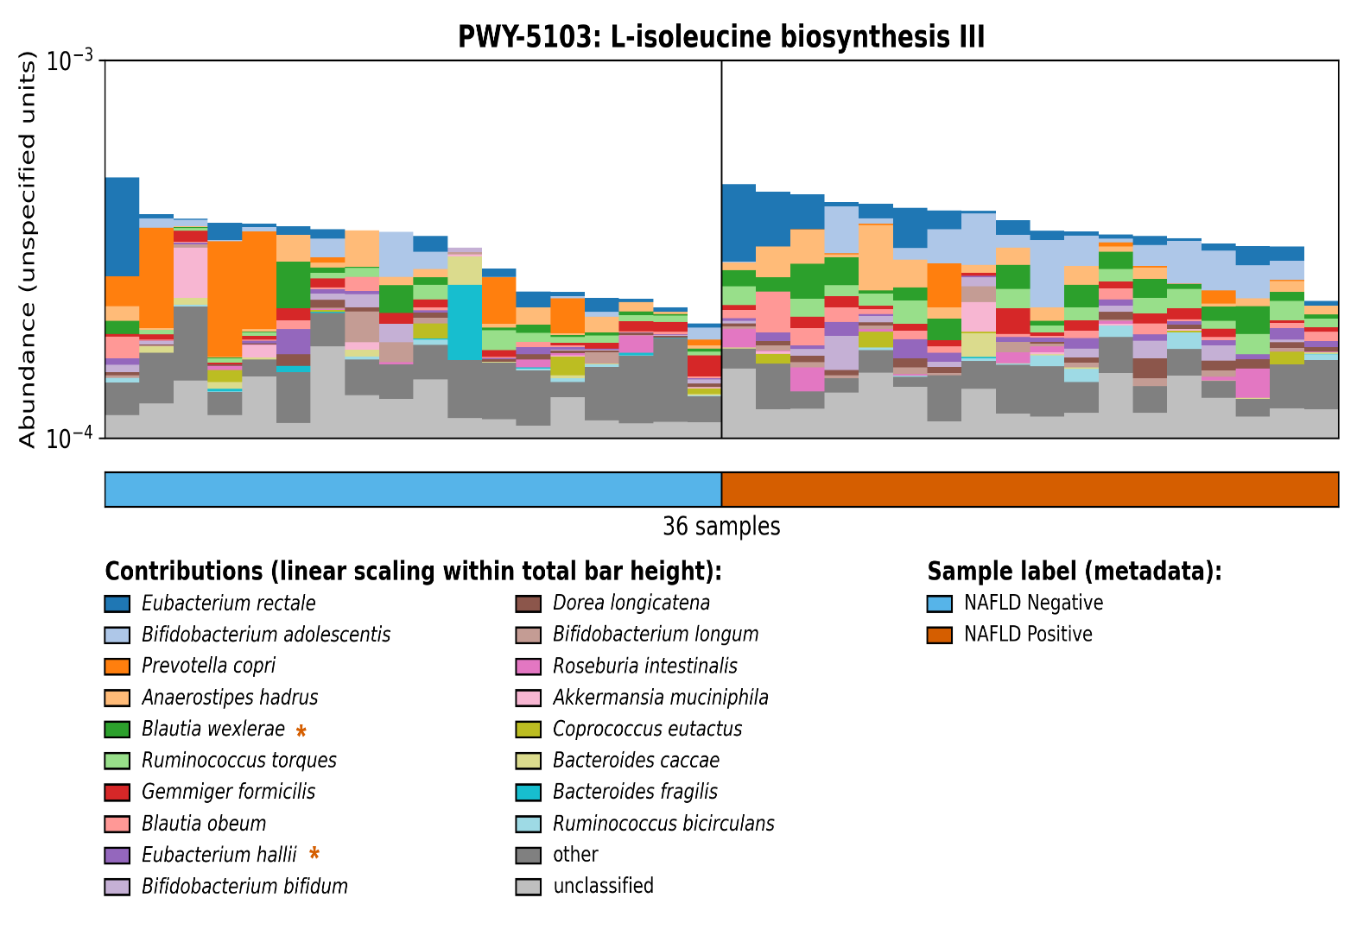
Supplemental Figure 12: Barplots Showing Relative Contribution of Individual Species to Total MetaCyc Pathway Abundance Per Sample. Samples are grouped and color coded based on NAFLD-status. Species contributions found to be statistically significantly different are marked with an asterisk and colored based on which group the species is elevated in. Bacteroides ovatus, Bacteroides stercoris, Bacteroiedes thetaiotamicron, and Parabacteroides distasonis are grouped into the “other” category but were found to be significantly elevated in the NAFLD negative group.

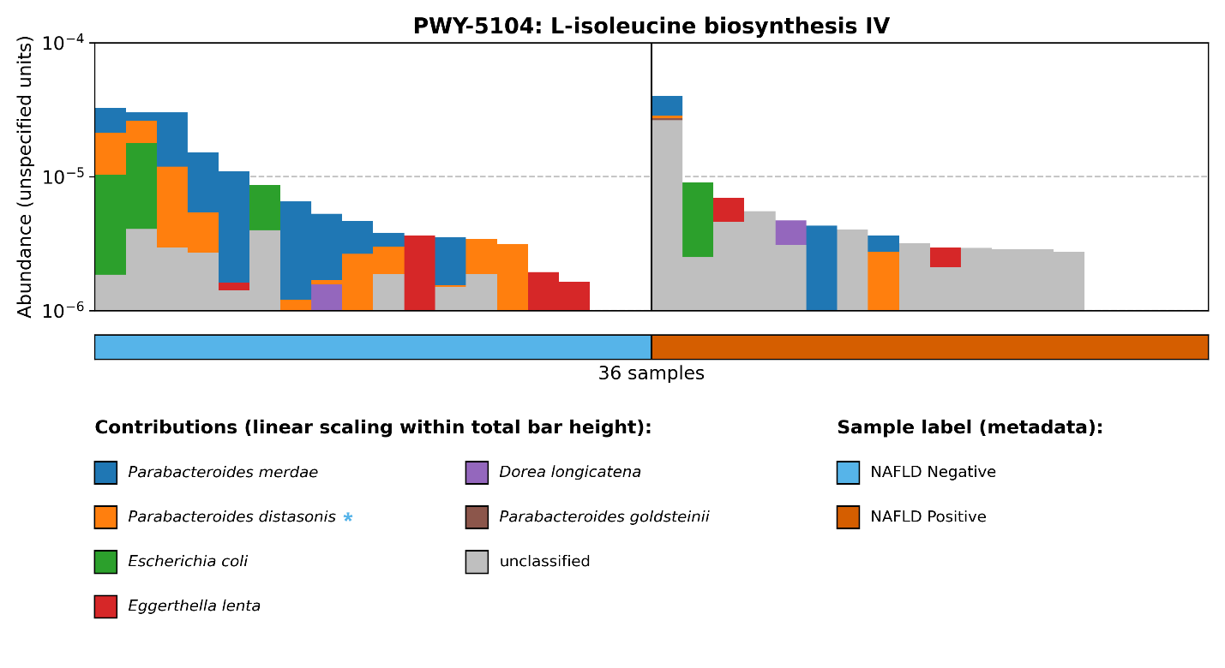
Supplemental Figure 13: Barplots Showing Relative Contribution of Individual Species to Total MetaCyc Pathway Abundance Per Sample. Samples are grouped and color coded based on NAFLD-status. Species contributions found to be statistically significantly different are marked with an asterisk and colored based on which group the species is elevated in.

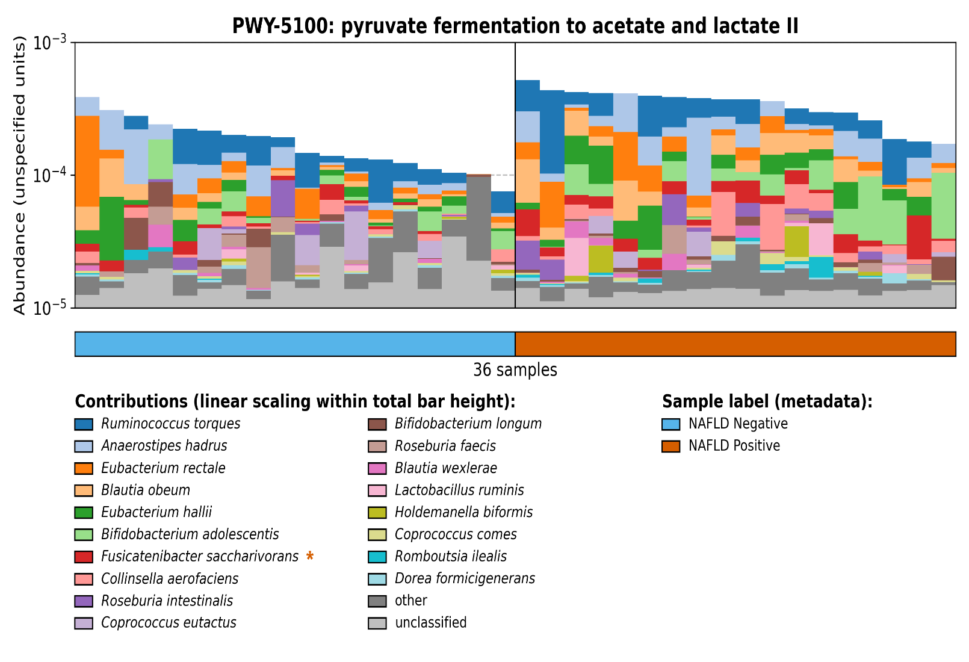
Supplemental Figure 14: Barplots Showing Relative Contribution of Individual Species to Total MetaCyc Pathway Abundance Per Sample. Samples are grouped and color coded based on NAFLD-status. Species contributions found to be statistically significantly different are marked with an asterisk and colored based on which group the species is elevated in. Streptococcus thermophilus and Streptococcus salivarius are grouped into the “other” category but were found to be significantly elevated in the NAFLD positive group as well.

Supplemental Table 1: Full Results of Pathway Abundance Comparison with Species Contribution Color Coded.

