Global warming impairs chemical communication between plants and pollinators

Supplementary material

Table S1. The amount (mg) of compounds contained in 150 µl of synthetic scent mixtures that were used for behavioral assays. The headspace of these mixtures resembled the floral scent emissions of 100 strawberry individuals for Optimum and Warmer scenarios each.
 | Optimum-scent | Warmer-scent
p-anisaldehyde | 0.01612 | 0.00100
1,4-dimethoxybenzene |  | 0.00165
benzyl alcohol | 0.00015
methyl salicylate | 0.00017
(E,E)-α-farnesene | 0.00024
acetone | 117.58823 | 117.59794

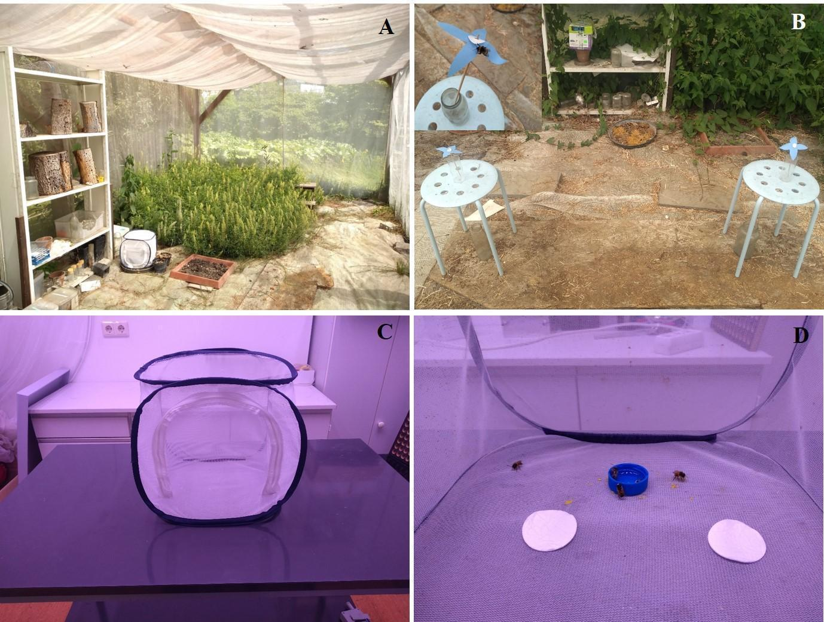
Figure S1. A-The flight cage in the Botanical Garden of the Paris-Lodron University of Salzburg. B-Set up of the behavioral experiments in the flight cage using artificial flowers and a Bombus terrestris bee on an artificial flower (inset photo); C- the small cage used indoors for behavioral assays; D- setup of indoor behavioral assays. For more details, see Methods.

