Supporting information

Multifunctional BN-Enabled Li₇La₃Zr₂O₁₂ Composite Electrolytes with Enhanced Toughness and Ionic Conductivity

Muhammad Mujtaba Syed^{1,2,#}, Balamurugan Thirumalraj^{1,2,#}, Jing Zhang³, Abdallah Kamal^{1,2}, Dawei Zhang¹, Baosong Li^{2,4}, Qingwen Li³, Kin Liao^{2,4}, Lianxi Zheng^{1,2,5,*}
¹Department of Mechanical and Nuclear Engineering, Khalifa University of Science and Technology, Abu Dhabi 127788, UAE
²Research & Innovation Center for Graphene and 2D Materials (RIC-2D), Khalifa University of Science and Technology, Abu Dhabi 127788, UAE
³ Key Laboratory of Multifunctional Nanomaterials and Smart Systems, Suzhou Institute of Nano-Tech and Nano-Bionics, Chinese Academy of Sciences, Suzhou 215123, China
⁴Department of Aerospace Engineering, Khalifa University of Science and Technology, Abu Dhabi 127788, UAE
⁵Research and Innovation Center on CO₂ and Hydrogen, Khalifa University of Science and Technology, Abu Dhabi 127788, UAE

*Corresponding author: lianxi.zheng@ku.ac.ae (Lianxi Zheng)
# Equal Contribution

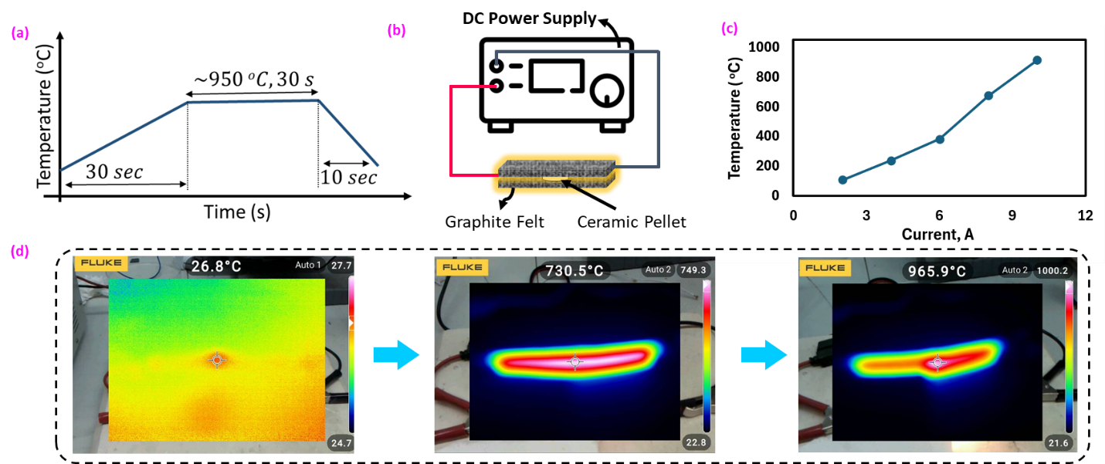

Figure S1. Ultrafast sintering of pellets using a joule heating setup. (a) Temperature profile used for sintering at ~950 °C. (b) Schematic of ultrafast joule heating setup (c) Temperature vs current achieved using this setup. (d) Thermal camera images capturing temperatures of 26.8, 730.5, and 966 ºC during sintering.

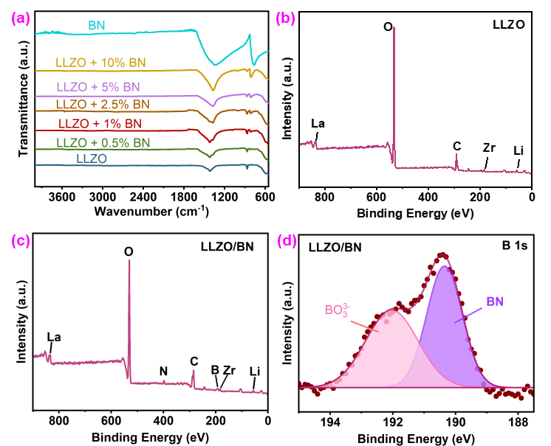
Figure S2. Full FTIR spectrum of pristine LLZO, h-BN, and LLZO/BN composites with varying BN weight percentage. XPS survey spectrum of (b) LLZO and (c) LLZO/BN composite. (d) High‑resolution XPS spectra of B 1s for the LLZO/BN composite.

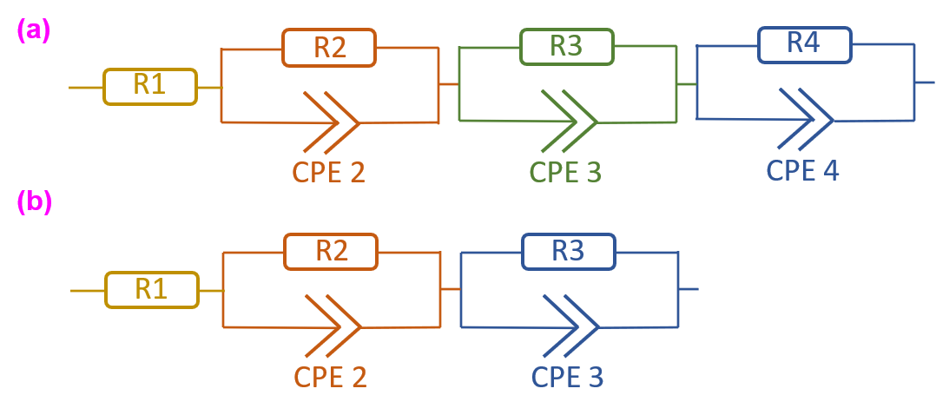
Figure S3. Equivalent circuit of Nyquist plots for (a) High grain boundary resistance, two semi-circles or curves observed in the Nyquist plot. (b) Low grain boundary resistance, one semi-circle or curve observed in the Nyquist plot.

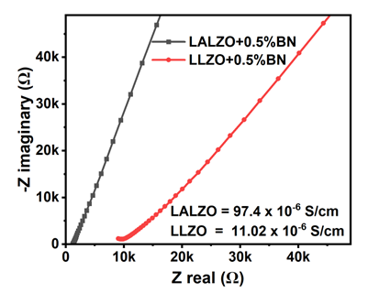
Figure S4. EIS Nyquist plots of LALZO/BN and LLZO/BN.

Table S1. Atomic composition of LLZO and LLZO/BN ceramic obtained using XPS data.
Material | Li (At.%) | Zr(At.%) | C(At.%) | O(At.%) | La(At.%) | B(At.%) | N(At.%)
LLZO | 36.36 | 0.21 | 17.28 | 45.67 | 0.48 | - | -
LLZO/BN | 28.07 | 0.17 | 23.03 | 42.38 | 0.62 | 3.47 | 2.26

Table S2. Density of LLZO and LLZO/BN composites measured using Archimedes' principle.
S.No. | Material | Relative Density
1 | LLZO | ~78.9%
2 | LLZO + 0.5% BN | ~93.6%
3 | LLZO + 1% BN | ~92.3%
4 | LLZO + 2.5%BN | ~86.9%
5 | LLZO + 5%BN | ~85.1%
6 | LLZO + 10%BN | ~73.4%

Table S3. Strain at 150 MPa of stress and toughness of LLZO and LLZO/BN composites calculated using stress-strain curves
Material | Strain at 150 MPa | Toughness (MJ/m³)
LLZO (0 wt.% BN) | Failure | 5.8 ± 1.7
LLZO + 0.5% BN | 0.0820 | 70.2 ± 4.1
LLZO + 1% BN | 0.0916 | 56.5 ± 2.9
LLZO + 2.5%BN | 0.1070 | 42.9 ± 3.3
LLZO + 5%BN | 0.1215 | 25.5 ± 3.3
LLZO + 10%BN | Failure | 2.2 ± 2.1

Table S4. Total resistance (grain plus grain boundary), thickness, ionic conductivity, and relative density of pristine LLZO and LLZO/BN composites.
Material | Total Resistance  (Ω) | t  (mm) | IC  (10⁻⁶ S/cm) | Relative Density
LLZO | 21200 | 0.6 | 4.45 | ~78.9%
LLZO + 0.5% BN | 9980 | 0.7 | 11.02 | ~93.6%
LLZO + 1% BN | 18350 | 0.7 | 5.99 | ~92.3%
LLZO + 2.5%BN | 60000 | 0.8 | 2.62 | ~86.9%

Table S5. Literature summary comparing various mechanical and electrochemical properties of solid electrolytes.
Material | Sintering  Temp | Sintering  Time | Hardness/  Toughness | Rt=KΩ | IC  10⁻⁵ S/cm | RD | Ea (eV) | Ref.
LGLZO | 1200 | 6 hr | - | - | 153 | - | 0.268 | ¹  2025
LLZTO/2wt.% Li₅AlO₄ | 1050 | 20 hr | - | 1.55  KΩ.cm | 67 | 95% | 0.415 | ²  2024
LGLZO + BN (2 mol%) | 1150 | 6 hr | 5.36 GPa/- | 1.23 | 67 | 92.9% | - | ³  2024
LLZTO | 1500 | 10 s | - | - | 100 | 97% | - | ⁴  2020
LLZTO+Li₃BO₃ (5:4)  LLZTO  LLZO | 1000  1000  1000 | 24 hr  24 hr  24 hr | - | 0.183  0.308  1.87 | 54.7  32.5  5.35 | 93.4%  93%  91.9% | - | ⁵  2019
LALZTO | 1200 | 8h | 8.9 GPa/-  51 MPa^ | - | 80 | 93% |  | ⁶  2019
LALZO  LALZO/1wt.%BN | 1100  1100 | 12 hr  12 hr | 0.076GPa/-  0.5 GPa/- | 21,65  0.87 | 0.196  6.21 | 77.13%  83.8% | 0.2659  0.22 | ⁷  2019
LLZO | 1150 | 15 hr | - | ~14 | 5.67 | 93% | 0.35 | ⁸  2017
LLZAO | 950 | *10 min | - | 0.97 | 33 | - | 0.38 | ⁹  2016
LLZGO | 1160 | 12 hr | - | - | 47.8 | 91.6% | 0.29 | ¹⁰  2016
LLZO | 1130 | 1h | - | - | 0.75 | - | 0.5 | ¹¹  2014
LLZO | 1200 | 24 hr | - | - | 0.99 | 91% | 0.43 | ¹²  2014
LLZO | 900 | 4 hr | - | - | 0.031 | - | 0.67 | ¹³  2011
LLZO/0.5%BN | 950 | 30s  UFJH | 70.2 MJ/m³ | 9.98 | 1.10 | 93.6% | 0.34 | This work
LLZO/0.5%BN | 950 | 8 hr | 45.8 MJ/m³ | 34.7 | 0.314 | 86.3% | 0.40 | This work
LALZO/0.5%BN | 950 | 30s  UFJH | - | 1.2 | 9.74 | - | - | This work
* Field-assisted sintering, Similar to Spark plasma sintering; they applied pressure as well as temperature for 10 minutes.
^ Fracture Stress

References

1. Nasir M, Seo J, Jung SI, Park HJ. Liquid electrolyte-assisted stabilization of the LLZO/Li interface for stable lithium metal batteries. EES Batteries. 2025;1(5):1314-1322. doi:10.1039/D5EB00026B
2. Zhou H, Zhou Y, Li X, Huang X, Tian B. Li ₅ AlO ₄ -Assisted Low-Temperature Sintering of Dense Li ₇ La ₃ Zr ₂ O ₁₂ Solid Electrolyte with High Critical Current Density. ACS Appl Mater Interfaces. 2024;16(5):5989-5998. doi:10.1021/acsami.3c17606
3. Zhao G, Luo C, Hua Q. Enhanced comprehensive performance of the LLZO series solid electrolyte via multifunctional additive. J Eur Ceram Soc. 2024;44(4):2251-2260. doi:10.1016/j.jeurceramsoc.2023.11.045
4. Wang C, Ping W, Bai Q, et al. A general method to synthesize and sinter bulk ceramics in seconds. Science (1979). 2020;368(6490):521-526. doi:10.1126/science.aaz7681
5. Xie H, Li C, Kan WH, et al. Consolidating the grain boundary of the garnet electrolyte LLZTO with Li ₃ BO ₃ for high-performance LiNi _{0.8} Co _{0.1} Mn _{0.1} O ₂ /LiFePO ₄ hybrid solid batteries. J Mater Chem A Mater. 2019;7(36):20633-20639. doi:10.1039/C9TA03263K
6. Yan G, Nonemacher JF, Zheng H, Finsterbusch M, Malzbender J, Krüger M. An investigation on strength distribution, subcritical crack growth and lifetime of the lithium-ion conductor Li7La3Zr2O12. J Mater Sci. 2019;54(7):5671-5681. doi:10.1007/s10853-018-03251-4
7. Zhang Z, Gonzalez AR, Choy KL. Boron Nitride Enhanced Garnet-Type (Li _{6.25} Al _{0.25} La ₃ Zr ₂ O ₁₂ ) Ceramic Electrolyte for an All-Solid-State Lithium-Ion Battery. ACS Appl Energy Mater. 2019;2(10):7438-7448. doi:10.1021/acsaem.9b01431
8. Zhao P, Wen Y, Cheng J, et al. A novel method for preparation of high dense tetragonal Li7La3Zr2O12. J Power Sources. 2017;344:56-61. doi:10.1016/j.jpowsour.2017.01.088
9. Botros M, Djenadic R, Clemens O, Möller M, Hahn H. Field assisted sintering of fine-grained Li7−3La3Zr2Al O12 solid electrolyte and the influence of the microstructure on the electrochemical performance. J Power Sources. 2016;309:108-115. doi:10.1016/j.jpowsour.2016.01.086
10. Hu S, Li YF, Yang R, Yang Z, Wang L. Structure and ionic conductivity of Li7La3Zr2−xGexO12 garnet-like solid electrolyte for all solid state lithium ion batteries. Ceram Int. 2018;44(6):6614-6618. doi:10.1016/j.ceramint.2018.01.065
11. Il’ina EA, Raskovalov AA, Shevelin PY, Voronin VI, Berger IF, Zhyravlev NA. Lithium stoichiometry of solid electrolytes based on tetragonal Li7La3Zr2O12. Mater Res Bull. 2014;53:32-37. doi:10.1016/j.materresbull.2014.01.041
12. Inada R, Kusakabe K, Tanaka T, Kudo S, Sakurai Y. Synthesis and properties of Al-free Li7−xLa3Zr2−xTaxO12 garnet related oxides. Solid State Ion. 2014;262:568-572. doi:10.1016/j.ssi.2013.09.008
13. Kokal I, Somer M, Notten PHL, Hintzen HT. Sol–gel synthesis and lithium ion conductivity of Li7La3Zr2O12 with garnet-related type structure. Solid State Ion. 2011;185(1):42-46. doi:10.1016/j.ssi.2011.01.002

