lims
Guolong Su¹, Xin Yu¹, Haitao Zhang¹*, Xiao Chen¹, Caixu He¹, Xiuzhong Zhu¹, Shaoming Wang²*.
¹ Faculty of Light Industry, Qilu University of Technology (Shandong academy of sciences).
² Department of Clinical Laboratory, The 960th Hospital of People's Liberation Army of China (PLA), Jinan, China.
* Correspondence: zhanghaitao@qlu.edu.cn (H.Z.), jykwsm960@163.com (S.W).
Tel.: +86-133-6531-6033 (H.Z.)

Fig S1. ¹H NMR spectra of compound 2.
Fig S2. ¹H NMR spectra of compound 3.

Fig S3. ¹H NMR spectra of EDOT-EN₁.
Fig S4. ¹H NMR spectra of EDOT-EN₂.
Fig S5. ¹H NMR spectra of EDOT-EN₃.
Fig S6. ¹H NMR spectra of EDOT-EN₄.

Fig S7. ¹³C NMR spectra of EDOT-EN₁.
Fig S8. ¹³C NMR spectra of EDOT-EN₂.
Fig S9. ¹³C NMR spectra of EDOT-EN₃.
Fig S10. ¹³C NMR spectra of EDOT-EN₄.
Fig S11. HR-MS spectrum of EDOT-EN.
Fig S12. ¹³C NMR spectra of EDOT-cad.

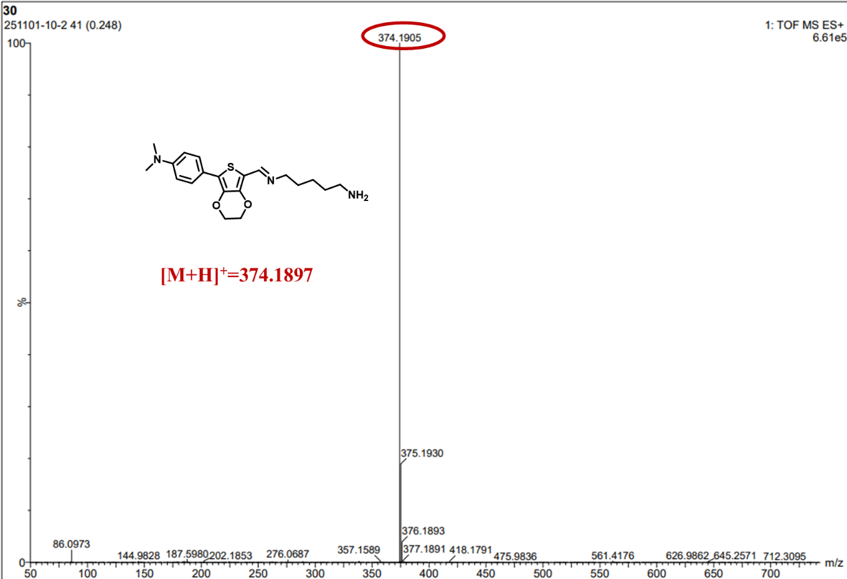
Fig S13. HR-MS spectrum of EDOT-cad
Fig S14. (a) UV absorption spectra of EDOT-EN₁ in different solvents; (b) UV absorption spectra of EDOT-EN₂ in different solvents; (c) UV absorption spectra of EDOT-EN₃ in different solvents; (d) UV absorption spectra of EDOT-EN₄ in different solvents; (d) UV absorption spectra of EDOT-EN₄ in different solvents; (d) UV absorption spectra of EDOT-EN₄ in different solvents
Fig S15. (a) The fluorescence intensities of EDOT-EN₁, EDOT-EN₂, EDOT-EN₃ and EDOT-EN₄ at different moisture contents. (b) 1, 2, 3 and 4 represent concentrations of 0.01 mM for EDOT-EN₁, EDOT-EN₂, EDOT-EN₃ and EDOT-EN₄ respectively. The upper part shows the visual differences under natural light, while the lower part shows the fluorescence differences under ultraviolet light.
Fig S16. Titration ¹H NMR spectra of EDOT-EN₁ with different amounts (from bottom to the top: 0, 50,150,250 μL) of Cad added.

