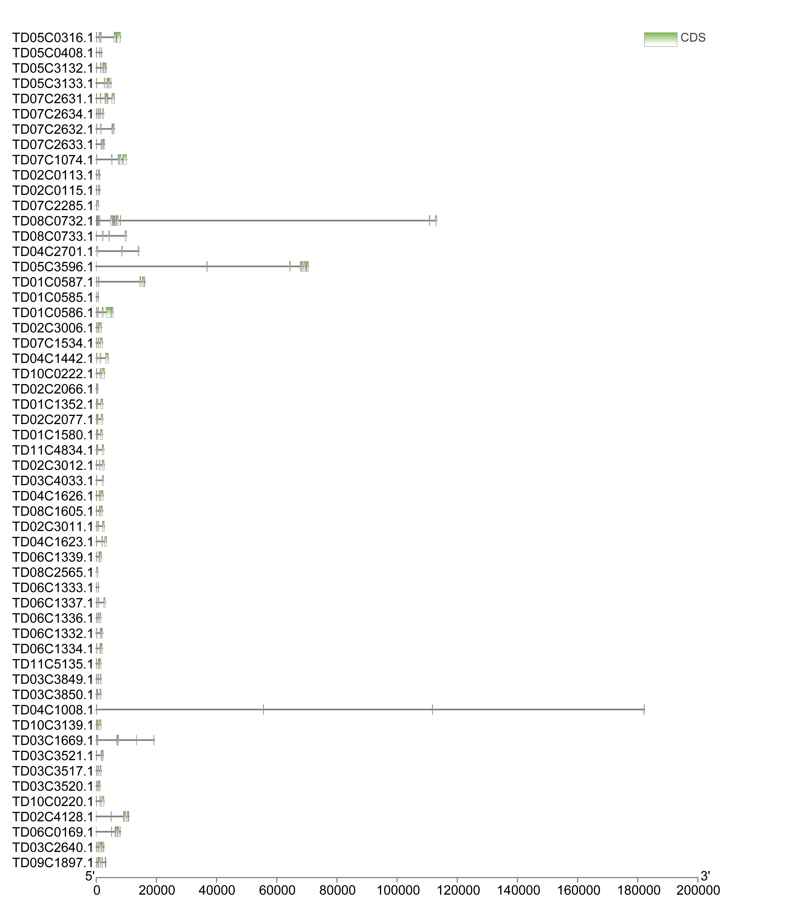
Fig. S1. Structural analysis of TdNAC genes.

