Supplementary Figures

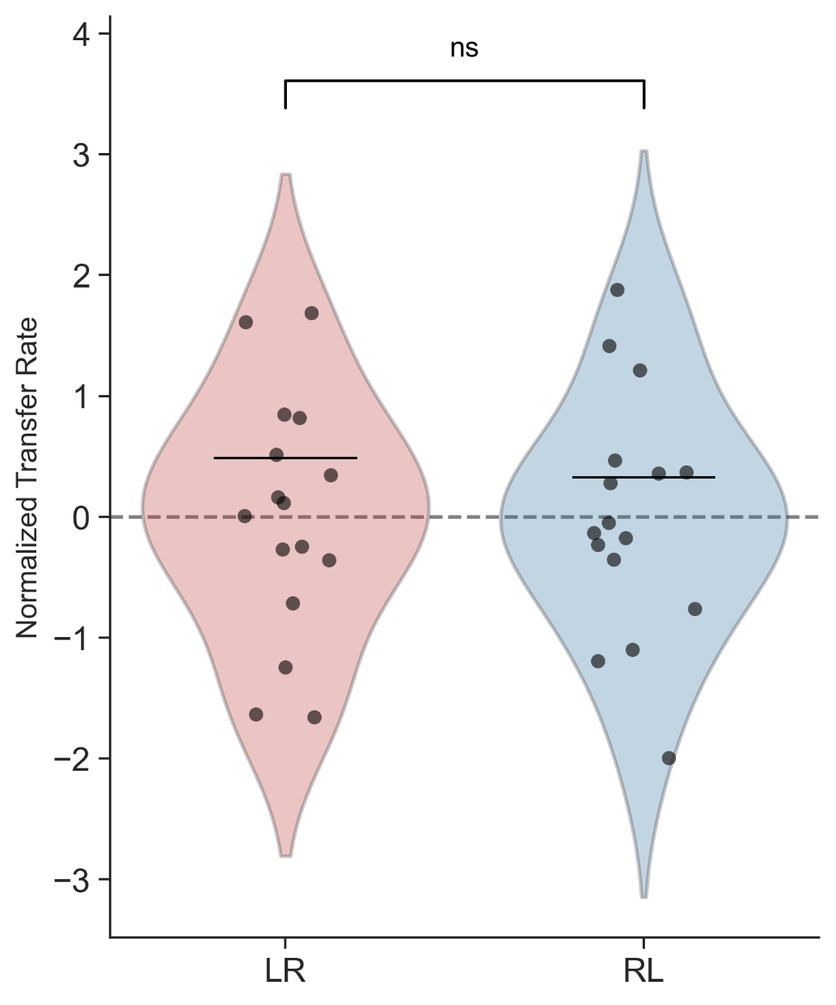
Figure S1. Distribution of intermanual transfer rate.
Violin plots illustrate the normalized transfer rate for the Left-to-Right (LR) and Right-to-Left (RL) groups. Individual participant data points are overlaid as semi-transparent black circles, highlighting the high degree of inter-subject variability within both groups. The black horizontal lines denote the mean transfer rate for each respective group. The dashed gray line at y = 0 represents a theoretical baseline of zero transfer, where positive values indicate a facilitation of initial performance upon switching hands, and negative values indicate a relative performance decrement (ns = not significant; p > 0.05).

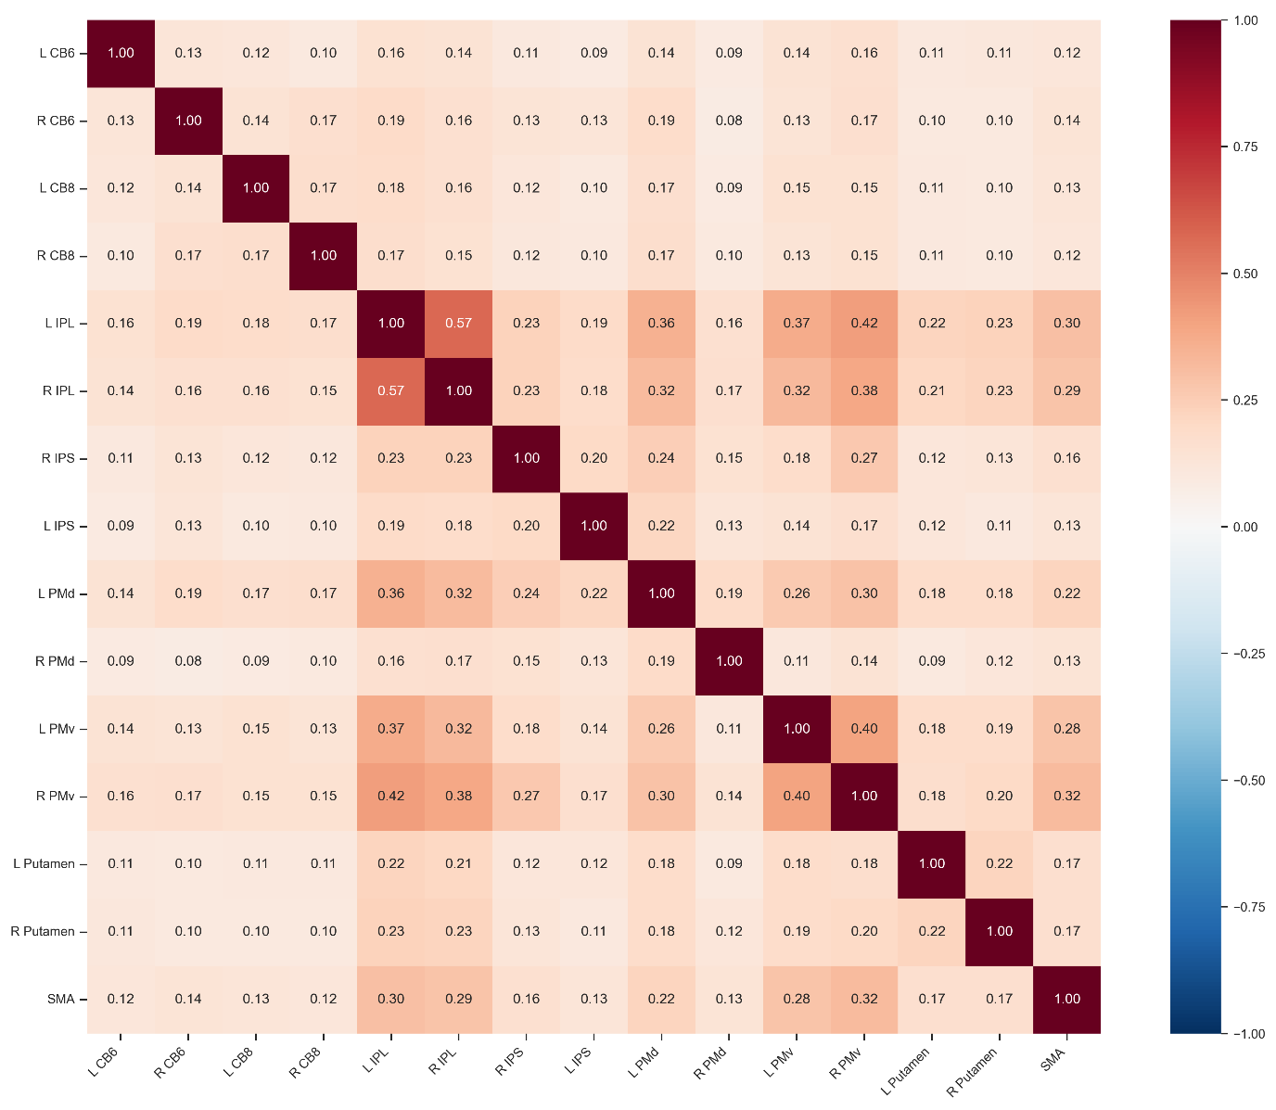
Figure S2. Group average resting-state functional connectivity within the sensorimotor network
The heatmap displays the mean functional connectivity between 15 pre-defined regions of interest (ROIs) across all participants. Individual subject correlation matrices were first Fisher z-transformed, averaged across the group, and subsequently back-transformed to Pearson correlation coefficients (r) for visualization. Numerical values within each cell represent the mean r-value for that specific neural connection. The color gradient indicates the strength of the connectivity, with darker red colors representing stronger positive correlations. Abbreviations: L, Left; R, Right; CB6, Cerebellar Lobule 6; CB8, Cerebellar Lobule 8; IPL, Inferior Parietal Lobule; IPS, Intraparietal Sulcus; PMd, Dorsal Premotor Cortex; PMv, Ventral Premotor Cortex; SMA, Supplementary Motor Area.

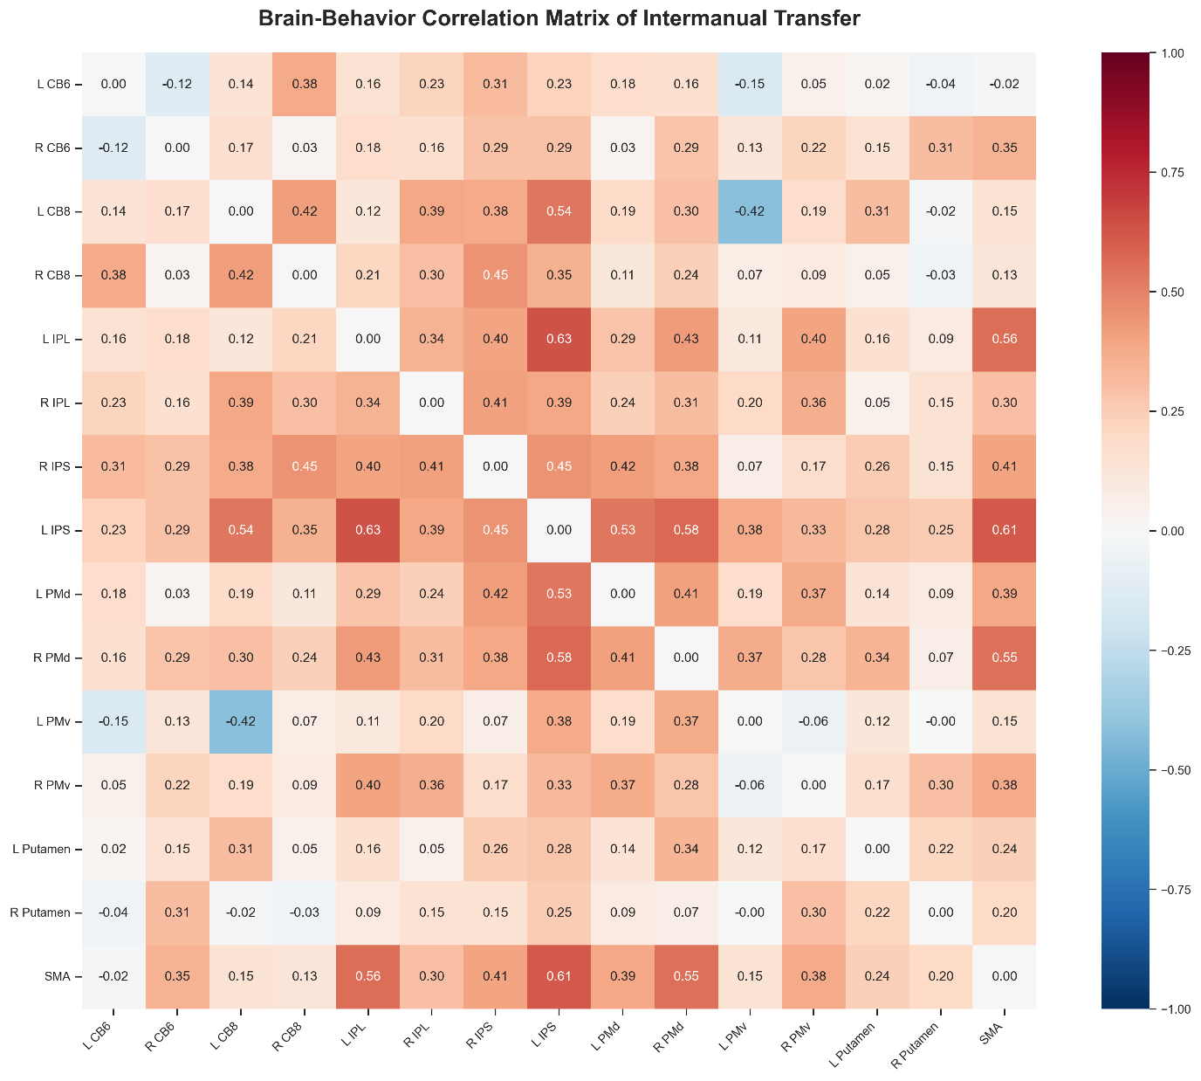
Figure S3. Brain-behavior correlation matrix for intermanual transfer.
Brain-behavior relationship matrix displaying the correlation coefficients (r) between the intrinsic resting-state functional connectivity of 15 seed regions and the normalized intermanual transfer rate across participants. Color intensity reflects the strength and direction of the correlation, with dark red indicating a strong positive association between regional coupling and behavioral transfer to the untrained hand. Widespread significant correlations are observed within a targeted fronto-parietal network, highlighting the Supplementary Motor Area (SMA), dorsal premotor cortex (PMd), and the parietal cortex (IPS/IPL) as pre-learning indicators associated with intermanual transfer in de novo motor skill.

