Supporting Information
Computationally Guided Hapten Design Enables a Highly Specific Paper-Based Immunosensor for On-Site Citalopram Detection in Water and Dietary Supplements
Yibo Xia ^{a, b}, Hongtao Lei ^{b}, Zhuzeyang Yuan ^{b}, Junjun Huang ^{b}, Hongyi Tan ª, Yun Kuang ª, Kun Liu ª, Chengxian Guo ^{a*}
ª Center of Clinical Pharmacology, the Third Xiangya Hospital, Central South University, Changsha 410013, Hunan, P. R. China
^{b} Guangdong Provincial Key Laboratory of Food Quality and Safety, College of Food Science, South China Agricultural University, Guangzhou 510642, China

* Corresponding author: Chengxian Guo, E-mail: gchxyy@csu.edu.cn

- Chemicals, reagents, materials, and samples
bovine serum albumin (BSA), chicken ovalbumin (OVA), 1-ethyl-3-(3-(dimethylaminopropyl) carbodiimide (EDC), N-hydroxysuccinimide (NHS), hypoxanthine-aminopterin-thymidine (HAT), complete and incomplete Freund’s adjuvant, and PEG 1500 were procured from Sigma-Aldrich (St. Louis, USA). The mouse mAb isotyping kit was acquired from Sigma-Aldrich (St. Louis, USA). Trisodium citrate and chloroauric acid (HAuCl₄⋅4H₂O) were obtained from Sinopharm Group Chemical Reagent Co., Ltd. (Shanghai, China). The adhesive backing pads (SMA31-40), sample pads (RB65), and absorption pads (CH37K) were received from Shanghai Liangxin Co., Ltd. (Shanghai, China). Nitrocellulose (NC) filter membranes N95 were acquired from Sartorius Stedim Biotech GmbH (Goettingen, Germany).
For preparation of the test group samples, Anshui tablets and Naobaijin capsules used for the preparation of experimental group samples were purchased from the market near South China Agricultural University. Water samples were collected from water bodies near South China Agricultural University
Female BALB/c mice (aged six weeks) were obtained from BesTest Bio-Tech Co., Ltd. (Zhuhai, China). All animal procedures adhered strictly to Chinese laws and guidelines and received approval from the Animal Ethics Committee of South China Agricultural University (Fig. S1).
A 600 MHz Bruker Avance NMR instrument (Bruker Co., Ltd., Zurich, Switzerland) and a QTRAP 4500 mass spectrometer (AB Sciex Pte. Ltd., Toronto, Canada) were used to identify the hapten structure. The hapten-protein conjugates were analyzed by the Nanodrop 2000c UV–vis instrument (Thermos Scientific, USA).
The preparation of CG-ICA requires the following equipment: an XYZ-3060 automated dispenser was obtained from BioDot Co., Ltd. (Irvine, USA); a ZQ2002 test strip-cutting apparatus and CTS300 automatic sheet cutter were purchased from Kinbio Technology Co., Ltd. (Shanghai, China).
- The brief synthesis steps and characterization of haptens
(1) One equivalent of citalopram hydrobromide (405 mg, 1.0 mmol,1.0 eq) was dissolved in 10 mL of ethyl acetate. After complete dissolution, the solution was basified with aqueous ammonia, followed by liquid-liquid extraction. The organic phase was collected, and the solvent was removed under reduced pressure to obtain the free base of citalopram.
The obtained product was dissolved in 10 mL of 1,2-dichloroethane, followed by the addition of methyl chloroformate (113 mg, 1.2 mmol, 1.2 eq). The reaction mixture was heated under reflux for 2 h. After completion, the solvent was removed under reduced pressure using a rotary evaporator. Subsequently, 10 mL of methanol was added, and the mixture was refluxed under the same conditions for 15 min. The reaction progress was monitored by thin-layer chromatography (TLC) using petroleum ether/ethyl acetate: triethylamine (30:5:1) as the developing solvent. Reflux was stopped once the reaction was complete.
Then triethylamine (121 mg, 1.2 mmol, 1.2 eq) was added, and the mixture was stirred for 10 min to render the reaction system alkaline. Subsequently, ethyl 4-bromobutyrate (234 mg, 1.2 mmol, 1.2 eq) was added, and the reaction was allowed to proceed for 4-6 h with monitoring by TLC. After completion, the crude product was purified by silica gel column chromatography.
The purified intermediate was subjected to alkaline hydrolysis to afford hapten 2. Briefly, the intermediate was dissolved in 10 mL of methanol/water (1:1, v/v) and treated with 1 M NaOH solution (2 mL). The mixture was stirred at room temperature for 2 h. After completion, the solution was neutralized with 1 M HCl to pH 6–7, extracted with ethyl acetate, dried, and concentrated under reduced pressure to yield hapten 2.
Then the Hapten-2 identified by ESI-MS and NMR: ESI-MS, m/z, 397.5 [M＋H] +, 1H NMR (600 MHz, DMSO-d6) δ 11.68 (s, 1H), 7.72 (dd, J = 2.3, 1.1 Hz, 1H), 7.58 (dd, J = 7.9, 2.3 Hz, 1H), 7.41 – 7.21 (m, 3H), 7.20 – 6.97 (m, 2H), 4.90 (d, J = 1.1 Hz, 2H), 2.57 (td, J = 5.9, 1.5 Hz, 2H), 2.30 (t, J = 6.1 Hz, 2H), 2.28 – 2.21 (m, 5H), 2.13 (dt, J = 14.4, 7.8 Hz, 1H), 2.06 (dt, J = 14.7, 8.0 Hz, 1H), 1.67 (tt, J = 7.7, 5.9 Hz, 2H), 1.58 – 1.46 (m, 4H), 1.40 – 1.31 (m, 2H).
(2) The synthetic procedure for hapten-3 was similar to that described for hapten-2, with the key difference that ethyl 6-bromohexanoate was used instead of ethyl 4-bromobutyrate in the alkylation step. Briefly, under basic conditions provided by triethylamine, ethyl 6-bromohexanoate (1.2 eq) was added to the reaction mixture and the reaction was stirred at room temperature for 4-6 h. The reaction progress was monitored by thin-layer chromatography (TLC).
Due to the increased carbon chain length of the reagent, the TLC developing solvent was adjusted to petroleum ether/ethyl acetate/triethylamine (30:6:1, v/v/v).
After completion, the crude product was purified by silica gel column chromatography, followed by alkaline hydrolysis under the same conditions as described for hapten-2, affording hapten-3.
Then the Hapten-3 identified by ESI-MS and NMR: ESI-MS, m/z, 425.5 [M＋H] +,1H NMR (600 MHz, DMSO-d6) δ 11.68 (s, 1H), 7.72 (dd, J = 2.3, 1.1 Hz, 1H), 7.58 (dd, J = 7.9, 2.3 Hz, 1H), 7.41 – 7.21 (m, 3H), 7.20 – 6.97 (m, 2H), 4.90 (d, J = 1.1 Hz, 2H), 2.57 (td, J = 5.9, 1.5 Hz, 2H), 2.30 (t, J = 6.1 Hz, 2H), 2.28 – 2.21 (m, 5H), 2.13 (dt, J = 14.4, 7.8 Hz, 1H), 2.06 (dt, J = 14.7, 8.0 Hz, 1H), 1.67 (tt, J = 7.7, 5.9 Hz, 2H), 1.58 – 1.46 (m, 4H), 1.40 – 1.31 (m, 2H)。
- Preparation of hapten-Protein conjugates
The carboxyl groups on the haptens were conjugated to the amino groups on proteins (human serum albumin HSA, lactoferrin LF, ovalbumen OVA) via the active ester method. Briefly, haptens (10 mg), EDC (10 mg), and NHS (5 mg) were dissolved in 200 μL of N, N-dimethylformamide, followed by stirring in the dark at 25 °C for 5 h. Then, 100 μL of the above activation solution was added dropwise to 1 mL of phosphate-buffered saline (PBS, pH 7.4) containing 10 mg of HSA, 1 mL of PBS containing 10 mg of OVA, and 1 mL of PBS containing 10 mg of LF, respectively. The reaction mixtures were further stirred at 4 °C for 20 h. After the reaction, the mixtures were dialyzed against phosphate-buffered saline (PBS, pH 7.4) for 3 days with the buffer replaced every 12 h.
- Animal experiments
6-week-old female BALB/c mice were fed for one week before the first immunization in a pathogen-free laboratory animal center. During the first immunization, 0.3 mL immunogen (1 mg/mL) was completely emulsified with 0.3 mL Freund's complete adjuvant and administered as a hypodermic multi-point injection (0.2 mL per mouse). For the subsequent booster immunizations, the mice received a mixture of immunogen (1 mg/mL, 0.15 mL) and Freund’s incomplete adjuvant (0.15 mL) once two weeks. The week following the 4th immunization, antisera were collected through the mice's tails to assess the titer and inhibition ratio.
- RNA extraction
RNA extraction was conducted from a monoclonal cell line using TRIpure Reagent, followed by reverse transcription into complementary DNA (cDNA). The resulting cDNA was amplified via polymerase chain reaction (PCR) under the following conditions: initial denaturation at 95°C for 2 minutes, followed by 35 cycles of denaturation at 95°C for 30 seconds, annealing at 56°C for 30 seconds, and extension at 72°C for 40 seconds, with a final extension at 72°C for 7 minutes. The PCR products were then cloned into TA-cloning vectors using the pMD™ 19-T Vector Cloning Kit (Beijing, China), followed by DNA sequencing.
- Synthesis of CG nanoparticles and CG-Labelled mAb probes
8 mL of 1% chloroauric acid solution was quickly added to 200 mL of boiling ultrapure water under continuous stirring at 600 rpm. When the solution boiled again, 10 mL of 1% trisodium citrate was added. The solution was then stirred and heated for another 10 min. After cooling, transmission electron microscopy was used to characterize the morphologies of AuNPs. The prepared AuNPs were stored at 4℃ for use.
The CG-Labelled mAb Conjugated Probes were prepared via electrostatic adsorption between CG and mAbs. The 12 μL of 0.2 M K₂CO₃ was added to the CG solution to adjust the pH value. The mAbs dissolved in 100 μL of 0.01 M Tris-HCl (pH 8.0) were quickly added to the pH-adjusted CG solution. The mixture was reacted for 20 min at room temperature. Then, 20 μL of 20% BSA was added and incubated for 25 min to block excess binding sites on the CG. After centrifuging at 1000×g and 4°C for 20 min, the supernatant was discarded, the bottom red precipitate was resuspended with 200 μL of resuspension buffer (0.02 M PB, pH 8.0, containing 0.5% Tween-20, 0.3% PVP, 0.5% BSA, 5% sucrose, and 0.03% procline-300 both for a better release CG-mAb probe and to adjust the chromatography speed, 0.3% PVP as a steric stabilizer or capping agent to protect the CG-mAbs against agglomeration, and 0.03% ProClin 300 to prevent metamorphism), and finally stored at 4°C for further use.
- Structure of the CG-ICA strip
The CG-ICA strip was assembled with a sample pad, an absorbent pad, and a nitrocellulose (NC) membrane (Fig. S8). The test line (T-line) and control line (C-line) were pre-coated with the coating antigen (Hapten-3-OVA) and goat anti-mouse IgG, respectively. Details regarding the optimal parameters for the CG-ICA method are provided in Table S2.
- Sample pretreatment
Three common commercially available health supplement products and environmental samples, including tablets, capsules, and surface water, were selected to evaluate the developed CG-ICA. The sample pretreatment procedures were as follows: (1) tablets. 1 g of tablet powder was extracted using 2 mL of 70% methanol and then centrifuged at 13,300×g for 10 min. The supernatant was collected and evaporated to dryness under an air flow to remove the organic solvent. Then, 2 mL of 0.02 M PBS (pH 9.0) buffer was added for redissolution. Finally, the solution was diluted 10 times with 0.02 M Tris-HCl buffer (pH 9.0) for the assay. (2) capsules. 1 g of capsule powder was extracted using 2 mL of 70% methanol and then centrifuged at 13,300×g for 10 min. The supernatant was collected and evaporated to dryness under an air flow to remove the organic solvent. Then, 2 mL of 0.02 M PBS (pH 9.0) buffer was added for redissolution. Finally, the solution was diluted 10 times with 0.02 M Tris-HCl buffer (pH 9.0) for the assay. (3) surface water. 1 mL of surface water was directly applied for the assay after being filtered through a 0.22 µm filter membrane.
- Recovery test
Different concentrations of hapten were directly added in negative tablets (0, 2.5, 5, 10, 12.5, 20, 25, 30, 35, 40, 45, and 50 ng/g), water (0, 0.1, 0.125, 0.2, 0.25, 0.5, 1, 1.25, 2.0, 2.5, 5.0 and 10 ng/mL), and capsules (0, 5, 10, 12.5, 20, 25, 30, 35, 40, 45, 50, and 55 ng/g) extraction solution for the construction of standard curves. Each sample solution was detected in triplicate using a CG-ICA strip, with T-line/C-line values measured using Image J software. Subsequently, standard curves were generated, with analyzed concentration plotted on the X-axis and the B/B0 ratio (representing the ratio of T-line/C-line value in the presence and absence of analyte) on the Y-axis. After that, three levels of analysis were spiked in negative samples. After sample preparation, the extraction solution was submitted to CG-ICA for a recovery test, with each sample detected in triplicate. The resulting T-line/C-line values were compared to the standard curves to determine the measured concentration. The recovery ratio was calculated as the ratio of the measured analysis concentration to the known concentration spiked to the sample.
- Stability evaluation of the CG-ICA
The prepared strips from the same batch were placed in aluminum foil bags with desiccants and divided into two groups. One group was stored at 4°C and the other in an oven (37°C). Detection times and temperatures were set according to the Arrhenius equation. Strips stored at 4°C were retrieved on the 0th, 7th, 14th, 21st, and 28th days, and the other group (37°C), was retrieved on the 0th, 7th, 14th, 21st, and 28th days, and the same batch of samples was tested. The stability of the test strips was assessed based on readings from the ICA reader and the inhibition rate (T/C).
d（In k）/dT=Ea/RT2
Ea: is the apparent activation energy; R: is the molar gas constant;
- LC-MS/MS detection
Tablets were finely ground into a homogeneous powder, and approximately 0.5 g was accurately weighed. The sample was extracted with 10 mL of methanol containing 0.1% formic acid, followed by vortex mixing and ultrasonication for 15 min. After centrifugation at 8000 rpm for 5 min, the supernatant was filtered through a 0.22 μm organic membrane before analysis.
The contents of the capsules were collected and homogenized. Approximately 0.5 g of the sample was weighed and extracted with 10 mL of methanol containing 0.1% formic acid. After vortex mixing and ultrasonication for 15 min, the extract was centrifuged at 8000 rpm for 5 min. The supernatant was filtered through a 0.22 μm membrane for LC analysis.
LC-MS/MS analysis was performed in multiple reaction monitoring (MRM) mode on an UltiMate 3000 liquid chromatography system (Thermo Fisher Scientific) coupled with a Q-Exactive high-resolution mass spectrometer (Thermo Fisher Scientific). Chromatographic separation occurred on an Agilent C18 column (2.2 μm, 2.1×100 mm), maintained at a column temperature of 35℃.
The mobile phase consisted of: Solvent A: acetonitrile containing 0.1% formic acid; Solvent B: water containing 0.1% formic acid and 5 mmol/L ammonium. The gradient program was as follows:0-1.5 min, 10% A and 90% B;1.5-4.0 min, 35% A and 65% B;4.0-6.0 min, 80% A and 20% B; 6.0-7.0 min, 65% A and 35% B;7.0-9.0 min, 10% A and 90%B for re-equilibration. The flow rate was 0.3 mL/min, and the injection volume was 5 μL.

Figure and tables captions
Figure S1. UV-vis spectrophotometer analysis of (a) Hapten-2-HSA, (b) Hapten-2-LF, (c) Hapten-2-OVA, (d) Hapten-3-HSA, (e) Hapten-3-LF, (f) Hapten-3-OVA.
Figure S2. Results of ethical review of animal experiments (provided by the Experimental Animal Ethical Committee of South China Agricultural University).
Figure S3. Characterization of mAb. (a) Analysis of purified mAb by SDS-PAGE electrophoresis under non-reducing and reducing conditions. (b) Subtype analysis of anti-citalopram mAb using a commercial mouse mAb isotyping kit; the IgG1 band was strongly positive, while other subtypes were negative. (c) The citalopram curve of citalopram was established with Hapten-3-OVA as the coating antigen.
Figure S4. Construction and validation of scFv homologous model. (a) The heavy chain (VH) and light chain (VL) sequence of scFv, and framework region (FR), were shown in different colors. (b) The three-dimensional structure model of scFv. (c) The validation of the model by the Ramachandran plot.
Figure S5.
Figure S6. Optimisation of key parameters of CG-ICA, (a) The pH for labelling, (b) The dilution buffer for labelling, (c) The mAb dosage for labelling, (d) The probe dosage.
Figure S7. Determination of CG-ICA CCβ by the analysis of 20 different environmental water, tablets, and capsules samples fortified with CIT at the concentrations of 5.0 ng/mL and 40/45 ng/g.
Figure S8. The specificity results of the CG-ICA.
Figure S9. Stability evaluation of the CG-ICA.
Table S1. The characterization of mouse antiserum against CITs with homologous and heterologous coating antigens.
Table S2. Working conditions of the CG-ICA.
Table S3. Detection of 15 blind samples by CG-ICA and LC-MS/MS methods (n=3).

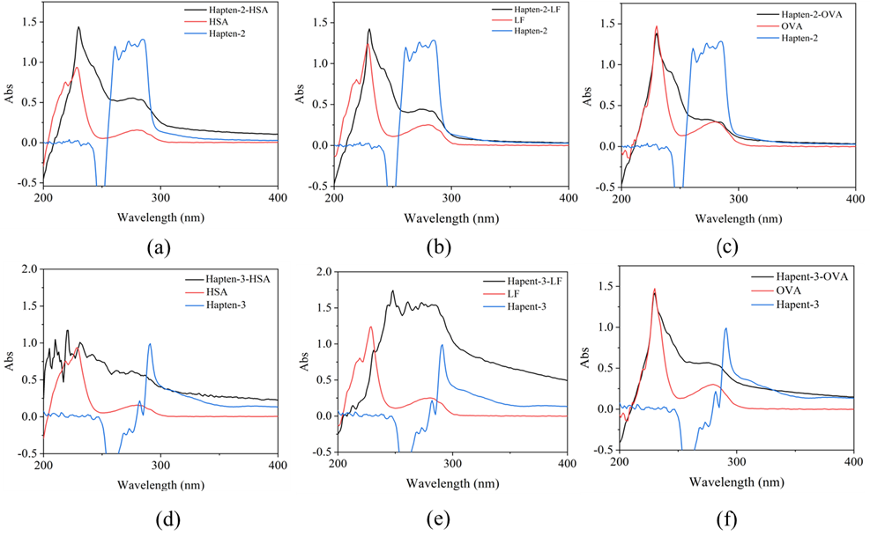
Figure S1. UV-vis spectrophotometer analysis of (a) Hapten-2-HSA, (b) Hapten-2-LF, (c) Hapten-2-OVA, (d) Hapten-3-HSA, (e) Hapten-3-LF, (f) Hapten-3-OVA.

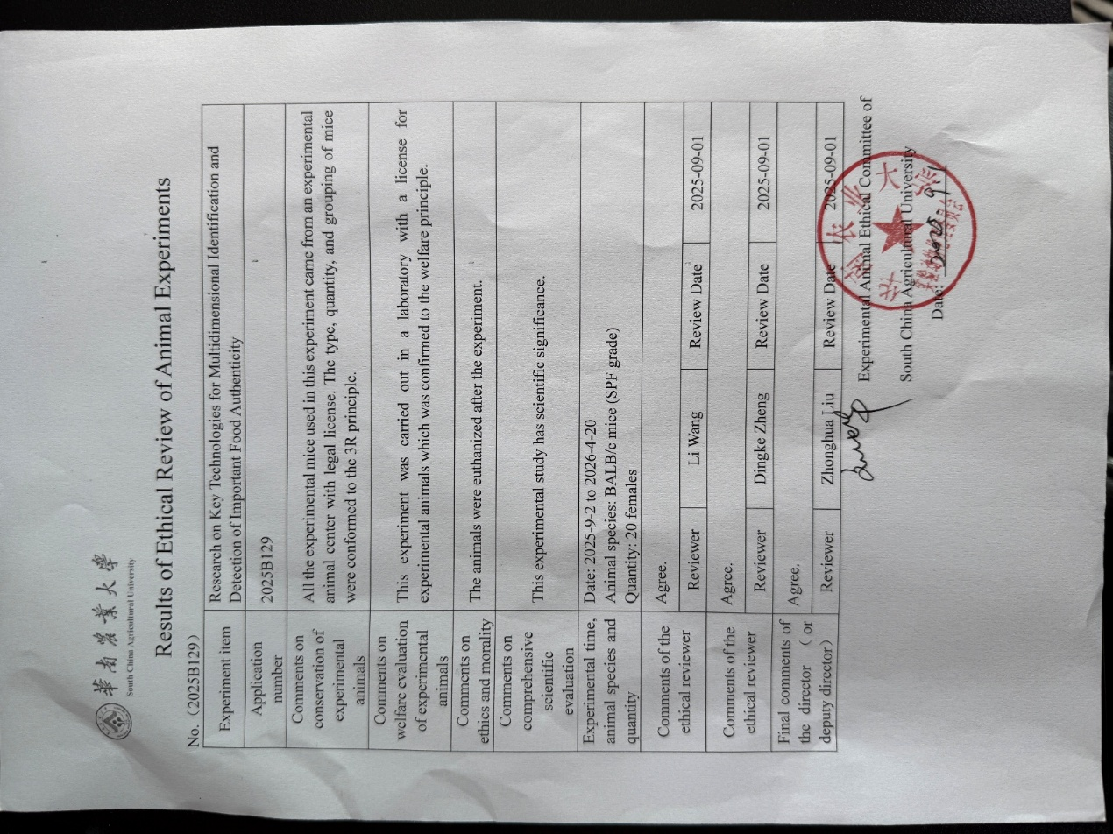
Figure S2. Results of ethical review of animal experiments (provided by the Experimental Animal Ethical Committee of South China Agricultural University).

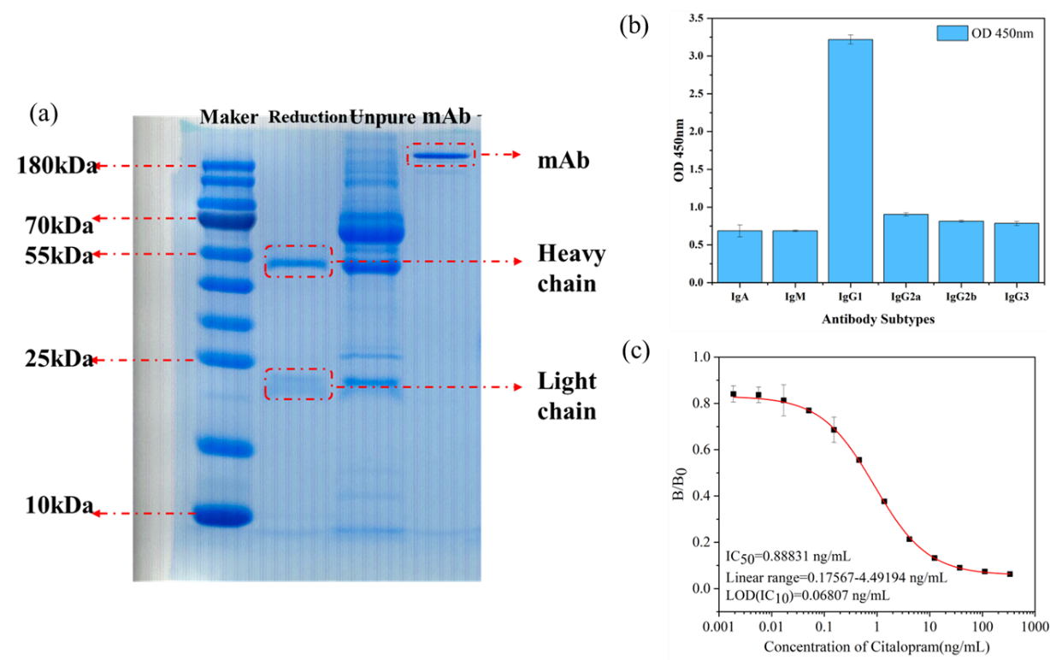
Figure S3. Characterization of mAb. (a) Analysis of purified mAb by SDS-PAGE electrophoresis under non-reducing and reducing conditions. (b) Subtype analysis of anti-citalopram mAb using a commercial mouse mAb isotyping kit; the IgG1 band was strongly positive, while other subtypes were negative. (c) Citalopram curve of citalopram was established with Hapten-3-OVA as the coating antigen.

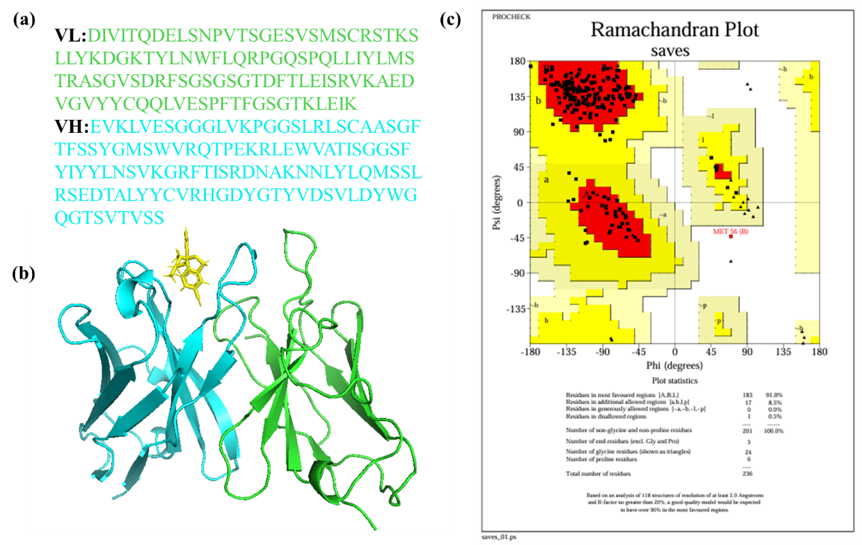

Figure S4. Construction and validation of scFv homologous model. (a) The heavy chain (VH) and light chain (VL) sequence of scFv, and framework region (FR), were shown in different colors. (b) The three-dimensional structure model of scFv. (c) The validation of the model by the Ramachandran plot.

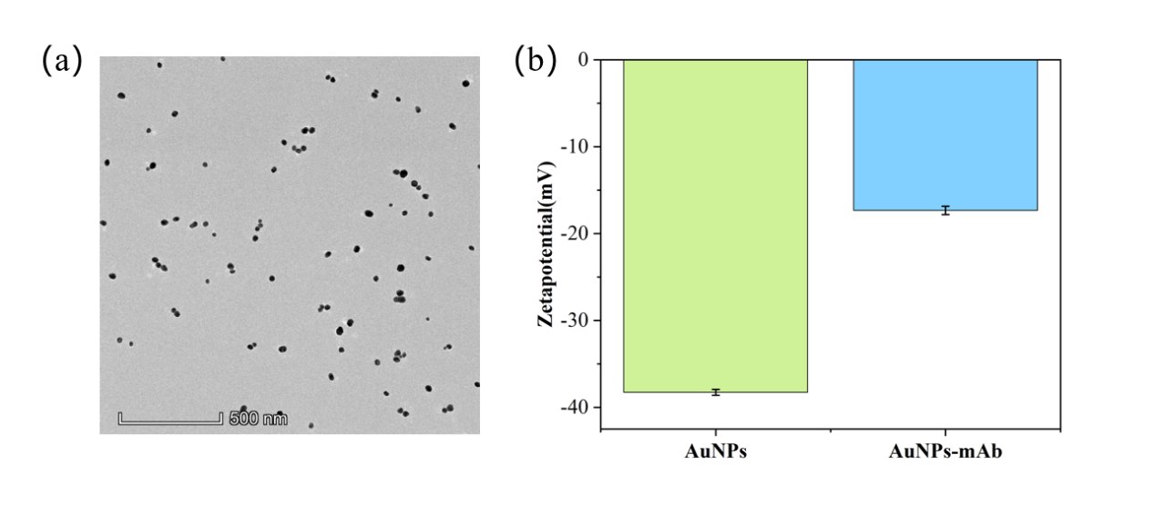
Figure S5. Characterization of colloidal gold. (a) Transmission electron microscopy (TEM) image of colloidal gold, (b) Zeta potential before and after conjugation of citalopram with colloidal gold-labeled antibody.

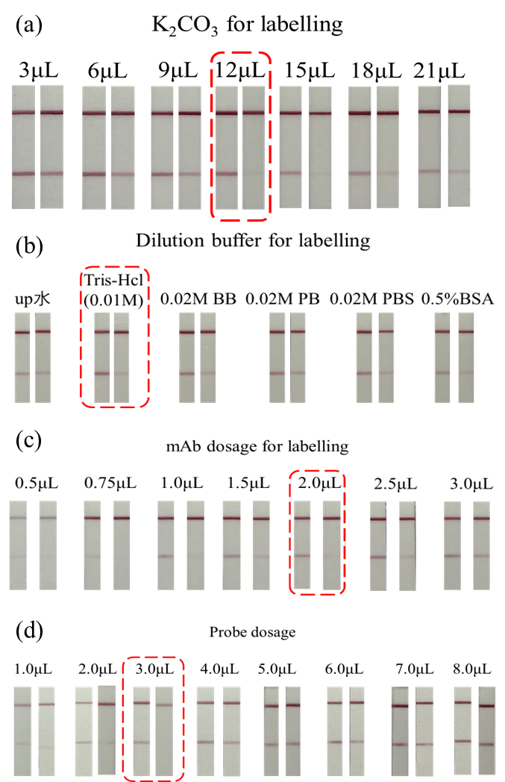
Figure S6. Optimisation of key parameters of CG-ICA: (a) The pH for labelling, (b) The dilution buffer for labelling, (c) The mAb dosage for labelling, (d) The probe dosage.

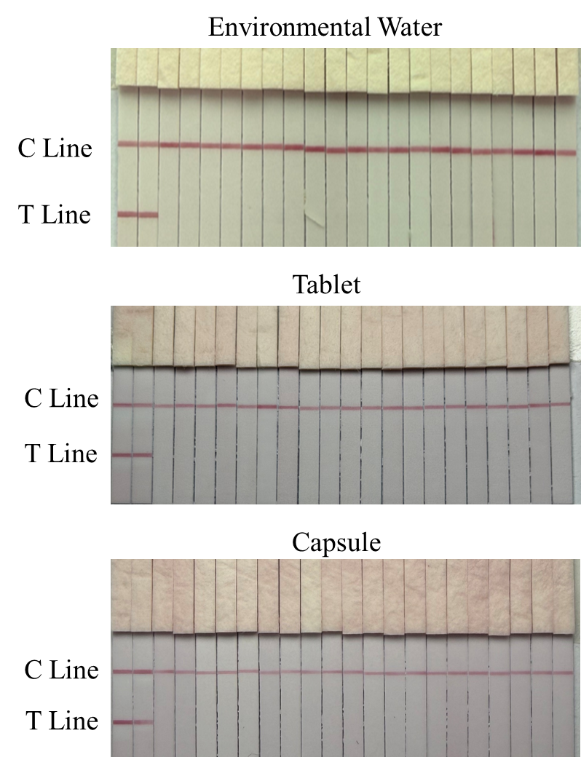
Figure S7. Determination of CG-ICA’s CCβ by the analysis of 20 different environmental water, tablets, and capsules samples fortified with CIT at the concentrations of 5.0 ng/mL, 40/45 ng/g.

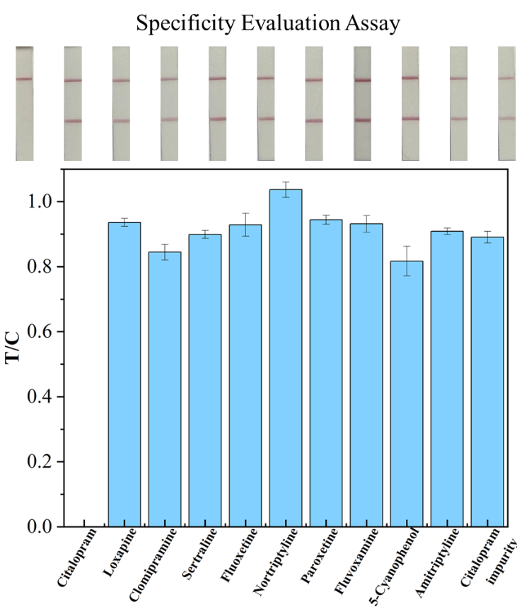
Figure S8. The specificity results of the CG-ICA.
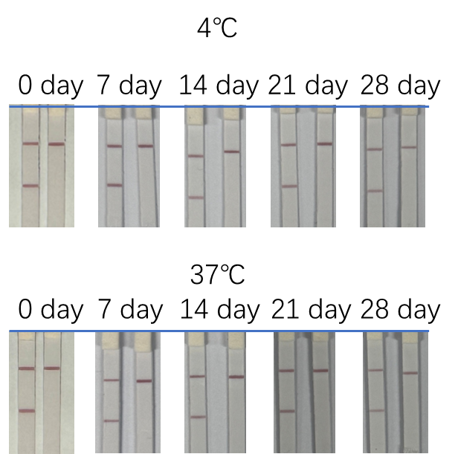
Figure S9. Stability evaluation of the CG-ICA.

Table S1. The characterization of mouse antiserum against citalopram with homologous and heterologous coating antigens.
Immunogens |  | Mouse#1 |  | Mouse#2 |  | Mouse#3
Immunogens | Coating  antigens | Titer | Inhibition rate(%) | Titer | Inhibition rate(%) | Titer | Inhibition rate(%)
Immunogens | Coating  antigens | （×10³） | Inhibition rate(%) | （×10³） | Inhibition rate(%) | （×10³） | Inhibition rate(%)
Hapten-2-LF | Hapten-2-HSA | 64 | 42.72 | 64 | 58.24 | 32 | 45.96
Hapten-2-LF | Hapten-2-OVA | 128 | 48.11 | 128 | 41.11 | 128 | 34.38
Hapten-2-LF | Hapten-3-HSA | 64 | 64.74 | 128 | 77.50 | 64 | 63.07
Hapten-2-LF | Hapten-3-OVA | 256 | 86.18 | 128 | 90.23 | 128 | 91.51
Hapten-2-LF | Hapten-3-LF | 128 | 40.72 | 64 | 60.54 | 64 | 54.12
Hapten-2-HSA | Hapten-2-LF | 32 | 55.69 | 32 | 48.88 | 32 | 48.11
Hapten-2-HSA | Hapten-2-OVA | 64 | 63.54 | 64 | 69.36 | 32 | 71.47
Hapten-2-HSA | Hapten-3-HSA | 32 | 40.56 | 32 | 33.21 | 32 | 40.27
Hapten-2-HSA | Hapten-3-LF | 64 | 45.31 | 64 | 60.33 | 64 | 64.78
Hapten-2-HSA | Hapten-3-OVA | 64 | 71.24 | 64 | 73.65 | 64 | 70.98
Hapten-3-HSA | Hapten-2-HSA | 16 | 73.66 | 16 | 66.33 | 16 | 61.88
Hapten-3-HSA | Hapten-2-OVA | 64 | 69.11 | 64 | 74.24 | 64 | 72.56
Hapten-3-HSA | Hapten-2-LF | 16 | 74.36 | 8 | 76.32 | 16 | 72.16
Hapten-3-HSA | Hapten-3-OVA | 64 | 70.75 | 32 | 78.66 | 64 | 73.96
Hapten-3-HSA | Hapten-3-LF | 32 | 68.45 | 64 | 70.06 | 32 | 68.94
Hapten-3-LF | Hapten-2-HSA | 64 | 64.52 | 32 | 63.74 | 64 | 50.35
Hapten-3-LF | Hapten-2-OVA | 32 | 57.25 | 32 | 65.88 | 16 | 62.85
Hapten-3-LF | Hapten-2-LF | 64 | 65.75 | 32 | 64.77 | 32 | 67.86
Hapten-3-LF | Hapten-3-HSA | 32 | 69.75 | 16 | 63.12 | 32 | 68.22
Hapten-3-LF | Hapten-3-OVA | 16 | 57.89 | 32 | 55.45 | 32 | 50.24

The concentration of coating antigens was 1 μg/mL.
Inhibition rate was calculated as follows:$Inhibition ratio (\%)=(1-\frac{OD}{OD0})×100$, where OD was the corresponding optical density value with the detection of CIT at the concentration of 1 μg/mL, OD0 was the corresponding optical density value without the detection of CIT.

Table S2. Working conditions of the CG-ICA.
Working condition | Parameters
Sample extract buffer | 70% methanol: tablets、capsules, and Surface water: directly diluted without an extraction step
Sample dilution buffer | 0.02 M Tris-HCl (pH 9.0)
Sample dilution factor | Tablets: 10-fold; capsules: 10-fold;
Coating antigen | Hapten-3-OVA
Concentration of coating antigen | 0.3 mg/mL
Concentration of goat anti-mouse IgG | 0.2 mg/mL
Coating buffer | 0.02 M PB containing 0.2 M NaCl
Amount of the K₂CO₃ for optimal labelling | 12 μL
Amount of mAb for labelling | 2.0 μL
mAb dilution buffer | 0.01 M PBS (pH 8.0)
Probes resuspension | 0.02 M PB (containing 0.5% Tween-20, 0.3% PVP, 0.5%  BSA, 5% sucrose, and 0.03% procline-300)
Sample pad material | SB08
Sample pad pretreatment solution | 0.02 M PB (containing 0.5% Tween-20, 0.3% PVP, 0.3%  BSA, 0.5% sucrose, and 0.03% procline-300)

Table S3. Detection of 15 blind samples by CG-ICA and LC-MS/MS methods (n=3).
Sample | Sample number | CG-ICA (ng/g) | LC-MS/MS (ng/g)
Ansleep tablets | Tablet 1 | ND | ND
Ansleep tablets | Tablet 2 | ND | ND
Ansleep tablets | Tablet 3 | ND | ND
Ansleep tablets | Tablet 4 | ND | ND
Ansleep tablets | Tablet 5 | ND | ND
Naobaijin capsules | Capsule 1 | ND | ND
Naobaijin capsules | Capsule 2 | ND | ND
Naobaijin capsules | Capsule 3 | ND | ND
Naobaijin capsules | Capsule 4 | ND | ND
Naobaijin capsules | Capsule 5 | ND | ND
Environmental water | Water 1 | ND | ND
Environmental water | Water 2 | ND | ND
Environmental water | Water 3 | ND | ND
Environmental water | Water 4 | ND | ND
Environmental water | Water 5 | ND | ND
Note: ND = Not Detected.

