Supplementary materials
(a) R-BINOL (b)S-BINOL
Scheme 1. Chemical structural of R-BINOL(left) and S-BINOL(right)

Scheme 2. Structrure of L·2HCIO₄（left) and Structrure of [NiL](ClO₄)₂ (right)
R-BINOL (Z)-2H,2'H-[1,1'-binaphthalenylidene]-2,2'-dione

S-BINOL (Z)-2H,2'H-[1,1'-binaphthalenylidene]-2,2'-dione
Scheme 3. Proposed oxidation of R-BINOL or S-BINOL by hydroperoxyl radicals (HOO•) to yield the same product, (Z)-2H,2′H-[1,1′-binaphthalenylidene]-2,2′-dione.

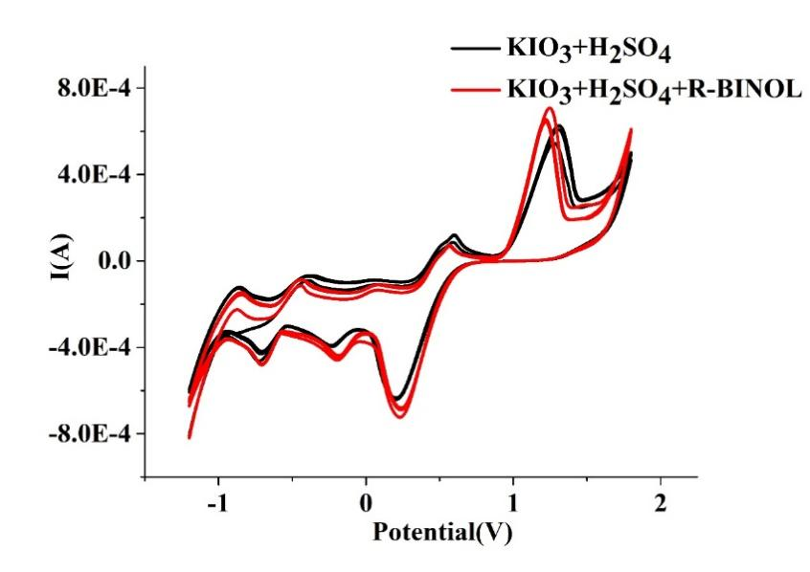
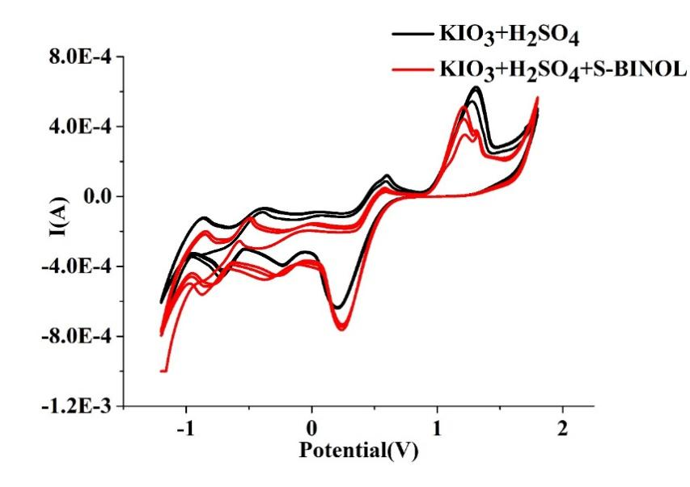
Figure S1 Cyclic voltammetryresults of KIO3-H2SO4 mixed solution (black) and KIO₃-H₂SO₄ mixed solution with low concentration of R-BINOL (red on left) or S-BINOL (red on right)
[H₂SO₄]= 0.025 mol/L, [KIO₃]= 1.625×10⁻² mol/L, [R-BINOL]= 6.25×10⁻⁶ mol/L, [S- BINOL]= 6.25×10⁻⁶ mol / L, scanning rate=100mv/s
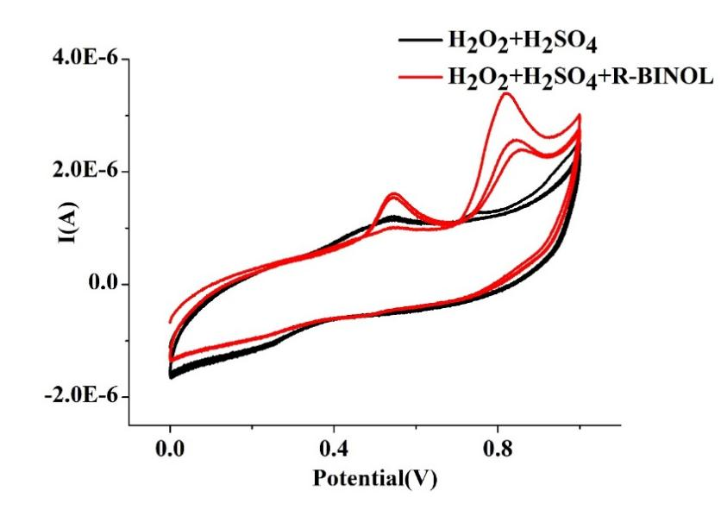
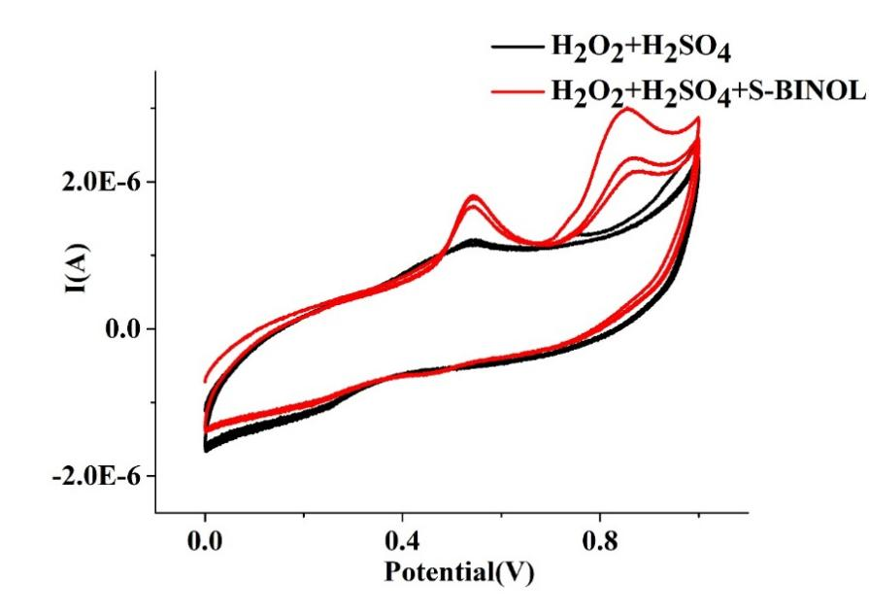
Figure S2 Cyclic voltammetry results of H₂O₂-H₂SO₄ mixed solution (black) and H₂O₂-H₂SO₄ mixed solution with low concentration of R-BINOL (red on left) or S-BINOL (red on right) scanning conditions
[H₂SO₄]= 0.025 mol/L, [H₂O₂]= 1.5375 mol/L，[R-BINOL]= 6.25×10⁻⁶ mol/L, [S- BINOL]= 6.25×10⁻⁶ mol / L, scanning rate=100mv/s
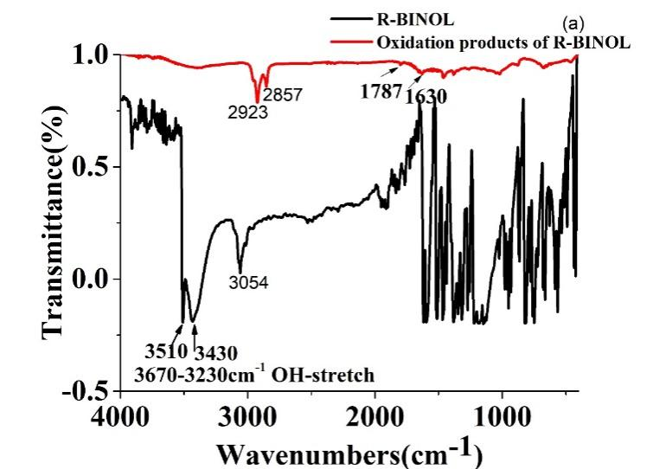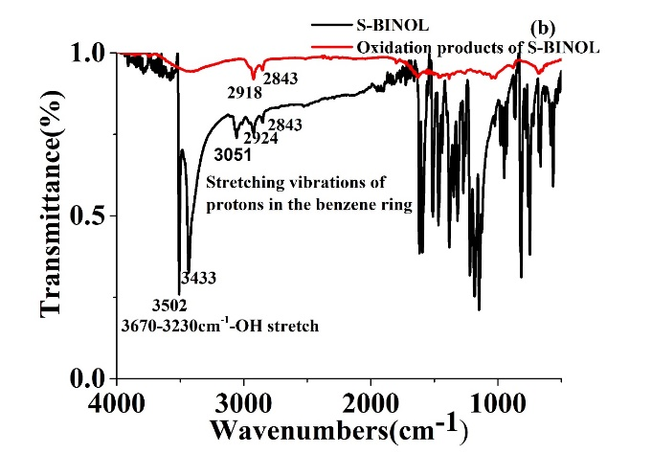
Figure S3 Infrared spectra of (a) R-BINOL and its oxidation products;(b) Infrared spectra of S-BINOL and its oxidation products;
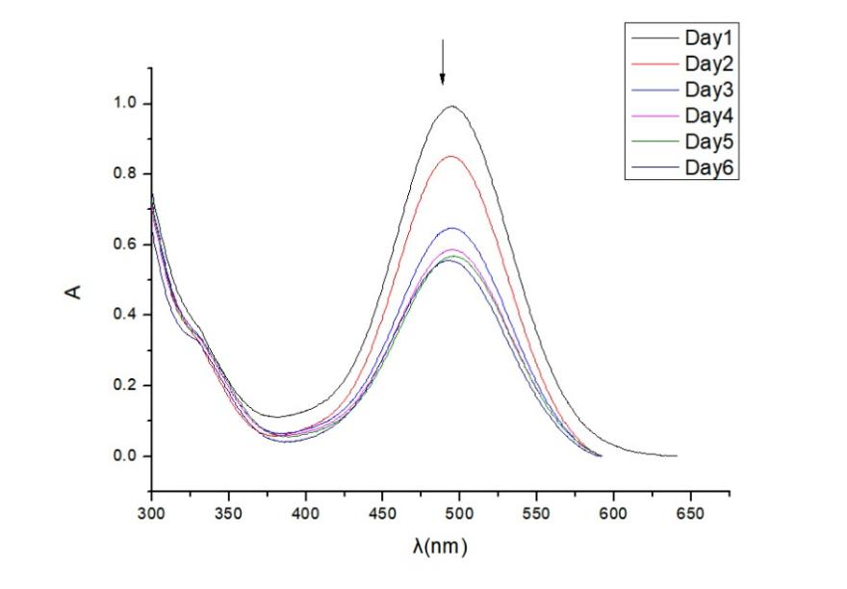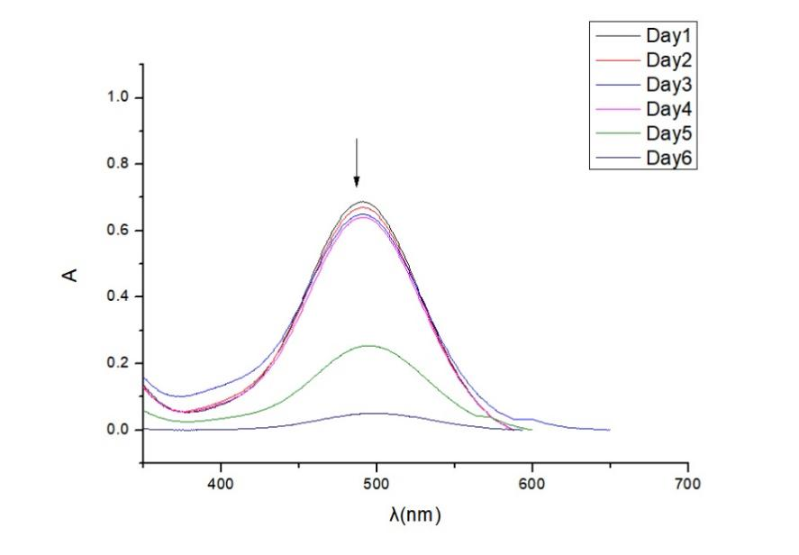
Figure S4 UV-Vis spectrum of oxidation products of R-BINOL(a); UV -Vis spectrum of oxidation products of S-BINOL(b)
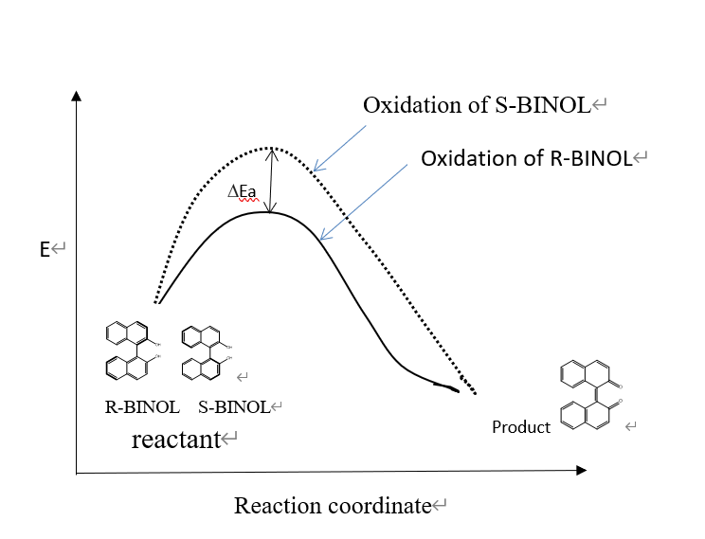
Figure S5 presents the reaction diagram with HOO• for both R-BINOL and S-BINOL. It indicates that R-BINOL has a lower activation energy in its intermediate state.

