Online Resource 1
Schematic overview, original German questionnaire, and English translation
Levothyroxine dose requirements in a thyroid cancer-predominant cohort: a target-aware analysis of gastrointestinal and medication-related factors
Wadim Bowl, Anne-Sophie Schmidt, Conrad-Amadeus Voltin, Markus Luster, Andreas Pfestroff, Pietro Di Fazio, Ali Ebrahimifard, Behrooz H. Yousefi, Shamim Bagheri, and Friederike Eilsberger
Endocrine
Corresponding author: Friederike Eilsberger, MD, Department of Nuclear Medicine, University Hospital Marburg, Philipps University Marburg, Baldingerstrasse 1, 35043 Marburg, Germany; friederike.eilsberger@staff.uni-marburg.de
Note: The German questionnaire is reproduced as administered. The English version is a publication translation and was not administered to participants or independently validated.

Figure S1. Schematic structure of the questionnaire
1. General information
Age, body weight, sex
↓
2. Thyroid disease and LT4 treatment
Thyroid diagnosis, LT4 use, and treatment duration
↓
3. Comorbidities and concomitant medication
Pre-existing conditions, additional medication, and interval from LT4
↓
4. Gastrointestinal symptoms
Nausea, vomiting, heartburn, diarrhea, and flatulence; three frequency categories
↓
5. Gastroprotective and symptom-directed medication
Agent and interval from LT4, where reported
↓
6. Gastrointestinal conditions and surgery
Medical treatment, inflammatory bowel disease, gastritis, H. pylori, ulcer, gastrointestinal surgery, celiac disease, lactose intolerance, gastroparesis, liver cirrhosis, and pancreatic dysfunction
Fig. S1 The questionnaire combined general treatment information with symptom frequency, medication timing, and predefined gastrointestinal conditions potentially relevant to LT4 therapy.

Original German questionnaire
The following two pages reproduce the questionnaire in its original German form.
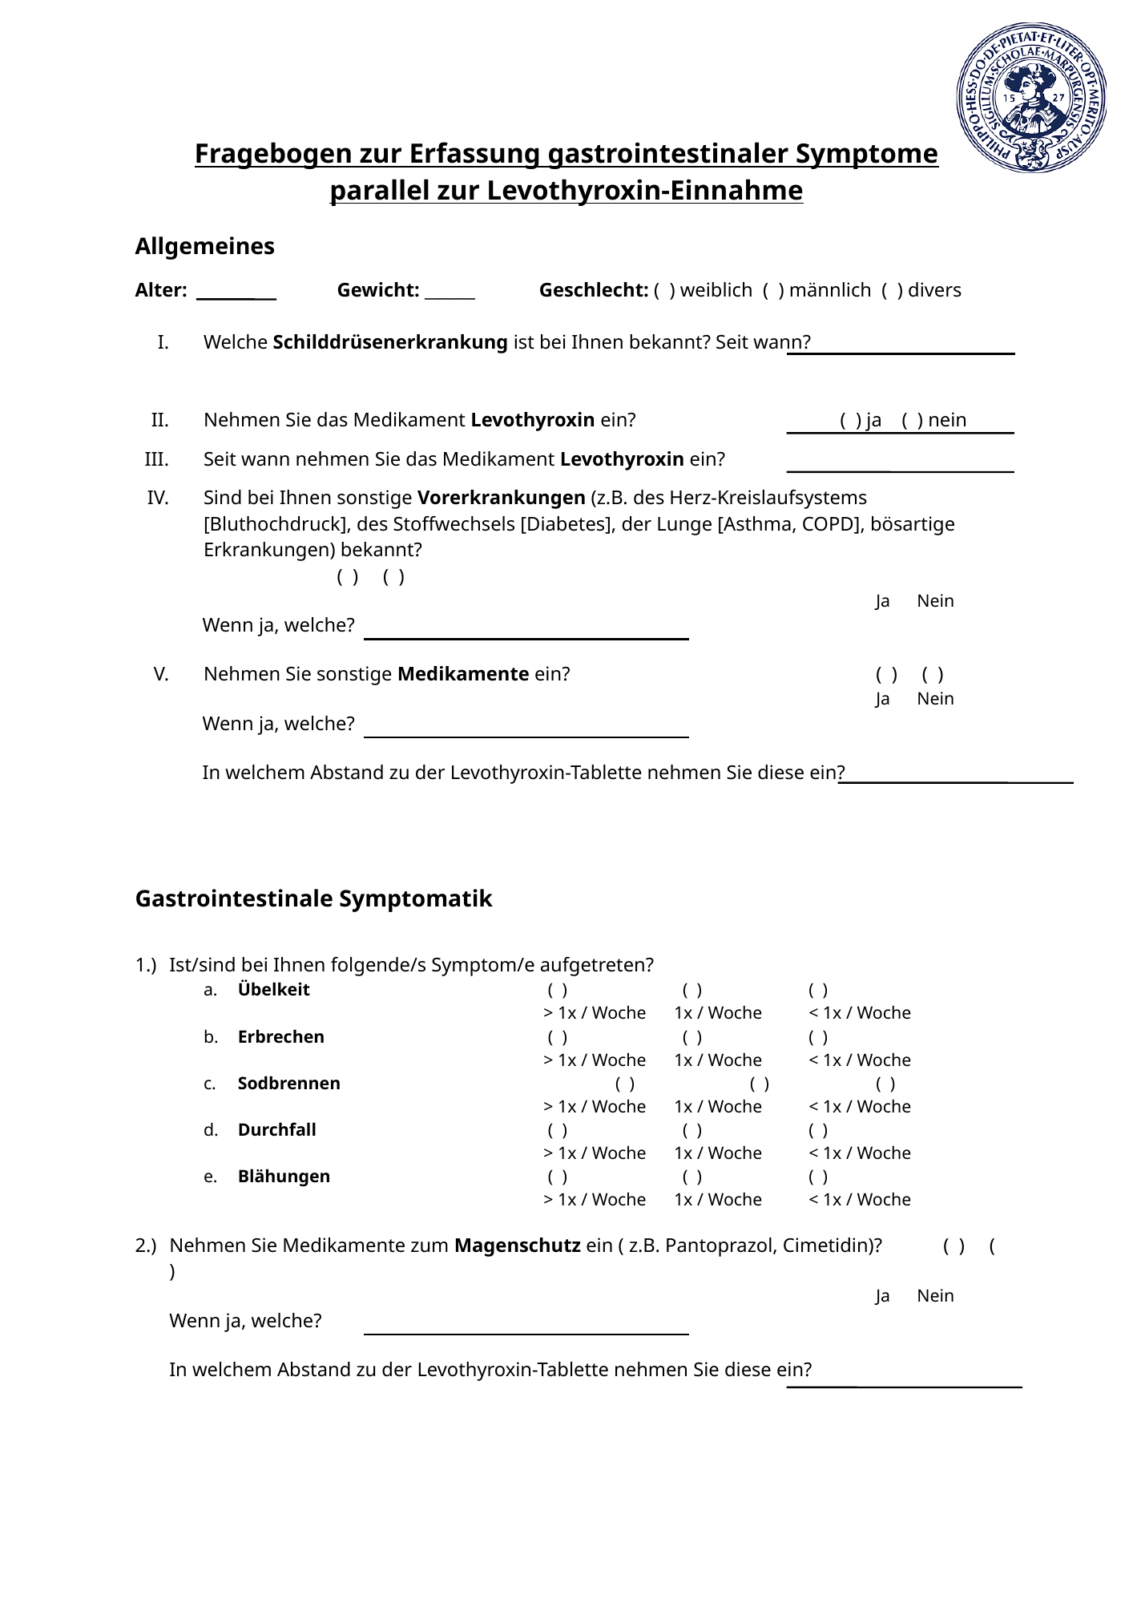
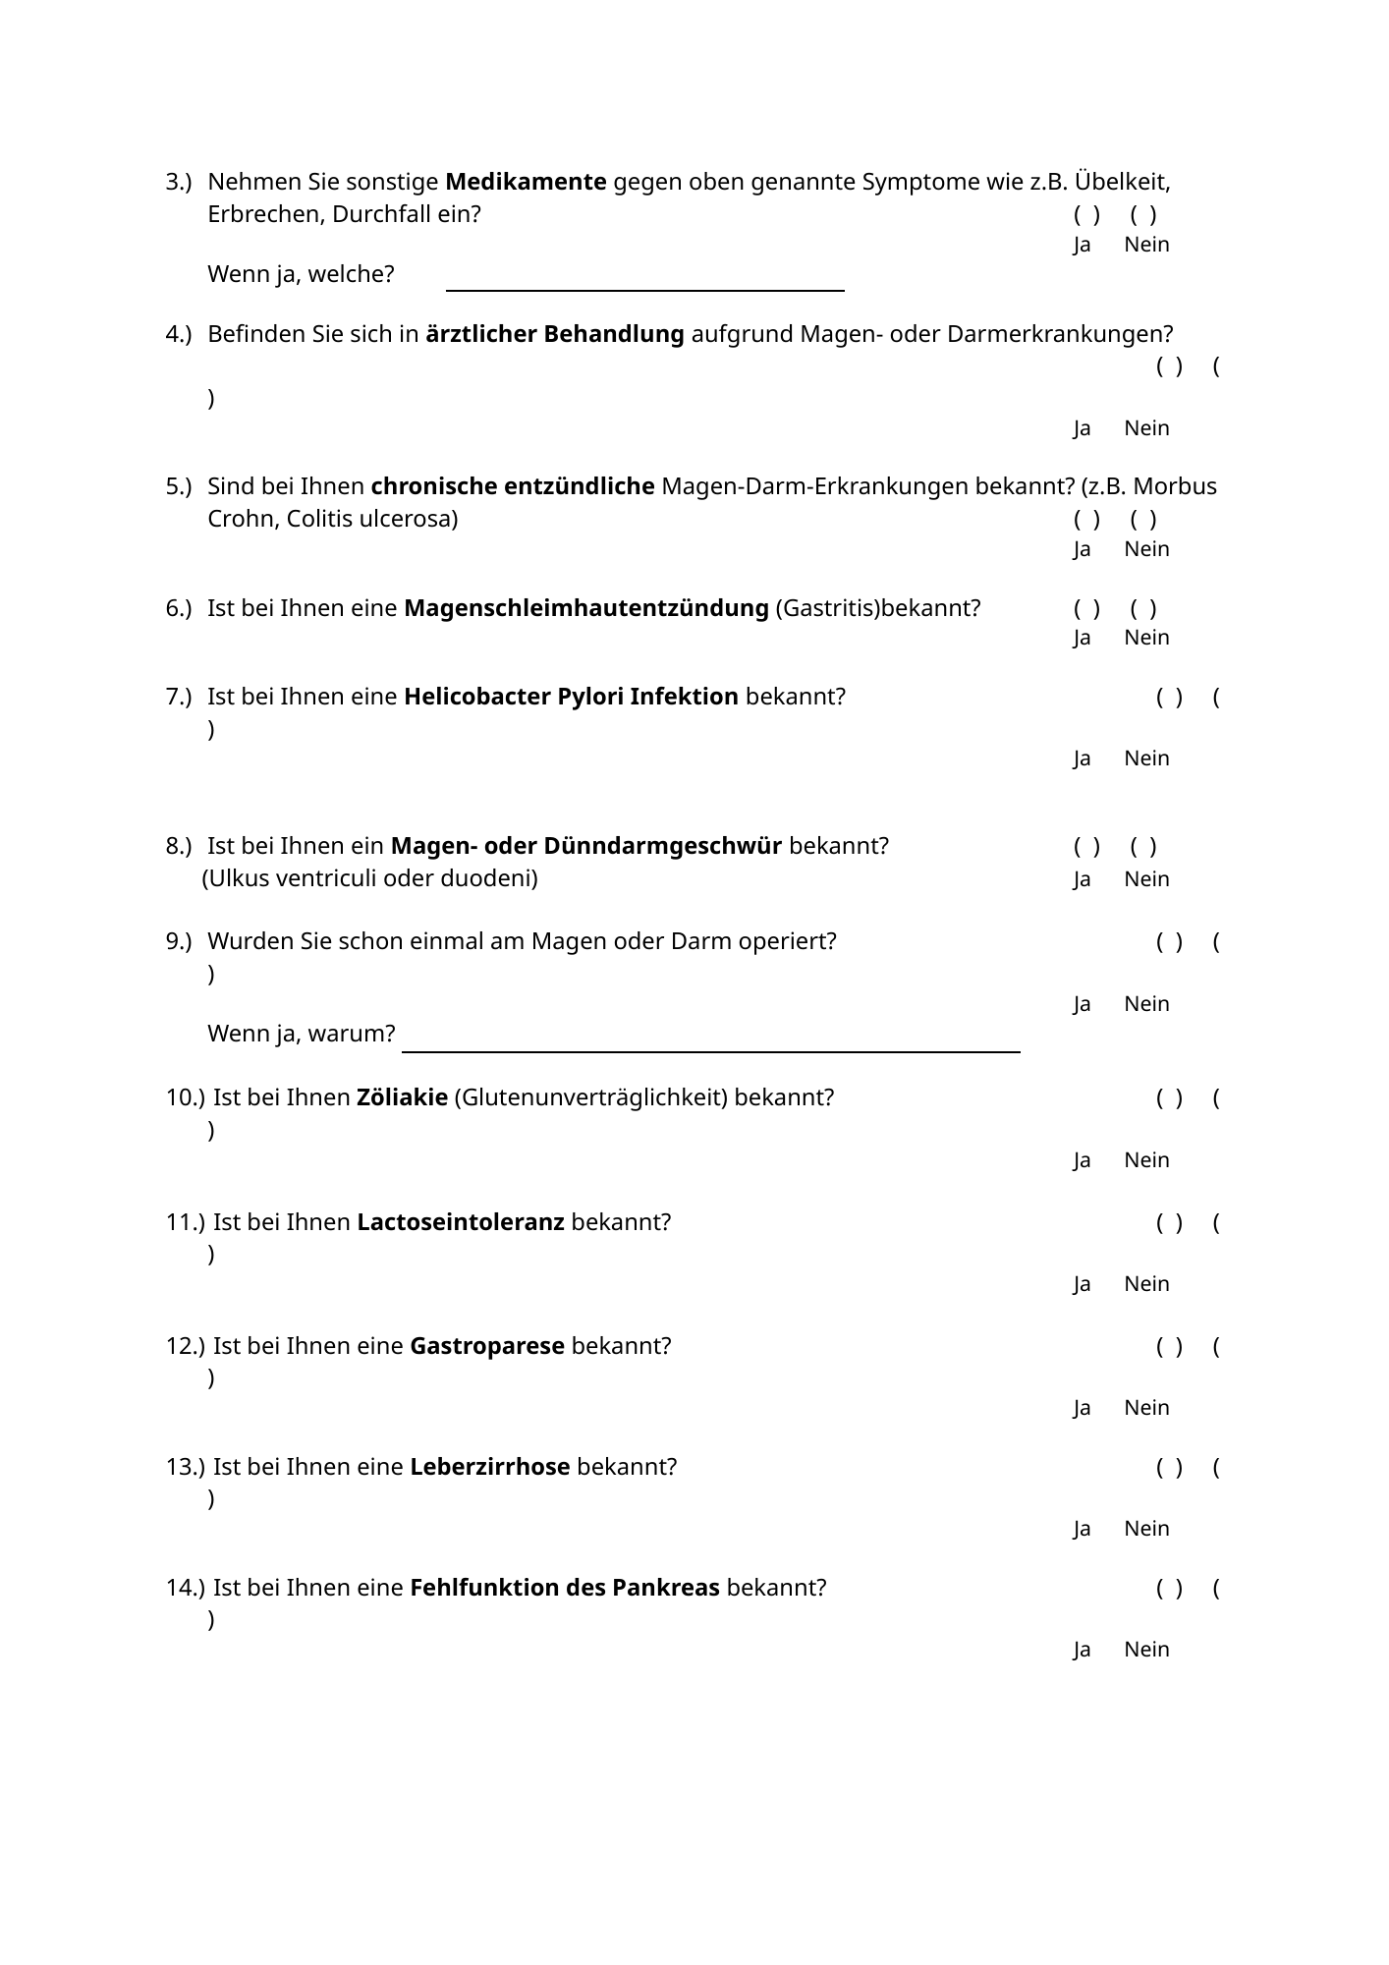

English translation
Questionnaire for recording gastrointestinal symptoms during levothyroxine treatment

General information
Age: ________ Weight: ________ Sex: □ female □ male □ diverse
I. Which thyroid disease have you been diagnosed with, and since when?
____________________________________________
II. Do you take levothyroxine?
□ Yes □ No
III. Since when have you been taking levothyroxine?
____________________________________________
IV. Do you have any other pre-existing conditions (e.g., cardiovascular disease [hypertension], metabolic disease [diabetes], pulmonary disease [asthma, COPD], or malignant disease)?
□ Yes □ No
If yes, which? ____________________________________________
V. Do you take any other medication?
□ Yes □ No
If yes, which? ____________________________________________
At what interval from the levothyroxine tablet do you take it? ______________________________

Gastrointestinal symptoms
1. Have you experienced any of the following symptoms?
Symptom | >1 time/week | 1 time/week | <1 time/week
Nausea | □ | □ | □
Vomiting | □ | □ | □
Heartburn | □ | □ | □
Diarrhea | □ | □ | □
Flatulence | □ | □ | □
2. Do you take medication for gastric protection (e.g., pantoprazole, cimetidine)?
□ Yes □ No
If yes, which? ____________________________________________
At what interval from the levothyroxine tablet do you take it? ______________________________
3. Do you take any other medication for the symptoms listed above, such as nausea, vomiting, or diarrhea?
□ Yes □ No
If yes, which? ____________________________________________
4. Are you receiving medical treatment for a gastric or intestinal disorder?
□ Yes □ No
5. Have you been diagnosed with a chronic inflammatory gastrointestinal disease (e.g., Crohn disease, ulcerative colitis)?
□ Yes □ No
6. Have you been diagnosed with inflammation of the gastric mucosa (gastritis)?
□ Yes □ No
7. Have you been diagnosed with Helicobacter pylori infection?
□ Yes □ No
8. Have you been diagnosed with a gastric or small-intestinal ulcer (gastric or duodenal ulcer)?
□ Yes □ No
9. Have you ever undergone gastric or intestinal surgery?
□ Yes □ No
If yes, why? ____________________________________________
10. Have you been diagnosed with celiac disease (gluten intolerance)?
□ Yes □ No
11. Have you been diagnosed with lactose intolerance?
□ Yes □ No
12. Have you been diagnosed with gastroparesis?
□ Yes □ No
13. Have you been diagnosed with liver cirrhosis?
□ Yes □ No
14. Have you been diagnosed with pancreatic dysfunction?
□ Yes □ No

