Supporting Information for
Efficient Removal of Endocrine Disrupting Chemicals by BiOBr/Bi₂O₂CO₃ Heterojunctions with the Presence of Chlorite: Photocatalytic and Chlorite Activation Mechanisms
Yuhan Wang^{a, b}, Guocong Liu^{a, *}, Jinyu Yang^{a, *}, Yuanhao Wang^{b, *}, Ming Luª, Zhu Liuª, Yuqiu Shenª, Wenqi Xianª, Guangji Zhangª
ª School of Chemistry and Materials Engineering, Huizhou University, Huizhou, 516007, PR China
^{b} Hoffmann Institute of Advanced Materials, Shenzhen Polytechnic University, 7098 Liuxian Boulevard, Nanshan District, Shenzhen 518055, PR China

Text S1. Chemicals
All the reagents, including bismuth nitrate pentahydrate (Bi(NO₃)₃·5H₂O), urea, potassium bromide (KBr), ethylene glycol (EG), cetyltrimethyl ammonium bromide (CTAB), bisphenol A (BPA), sulfuric acid, sodium chlorite, 5-dimethyl-pyrroline-N-oxide (DMPO), 2,2,6,6-tetramethyl-4-piperidine (TEMP), 2,2,6,6-tetramethylpiperidinooxy (TEMPO), potassium sulfate, potassium chloride, potassium bicarbonate, sodium hydroxide (AR), copper sulfate pentahydrate, zinc sulfate heptahydrate, tert-butyl alcohol (TBA), benzoquinone (BQ), L-histidine, formic acid (FA), Sodium Hydrosulfite (Na₂S₂O₄), and humic acid were obtained from Macklin Biochemical Co., Ltd. (China) without further purification. Distilled water was used throughout the whole experimental process.

Text S2. Characterizations
The X-ray diffraction (XRD) patterns were obtained from a Bruker D8 diffractometer using Cu Kα radiation to identify the crystal phases. X-ray photoelectron spectroscopy (XPS) was anlyzed, and the valence band positions of both components were measured on an EscaLab Xi+ spectrometer with Al Kα radiation as the excitation source. The catalysts' UV-vis diffuse reflectance spectra (UV-vis DRS) was performed with a UV 3600 Plus spectrophotometer equipped with BaSO₄ as the reference. An ALPHA spectrometer (Bruker) was utilized to acquire the Fourier-transform infrared (FT-IR) spectroscopy. The morphology of the samples was determined by a scanning electron microscope (SEM, EM-30 Plus, COXEM) equipped with an energy-dispersive X-ray spectrometer (EDS) and a transmission electron microscope (TEM, G2 F20, FEI). Photoluminescence (PL) spectra were measured on an F7000 spectrofluorometer (HITACHI). An ASAP2020 nitrogen adsorption apparatus was used to confirm the catalysts' Brunauer-Emmett-Teller (BET) surface areas. The active species were detected by an electron spin resonance (ESR) spectrometer (E500, BRUKER). Photoelectrochemical measurements were carried out with a Chenhua CHI-760E electrochemical workstation. In a typical process, a standard three-electrode system was used (containing a carbon rod counter electrode, a saturated calomel reference electrode (SCE), and a working electrode) to investigate the transient photocurrent responses and electrochemical impedance (EIS), using 0.5 M Na₂SO₄ solution.

Text S3. Computational methods
In this work, we have employed the Vienna Ab Initio Simulation Package (VASP) to perform the density functional theory (DFT) calculations within the generalized gradient approximation (GGA) using the PBE formulation. We have chosen the projected augmented wave (PAW) potentials to describe the ionic cores and take valence electrons into account using a plane wave basis set with a kinetic energy cutoff of 400 eV. Partial occupancies of the Kohn−Sham orbitals were allowed using the Gaussian smearing method and a width of 0.05 eV. The electronic energy was considered self-consistent when the energy change was smaller than 10⁻⁵ eV. A geometry optimization was considered convergent when the force change was smaller than 0.02 eV/Å. Grimme’s DFT-D3 methodology was used to describe the dispersion interactions.
The equilibrium lattice constants of tetragonal BiOBr unit cell were optimized to be a=3.933 Å, c=7.985 Å. We then use it to construct a BiOBr(001) surface model (model 1) with p(2×2) periodicity in the X and Y directions and two stoichiometric layers in the Z direction separated by a vacuum layer in the depth of 15 Å in order to separate the surface slab from its periodic duplicates. Model 1 comprises of 16 Bi, 16 O and 16 Br atoms. During structural optimizations, a 2×2×1 k-point grid in the Brillouin zone was used for k-point sampling, and the bottom stoichiometric layer was fixed while the rest were allowed to relax.
The equilibrium lattice constants of orthorhombic Bi₂CO₃O₂ unit cell were optimized to be a=3.595 Å, b=4.321 Å, c=13.468 Å. We then use it to construct a Bi₂CO₃O₂(001) surface model (model 2) with p(2×2) periodicity in the X and Y directions and one stoichiometric layer in the Z direction separated by a vacuum layer in the depth of 15 Å in order to separate the surface slab from its periodic duplicates. Model 2 comprises of 16 Bi, 8 C and 40 O atoms. During structural optimizations, a 2×2×1 k-point grid in the Brillouin zone was used for k-point sampling, and the bottom half stoichiometric layer was fixed while the rest were allowed to relax.
The adsorption energy (E_{ads}) of adsorbate A was defined as
E_{ads} = E_{A/surf} – E_{surf} – E_{A(g)}
where E_{A/surf}, E_{surf} and E_{A(g)} are the energy of adsorbate A adsorbed on the surface, the energy of clean surface, and the energy of isolated A molecule in a cubic periodic box with a side length of 20 Å, respectively.
The calculations were performed using Gaussian 09. The B3LYP function uses 6-311G(d) as the computational basis to optimize molecular symmetry. Frequency calculations were performed at the same level of theory. The wave function analysis programme Multiwfn was used. DFT simulations using fukui functions eq. (1), (2), (3) have been used:
- Nucleophilic attack f⁻ = q(N-1) - q(N)
- Electrophilic attack f⁺ = q(N) - q(N+1)
- Radical attack f⁰ = (q(N-1) - q(N+1))/2
Here, f signifies a change in the electron density of atom when the number of electrons changes, q represents the charge on atom, and (N-1), N, (N+1) signifies anionic, neutral, and cationic species, respectively.
The Wiberg Bond Index (WBI) is a numerical indicator of the bonding strength of two neighboring atoms in the molecular orbital method, usually calculated on the basis of natural bond orbital (NBO) analysis (eq. (4)).
- W_AB = ∑[i∈A]∑[j∈B]P(i,j)^2, where P is the density matrix.

Table S1. Water quality parameters of different water bodies.
Parameters | Secondary effluent | River water
Conductivity (µS/cm) | 870.00 | 325.00
TOC (mg/L) | 3.06 | 3.42
ORP (mV) | 150.30 | 126.10
pH | 7.62 | 7.70
NO₃⁻ (mg/L) | 10.50 | 6.49
Cl⁻ (mg/L) | 60.36 | 15.60
F⁻ (mg/L) | 10.06 | 0.21
SO₄²⁻ (mg/L) | 50.20 | 31.34
K⁺ (mg/L) | 28.36 | 10.29
Ca²⁺ (mg/L) | 30.26 | 33.47
Na⁺ (mg/L) | 67.20 | 16.35
Mg²⁺ (mg/L) | 13.28 | 3.65
Al³⁺ (mg/L) | 0.09 | 0.05

Table S2. Condensed Fukui function and dual descriptor of H atom in BPA.
No. | Atom | q(N) | q(N+1) | q(N-1) | f⁻ | f⁺ | f⁰ | CDD
18 | H | -0.0034 | -0.0216 | 0.0127 | 0.0161 | 0.0182 | 0.0172 | 0.0021
19 | H | 0.0556 | 0.0082 | 0.0918 | 0.0362 | 0.0474 | 0.0418 | 0.0112
20 | H | -0.0041 | -0.0223 | 0.0121 | 0.0162 | 0.0183 | 0.0172 | 0.0021
21 | H | -0.0034 | -0.0216 | 0.0127 | 0.0161 | 0.0182 | 0.0172 | 0.0021
22 | H | 0.0556 | 0.0082 | 0.0918 | 0.0362 | 0.0474 | 0.0418 | 0.0112
23 | H | -0.0041 | -0.0223 | 0.0121 | 0.0162 | 0.0183 | 0.0172 | 0.0021
24 | H | 0.0427 | 0.0133 | 0.0617 | 0.019 | 0.0294 | 0.0242 | 0.0103
25 | H | 0.0427 | 0.0133 | 0.0617 | 0.019 | 0.0294 | 0.0242 | 0.0103
26 | H | 0.0438 | 0.0155 | 0.0627 | 0.0188 | 0.0284 | 0.0236 | 0.0095
27 | H | 0.0438 | 0.0155 | 0.0627 | 0.0188 | 0.0284 | 0.0236 | 0.0095
28 | H | 0.0293 | 0.0117 | 0.0444 | 0.0151 | 0.0176 | 0.0164 | 0.0024
29 | H | 0.0293 | 0.0117 | 0.0444 | 0.0151 | 0.0176 | 0.0164 | 0.0024
30 | H | 0.0247 | 0.0082 | 0.0404 | 0.0157 | 0.0165 | 0.0161 | 0.0009
31 | H | 0.0247 | 0.0082 | 0.0404 | 0.0157 | 0.0165 | 0.0161 | 0.0009
32 | H | 0.1649 | 0.1517 | 0.1797 | 0.0148 | 0.0132 | 0.014 | -0.0016
33 | H | 0.1649 | 0.1517 | 0.1797 | 0.0148 | 0.0132 | 0.014 | -0.0016

Fig. S1 XRD patterns of xyDBi.

Fig. S2 FT-IR spectra of BiOBr, Bi₂O₂CO₃, and xyDBi.

Fig. S3 XPS spectra of single BiOBr, Bi₂O₂CO₃, BOB1, and BOC1: (a, b) Bi 4f, (c) Br 3d, and (d) C 1s.

Fig. S4 Low-temperature ESR spectra of the as-prepared catalysts.

Fig. S5 SEM images of (a) BiOBr and (b) Bi₂O₂CO₃.

Fig. S6 Nitrogen adsorption-desorption isotherms of individual BiOBr, Bi₂O₂CO_{3,} and 11DBi.

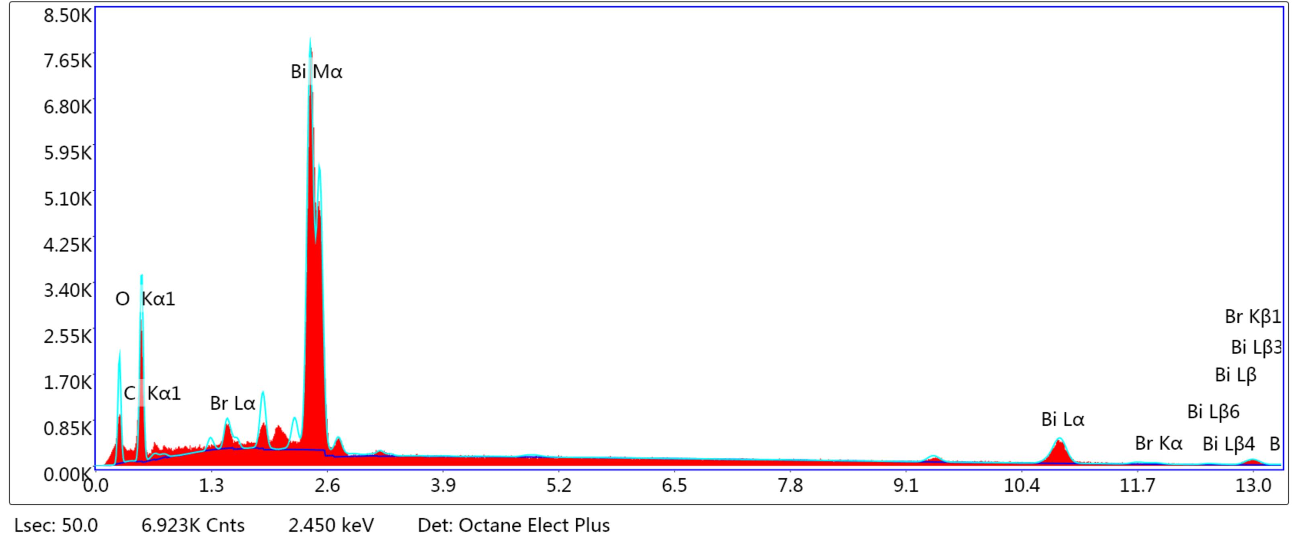
Fig. S7 EDS of 11DBi.

Fig. S8 PL spectra of BiOBr, Bi₂O₂CO_{3,} and xyDBi.

Fig. S9 (a) Photocurrent responses, and (b) EIS Nyquist plots of BiOBr, Bi₂O₂CO_{3,} and 11DBi.

Fig. S10 Degradation efficiency in different water bodies. ([BPA]₀ = 25 mg/L, 50 mg of photocatalyst, [NaClO₂]₀ = 0.1 mM, light intensity: 30 mW/cm²).

Fig. S11 BPA removal under different pH values ([BPA]₀ = 25 mg/L, 50 mg of photocatalyst, [NaClO₂]₀ = 0.1 mM, light intensity: 30 mW/cm²).

Fig. S12 The XRD patterns of 11DBi before and after recycles.

Fig. S13 The optimized molecular structure of BPA.

Fig. S14 (a) HOMO and (b) LUMO orbital distribution of BPA (The blue and red colors represent the negative and positive phases of the molecular orbitals).

Fig. S15 The Wiberg bond orders in the skeleton of BPA.

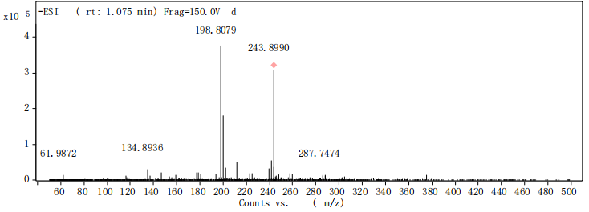
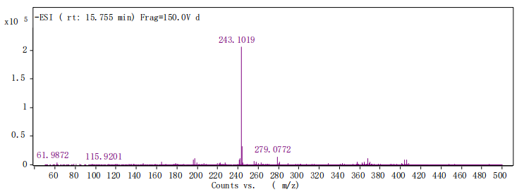
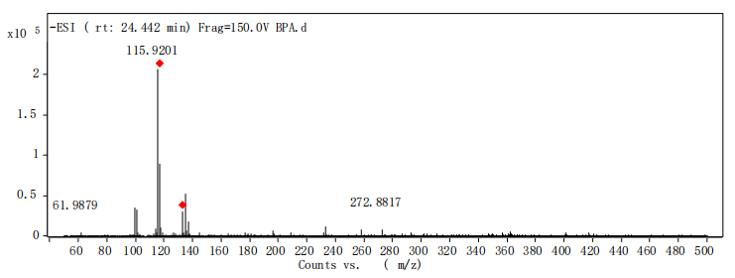
Fig. S16 Degradation intermediates of BPA determined by LC-MS.

Fig. S17 (a) The developmental toxicity, (b) bioaccumulation factor of BPA and its possible degradation intermediate products.

Fig. S18 Effect of different scavengers on BPA degradation in the vis/11DBi/ClO₂⁻ systrem ([BPA]₀ = 25 mg/L, 50 mg of photocatalyst, [NaClO₂]₀ = 0.1 mM, light intensity: 30 mW/cm²).

Fig. S19 In situ DRIFTS of 11DBi in the light/ClO₂⁻ system.

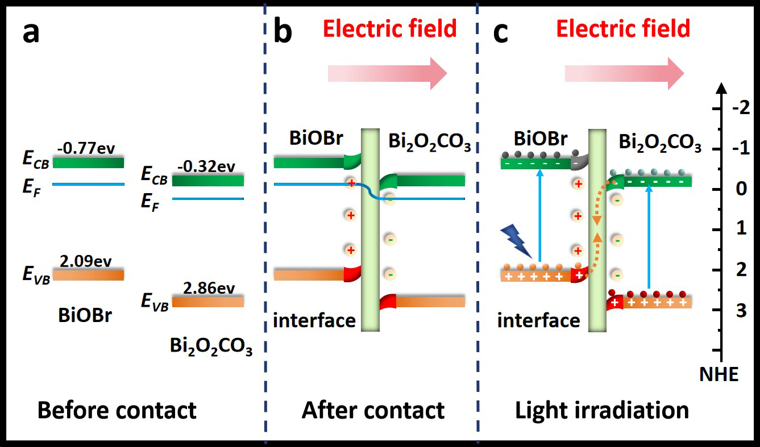
Fig. S20 S-scheme heterojunction charge transfer process.

