Supplementary Information

Reexamining empathy in autism: The role of empathic disequilibrium in autism and autistic traits

Ido Shalev, Varun Warrier, David M. Greenberg, Paula Smith, Carrie Allison, Simon Baron-Cohen, Alal Eran, Florina Uzefovsky

Supplementary Information Text
To understand further the implications of Empathic Disequilibrium (ED) on the autism-related measures described in the main text, we conducted exploratory analyses of the subscales of the Autism-Spectrum Quotient (AQ)¹. AQ comprised of five different subscales: ‘social skill’, ‘communication’, ‘imagination’, ‘attention switching’, and ‘attention to detail’,
In the below analyses we followed the same methodology described in the main article. Meaning, total empathy and ED were measures using Empathy Quotient (EQ)². Polynomial regression analysis^{3,4} was conducted to simultaneously investigate the association between ED, total empathy and autistic traits in each subscale. Differences in surface parameters were investigated between autistic and non-autistic individuals. Age and sex were used as covariates. As each of the five subscales of AQ was examined separately, we used a strict Bonferroni correction of p < 0.05/5 subscales = 0.01 to account for multiple testing.

AQ subscales analyses
Social skill. The overall polynomial regression of empathy predicted autistic traits measured using the AQ (R² = 0.65, p < 1x10⁻¹⁰⁰) in autistic and non-autistic populations (see Table S1 and Figure S1). Autism diagnosis was associated with higher autistic traits in the social skill domain (β = 0.52, p < 1x10⁻¹⁰⁰), and males showed higher autistic traits in this domain than females (β = 0.06, p = 9x10⁻¹¹). Age was also associated with autistic traits in this subscale (β = 0.08, p = 1x10⁻²¹).

Table S1. Polynomial regression with response surface parameters predicting the ‘social skill’ subscale.
 | Autism |  |  | non-autistic
Effect | Estimate (SE) | p-value | beta | Estimate (SE) | p-value | beta
CE | -0.95 (0.15) | 2x10⁻¹⁰ | -0.26*** | -1.08 (0.04) | 2x10⁻¹³⁰ | -0.24***
EE | -0.225 (0.12) | 0.06 | -0.055 | -0.36 (0.04) | 6x10⁻¹⁶ | -0.08***
CE² | -0.03 (0.07) | 0.695 | -0.015 | 0.52 (0.04) | 7x10⁻³⁷ | 0.15***
EE² | 0.004 (0.05) | 0.92 | 0.002 | 0.12 (0.04) | 0.0016 | 0.04*
CE x EE | 0.11 (0.07) | 0.12 | 0.05 | -0.17 (0.05) | 0.00025 | -0.04**
Response surface parameters |  |  |  |  |  |  | Group Comparison
a1 | -1.17 (0.17) | 2x10⁻¹² | -0.31*** | -1.4 (0.05) | 2x10⁻¹⁷⁸ | -0.33*** | 0.62
a2 | 0.09 (0.075) | 0.87 | 0.04 | 0.47 (0.05) | 6x10⁻²⁵ | 0.145*** | 0.00001***
a3 | -0.72 (0.21) | 0.0055 | -0.2* | -0.72 (0.07) | 2x10⁻²² | -0.16*** | 1
a4 | -0.135 (0.14) | 0.95 | -0.07 | 0.81 (0.09) | 3x10⁻¹⁸ | 0.23*** | 3x10⁻⁸***
*p < 0.01, **p < 0.001, ***p < 0.0001
Parameters of the polynomial regression with response surface analysis (PRRSA) of EE and CE, predicting ‘social skill’ subscale of the Autism-Spectrum Quotient score in autistic and non-autistic individuals.

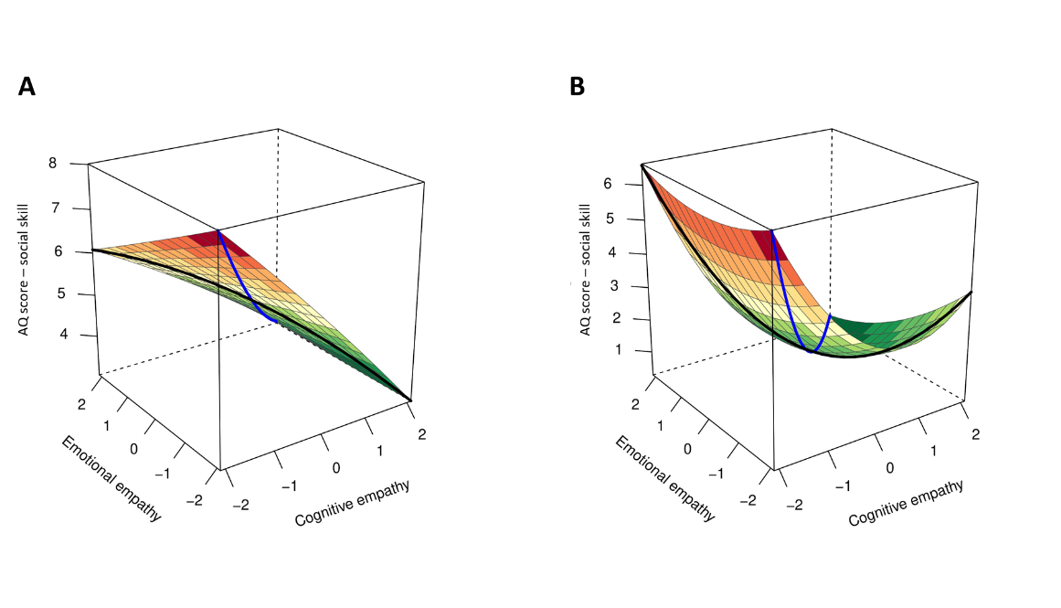
a b

Fig. S1. Polynomial regression plot predicting the ‘social skill’ subscale. A Plot of the polynomial regression with response surface analysis (PRRSA) predicting Autism-Spectrum Quotient (AQ) score of the ‘social skill’ subscale, predicting autism-quotient score in a. autistic individuals (N = 1,905), and b. non-autistic individuals (N = 3,009). The black line represents ED, and the blue line represents total empathy.

Total empathy - Lower total empathy was associated with higher deficits in social skills in both autistic and non-autistic individuals, showing linear (a1). Curvilinear (a2) association between total empathy and the social skill subscale was found only for non-autistic individuals, but not for autistic individuals.
ED - A linear association between ED and autistic traits was found for both autistic and non-autistic individuals, with higher EE-dominance predicting higher autistic traits (negative a3). A curvilinear association of ED and autistic traits was also found for non-autistic individuals, which differed from the non-significant curvilinear effect of ED in autistic individuals.
Communication. The overall polynomial regression of empathy predicted autistic traits measured using the AQ (R² = 0.72, p < 1x10⁻¹⁰⁰) in autistic and non-autistic population (see Table S2 and Figure S2). Autism diagnosis was associated with higher autistic traits in the communication domain (β = 0.54, p < 1x10⁻¹⁰⁰), and males showed higher autistic traits in this domain than females (β = 0.03, p = 0.0001). Age was also associated with AQ scores of the ‘communication’ subscale (β = 0.025, p = 0.0009).

Table S2. Polynomial regression with response surface parameters predicting the ‘communication’ subscale.
 | Autism |  |  | non-autistic
Effect | Estimate (SE) | p-value | beta | Estimate (SE) | p-value | beta
CE | -1 (0.13) | 2x10⁻¹⁴ | -0.28*** | -0.92 (0.04) | 1x10⁻¹²² | -0.21***
EE | 0.02 (0.1) | 0.85 | 0.005 | -0.23 (0.04) | 7x10⁻⁹ | -0.05***
CE² | 0.06 (0.06) | 0.3 | 0.04 | 0.48 (0.04) | 2x10⁻⁴⁰ | 0.14***
EE² | 0.12 (0.03) | 0.0002 | 0.05** | 0.12 (0.03) | 0.0002 | 0.04**
CE x EE | 0.05 (0.06) | 0.43 | 0.02 | -0.16 (0.04) | 0.00009 | -0.04***
Response surface parameters |  |  |  |  |  |  | Group Comparison
a1 | -0.98 (0.15) | 3x10⁻¹¹ | -0.27*** | -1.14 (0.04) | 3x10⁻¹⁴⁸ | -0.26*** | 0.27
a2 | 0.21 (0.07) | 0.0017 | 0.11* | 0.44 (0.04) | 2x10⁻²⁸ | 0.14*** | 0.002*
a3 | -1.02 (0.18) | 3x10⁻⁸ | -0.28*** | -0.69 (0.06) | 2x10⁻²⁶ | -0.16*** | 0.09
a4 | 0.11 (0.12) | 0.38 | 0.06 | 0.76 (0.08) | 1x10⁻²⁰ | 0.22*** | 0.00001***
Parameters of polynomial regression with response surface analysis (PRRSA) of EE and CE, predicting ‘communication’ subscale of the Autism-Spectrum Quotient in autistic and non-autistic individuals.
*p < 0.01, **p < 0.001, ***p < 0.0001
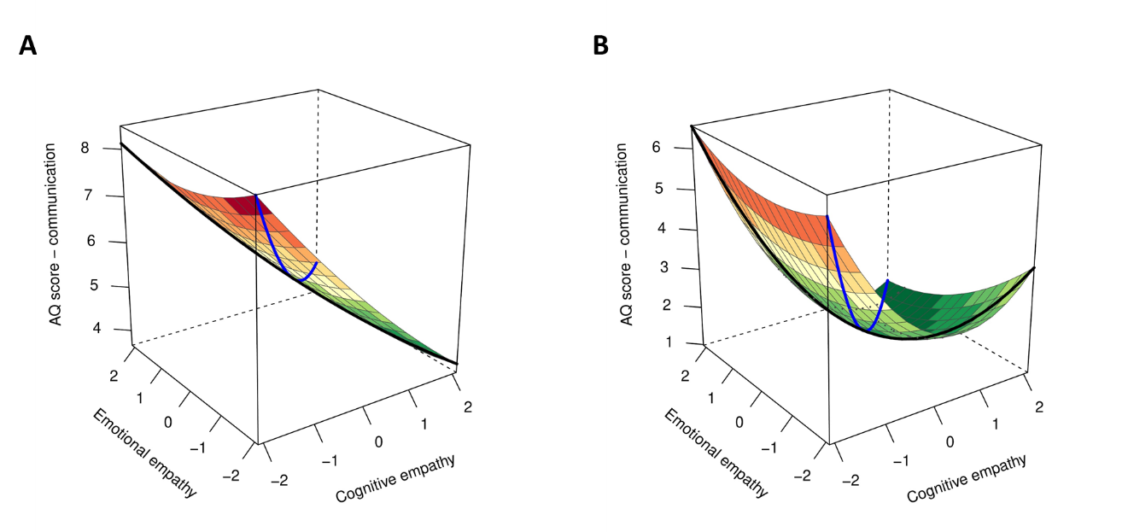
a b

Fig. S2. Polynomial regression plot predicting the ‘communication’ subscale. A Plot of the polynomial regression with response surface analysis (PRRSA) predicting Autism-Spectrum Quotient (AQ) score of the ‘communication’ subscale, predicting autism-quotient score in a. autistic individuals (N = 1,905), and b. non-autistic individuals (N = 3,009). The black line represents ED, and the blue line represents total empathy.

Total empathy - Lower total empathy was associated with higher deficits in communication in both autistic and non-autistic individuals, showing linear (a1) and curvilinear (a2) associations.
ED - A linear association between ED and autistic traits was found for both autistic and non-autistic individuals, with higher EE-dominance predicting higher autistic traits (negative a3). A curvilinear association of ED and autistic traits was also found only for non-autistic individuals.
Imagination. The overall polynomial regression of empathy predicted autistic traits measured using the AQ (R² = 0.55, p < 1x10⁻¹⁰⁰) in autistic and non-autistic population (see Table S3 and Figure S3). Autism diagnosis was associated with higher autistic traits in the imagination domain (β = 0.38, p = 1x10⁻⁵⁹). Age was associated with the ‘imagination’ subscale (β = 0.06, p = 2x10⁻¹⁰). No sex differences were found (β = 0.007, p = 0.48).

Table S3. Polynomial regression with response surface parameters predicting the ‘imagination’ subscale.
 | Autism |  |  | non-autistic
Effect | Estimate (SE) | p-value | beta | Estimate (SE) | p-value | beta
CE | -0.49 (0.14) | 0.0003 | -0.16** | -0.48 (0.04) | 5x10⁻³³ | -0.13***
EE | -0.31 (0.11) | 0.004 | -0.09* | -0.25 (0.04) | 2x10⁻⁹ | -0.07***
CE² | 0.17 (0.065) | 0.01 | 0.115* | 0.16 (0.04) | 0.00001 | 0.06***
EE² | 0.06 (0.04) | 0.18 | 0.03 | 0.04 (0.03) | 0.31 | 0.01
CE x EE | 0.04 (0.07) | 0.525 | 0.02 | -0.02 (0.04) | 0.69 | -0.005
Response surface parameters |  |  |  |  |  |  | Group Comparison
a1 | -0.81 (0.15) | 0.0000002 | -0.26*** | -0.73 (0.04) | 1x10⁻⁵⁷ | -0.2*** | 0.63
a2 | 0.27 (0.07) | 0.0001 | 0.17*** | 0.18 (0.04) | 0.00001 | 0.06*** | 0.29
a3 | -0.18 (0.19) | 0.36 | -0.07 | 0.23 (0.07) | 0.0006 | -0.06** | 0.79
a4 | 0.185 (0.13) | 0.16 | 0.125 | 0.22 (0.09) | 0.01 | 0.08* | 0.84

Parameters of polynomial regression with response surface analysis (PRRSA) of EE and CE, predicting ‘imagination’ subscale of the Autism-Spectrum Quotient in autistic individuals and non-autistic individuals.

*p < 0.01, **p < 0.001, ***p < 0.0001

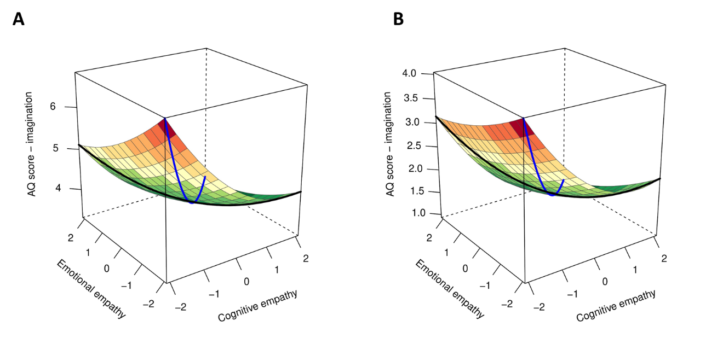
a b
Fig. S3. Polynomial regression plot predicting the ‘imagination’ subscale. Plot of the polynomial regression with response surface analysis (PRRSA) predicting Autism-Spectrum Quotient (AQ) score of the ‘imagination’ subscale, predicting autism-quotient score in a. autistic individuals (N = 1,905), and b. non-autistic individuals (N = 3,009). The black line represents ED, and the blue line represents total empathy.

Total empathy - Lower total empathy was associated with higher deficits in imagination in both autistic and non-autistic individuals, showing linear (a1) and curvilinear (a2) associations.
ED - A linear and curvilinear associations between ED and autistic traits were found for non-autistic individuals, with higher EE-dominance predicting higher autistic traits (negative a3). ED was not associated with deficits in imagination in autistic individuals.
Attention switching. The overall polynomial regression of empathy predicted autistic traits measured using the AQ (R² = 0.57, p < 1x10⁻¹⁰⁰) in autistic and non-autistic populations (see Table S4 and Figure S4). Autism diagnosis was associated with higher autistic traits in the attention switching domain (β = 0.54, p < 1x10⁻¹⁰⁰). Males showed more deficits in attention switching than females (β = 0.04, p = 0.00005). Age was negatively correlated with deficits in attention switching in this subscale (β = -0.03, p = 0.0004).

Table S4. Polynomial regression with response surface parameters predicting the ‘attention switching’ subscale.
 | Autism |  |  | non-autistic
Effect | Estimate (SE) | p-value | beta | Estimate (SE) | p-value | beta
CE | -0.75 (0.14) | 0.0000001 | -0.23*** | -0.74 (0.04) | 3x10⁻⁶⁹ | -0.2***
EE | 0.04 (0.11) | 0.74 | 0.01 | -0.06 (0.04) | 0.155 | -0.02
CE² | -0.005 (0.07) | 0.94 | -0.003 | 0.29 (0.04) | 8x10⁻¹⁴ | 0.1***
EE² | 0.02 (0.04) | 0.59 | 0.01 | 0.08 (0.04) | 0.03 | 0.03
CE x EE | 0.05 (0.07) | 0.45 | 0.03 | -0.08 (0.04) | 0.06 | -0.02
Response surface parameters |  |  |  |  |  |  | Group Comparison
a1 | -0.71 (0.16) | 0.000009 | -0.22*** | -0.8 (0.05) | 1x10⁻¹⁰⁰ | -0.21*** | 0.6
a2 | 0.07 (0.07) | 0.32 | 0.04 | 0.29 (0.04) | 4x10⁻¹¹ | 0.1*** | 0.01*
a3 | -0.78 (0.2) | 0.00009 | -0.245*** | -0.68 (0.07) | 1x10⁻¹⁰⁰ | -0.18*** | 0.61
a4 | -0.03 (0.14) | 0.8 | -0.02 | 0.45 (0.09) | 0.0000004 | 0.15*** | 0.003*
Parameters of polynomial regression with response surface analysis (PRRSA) of EE and CE, predicting ‘attention switching’ subscale of the Autism-Spectrum Quotient in autistic and non-autistic individuals.
*p < 0.01, **p < 0.001, ***p < 0.0001

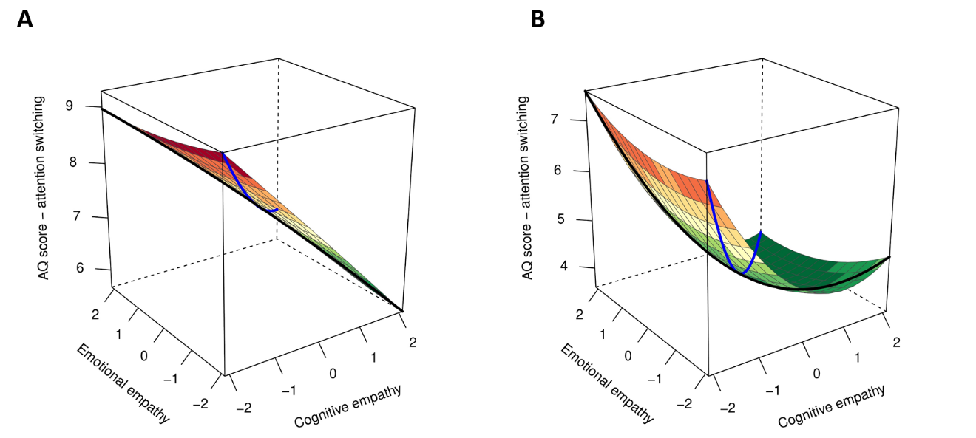
a b

Fig. S4. Polynomial regression plot predicting the ‘attention switching’ subscale. Plot of the polynomial regression with response surface analysis (PRRSA) predicting Autism-Spectrum Quotient (AQ) score of the ‘attention switching’ subscale, predicting autism-quotient score in a. autistic individuals (N = 1,905), and b. non-autistic individuals (N = 3,009). The black line represents ED, and the blue line represents total empathy.

Total empathy - Lower total empathy was linearly associated with higher deficits in attention switching in both autistic and non-autistic individuals. A curvilinear association between total empathy and deficits in attention switching was found for non-autistic individuals only.
ED - A linear association between ED and autistic traits was found for both autistic and non-autistic individuals, with higher EE-dominance predicting higher autistic traits (negative a3). A curvilinear association of ED and autistic traits was also found only for non-autistic individuals.
Attention to detail. The overall polynomial regression of empathy predicted autistic traits measured using the AQ (R² = 0.21, p < 1x10⁻¹⁰⁰) in autistic and non-autistic population (see Table S5 and Figure S5). Autism diagnosis was associated with higher autistic traits in the attention to detail domain (β = 0.32, p = 2x10⁻²⁵). Neither sex (β = 0.02, p = 0.14) nor age (β = -0.015, p = 0.25) were associated with the ‘attention to detail’ subscale of the AQ.
Table S5. Polynomial regression with response surface parameters predicting the ‘attention to detail’ subscale.
 | Autism |  |  | non-autistic
Effect | Estimate (SE) | p-value | beta | Estimate (SE) | p-value | beta
CE | -0.37 (0.16) | 0.017 | -0.14 | 0.07 (0.05) | 0.12 | 0.02
EE | -0.01 (0.125) | 0.92 | -0.004 | -0.24 (0.05) | 0.0000003 | -0.08***
CE² | -0.005 (0.075) | 0.95 | -0.004 | 0.14 (0.04) | 0.0007 | 0.06**
EE² | 0.05 (0.05) | 0.27 | 0.04 | 0.08 (0.04) | 0.05 | 0.03
CE x EE | 0.015 (0.08) | 0.84 | 0.01 | -0.03 (0.05) | 0.54 | -0.01
Response surface parameters |  |  |  |  |  |  | Group Comparison
a1 | -0.385 (0.18) | 0.03 | -0.15 | -0.17 (0.05) | 0.0008 | -0.055** | 0.25
a2 | 0.06 (0.08) | 0.42 | 0.04 | 0.2 (0.05) | 0.00005 | 0.08*** | 0.16
a3 | -0.36 (0.22) | 0.1 | -0.14 | 0.31 (0.08) | 0.00005 | 0.1*** | 0.004*
a4 | 0.03 (0.15) | 0.83 | 0.02 | 0.26 (0.98) | 0.009 | 0.1* | 0.22
Parameters of polynomial regression with response surface analysis (PRRSA) of EE and CE, predicting ‘attention to detail’ subscale of the Autism-Spectrum Quotient in autistic and non-autistic individuals.
*p < 0.01, **p < 0.001, ***p < 0.0001
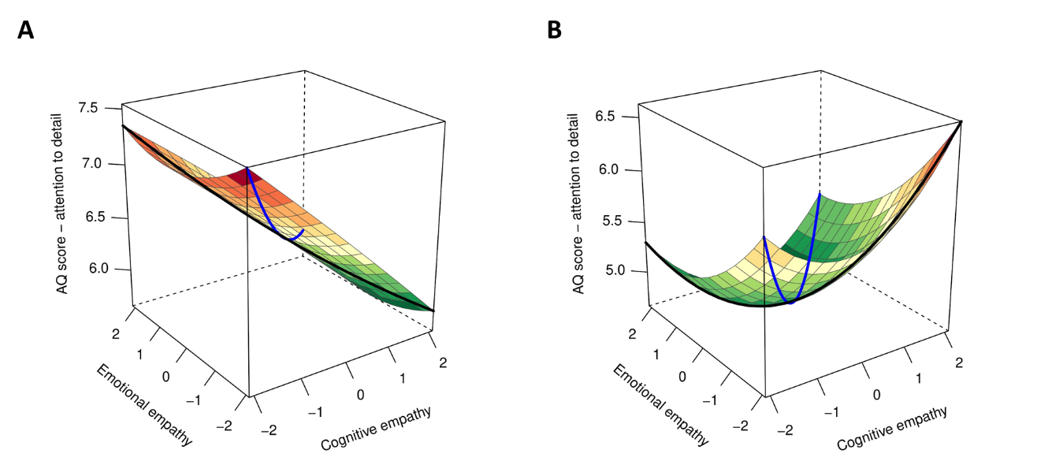
a b

Fig. S5. Polynomial regression plot predicting the ‘attention to detail’ subscale. Plot of the polynomial regression with response surface analysis (PRRSA) predicting Autism-Spectrum Quotient (AQ) score of the ‘attention to detail’ subscale, predicting autism-quotient score in a. autistic individuals (N = 1,905), and b. non-autistic individuals (N = 3,009). The black line represents ED, and the blue line represents total empathy.

Total empathy - Lower total empathy was associated with higher deficits in attention to details only in non-autistic individuals, showing linear (a1) and curvilinear (a2) associations. No association between total empathy and deficits in attention to details were found in autistic individuals.
ED - A linear and curvilinear associations between ED and deficits in attention to details were found for non-autistic individuals only, with higher CE-dominance predicting higher autistic traits (positive a3). No associations were found between ED and attention to details in autistic individuals.
SI References
1. Baron-Cohen, S., Wheelwright, S., Skinner, R., Martin, J. & Clubley, E. The Autism-Spectrum Quotient (AQ): Evidence from Asperger Syndrome/High-Functioning Autism, Males and Females, Scientists and Mathematicians. Journal of Autism and Developmental Disorders 31, 5-17 (2001).
2. Baron-Cohen, S. & Wheelwright, S. The Empathy Quotient: An Investigation of Adults with Asperger Syndrome or High Functioning Autism, and Normal Sex Differences. Journal of Autism and Developmental Disorders 34, 163-175 (2004).
3. Shanock, L.R., Baran, B.E., Gentry, W.A., Pattison, S.C. & Heggestad, E.D. Polynomial Regression with Response Surface Analysis: A Powerful Approach for Examining Moderation and Overcoming Limitations of Difference Scores. Journal of Business and Psychology 25, 543-554 (2010).
4. Edwards, J.R. & Parry, M.E. On the Use of Polynomial Regression Equations As An Alternative to Difference Scores in Organizational Research. Academy of Management Journal 36, 1577-1613 (1993).

