Supporting Information for

From the Stratosphere to the Surface:
The Case of the April 2025 Wind Extremes in Eastern Asia

Yueyue Yu ^{1*}, Min Jiao ², Haishan Chen ³, Zhicong Yin ³,
Yang Liu¹, Bowen Liu ⁴, Ke Wei ⁴
¹ State Key Laboratory of Environment Characteristics and Effects for Near-space, Ministry of Education/Collaborative Innovation Center on Forecast and Evaluation of Meteorological Disasters/ Nanjing University of Information Science and Technology, Nanjing 210044, China
² Shenyang Institute of Atmospheric Environment, China Meteorological Administration, Shenyang 110166, China
³ State Key Laboratory of Climate System Prediction and Risk Management, Ministry of Education/Collaborative Innovation Center on Forecast and Evaluation of Meteorological Disasters, Nanjing University of Information Science and Technology, Nanjing 210044, China
⁴ Institute of Atmospheric Physics, Chinese Academy of Sciences, Beijing 100029, China

Corresponding author: Yueyue Yu, yuyy@nuist.edu.cn

Contents of this file
Section S1 to S3
Figure S1 to S3

S1 Consistency between in-situ station observations and ERA5 reanalysis for extreme gust speed
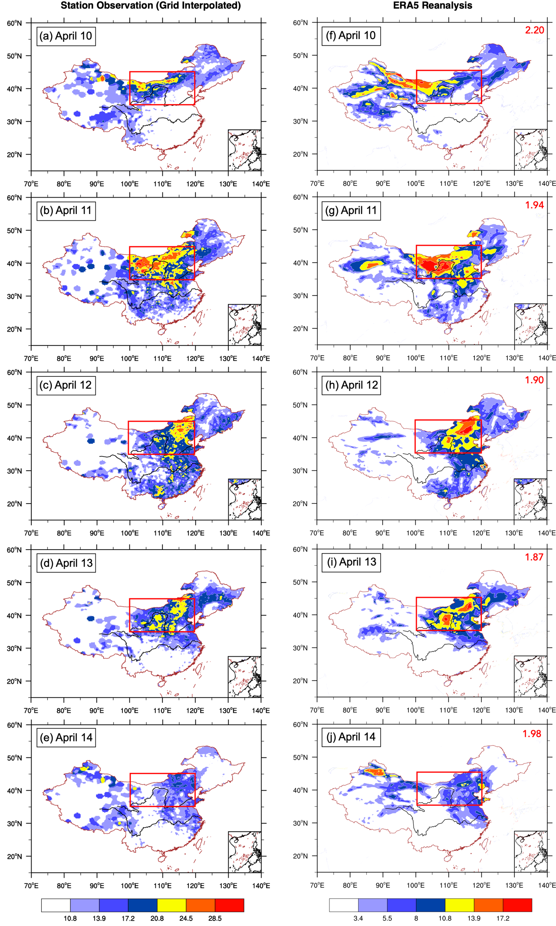
Figure S1 | Maps of (a–e) extreme gust speed from station observations interpolated into 0.25° × 0.25° grids (matching ERA5 resolution) and (f–j) the extreme gust speed derived from hourly ERA5 Reanalysis gridded data according to the scheme described in sect. 4.2.1. The scheme is mainly made by the daily dynamic gust factor derived as the amplification ratio (ERA5/observation) of wind speeds averaged over domain (35°–45°N, 100°–120°E), which encompasses the primary region of observed extreme wind gusts, as displayed in each panel’s upper right corner.
Extreme gust speed is not archived in the ERA5 reanalysis; therefore, a conversion based on station observations is required (details are provided in Section 4.2.1). Briefly, we select the daily maximum of the hourly 10‑m total wind speed from ERA5 and then apply a daily dynamic gust factor. This factor is derived as the ratio between the observed gust and the daily maximum 10‑m wind speed in ERA5, averaged over the strong‑wind domain during the April 2025 EWS event (35°–45°N, 100°–120°E). Results show that ERA5 systematically underestimates the observed extreme gust wind speeds: the average ratio of station‑observed wind speeds to their ERA5 counterparts across the core region of the event is approximately 2:1. Consequently, the observed gust intensity can only be recovered from ERA5 after applying this scaling factor – the dynamic gust factor.
A comparison between the daily extreme gust speed at 10 m from in‑situ station observations and that derived from hourly 10‑m wind speed fields in the ERA5 reanalysis demonstrates strong agreement in their spatiotemporal evolution (cf. Fig. S1a–e and Fig. 2f–j). This consistency indicates that ERA5 faithfully captures the spatiotemporal evolution of the EWS event, implying that it is highly likely to also capture the development of the key circulation systems that drove the event. This supports the utility of ERA5 for the dynamical diagnosis that follows. Note that the reduced magnitude on the left side of Fig. S1 compared to Fig. 1 arises because the denser station network (with potentially multiple stations within a single 0.25° grid cell) leads to smoothing after interpolation.

S2 Evolution of polar vortex characteristics before and during the EWS event
Displayed in Fig. S2 are the spatial maps of geopotential height at 50 hPa, 100 hPa and 500 hPa, representing the stratospheric polar vortex (SPV) morphology before and during the EWS event. It is seen that high‑pressure anomalies dominated the Arctic region and shifted toward East Asia. By early April, the main body of the vortex at 50 hPa had shifted toward East Asia (Fig. S2a–e). Below it, the vortex at 100 hPa exhibited a dispersed structure, with a pronounced lobe extending toward East Asia until the end of the extreme wind event on 13 April (Fig. S2f–j). The 500 hPa level is characterized by strong pairs of pressure waves, with a similar low‑pressure centre extending into East Asia from 9 April and a cut‑off‑low‑like feature appearing over North China on 13 April (Fig. S2k–o). This vertically coherent configuration resulted in a meridional dipole pattern of geopotential height anomalies near 115°–130°E (i.e., covering the longitudinal sector of central and eastern China), characterised by positive anomalies north of 50°N and negative anomalies to the south. This dipole also contributed to a pronounced weakening of the East Asian jet stream.
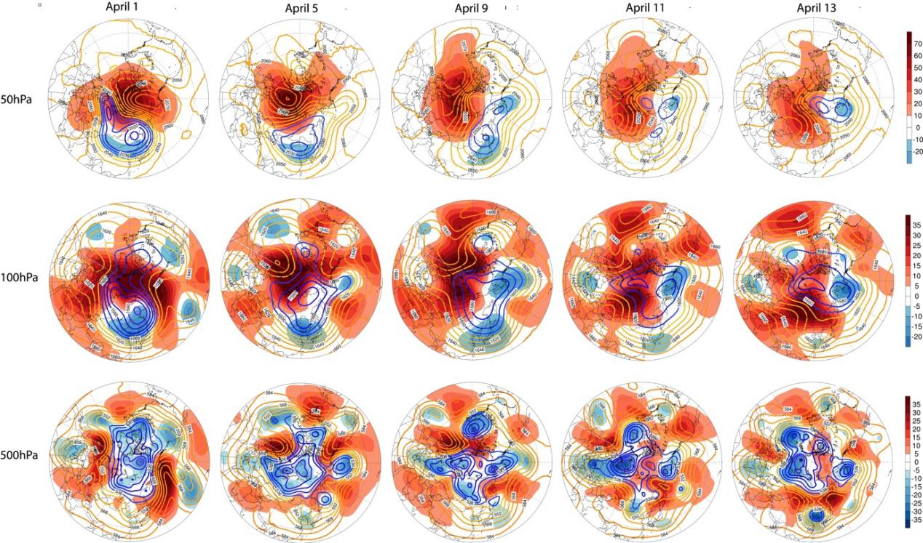
Figure S2 | Polar stereographic projection of geopotential height (contours: total fields; shading: anomalies; units: dagpm) at (a–e) 50 hPa, (f–j) 100 hPa, and (k–o) 500 hPa on selected dates prior to or during the extreme wind event (April 1, 5, 9, 11, and 13).
S3 Impact of stratospheric information on 500 hPa trough forecasts
We further examine the performance of the deep‑learning forecast model trained with and without stratospheric signals in predicting the East Asian trough. Fig. S3 compares the 500 hPa geopotential height and its forecast error fields relative to observations. Panels S3a and S3c show forecasts with stratospheric signals (the stratosphere-informed forecast), while panels S3b and S3d show forecasts without stratospheric signals (the control) for 12–13 April.
The model with stratospheric signals accurately captures the intensity of the low‑pressure system over 30°–40°N, with very small errors (shading), although the low‑pressure intensity over Mongolia (40°–60°N, 100°–130°E) is slightly overestimated on 13 April. In contrast, the model without stratospheric signals shows overestimated forecast biases for the low pressure over Mongolia on both 12 and 13 April, along with significant positive biases over 30°–40°N, indicating a failure to predict the deepening and southward extension of the East Asian trough. This is consistent with the substantially weaker wind speed forecasts from that model. These results further confirm the important role of the weak‑SPV signal in deepening the East Asian trough and sustaining the high winds during the later stage of this EWS event, thereby materially improving wind‑speed forecast skill.
Figure S3 | 500 hPa geopotential height (contours, in dagpm) from forecasts initialized on 8 April. (a) Stratosphere‑informed forecast valid on 12 April; (c) same forecast valid on 13 April. (b) and (d) as in (a) and (c), but for the forecast model without stratospheric input. Shading indicates the forecast error (in dagpm), calculated as the difference between the forecast and the observation interpolated onto the deep‑learning model’s coarse grid.

