Chromosome Location | Ref/Alt | Gene Names | HGVS c. | HGVS p. | Effect
1:12617239 | G/A | DHRS3 | c.110C>T | p.Ser37Leu | Missense
1:22863094 | C/A | EPHB2 | c.869C>A | p.Pro290His | Missense
1:24458944 | A/G | NIPAL3 | c.830A>G | p.Tyr277Cys | Missense
1:25446845 | T/G | MACO1 | c.164T>G | p.Leu55Arg | Missense
1:52698320 | C/A | COA7 | c.7G>T | p.Gly3Cys | Missense
1:62555824 | C/T | DOCK7 | c.2596+1G>A |  | LoF
1:92245604 | T/C | C1orf146 | c.473T>C | p.Ile158Thr | Missense
2:108766258 | A/G | RANBP2 | c.5719A>G | p.Asn1907Asp | Missense
2:112659645 | A/G | SLC20A1 | c.1490A>G | p.Asn497Ser | Missense
2:11618333 | C/T | GREB1 | c.3458C>T | p.Pro1153Leu | Missense
2:178738241 | G/A | TTN | c.14212C>T | p.Arg4738Ter | LoF
2:178747180 | A/G | TTN | c.11312-5259T>C |  | Missense
2:200573408 | C/G | SGO2 | c.3062C>G | p.Ser1021Cys | Missense
2:21142968 | T/C | TDRD15 | c.5501T>C | p.Val1834Ala | Missense
2:214410244 | G/A | SPAG16 | c.1825G>A | p.Val609Ile | Missense
2:235883447 | C/T | AGAP1 | c.1153C>T | p.His385Tyr | Missense
2:24821592 | C/T | ADCY3 | c.3055G>A | p.Asp1019Asn | Missense
2:27581847 | T/C | C2orf16 | c.5275T>C | p.Cys1759Arg | Missense
2:47029351 | A/G | TTC7A | c.1769A>G | p.Asn590Ser | Missense
2:88627076 | C/T | EIF2AK3 | c.199G>A | p.Ala67Thr | Missense
2:96193078 | C/T | STARD7 | c.743G>A | p.Arg248His | Missense
3:12557158 | C/T | MKRN2 | c.8C>T | p.Thr3Ile | Missense
3:129315334 | G/A | H1-10 | c.569C>T | p.Ala190Val | Missense
3:134561462 | G/A | CEP63 | c.2039G>A | p.Arg680His | Missense
3:179563094 | T/G | ACTL6A | c.2T>G | p.Met1Arg | LoF
3:189894226 | C/G | TP63 | c.1767C>G | p.Ile589Met | Missense
3:195725943 | C/T | MUC20 | c.1340C>T | p.Thr447Met | Missense
3:195782050 | A/G | MUC4 | c.9530T>C | p.Val3177Ala | Missense
3:195786568 | G/A | MUC4 | c.5012C>T | p.Ser1671Phe | Missense
3:31990509 | C/G | ZNF860 | c.1430C>G | p.Thr477Ser | Missense
3:36830891 | G/A | TRANK1 | c.8692C>T | p.Arg2898Trp | Missense
3:50302157 | G/A | HYAL1 | c.800C>T | p.Ala267Val | Missense
3:51984131 | C/T | ACY1 | c.67C>T | p.Arg23Cys | Missense
4:121164073 | G/A | TNIP3 | c.53C>T | p.Thr18Met | Missense
4:147875102 | C/T | ARHGAP10 | c.784C>T | p.Arg262Ter | LoF
4:48382595 | C/T | SLAIN2 | c.890C>T | p.Thr297Met | Missense
4:48561507 | C/T | FRYL | c.3826G>A | p.Ala1276Thr | Missense
4:52029703 | A/G | SGCB | c.404T>C | p.Leu135Ser | Missense
4:5841335 | C/T | CRMP1 | c.1126G>A | p.Asp376Asn | Missense
5:13919284 | G/C | DNAH5 | c.867C>G | p.His289Gln | Missense
5:73866000 | G/T | ARHGEF28 | c.2139G>T | p.Gln713His | Missense
5:77039595 | G/A | AGGF1 | c.746G>A | p.Arg249His | Missense
6:113953409 | C/G | HDAC2 | c.507G>C | p.Gln169His | Missense
6:113953410 | T/G | HDAC2 | c.506A>C | p.Gln169Pro | Missense
6:158493629 | C/T | TULP4 | c.1688C>T | p.Ser563Phe | Missense
6:161106684 | T/C | MAP3K4 | c.4027T>C | p.Trp1343Arg | Missense
6:26107744 | G/A | H1-6 | c.350C>T | p.Pro117Leu | Missense
6:30986727 | G/C | MUC21 | c.552G>C | p.Glu184Asp | Missense
6:30986737 | G/A | MUC21 | c.562G>A | p.Val188Met | Missense
6:32530209 | G/A | HLA-DRB5 | c.16C>T | p.Leu6Phe | Missense
6:32584273 | A/T | HLA-DRB1 | c.206T>A | p.Phe69Tyr | Missense
6:54940571 | C/T | FAM83B | c.1600C>T | p.Leu534Phe | Missense
6:98836046 | A/T | POU3F2 | c.1173A>T | p.Leu391Phe | Missense
7:121996450 | G/A | PTPRZ1 | c.997G>A | p.Glu333Lys | Missense
7:128866780 | C/T | ATP6V1FNB | c.371C>T | p.Thr124Met | Missense
7:134947749 | G/A | CALD1 | c.1774G>A | p.Asp592Asn | Missense
7:149826185 | G/A | SSPOP | c.14369G>A | p.Arg4790Gln | Missense
7:151023204 | T/C | ATG9B | c.662A>G | p.Gln221Arg | Missense
7:155803204 | G/A | SHH | c.1085C>T | p.Ser362Leu | Missense
7:78343861 | C/T | MAGI2 | c.1325G>A | p.Gly442Asp | Missense
7:80828605 | T/C | SEMA3C | c.244A>G | p.Ile82Val | Missense
7:93134086 | C/T | SAMD9L | c.1886G>A | p.Arg629Gln | Missense
7:97007691 | G/C | DLX6 | c.490G>C | p.Gly164Arg | Missense
8:10607950 | G/A | RP1L1 | c.6148C>T | p.Pro2050Ser | Missense
8:125083835 | C/A | WASHC5 | c.64G>T | p.Gly22Cys | Missense
8:143924216 | C/T | PLEC | c.5794G>A | p.Glu1932Lys | Missense
8:144512000 | C/A | RECQL4 | c.3304G>T | p.Asp1102Tyr | Missense
8:144722489 | T/C | ZNF251 | c.1171A>G | p.Ser391Gly | Missense
9:121021568 | C/T | C5 | c.1243G>A | p.Asp415Asn | Missense
9:131128358 | C/G | NUP214 | c.268C>G | p.Pro90Ala | Missense
9:134887404 | C/T | FCN2 | c.931C>T | p.Arg311Ter | LoF
9:33796675 | G/A | PRSS3 | c.244G>A | p.Val82Ile | Missense
9:89381234 | C/T | SEMA4D | c.1559G>A | p.Cys520Tyr | Missense
10:100989673 | A/C | TWNK | c.1273A>C | p.Ile425Leu | Missense
10:110821608 | G/A | RBM20 | c.2989G>A | p.Val997Met | Missense
10:26021561 | C/G | MYO3A | c.644C>G | p.Ser215Cys | Missense
10:5937203 | C/T | FBH1 | c.3208C>T | p.Gln1070Ter | LoF
10:69572797 | T/C | NEUROG3 | c.247A>G | p.Ser83Gly | Missense
10:71730574 | A/T | CDH23 | c.3685A>T | p.Ile1229Phe | Missense
10:90915813 | G/A | ANKRD1 | c.719C>T | p.Ala240Val | Missense
10:97057258 | G/A | SLIT1 | c.1109C>T | p.Thr370Ile | Missense
11:1188914 | G/A | MUC5AC | c.10769G>A | p.Arg3590His | Missense
11:55344004 | A/C | OR4A16 | c.804A>C | p.Leu268Phe | Missense
11:65389453 | G/A | FRMD8 | c.178G>A | p.Ala60Thr | Missense
11:6567652 | G/A | DNHD1 | c.12143G>A | p.Arg4048Gln | Missense
11:66715280 | A/T | SPTBN2 | c.425T>A | p.Val142Glu | Missense
11:84534687 | T/A | DLG2 | c.402A>T | p.Leu134Phe | Missense
11:95979264 | T/C | MAML2 | c.3155A>G | p.Asn1052Ser | Missense
12:110614214 | T/C | TCTN1 | c.32T>C | p.Val11Ala | Missense
12:47796247 | T/C | HDAC7 | c.755A>G | p.Asn252Ser | Missense
12:49050509 | G/A | KMT2D | c.3079C>T | p.Leu1027Phe | Missense
12:50352111 | G/T | FAM186A | c.4721C>A | p.Ala1574Asp | Missense
12:50352111 | G/T | FAM186A | c.4721C>A | p.Ala1574Asp | Missense
12:50352857 | G/C | FAM186A | c.3975C>G | p.Ile1325Met | Missense
12:63802407 | T/A | RXYLT1 | c.743+2T>A |  | LoF
13:102875878 | C/T | ERCC5 | c.3536C>T | p.Ala1179Val | Missense
13:19835686 | G/A | ZMYM5 | c.1042C>T | p.Arg348Cys | Missense
13:95763714 | G/A | DNAJC3 | c.920G>A | p.Arg307His | Missense
14:104948630 | G/A | AHNAK2 | c.6821C>T | p.Ala2274Val | Missense
14:104948633 | G/C | AHNAK2 | c.6818C>G | p.Thr2273Arg | Missense
14:104948637 | C/T | AHNAK2 | c.6814G>A | p.Val2272Met | Missense
14:23990277 | C/T | DHRS4L2 | c.224C>T | p.Thr75Met | Missense
14:53093367 | T/C | DDHD1 | c.1111A>G | p.Thr371Ala | Missense
14:57208791 | T/C | EXOC5 | c.1945A>G | p.Met649Val | Missense
14:78967390 | A/T | NRXN3 | c.2960A>T | p.Asp987Val | Missense
14:81144181 | G/C | TSHR | c.2123G>C | p.Gly708Ala | Missense
15:40200274 | A/T | BUB1B | c.1432A>T | p.Thr478Ser | Missense
15:58821727 | T/C | MINDY2 | c.1133T>C | p.Ile378Thr | Missense
15:78180855 | G/A | ACSBG1 | c.1153C>T | p.Arg385Cys | Missense
15:88856906 | A/G | ACAN | c.4321A>G | p.Thr1441Ala | Missense
15:89582731 | C/G | TICRR | c.700C>G | p.Leu234Val | Missense
16:1775841 | G/A | EME2 | c.824G>A | p.Arg275His | Missense
16:2255717 | T/C | RNPS1 | c.686A>G | p.Asp229Gly | Missense
16:28538847 | C/A | NUPR1 | c.61G>T | p.Asp21Tyr | Missense
16:48138240 | T/G | ABCC12 | c.967A>C | p.Asn323His | Missense
16:5056123 | C/G | C16orf89 | c.693G>C | p.Met231Ile | Missense
16:53156715 | A/G | CHD9 | c.626A>G | p.Asn209Ser | Missense
16:67645262 | G/A | CARMIL2 | c.16G>A | p.Asp6Asn | Missense
16:9763618 | C/T | GRIN2A | c.3926G>A | p.Arg1309Gln | Missense
17:19019527 | C/T | SLC5A10 | c.1394C>T | p.Ser465Phe | Missense
17:3216519 | G/A | OR1A1 | c.899G>A | p.Arg300Gln | Missense
17:33291652 | C/T | ASIC2 | c.464G>A | p.Gly155Asp | Missense
17:4032234 | C/T | ZZEF1 | c.6784G>A | p.Val2262Ile | Missense
17:41756183 | T/C | JUP | c.2078A>G | p.Tyr693Cys | Missense
17:41821726 | C/A | FKBP10 | c.1472C>A | p.Thr491Lys | Missense
17:41912433 | C/T | ACLY | c.269G>A | p.Gly90Glu | Missense
17:4884399 | G/T | MINK1 | c.343G>T | p.Asp115Tyr | Missense
17:4887701 | C/T | MINK1 | c.1141C>T | p.Arg381Ter | LoF
17:68921472 | C/T | ABCA8 | c.1522G>A | p.Glu508Lys | Missense
17:7284563 | G/A | SLC2A4 | c.806G>A | p.Arg269His | Missense
17:75809893 | G/A | UNK | c.238G>A | p.Gly80Ser | Missense
17:9802513 | A/G | GSG1L2 | c.755T>C | p.Phe252Ser | Missense
18:35677701 | G/A | GALNT1 | c.425G>A | p.Arg142His | Missense
18:57701307 | G/A | ATP8B1 | c.400C>T | p.Pro134Ser | Missense
18:62211239 | G/A | RELCH | c.613G>A | p.Ala205Thr | Missense
18:62570232 | G/T | ZCCHC2 | c.1975+1G>T |  | LoF
18:63793232 | C/A | SERPINB7 | c.291C>A | p.Ser97Arg | Missense
19:10403376 | A/G | CDC37 | c.102+2T>C |  | LoF
19:10514953 | T/C | S1PR5 | c.59A>G | p.Asn20Ser | Missense
19:12792168 | G/A | JUNB | c.397G>A | p.Glu133Lys | Missense
19:13983583 | C/T | RFX1 | c.332G>A | p.Arg111Gln | Missense
19:20807211 | C/A | ZNF66 | c.1611C>A | p.His537Gln | Missense
19:20807211 | C/A | ZNF66 | c.1611C>A | p.His537Gln | Missense
19:20807213 | A/T | ZNF66 | c.1613A>T | p.Lys538Met | Missense
19:20807213 | A/T | ZNF66 | c.1613A>T | p.Lys538Met | Missense
19:35785048 | C/T | ARHGAP33 | c.1663C>T | p.Arg555Trp | Missense
19:41197899 | G/A | CYP2S1 | c.464G>A | p.Cys155Tyr | Missense
19:54575487 | A/C | LILRA2 | c.887A>C | p.Tyr296Ser | Missense
19:54773524 | A/G | KIR2DL1 | c.262A>G | p.Ser88Gly | Missense
19:54775225 | A/G | KIR2DL1 | c.431A>G | p.Asn144Ser | Missense
19:57874619 | C/G | ZNF814 | c.771G>C | p.Leu257Phe | Missense
19:58516973 | G/A | ZBTB45 | c.701C>T | p.Pro234Leu | Missense
19:8499546 | C/A | PRAM1 | c.262G>T | p.Val88Phe | Missense
19:8499546 | C/A | PRAM1 | c.262G>T | p.Val88Phe | Missense
19:8499546 | C/A | PRAM1 | c.262G>T | p.Val88Phe | Missense
19:8951340 | G/C | MUC16 | c.25430C>G | p.Ala8477Gly | Missense
20:46013314 | C/A | MMP9 | c.1390C>A | p.Pro464Thr | Missense
20:58854572 | C/A | GNAS | c.1307C>A | p.Ala436Asp | Missense
21:44943819 | G/A | FAM207A | c.265G>A | p.Val89Ile | Missense
22:29489649 | T/A | NEFH | c.2009T>A | p.Val670Glu | Missense
22:38645588 | C/T | FAM227A | c.200G>A | p.Arg67His | Missense
22:45328021 | G/C | FAM118A | c.480G>C | p.Gln160His | Missense
Supplementary Table 1: List of de novo mutations (DNMs) identified in nsCL/P African case-parent trios through analysis of the Whole-genome sequence.

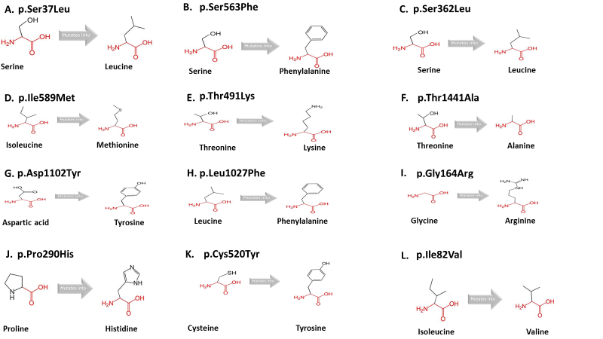

Supplementary Figure 1: Predicted effects of the DNMs on protein structures and functions. A: Deleterious p.Ser37Leu DNM in DHRS3 found in the catalytic domain. B: Damaging p.Ser563Phe DNM in TULP4 disrupts the secondary structure of the polypeptide chain. C: Deleterious p.Ser362Leu DNM in SHH disrupts the secondary structure of the protein. D: Deleterious p.Ile589Met DNM in TP63 found in the sterile alpha motif (SAM) domain. This mutation cause a disruption in the protein interaction of this domain. E: p.Thr491Lys DNM in FKBP10 which cause a disruption in the structure of the protein. F: p.Thr1441Ala DNM in ACAN which likely affect the protein structure and function. G: Damaging p.Asp1102Tyr DNM in RECQL4 which affect the charge thus affecting the interactive function of the protein. H: Deleterious p.Leu1027Phe DNM in KMT2D affects the structure and interaction with other proteins. I: Deleterious p.Gly164Arg DNM in DLX6 affects the protein interaction function of the Homeobox-like domain. J: Damaging p.Pro290His DNM in the EPHB2 alter the special conformation of the protein and interaction. K: Damaging p.Cys520Tyr DNM in the SEMA4D found in the highly conserved PSI domain. The wildtype amino acid residue is highly conserved at this location and mutation could cause a disruption in the binding function of the PSI domain. L: p.Ile82Val DNM in SEMA3C is found within the protein-binding domain thus it may abolish the function.

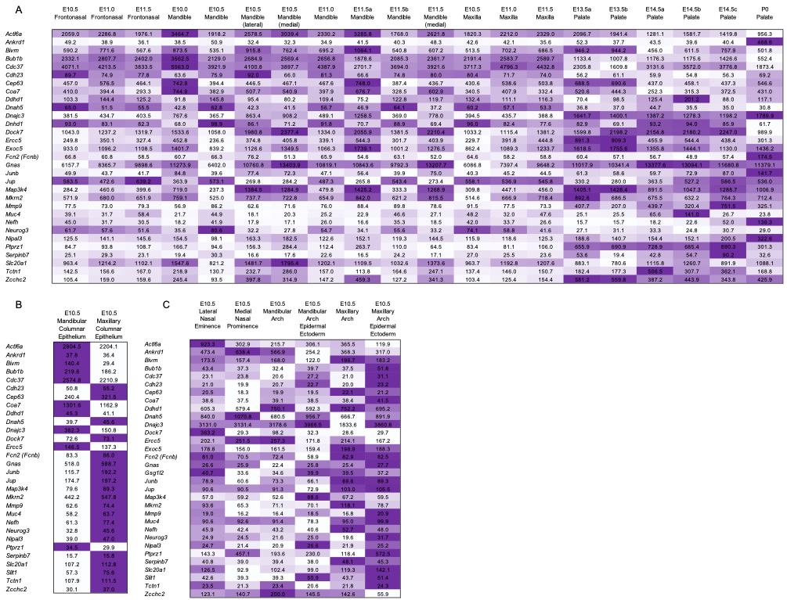

Supplementary Figure 2: SysFACE-based expression analysis of candidate genes in mouse facial
generated on the Affymetrix Mouse Genome 430 2.0 Array platform, (B) FaceBase microarray data generated on the Affymetrix Mouse Gene 1.0 ST Array platform, and (C) GSE55965 microarray data generated on the Affymetrix Mouse Gene 1.0 ST Array platform. Heat-map denotes row-wise comparative expression of individual genes in different tissues at Embryonic (E) and/or postnatal (P) stages. Intensity of the color in the heat-map is representative of candidate gene expression and the average fluorescence signal intensity is shown.

