Table S1 Top 10 productive countries/regions
Rank | Country | Total Publications | Percentage  (%) | SCP | MCP | MCP % | Total Citations | Average Citations
1 | USA | 353 | 36.9 | 292 | 61 | 17.3 | 17840 | 50.5
2 | Canada | 73 | 7.6 | 62 | 11 | 15.1 | 1452 | 19.9
3 | Italy | 71 | 7.4 | 56 | 15 | 21.1 | 684 | 9.6
4 | Spain | 68 | 7.1 | 53 | 15 | 22.1 | 1766 | 26
5 | United Kingdom | 53 | 5.5 | 28 | 25 | 47.2 | 1294 | 24.4
6 | France | 39 | 4.1 | 26 | 13 | 33.3 | 617 | 15.8
7 | Japan | 33 | 3.5 | 25 | 8 | 24.2 | 572 | 17.3
8 | China | 31 | 3.2 | 25 | 6 | 19.4 | 420 | 13.5
9 | Netherlands | 27 | 2.8 | 13 | 14 | 51.9 | 1326 | 49.1
10 | Australia | 25 | 2.6 | 22 | 3 | 12.0 | 259 | 10.4

Table S2 The top 20 most prolific and cited authors
Author | Count | Total Citations | H-index | G-index
PAES B | 29 | 635 | 14 | 25
SIMOES EAF | 25 | 2974 | 19 | 25
MITCHELL I | 24 | 663 | 13 | 24
LANCTÔT KL | 22 | 542 | 14 | 22
RAMILO O | 20 | 1663 | 16 | 20
LI A | 20 | 419 | 13 | 20
VILLAFANA T | 17 | 2223 | 13 | 17
CARBONELL-ESTRANY X | 15 | 773 | 9 | 15
TRIPP RA | 14 | 720 | 13 | 14
PAES BA | 14 | 270 | 10 | 14
GRAHAM BS | 12 | 1350 | 12 | 12
GROOTHUIS JR | 12 | 2253 | 11 | 12
BONT L | 11 | 632 | 9 | 11
JIT M | 11 | 283 | 9 | 11
LEACH A | 11 | 1299 | 9 | 11
GRIFFIN MP | 10 | 2266 | 10 | 10
ANDERSON LJ | 10 | 612 | 9 | 10
HAYNES LM | 9 | 556 | 9 | 9
LOSONSKY GA | 9 | 805 | 9 | 9
MCLELLAN JS | 9 | 1156 | 9 | 9
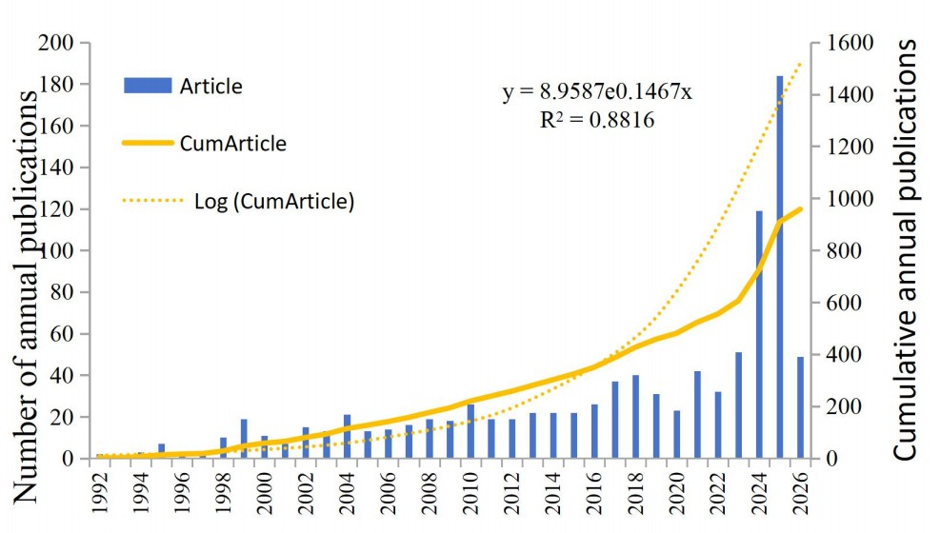
Fig. S1 Trends in the growth of publications and the number of citations
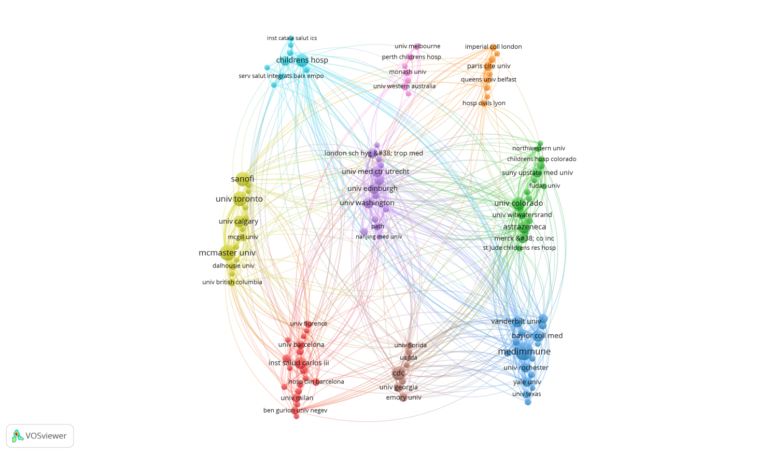
Fig. S2a Research institution collaboration network
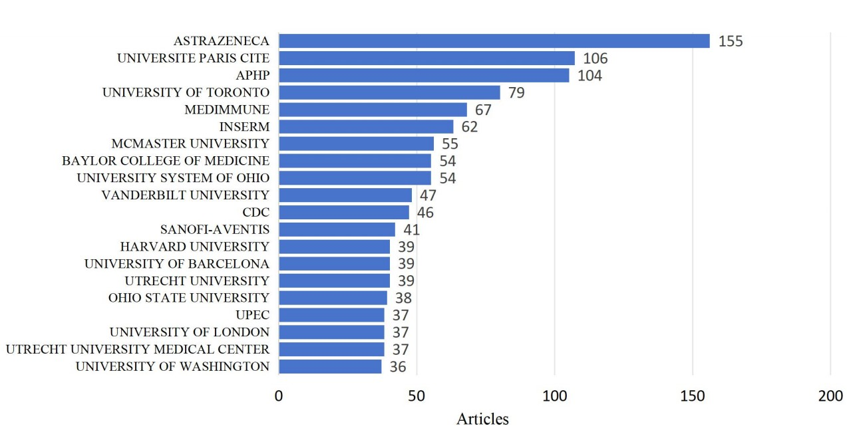
Fig. S2b Number of publications by research institution
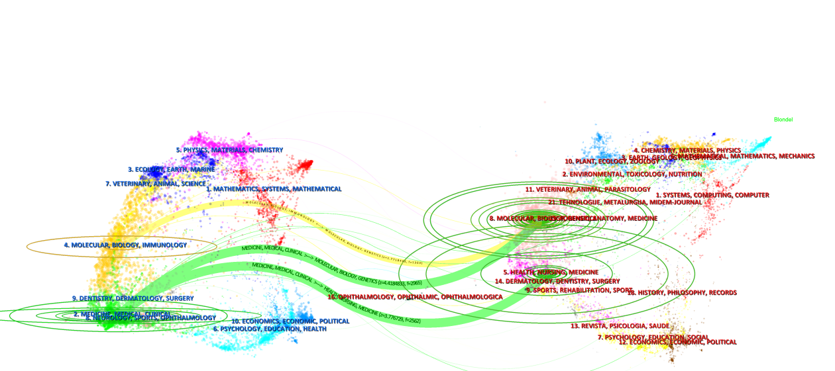
Fig. S3 The dual-map overlay of journals

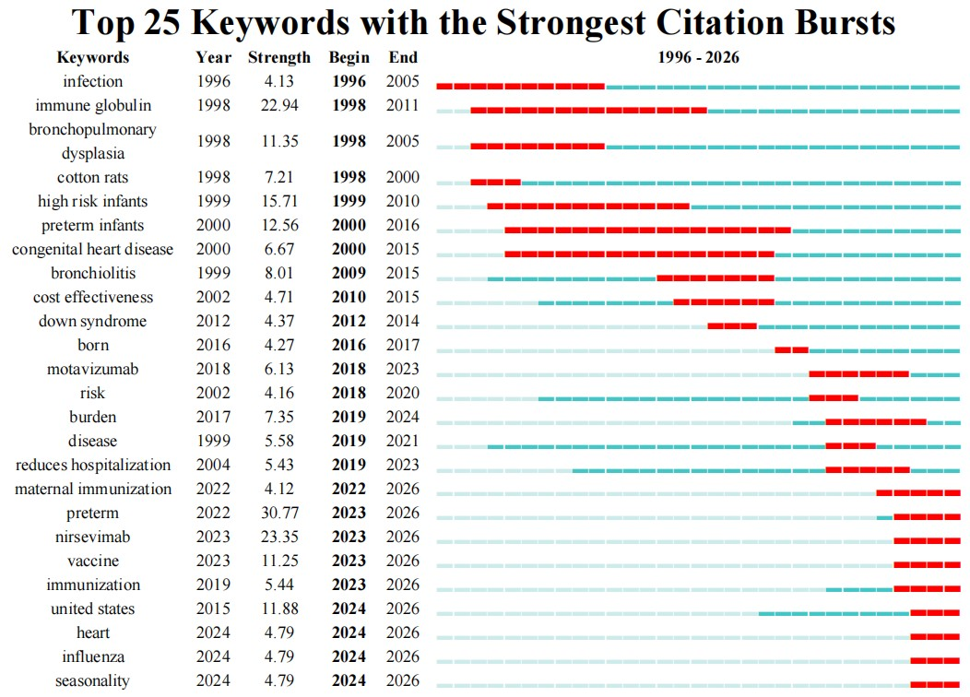 Fig. S4 Top 25 keywords with the strongest citation bursts

