Supplementary Information: Figures and Tables for

Using a Benign Lutidinium Moiety for Mitochondrion-Targeted Drug Delivery

Manjusha Roy Choudhury, Shameer M. Kondengadan, Xiaoxiao Yang, Shubham Bansal, Zhixiang Pan, and Binghe Wang*

Department of Chemistry and Center for Diagnostics and Therapeutics, Georgia State University, Atlanta, Georgia 30301 USA
#.
*Address correspondence to
Dr. Binghe Wang
Department of Chemistry
Georgia State University
Atlanta, Georgia 30301
USA
wang@gsu.edu
Phone: 404-413-5544

Figure S 1 Standard Curve for BCA Assay

Figure S 2 Standard curves for BODIPY-Lutidine (7a) and BODIPY-TPP (7b) inside mitochondria solution for fluorescence spectroscopy experiment (Batch 1)

Figure S 3 Standard curves for BODIPY-Lutidine (7a) and BODIPY-TPP (7b) in ex-mito buffer for fluorescence spectroscopy experiment (Batch1)

Figure S 4 Determination of accumulation rate using fluorescence spectroscopy (experiment performed in triplicates) (Batch 1)

Figure S 5 (A) Standard curves for BODIPY-Lutidine (7a) and BODIPY-TPP (7b) inside mitochondria solution for fluorescence spectroscopy experiment (Batch 2)

Figure S 5 (B) Standard curves for BODIPY-Alkyl (7c) inside mitochondria solution for fluorescence spectroscopy experiment (Batch 2)

Figure S 6 (A) Standard curves for BODIPY-TPP (7b) and BODIPY-Lutidine (7a) in ex-mito buffer for fluorescence spectroscopy experiment (Batch2)

Figure S 6 (B) Standard curves for BODIPY-Alkyl (7c) in ex-mito buffer for fluorescence spectroscopy experiment (Batch2)

Figure S 7 (A) Determination of accumulation rate using fluorescence spectroscopy (Batch 2)

Figure S 7 (B) Determination of accumulation rate using fluorescence spectroscopy (Batch 2)

(A) BODIPY-Lutidinium, 8a (FITC)
(C) Merge (BODIPY-Lutidinium 8a + MitoTracker)
(B) MitoTracker (Deep Red Channel)
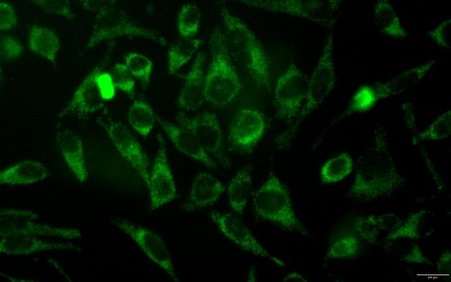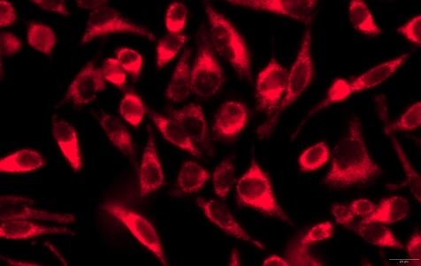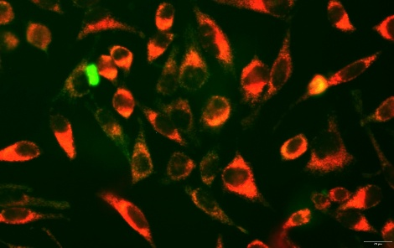
(F) Merge (BODIPY-TPP 8b + MitoTracker)
(E) MitoTracker (Deep Red Channel)
(D) BODIPY-TPP,8b (FITC)
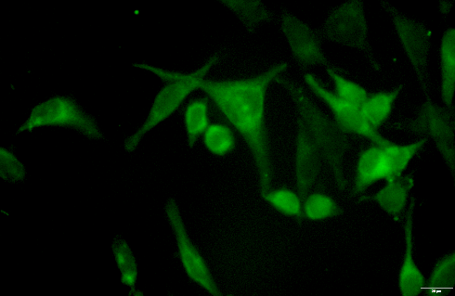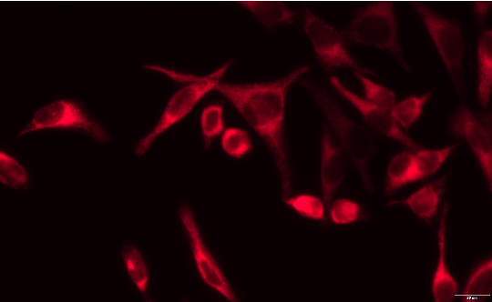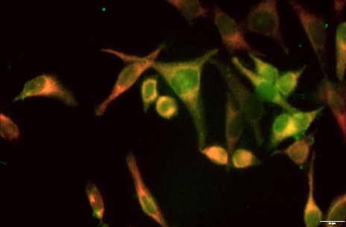
Figure S 8 Representative fluorescence images of compound (BODIPY-Lutidinium 7a and BODIPY-TPP 7b) localization relative to mitochondria in live HeLa cells.
(A,D) Compound (BODIPY-Lutidine 7a or BODIPY-TPP 7b) fluorescence imaged in the FITC channel.
(B,E) Mitochondria labeled with MitoTracker Deep Red.
(C,F) Merged fluorescence images showing regions of overlap between compound (green) and mitochondria (red). Images from two independent fields of view are shown.

Table S 1 Batch 1 Calculation of Accumulation Ratio with LC-MS/MS Technique

Compound | UV absorabance (BCA Assay) | Mitochondrial Volumn (µL) | Volume of Buffer/Volume of Mito | Mito Peak Area | Buffer Peak Area | Accumulation Ratio
Blank | 0.349
Lutidinium compound 1 (1) | 2.45 | 0.157 | 3184.7 | 293106.3 | 2807193.0 | 325.0
Lutidinium compound 1 (2) | 2.934 | 0.196 | 2551.0 | 190693.0 | 2357601.0 | 206.0
Lutidinium compound 1 (3) | 2.736 | 0.18 | 2777.7 | 194530.0 | 2094100.0 | 258.0
TPP compound 2 (1) | 2.752 | 0.181 | 2762.4 | 19514.0 | 63555.0 | 848.0
TPP compound 2 (2) | 2.122 | 0.131 | 3816.7 | 21968.0 | 58275.0 | 1439.0
TPP compound 2 (3) | 2.705 | 0.177 | 2824.8 | 20086.0 | 61306.0 | 925.5

Table S 2 Batch 2 Calculation of Accumulation Ratio with LC-MS/MS Technique

Compound | UV absorabance (BCA Assay) | Mitochondrial Volumn (µL) | Volume of Buffer/Volume of Mito | Mito Peak Area | Buffer Peak Area | Accumulation Ratio
Blank | 0.13
Lutidinium compound 1 (1) | 3.292 | 0.241 | 2074.7
Lutidinium compound 1 (2) | 3.42 | 0.252 | 1984.1 | 54197.0 | 308610.0 | 365.0
Lutidinium compound 1 (3) | 3.369 | 0.248 | 2016.1 | 48962.0 | 371720.0 | 340.0
TPP compound 2 (1) | 3.067 | 0.224 | 2232.1 | 702480.0 | 407330.0 | 4465.0
TPP compound 2 (2) | 3.011 | 0.219 | 2283.1 | 614270.0 | 482110.0 | 3374.0
TPP compound 2 (3) | 3.009 | 0.219 | 2283.1 | 787210.0 | 406360.0 | 5130.0
Berberine (1) | 3.329 | 0.245 | 2040.8 | 73463.0 | 48722.0 | 3569.0
Berberine (2) | 3.307 | 0.243 | 2057.6 | 70316.0 | 53833.0 | 3117.0
Berberine (3) | 3.314 | 0.244 | 2049.2 | 74027.0 | 47392.0 | 3712.0

Table S 3 Batch 1 Calculation of Accumulation Ratio with Fluorescent Spectroscopy

Compound | Mitochondrial Volume Used (µL) | Accumulation Ratio
BODIPY-Lutidine 7a (1) | 0.24 | 563
BODIPY-Lutidine 7a (2) | 0.24 | 1054
BODIPY-Lutidine 7a (3) | 0.24 | 843
BODIPY-TPP 7b (1) | 0.29 | 2296
BODIPY-TPP 7b (2) | 0.27 | 1859
BODIPY-TPP 7b (3) | 0.26 | 2046

Table S 4 Batch 2 Calculation of Accumulation Ratio with Fluorescent Spectroscopy

Compound | Mitochondrial Volume Used (µL) | Accumulation Ratio
BODIPY-Lutidine 7a (1) | 0.14 | 1495
BODIPY-Lutidine 7a (2) | 0.16 | 867
BODIPY-Lutidine 7a (3) | 0.14 | 1206
BODIPY-TPP 7b (1) | 0.15 | 765
BODIPY-TPP 7b (2) | 0.17 | 992
BODIPY-TPP 7b (3) | 0.14 | 1245
BODIPY-Alkyl 7c (1) | 0.14 | 400
BODIPY-Alkyl 7c (2) | 0.15 | 299
BODIPY-Alkyl 7c (3) | 0.16 | 306

LC-MS/MS for Mitochondria Targeting Small Molecules for Drug Delivery Application (only for Batch 2 shown here)
MS/MS Lutidinium compound 1 (2) buffer

MS/MS Lutidinium compound 1 (2) mito

MS/MS Lutidinium compound 1 (3) buffer

MS/MS Lutidinium compound 1 (3) mito

MS/MS TPP compound 2 (1) buffer

MS/MS TPP compound 2 (1) mito

MS/MS TPP compound 2 (2) buffer

MS/MS TPP compound 2 (2) mito

MS/MS TPP compound 2 (3) buffer

MS/MS TPP compound 2 (3) mito

MS/MS Berberine (1) buffer

MS/MS Berberine (1) mito

MS/MS 3 Berberine (2) buffer

MS/MS Berberine (2) mito

MS/MS Berberine (3) buffer

MS/MS Berberine (3) mito

¹H and ¹³C NMR spectrum of the synthesized compounds
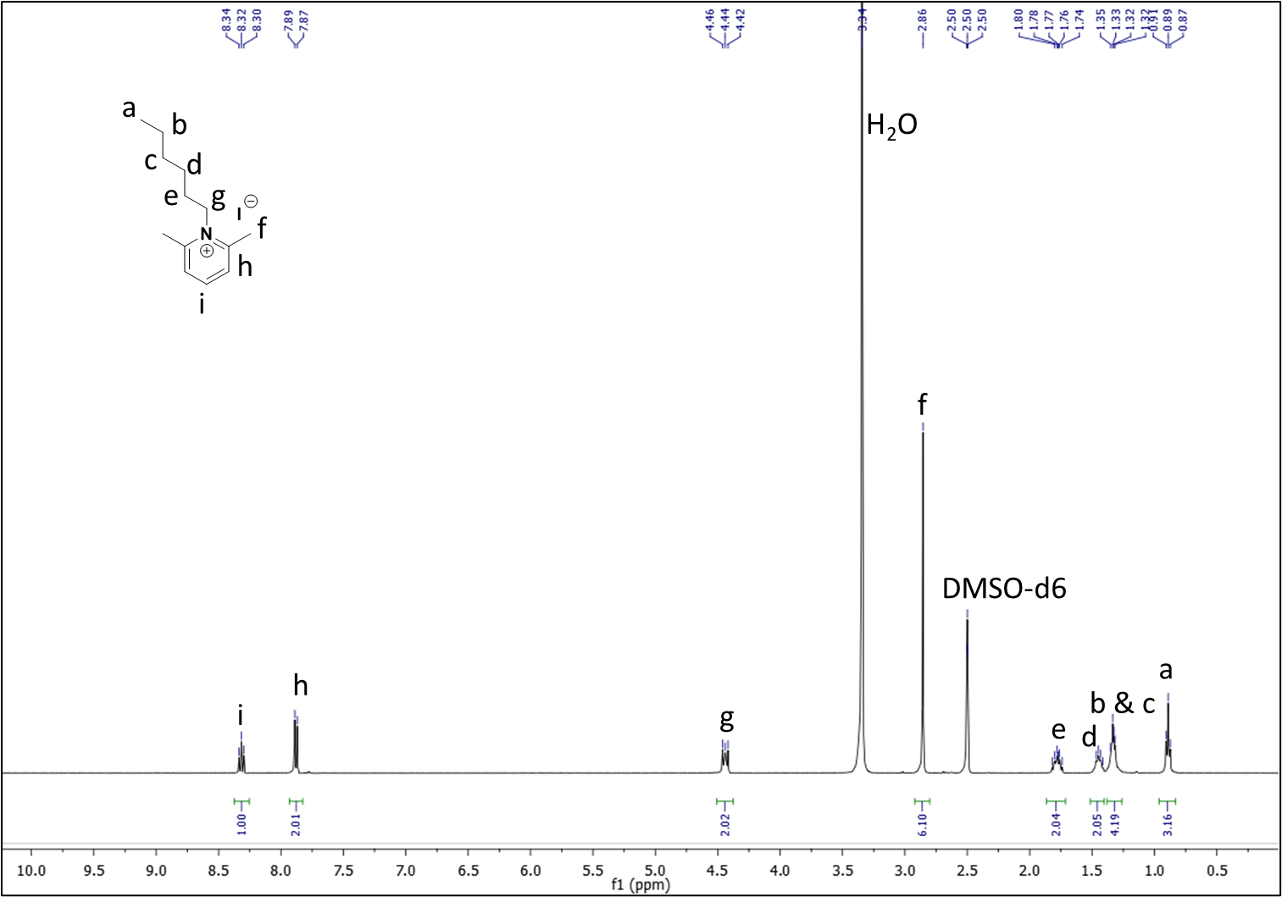
NMR. ¹H NMR of Lutidinium compound 1.
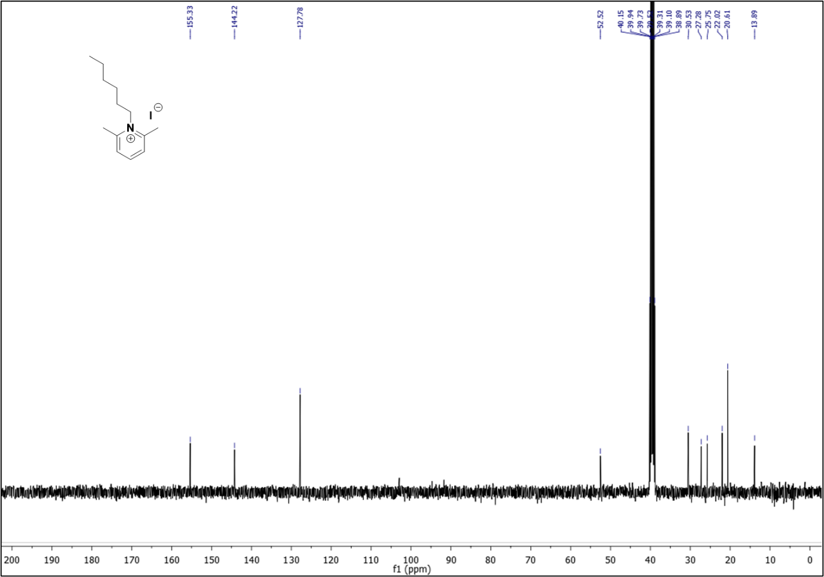
NMR. ¹³C NMR of Lutidinium compound 1.

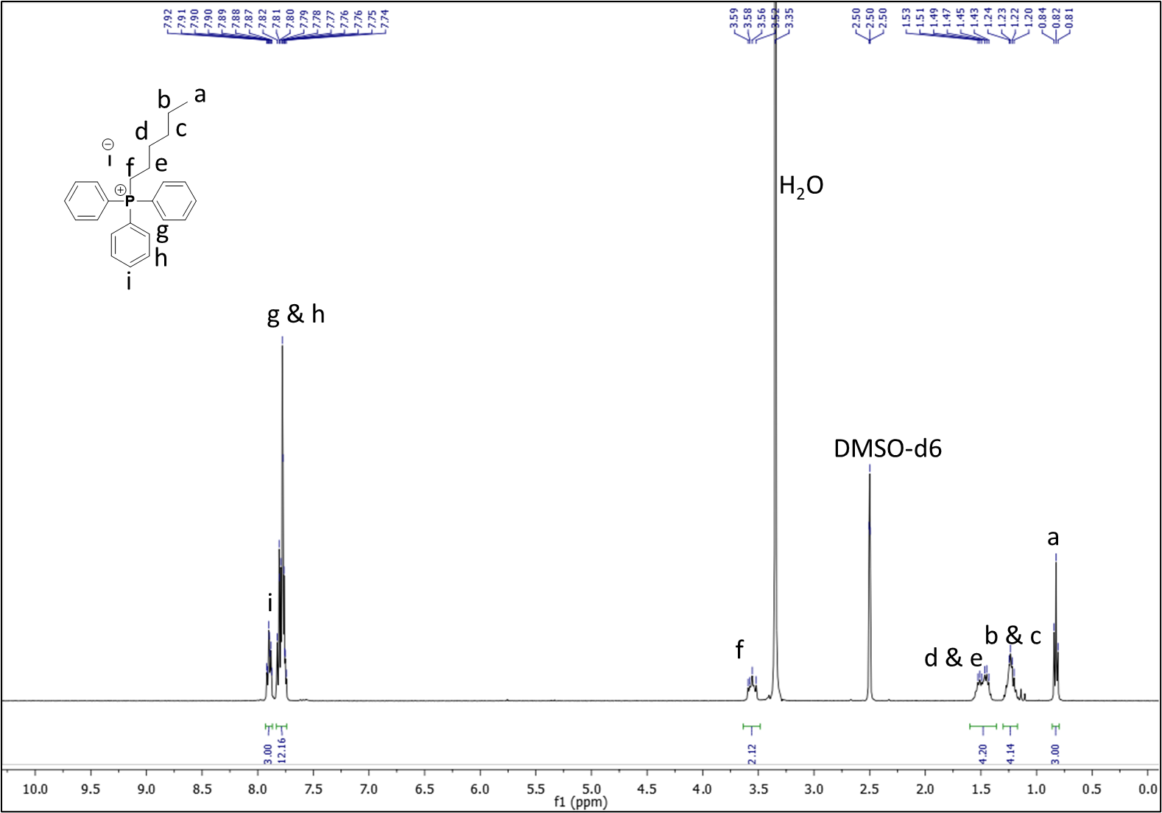
NMR. ¹H NMR of TPP compound 2.

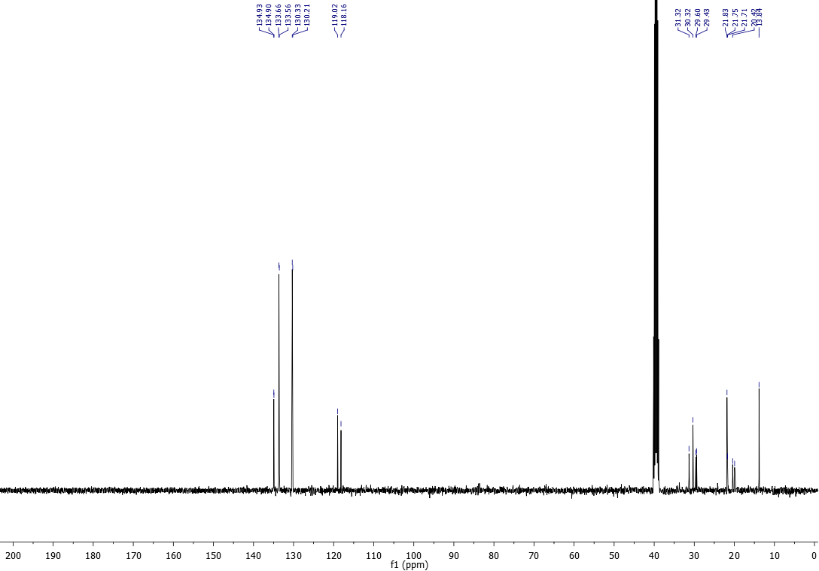

NMR. ¹³C NMR of TPP compound 2.

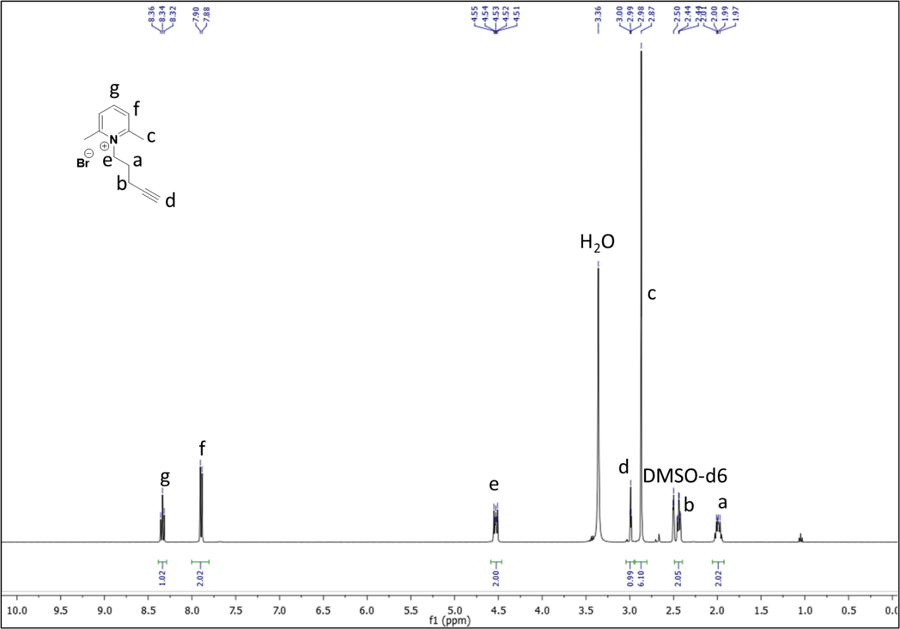
NMR. ¹H NMR of compound 3a.

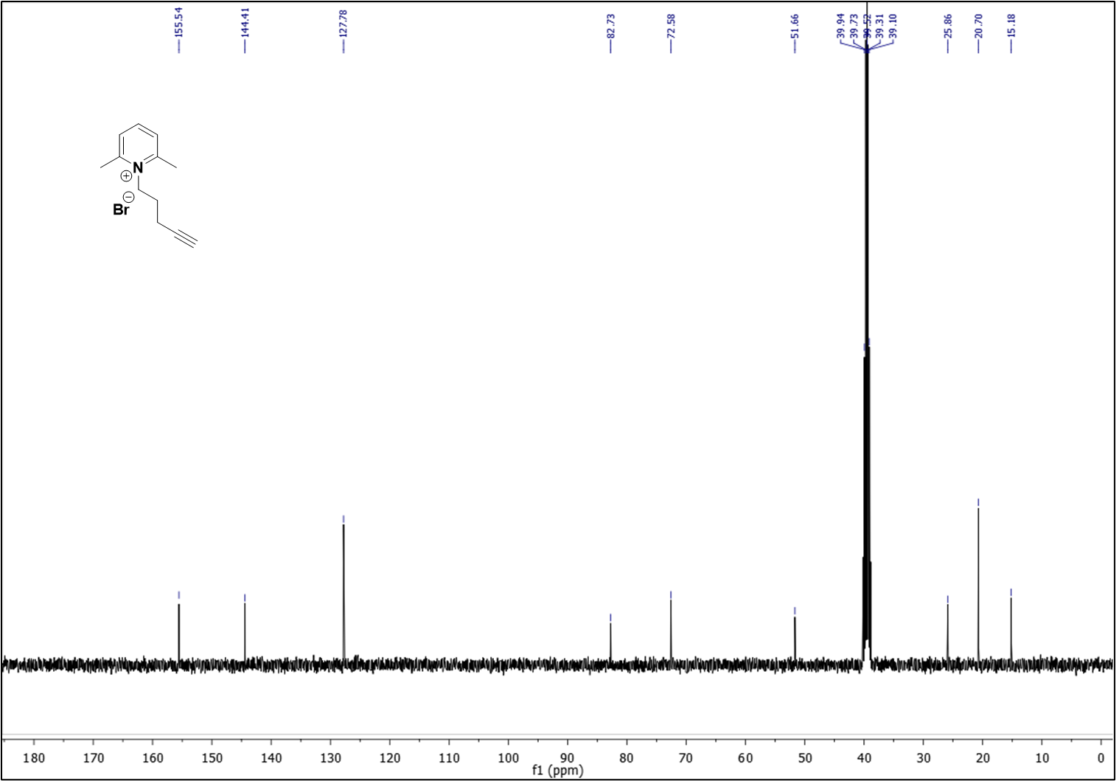
NMR. ¹³C NMR of compound 3a.

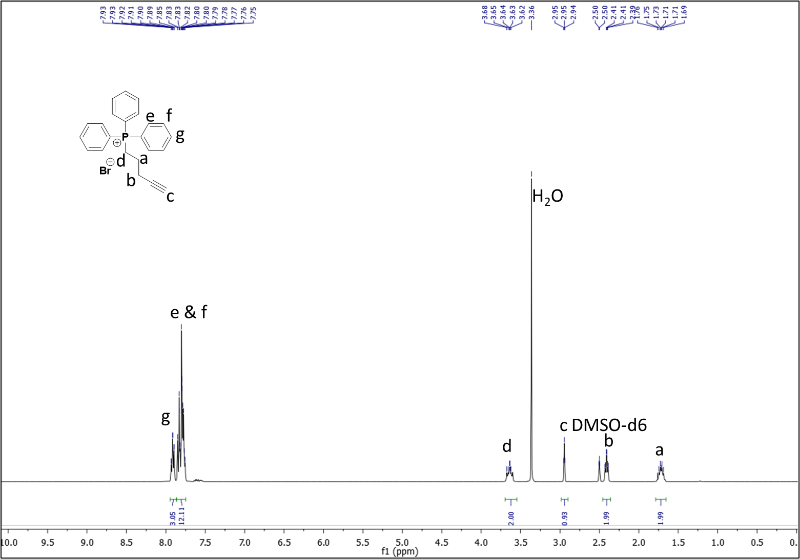
NMR. ¹H NMR of compound 3b.

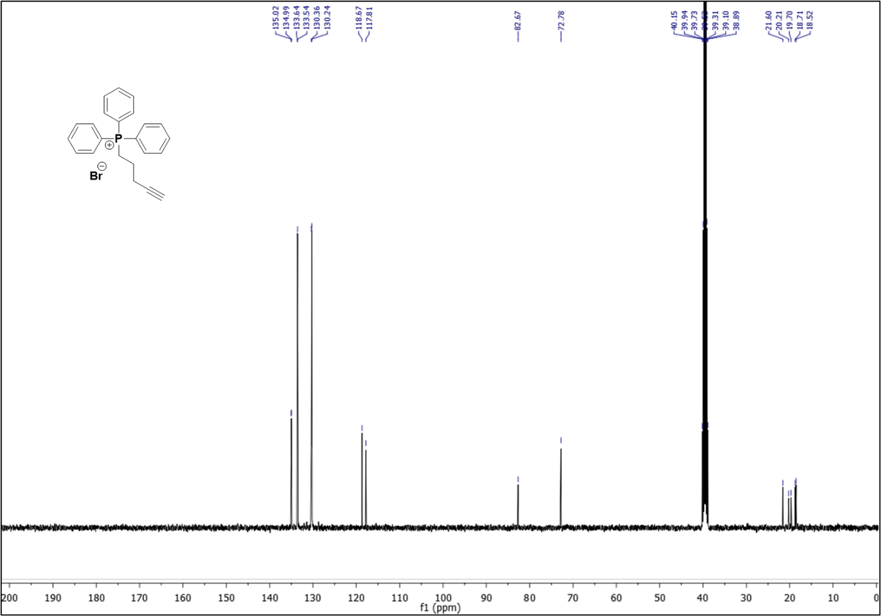
NMR. ¹³C NMR of compound 3b.

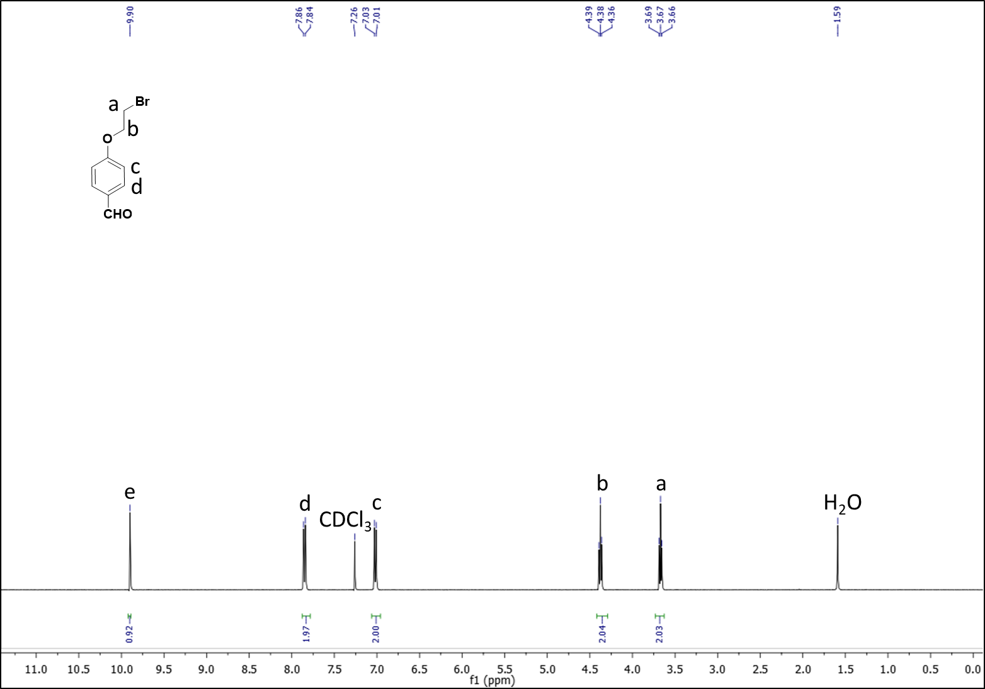
NMR. ¹H NMR of compound 4.

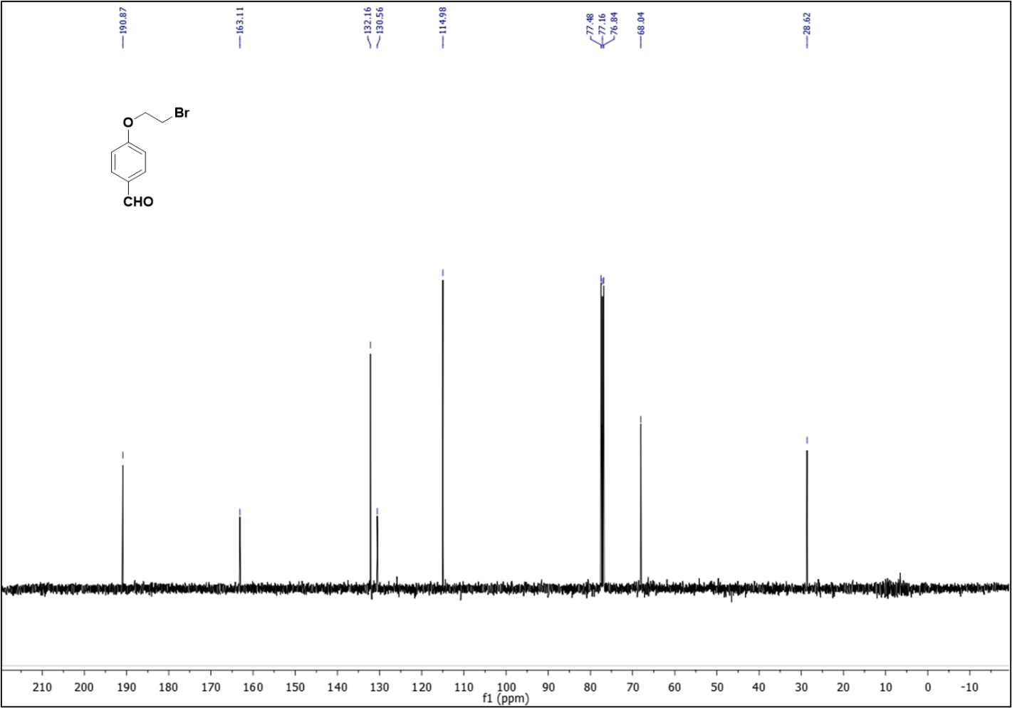 NMR. ¹³C NMR of compound 4.

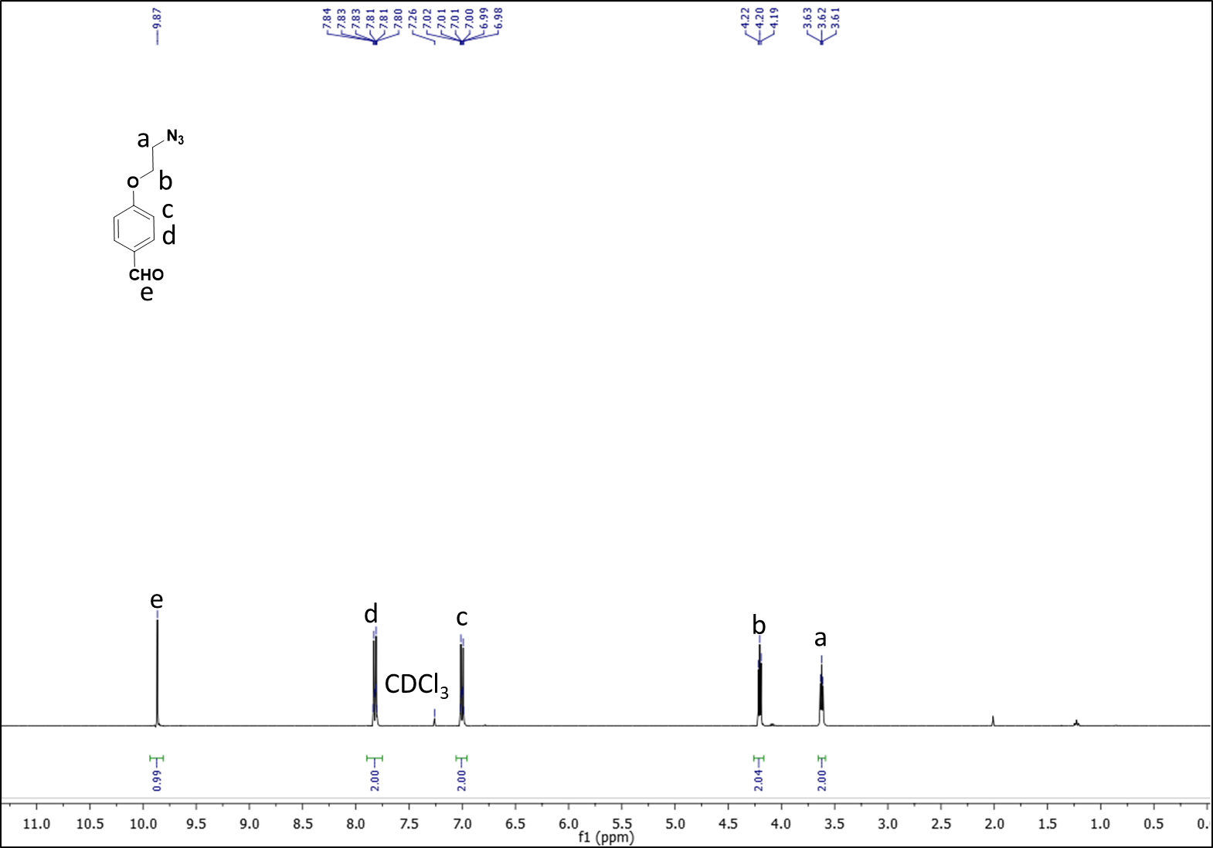
NMR. ¹H NMR of compound 5.

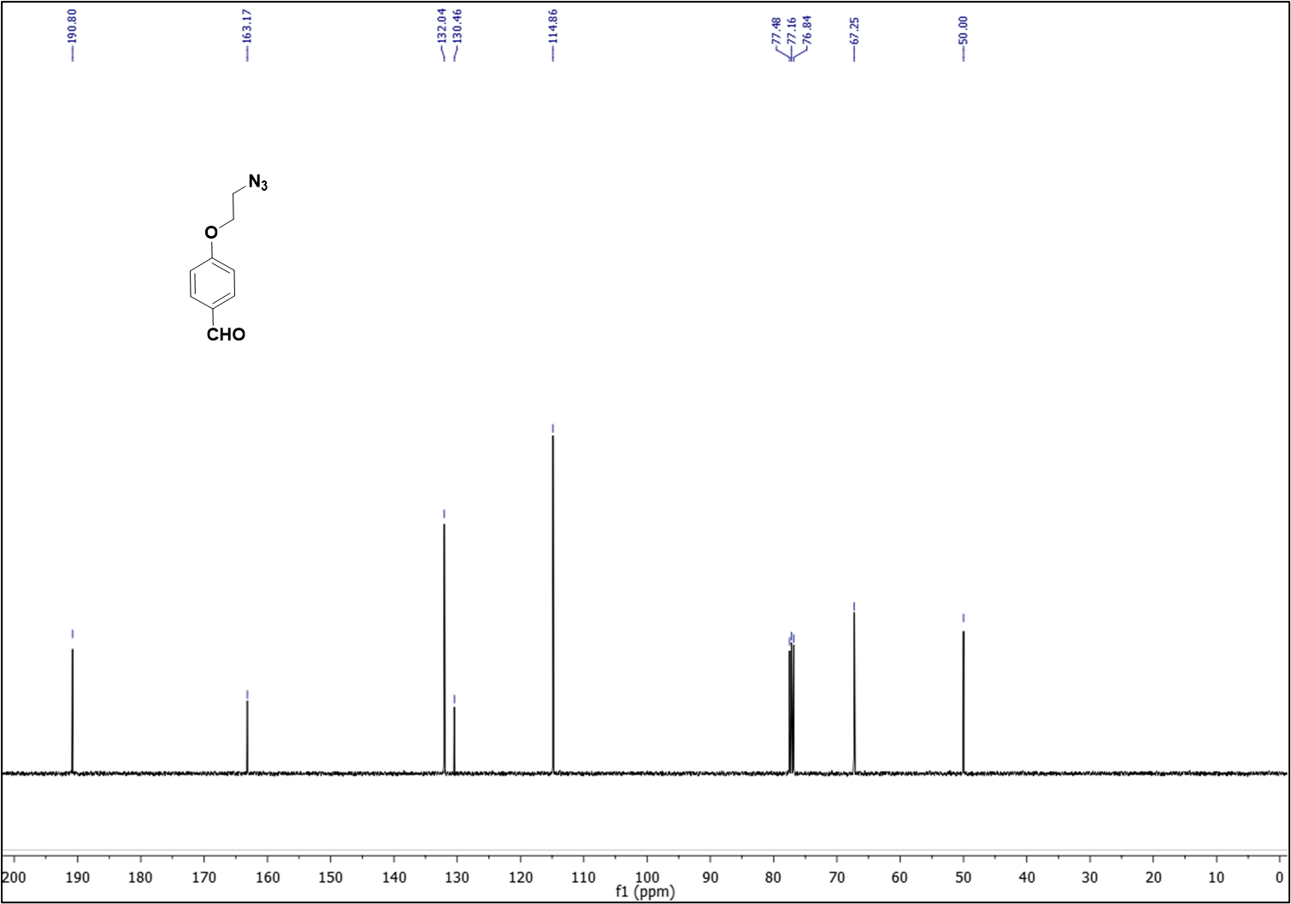
NMR. ¹³C NMR of compound 5.

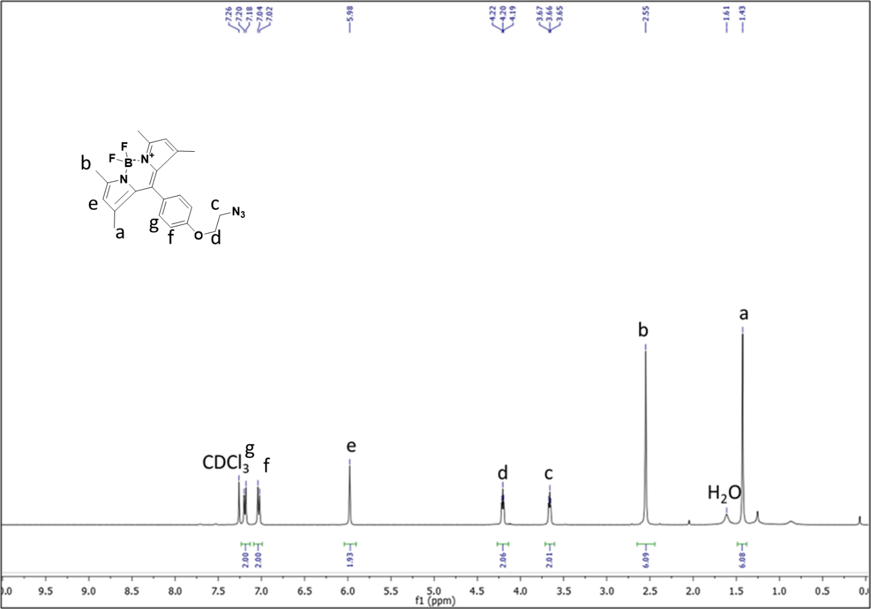
NMR. ¹H NMR of compound 6.

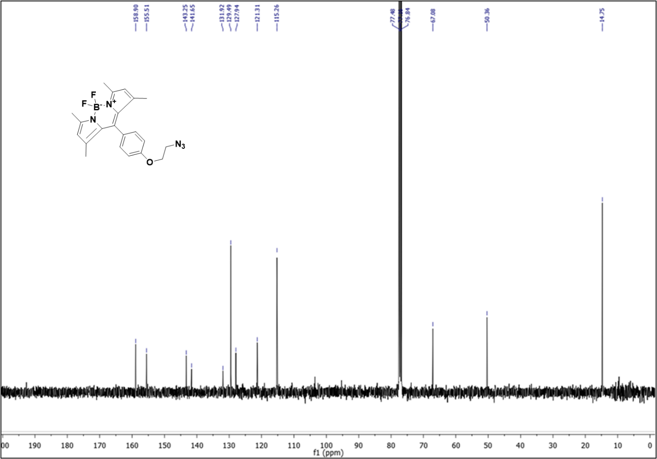
NMR. ¹³C NMR of compound 6.

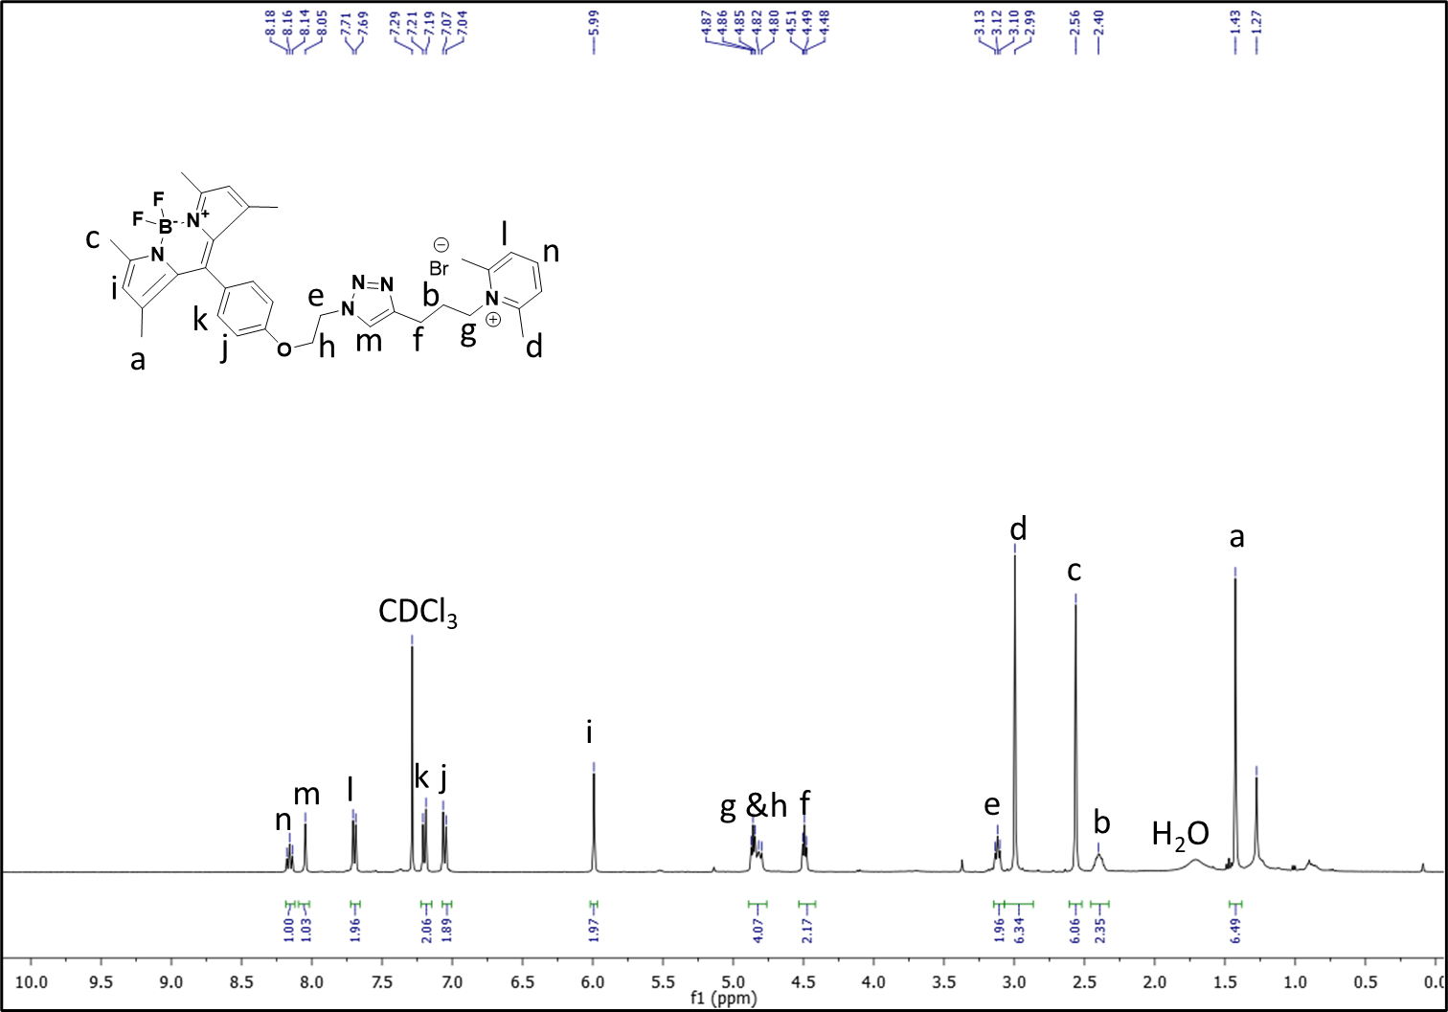
NMR. ¹H NMR of compound BODIPY-Lutidine (7a).

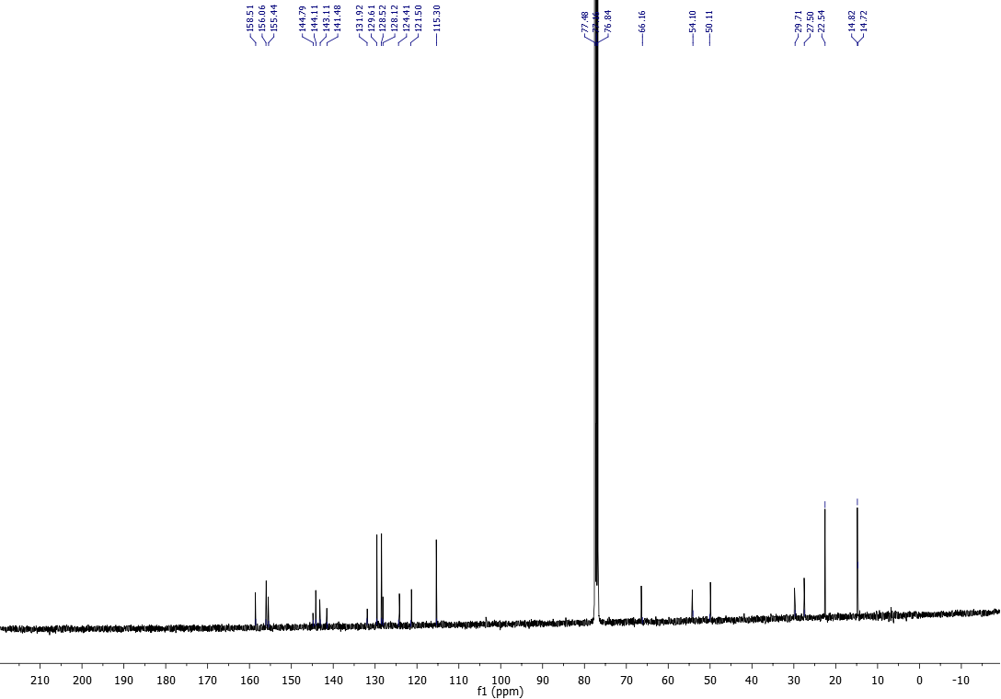

NMR. ¹³C NMR of compound BODIPY-Lutidine (7a).

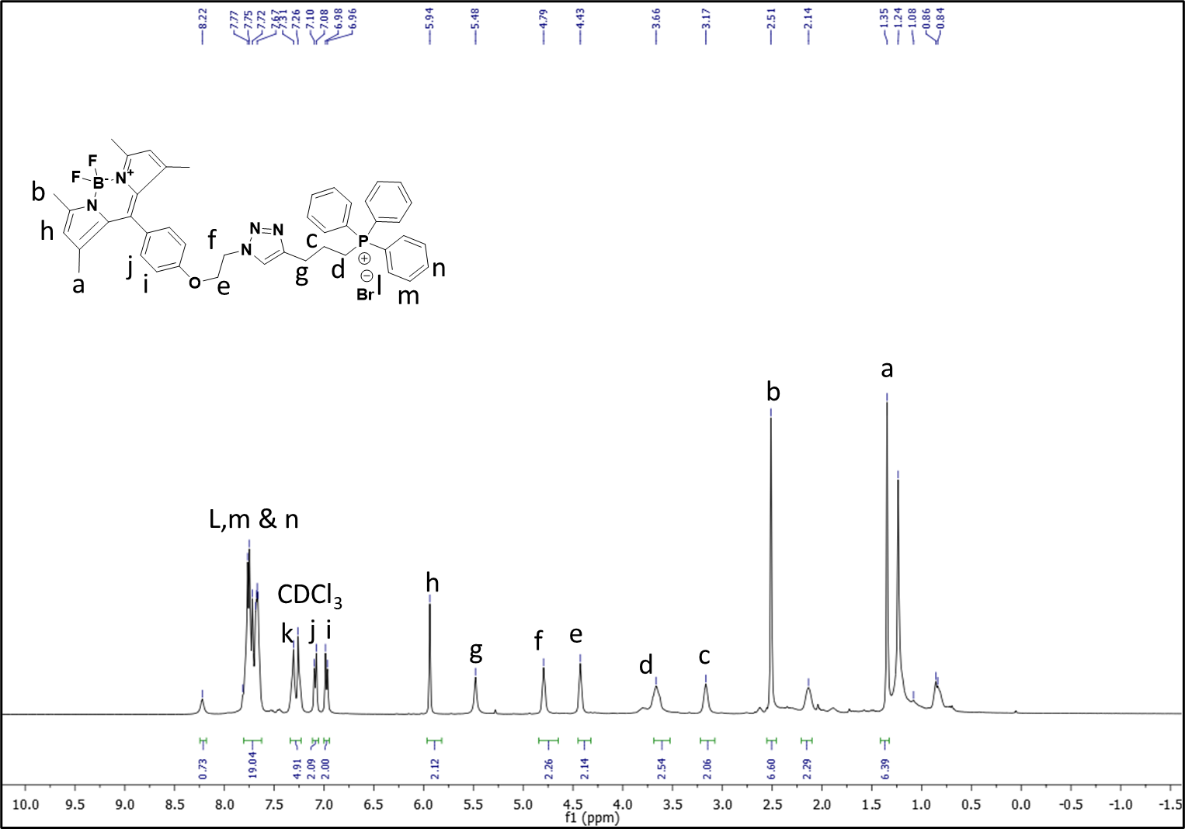

NMR. ¹H NMR of compound BODIPY-TPP (7b).

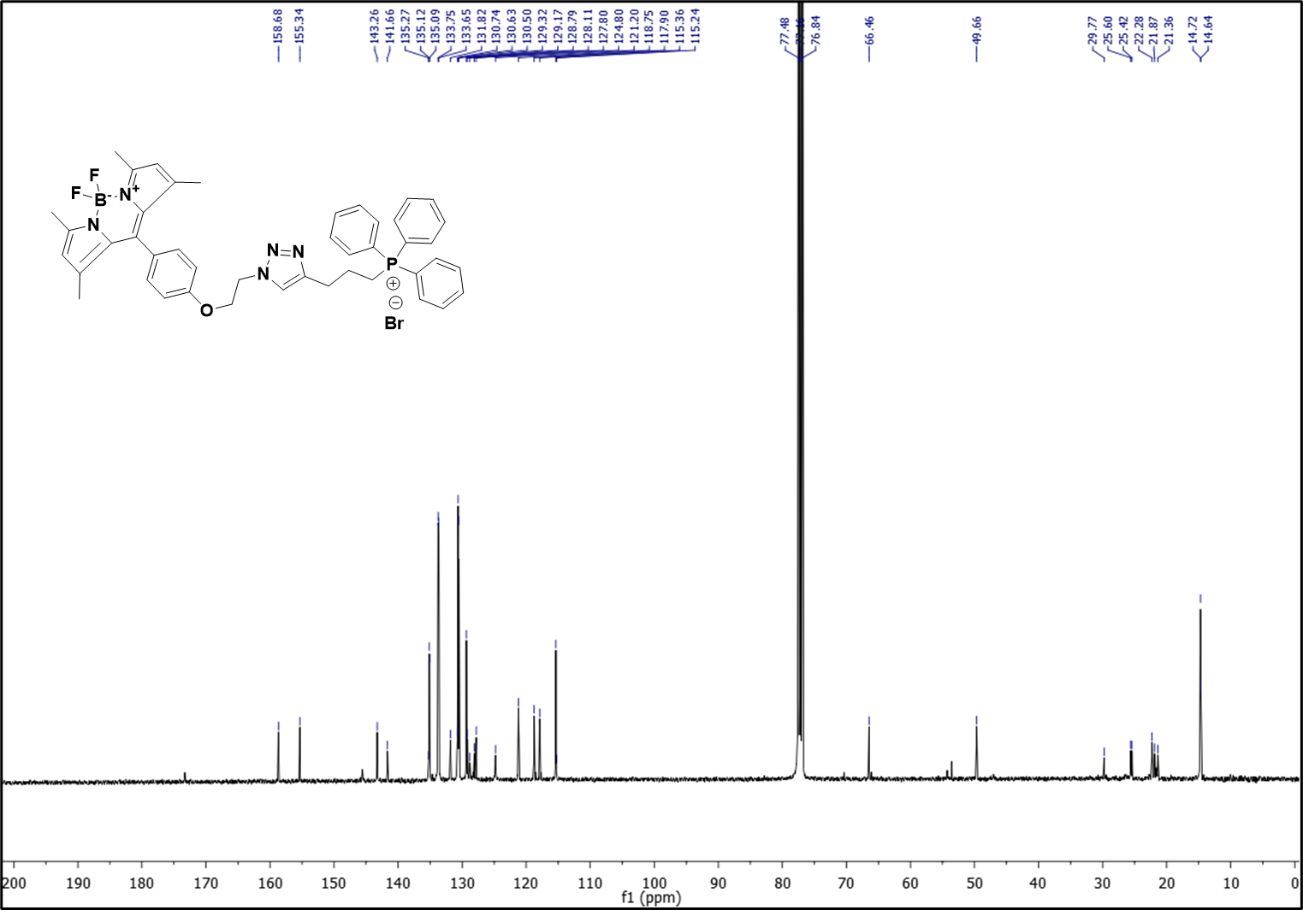
NMR. ¹³C NMR of compound BODIPY-TPP (7b).

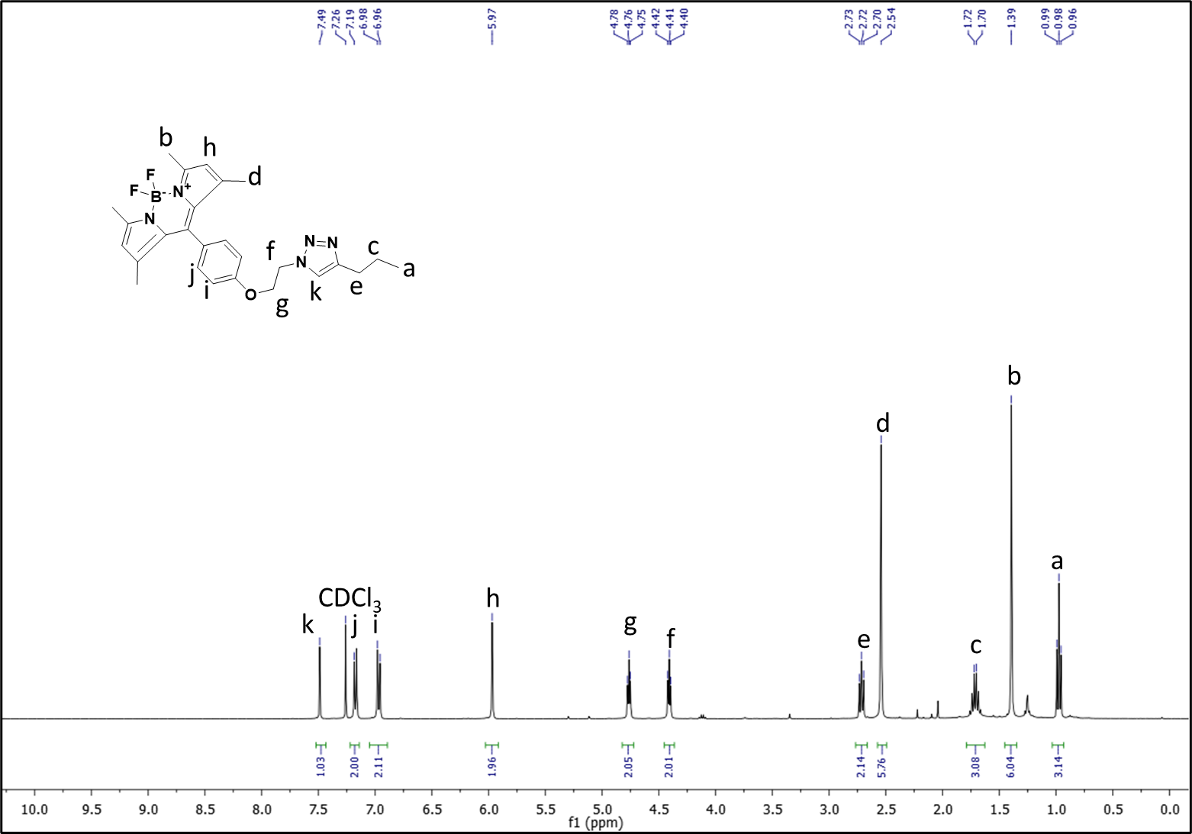
NMR. ¹H NMR of compound BODIPY-Alkyl (7c).

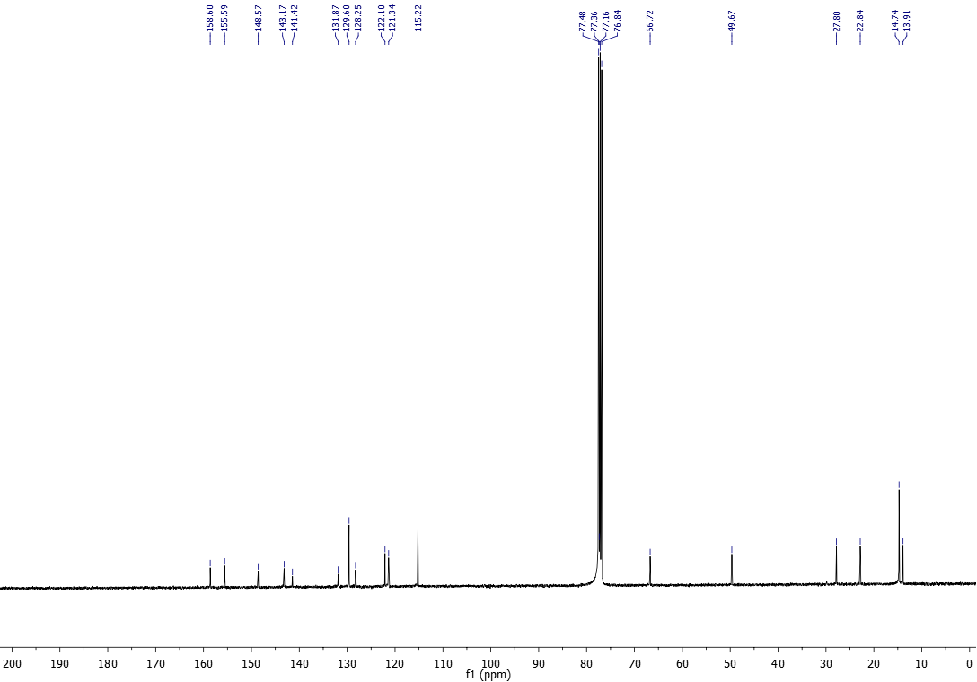

NMR. ¹³C NMR of compound BODIPY-Alkyl(7c).

