Development of radiophotoluminescence dosimeters using radiation chemical reactions of polymer materials containing benzoic acid
*Tomoaki Yashiro¹, Masanori Koshimizu^{2*}
¹ Department of Electronic Material Science, Shizuoka University, 3-5-1 Johoku, Chuo-ku, Hamamatsu 432-8011, Japan
² Research Institute of Electronics, Shizuoka University, 3-5-1 Johoku, Chuo-ku, Hamamatsu, 432-8011, Japan
Corresponding author: koshimizu.masanori@shizuoka.ac.jp

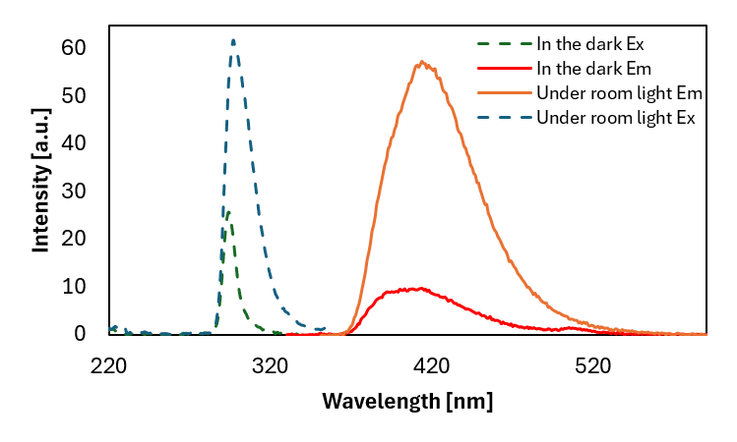
Fig. S1. Photoluminescence excitation and emission spectra of aqueous solutions of benzoic acid stored in the dark or under room lighting for a week. (In the dark: excitation wavelength: 294 nm, emission wavelength: 413 nm. Under room light: excitation wavelength: 297 nm, emission wavelength: 417 nm).
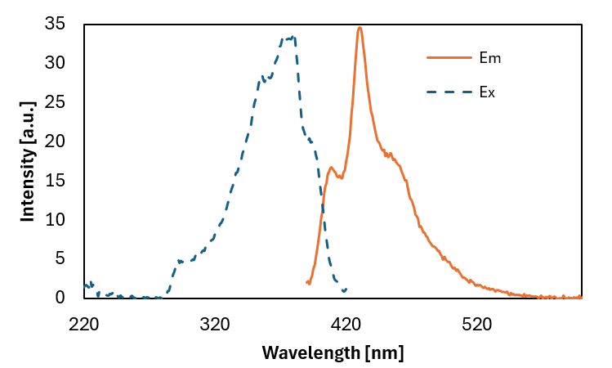
Fig. S2. Photoluminescence excitation and emission spectra of the THF solution of benzoic acid (0.01 g/ml), longer than one day after dissolution. (excitation wavelength: 379 nm, emission wavelength: 430 nm).
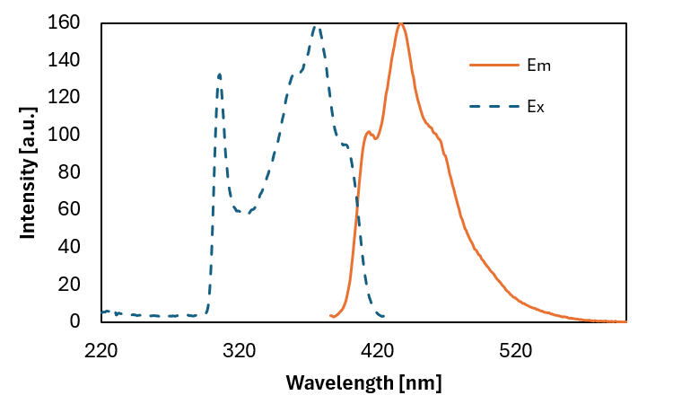
Fig. S3. Photoluminescence excitation and emission spectra of toluene solution of benzoic acid (0.01 g/ml), longer than one day after dissolution. (excitation wavelength: 376 nm, emission wavelength: 437 nm).

