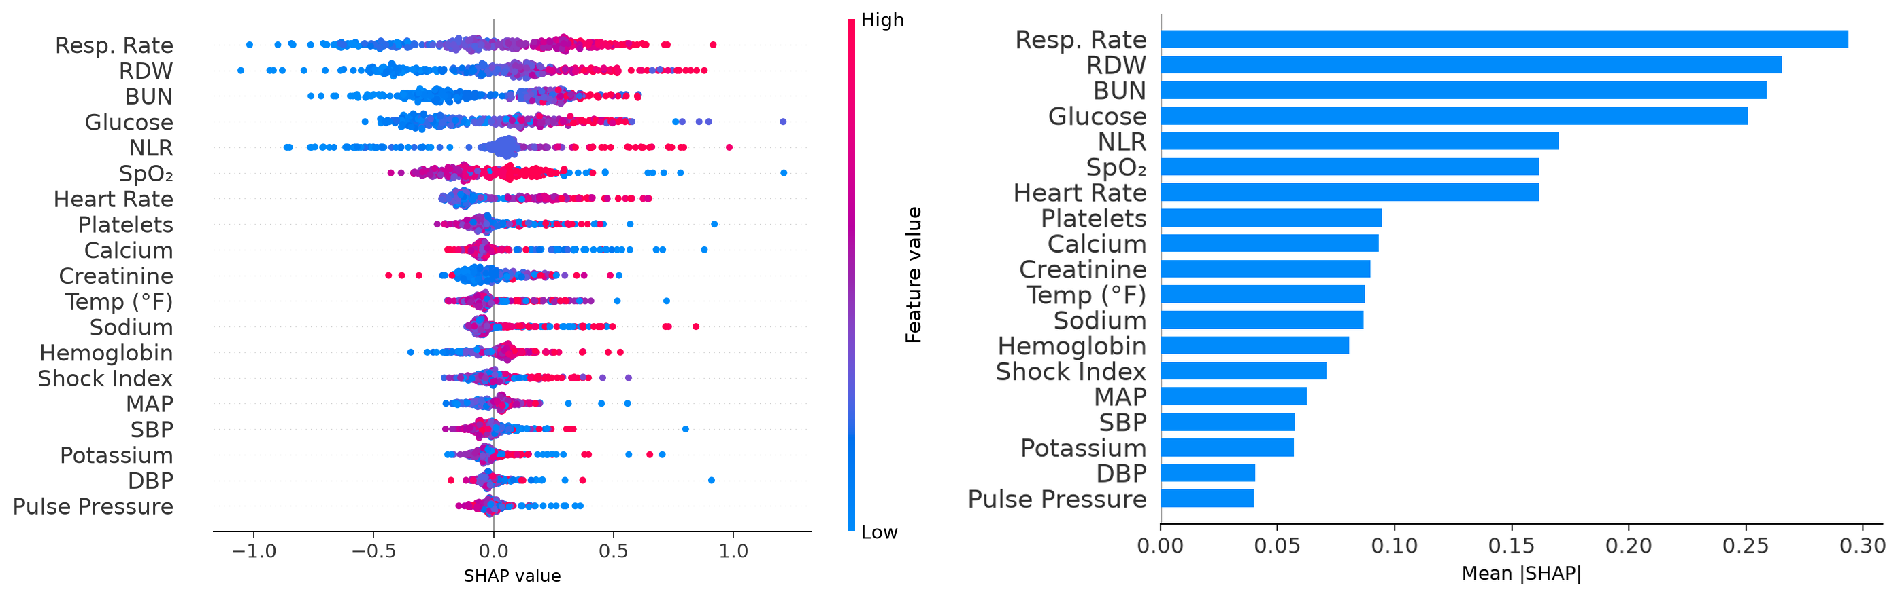
Fig S1 (Supplementary). SHAP analysis for the MIMIC-IV HistGBM model. (A) SHAP beeswarm plot; (B) SHAP bar plot. Features are ranked by mean absolute SHAP value.

