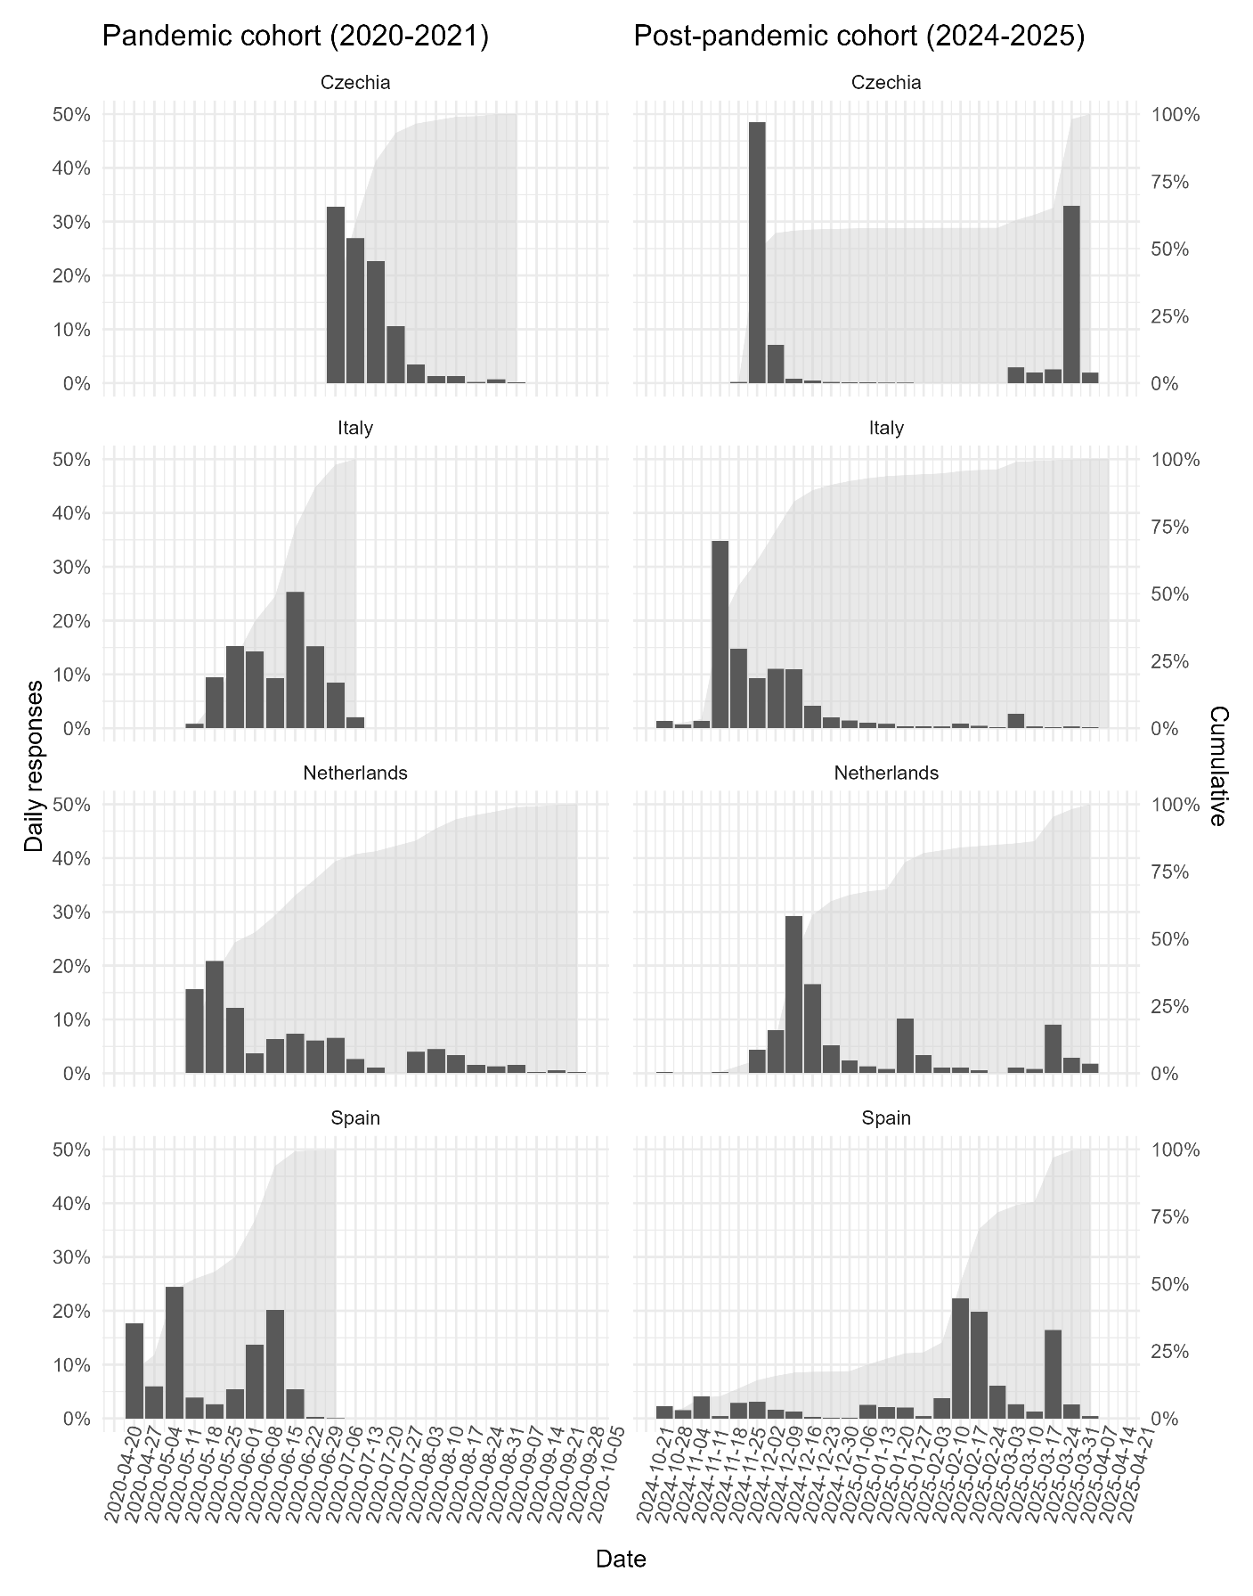
Supplementary Figure S1. Weekly data collection over the recruitment period for each year and country. The columns represent the daily response proportion, and the shadowed area represents the cumulative proportion for that country and year.

Supplementary Table S1. Working conditions item sources, wording, values, and transformations.
Item | Source | Question | Original responses | Dichotomisation
Daily working hours | Ad hoc | HEROES:  During those days, how many hours did you work on average?  MeND:  How many hours do you usually work per week? (Commuting not included) | Free text. | Extended daily working hours are defined as people working more than 8 hours per day.
Angry patients or relatives | Ad hoc; EWCTS 2021 | HEROES:  In the past three months, due to your job, have you experienced any conflictive situations (physical or verbal aggression, accusations of malpractice, etc.) with family members of patients with COVID-19?  MeND:  Does your work involve handling angry patients or angry patients' relatives/friends? | HEROES:  Ordinary scale with subjective frequency responses (e.g., “No, no problems”, “Yes, one problem”, “Yes, some problems”, “Yes, many problems”).  MeND:  Ordinary scale with time dimension responses (e.g., “Never”, “Around ¼ of the time”, “Almost all of the time”). | Recoded to harmonised ordinal scale (“No”, “A few times”, “Sometimes”, “Often”) and subsequently to negative answer if “No” or “A few times” and positive answer if “Sometimes” or “Often”.
Physical violence | Ad hoc; COPSOQ-II | HEROES:  In the past three months, I have experienced violence due to being a health worker during the pandemic.  MeND:  Have you been exposed to physical violence at your workplace during the last 12 months? | HEROES:  Likert scale with agreement level (e.g., “Strongly disagree”, “Agree”).  MeND:  “No”, and an ordinal scale for positive responses in time dimension: “Yes,…”, with one of the following: “…daily”, “…weekly”,  “…monthly”, “…a few times”. | Any positive response, regardless of periodicity or level of agreement was considered as having been exposed to violence.
Colleague support | Ad hoc; COPSOQ-II | HEROES:  I have a reliable network of supportive colleagues at work.  MeND:  How often do you get help and support from your colleagues? | HEROES:  Likert scale with agreement level (e.g., “Strongly disagree”, “Agree”).  MeND:  Ordinary scale with time dimension responses (e.g., “Never/Hardly ever”, “Seldom”, “Often”). | If positive agreement, “Often” or “Always” were reported, the participant was classified as perceiving support.
Note.
COPSOQ-II: Copenhagen Psychosocial Questionnaire – Version II; EWCTS 2021: European Working Conditions Telephone Survey 2021.

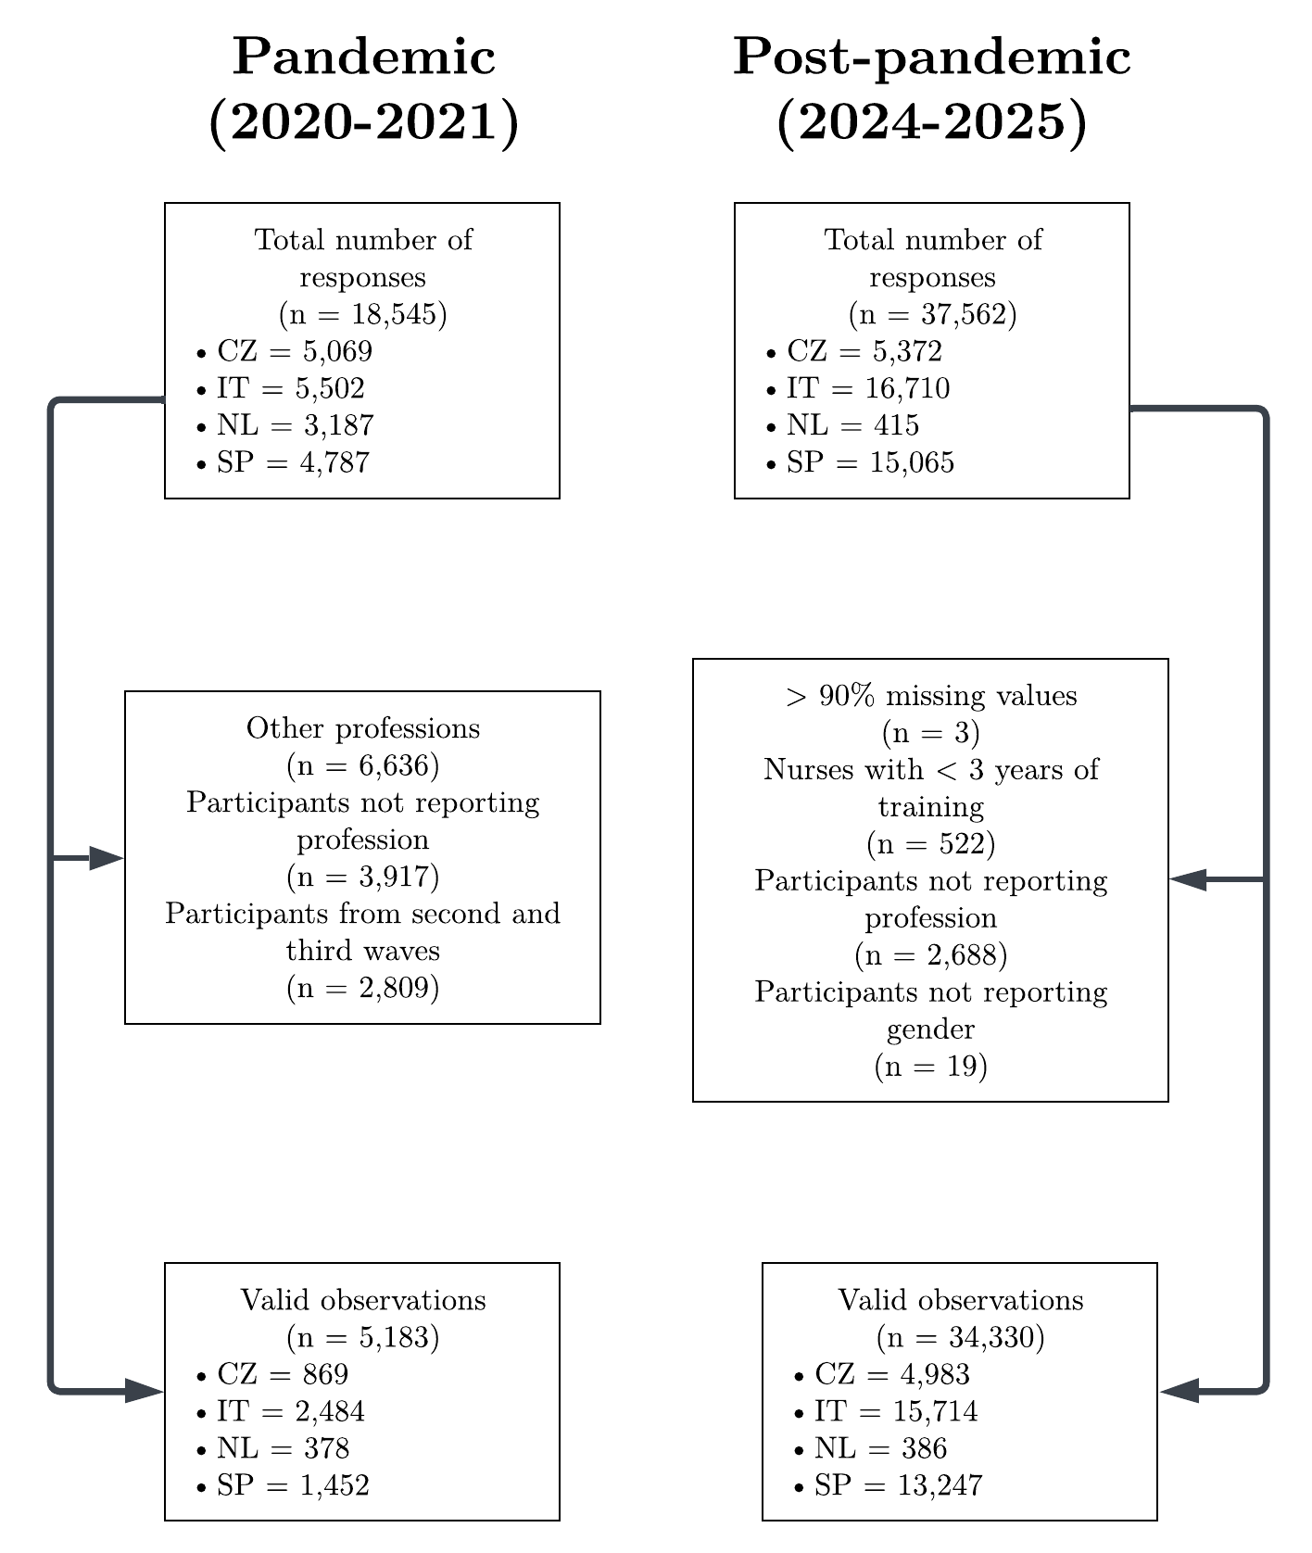
Supplementary Figure S2. Participant flowchart. Exclusion reasons and resulting sample sizes are showed for each stage.

Supplementary Table S2. Sample size and proportions of participants by year, country, and study.
 | Pandemic  (2020-2021) |  |  | Post-pandemic  (2024-2025)
Characteristic | Overall  N = 5 183ª | Doctor  N = 3 242ª | Nurse  N = 1 941ª | Overall  N = 34 330ª | Doctor  N = 13 235ª | Nurse  N = 21 095ª
Country
Czechia | 869 (17%) | 466 (14%) | 403 (21%) | 4 983 (15%) | 4 485 (34%) | 498 (2.4%)
Italy | 2 484 (48%) | 1 834 (57%) | 650 (33%) | 15 714 (46%) | 816 (6.2%) | 14 898 (71%)
Netherlands | 378 (7.3%) | 186 (5.7%) | 192 (9.9%) | 386 (1.1%) | 205 (1.5%) | 181 (0.9%)
Spain | 1 452 (28%) | 756 (23%) | 696 (36%) | 13 247 (39%) | 7 729 (58%) | 5 518 (26%)
ªn (%). Note: Unweighted estimates.

Supplementary Table S3. Sociodemographic characteristics by year and profession, for each country.
 |  | Pandemic (2020-2021) |  |  |  | Post-pandemic (2024-2025)
Group | Characteristic | N | Overallª | Doctorª | Nurseª | N | Overallª | Doctorª | Nurseª
Czechia | Age group | 869 |  |  |  | 4 983
 | ≤ 30 |  | 125 (14%) | 56 (12%) | 69 (17%) |  | 622 (12%) | 482 (11%) | 140 (28%)
 | 31-40 |  | 197 (23%) | 99 (21%) | 98 (24%) |  | 1 014 (20%) | 914 (20%) | 100 (20%)
 | 41-50 |  | 262 (30%) | 126 (27%) | 136 (34%) |  | 1 014 (20%) | 885 (20%) | 129 (26%)
 | 51-60 |  | 197 (23%) | 114 (24%) | 83 (21%) |  | 1 083 (22%) | 986 (22%) | 97 (19%)
 | > 60 |  | 88 (10%) | 71 (15%) | 17 (4.2%) |  | 1 250 (25%) | 1 218 (27%) | 32 (6.4%)
 | Gender (Binary) | 868 |  |  |  | 4 976
 | Female |  | 678 (78%) | 304 (65%) | 374 (93%) |  | 3 439 (69%) | 2 987 (67%) | 452 (91%)
 | Male |  | 190 (22%) | 161 (35%) | 29 (7.2%) |  | 1 537 (31%) | 1 491 (33%) | 46 (9.2%)
 | Missing |  | 1 | 1 | 0 |  | 7 | 7 | 0
 | Children in household | 768 | 380 (49%) | 215 (52%) | 165 (47%) | 4 979 | 2 616 (53%) | 2 384 (53%) | 232 (47%)
 | Missing |  | 101 | 52 | 49 |  | 4 | 3 | 1
 | Health sector | 869 |  |  |  | 4 811
 | Public sector |  | 708 (81%) | 339 (73%) | 369 (92%) |  | 3 445 (72%) | 3 038 (70%) | 407 (86%)
 | Private sector |  | 161 (19%) | 127 (27%) | 34 (8.4%) |  | 1 366 (28%) | 1 298 (30%) | 68 (14%)
 | Missing |  |  |  |  |  | 172 | 149 | 23
Italy | Age group | 2 400 |  |  |  | 15 712
 | ≤ 30 |  | 370 (15%) | 246 (14%) | 124 (20%) |  | 2 034 (13%) | 56 (6.9%) | 1 978 (13%)
 | 31-40 |  | 597 (25%) | 485 (27%) | 112 (18%) |  | 3 221 (21%) | 222 (27%) | 2 999 (20%)
 | 41-50 |  | 499 (21%) | 332 (19%) | 167 (27%) |  | 3 228 (21%) | 138 (17%) | 3 090 (21%)
 | 51-60 |  | 551 (23%) | 348 (20%) | 203 (32%) |  | 5 950 (38%) | 137 (17%) | 5 813 (39%)
 | > 60 |  | 383 (16%) | 362 (20%) | 21 (3.3%) |  | 1 279 (8.1%) | 263 (32%) | 1 016 (6.8%)
 | Missing |  | 84 | 61 | 23 |  | 2 | 0 | 2
 | Gender (Binary) | 2 481 |  |  |  | 15 704
 | Female |  | 1 569 (63%) | 1 045 (57%) | 524 (81%) |  | 12 259 (78%) | 466 (57%) | 11 793 (79%)
 | Male |  | 912 (37%) | 787 (43%) | 125 (19%) |  | 3 445 (22%) | 350 (43%) | 3 095 (21%)
 | Missing |  | 3 | 2 | 1 |  | 10 | 0 | 10
 | Children in household | 2 048 | 737 (36%) | 528 (35%) | 209 (38%) | 15 693 | 9 668 (62%) | 524 (64%) | 9 144 (61%)
 | Missing |  | 436 | 333 | 103 |  | 21 | 2 | 19
 | Health sector | 2 473 |  |  |  | 15 300
 | Public sector |  | 2 210 (89%) | 1 621 (89%) | 589 (91%) |  | 12 583 (82%) | 732 (94%) | 11 851 (82%)
 | Private sector |  | 263 (11%) | 205 (11%) | 58 (9.0%) |  | 2 717 (18%) | 46 (5.9%) | 2 671 (18%)
 | Missing |  | 11 | 8 | 3 |  | 414 | 38 | 376
Netherlands | Age group | 363 |  |  |  | 386
 | ≤ 30 |  | 44 (12%) | 17 (9.3%) | 27 (15%) |  | 41 (11%) | 23 (11%) | 18 (9.9%)
 | 31-40 |  | 136 (37%) | 84 (46%) | 52 (29%) |  | 79 (20%) | 49 (24%) | 30 (17%)
 | 41-50 |  | 90 (25%) | 55 (30%) | 35 (19%) |  | 86 (22%) | 47 (23%) | 39 (22%)
 | 51-60 |  | 62 (17%) | 17 (9.3%) | 45 (25%) |  | 112 (29%) | 40 (20%) | 72 (40%)
 | > 60 |  | 31 (8.5%) | 9 (4.9%) | 22 (12%) |  | 68 (18%) | 46 (22%) | 22 (12%)
 | Missing |  | 15 | 4 | 11
 | Gender (Binary) | 376 |  |  |  | 386
 | Female |  | 295 (78%) | 137 (74%) | 158 (83%) |  | 311 (81%) | 152 (74%) | 159 (88%)
 | Male |  | 81 (22%) | 48 (26%) | 33 (17%) |  | 75 (19%) | 53 (26%) | 22 (12%)
 | Missing |  | 2 | 1 | 1
 | Children in household | 0 | 0 (NA%) | 0 (NA%) | 0 (NA%) | 386 | 211 (55%) | 112 (55%) | 99 (55%)
 | Missing |  | 378 | 186 | 192
 | Health sector | 73 |  |  |  | 368
 | Public sector |  | 65 (89%) | 48 (87%) | 17 (94%) |  | 345 (94%) | 176 (91%) | 169 (97%)
 | Private sector |  | 8 (11%) | 7 (13%) | 1 (5.6%) |  | 23 (6.3%) | 18 (9.3%) | 5 (2.9%)
 | Missing |  | 305 | 131 | 174 |  | 18 | 11 | 7
Spain | Age group | 1 406 |  |  |  | 13 245
 | ≤ 30 |  | 364 (26%) | 190 (26%) | 174 (26%) |  | 1 802 (14%) | 1 054 (14%) | 748 (14%)
 | 31-40 |  | 370 (26%) | 173 (24%) | 197 (29%) |  | 3 284 (25%) | 1 953 (25%) | 1 331 (24%)
 | 41-50 |  | 311 (22%) | 157 (21%) | 154 (23%) |  | 3 436 (26%) | 1 821 (24%) | 1 615 (29%)
 | 51-60 |  | 254 (18%) | 142 (19%) | 112 (17%) |  | 3 092 (23%) | 1 667 (22%) | 1 425 (26%)
 | > 60 |  | 107 (7.6%) | 72 (9.8%) | 35 (5.2%) |  | 1 631 (12%) | 1 233 (16%) | 398 (7.2%)
 | Missing |  | 46 | 22 | 24 |  | 2 | 1 | 1
 | Gender (Binary) | 1 451 |  |  |  | 13 216
 | Female |  | 1 120 (77%) | 534 (71%) | 586 (84%) |  | 9 854 (75%) | 5 201 (67%) | 4 653 (84%)
 | Male |  | 331 (23%) | 222 (29%) | 109 (16%) |  | 3 362 (25%) | 2 508 (33%) | 854 (16%)
 | Missing |  | 1 | 0 | 1 |  | 31 | 20 | 11
 | Children in household | 1 258 | 477 (38%) | 238 (37%) | 239 (39%) | 13 238 | 7 419 (56%) | 4 195 (54%) | 3 224 (58%)
 | Missing |  | 194 | 112 | 82 |  | 9 | 6 | 3
 | Health sector | 1 440 |  |  |  | 12 675
 | Public sector |  | 1 388 (96%) | 726 (97%) | 662 (96%) |  | 12 014 (95%) | 7 025 (95%) | 4 989 (95%)
 | Private sector |  | 52 (3.6%) | 25 (3.3%) | 27 (3.9%) |  | 661 (5.2%) | 391 (5.3%) | 270 (5.1%)
 | Missing |  | 12 | 5 | 7 |  | 572 | 313 | 259
ªn (%)

Supplementary Table S4. Sample sociodemographic characteristics, by year and profession.
 | Pandemic  (2020-2021) |  |  | Post-pandemic  (2024-2025)
Characteristic | Overall  N = 5 183ª | Doctor  N = 3 242ª | Nurse  N = 1 941ª | Overall  N = 34 330ª | Doctor  N = 13 235ª | Nurse  N = 21 095ª
Age group
≤ 30 | 903 (12%) | 509 (8.6%) | 394 (17%) | 4 499 (13%) | 1 615 (11%) | 2 884 (15%)
31-40 | 1 300 (19%) | 841 (19%) | 459 (21%) | 7 598 (23%) | 3 138 (23%) | 4 460 (22%)
41-50 | 1 162 (23%) | 670 (21%) | 492 (25%) | 7 764 (22%) | 2 891 (22%) | 4 873 (22%)
51-60 | 1 064 (25%) | 621 (23%) | 443 (29%) | 10 237 (29%) | 2 830 (22%) | 7 407 (34%)
> 60 | 609 (21%) | 514 (29%) | 95 (8.4%) | 4 228 (13%) | 2 760 (22%) | 1 468 (7.1%)
Gender (Binary)
Female | 3 662 (71%) | 2 020 (62%) | 1 642 (85%) | 25 863 (76%) | 8 806 (68%) | 17 057 (81%)
Male | 1 514 (29%) | 1 218 (38%) | 296 (15%) | 8 419 (24%) | 4 402 (32%) | 4 017 (19%)
Children in household | 1 594 (38%) | 982 (37%) | 613 (38%) | 19 914 (58%) | 7 215 (56%) | 12 699 (59%)
Health sector
Public sector | 4 371 (90%) | 2 734 (87%) | 1 637 (94%) | 28 387 (86%) | 10 971 (86%) | 17 416 (85%)
Private sector | 484 (10%) | 364 (13%) | 120 (6.1%) | 4 767 (14%) | 1 753 (14%) | 3 014 (15%)
ªn (weighted %). Note: Age and gender calibrated estimates.

Supplementary Table S5. Sample size and proportions of participants by year, country and profession.
 | Pandemic  (2020-2021) |  |  | Post-pandemic  (2024-2025)
Characteristic | Overall  N = 5 183ª | Doctor  N = 3 242ª | Nurse  N = 1 941ª | Overall  N = 34 330ª | Doctor  N = 13 235ª | Nurse  N = 21 095ª
Country
Czechia | 869 (17%) | 466 (15%) | 403 (22%) | 4 983 (13%) | 4 485 (32%) | 498 (2.3%)
Italy | 2 484 (48%) | 1 834 (56%) | 650 (33%) | 15 714 (47%) | 816 (6.2%) | 14 898 (71%)
Netherlands | 378 (7.0%) | 186 (5.4%) | 192 (9.6%) | 386 (1.1%) | 205 (1.5%) | 181 (0.8%)
Spain | 1 452 (28%) | 756 (24%) | 696 (36%) | 13 247 (39%) | 7 729 (60%) | 5 518 (26%)
ªn (weighted %). Note: Age and gender calibrated estimates.

Supplementary Table S6. Prevalence rates for probable depression and suicidal thoughts, and mean and standard deviation for depressive symptoms scores, by year and profession.
 | Pandemic (2020-2021) |  |  | Post-pandemic (2024-2025)
Outcome | Overall  N = 5 183ª | Doctor  N = 3 242ª | Nurse  N = 1 941ª | Overall  N = 34 330ª | Doctor  N = 13 235ª | Nurse  N = 21 095ª
Probable depression | 18.3% (17.0-19.7) | 16.7% (15.1-18.3) | 21.1% (19.0-23.4) | 29.0% (28.5-29.5) | 25.3% (24.5-26.1) | 31.2% (30.5-31.9)
Suicidal thoughts | 5.9% (5.1-6.6) | 5.7% (4.8-6.7) | 6.1% (4.9-7.4) | 14.1% (13.7-14.6) | 14.6% (13.9-15.3) | 13.9% (13.4-14.4)
Depression symptoms | 6.2 (5.1) | 5.9 (4.9) | 6.7 (5.6) | 8.0 (5.6) | 7.7 (5.7) | 8.2 (5.5)
ªWeighted Prevalence (95% CI) / Mean (SD). Note: Age and gender calibrated estimates.

Supplementary Table S7. Prevalence rates for probable depression and suicidal thoughts, and mean and standard deviation for depressive symptoms scores, by country and profession.
 |  | Pandemic (2020-2021) |  |  |  | Post-pandemic (2024-2025)
Group | Characteristic | N | Overall¹ | Doctor¹ | Nurse¹ | N | Overall¹ | Doctor¹ | Nurse¹
Czechia | Probable depression | 706 | 88 (12%) | 43 (11%) | 45 (14%) | 4 219 | 1 308 (31%) | 1 133 (30%) | 175 (43%)
 | Missing |  | 163 | 86 | 77 |  | 764 | 673 | 91
 | Suicidal thoughts | 707 | 33 (4.7%) | 17 (4.5%) | 16 (4.9%) | 4 233 | 707 (17%) | 632 (17%) | 75 (18%)
 | Missing |  | 162 | 86 | 76 |  | 750 | 660 | 90
 | Depression symptoms | 706 | 4.6 (4.8) | 4.3 (4.5) | 4.9 (5.1) | 4 219 | 7.6 (5.5) | 7.5 (5.5) | 9.0 (5.5)
 | Missing |  | 163 | 86 | 77 |  | 764 | 673 | 91
Italy | Probable depression | 2 147 | 508 (24%) | 332 (21%) | 176 (31%) | 13 894 | 4 663 (34%) | 167 (25%) | 4 496 (34%)
 | Missing |  | 337 | 252 | 85 |  | 1 820 | 141 | 1 679
 | Suicidal thoughts | 2 148 | 179 (8.3%) | 119 (7.5%) | 60 (11%) | 13 928 | 2 008 (14%) | 96 (14%) | 1 912 (14%)
 | Missing |  | 336 | 251 | 85 |  | 1 786 | 138 | 1 648
 | Depression symptoms | 2 147 | 6.8 (5.1) | 6.4 (4.8) | 7.9 (5.5) | 13 894 | 8.3 (5.4) | 7.2 (5.0) | 8.4 (5.4)
 | Missing |  | 337 | 252 | 85 |  | 1 820 | 141 | 1 679
Netherlands | Probable depression | 265 | 9 (3.4%) | 4 (3.5%) | 5 (3.3%) | 336 | 60 (18%) | 29 (17%) | 31 (19%)
 | Missing |  | 113 | 71 | 42 |  | 50 | 32 | 18
 | Suicidal thoughts | 265 | 10 (3.8%) | 7 (6.1%) | 3 (2.0%) | 337 | 30 (8.9%) | 13 (7.5%) | 17 (10%)
 | Missing |  | 113 | 71 | 42 |  | 49 | 32 | 17
 | Depression symptoms | 265 | 3.07 (3.14) | 3.26 (2.99) | 2.93 (3.26) | 336 | 5.4 (5.1) | 5.0 (5.1) | 5.9 (4.9)
 | Missing |  | 113 | 71 | 42 |  | 50 | 32 | 18
Spain | Probable depression | 1 219 | 232 (19%) | 106 (16%) | 126 (22%) | 11 420 | 2 687 (24%) | 1 606 (24%) | 1 081 (23%)
 | Missing |  | 233 | 113 | 120 |  | 1 827 | 1 059 | 768
 | Suicidal thoughts | 1 223 | 57 (4.7%) | 33 (5.1%) | 24 (4.2%) | 11 449 | 1 529 (13%) | 944 (14%) | 585 (12%)
 | Missing |  | 229 | 110 | 119 |  | 1 798 | 1 046 | 752
 | Depression symptoms | 1 219 | 7.4 (5.3) | 6.9 (5.1) | 8.0 (5.3) | 11 420 | 8 (6) | 8 (6) | 8 (6)
 | Missing |  | 233 | 113 | 120 |  | 1 827 | 1 059 | 768
¹n (%); Mean (SD). Note: Unweighted estimates.

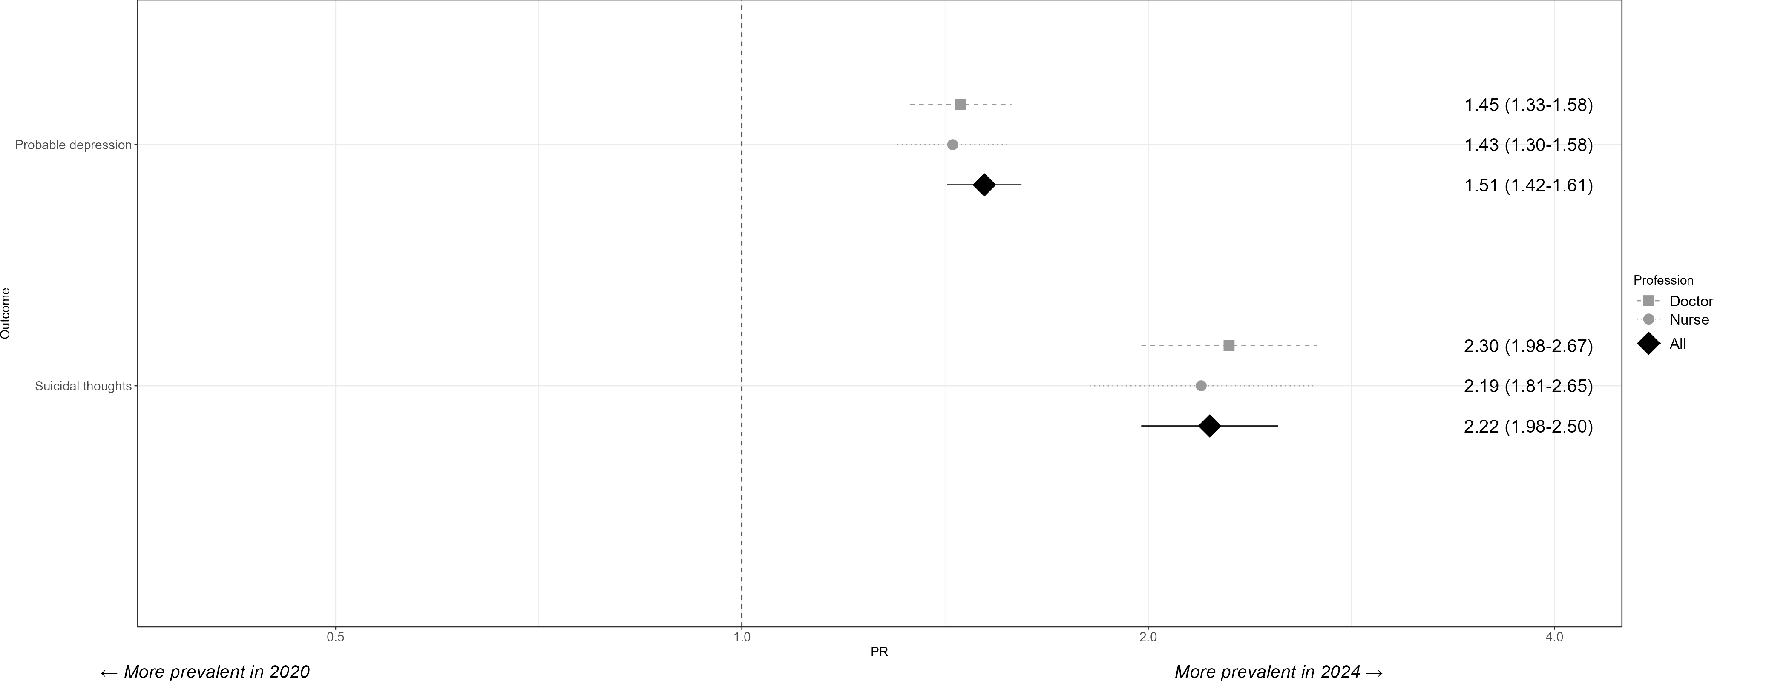
Supplementary Figure S3. Prevalence of depressive symptoms and suicidal thoughts over time. Prevalence Ratios (PRs) and 95 percent confidence intervals obtained from crude modified Poisson regression models. PRs < 1 indicate higher prevalence rates in the pandemic cohort and PRs > 1 indicate higher prevalences in the post-pandemic cohort.

Supplementary Table S8. Reported proportions of exposure to working conditions, by year and profession.
 | Pandemic (2020-2021) |  |  | Post-pandemic (2024-2025)
Exposure | Overall  N = 5 183ª | Doctor  N = 3 242ª | Nurse  N = 1 941ª | Overall  N = 34 330ª | Doctor  N = 13 235ª | Nurse  N = 21 095ª
Extended daily working hours | 33.9% (32.2-35.6) | 39.7% (37.5-42.0) | 23.2% (20.9-25.5) | 25.2% (24.7-25.7) | 34.6% (33.7-35.5) | 19.5% (19.0-20.1)
Angry patients or relatives | 7.9% (7.1-8.8) | 7.7% (6.6-8.9) | 8.4% (7.0-9.9) | 47.8% (47.2-48.3) | 38.5% (37.6-39.4) | 53.2% (52.5-53.9)
Physical violence | 6.6% (5.4-8.0) | 4.8% (4.0-5.7) | 9.8% (7.0-13.2) | 2.5% (2.4-2.7) | 1.8% (1.5-2.0) | 3.0% (2.7-3.3)
Colleague support | 84.7% (83.4-85.9) | 84.4% (82.6-86.0) | 85.2% (83.3-87.1) | 89.5% (89.2-89.9) | 88.7% (88.0-89.3) | 90.1% (89.6-90.5)
ªWeighted Prevalence (95% CI). Note: Age and gender calibrated estimates.

Supplementary Table S9. Reported proportions of exposure to working conditions, by year, country, and profession.
 |  | Pandemic (2020-2021) |  |  |  | Post-pandemic (2024-2025)
Group | Characteristic | N | Overall¹ | Doctor¹ | Nurse¹ | N | Overall¹ | Doctor¹ | Nurse¹
Czechia | Extended daily working hours | 822 | 490 (60%) | 210 (48%) | 280 (72%) | 4 345 | 1 612 (37%) | 1 282 (33%) | 330 (75%)
 | Missing |  | 47 | 33 | 14 |  | 638 | 578 | 60
 | Angry patients or relatives | 819 | 104 (13%) | 56 (13%) | 48 (13%) | 4 470 | 1 183 (26%) | 944 (23%) | 239 (54%)
 | Missing |  | 50 | 23 | 27 |  | 513 | 461 | 52
 | Physical violence | 818 | 35 (4.3%) | 14 (3.2%) | 21 (5.6%) | 4 384 | 69 (1.6%) | 38 (1.0%) | 31 (7.1%)
 | Missing |  | 51 | 24 | 27 |  | 599 | 538 | 61
 | Colleague support | 688 | 609 (89%) | 330 (89%) | 279 (88%) | 4 552 | 3 810 (84%) | 3 396 (83%) | 414 (91%)
 | Missing |  | 181 | 96 | 85 |  | 431 | 388 | 43
Italy | Extended daily working hours | 2 376 | 810 (34%) | 731 (42%) | 79 (13%) | 14 103 | 2 418 (17%) | 321 (45%) | 2 097 (16%)
 | Missing |  | 108 | 77 | 31 |  | 1 611 | 96 | 1 515
 | Angry patients or relatives | 2 376 | 175 (7.4%) | 137 (7.8%) | 38 (6.1%) | 14 520 | 7 676 (53%) | 368 (51%) | 7 308 (53%)
 | Missing |  | 108 | 85 | 23 |  | 1 194 | 98 | 1 096
 | Physical violence | 2 377 | 163 (6.9%) | 98 (5.6%) | 65 (10%) | 14 326 | 304 (2.1%) | 8 (1.1%) | 296 (2.2%)
 | Missing |  | 107 | 85 | 22 |  | 1 388 | 115 | 1 273
 | Colleague support | 2 107 | 1 696 (80%) | 1 247 (80%) | 449 (81%) | 14 612 | 12 841 (88%) | 580 (80%) | 12 261 (88%)
 | Missing |  | 377 | 281 | 96 |  | 1 102 | 89 | 1 013
Netherlands | Extended daily working hours | 359 | 181 (50%) | 133 (75%) | 48 (26%) | 356 | 170 (48%) | 129 (69%) | 41 (24%)
 | Missing |  | 19 | 9 | 10 |  | 30 | 19 | 11
 | Angry patients or relatives | 365 | 88 (24%) | 33 (18%) | 55 (30%) | 350 | 60 (17%) | 26 (14%) | 34 (20%)
 | Missing |  | 13 | 6 | 7 |  | 36 | 22 | 14
 | Physical violence | 366 | 30 (8.2%) | 8 (4.4%) | 22 (12%) | 342 | 8 (2.3%) | 1 (0.6%) | 7 (4.2%)
 | Missing |  | 12 | 6 | 6 |  | 44 | 29 | 15
 | Colleague support | 326 | 291 (89%) | 149 (90%) | 142 (88%) | 353 | 336 (95%) | 177 (96%) | 159 (95%)
 | Missing |  | 52 | 21 | 31 |  | 33 | 20 | 13
Spain | Extended daily working hours | 1 386 | 495 (36%) | 276 (38%) | 219 (33%) | 11 897 | 3 631 (31%) | 2 416 (35%) | 1 215 (25%)
 | Missing |  | 66 | 31 | 35 |  | 1 350 | 763 | 587
 | Angry patients or relatives | 1 381 | 48 (3.5%) | 27 (3.7%) | 21 (3.2%) | 12 004 | 5 968 (50%) | 3 268 (47%) | 2 700 (54%)
 | Missing |  | 71 | 27 | 44 |  | 1 243 | 724 | 519
 | Physical violence | 1 382 | 98 (7.1%) | 47 (6.4%) | 51 (7.8%) | 11 803 | 391 (3.3%) | 167 (2.4%) | 224 (4.5%)
 | Missing |  | 70 | 27 | 43 |  | 1 444 | 850 | 594
 | Colleague support | 1 220 | 1 076 (88%) | 576 (90%) | 500 (87%) | 12 103 | 11 279 (93%) | 6 516 (92%) | 4 763 (95%)
 | Missing |  | 232 | 114 | 118 |  | 1 144 | 665 | 479
¹n (%)

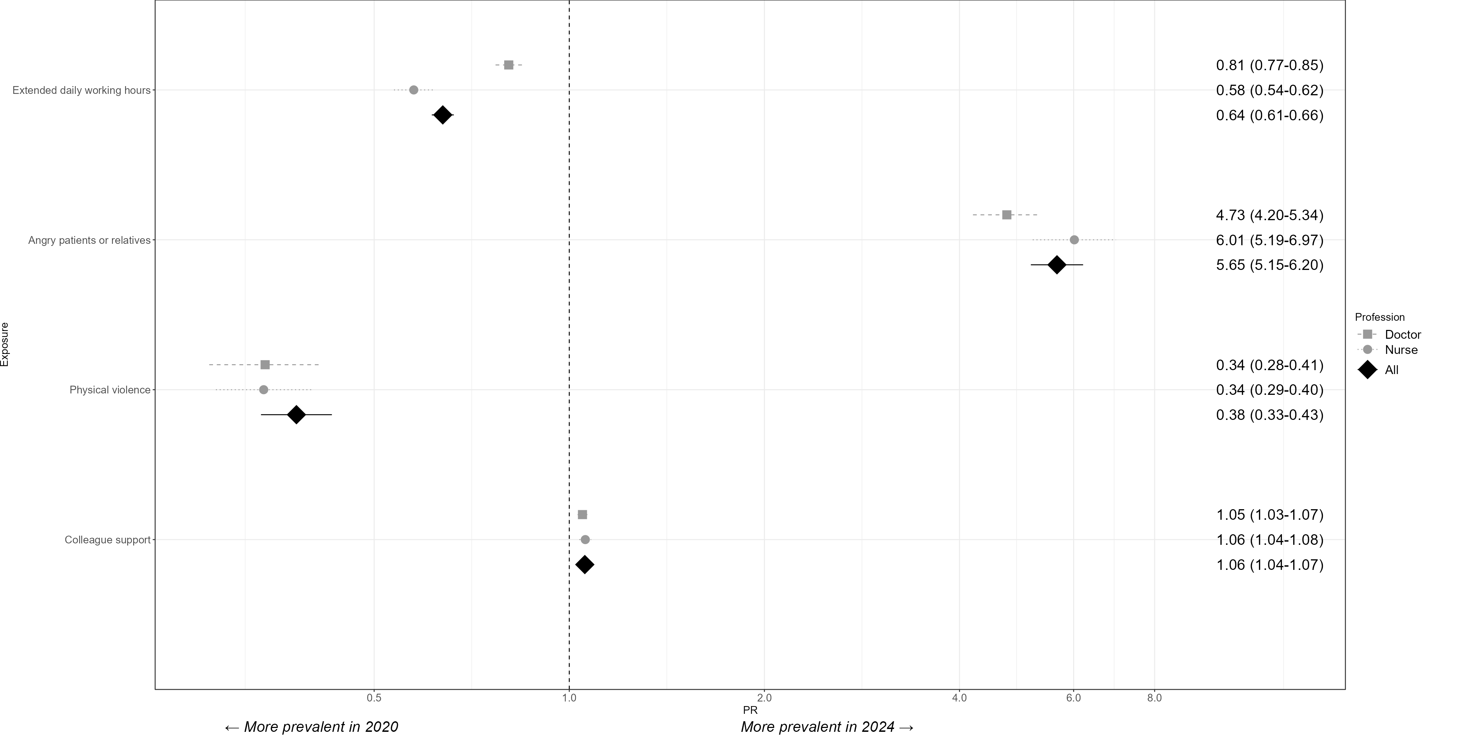
Supplementary Figure S4. Prevalence of reported working conditions over time. Prevalence Ratios (PRs) and 95 percent confidence intervals obtained from crude modified Poisson regression models. PRs < 1 indicate higher prevalence rates in the pandemic cohort and PRs > 1 indicate higher prevalence rates in the post-pandemic cohort.
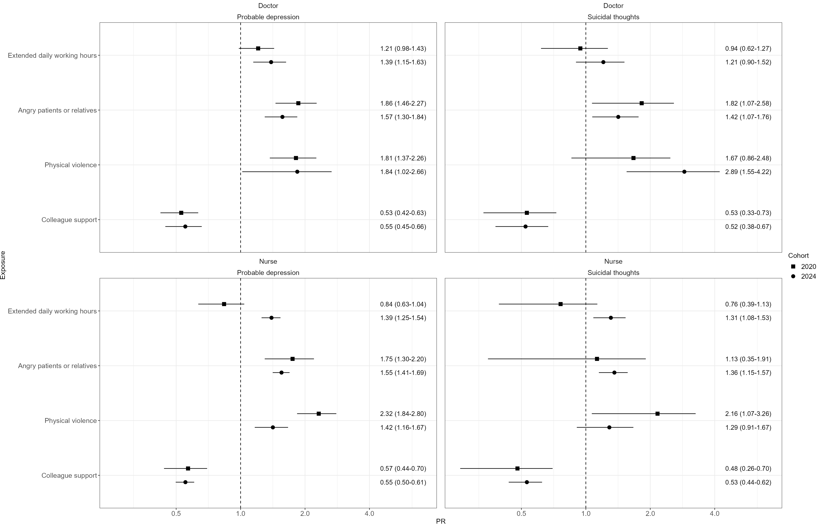
Supplementary Figure S5. Associations between working conditions and depressive symptoms and suicidal thoughts, by profession. Prevalence Ratio (PR) estimates and their 95 percent confidence intervals for each profession from exposure-outcome association models, stratified by year. Models were adjusted for country (fixed effects), age group, gender, profession, presence of children in the household, and healthcare sector for daily working hours and colleague support, and for country (fixed effects), age group, gender, profession, and healthcare sector for angry patients or relatives and physical violence.
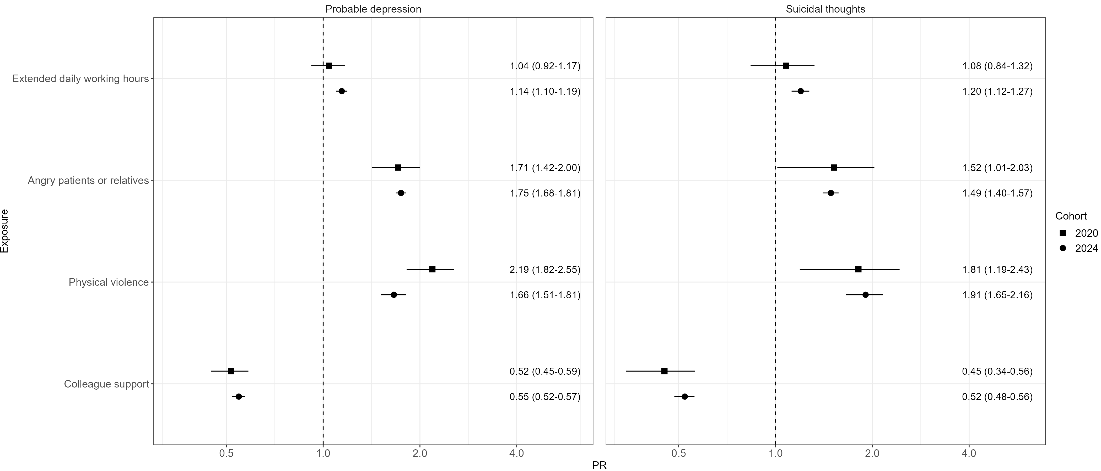
Supplementary Figure S6. Associations between working conditions and depressive symptoms and suicidal thoughts. Prevalence Ratio (PR) estimates and their 95 percent confidence intervals for both professions from exposure-outcome crude association models, stratified by year.
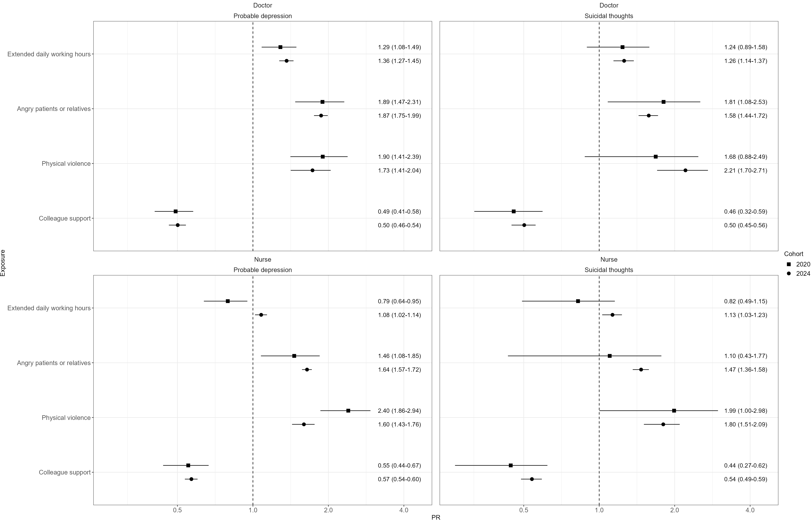
Supplementary Figure S7. Associations between working conditions and depressive symptoms and suicidal thoughts, by profession. Prevalence Ratio (PR) estimates and their 95 percent confidence intervals for each profession from exposure-outcome crude association models, stratified by year.

Supplementary Table S10. Adjusted estimated marginal means (EMMs) and 95 percent confidence intervals for mental health outcomes across levels of working conditions from categorical dose-response models.
 | Pandemic (2020-2021) |  |  |  | Post-pandemic (2024-2025)
 | PHQ-9 score |  | PHQ-9 suicidality item score |  | PHQ-9 score |  | PHQ-9 suicidality item score
 | Crude | Adjusted | Crude | Adjusted | Crude | Adjusted | Crude | Adjusted
Daily working hours
0 | 5.75 (0.74, 10.76) | 6.02 (5.16, 6.89) | 0.25 (-0.09, 0.59) | 0.17 (-0.14, 0.49) | 6.00 (-0.34, 12.34) | 4.83 (1.93, 7.74) | 0.33 (-0.24, 0.91) | 0.20 (-0.18, 0.57)
1 | 2.00 (-3.01, 7.01) | 10.03 (9.38, 10.68) | 0.25 (-0.09, 0.59) | 1.04 (0.99, 1.08) | 6.64 (5.09, 8.19) | 6.34 (4.25, 8.42) | 0.18 (0.04, 0.32) | 0.12 (0.01, 0.24)
2 | 6.00 (2.21, 9.79) | 6.24 (2.32, 10.16) | -0.00 (-0.26, 0.26) | 0.02 (-0.03, 0.08) | 5.71 (4.14, 7.28) | 5.53 (4.11, 6.95) | 0.10 (-0.04, 0.24) | 0.05 (-0.01, 0.12)
3 | 6.70 (4.46, 8.94) | 6.62 (3.80, 9.45) | 0.05 (-0.10, 0.20) | 0.05 (-0.06, 0.17) | 5.57 (4.35, 6.80) | 4.96 (4.05, 5.87) | 0.09 (-0.02, 0.20) | 0.09 (0.01, 0.18)
4 | 5.22 (3.73, 6.72) | 4.96 (3.48, 6.44) | 0.09 (-0.01, 0.19) | 0.09 (-0.01, 0.19) | 5.86 (5.11, 6.60) | 5.45 (4.80, 6.10) | 0.09 (0.02, 0.15) | 0.07 (0.02, 0.13)
5 | 5.49 (4.32, 6.65) | 5.04 (3.88, 6.19) | 0.15 (0.07, 0.23) | 0.15 (0.04, 0.26) | 6.47 (5.89, 7.05) | 5.75 (5.13, 6.36) | 0.19 (0.14, 0.24) | 0.22 (0.14, 0.30)
6 | 6.35 (5.69, 7.00) | 5.51 (4.77, 6.25) | 0.10 (0.06, 0.15) | 0.08 (0.03, 0.14) | 7.57 (7.36, 7.78) | 6.18 (5.89, 6.47) | 0.17 (0.15, 0.19) | 0.16 (0.13, 0.18)
7 | 6.73 (6.40, 7.07) | 5.47 (5.00, 5.94) | 0.08 (0.05, 0.10) | 0.07 (0.04, 0.10) | 7.82 (7.71, 7.94) | 6.48 (6.24, 6.72) | 0.17 (0.16, 0.18) | 0.16 (0.14, 0.18)
8 | 6.09 (5.80, 6.38) | 5.71 (5.30, 6.12) | 0.07 (0.05, 0.09) | 0.07 (0.03, 0.10) | 8.13 (8.02, 8.25) | 6.86 (6.64, 7.08) | 0.18 (0.17, 0.19) | 0.16 (0.14, 0.18)
9 | 6.46 (5.98, 6.94) | 6.55 (5.91, 7.19) | 0.08 (0.05, 0.11) | 0.07 (0.03, 0.12) | 8.23 (8.00, 8.46) | 7.21 (6.92, 7.50) | 0.20 (0.17, 0.22) | 0.18 (0.16, 0.21)
10 | 7.03 (6.57, 7.49) | 6.52 (5.91, 7.13) | 0.10 (0.07, 0.13) | 0.09 (0.04, 0.13) | 8.77 (8.53, 9.01) | 7.69 (7.39, 8.00) | 0.23 (0.21, 0.25) | 0.21 (0.19, 0.24)
11 | 6.14 (5.02, 7.26) | 5.76 (4.67, 6.86) | 0.06 (-0.01, 0.14) | 0.04 (-0.02, 0.09) | 8.38 (7.72, 9.04) | 7.45 (6.71, 8.19) | 0.17 (0.11, 0.23) | 0.16 (0.10, 0.22)
12 | 6.12 (5.67, 6.57) | 5.60 (5.05, 6.16) | 0.09 (0.06, 0.12) | 0.07 (0.02, 0.12) | 8.61 (8.36, 8.86) | 6.73 (6.38, 7.08) | 0.21 (0.19, 0.24) | 0.17 (0.14, 0.20)
13 | 6.26 (4.33, 8.19) | 6.35 (3.92, 8.78) | 0.04 (-0.09, 0.17) | -0.00 (-0.03, 0.03) | 9.50 (8.32, 10.68) | 7.26 (5.80, 8.73) | 0.29 (0.18, 0.40) | 0.23 (0.09, 0.38)
14 | 6.78 (5.01, 8.55) | 5.64 (4.31, 6.96) | 0.06 (-0.06, 0.18) | 0.04 (-0.03, 0.10) | 10.16 (9.13, 11.18) | 8.75 (7.36, 10.14) | 0.35 (0.26, 0.44) | 0.26 (0.13, 0.40)
15 | 11.83 (7.74, 15.93) | 7.61 (3.66, 11.57) | -0.00 (-0.28, 0.28) | 0.02 (-0.02, 0.06) | 9.89 (8.38, 11.40) | 9.94 (5.95, 13.93) | 0.37 (0.24, 0.51) | 0.49 (0.09, 0.90)
16 | 5.25 (2.36, 8.14) | 5.88 (2.70, 9.06) | 0.50 (0.30, 0.70) | 0.45 (-0.19, 1.08) | 10.42 (8.69, 12.16) | 10.05 (7.74, 12.36) | 0.48 (0.32, 0.63) | 0.42 (0.08, 0.75)
17 | 7.00 (3.83, 10.17) | 3.47 (0.57, 6.37) | 0.10 (-0.11, 0.31) | 0.14 (-0.09, 0.38) | 9.32 (7.53, 11.10) | 8.56 (6.55, 10.57) | 0.18 (0.02, 0.35) | 0.15 (-0.02, 0.31)
18 | 7.63 (4.08, 11.17) | 7.26 (4.33, 10.18) | -0.00 (-0.24, 0.24) | -0.00 (-0.05, 0.04) | 10.40 (6.93, 13.87) | 10.65 (3.64, 17.66) | 0.20 (-0.11, 0.51) | 0.40 (-0.10, 0.89)
19 | 3.00 (-7.02, 13.02) | 3.41 (2.82, 4.00) | -0.00 (-0.68, 0.68) | -0.02 (-0.06, 0.03) | 7.00 (-0.77, 14.77) | 6.79 (5.94, 7.63) | 0.00 (-0.70, 0.70) | 0.04 (-0.02, 0.10)
20 | 6.90 (3.73, 10.07) | 6.45 (-0.69, 13.60) | 0.10 (-0.11, 0.31) | 0.18 (-0.16, 0.51) | 8.00 (4.83, 11.17) | 6.57 (3.90, 9.25) | 0.33 (0.05, 0.62) | 0.63 (0.12, 1.14)
21 | 8.50 (1.41, 15.59) | 6.03 (3.77, 8.29) | -0.00 (-0.48, 0.48) | -0.00 (-0.03, 0.03) | 6.00 (-1.77, 13.77) | 3.19 (2.82, 3.56) | 0.00 (-0.70, 0.70) | 0.00 (-0.02, 0.03)
22 | 11.00 (3.91, 18.09) | 11.60 (7.77, 15.44) | 0.50 (0.02, 0.98) | 0.37 (-0.25, 0.99) | 6.00 (-1.77, 13.77) | 4.88 (-2.24, 11.99) | 0.50 (-0.20, 1.20) | 0.51 (-0.16, 1.17)
24 | 6.31 (5.12, 7.50) | 6.18 (4.68, 7.68) | 0.11 (0.03, 0.19) | 0.16 (-0.01, 0.32) | 8.31 (7.55, 9.07) | 9.57 (7.95, 11.19) | 0.22 (0.15, 0.29) | 0.31 (0.14, 0.48)
Angry patients or relatives
0 | 5.89 (5.71, 6.06) | 5.26 (4.98, 5.54) | 0.07 (0.06, 0.08) | 0.07 (0.05, 0.08) | 6.32 (6.20, 6.44) | 5.91 (5.66, 6.16) | 0.13 (0.12, 0.14) | 0.15 (0.13, 0.18)
1 | 7.74 (7.39, 8.09) | 6.97 (6.52, 7.41) | 0.11 (0.08, 0.13) | 0.10 (0.07, 0.14) | 7.40 (7.27, 7.52) | 6.60 (6.35, 6.84) | 0.15 (0.14, 0.16) | 0.16 (0.13, 0.18)
2 | 7.55 (6.99, 8.12) | 7.86 (7.13, 8.59) | 0.12 (0.08, 0.16) | 0.11 (0.05, 0.16) | 8.64 (8.51, 8.78) | 7.78 (7.51, 8.05) | 0.20 (0.18, 0.21) | 0.21 (0.18, 0.24)
3 | 10.69 (9.32, 12.07) | 11.13 (8.83, 13.43) | 0.27 (0.18, 0.36) | 0.27 (0.04, 0.49) | 10.00 (9.88, 10.12) | 9.06 (8.77, 9.34) | 0.26 (0.24, 0.27) | 0.27 (0.24, 0.30)
Physical violence
0 | 5.53 (5.33, 5.73) | 5.00 (4.71, 5.28) | 0.06 (0.04, 0.07) | 0.05 (0.03, 0.07) | 7.67 (7.60, 7.74) | 6.69 (6.52, 6.86) | 0.16 (0.16, 0.17) | 0.16 (0.15, 0.18)
1 | 7.06 (6.82, 7.31) | 6.38 (6.03, 6.73) | 0.10 (0.08, 0.12) | 0.09 (0.07, 0.12) | 9.61 (9.45, 9.77) | 8.48 (8.23, 8.73) | 0.25 (0.24, 0.27) | 0.26 (0.23, 0.28)
2 | 9.88 (9.25, 10.52) | 8.96 (8.17, 9.75) | 0.16 (0.11, 0.20) | 0.16 (0.09, 0.23) | 10.46 (9.84, 11.07) | 8.84 (7.70, 9.98) | 0.36 (0.31, 0.42) | 0.30 (0.21, 0.40)
3 | 9.94 (8.52, 11.35) | 9.02 (6.73, 11.32) | 0.37 (0.28, 0.47) | 0.34 (0.07, 0.60) | 11.92 (11.39, 12.45) | 10.40 (9.40, 11.40) | 0.44 (0.39, 0.49) | 0.37 (0.28, 0.47)
Colleague support
0 | 8.30 (7.54, 9.06) | 6.83 (5.44, 8.21) | 0.17 (0.12, 0.22) | 0.16 (0.05, 0.26) | 11.40 (10.94, 11.86) | 11.48 (10.67, 12.28) | 0.47 (0.43, 0.51) | 0.55 (0.45, 0.66)
1 | 8.27 (7.81, 8.72) | 7.58 (6.98, 8.18) | 0.14 (0.11, 0.17) | 0.13 (0.09, 0.17) | 10.69 (10.48, 10.90) | 10.13 (9.82, 10.43) | 0.34 (0.32, 0.36) | 0.36 (0.32, 0.39)
2 | 6.17 (5.96, 6.37) | 5.66 (5.33, 5.99) | 0.08 (0.07, 0.10) | 0.09 (0.06, 0.11) | 9.19 (9.08, 9.31) | 8.18 (7.98, 8.38) | 0.23 (0.22, 0.24) | 0.23 (0.21, 0.25)
3 | 5.82 (5.54, 6.11) | 5.22 (4.79, 5.65) | 0.05 (0.03, 0.07) | 0.06 (0.03, 0.10) | 7.06 (6.98, 7.14) | 6.03 (5.86, 6.21) | 0.13 (0.13, 0.14) | 0.13 (0.12, 0.15)

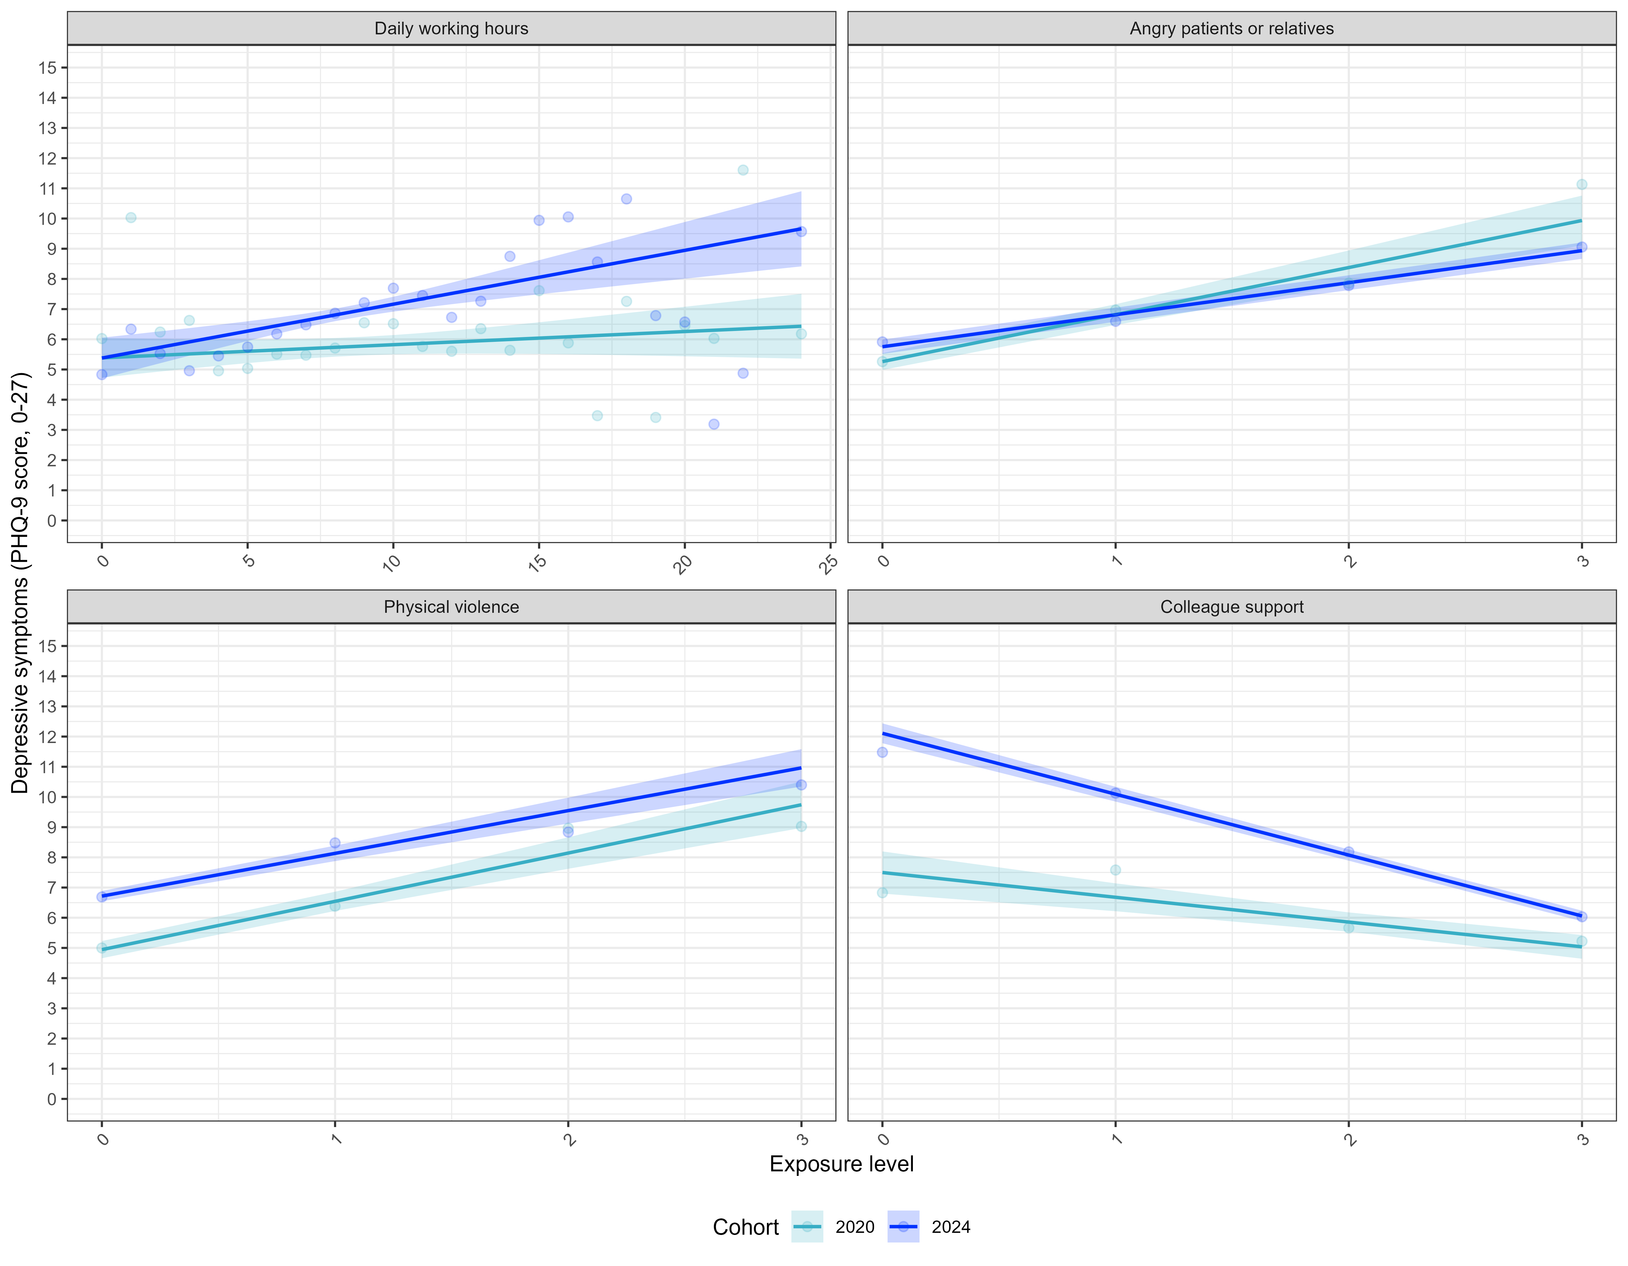
Supplementary Figure S8. Dose-response relationship between working conditions and depression symptoms. Estimated marginal means (EMMs; dots) were obtained from categorical models and adjusted for relevant covariates (see Methods). Slopes indicate the dose-response tendency and its 95% confidence interval of depression across levels of working conditions, extracted from the continuous models. Depression was measured with the PHQ-9 (range 0–27), with higher scores indicating more severe depressive symptoms. Extended daily working hours slopes: 2024: B = 0.04 (95% CI -0.02 to 0.11); 2024: B = 0.18 (95% CI 0.10 to 0.26); Interaction B = -0.10 (95% CI -0.18 to -0.02; p < 0.05). Angry patients or relatives slopes: 2024: B = 1.56 (95% CI 1.27 to 1.84); 2024: B = 1.06 (95% CI 1.00 to 1.12); Interaction B = 0.58 (95% CI -0.04 to 1.21; p = 0.068). Physical violence slopes: 2024: B = 1.60 (95% CI 1.33 to 1.87); 2024: B = 1.42 (95% CI 1.21 to 1.62); Interaction B = 0.13 (95% CI -0.20 to 0.47; p = 0.438). Colleague support slopes: 2024: B = -0.82 (95% CI -1.11 to -0.53); 2024: B = -2.02 (95% CI -2.12 to -1.91); Interaction B = 1.38 (95% CI 1.06 to 1.70; p < 0.001).
> 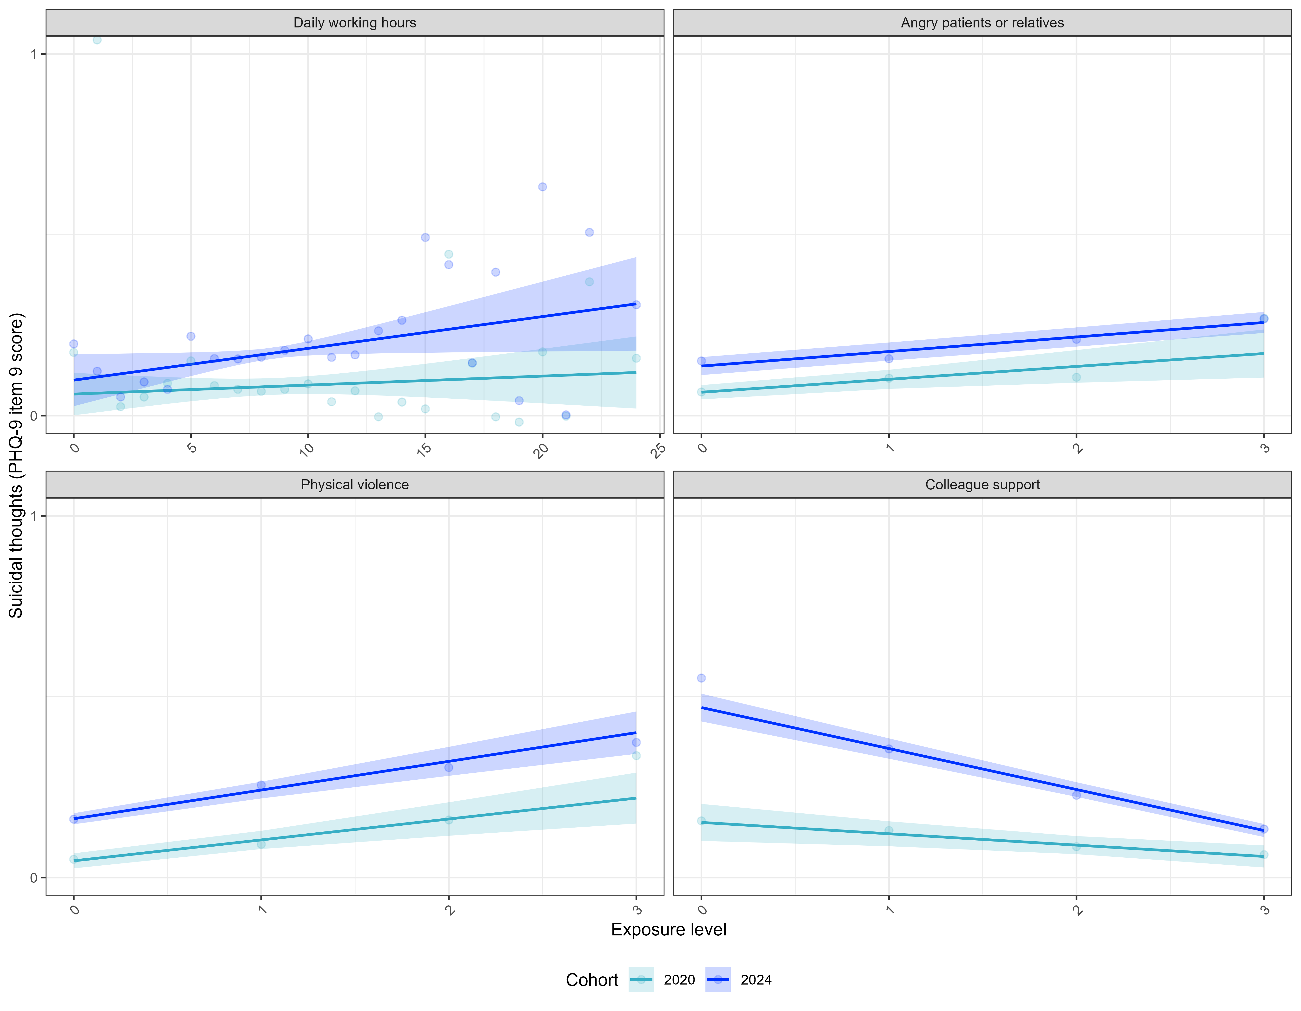
Supplementary Figure S9. Dose-response relationship between working conditions and suicidal thoughts. Estimated marginal means (EMMs; dots) were obtained from categorical models and adjusted for relevant covariates (see Methods). Slopes indicate the dose-response tendency and its 95% confidence interval of suicidal thoughts across levels of working conditions, extracted from the continuous models. Suicidal thoughts were identified with the 9th item of the PHQ-9 (range 0–3), with higher scores indicating higher frequency. Extended daily working hours slopes: 2024: B = 0.00 (95% CI -0.00 to 0.01); 2024: B = 0.01 (95% CI 0.00 to 0.02); Interaction B = -0.01 (95% CI -0.02 to -0.00; p < 0.05). Angry patients or relatives slopes: 2024: B = 0.04 (95% CI 0.01 to 0.06); 2024: B = 0.04 (95% CI 0.03 to 0.05); Interaction B = 0.01 (95% CI -0.04 to 0.06; p = 0.586). Physical violence slopes: 2024: B = 0.06 (95% CI 0.03 to 0.08); 2024: B = 0.08 (95% CI 0.06 to 0.10); Interaction B = -0.03 (95% CI -0.06 to -0.00; p < 0.05). Colleague support slopes: 2024: B = -0.03 (95% CI -0.05 to -0.01); 2024: B = -0.11 (95% CI -0.13 to -0.10); Interaction B = 0.09 (95% CI 0.07 to 0.12; p < 0.001).

