Gut Microbiome Associations with Cingulate Cortex Structure and Autistic Symptom Severity

SUPPLEMENTARY METHODS
- Participants and Procedure
- Measures
- Image acquisition, whole-brain segmentation, and cortical thickness and surface area calculation
- Collection of Fecal Samples and Extraction of DNA
- Microbial community diversity, differential abundance, and functional analysis

SUPPLEMENTARY RESULTS

SUPPLEMENTARY TABLES
Table S1. The correlation matrix between the subscale and total scores of the Social Responsiveness Scale and the Gastrointestinal Symptoms Questionnaire.
Table S2. The details of the upper GI symptoms, bowel habits, and food preferences between the ASD and TDC groups

SUPPLEMENTARY FIGURES

Figure S1. Cingulate substructures delineated by the Freesurfer Desikan-Killiany atlas (aparc), shown on the fsaverage template surface. (a) Left cingulate cortex. (b) Right cingulate cortex.

Figure S2. Taxonomy visualization in autism spectrum disorder (ASD) and typically developing control (TDC).

Figure S3. The cluster-level species heat tree for autism spectrum disorder (ASD) and typically developing control (TDC).
Figure S4. The differential relative abundance of gut microbiota compositions in the autism spectrum disorder (ASD) and typically developing control (TDC) groups at the less stringent LEfSe threshold (linear discriminant analysis [LDA] score > 2). Bars show the LDA score (log₁₀) for each of the 39 discriminating taxa, ordered by signed effect size: 18 enriched in the ASD group (blue, positive scores) and 21 enriched in the TDC group (orange, negative scores).
Figure S5. MetaCyc pathways predicted by PICRUSt2 (v2.5.1) that differed between the autism spectrum disorder (ASD) and typically developing control (TDC) groups at uncorrected p < 0.05 (two-sided Wilcoxon rank-sum test). Left panel: mean relative proportion (%) in each group. Right panel: difference in mean proportions with 95% confidence intervals; values on the right are uncorrected p-values.

REFERENCE

SUPPLEMENTARY METHODS
- Participants and Procedure
Autistic individuals were clinically diagnosed based on the DSM-5 criteria (1), confirmed through the Autism Diagnostic Interview-Revised (ADI-R) (2) and the Autism Diagnostic Observation Schedule (ADOS) (3) interviews, utilizing authorized Chinese editions of ADI-R and ADOS by the World Psychiatric Association in June 2007 and April 2008, respectively, for ethnic Chinese populations (3-5).
TDC participants, recruited from the same neighborhoods as autistic participants, had no lifetime or current DSM-5 psychiatric disorders, confirmed through the Kiddie-Schedule for Affective Disorders and Schizophrenia for School-Age Children–Epidemiological Version interview (K-SADS-E)(6, 7). The non-autistic status was confirmed through clinical diagnostic interviews conducted by the corresponding author, S.S.-F.G. Exclusion criteria for all participants included neurological or systemic medical conditions, major mental disorders (i.e., substance use disorders, schizophrenia, mood disorders, and anxiety disorders), current use of psychotropic medication, recent use of probiotics, prebiotics, or antibiotics within the past month, and a full-scale intelligence quotient (FIQ) < 70, as assessed by the Wechsler Intelligence Scale for Children–3rd Edition (age <16 years) or Wechsler Adult Intelligence Scale-3rd Edition (age ≥16 years). Gastrointestinal symptoms were evaluated using the Gastrointestinal Symptoms Questionnaire (8), and participants were excluded if they had gastrointestinal disorders or had used probiotics in the past 3 months. For participants who maintained regular medication usage and dietary and bowel habits, we evaluated their gastrointestinal habits and problems over the past four weeks. We recruited all participants between August 1, 2017, and December 12, 2022.

- Measures
Social Responsiveness Scale (SRS)
The SRS is a self-report or caregiver-report questionnaire designed to assess autism-related behaviors (9) across all ages, races, IQ levels, or educational backgrounds (10). This 65-item scale ranges from 0 (never true) to 3 (almost always true), with higher scores indicating more pronounced autistic traits. The psychometric evaluation of the Chinese SRS revealed four domains: social communication, unique mannerisms, social awareness, and social emotion (11). It demonstrates high reliability ( internal consistency, Cronbach's α 0.94–0.95; intra-class correlation, ICC 0.75–0.85) and strong convergent validity with the Chinese Social Communication Questionnaire (Pearson's r 0.61–0.87) (11). It has been widely used in Taiwan to evaluate autistic social deficits (12, 13).

Gastrointestinal Symptoms Questionnaire
The Gastrointestinal Symptoms Questionnaire, developed by Bovenschen et al. (8), evaluates the severity of gastrointestinal symptoms experienced by individuals over the past four weeks. The 32-item questionnaire is divided into four distinct subscales: abdominal pain (6 items), upper gastrointestinal symptoms (11 items), bowel habits (11 items), and food preferences (4 items). Participants and their parents were interviewed to rate each item on a scale from 0 (no complaints) to 6 (most severe and intolerable symptoms).

- Image acquisition, whole-brain segmentation, and cortical thickness and surface area calculation
Image acquisition
T1-weighted images were acquired using a 3D Magnetization Prepared Rapid Acquisition Gradient Echo sequence on a Siemens Magnetom Tim Trio 3-T MRI scanner equipped with a 32-channel phased-arrayed head coil. The imaging parameters were as follows: TR=2000 ms; TE=2.98 ms; TI=900 ms; flip angle=9°; FOV=256 × 256 mm³; slice thickness=1.0 mm; isotropic voxel size=1mm3).

Whole brain segmentation, cortical thickness, and surface area calculation
Cortical reconstruction was performed utilizing Freesurfer (version 7.2.0; http://surfer.nmr.mgh.harvard.edu/) on a 64-bit Linux operating system, following the thickness and surface processing pipelines (14). The procedure began with white matter segmentation, followed by subdivision of the gray/white matter boundary, generating an initial surface after automated topological correction. This surface was the initial model for the deformable approach used in pial surface reconstruction. After reconstructing all surfaces, cortical thickness measurements were calculated. Furthermore, point correspondences across subjects were established within a standardized surface-based coordinate system. The subsequent steps included creating an average template, reconstructing cortical surfaces (15), and resampling cortical thickness data. A smoothing width of 20 mm was applied to the cortical thickness map to enhance the signal-to-noise ratio and improve the detection of morphometric changes (16). The postprocessing outputs for each subject underwent automated quality control procedures and visual inspection by the first author (Jung-Chi Chang) to ensure processing accuracy and image quality. We extracted cortical parcellation results using the Desikan-Killiany atlas (17). The present study specifically focused on the cingulate substructures, divided into four subregions: the rostral anterior, caudal anterior, isthmus, and posterior cingulate gyri (Figure S1). Measurements of cortical thickness and surface area were obtained for these regions of interest.

- Collection of Fecal Samples and Extraction of DNA
Extraction of the genomic DNA
The QIAamp PowerFecal DNA Kit (Qiagen), a column-based extraction method, was utilized to isolate genomic DNA from the samples. The DNA concentration was quantified using the Qubit 4.0 Fluorometer (Thermo Scientific) and subsequently adjusted to 1 ng/μL for subsequent processing.
PCR Amplification and Purification
The study employed a barcoded 16S gene-specific primer approach to amplify the full-length 16S genes (covering the V1-V9 regions). The primers were designed to include a 5' buffer sequence (GCATC) with a 5' phosphate modification, a 16-base barcode, and the degenerate 16S gene-specific forward or reverse primer sequences (Forward: 5'Phos/GCATC16-base barcode -AGRGTTYGATYMTGGCTCAG -3', Reverse: 5'Phos/GCATC- 16-base barcode – RGYTACCTTGTTACGACTT -3'). The degenerate base identities are R = A, G; Y = C, T; M = A, C. The PCR reaction was carried out using 2 ng of genomic DNA and KAPA HiFi HotStart ReadyMix (Roche), with the following cycling conditions: 95°C for 3 minutes; 20~27 cycles (sample-dependent) of 95°C for 30 seconds, 57°C for 30 seconds, and 72°C for 60 seconds; followed by a final extension at 72°C for 5 minutes and holding at 4°C. The PCR products were visualized on a 1% agarose gel, and samples with a prominent band at approximately 1500 bp were selected and purified using AMPure PB Beads for subsequent library preparation.

SMRTbell library construction and sequencing
The SMRTbell library was constructed following the Amplification of a Full-Length 16S Gene with Barcoded Primers for Multiplexed SMRTbell Library Preparation and Sequencing Protocol (PacBio). In summary, an equimolar mixture of each barcoded PCR product was combined, and 500-1000 ng of the pooled amplicon was subjected to DNA damage repair, followed by End-repair/A-tailing and ligation to attach universal hairpin adapters to the double-stranded DNA fragments. The SMRTbell library was purified with AMPure PB beads to eliminate adapter dimers, then incubated with sequencing primer v4 and the Sequel II Binding Kit 2.1 for primer annealing and polymerase binding. Finally, sequencing was carried out in circular consensus sequence (CCS) mode on a PacBio Sequel IIe system to generate HiFi reads with a predicted Phred score of 30.

- Microbial community diversity, differential abundance, and functional analysis
Alpha diversity reflects the species complexity within individual samples based on three criteria: observed species, Shannon index, and Simpson index (18). The observed species metric counts the different species present in a microbial community. The Shannon and Simpson indices measure diversity, considering both species' relative abundance and evenness.
Beta diversity was assessed to evaluate differences in microbial community composition between samples. Distance matrices were calculated using Bray-Curtis, weighted UniFrac, and unweighted UniFrac metrics (19, 20) with the phyloseq package in R software version 4.3.2. Principal coordinate analysis (PCoA) was then performed on each distance matrix to visualize between-sample dissimilarities in a reduced-dimensional space (21). In PCoA, the distance matrix is transformed into a set of orthogonal coordinate axes, with the first principal coordinate explaining the largest proportion of variation in community dissimilarity, followed by the second and subsequent coordinates.
The statistical significance of species across different taxonomic levels was assessed using a zero-inflated Gaussian (ZIG) log-normal model via the "fitFeatureModel" function in the Bioconductor metagenomeSeq package (22). Welch's t-test was performed using the stats package in R. Significant biomarkers were identified using LEfSe analysis (23), which employs nonparametric Kruskal-Wallis and Wilcoxon rank-sum tests to discern bacterial taxa with significant relative abundance differences between groups, followed by Linear Discriminant Analysis (LDA) to evaluate the effect size of each differentially abundant taxon. Taxa with an LDA score (log 10) above 2 were considered statistically significant. For functional prediction, 16S rRNA sequencing data were analyzed using PICRUSt2 (v2.5.1) (24).

SUPPLEMENTARY RESULTS
The predicted function and pathway between ASD and TDC
We used PICRUSt2 to predict microbiota function, initially focusing on differences in prokaryotic taxa and their links to metabolic functions in ASD and TDC. Analyses of the MetaCyc database using PICRUSt2 and the Wilcoxon test identified 25 pathways with functional differences at uncorrected p-values below 0.05. Specifically, 10 functional pathways were more dominant in ASD, while 15 were more prevalent in TDC (Figure S5). Noteworthy among these were two functionally predicted pathways in ASD: pyrimidine deoxyribonucleotides biosynthesis from CTP (p = 0.007) and pyrimidine deoxyribonucleotides de novo biosynthesis IV (p = 0.006), both exhibiting higher mean proportions than TDC, with p-values less than 0.01. However, these did not retain statistical significance after the FDR adjustment.

SUPPLEMENTARY TABLES
Table S1. The correlation matrix of the Social Responsiveness Scale and the Gastrointestinal Symptoms Questionnaire subscale and total scores for the whole sample.
 |  | Social communication | Unique mannerisms | Social awareness | Social emotion | Total score
Food preferences | Spearman's rho | 0.417 | 0.371 | 0.245 | 0.367 | 0.398
 | p-value | < 0.001 | < 0.001 | 0.001 | < 0.001 | < 0.001
Bowel habits | Spearman's rho | 0.362 | 0.353 | 0.182 | 0.362 | 0.366
 | p-value | < 0.001 | < 0.001 | 0.006 | < 0.001 | < 0.001
Upper GI symptoms | Spearman's rho | 0.275 | 0.284 | 0.140 | 0.305 | 0.279
 | p-value | < 0.001 | < 0.001 | 0.034 | < .001 | < 0.001
Epigastric pain | Spearman's rho | 0.065 | 0.078 | -0.024 | 0.049 | 0.059
 | p-value | 0.329 | 0.239 | 0.720 | 0.457 | 0.373
Abdominal pain | Spearman's rho | 0.104 | 0.122 | 0.035 | 0.113 | 0.102
 | p-value | 0.114 | 0.064 | 0.594 | 0.088 | 0.123
Note: The bolded values indicate statistically significant correlations (p < 0.05) between the subscales of the social responsiveness scale and the variables from the gastrointestinal symptoms questionnaire.

Table S2. The details of the upper GI symptoms, bowel habits, and food preferences between the ASD and TDC groups
Mean (SD) | ASD  (n=139) | TDC  (n=92) | Effect size | p-value
Abdominal pain | 1.11 (1.87) | 0.79 (1.51) | 0.18 | 0.178
in common (0-6) | 0.33 (0.64) | 0.29 (0.56) | 0.07 | 0.584
postprandial (0-6) | 0.40 (0.75) | 0.19 (0.45) | 0.32 | 0.017
fasting (0-6) | 0.25 (0.57) | 0.21 (0.61) | 0.07 | 0.584
doesn't decline after defection (0-6) | 0.13 (0.36) | 0.11 (0.31) | 0.06 | 0.671
Epigastric pain | 0.54 (1.20) | 0.37 (0.89) | 0.16 | 0.253
in common (0-6) | 0.14 (0.40) | 0.09 (0.32) | 0.13 | 0.345
during daytime (0-6) | 0.26 (0.57) | 0.22 (0.49) | 0.08 | 0.574
at night/asleep (0-6) | 0.14 (0.47) | 0.08 (0.31) | 0.15 | 0.278
Upper GI symptoms | 3.34 (4.04) | 1.81 (2.88) | 0.42 | 0.002
Heartburn (0-6) | 0.01 (0.09) | 0.02 (0.15) | -0.13 | 0.340
Regurgitation (0-6) | 0.03 (0.17) | 0.01 (0.10) | 0.12 | 0.364
Abdominal rumbling (0-6) | 0.20 (0.54) | 0.15 (0.56) | 0.08 | 0.571
Bloating (0-6) | 0.38 (0.75) | 0.15 (0.45) | 0.35 | 0.011
Empty feeling (0-6) | 0.35 (0.85) | 0.12 (0.36) | 0.32 | 0.017
Nausea (0-6) | 0.14 (0.39) | 0.04 (0.25) | 0.29 | 0.031
Vomiting (0-6) | 0.14 (0.46) | 0.03 (0.23) | 0.27 | 0.044
Loss of appetite (0-6) | 0.39 (0.75) | 0.16 (0.45) | 0.36 | 0.008
Postprandial fullness (0-6) | 0.61 (0.93) | 0.42 (0.70) | 0.23 | 0.090
Bleching (0-6) | 0.43 (0.74) | 0.40 (0.73) | 0.04 | 0.749
Flatulence (0-6) | 0.52 (0.88) | 0.27 (0.67) | 0.31 | 0.024
Haematemesis (0-6) | 0.00 (0.00) | 0.00 (0.00) | NaN | NaN
Dysphagia (0-12) | 0.17 (0.51) | 0.04 (0.25) | 0.30 | 0.025
Bowel habits | 4.02 (4.32) | 1.57 (2.42) | 0.67 | < .001
Melaena (0-6) | 0.05 (0.25) | 0.07 (0.29) | -0.06 | 0.678
Bloody stool (0-6) | 0.04 (0.24) | 0.02 (0.21) | 0.10 | 0.479
Mucus in stool (0-6) | 1.11 (1.87) | 0.79 (1.51) | 0.34 | 0.014
Frequent hard stool (0-6) | 0.33 (0.64) | 0.29 (0.56) | 0.47 | < 0.001
Diarrhea (0-6) | 0.40 (0.75) | 0.19 (0.45) | 0.42 | 0.002
Mixed stool consistency (0-6) | 0.25 (0.57) | 0.21 (0.61) | 0.39 | 0.005
Constipation (0-6) | 0.13 (0.36) | 0.11 (0.31) | 0.59 | < 0.001
Frequent pain experience (0-6) | 0.54 (1.20) | 0.37 (0.89) | 0.41 | 0.003
Urging stools (0-6) | 0.14 (0.40) | 0.09 (0.32) | 0.35 | 0.011
Incomplete evacuation (0-6) | 0.26 (0.57) | 0.22 (0.49) | 0.49 | < 0.001
Steatorrhea (0-6) | 0.14 (0.47) | 0.08 (0.31) | 0.11 | 0.414
Food preferences | 3.34 (4.04) | 1.81 (2.88) | 0.79 | < 0.001
Meat (0-6) | 0.01 (0.09) | 0.02 (0.15) | 0.43 | 0.002
Vegetable (0-6) | 0.03 (0.17) | 0.01 (0.10) | 0.72 | < 0.001
Fruit (0-6) | 0.20 (0.54) | 0.15 (0.56) | 0.63 | < 0.001
Grain (0-6) | 0.38 (0.75) | 0.15 (0.45) | 0.52 | < 0.001
Dessert (0-6) | 0.35 (0.85) | 0.12 (0.36) | 0.26 | 0.060
ASD: autism spectrum disorder; TDC: typically developing control; GI: gastrointestinal.

SUPPLEMENTARY FIGURES

Figure S1. Cingulate substructures delineated by the Freesurfer Desikan-Killiany atlas (aparc), shown on the fsaverage template surface. (a) Left cingulate cortex. (b) Right cingulate cortex.

Figure S2. Taxonomy visualization in autism spectrum disorder (ASD) and typically developing control (TDC).

A. ASD

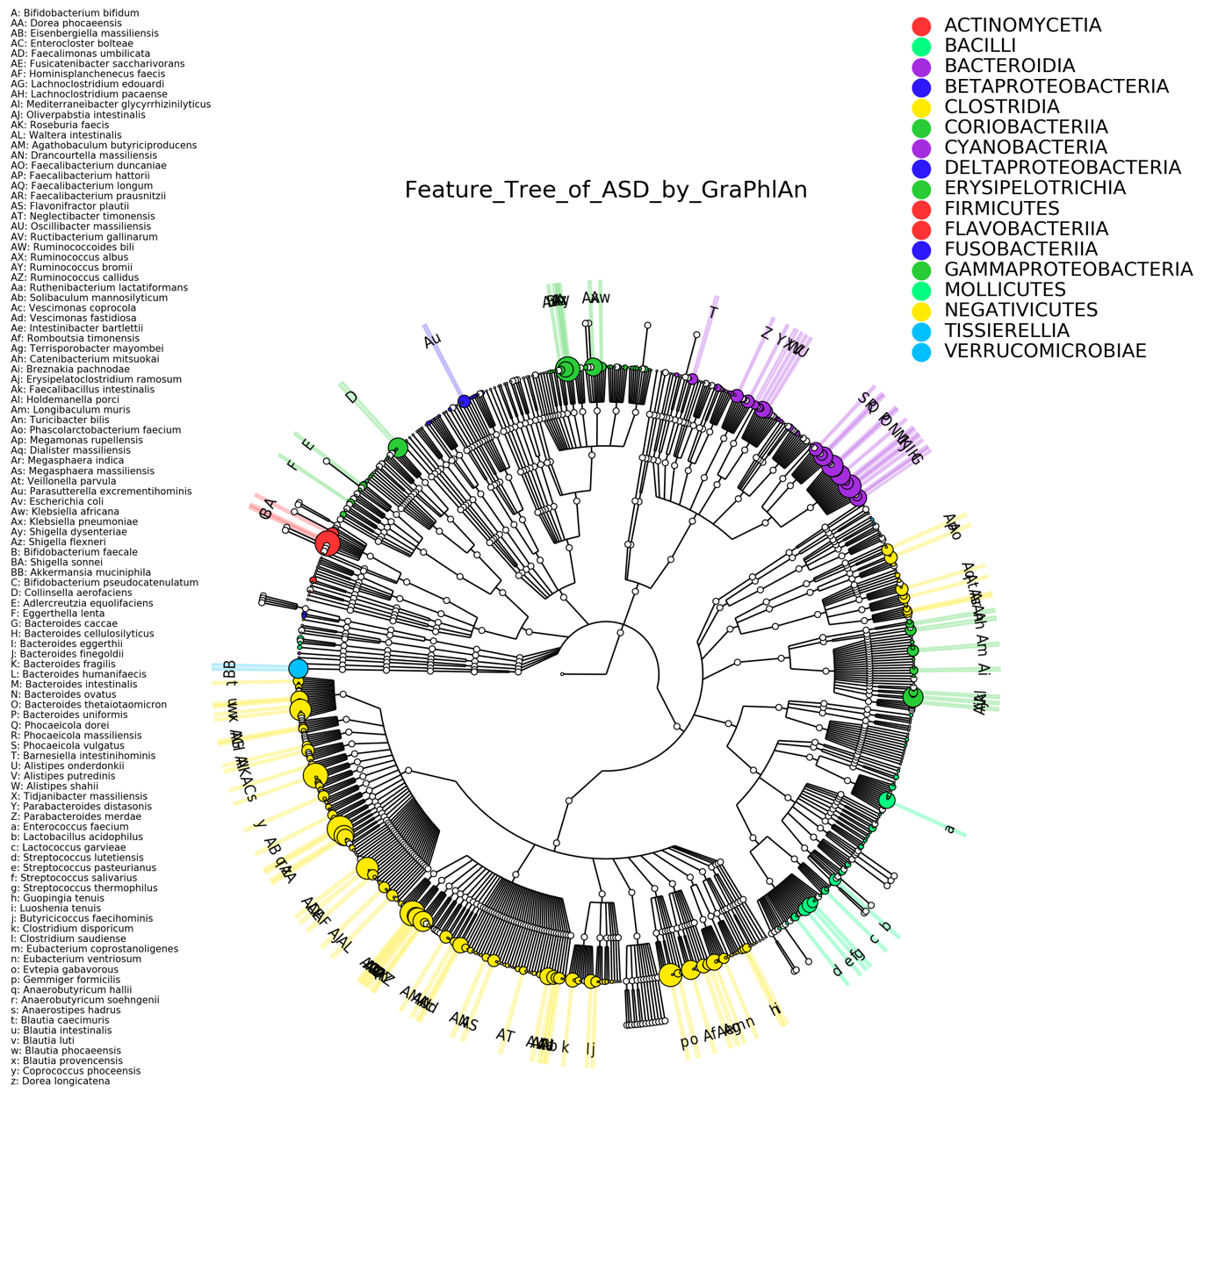

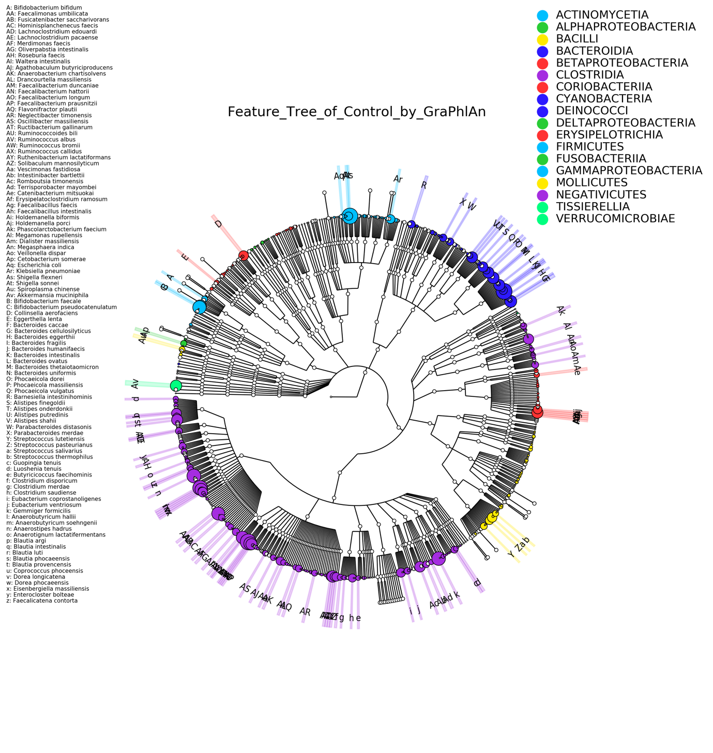
B. TDC

Figure S3. The cluster-level species heat tree in autism spectrum disorder (ASD) and typically developing control (TDC).

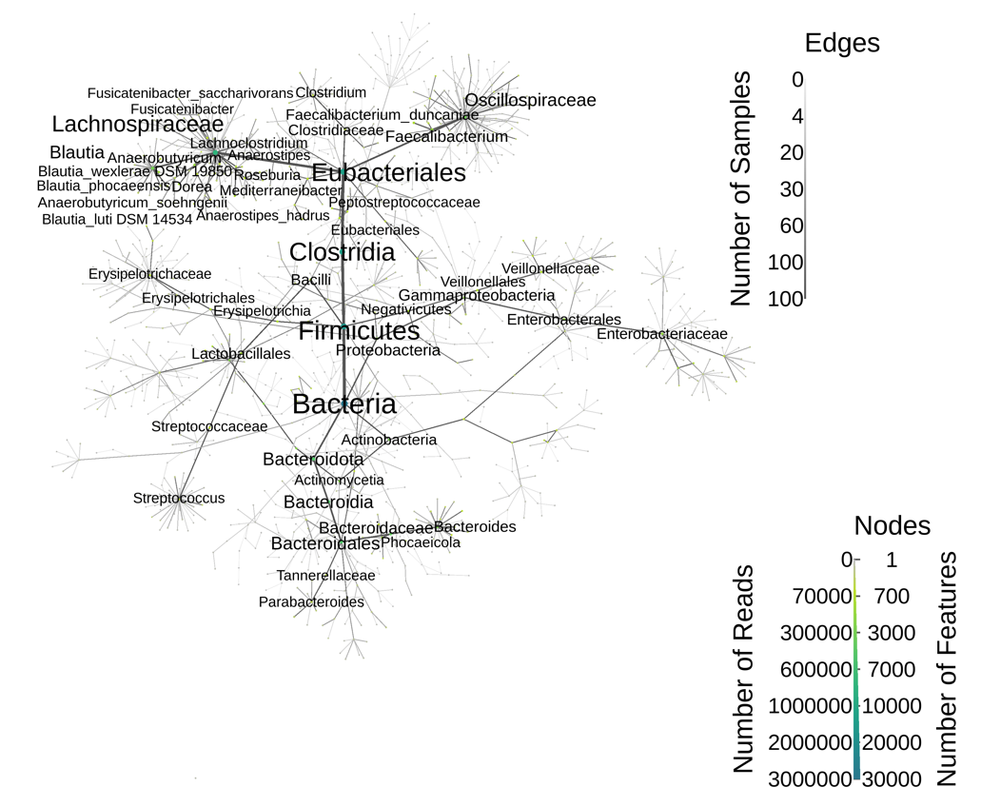
A. ASD

B. TDC
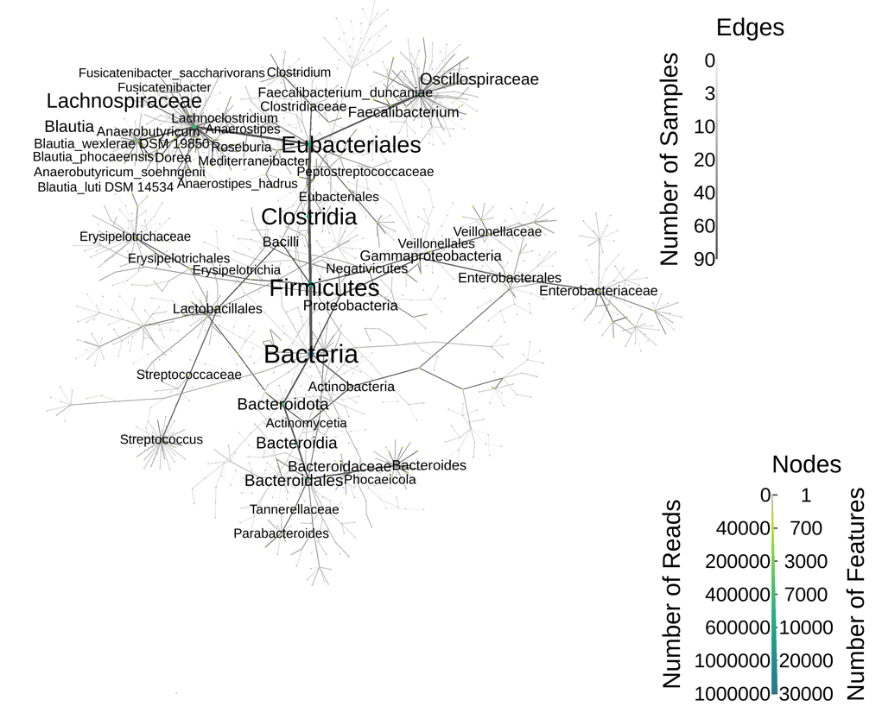

Figure S4. The differential relative abundance of gut microbiota compositions in the autism spectrum disorder (ASD) and typically developing control (TDC) groups at the less stringent LEfSe threshold (linear discriminant analysis [LDA] score > 2). Bars show the LDA score (log₁₀) for each of the 39 discriminating taxa, ordered by signed effect size: 18 enriched in the ASD group (blue, positive scores) and 21 enriched in the TDC group (orange, negative scores).

Figure S5. MetaCyc pathways predicted by PICRUSt2 (v2.5.1) that differed between the autism spectrum disorder (ASD) and typically developing control (TDC) groups at uncorrected p < 0.05 (two-sided Wilcoxon rank-sum test). Left panel: mean relative proportion (%) in each group. Right panel: difference in mean proportions with 95% confidence intervals; values on the right are uncorrected p-values.

REFERENCE
1. American Psychiatric Association (2013): Diagnostic and Statistical Manual of Mental Disorders, Fifth Edition. 5th ed ed. Arlinton, VA: American Psychiatric Association.
2. Gau SS, Lee CM, Lai MC, Chiu YN, Huang YF, Kao JD, et al. (2011): Psychometric properties of the Chinese version of the social communication questionnaire. Res Autism Spectr Disord. 5:809–818.
3. Chang JC, Lai MC, Chien YL, Cheng CY, Wu YY, Gau SS (2023): Psychometric properties of the Mandarin version of the autism diagnostic observation schedule-generic. Journal of the Formosan Medical Association = Taiwan yi zhi.
4. Gau SS, Chou MC, Lee JC, Wong CC, Chou WJ, Chen MF, et al. (2010): Behavioral problems and parenting style among Taiwanese children with autism and their siblings. Psychiatry Clin Neurosci. 64:70–78.
5. Lo YC, Chen YJ, Hsu YC, Chien YL, Gau SS, Tseng WI (2019): Altered frontal aslant tracts as a heritable neural basis of social communication deficits in autism spectrum disorder: A sibling study using tract-based automatic analysis. Autism Res. 12:225–238.
6. Chen Y-L, Shen L-J, Gau SS-F (2017): The Mandarin version of the Kiddie-Schedule for Affective Disorders and Schizophrenia-Epidemiological version for DSM–5–A psychometric study. Journal of the Formosan Medical Association. 116:671–678.
7. Gau SS, Chong MY, Chen TH, Cheng AT (2005): A 3-year panel study of mental disorders among adolescents in Taiwan. Am J Psychiatry. 162:1344–1350.
8. Bovenschen HJ, Janssen MJ, van Oijen MG, Laheij RJ, van Rossum LG, Jansen JB (2006): Evaluation of a gastrointestinal symptoms questionnaire. Dig Dis Sci. 51:1509–1515.
9. Constantino JN, Gruber CP, Services WP (2007): Social Responsiveness Scale (SRS). Western Psychological Services.
10. Constantino JN, Davis SA, Todd RD, Schindler MK, Gross MM, Brophy SL, et al. (2003): Validation of a brief quantitative measure of autistic traits: comparison of the social responsiveness scale with the autism diagnostic interview-revised. J Autism Dev Disord. 33:427–433.
11. Gau SS-F, Liu L-T, Wu Y-Y, Chiu Y-N, Tsai W-C (2013): Psychometric properties of the Chinese version of the Social Responsiveness Scale. Research in Autism Spectrum Disorders. 7:349–360.
12. Chang J-C, Lai M-C, Tai Y-M, Gau SS-F (2021): Mental health correlates and potential childhood predictors for the wish to be of the opposite sex in young autistic adults. Autism.13623613211024098.
13. Zhou B, Zhou H, Wu L, Zou X, Luo X, Fombonne E, et al. (2017): Assessing the Accuracy of the Modified Chinese Autism Spectrum Rating Scale and Social Responsiveness Scale for Screening Autism Spectrum Disorder in Chinese Children. Neuroscience Bulletin. 33:168–174.
14. Fischl B (2012): FreeSurfer. Neuroimage. 62:774–781.
15. Fischl B, Sereno MI, Tootell RB, Dale AM (1999): High-resolution intersubject averaging and a coordinate system for the cortical surface. Hum Brain Mapp. 8:272–284.
16. Chung MK, Robbins SM, Dalton KM, Davidson RJ, Alexander AL, Evans AC (2005): Cortical thickness analysis in autism with heat kernel smoothing. Neuroimage. 25:1256–1265.
17. Desikan RS, Ségonne F, Fischl B, Quinn BT, Dickerson BC, Blacker D, et al. (2006): An automated labeling system for subdividing the human cerebral cortex on MRI scans into gyral based regions of interest. Neuroimage. 31:968–980.
18. Whittaker RH (1972): Evolution and measurement of species diversity. Taxon. 21:213–251.
19. Lozupone C, Knight R (2005): UniFrac: a new phylogenetic method for comparing microbial communities. Appl Environ Microbiol. 71:8228–8235.
20. Lozupone C, Lladser ME, Knights D, Stombaugh J, Knight R (2011): UniFrac: an effective distance metric for microbial community comparison. Isme j. 5:169–172.
21. Jiang XT, Peng X, Deng GH, Sheng HF, Wang Y, Zhou HW, et al. (2013): Illumina sequencing of 16S rRNA tag revealed spatial variations of bacterial communities in a mangrove wetland. Microb Ecol. 66:96–104.
22. Paulson JN, Stine OC, Bravo HC, Pop M (2013): Differential abundance analysis for microbial marker-gene surveys. Nat Methods. 10:1200–1202.
23. Segata N, Izard J, Waldron L, Gevers D, Miropolsky L, Garrett WS, et al. (2011): Metagenomic biomarker discovery and explanation. Genome Biol. 12:R60.
24. Douglas GM, Maffei VJ, Zaneveld JR, Yurgel SN, Brown JR, Taylor CM, et al. (2020): PICRUSt2 for prediction of metagenome functions. Nature Biotechnology. 38:685–688.

