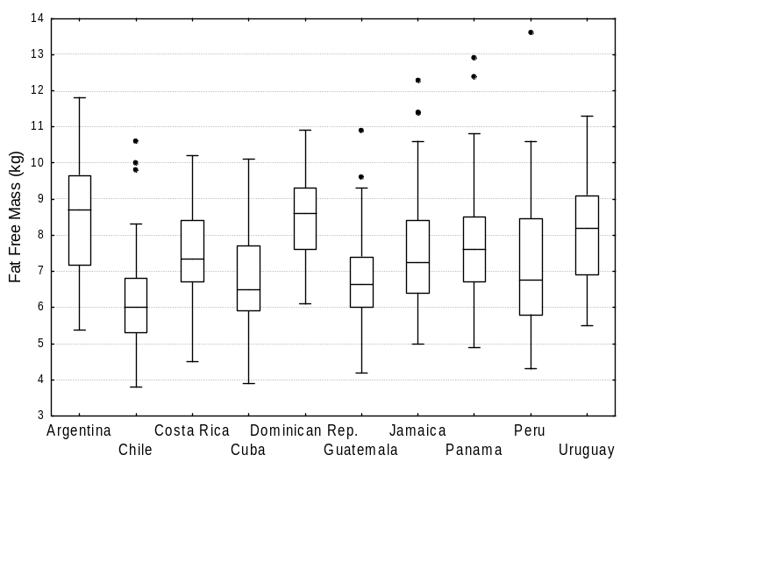
Figure A 2. Distribution of FFM (kg) by country in the study sample.

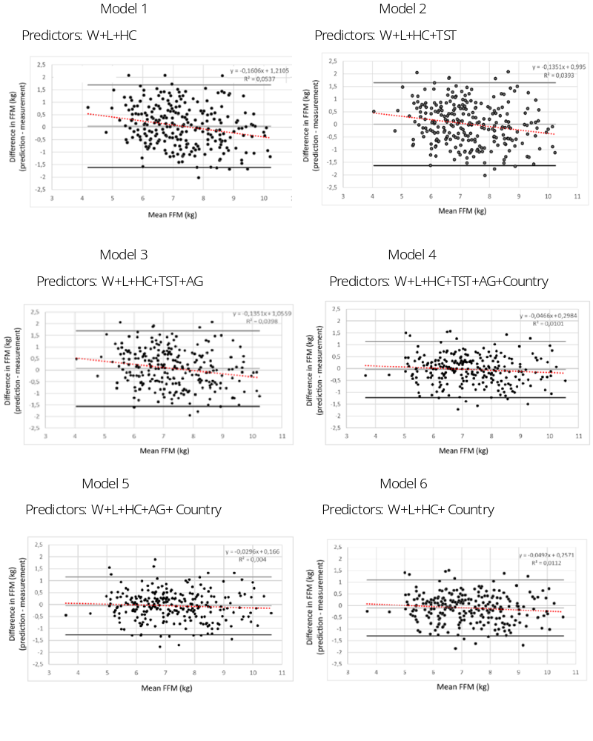
Fig. 1. Bland-Altman plots in the validation sample to determine the levels of agreement between the MLG (kg) obtained directly by the deuterium dilution method and that predicted by the predictive equations.

Model 1 Model 2
Predictors: W+L+HC Predictors: W+L+HC+TST
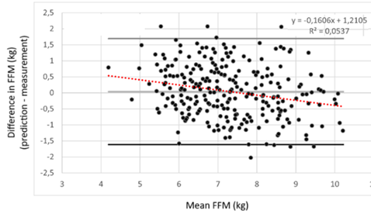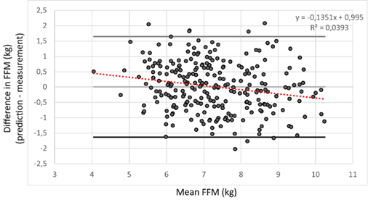
Model 3 Model 4
Predictors: W+L+HC+TST+AG Predictors: W+L+HC+TST+AG+Country
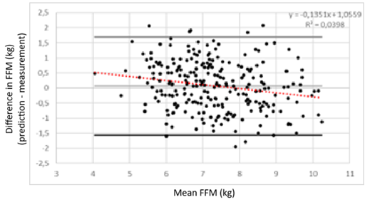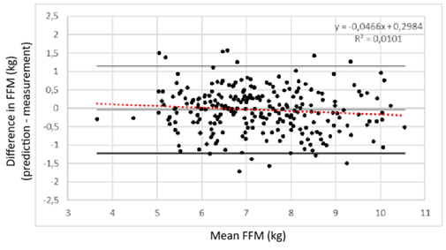
Model 5 Model 6
Predictors: W+L+HC+AG+ Country Predictors: W+L+HC+ Country
