Age: 6-12 months

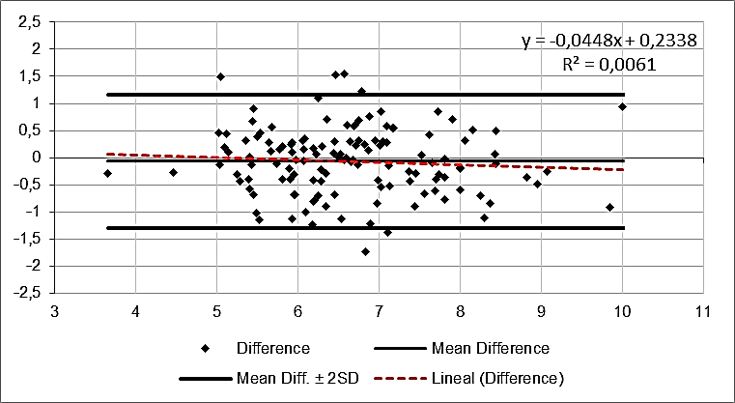

Mean Difference | SD | Mean Diff+2SD | Mean Diff.-2SD
-0,064 | 0,615 | 1,167 | -1,295

Age: 13-18 months

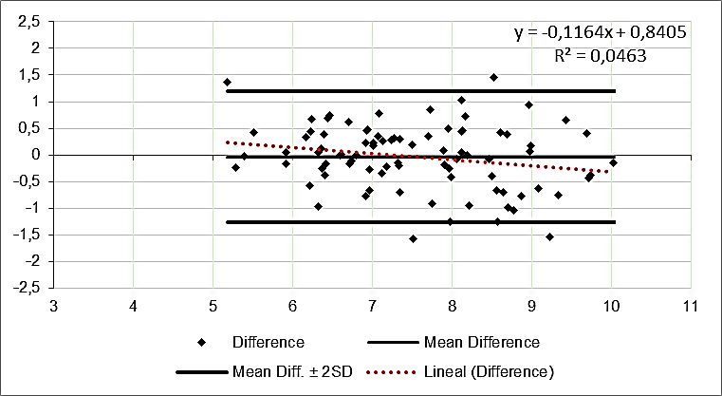

Mean Difference | SD | Mean Diff.+2SD | Mean Diff.-2SD
-0,036 | 0,613 | 1,190 | -1,262

Age: 19-24 months

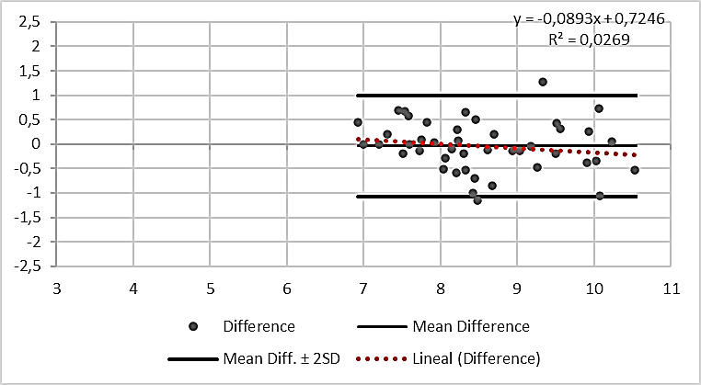

Mean Difference | SD | Mean Diff.+2SD | Mean Diff.-2SD
-0,038 | 0,519 | 0,999 | -1,076

Figure A6. Bland–Altman plots by age group showing agreement between FFM (kg) obtained by the deuterium dilution method and FFM predicted by equation 5.

