1. Systematic review methods

We used the RepOrting standards for Systematic Evidence Syntheses to prepare this Supporting Information Appendix (1) and developed and followed a predetermined protocol when conducting our review (unpublished). Below, we detail our two rounds of literature searching (tillage intensity first, then cover crops and ley-arable together) and screening of records by title, abstract and full text. We provide information on data extraction from relevant studies and critical appraisal, and further details of using these data for quantitative Bayesian meta-analysis. Further supporting files are provided online (2).
Table S1. Review question elements separated by Population, Intervention, Comparator, Outcome and Location (PICOL) for each intervention of interest
PICOL element | Tillage intensity (TI) | Cover crops (CC) | Ley-arable (LA)
Population | Arable systems (including research stations, experimental plots, field trials and working farms but excluding greenhouse or laboratory experiments)
Intervention | Any tillage practice, included no tillage (direct drilling), reduced/minimum/conservation tillage, conventional tillage (typically with use of mouldboard plough) | An arable rotation that contains a sown cover or catch crop at a least one point in the rotation between arable cash crops | An arable rotation that contains a temporary grass-based ley for one or multiple consecutive years between arable cash crops
Comparator | A different intensity of tillage | Soils or stubble left bare between annual cash crops | Continuous arable cropping or a different ley duration
Outcomes | Soil organic carbon (SOC), soil organic matter (SOM) or soil total carbon (StC) where soils are shown to be free of carbonates, either as a concentration (g/100g) or stock (t/ha)  Crop yield (t/ha)
Location | Regions with temperate oceanic climate with no dry season and warm summer  (i.e. Köppen–Geiger climate classification Cfb (3)),  restricted to countries that are exclusively Cfb  (Britain including Ireland, Belgium, Netherlands, Luxembourg, New Zealand)  or have substantial Cfb regions (France, Germany, Spain, Denmark, Australia).

1.1. Search strategy

We carried out the tillage search first, followed by the cover crops and ley-arable searches together due to the similarity between the search terms (Table S2). Searches were conducted for “All years” in bibliographic databases and citation indices, with search results from Haddaway, et al. (4) excluded in Endnote X9 before citation screening to prevent duplication of effort. This approach was taken because we added the bibliographic database CAB Abstracts to our search strategy to capture relevant citations missed by the previous searches. We included relevant records from the previous searches of Haddaway, et al. (4), (5) in our data extraction (Section 1.3). We did not estimate the comprehensiveness of the search here as the search string had previously been refined to achieve this when developed by Haddaway, et al. (4), (5).

We did not specifically search for grey literature and only included studies published in English in our database, but we are confident that this is unlikely to have biased our results as grey literature is unlikely to report sufficient data for inclusion in meta-analysis and most published literature in our geographic region of interest is in English, as found by Haddaway et al. (2017a). Although separate literature searches for studies that measured SOC or yield would have resulted in more data for analysis, this would have disproportionally increased the volume of literature for screening and running a multi-variate analysis using only paired observations of soil carbon and yield was central to testing our hypotheses. We did not include studies from other climatic zones, to maximise the generalisability of our findings to the context of interest and to enable use of these data in parametrising a spatially explicit soil carbon model at a national scale in future work (Jordon et al., in prep).

For cover crops and ley-arable, we conducted title screening of the reference lists of relevant reviews and meta-analysis. A list of citations identified as having relevant titles is available online (2), along with information of whether the record abstract is relevant and full text downloaded for inclusion in full text screening.

Table S2. Search strategy for systematic review
 | Tillage (NT) | Cover crops (CC) |  | Ley-arable (LA)
Systematic search updated | 2015 search, Haddaway, et al. (5) | 2013 search, Haddaway, et al. (4)
Search string | SI Appendix 1.1.1 | SI Appendix 1.1.2
Bibliographic databases and citation indexes | Web of Science:  - Web of Science Core Collection (1900–present)  - Science Citation Index Expanded (1900–present)  - Social Sciences Citation Index (1900–present)  - Arts & Humanities Citation Index (1975–present)  - Conference Proceedings Citation Index-Science (1990–present)  - Conference Proceedings Citation Index-Social Science & Humanities (1990–present)  - Book Citation Index–Science (2005–present)  - Book Citation Index–Social Sciences & Humanities (2005–present)  - Emerging Sources Citation Index (2015–present)  - Current Chemical Reactions (1986–present) (includes Institut National de la Propriete Industrielle structure data back to 1840)  - Index Chemicus (1993–present)  - BIOSIS Citation Index (1969–present)  - Current Contents Connect (1998–present)  - Data Citation Index (1993–present)  - Derwent Innovations Index (1993–present)  - KCI-Korean Journal Database (1980–present)  - MEDLINE® (1950–present)  - Russian Science Citation Index (2005–present)  - SciELO Citation Index (2002–present)  - Zoological Record (1993–present)  CAB Abstracts  Scopus
Search dates | 21 July 2020 | 12 Jan 2021
Search date range | 2015 onwards for Web of Science and Scopus, as updating 2015 search from Haddaway, et al. (5); all years for CAB Abstracts as not previously searched by Haddaway, et al. (5) | All years
Grey literature searched | None
Languages searched | English
Snowballing from previous reviews and meta-analysis | No |  | Yes, title-relevant citations from reviews and meta-analyses provided online (2)

For the tillage search, Location terms were not included in the search string, as we were concerned that this would lead to relevant citations being missed. However, due to the high resource requirements of screening large numbers of non-relevant citations, for the cover crop and ley-arable search, we ran the search both with and without Location terms. These returned 3025 and 14,753 citations respectively. We screened a random sample of 600 (appox. 5%) from the 11,728 citations returned by the ‘without Location’ search but missed by the ‘with location’ search. We identified no relevant full texts from this random sample and so estimate that less than 1 in 600 (i.e. <0.17%) of the 11,728 would be relevant at full text. As such, we only screening the results from the ‘with Location’ search due to the low chance of missing relevant citations.

1.1.1. Tillage search string

soil*
AND
arable OR agricult* OR farm* OR crop* OR cultivat*
AND
till* OR “no till*” OR “reduced till*” OR “direct drill*” OR “conservation till*” OR “minimum till*”
AND
“soil organic carbon” OR “soil carbon” OR “soil C” OR “soil organic C” OR SOC OR “carbon pool” OR “carbon stock” OR “carbon storage” OR “soil organic matter” OR SOM OR “carbon sequestrat*” OR “C sequestrat*”
AND
yield* OR harvest* OR return* OR performance OR productivity OR production

Groups of terms between AND operators searched by “Topic” field in Web of Science, “TITLE-ABS-KEY” in Scopus and “All fields” in CAB Abstracts. No location terms in search string.

1.1.2. Cover crop and ley-arable search string

Web of Science

TS=(soil*)
AND
TS=(arable OR agricult* OR farm* OR crop* OR cultivat*)
AND
TS=(rotat* OR “break crop*” OR grass* OR clover OR clovers OR ley* OR legum* OR “cover crop*” OR “grass clover” OR “crop* system*” OR fallow* OR “set*aside” OR “catch*crop*” OR intercrop* OR “green manur*” OR perennial* OR “mixed farm*” OR “fertility build*” OR “under*sow*”
OR
sheep OR ewe* OR lamb OR lambs OR "Ovis aries" OR ovine OR “Bos taurus” beef OR dairy OR cattle OR cow OR bull OR steer OR heifer OR cows OR bulls OR steers OR heifers OR calf OR calves OR bovine OR ruminant OR ruminants OR livestock
OR
grazed OR grazing OR graze OR pasture OR pastures OR pastoral OR herbage OR sward* OR “sod based” OR hay OR silage OR forag* OR fodder OR cut OR cutting)
AND
TS=(“soil organic carbon” OR “soil carbon” OR “soil C” OR “soil organic C” OR SOC OR “carbon pool” OR “carbon stock” OR “carbon storage” OR “soil organic matter” OR SOM OR “carbon sequestrat*” OR “C sequestrat*”)
AND
TS=(yield* OR harvest* OR return* OR performance OR productivity OR production OR biomass)
AND
TS=(UK OR “United Kingdom” OR Britain OR British OR England OR English OR Scotland OR Scottish OR Wales OR Welsh OR Ireland OR Irish OR France OR French OR Germany OR German OR Belgium OR Belgian OR Luxembourg OR Netherlands OR Holland OR Dutch OR Denmark OR Danish OR Spain OR Spanish OR Australia OR Australian OR “New Zealand”)

Scopus

TITLE-ABS-KEY(soil*)
AND
TITLE-ABS-KEY(arable OR agricult* OR farm* OR crop* OR cultivat*)
AND
TITLE-ABS-KEY(rotat* OR “break crop*” OR grass* OR clover OR clovers OR ley* OR legum* OR “cover crop*” OR “grass clover” OR “crop* system*” OR fallow* OR “set*aside” OR “catch*crop*” OR intercrop* OR “green manur*” OR perennial* OR “mixed farm*” OR “fertility build*” OR “under*sow*”
OR
sheep OR ewe* OR lamb OR lambs OR "Ovis aries" OR ovine OR “Bos taurus” beef OR dairy OR cattle OR cow OR bull OR steer OR heifer OR cows OR bulls OR steers OR heifers OR calf OR calves OR bovine OR ruminant OR ruminants OR livestock
OR
grazed OR grazing OR graze OR pasture OR pastures OR pastoral OR herbage OR sward* OR “sod based” OR hay OR silage OR forag* OR fodder OR cut OR cutting)
AND
TITLE-ABS-KEY(“soil organic carbon” OR “soil carbon” OR “soil C” OR “soil organic C” OR SOC OR “carbon pool” OR “carbon stock” OR “carbon storage” OR “soil organic matter” OR SOM OR “carbon sequestrat*” OR “C sequestrat*”)
AND
TITLE-ABS-KEY(yield* OR harvest* OR return* OR performance OR productivity OR production OR biomass)
AND
TITLE-ABS-KEY(UK OR “United Kingdom” OR Britain OR British OR England OR English OR Scotland OR Scottish OR Wales OR Welsh OR Ireland OR Irish OR France OR French OR Germany OR German OR Belgium OR Belgian OR Luxembourg OR Netherlands OR Holland OR Dutch OR Denmark OR Danish OR Spain OR Spanish OR Australia OR Australian OR “New Zealand”)

CAB Abstracts

All Fields: (soil$)
AND
All Fields: (arable OR agricult$ OR farm$ OR crop$ OR cultivat$)
AND
All Fields: (crop rotat$ OR break crop$ OR grass$ OR clover OR clovers OR ley$ OR legum$ OR cover crop$ OR grass clover OR crop$ system$ OR fallow$ OR set$ aside OR catch$ crop$ OR intercrop$ OR green manur$ OR perennial$ OR mixed farm$ OR fertility build& OR under$ sow$ OR sheep OR ewe OR ewes OR lamb OR lambs OR Ovis aries OR ovine OR Bos taurus beef OR dairy OR cattle OR cow OR bull OR steer OR heifer OR cows OR bulls OR steers OR heifers OR calf OR calves OR bovine OR ruminant OR ruminants OR livestock OR grazed OR grazing OR graze OR pasture OR pastures OR pastoral OR herbage OR sward$ OR sod based OR hay OR silage OR forag$ OR fodder OR cut OR cutting)
AND
All Fields: (soil organic carbon OR soil carbon OR soil C OR soil organic C OR SOC OR carbon pool OR carbon stock OR carbon storage OR soil organic matter OR SOM OR carbon sequestrat$ OR C sequestrat$)
AND
All Fields: (yield$ OR harvest$ OR return$ OR performance OR productivity OR production OR biomass)
AND
Title OR Abstract OR Descriptor Index: (UK OR United Kingdom OR Britain OR British OR England OR English OR Scotland OR Scottish OR Wales OR Welsh OR Ireland OR Irish OR France OR French OR Germany OR German OR Belgium OR Belgian OR Luxembourg OR Netherlands OR Holland OR Dutch OR Denmark OR Danish OR Spain OR Spanish OR Australia OR Australian OR New Zealand)

1.2. Article screening

Title and abstract screening of Tillage citations was conducted in the online platform sysrev, to allow consistency of screening decisions to be easily checked. MWJ and NRH double-screened citations in batches of 50, discussing and resolving disagreements, until the agreement threshold of a Cohen’s kappa score of 0.6 was exceeded (after 150 double-screened citations in total), at which point MWJ single-screened the remainder of the citations. Title and abstract screening of Cover crop and ley-arable citations was carried out by MWJ in MS Excel, having previously established a consistency in screening decisions with NRH for tillage studies. Article full texts were searched for in Google Scholar, Web of Science and the University of Oxford’s online library portal. Citations for full texts that could not be found are provided online (2). All full text screening was carried out in MS Excel by MWJ, with one exclusion reason given per article in the order of Population, Intervention, Comparator, Outcome, Location, Duplicate or Review article, available online (2). Inclusion and exclusion criteria for title, abstract and full text screening are given in Table S3.

Table S3. Inclusion and exclusion criteria for title, abstract and full text screening of
 | Tillage (NT) | Cover crops (CC) | Ley-arable (LA)
Population | Included: Arable systems, including research stations, experimental plots, field trials and working farms  Excluded: greenhouse, pot or laboratory experiments
Intervention | Included: all tillage practices, including: no-tillage (also described as direct drill); reduced, minimum or conservation tillage (i.e. chisel plough, disc plough, harrow, mulch plough, ridge till); conventional tillage (i.e. mouldboard plough); subsoiling. | Included: an arable rotation that contains a sown cover or catch crop at a least one point in the rotation between arable cash crops  Excluded: fallow-only with no cover or cash crop explicitly sown | Included: an arable rotation that contains a temporary grass-based ley for one or multiple consecutive years between arable cash crops  Excluded: studies where long term permanent pasture is one-off converted to arable, or long term continuous cropping arable is converted pasture; treatment must have both ley and arable components in rotation
Comparator | Included: a treatment with a different tillage regime or intensity (e.g. depth of tillage, different mechanical implement used), with all other aspects of the treatment remaining the same (or factorial treatments)  Excluded: multiple aspects of the treatment differed in a non-factorial manner, or no comparator | Included: an arable rotation with a different frequency of cover or cash crop inclusion that is otherwise identical or very similar  Excluded: multiple aspects of the treatment differed in a non-factorial manner, or no comparator | Included: an arable rotation that is similar but does not contain a temporary ley, or an arable rotation with a temporary ley of a different duration Excluded: multiple aspects of the treatment differed in a non-factorial manner, or no comparator
Outcomes | Included: Soil organic carbon, soil organic matter or soil total carbon (where soils are shown to be free of carbonates), either as a concentration (g/100g) or stock (t/ha)  Excluded: studies that only present other chemical, physical or biological properties of soil
Outcomes | Included: combinable crop grain yield (t/ha), or root yield in the case of potatoes, sugar beet etc.  Excluded: studies that only present other properties of crop, such as growth rates
Location | Included: studies in the British Isles (including Ireland), Belgium, Netherlands, Luxembourg and New Zealand (entirely temperate oceanic climate, Cfb Köppen-Geiger classification, Peel et al. 2007). Also studies in Cfb regions of France, Germany, Spain, Denmark and Australia.  Excluded: studies in non-Cfb regions of France, Germany, Spain, Denmark and Australia. Initial conservative exclusion from specification of study climate in title, abstract or full text, and inspection of study location for Spain and Australia. Full exclusion using Peel et al. Köppen-Geiger raster and study degrees decimal coordinates.

1.3. Data extraction and critical appraisal

Data was extracted directly from relevant studies to a predefined data extraction form in MS Excel by MWJ, who checked for errors and consistency of coding decisions during extraction. The complete spreadsheet of extracted data from relevant studies is provided in the SI Dataset. Study critical appraisal was carried out alongside data extraction using a scoring system based on Haddaway, et al. (5)(Table S4).

Table S4. Critical appraisal criteria used to score relevant studies, adapted from Haddaway, et al. (5)
Variable | Value | Score‡
Spatial (true) replication | 1 replicate | -1†
Spatial (true) replication | 2 replicates | 0
Spatial (true) replication | 3-4 replicates | 1
Spatial (true) replication | > 4 replicates | 2
Temporal replication | ≤ 3 replicates | 0
Temporal replication | 4-6 replicates | 1
Temporal replication | > 6 replicates | 2
Treatment allocation | Purposive (selective) | 0
Treatment allocation | Split-plot/latin square/ blocked/randomised | 2
Duration of experiment (years) | < 5 | -2†
Duration of experiment (years) | 5-9 | -1†
Duration of experiment (years) | 10-19 | 0
Duration of experiment (years) | 20-29 | 1
Duration of experiment (years) | ≥ 30 | 2
Soil sampling depth | Shallow (≤ 15 cm) sampling | 0
Soil sampling depth | Plough layer (maximum depth 15–25 cm) single or multiple sampling, or deep (maximum depth > 25 cm) single sampling | 1
Soil sampling depth | Multiple deep sampling (maximum depth > 25 cm) | 2
‡ Where insufficient information is given to assign a score, a “?” is used
† Negative scores introduced here to capture studies previously excluded by Haddaway, et al. (5) in particular because we did not require study duration to be 10+ years for inclusion.

Following the method of Haddaway, et al. (5), the critical appraisal scores for spatial replication and treatment allocation were summed. Scores of 3 or 4 were assigned ‘high’ validity and while those of 2 or less were assigned ‘low’ validity. All studies were included in the meta-analysis, but a sensitivity analysis was conducted excluding studies of low and unclear validity to check if this influenced model output and interpreted accordingly.

Where additional calculations for producing usable data for analyses were required, these were carried out in individual spreadsheets, available online (2).Extra calculations undertaken are recorded in the main datasheet and only the calculated data are retained here. The methods for these calculations are given in Table S5.

Table S5. Additional calculations required when extracting data from studies
Operation | Method | Further details
Extracting data from article figures when not available in tables | Used free online tool WebPlotDigitiser version 4.4
Pool either SOC or yield data when presented factorially across a non-interest treatment but the other data (yield or SOC, respectively) is not | rma function in metafor package, implemented in R version 4.0.3 | Calculates weighted mean and standard error, taking means with standard errors as input
Convert soil organic matter (SOM to soil organic carbon (SOC) | $$SOC= \frac{SOM}{1.724}$$ | After Haddaway, et al. (5)
Convert SOC stocks (t/ha) to SOC concentration (g/100g) | $$SOC conc (g/{100g})= \frac{SOC stock (ha)}{Bulk density \left(g/{{cm}^{3}}\right) x Soil depth (cm)}$$ | After Haddaway, et al. (5)
Convert standard deviation (SD) to standard error (SE) | $$SE= \frac{SD}{\sqrt{n}}$$ | Where n is the number of samples. After Haddaway, et al. (5)
Convert confidence interval (CI) to standard error (SE) | $$SE= \frac{CI}{t}$$ | Where t is the appropriate value from t-table. After Haddaway, et al. (5)
Convert least significant difference (LSD) to standard deviation (SD)† | $$SD= \sqrt{\frac{{\left(\frac{LSD}{t}\right)}^{2}}{\left(\frac{1}{n_{1}}+\frac{1}{n_{2}}\right)}}$$  $${df}_{t}=a.b.c.\left(n-1\right)$$ | Where a x b x c is the number of levels of each factor used in the analysis producing the LSD. After Haddaway, et al. (5)
Estimate standard deviation (S)† from box plots | 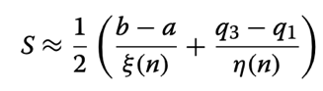 | After (6), where a is the minimum value, b is the maximum value, q₁ is the first quartile, q₃ is the third quartile, n is the sample size, and the two constants are available from Tables 1 and 2 in Wan et al. respectively.
Estimate standard deviation (SD)† from range | $$SD≈f x range$$ | After (7), where f is a conversion factor from Table 1 in Walter & Yao.
† Subsequent conversion to standard error (SE) given above.

When categorising tillage treatment, full inversion tillage (typically with a mouldboard plough) was classed as ‘conventional tillage’, direct drilling with no soil disturbance was classed as ‘no tillage’, and intermediate measures that involved some degree of non-inversion soil disturbance were coded as ‘reduced tillage’. We did not encounter chisel tillage deeper than 40 cm which has previously been classed alongside mouldboard ploughing as high-intensity tillage (5). Our categorisations usually agreed with the terms used in the original publications. Where a range was given for tillage depth (e.g. 25-30cm) the deepest of these was recorded, to be conservative.

Where error or variability values were clearly for between treatments rather than within treatments, these were not extracted as they do not relate to the error term of interest.

Some studies had a factorial design, where one of the interventions in the factorial design met our inclusion criteria but the other intervention/s did not. Where results were presented separately for each factor, only those for the intervention of interest were extracted. However, where results were presented factorially across intervention combinations, we extracted all data and let the meta-analysis model pool across the non-target factors (rather than pooling manually in advance), i.e. the model estimated the effects of interest across multiple observations that differed due to interventions not included in the analysis as predictors.

Where multiple articles were captured by the search that presented data for the same study, the citation and Unique article ID from the most recent study were used, and other articles were coded as ‘duplicate’ and their citations recorded in the datasheet. Similarly, where articles referred to previous articles for information about the same study, these were found where possible and their citations also recorded in the datasheet.

1.4. Requests for missing data

Where desired data was missing from studies (Table S6), we contacting the corresponding author of the article, using the following template:

Dear Dr/Prof [name],

I am a PhD student at the University of Oxford. I am conducting a systematic review (following Collaboration for Environmental Evidence guidelines) on the soil carbon and yield impacts of adopting no- or reduced tillage, cover crops, and ley-arable rotations in temperate arable systems, in collaboration with Prof Pete Smith and Dr Neal Haddaway.

I am including your study “[title]” published in [year] in the meta-analysis, and am contacting you to request if you could please provide some additional information to fully parametrise the analysis.

In particular, do you have any information on [delete as appropriate]
- Study site soil clay content (%)
- Study site soil bulk density (g/cm⁻³)
- Baseline (i.e. pre-intervention) measurement of the soil organic carbon (g/kg or t/ha) and corresponding standard deviation/error
- Within-treatment estimates of the variation associated with soil carbon measurements presented in the paper (standard deviation or standard error)
- Baseline (i.e. pre-intervention) measurement of crop yields (t/ha) and corresponding standard deviation/error
- Within-treatment estimates of the variation associated with crop yield measurements presented in the paper (standard deviation or standard error)
- What do the error values presented for soil carbon and/or yield correspond to (are these standard error, standard deviation, least significant difference, or other)?
- The number of soil samples used to calculate the mean estimates and error values presented in the study (i.e. what is ‘n’ for these values)

I would be very grateful if you could send me any of this information and would include you in the acknowledgments of the paper when written up. I am happy to get information from other published research articles where applicable if you could point me to these. It would also be useful to know if these data were not measured in your study or you no longer have access to the data.

Thank you very much.
Best wishes,
Matt

We thank authors who responded in the Acknowledgments section of the main paper.

Table S6. Required data missing from studies. P: information provided in study article, M: information missing from study article, MP: information missing from study article but provided by author upon contact.
Unique Study ID | Clay (%) | Bulk density | SOC baseline | SOC baseline error | SOC endline error | Yield endline error
2021RGHL_CCLANT025 | P | M | P | M | MP | MP
2021RGHL_CCLANT029 | M | M | M | M | P | P
2021RGHL_CCLANT029 | M | M | M | M | P | M
2020UPDTCCLA003 | P | P | P | P | MP | M
2020UPDTCCLA037_  2016UPDT014 | P | P | P | P | P | M
2020UPDTCCLA061a | P | P | P | M | M | M
2020UPDTCCLA061c | P | P | P | M | M | M
2020UPDTCCLA071 | P | P | M | M | P | P
2020UPDTCCLA072 | P | P | P | M | M | M
2020UPDTCCLA074a | MP | MP | M | M | P | P
2020UPDTCCLA074b | MP | M | M | M | P | P
2020UPDTCCLA074c | MP | M | M | M | P | P
2020UPDTCCLA081 | M | M | P | M | M | P
2020UPDTCCLA114 | P | P | P | P | P | P
2020UPDTCCLA116 | P | P | P | P | P | MP
2020UPDTCCLA136 | P | MP | M | M | P | M
2020UPDTCCLA136 | P | M | M | M | M | M
2020UPDTCCLAsnowball161a | M | P | M | M | P | M
2020UPDTCCLAsnowball161b | M | P | M | M | P | M
2020UPDTCCLAsnowball161c | M | P | M | M | P | M
2020UPDTCCLAsnowball162_  THOMS04V20.1 | P | P | M | M | P | M
2020UPDTCCLAhdwymissed184 | P | M | M | M | M | M
TAYLO06V144.2a | M | M | M | M | M | P
TAYLO06V144.2b | M | M | M | M | M | P
BROCK11V174.3 | M | M | M | M | P | P
2020UPDT006 | P | P | M | M | P | P
2020UPDT011 | P | P | P | M | M | P
2020UPDT012 | P | P | M | M | M | P
2020UPDT038 | P | P | M | M | P | P
2020UPDT043a | M | M | MP | MP | M | M
2020UPDT043b | M | M | MP | MP | M | M
2020UPDT043c | M | M | MP | MP | P | M
2020UPDT058a | M | P | P | M | M | P
2020UPDT058b | M | P | P | M | M | P
2020UPDT066 | P | M | M | M | M | M
2020UPDT070 | P | MP | M | M | P | P
2020UPDT126 | P | MP | P | P | P | P
2020UPDT199 | M | P | M | M | P | M
10245926 | P | P | M | M | P | P
2016UPDT018b | MP | P | M | M | M | M
2016UPDT018c | MP | P | M | M | M | M
2016UPDT018e | MP | P | M | M | M | M

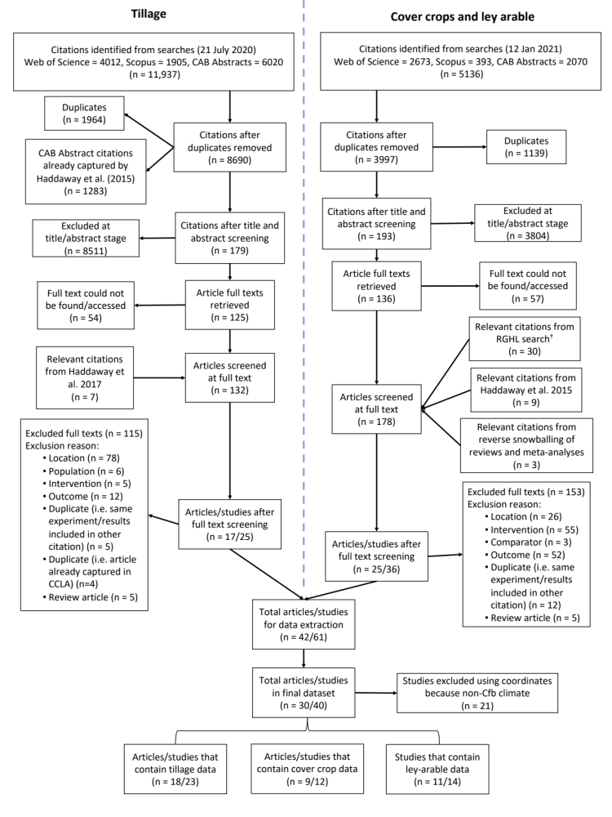
Figure S1. The literature searching and screening process, with the number of records included and excluded at each stage. For articles excluded at the full text screening stage, the number excluded for each reason are also given. This flow chart follows the template of (8). † RGHL search undertaken for a separate meta-analysis following similar systematic review methods of rotational grazing and herbal ley interventions in temperate oceanic regions (Jordon et al., in prep).
2. Bayesian meta-regression methods

Because we included tillage, cover crop and ley-arable interventions in the same analyses, where studies were not explicit about any of these regimes, we assumed ‘conventional’ practice as the default (i.e. conventional tillage, no cover crops, and no ley phase in arable rotation). In particular, some ley-arable and cover crop studies did not specify tillage regime. When we included ‘not specified’ as a level in the tillage intensity categorical predictor, this was not significantly different to the ‘conventional tillage’ level, which gives us confidence that this is a suitable approach.

Although we extracted data on intervention-specific predictors such as tillage depth, cover crop composition, and ley management, we lacked observations to robustly include these in intervention-specific analyses. Because many studies did not present both SOC and crop yield results factorially across fertiliser treatments, or did not specify fertiliser applications, we were unable to include fertiliser as a predictor in the analysis. Because no studies presented true baseline data for yield, we were unable to include this as a predictor. We did not include study site as a nested random factor with Unique study ID, because there were few sites with multiple studies in our dataset. We did not conduct a depth-distributed analysis for tillage studies as in Haddaway, et al. (5) as we were primarily interested in the overall impact of interventions on SOC and including multiple sampling depths per study treatment was not possible in a multivariate analysis with yield.

Table S7. Details of brm sampling when fitting models
Model | Chains | Iterations‡ | Warmup samples‡ | Total post-warmup samples
EP | 4 | 2000 | 1000 | 4000
EI | 40† | 2000 | 1000 | 40000
EIBP | 40† | 8000 | 4000 | 160000
EIBI | 40† | 8000 | 4000 | 160000
‡per chain
†4 chains per imputed dataset, 10 imputed datasets

Table S8. Results of univariate analysis estimating the effect on ‘endline’ arable crop yield (t.ha⁻¹) of interactions between ‘endline’ soil organic carbon (g.100g⁻¹) and regenerative interventions, using EI (error imputed) dataset (195 observations from 40 studies). See Methods in main text for further details. 95% Credible Intervals are given in brackets, with * denoting where these do not overlap with 0
Intercept | SOC endline | No till | Reduced till | Cover crops | Ley-arable | R2
 |  |  |  |  |  | Whole model | Fixed effects
1.94  (-4.76, 8.54) | 4.66  (1.29, 8.05)* | -0.81  (-4.10, 2.51) | 0.56  (-2.42, 3.55) | -0.05  (-6.49, 6.37) | -0.23  (-1.79, 1.36) | 0.943 | 0.509
SOC:intervention  interaction terms |  | -0.23  (-2.04, 1.57) | -0.86  (-2.50, 0.77) | -0.05  (-4.71, 4.67) | 0.08  (-0.77, 0.93) | 0.943 | 0.509

3. Additional Supplementary Figures

Figure S2. Forest plots showing treatment results from studies of reduced tillage intensity identified by systematic review, for (a) soil organic carbon (g.100g⁻¹) and (b) cash crop yield (t.ha⁻¹). Estimates of SOC and yield with 95% confidence intervals for each treatment extracted from studies are given in the table and plotted adjacent for each row. Where treatment standard errors were imputed for analysis (see main text methods), these are presented in the confidence intervals. Tillage treatment categories are conventional tillage (CT), reduced tillage (RT) and no-till (NT). The number of soil samples (n) per treatment are given in (a), while the crop that yield was measured for are given in (b). Treatment duration at the point of SOC or yield measurement is given in years. Summary estimates and 95% credible intervals for each tillage category from a tillage-only meta-analysis are also shown. Note that main analysis results presented in text were estimated using full dataset across all interventions (see Methods in main text for details).

Figure S3. Forest plots showing treatment results from studies of cover cropping identified by systematic review, for (a) soil organic carbon (g.100g⁻¹) and (b) cash crop yield (t.ha⁻¹). Estimates of SOC and yield with 95% confidence intervals for each treatment extracted from studies are given in the table and plotted adjacent for each row. Where treatment standard errors were imputed for analysis (see main text methods), these are presented in the confidence intervals. The proportion of years in the arable rotation that cover crops were present is given. The number of soil samples (n) per treatment are given in (a), while the crop that yield was measured for are given in (b). Treatment duration at the point of SOC or yield measurement is given in years. Summary estimates and 95% credible intervals of cover crop presence in rotation for no years or all years (expressed as proportion) from a cover crop-only meta-analysis are also shown. Note that main analysis results presented in text were estimated using full dataset across all interventions (see Methods in main text for details).

Figure S4. Forest plots showing treatment results from studies of ley-arable systems identified by systematic review, for (a) soil organic carbon (g.100g⁻¹) and (b) cash crop yield (t.ha⁻¹). Estimates of SOC and yield with 95% confidence intervals for each treatment extracted from studies are given in the table and plotted adjacent for each row. Where treatment standard errors were imputed for analysis (see main text methods), these are presented in the confidence intervals. The length of the ley phase within the arable rotation for each treatment is given in years. The number of soil samples (n) per treatment are given in (a), while the crop that yield was measured for are given in (b). Treatment duration at the point of SOC or yield measurement is given in years. Summary estimates and 95% credible intervals for ley durations of 0 and 1 year from a ley-arable-only meta-analysis are also shown. Note that main analysis results presented in text were estimated using full dataset across all interventions (see Methods in main text for details).

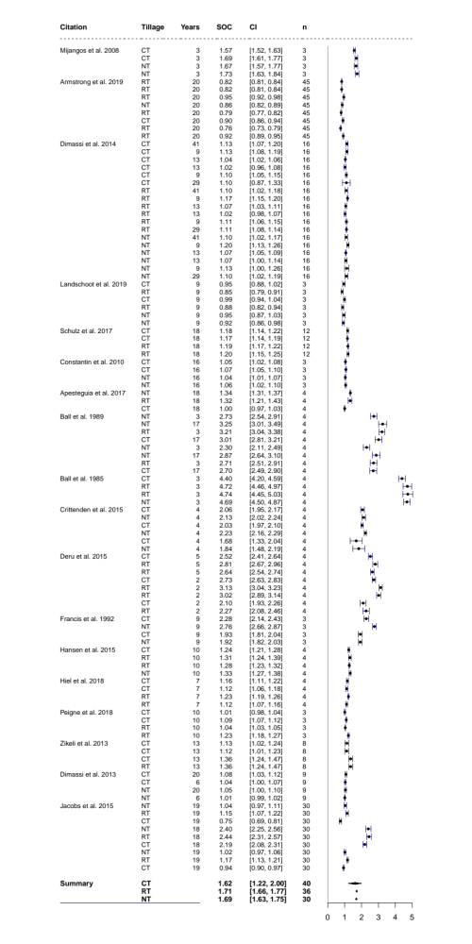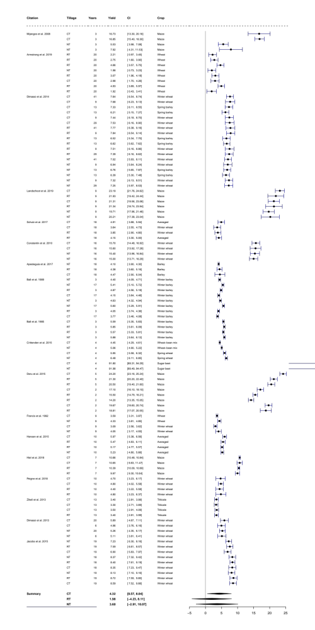
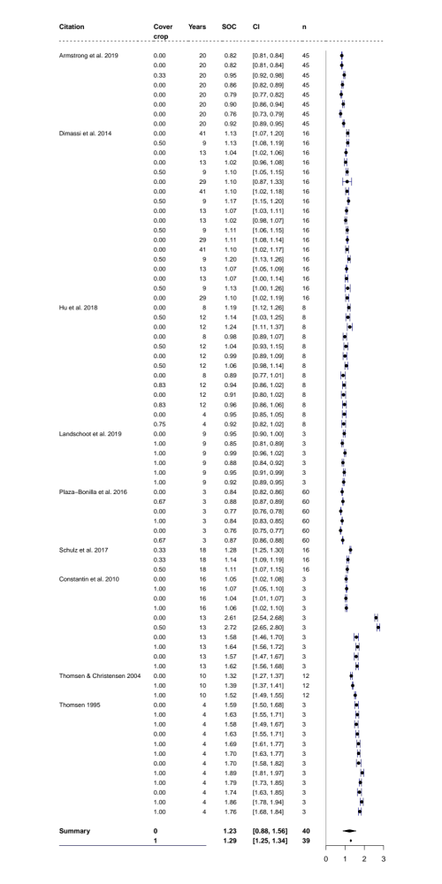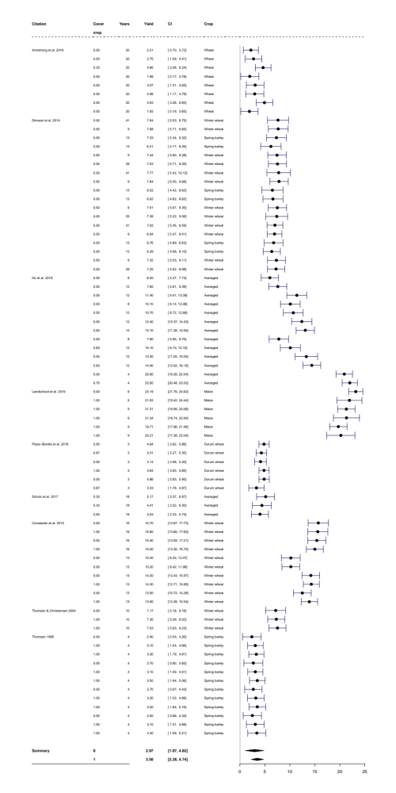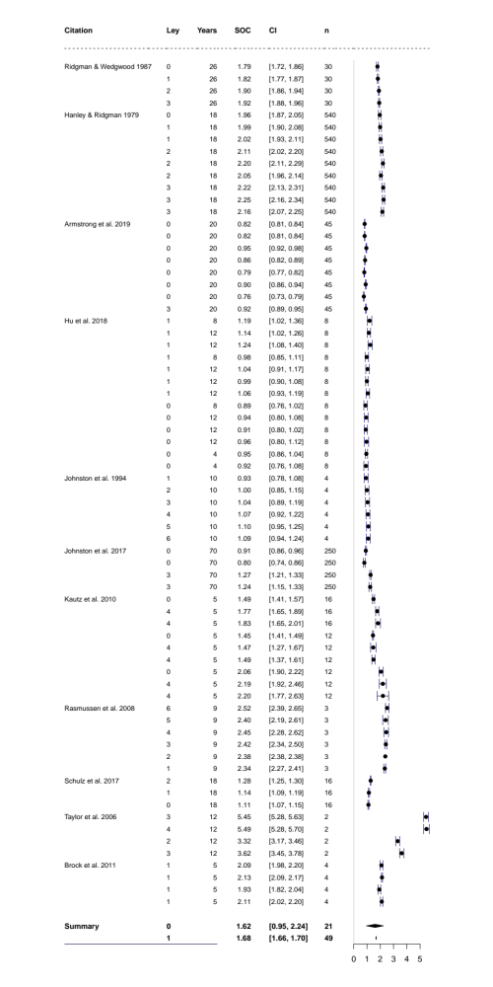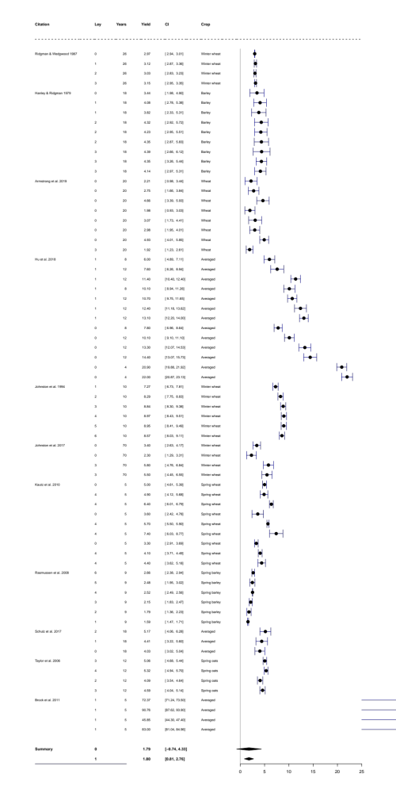
References

1. N. R. Haddaway, B. Macura, P. Whaley, A. S. Pullin (2017) ROSES for Systematic Review Reports.
2. M. W. Jordon, Supplementary Files for Systematic Review. DOI: 10.5281/zenodo.5517420
3. M. C. Peel, B. L. Finlayson, T. A. McMahon, Updated world map of the Köppen-Geiger climate classification. Hydrology and Earth System Sciences 11, 1633-1644 (2007).
4. N. R. Haddaway et al., What are the effects of agricultural management on soil organic carbon in boreo-temperate systems? Environmental Evidence 4 (2015).
5. N. R. Haddaway et al., How does tillage intensity affect soil organic carbon? A systematic review. Environmental Evidence 6 (2017).
6. X. Wan, W. Wang, J. Liu, T. Tong, Estimating the sample mean and standard deviation from the sample size, median, range and/or interquartile range. BMC Medical Research Methodology 14, 135 (2014).
7. S. D. Walter, X. Yao, Effect sizes can be calculated for studies reporting ranges for outcome variables in systematic reviews. J Clin Epidemiol 60, 849-852 (2007).
8. N. R. Haddaway, B. Macura, P. Whaley, P. A.S., ROSES flow diagram for systematic reviews. Version 1.0. . 10.6084/m9.figshare.5897389 (2017).

