Supplementary Table S1. Baseline demographic and anthropometric data for children categorized by left ventricular remodeling geometry (remodeling vs normal).
 | LVR Group  n=63 | Normal-geometry Group  n=63 | P value | SMD
Age, years | 13.00 ± 2.00 | 13.00±2.00 | - | -
Male sex, n (%) | 54 (85.7%) | 54 (85.7%) | - | -
Height (cm) | 169.10±12.55 | 170.86±11.50 | 0.586 | -0.146
Weight (kg) | 96.80±17.06 | 98.09±19.51 | 0.694 | -0.070
Body mass index (kg/m²) | 33.62±5.34 | 33.28±4.65 | 0.705 | 0.068
Body surface area (m²) | 2.13±0.24 | 2.15±0.26 | 0.621 | -0.088
Waist Circumference (cm) | 106.02±11.34 | 107.14±14.53 | 0.63 | -0.086
Hip Circumference (cm) | 112.09±10.96 | 111.86±9.37 | 0.899 | 0.023
Waist-To-height ratio | 0.63±0.09 | 0.63±0.08 | 0.955 | 0.045
VAI | 1.76 (1.37–2.88) | 1.66 (1.37–2.10) | 0.222 | 0.364
Data are reported as mean ± SD, median with (IQR), or counts (percentage), where appropriate. Cases and controls were matched at a 1:1 ratio without replacement, with exact matching on age and sex, and optimal matching to reduce overall BMI discrepancies. Postmatching balance was evaluated via SMDs, with an absolute SMD <0.10 considered adequate. Height and VAI exhibited residual imbalance.
Abbreviations: BMI, body mass index; BSA, body surface area; IQR, interquartile range; LVR, left ventricular remodeling; SD, standard deviation; SMD, standardized mean difference; VAI, visceral adiposity index.

Supplementary Table S2. Complete baseline characteristics for the matched cohort stratified by LVR presence.
 | LVR group (n=63) | Normal-geometry Group  n=63 | P-value
Ambulatory Blood Pressure (ABPM)
24-h Mean SBP (mmHg) | 128.51 ± 7.68 | 126.50 ± 6.23 | 0.086
24-h Mean DBP (mmHg) | 75.00 (70.00–79.45) | 73.00 (71.00–77.00) | 0.173
Daytime SBP (mmHg) | 131.94 ± 9.11 | 129.18 ± 6.91 | 0.046
Daytime DBP (mmHg) | 77.80 (70.42–81.00) | 76.00 (73.00–79.50) | 0.693
Nighttime SBP (mmHg) | 122.96 ± 8.12 | 122.05 ± 6.93 | 0.478
Nighttime DBP (mmHg) | 71.93 ± 7.19 | 69.80 ± 6.48 | 0.063
SBP dipping rate (%) | 6.64 ± 5.84 | 5.66 ± 4.10 | 0.224
DBP dipping rate (%) | 6.25 ± 7.28 | 6.70 ± 5.58 | 0.674
Clinical Characteristics
Hypertension grade, n（%） |  |  | 0.005
Grade 1 | 33 (52.4%） | 49 (77.8%)
Grade 2 | 30 (47.6%) | 14 (22.2%)
Parental history of hypertension，n（%） | 33 (52.4%) | 19 (30.2%) | 0.016
Maternal gestational hypertension, n（%） | 7 (11.1%) | 5 (7.9%) | 0.774
Hyperuricemia, n（%） | 45 (71.4%) | 48 (76.2%) | 0.678
Hypertriglyceridemia, n（%） | 21 (33.3%) | 24 (38.1%) | 0.701
OSAS, n（%） | 51 (81.0%) | 36 (57.1%) | 0.001
Diabetes mellitus, n（%） | 8 (12.7%) | 8 (12.7%) | 1.000
Metabolic syndrome, n（%） | 39 (61.9%) | 43 (68.3%) | 0.585
WBC (×10⁹/L) | 7.58 ± 1.19 | 7.37 ± 1.27 | 0.389
RBC (×10¹²/L) | 5.14 ± 0.41 | 5.18 ± 0.53 | 0.598
ANC (×10⁹/L) | 4.58 ± 1.19 | 4.34 ± 1.15 | 0.197
Hb (g/L) | 144.00 (136.13–152.00) | 140.00 (127.50–154.97) | 0.333
Hct (%) | 42.67 ± 3.17 | 42.68 ± 4.78 | 0.985
MCV (fL) | 82.82 (81.12–85.65) | 82.90 (79.17–85.85) | 0.146
MCH (pg) | 28.20 (27.20–29.10) | 28.07 (26.45–29.05) | 0.121
MCHC (g/L) | 340.99 (328.00–351.65) | 334.19 (325.79–343.75) | 0.015
RDW (%) | 12.71 (12.20–13.37) | 13.00 (12.40–13.84) | 0.202
PLT (×10⁹/L) | 305.00 ± 85.96 | 332.29 ± 56.76 | 0.027
MPV (fL) | 10.44 ± 0.89 | 9.93 ± 0.78 | 0.002
PDW (fL) | 12.22 ± 1.44 | 11.13 ± 1.18 | <0.001
PCT (%) | 0.33 ± 0.08 | 0.33 ± 0.06 | 0.969
ALC (×10⁹/L) | 2.89 ± 0.76 | 2.70 ± 0.66 | 0.131
NEU (%) | 54.84 ± 7.83 | 56.01 ± 7.81 | 0.394
LYM (%) | 34.50 ± 8.28 | 35.11 ± 7.38 | 0.651
PLR | 117.65 ± 33.11 | 121.93 ± 31.72 | 0.456
NLR | 1.71 ± 0.56 | 1.56 ± 0.54 | 0.142
ESR (mm/h) | 10.35 ± 4.29 | 9.06 ± 4.47 | 0.079
Homocysteine (μmol/L) | 9.77 (8.36–14.57) | 10.57 (8.39–19.43) | 0.091
Potassium (mmol/L) | 4.28 ± 0.36 | 4.19 ± 0.33 | 0.206
Sodium (mmol/L) | 139.76 ± 1.99 | 139.44 ± 2.04 | 0.356
Total cholesterol (mmol/L) | 4.27 ± 0.92 | 4.05 ± 0.77 | 0.179
Uric acid (μmol/L) | 489.88 ± 136.53 | 485.59 ± 90.64 | 0.816
Glucose (mmol/L) | 4.81 (4.56–5.15) | 4.93 (4.50–5.44) | 0.477
Total calcium (mmol/L) | 2.38 ± 0.13 | 2.40 ± 0.13 | 0.417
Triglycerides (mmol/L) | 1.37 (1.11–1.90) | 1.23 (0.96–1.54) | 0.050
HDL-C (mmol/L) | 1.05 ± 0.20 | 1.08 ± 0.22 | 0.470
LDL-C (mmol/L) | 2.63 ± 0.70 | 2.51 ± 0.56 | 0.266
HOMA-IR | 7.41 (4.43–10.89) | 6.62 (5.03–8.92) | 0.913
Data are presented as mean ±SD or median interquartile range, while categorical variables are presented as counts (percentages). To account for the matched design, paired t-tests or Wilcoxon signed-rank tests were applied to continuous measures, and McNemar’s tests to categorical ones. Statistically significant P-values are bolded.
Abbreviations used: SBP, systolic blood pressure; DBP, diastolic blood pressure; OSAS, obstructive sleep apnea syndrome; MCHC, mean corpuscular hemoglobin concentration; PLT, platelet count; MPV, mean platelet volume; PDW, platelet distribution width; ESR, erythrocyte sedimentation rate; HOMA-IR, homeostasis model assessment of insulin resistance.

Supplementary Table S3. Predictive accuracy of platelet distribution width (PDW) as a single marker for LVR in the matched study cohort.
Marker | AUC (95% CI) | Optimal cutoff (fL) | Sensitivity | Specificity
PDW | 0.696(0.603–0.788) | 11.500 | 0.698 | 0.651

Note：The area under the receiver operating characteristic curve is denoted by AUC. The Youden index was used to determine the optimal cutoff value. Bootstrap resampling (1,000 iterations) yielded the 95% CI for AUC.

Supplementary Figure S1. Comparison of PDW values between children with and without LVR.
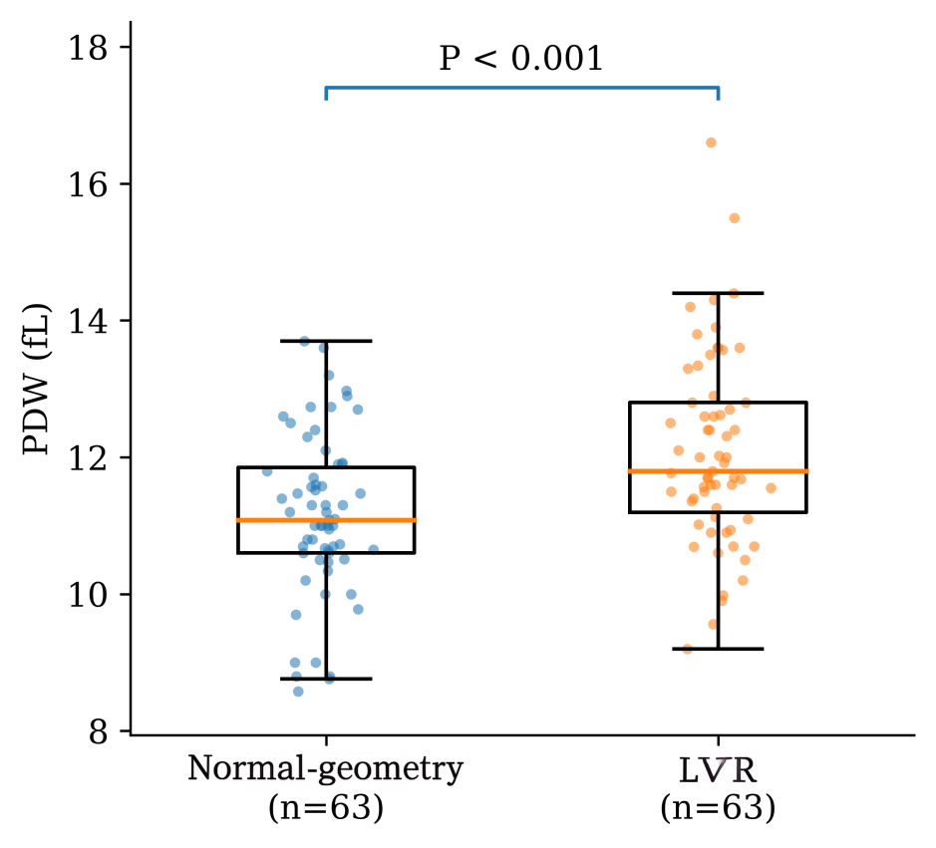
The boxplots illustrate the median and interquartile ranges, with individual data points also shown. The Wilcoxon signed-rank test was used for group comparisons. PDW values were higher in children with LVR than in matched controls with normal left ventricular geometry

Supplementary Figure S2. Platelet distribution width (PDW) in relation to left ventricular mass index (LVMI).

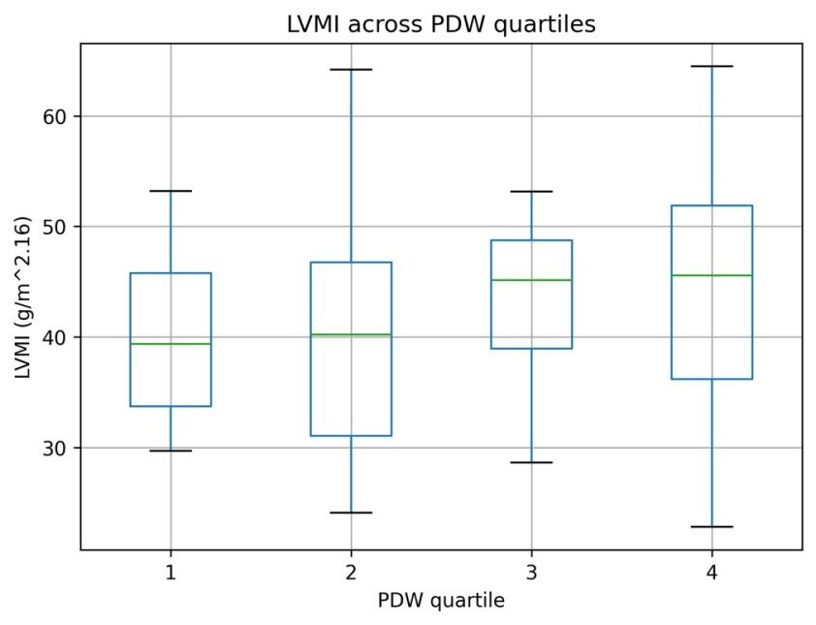
Supplementary Figure S2. Association between platelet distribution width (PDW) and left ventricular mass index (LVMI).
(A) Scatter plot showing the association between PDW and LVMI. The solid line represents the fitted linear regression line, and the shaded area represents its 95% confidence interval.
(B) Distribution of LVMI across PDW quartiles (Q1–Q4). The P value for trend was derived from a linear regression model treating PDW quartiles as an ordinal variable.
In the continuous analysis, higher PDW was associated with higher LVMI (β = 1.77, P = 0.002; Supplementary Figure S2A). When PDW was categorized into quartiles, LVMI increased progressively across PDW quartiles (P for trend = 0.028; Supplementary Figure S2B).

Supplementary Figure S3. Receiver operating characteristic (ROC) curve of PDW for left ventricular remodeling prediction.

Supplementary Figure S3. Receiver operating characteristic (ROC) curve showing the discrimination capacity of platelet distribution width (PDW) for predicting left ventricular remodeling(LVR)in the matched study population. The AUC value was 0.696 (95% CI presented in Supplementary Table S3).

