Extended Data Figures

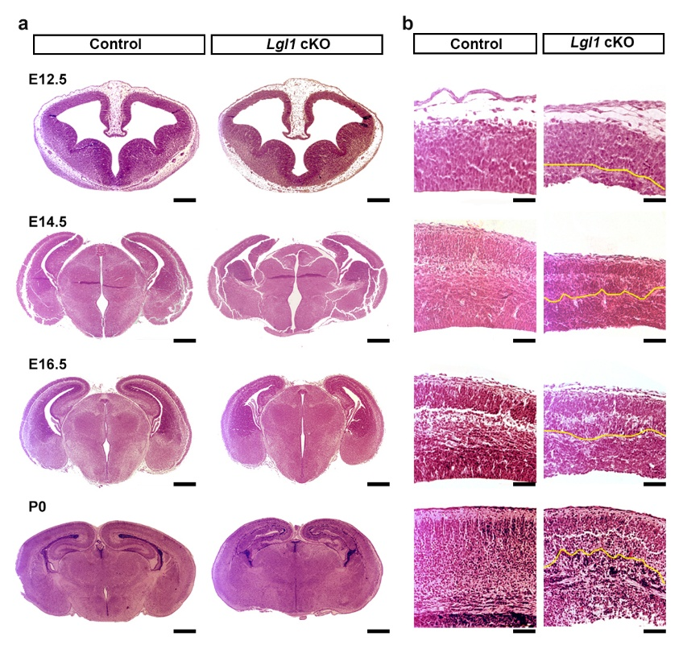
Extended Data Fig. 1: Lgl1 deletion in cortical progenitors causes heterotopia formation. a, Representative H&E images of cortical sections of Lgl1 cKO and Control littermates. Scale bar E12.5, 500 µm. Scale bar E14.5-P0, 1000 µm. b, Zoomed H&E images of cortical sections of Lgl1 cKO and Control littermates. Heterotopia area distinguished from normal cortex by yellow dashed line. Scale bars, 100 µm.

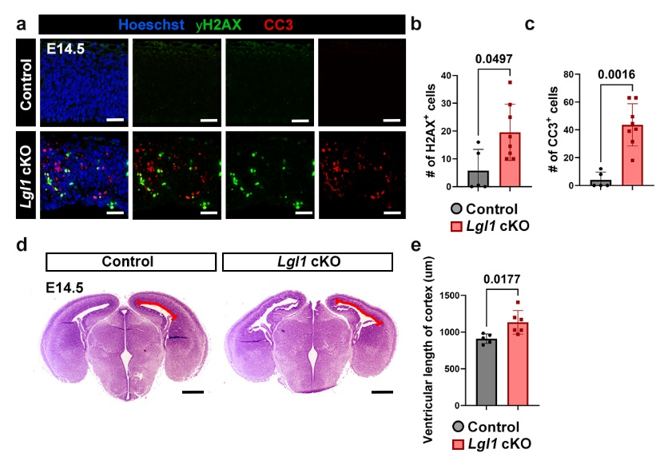
Extended Data Fig. 2: Lgl1 deletion leads to increased cell death and ventricular length. a, Representative IF images of γH2AX and CC3 staining at E14.5 in Control and Lgl1 cKO. Scale bar, 50 µm. b, Quantification of γH2Ax+ cells in (a). Control n=5; Lgl1 cKO n=8. c, Quantification of CC3+ cells in (a). Control n=5; Lgl1 cKO n=8. d, Representative H&E staining at E14.5 of Control and Lgl1 cKO. The red line indicates the length measured in (e). Scale bar, 500 µm. e, Quantification of total lateral ventricular length in (d). Data are mean ± s.e.m. Each data point represents the average of 1-2 sections per sample. Mann-Whitney test was performed for (b) and (c). Unpaired students' t-test was performed for (e).
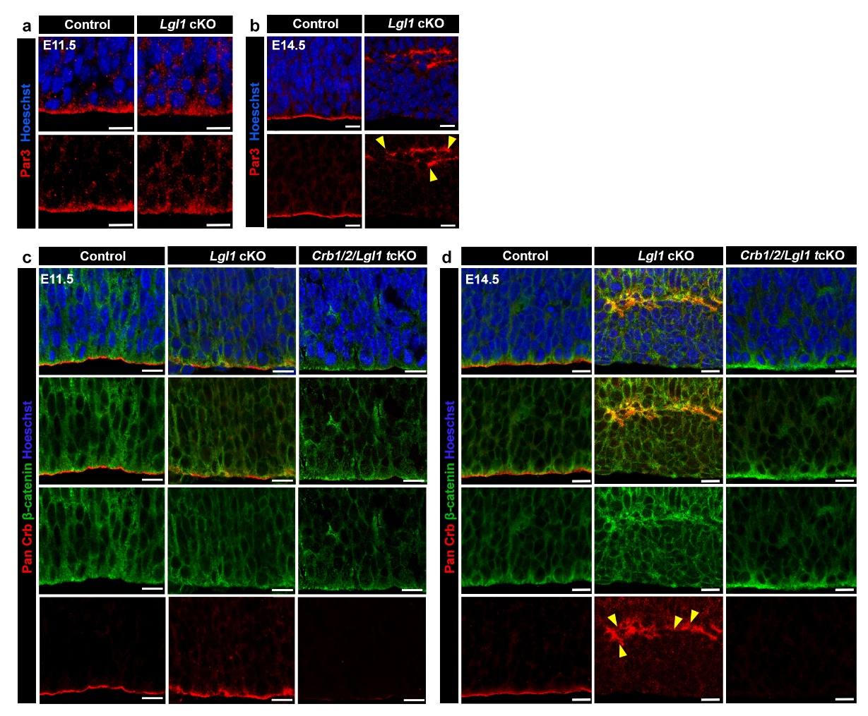
Extended Data Fig 3: Lgl1 deletion leads to disrupted junctions and expanded apical proteins Par3 and Crbs, with concurrent KO of Crb1/2 restoring junction defects. a, Representative IF images of Par3 staining in E11.5 cortices in Control and Lgl1 cKO. Scale bar, 10 μm. b, Representative IF images of Par3 staining in E14.5 cortices in Control and Lgl1 cKO. Scale bar,10 µm. c, Representative IF images of Control and Lgl1 cKO, Crb1/2/Lgl1 tcKO at E11.5 with PanCrb and b-Catenin staining. Scale bars, 10 µm. d, Representative IF images of Control, Lgl1 cKO, and Crb1/2/Lgl1 tcKO at E14.5 with PanCrb and b-Catenin. Scale bars, 10µm.

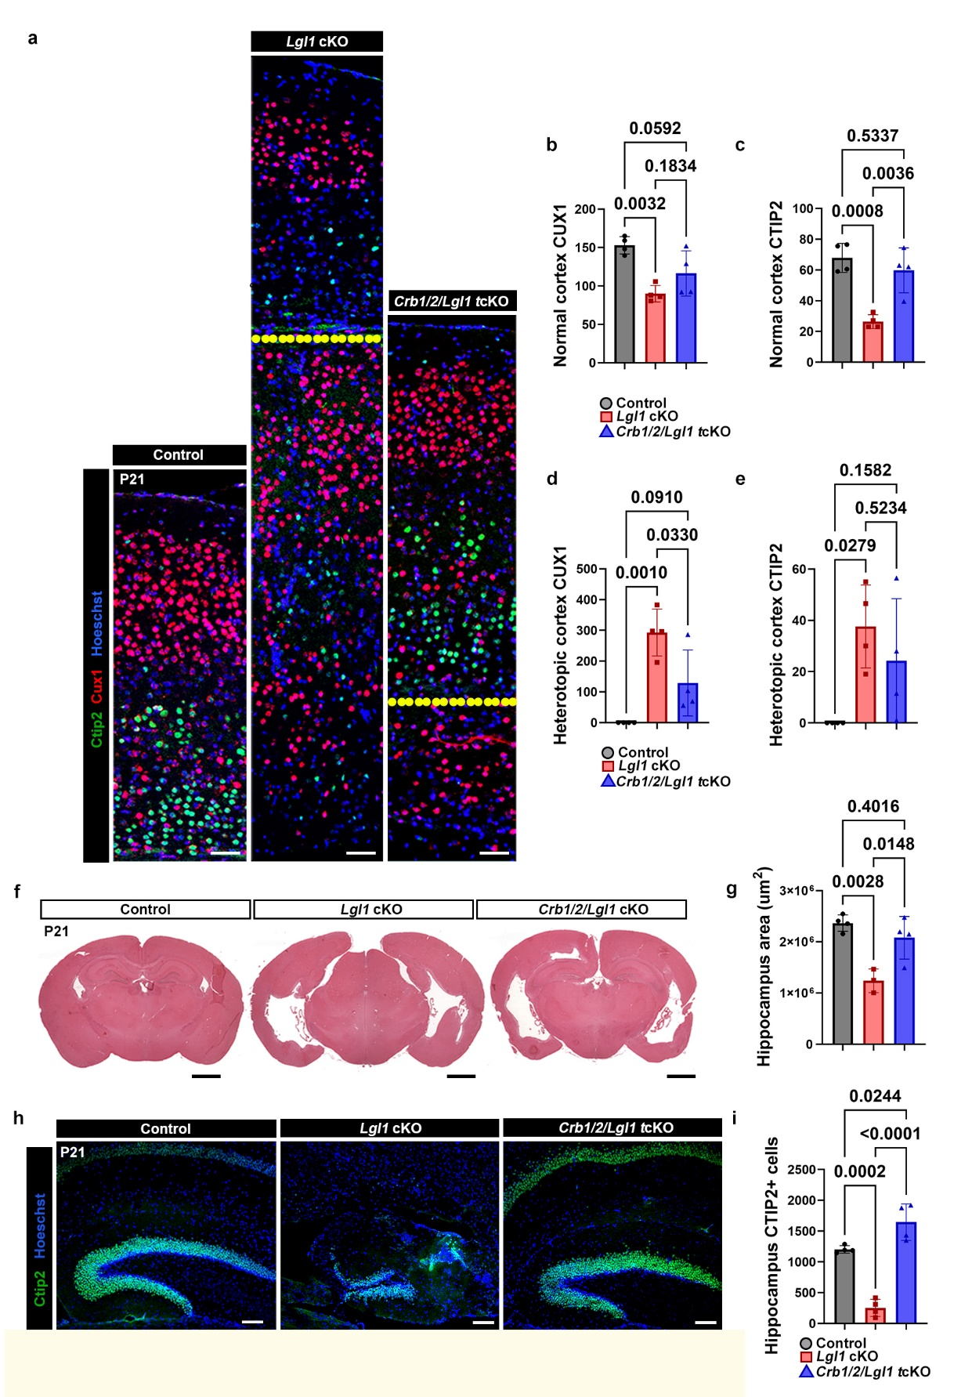
Extended Data Fig. 4: Heterotopia, layer, and hippocampus formation in Lgl1 mutants is partially rescued by Crb1/Crb1 genetic deletion. a, Representative IF images of Cux1 and Ctip2 layer staining in P21 cortical sections in Control, Lgl1 cKO and Crb1/2/Lgl1 tcKO. Scale bar, 50 µm. b, Quantification of Cux1+ cells in the normotopic cortex region in (a). Control n= 5; Lgl1 cKO n=4; Crb1/Crb2/Lgl1 tcKO n=4. c, Quantification of Ctip2+ cells in the normotopic cortex region in (a). Control n= 5; Lgl1 cKO n=4; Crb1/Crb2/Lgl1 tcKO n=4. d, Quantification of Cux1+ cells in the heterotopic cortex region in (a). Control n= 5; Lgl1 cKO n=4; Crb1/Crb2/Lgl1 tcKO n=4. e, Quantification of Ctip2+ cells in the heterotopic cortex region in (a). Control n= 5; Lgl1 cKO n=4; Crb1/Crb2/Lgl1 tcKO n=4. f, Representative H&E images of cortical sections of Lgl1 cKO, Crb1/Crb2/Lgl1 tcKO, and Control littermates at P21. Scale bar, 1000 µm. g, Quantification of hippocampus area in (f). Control n=4; Lgl1 cKO n=3; Crb1/2/Lgl1 tcKO n=4. h, Representative IF images of Ctip2 in the hippocampus of P21 cortical sections. Scale bars, 100 µm. i, Quantification of Ctip2+ cells in the hippocampus. Control n=4; Lgl1 cKO n=4; Crb1/2/Lgl1 tcKO n=4. Each data point represents the average of 1-2 sections per sample. All data bars presented as the mean ± s.e.m.; statistical significance was determined by Ordinary one-way ANOVA with Tukey’s multiple comparisons test between groups.

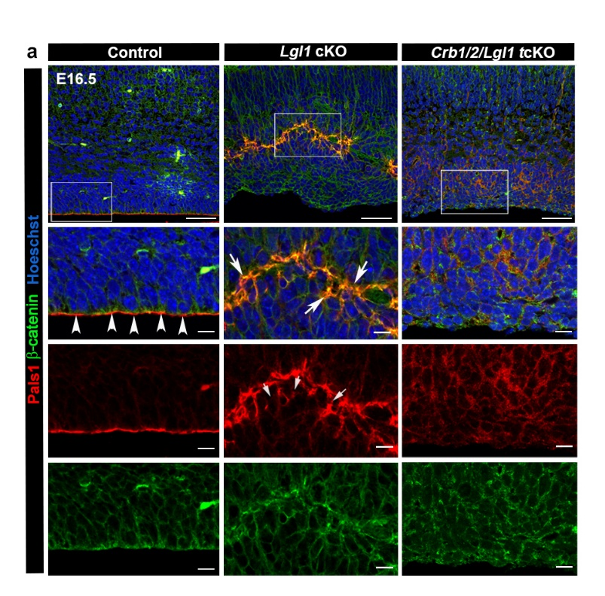
Extended Data Fig 5: Crb1/Crb2 are required for junction formation during late neurogenesis. a, Representative IF images of Pals1 and N-cadherin in E16.5 cortical sections of Control, Lgl1 cKO and Crb1/Crb2/Lgl1 tcKO. Scale bars top, 50 µm. Zoomed scale bars, 10 µm.

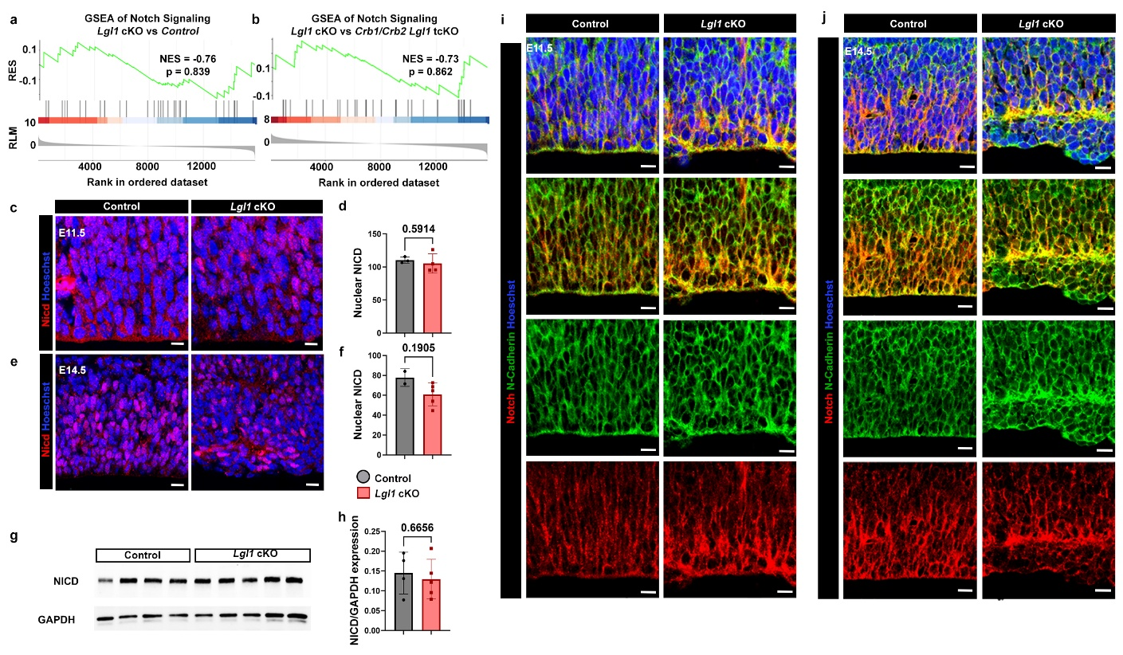
Extended Data Fig. 6: Notch signaling is unaltered in Lgl1 cKO. a, Gene set enrichment analysis of bulk RNA sequencing data of Lgl1 cKO vs Control. b, Gene set enrichment analysis of bulk RNA sequencing data of Lgl1 cKO vs Crb1/2/Lgl1 tcKO. c, Representative IF images of Nicd staining at E11.5 in Control and Lgl1 cKO. Scale bar, 10 µm. d, Quantification of 100 µm width of cortex for nuclear Nicd in (c). Control n=3; Lgl1 cKO n=4. e, Representative IF images of Nicd staining at E14.5 in Control and Lgl1 cKO. Scale bar, 10 µm. f, Quantification of 100 µm width of cortex for nuclear Nicd in (e). Control n=2; Lgl1 cKO n=5. g, Western blot for Nicd and Gapdh control. h, Quantification of blot in (g). Control n=4; Lgl1 cKO n=5. i, Representative IF images of Notch and N-cadherin staining at E11.5 in Control and Lgl1 cKO. Scale bar, 10 µm. j, Representative IF images of Notch and N-cadherin staining at E14.5 in Control and Lgl1 cKO. Scale bar, 10 µm. Each data point (n) represents 1-2 sections per sample. All data bars presented as the mean ± s.e.m. Unpaired t test (d,h); Mann-Whitney test (f).
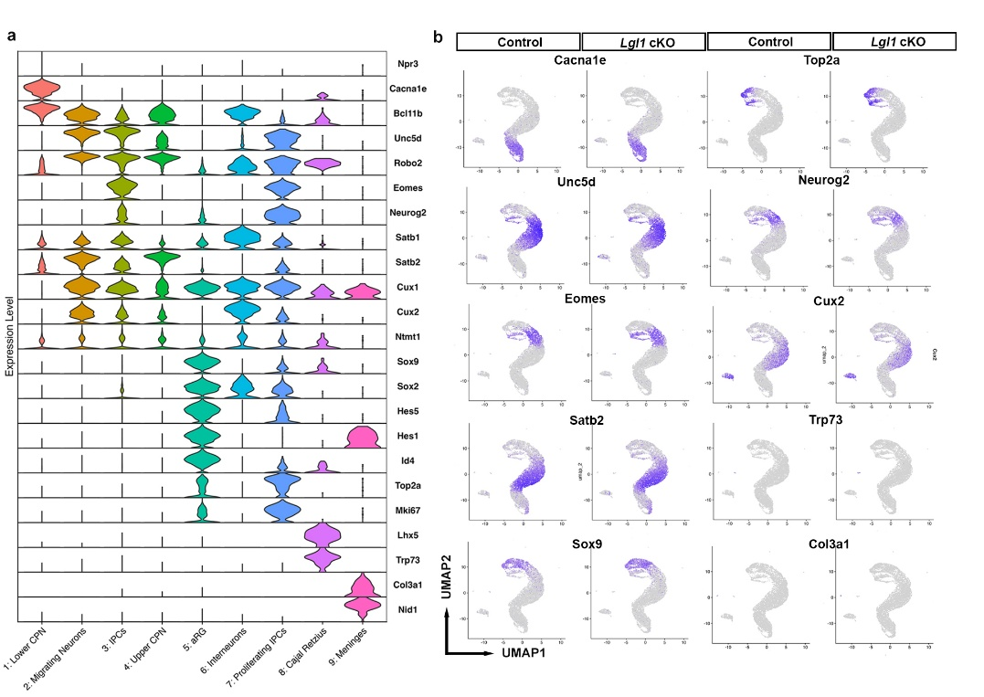
Extended Data Fig 7: Single-cell RNA transcriptomic analysis performed at E15.5 cortices yields 9 distinct clusters. a, Violin plot of select markers across all clusters. b, Uniform manifold approximation and projection (UMAP) of Control and Lgl1 cKO with corresponding cluster identities corresponding to (a).
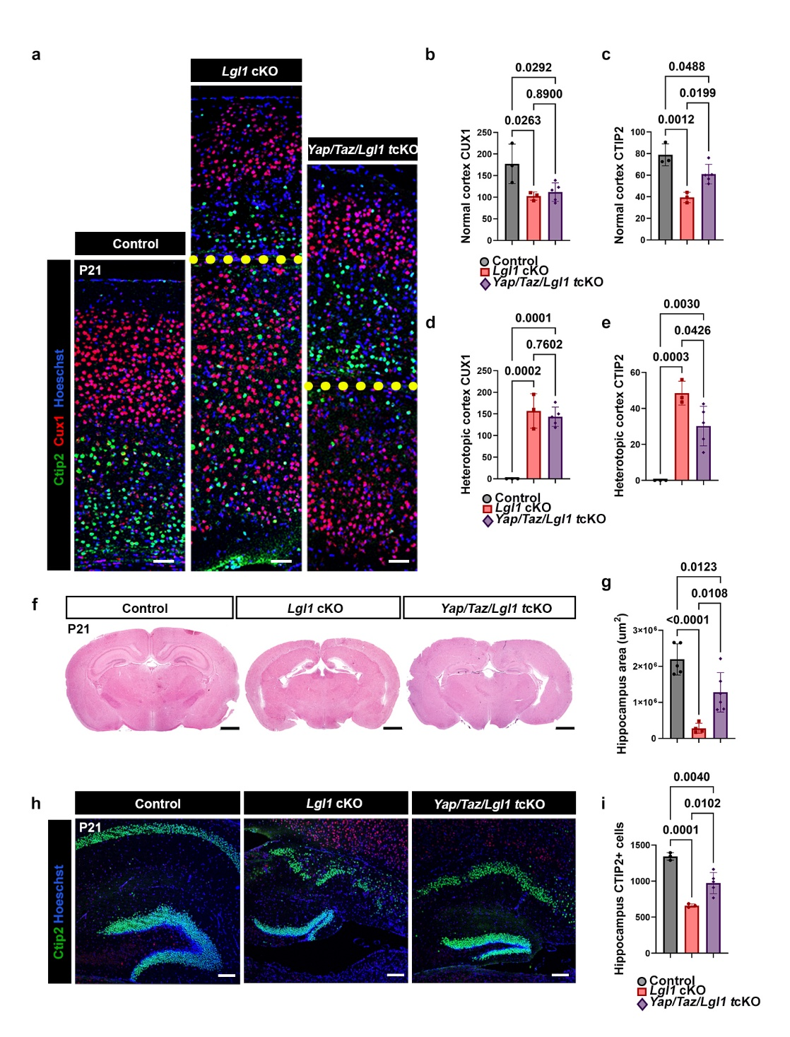
Extended Data Fig 8: Heterotopia, layer, and hippocampus formation in Lgl1 cKO is partially rescued by Yap/Taz genetic deletion. a, Representative IF images of Cux1 and Ctip2 layer staining in P21 cortical sections in Control, Lgl1 cKO and Yap/Taz/Lgl1 tcKO. Scale bar, 50 μm. b, Quantification of Cux1+ cells in the normotopic cortex region in (a). Control n= 3; Lgl1 cKO n=3; Yap/Taz/Lgl1 tcKO n=5.

c, Quantification of Ctip2+ cells in the normotopic cortex region in (a). Control n= 3; Lgl1 cKO n=3; Yap/Taz/Lgl1 tcKO n=5. d, Quantification of Cux1+ cells in the heterotopic cortex region in (a). Control n= 3; Lgl1 cKO n=3; Yap/Taz/Lgl1 tcKO n=5. e, Quantification of Ctip2+ cells in the heterotopic cortex region in (a). Control n= 3; Lgl1 cKO n=3; Yap/Taz/Lgl1 tcKO n=5. f, Representative H&E images of cortical sections of Lgl1 cKO, Yap/Taz/Lgl1 tcKO, and Control littermates at P21. Scale bar, 1000 μm. g, Quantification of hippocampus area in (f). Control n=5; Lgl1 cKO n=4; Yap/Taz/Lgl1 tcKO n=6. h, Representative IF images of Ctip2 in the hippocampus of P21 cortical sections. Scale bars, 100 μm. i, Quantification of Ctip2+ cells in the hippocampus. Control n=3; Lgl1 cKO n=3; Yap/Taz/Lgl1 tcKO n=5. Each data point represents the average of 1-2 sections per sample. All data bars presented as the mean ± s.e.m.; statistical significance was determined by Ordinary one-way ANOVA with Tukey’s multiple comparisons test between groups.
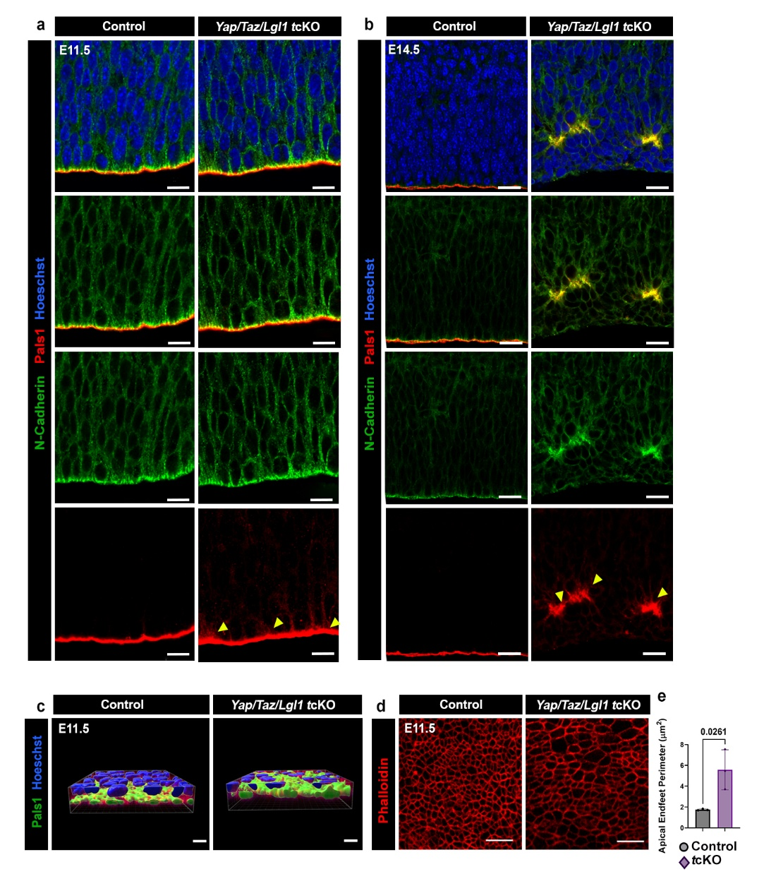
Extended Data Fig 9: Yap/Taz deletion does not restore apical expansion, ectopic AJ, or apical endfeet widening. a, Representative IF images of Pals1 and N-cadherin in Control and Yap/Taz/Lgl1 tcKO littermates at E11.5. Scale bars, 10 µm. b, Representative IF images of Pals1 and N-cadherin in Control and Yap/Taz/Lgl1 tcKO littermates at E14.5. Scale bars, 20 µm. c, Imaris reconstruction of E11.5 Pals1 staining. Scale bars, 5 µm. d, Apical explant staining visualizing apical endfeet. Scale bar, 5 µm. e, Quantification of endfeet area. Control n=3; Yap/Taz/Lgl1 tcKO n=3. Data bars presented as the mean ± s.e.m.; statistical significance was determined by students' t-test.

