Supplemental Methods

Flow cytometry analysis of NK-, tumor- and mouse cells
Analysis of Flow cytometry data was performed using the FlowJo software (BD Biosciences).

Purity check & quality control of NK cells
The purity and phenotype of (CAR-) NK cells after manual- and CliniMACS Prodigy production were assessed biweekly after transduction. T cell contamination (PerCP, UCHT1, Biolegend), CD16 (BUV395, 3G8, BD Horizon), CD56 (BV786, NCAM16.2, BD Horizon) and CAR expression (CD33-/CD123-Biotin detection reagent, Miltenyi Biotec) combined with Biotin (PE, REA746 | Bio3-18E7, Miltenyi Biotec), were measured by using a BD FACSCelesta (BD Biosciences).
As part of the quality control after transport, large-scale CAR-NK cells were checked for Viability (7-AAD, Viability-dye, Beckman Coulter), CAR-, CD69- (BV650, FN50, BD Horizon), CD57-(FITC, NC1, Beckman Coulter) and NKG2A- (APC, Z199, Beckman Coulter) expression.

NK and tumor cells in PDX model
For analysis of residual tumor and NK cells in NSG mice, Fluorochrome-conjugated antibodies specific for human CD123 (REA918 | 6H6, Miltenyi Biotec), CD33 (WM53, BD Horizon), CD45 (2D1, Bioloegend), and CD56 (NCAM16.2, BD Horizon), as well as mouse CD45 (A20, Biolegend), were used. Cell viability was assessed using the LIVE/DEAD Fixable Aqua Dead Cell Stain (Invitrogen). Data acquisition was conducted on a BD LSRFortessa flow cytometer (BD Biosciences). Appropriate gating strategies were applied to distinguish human leukemic and immune cell populations from mouse background cells, based on human CD45 and mouse CD45 expression (S3A).

Tumor marker expression on OCI-AML2^{(CD123+)} and primary AML cells
Target expression on AML cell lines as well as primary AML and NK cells was analyzed by flow cytometry using CD33 (BV421, WM53, BD Bioscience) and CD123 (BV421, 9F5, BD Horizon).

Analysis of tumor load in bone marrow of xenograft model mice
Tumor load in the bone marrow was analyzed on day 21 post tumor cell injection by using full spectrum flow cytometry. Bone marrow cells were isolated from the femur by flushing with MACS Buffer (DPBS (-Ca/-Mg), 0.5 mM EDTA, BSA 0.5%) and disaggregated through 100 µm strainer. Red blood cells were lysed by adding 2 mL ACK lysis buffer (0.15 M NH₄Cl, 1 mM KHCO₃, 0.1 mM Na2 EDTA, pH 7.2-7.4) for 5-10 min at RT. Cells were washed in 5 mL MACS Buffer and adjusted to a final concentration of 80,000 cells/µL for staining. Cells were then stained with the antibodies in table S7 for 20 minutes at 4⁰C in the dark. Samples were washed with 1-2 mL MACS Buffer and fixed with 4% PFA in PBS for 10 min at 4⁰C. Data acquisition was conducted on a Laser Cytek Aurora (Cytek® Biosciences).

Primary AML samples for in vitro and in vivo studies
Frozen primary AML cells from patient F1-F3, used for in vitro analysis, were thawed and incubated at 37°C in IMDM (L-Glut./HEPES+), supplemented with 20% FCS (Thermo Fisher Scientific) and 1% Pen/Strep (Thermo Fisher Scientific) with 100 µg/ml DNAse I for 10 minutes. Cells were then cultured in IMDM (L-Glut./HEPES+) supplemented with 1% Pen/Strep (Thermo Fisher Scientific), 100 ng/mL stem cell factor (SCF, Peprotech), 20ng/mL IL-3 (Peprotech), 20 ng/mL IL-6 (Peprotech), and 100 ng/mL FMS-like tyrosine kinase 3 ligand (FLT3L, Peprotech), at a concentration of 2x10⁶ in a 24-well plate.

Histological analysis of organs acquired from PDX mouse model
All tissues were fixed in 4% formalin and paraffin embedded. For histology 3-5 µm-thick sections were cut and stained with haematoxylin and eosin (H&E). Immunohistochemistry was performed on an automated immunostainer (Ventana Discovery Ultra, Ventana Medical Systems, Inc.) according to the company’s protocols for open procedures. All samples were stained with antibodies for CD33 (Novocastra) and CD123 (BD Bioscience). Appropriate positive and negative controls were used to confirm the adequacy of the staining. The immune cell infiltration was scored blindly as negative or minimal (0), low (1), mild (2), moderate (3), prominent (4). All samples were scanned with the Ventana DP200 (Roche, Basel, Switzerland) and processed with the Image Viewer MFC Application. Final image preparation was performed with Adobe Photoshop 2025.

Chromium single-cell RNA-sequencing
After four hours of co-culture of (CAR-) NK cells with OCI-AML2CD123+ at an E:T of 1:1, cells were fixed with the GEM-X Flex Gene Fixation kit (10x Genomics, Pleasanton, California).
Single-cell analyses were performed using the GEM-x Flex Gene Expression Reagent Kit and the Chromium controler (10x Genomics, Pleasanton, California). Briefly, the cells were thawed and counted. Up to 300,000 cells each were used for overnight hybridization (18 h) with the barcoded human WTA probe set. Custom probes, designed for the detection of the transduced CAR constructs were spiked in. Next day, the cells were washed, counted again, and an equal number of cells from each sample was combined into a single pool. Subsequently, up to 11000 cells per sample were used for cell partitioning using the Chromium, followed by the preparation of the sequencing library. The created library was quantified (dsDNA HS Kit, ThermoFisher) and the molarity was calculated. Sequencing was performed on a NextSeq 2000 instrument (Illumina, San Diego, California) using P3 XLEAP SBS reagent kits (100 cycles) with a 28-10-10-90 read setup. The target was a mean coverage of at least 18,000 reads per cell. The final molarity of the library pool on the sequencing flow cell was 650 pM including 5% PhiX library.

Single-cell transcriptomics data analysis

Preprocessing and cell annotation
Single-cell gene expression data were processed using CellRanger v9.0.1 with the cellranger multi pipeline¹. Reads were aligned to the latest human reference genome provided by 10x Genomics (refdata-gex-GRCh38-2024-A). To enable detection of CAR positive cells, a custom probe set was created by adding three synthetic probes specific to each CAR construct (anti-CD33 and anti-CD123) to the standard Chromium Human Transcriptome Probe Set v1.1.0 (GRCh38-2024-A). If not stated otherwise, all functions were used with default parameter settings.
For the subsequent processing of raw counts, R v4.4.3 and Seurat v5.3.0 were used ². Cell barcodes that met any of the following criteria were excluded: (1) fewer than 500 genes; (2) more than 7500 genes; (3) fewer than 1,000 UMIs; (4) more than 40,000 UMIs; or (5) mitochondrial transcripts fraction more than 15%; and (6) cell complexity less than 0.8. Cell complexity was defined as follows: log10(nbr. of present genes)/log10(nbr. of UMIs). R packages scDblFinder v1.18.0³, with `dbr.sd = 1` for FLEX samples, and the cxds_bcds_hybrid models from the package scds v1.20.0⁴ were used in combination to annotate potential doublets. Barcodes (cells) were excluded if either method classified them as doublets. Cell counts before and after filtering for each sample are provided in table S8, with a final total of 27,383 high-quality cells retained for downstream analysis. Raw gene expression data was normalized using the LogNormalize method of the NormalizeData function in Seurat.
Samples were first annotated using the default NK cell and myeloid lineage models in scGate v1.7.2⁵. This scGate model-based classification was then re-checked with gene module scoring, using the following approach. First, cells were classified as NK if the scGate “NK” model assigned them as “Pure”, and as AML if the scGate “AML” model assigned them as “Pure”. Cells classified as “Pure” by both models were considered conflicting annotations and excluded. Second, to refine scGate annotations and identify potential misclassifications (e.g. AML-labeled cells with strong NK-associated transcriptional signatures), we computed gene module scores using AddModuleScore. Marker genes were selected based on established lineage-associated expression patterns and their ability to robustly discriminate NK cells from AML populations. NK score was calculated using NKG7, PRF1, GNLY, KLRD1, GZMB, and GZMH, while AML score was calculated using CD33, IL3RA, CSF3R, FCGR1A, FLT3, LYZ. To identify potentially misclassified cells, score thresholds were defined dynamically based on the 99th percentile of the corresponding module score of the opposing cell population. Specifically, AML-labeled cells with NK scores exceeding the 99th percentile of NK scores observed in AML cells, and NK-labeled cells with AML scores exceeding the 99th percentile of AML scores observed in NK cells, were flagged as conflicting and excluded from downstream analyses. CAR+ NK cells were defined as NK cells with at least one detected raw count for the corresponding CD33 or CD123 CAR custom probe sets.

Sample integration and dimension reduction
Integration across samples were performed separately for all cells annotated as NK cells (total: 5861 cells) following the two-step annotation approach as described in previous section, as well as for the subset of CAR+ NK cells using the following workflow. For each sample, the 2,000 most variable genes were estimated using the vst method of the FindVariableFeatures function. Genes associated with mitochondrial transcripts (as annotated using SignatuR v0.2.1, https://github.com/carmonalab/SignatuR) were excluded from variable feature selection to minimize unwanted sources of variation. Highly variable genes shared across samples were selected using SelectIntegrationFeatures (n = 2,000), and expression values were standardized using ScaleData with regression of cell cycle scores. Principal component analysis (PCA) was performed on the scaled data using RunPCA, and the top 15 principal components were used for integration with the Harmony algorithm (v1.2.3) via RunHarmony (group.by.vars = "sample_ID", dims = 1:15)⁶. Using Harmony-corrected embeddings, a shared nearest neighbor (SNN) graph was constructed with FindNeighbors (reduction = "harmony", dims = 1:20). Cell clusters were then identified using the Louvain algorithm implemented in the FindClusters function. Cluster marker genes were identified using Seurat’s FindAllMarkers function with the Wilcoxon rank-sum test. Only positively enriched genes expressed in at least 20% of cells in either group and with a minimum log fold-change threshold of 0.25 were retained. Dimensionality reduction for visualization was performed using Uniform Manifold Approximation and Projection (UMAP) on the same dimensions used for integration or PCA.

Differential gene expression and enrichment analysis
Differentially expressed genes between groups were identified by the FindMarkers function implemented in Seurat, using the MAST algorithm⁷. When fitting the hurdle model, the total number of UMIs per cell were used to reduce false positives due to different mRNA capture rates. To retain only genes that were robustly expressed, differential gene expression was calculated only for genes that were expressed in at least 20% of cells in one analyzed group (min.pct = 0.20). Genes with an adjusted p-value <0.05 (Bonferroni correction) and an absolute log fold change of 1.25 were considered as significantly differentially expressed (DE) genes. As biological replicates were not available, differential expression results were interpreted in an exploratory manner and primarily used for subsequent enrichment analyses. Therefore, genes were ranked according to their average log2 fold-change values obtained from MAST-based differential expression analysis. Ranked enrichment analysis against Gene Ontology Biological Process terms was performed using the gseGO function implemented in the clusterProfiler package v4.12.6 based on the org.Hs.eg.db annotation database v3.19.1⁸. Gene sets containing less than 10 genes and over 500 genes were removed, and terms with adjusted p-value <0.05 (Benjamini Hochberg correction) were considered significant. To reduce redundancy among enriched GO terms, semantic similarity filtering was applied using the simplify function by clusterProfiler with a similarity cutoff of 0.7, retaining the most significant representative term per cluster of related pathways. Enriched pathways were subsequently grouped into broader manually curated functional themes.

NK subset signature scoring
To compare NK transcriptional states with previously described NK cell populations from healthy human blood, published NK1–NK3 gene signatures⁹ were used. The top 20 marker genes reported in the reference study were used as signature gene sets, and module scores were calculated for each cell using Seurat’s AddModuleScore function.

References
1. Zheng GXY, Terry JM, Belgrader P, et al. Massively parallel digital transcriptional profiling of single cells. Nat Commun 2017 81. 2017;8(1):14049-. doi:10.1038/ncomms14049
2. Hao Y, Stuart T, Kowalski MH, et al. Dictionary learning for integrative, multimodal and scalable single-cell analysis. Nat Biotechnol 2023 422. 2023;42(2):293-304. doi:10.1038/s41587-023-01767-y
3. Germain PL, Robinson MD, Lun A, Garcia Meixide C, Macnair W. Doublet identification in single-cell sequencing data using scDblFinder. F1000Research. 2022;10:979. doi:10.12688/F1000RESEARCH.73600.2
4. Bais AS, Kostka D. scds: computational annotation of doublets in single-cell RNA sequencing data. Bioinformatics. 2020;36(4):1150-1158. doi:10.1093/BIOINFORMATICS/BTZ698
5. Andreatta M, Berenstein AJ, Carmona SJ. scGate: marker-based purification of cell types from heterogeneous single-cell RNA-seq datasets. Bioinformatics. 2022;38(9):2642-2644. doi:10.1093/BIOINFORMATICS/BTAC141
6. Korsunsky I, Millard N, Fan J, et al. Fast, sensitive and accurate integration of single-cell data with Harmony. Nat Methods 2019 1612. 2019;16(12):1289-1296. doi:10.1038/s41592-019-0619-0
7. Finak G, McDavid A, Yajima M, et al. MAST: A flexible statistical framework for assessing transcriptional changes and characterizing heterogeneity in single-cell RNA sequencing data. Genome Biol. 2015;16(1). doi:10.1186/S13059-015-0844-5
8. Yu G, Wang LG, Han Y, He QY. clusterProfiler: an R package for comparing biological themes among gene clusters. OMICS. 2012;16(5):284-287. doi:10.1089/OMI.2011.0118
9. Rebuffet L, Melsen JE, Escalière B, et al. High-dimensional single-cell analysis of human natural killer cell heterogeneity. Nat Immunol. 2024;25(8):1474-1488. doi:10.1038/s41590-024-01883-0

Supplemental Tables
For supplemental tables S1-S6 see Excel files.
Table S7 List of antibodies used for tumor load assessment in bone marrow of OCI-AML2^{CD123+} xenograft model mice, using full spectrum flow cytometry.
Target | Fluorochrome | Dilution | Clone | Source
CD33 | BV421 | 1:500 | WM53 | BioLegend
CD19 | Spark Violet 423 | 1:500 | HIB19 | BioLegend
CD16 | Pacific Blue | 1:500 | 3G8 | BioLegend
CLL-1 (CLEC12A) | BV605 | 1:300 | 50C1 | BD Biosciences
HLA-E | BV650 | 1:1000 | 3D12 | BD Biosciences
CD279 (PD-1) | BV711 | 1:1000 | NAT105 | BioLegend
CD34 | BV750 | 1:1000 | 563 | BD Biosciences
CD56 | BV785 | 1:300 | NCAM16.2 | BD Biosciences
CD133 | PE | 1:200 | W6B3C1 | BioLegend
CD7 | PE/Dazzle 594 | 1:200 | CD7-6B7 | BioLegend
CD3 | PerCP-Cy5.5 | 1:200 | OKT3 | BioLegend
CD117 | PE-Cy7 | 1:500 | 10D2 | BioLegend
CD366 (Tim-3) | PE/Fire™ 810 | 1:500 | F38-2E2 | BioLegend
CD38 | APC | 1:200 | HIT2 | BioLegend
CD123 | AF647 | 1:300 | 9F5 | BD Biosciences
CD14 | AF700 | 1:300 | 63D3 | BioLegend
HLA-DR | APC-Cy7 | 1:500 | L243 | BioLegend
CD45 | APC/Fire™ 810 | 1:500 | HI30 | BioLegend
Viability Dye | Zombie NIR™ | 1:1000 | — | BioLegend

Table S8. Cell numbers before and after filtering and doublet detection.
Sample | Number of cells before QC | Number of cells after filtering low quality cells | Number of cells after removing doublets
NTNK-OCIAML2 | 7631 | 7352 | 5758
Prod_CD123-OCIAML2 | 10171 | 8807 | 6522
SmS_CD123-OCIAML2 | 10243 | 9869 | 7640
SmS_CD33-OCIAML2 | 10241 | 9764 | 7463

Supplemental Figures

Supplemental Figure 1
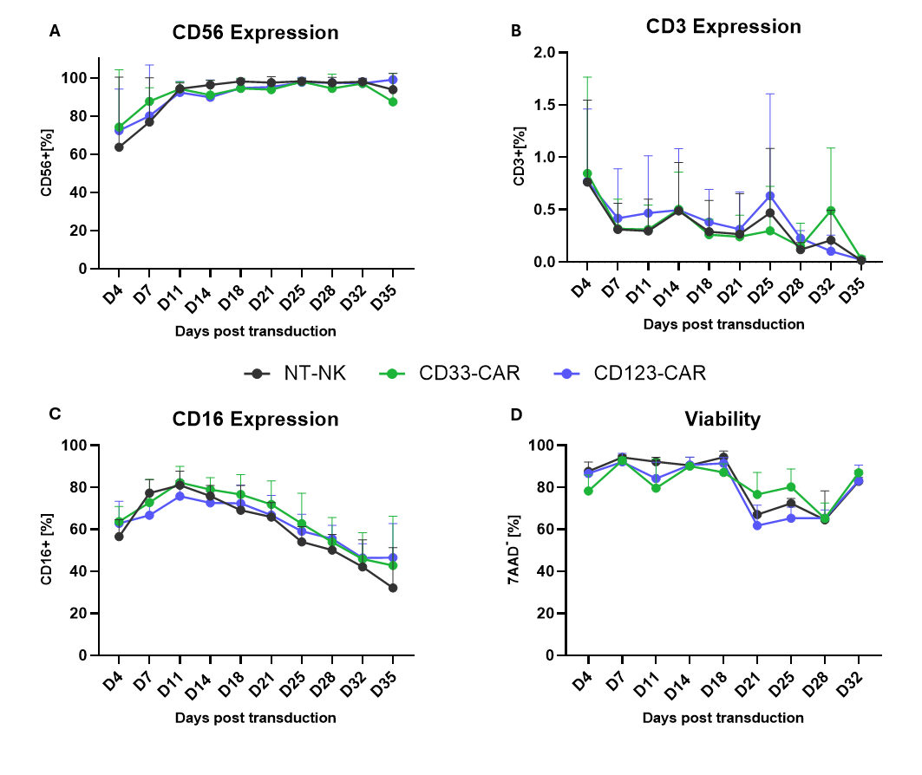
Figure S1: (CAR-)NK cells demonstrated high purity, viability, and activity for a duration of at least 18 days following transduction, which constituted the experimental timeframe. Flow cytometry analysis of CD56 (A), CD3 (B) and CD16 (C) expression of NT- and CD33-/CD123-CAR-NK cells following lentiviral transduction (n=6). (D) Viability assessment via 7AAD negative cells over time, after transduction (n=2). Points show mean values with corresponding standard deviation. Statistical analysis was carried out by two-way ANOVA with no significant differences found between groups.

Supplemental Figure 2
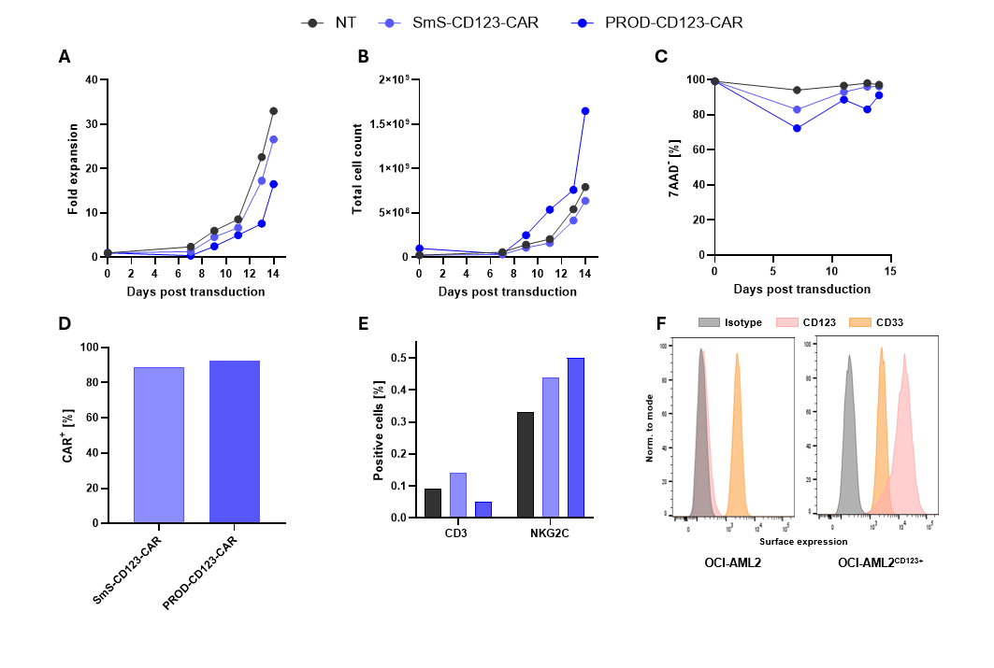
Figure S2: Comparison of small-scale and large-scale produced CAR-NK cell products and marker expression on target cell line. Fold expansion (A), total cell count (B) and viability (C) of small-scale and large-scale produced CD123-CAR-NK cells over time, after lentiviral transduction with the CliniMACS Prodigy system (n=1). (D) Representative CAR expression on day 14 post transduction (n=1). (E) Percentage of CD3 and NKG2C positive cells on the day of transplantation (d14 post transduction). (F) Comparison of CD33 and CD123 surface expression of WT OCI-AML2 and CD123 transduced OCI-AML2 cells (OCI-AML2^{CD123+}).

Supplemental Figure 3
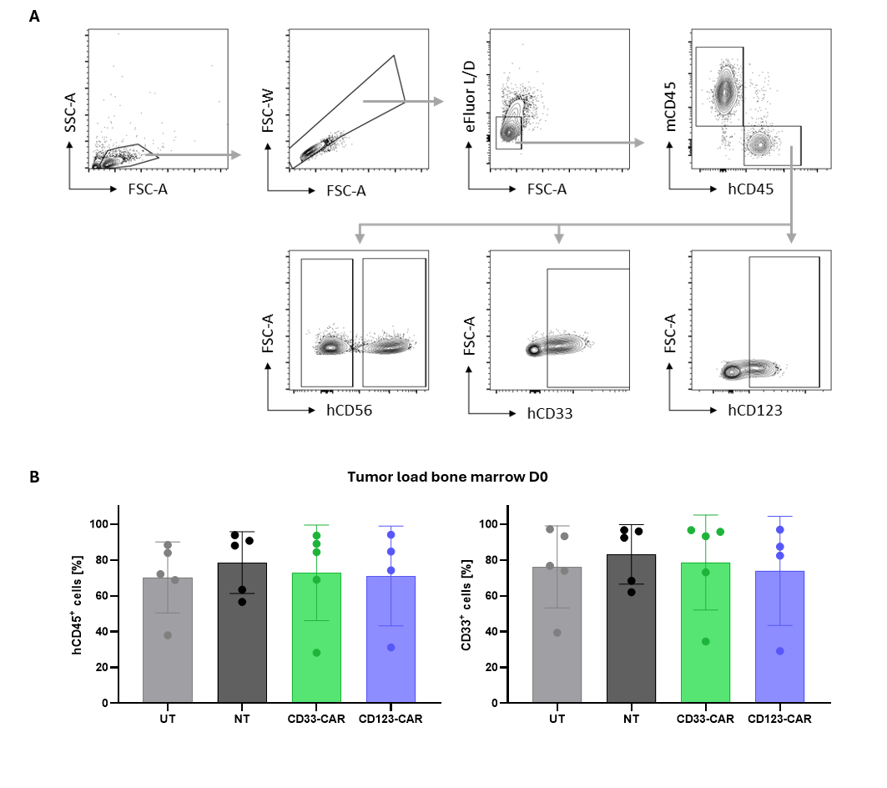
Figure S3: Gating strategy for flow cytometric analysis of human immune and leukemic cell populations and tumor load on day of NK cell injection in AML PDX models. (A) Samples from peripheral blood, bone marrow, spleen, or liver were processed into single-cell suspensions. Cells were first gated on FSC-A/SSC-A to exclude debris, followed by singlet discrimination using FSC-W/FSC-A. Live cells were identified using LIVE/DEAD Fixable Aqua viability dye. Human cells were gated as hCD45⁺ and mCD45⁻. Within the hCD45⁺ population, NK cells were defined as CD56⁺, and leukemic cells were identified as CD33⁺ or CD123⁺. Gates were drawn based on fluorescence-minus-one (FMO) controls. Representative plots are shown. (B) Tumor load was determined on day 0 based on human CD45+ cells in bone marrow aspirates. Mice were then grouped accordingly.

Supplemental Figure 4
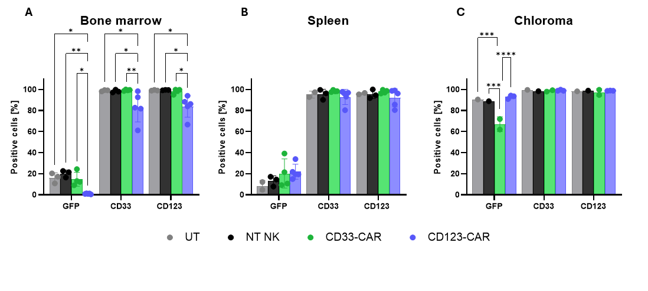
Figure S4: Tumor load and target downregulation on day of sacrifice in OCI-AML2^{CD123+}-xenograft model. Mice were sacrificed when scoring criteria were reached in the survival setting and bone marrow (A), spleen (B) and chloroma (C) were analyzed via flow cytometry for detection of GFP positive tumor cells. CD33 and CD123 expression was assessed on tumor cells to determine downregulation of CAR targets on OCI-AML2^{CD123+}.

Supplemental Figure 5
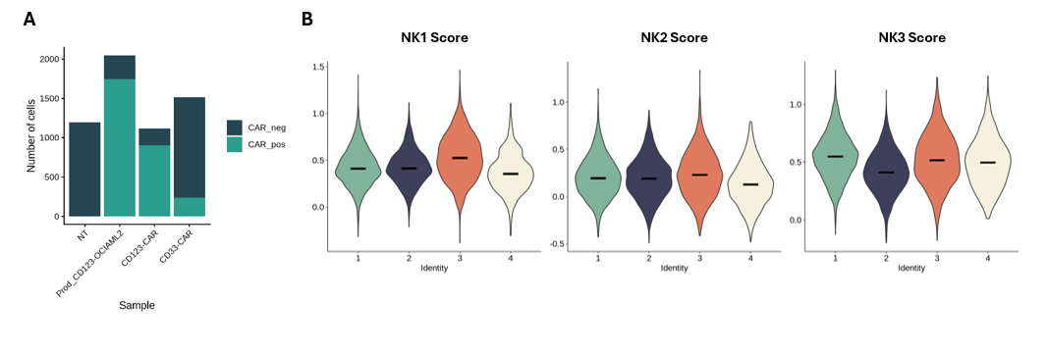
Figure S5. A. Number of absolute NK cells and CAR+ NK cells per sample. B. Scoring of the four NK clusters with respect to established NK1, NK2 and NK3 signatures from Rebuffet et al. 2024.

