Plasma RIPK3 and HMGB1 predict severe COVID-19 progression in ICU patients: a single-center cohort study

Electronic Supplementary Material

Katharina Ruskowski, Holger Neb, Steven R Talbot, Suma Choorapoikayil, Elisabeth H Adam, Andreas von Knethen, Kai Zacharowski, and Ulrike Heinicke

Abbreviations:
- CD – Cluster of Differentiation
- COVID-19 – Coronavirus disease 2019
- COPD – chronic obstructive pulmonary disease
- CRP – C reactive protein
- DNA – Desoxyribonucleic acid
- ECMO – Extracorporeal membrane oxygenation
- ELISA – Enzyme-linked Immunosorbent Assay
- FcR – fragment crystallizable receptor
- HMGB1 – High-Mobility Group Box 1
- ICU – Intensive care unit
- IL – Interleukin
- LDH – Lactate Dehydrogenase
- MLKL – Mixed lineage kinase domain-like
- MitoSOX – Mitochondrial Superoxide Indicator
- MitoPY1 – Mitochondria Peroxy Yellow 1
- mtROS – mitochondrial ROS
- PBS – phosphate-buffered saline
- PCT – Procalcitonin
- RAGE – receptor for advanced glycation endproducts
- RIPK1 – Receptor-interacting serine/threonine-protein kinases 1
- RIPK3 – Receptor-interacting serine/threonine-protein kinases 3
- ROS – Reactive oxygen species
- SARS-CoV-2 – Severe acute respiratory syndrome coronavirus type 2
- TNF – Tumor necrosis factor

Supplemental Methods:

COVID-19 cohort with single measurements
This cohort included 30 Coronavirus disease 2019 (COVID-19) patients (≥18-years) who were admitted to the intensive care unit (ICU) of the University Hospital Frankfurt am Main, Germany, between December 2020 and January 2021. Blood samples were collected once. Patients were divided into three groups: 12 patients who were on non-invasive ventilation (non-intubated), 12 patients who were intubated, and 6 patients who required extracorporeal membrane oxygenation (ECMO) support. Receptor-interacting serine/threonine-protein kinases 3 (RIPK3), mixed lineage kinase domain-like (MLKL), high-mobility group box 1 (HMGB1), and receptor-interacting serine/threonine-protein kinases 1 (RIPK1) plasma levels were measured as described in the methods section of the manuscript.

Cell death measurement
A total of 200 µl of whole blood samples were incubated with red blood cell lysing buffer (1x BD Pharm lysing buffer, BD Bioscience, Franklin Lakes, New Jersey, USA). The remaining cells were washed and diluted in phosphate-buffered saline (DPBS, Gibco/ ThermoFisher, Waltham, MA, USA), following the manufacturer’s instructions. Non-specific protein binding areas were blocked by FcR Blocking Reagent (Miltenyi Biotec, Bergisch Gladbach, Germany) and bovine serum albumin (BSA, Albumin Fraktion V, Carl Roth GmBH, Karlsruhe, Germany) diluted in PBS. Peripheral blood leukocytes were phenotyped by staining for CD66b, CD3, and CD19 (APC/ Cyanine 7 anti-human CD66b – 305126, Biolegend, San Diego, USA; VioBlue® anti-human CD3 – 130-115-519, Miltenyi Biotec; APC anti-human CD19 – 392504, Biolegend) as representative markers for granulocytes, T-lymphocytes, and B-lymphocytes, respectively.
For cell death measurements, samples were incubated for 10 minutes with Annexin V (PE – 31490014, Immunotools, Friesoythe, Germany) and 7-Aminoacinomycin (7-AAD) (PerCP-Cy5-5 – 559925, BD Bioscience) diluted in Annexin V Binding Buffer (BD Bioscience). Cell death was analyzed within one hour by flow cytometry (FACSCanto II, BD Bioscience). For gating strategies, see Fig. S3.

mtROS measurement
For mitochondrial reactive oxygen species (mtROS) measurements, 200 µl of whole blood samples were set up similarly to cell death measurement preparation followed by incubation in phenol-free RPMI 1640 (Gibco/ ThermoFisher) at 37°C. The presence of mtROS was detected by using 5 µM Mitochondrial Superoxide indicator (MitoSOX™) for mitochondrial superoxide (mtO₂⁻) (PE – M36008, ThermoFisher) and 5 µM Mitochondrial peroxy yellow 1 (MitoPY1) for mitochondrial hydrogen peroxide (mtH₂O₂) (FITC – 4428, Tocris, Bio-Techne, Bristol, UK) diluted in PBS.
Oligomycin A (11342, Cayman Chemicals, Ann Arbor, Michigan, USA) and hydrogen peroxide (H₂O₂) (7722-84-1, Merck, Darmstadt, Germany) served as positive controls. mtROS were measured immediately by flow cytometry. Results were analyzed using BD FACSDiva 6.1.2 software and FlowJo (10.7.1). For gating strategies, see Fig. S5. Statistical differences in mtROS production between healthy controls and COVID-19 patients were determined with the Wilcoxon signed rank test and a Bonferroni correction for multiple comparisons.

Supplementary Analysis:

Demographic characteristics and laboratory parameters of the COVID-19 cohort with single measurements
We performed additional single measurements in a total of 30 COVID-19 patients that were divided into three groups: 12 non-intubated, 12 intubated, and 6 ECMO patients (Table S1). The rate of arterial hypertension differed significantly between non-intubated (33.3%), intubated (75%), and ECMO (16.7%) patients (p=0.046). PCT levels were significantly higher in intubated than in non-intubated patients (p_{adj}=0.023). Furthermore, patients’ CRP (96.7%), IL-6 (96.7%), and LDH (100%) levels in all three subgroups were elevated compared to the hospital’s central laboratory’s threshold levels.

Impact of COVID-19, ventilation mode, and outcome on plasma levels of RIPK3, MLKL, HMGB1, and RIPK1 in single measurements
Similar to the COVID-19 cohort with prolonged measurements, RIPK3 (p<0.0001), MLKL (p=0.001), and RIPK1 (p=0.0028) plasma levels were significantly higher in the COVID-19 cohort with single measurements compared to healthy controls, whereas HMGB1 elevations remained statistically insignificant in this cohort (p=0.061) (Fig. S2a-d, first column). Interestingly, we found a significant association between plasma HMGB1 and the mode of ventilation, comparing non-intubated, intubated, and ECMO patients. Intubated COVID-19 patients had significantly higher HMGB1 plasma levels than non-intubated (p_{adj}<0.0006) (Fig. S2c, second column). Furthermore, we detected significantly higher plasma HMGB1 levels in COVID-19 non-survivors compared to survivors in the same cohort (p=0.0063) (Fig. S2c, third column).

Viability, apoptosis, and necrosis of peripheral leukocytes in COVID-19 patients
To examine if peripheral leukocytes contributed to the detected necroptosis-related marker levels, we further investigated flow cytometric cell death measurements in the COVID-19 cohort with single measurements and examined circulating leukocytes for viability, apoptosis, and necrosis (Fig. S4).
The percentage of viable leukocytes was significantly lower in ECMO patients compared to healthy controls (p_{adj}=0.0173) and non-intubated patients (p_{adj}=0.0267). In addition, the percentage of apoptotic leukocytes was significantly higher in ECMO patients compared to healthy controls (p_{adj}=0.0198) and non-intubated patients (p_{adj}=0.0437). Furthermore, the percentage of necrotic leukocytes was significantly higher in ECMO compared to intubated patients (p_{adj}=0.0265) (Fig. S4a).
Moreover, we examined individual leukocyte subsets to determine the percentage of cell death in various cell populations. The percentage of viable granulocytes (CD66b⁺) was lower in ECMO compared to non-intubated patients (p_{adj}=0.0422). Surprisingly, we found a higher percentage of necrotic granulocytes in healthy controls compared to non-intubated patients (p_{adj}=0.0105) and intubated patients (p_{adj}=0.0265) (Fig. S4b).
However, we found a significantly lower percentage of viable T-lymphocytes (CD3⁺) in ECMO compared to non-intubated patients (p_{adj}=0.0479). Besides, the percentage of apoptotic T-lymphocytes was higher in ECMO compared to non-intubated patients (p_{adj}=0.049) (Fig. S4c).
We observed a significantly lower percentage of viable B-lymphocytes (CD19⁺) and accordingly a higher percentage of apoptotic B-lymphocytes in ECMO patients than in healthy controls (p_{adj}=0.001; p_{adj}=0.0006), non-intubated (p_{adj}=0.0006; p_{adj}=0.0005), and intubated (p_{adj}=0.0105; p_{adj}=0.0102) patients (Fig. S4d).
Given that there were only 6 patients in this cohort who required ECMO support, these results should be interpreted carefully, however, they indicate that especially these patients show a loss of viable peripheral leukocytes, as well as higher percentages of apoptosis in these cells.

The production of mtROS in peripheral leukocytes in COVID-19 patients
Since mtROS participate in necroptotic processes, we next investigated whether the production of key mtROS (mtO₂⁻ and mtH₂O₂) in circulating leukocytes was involved in COVID-19 progression in the COVID-19 cohort with single measurements (Fig. S6). Leukocytes of non-intubated (p_{adj}=0.0096) as well as intubated (p_{adj}=0.0196) patients showed significantly reduced mtO₂⁻ than leukocytes of healthy controls (Fig. S6a). We further analyzed leukocyte subgroups and found that granulocytes (Fig. S6b) (CD66b⁺) of non-intubated (p_{adj}=0.002), intubated (p_{adj}=0.008) and B-cells (Fig. S6d) (CD19⁺) of intubated (p_{adj}=0.0272) COVID-19 patients presented with significantly fewer mtO₂⁻. In contrast, T-cells (CD3⁺) of COVID-19 patients did not show significant differences compared to healthy controls (Fig. S6c).

Supplemental Tables:
 |  |  | Overall | non-intubated | intubated | ECMO | p
Totalª |  |  | 30 (100%) | 12 (40%) | 12 (40%) | 6 (20%)
Gender, femaleª |  |  | 4 (13.3%) | 2 (16.7%) | 1 (8.3%) | 1 (16.7%) | 1.000
Age^{b}, yr |  |  | 61 (55.5-70) | 57 (51-70) | 68 (61.5-72.8) | 58.5 (57.3-62) | 0.106
Bodyweight^{b}, kg |  |  | 90 (80-100) | 85 (81-107.5) | 90 (78.8-102.5) | 90 (70-90) | 0.604
ICU stay^{b}, d |  |  | 18 (14-29) | 16.5 (8.8-26) | 16.5 (14-23.8) | 42 (31.3-66.8) | 0.034
Outcome, deathª |  |  | 19 (63.3%) | 4 (33.3%) | 11 (91.7%) | 4 (66.7%) | 0.012
Comorbidity
 | Arterial hypertensionª |  | 14 (46.7%) | 4 (33.3%) | 9 (75%) | 1 (16.7%) | 0.046
 | Diabetes mellitusª |  | 8 (26.7%) | 3 (25%) | 4 (33.3%) | 1 (16.7%) | 0.876
 | Adipositasª |  | 4 (13.3%) | 2 (16.7%) | 2 (16.7%) | 0 (0%) | 0.653
 | COPDª |  | 1 (3.3%) | 0 (0%) | 0 (0%) | 1 (16.7%) | 0.200
 | Asthma bronchialeª |  | 3 (10%) | 1 (8.3%) | 1 (8.3%) | 1 (16.7%) | 1.000
Laboratory parameters
 | CRP^{b}, mg/dl |  | 13.1 (6-20.7) | 13.4 (9.2-16.8) | 11.7 (4.6-26.8) | 14.2 (11.8-26.4) | 0.891
 |  | >0.5 mg/dlª | 29 (96.7%) | 12 (100%) | 11 (91.7%) | 6 (100%) | 1.000
 | Leukocyte counts^{b}, /nl |  | 9.7 (7.6-11.4) | 8.3 (7-10.3) | 10.6 (7.4-11.5) | 10.1 (9.7-11) | 0.516
 |  | >10.41 /nlª | 11 (36.7%) | 3 (25%) | 6 (50%) | 2 (33.3%) | 0.499
 | IL-6^{b}, pg/ml |  | 72 (25-173.8) | 47 (19.9-159.8) | 127 (32.1-260.5) | 83 (57.8-115.5) | 0.440
 |  | >7 pg/mlª | 29 (96.7%) | 11 (91.7%) | 12 (100%) | 6 (100%) | 1.000
 | PCT^{b}, ng/ml |  | 0.4 (0.2-0.8) | 0.2 (0.2-0.3) | 0.5 (0.4-1.4) | 0.6 (0.4-1.1) | 0.021
 |  | >0.5 ng/mlª | 12 (40%) | 3 (25%) | 6 (50%) | 3 (50%) | 0.450
 | LDH^{b}, U/l |  | 429 (374.8-530) | 434.5 (389.8-518) | 425.5 (374-562.8) | 429.5 (373.3-479) | 0.837
 |  | >248 U/lª | 30 (100%) | 12 (100%) | 12 (100%) | 6 (100%)

Table S1 Patient demographics of the COVID 19 cohort with single measurements. Data are presented as ªn (%) for categorical variables or ^{b}median (interquartile range) for continuous variables. p-values comparing non-intubated, intubated, and ECMO COVID-19 patients were calculated with the Kruskal-Wallis test or Fisher’s exact test. Additionally, patients’ laboratory parameter levels were compared to the hospital’s central laboratory’s threshold levels. Respective quantities in the pathological range were determined and then compared among the subgroups by Fisher’s exact test.

Supplemental Figures:

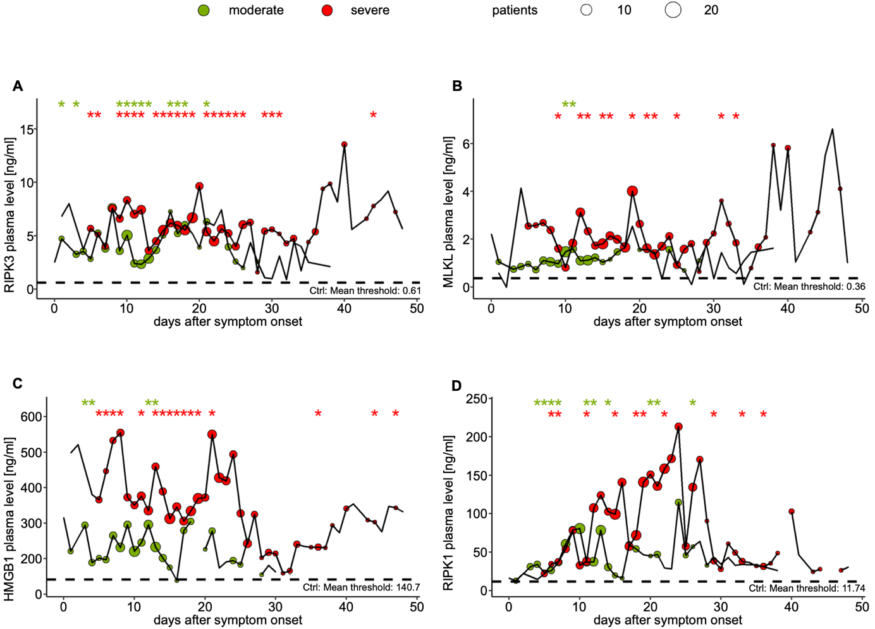
d
c
a
b
Fig. S1 Elevated RIPK3, MLKL, HMGB1, and RIPK1 plasma levels in COVID-19 intensive care patients after symptom onset. Mean longitudinal levels of the COVID-19 cohort with prolonged measurements with 28 patients with moderate (green) and 18 patients with severe (red) COVID-19 are presented. Bubble size is equivalent to the number of patients. (a) RIPK3, (b) MLKL, (c) HMGB1, and (d) RIPK1 plasma levels are plotted by days after symptom onset. Statistical differences between plasma levels of patients with moderate as well as severe COVID-19 and 15 controls (Ctrl; black dotted line) were assessed using unpaired two-sided Student’s t-test; *p˂0.05

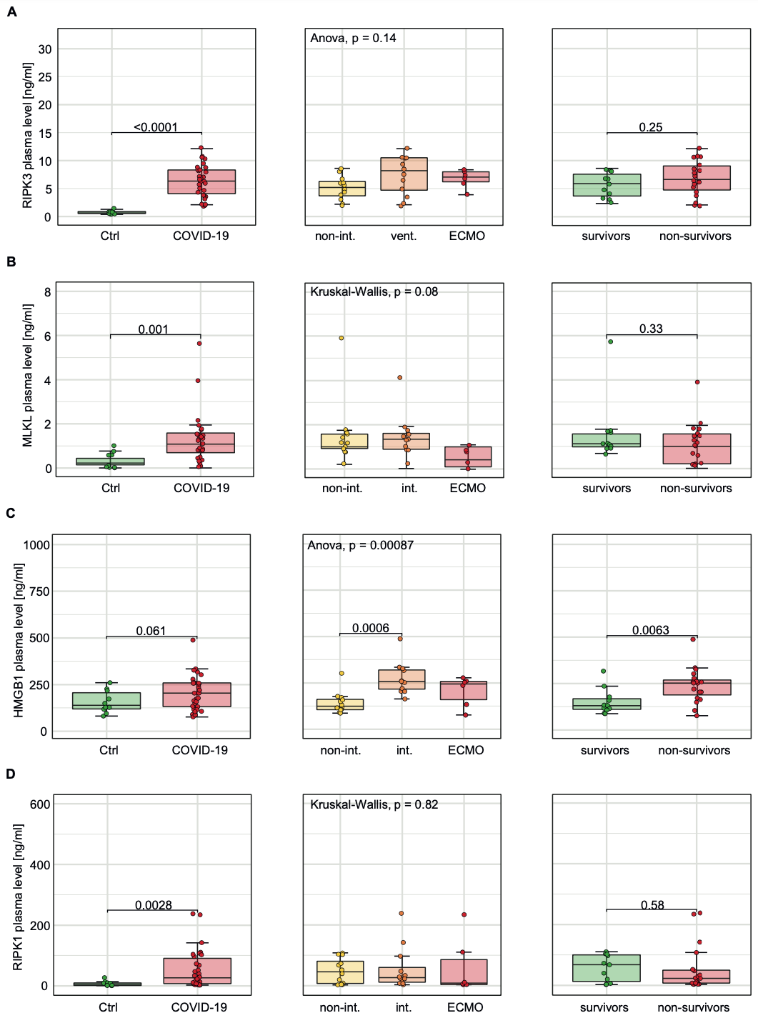
a
b
d
c
Fig. S2 Elevated plasma RIPK3, MLKL, HMGB1, and RIPK1 levels in COVID-19 patients in single measurements. Quantification of RIPK3, MLKL, HMGB1, and RIPK1 plasma levels in COVID-19 cohort with single measurements. Plasma levels of (a) RIPK3, (b) MLKL, (c) HMGB1, and (d) RIPK1 are compared between 10 healthy controls (Ctrl, green) and 30 COVID-19 patients (red) in the left column, between 12 non-intubated (non-int., yellow), 12 intubated (int., orange), and 6 ECMO (red) patients in the middle column, and between 11 survivors (green) and 19 non-survivors (red) in the right column. Results are presented as box plots. Statistical differences between two groups were assessed using unpaired two-sided Student’s t-tests or Mann-Whitney U tests. Multiple comparisons were performed by ANOVAs with Tukey’s post hoc test or Kruskal-Wallis tests with Dunn’s post hoc test. Differences were regarded as significant at p˂0.05

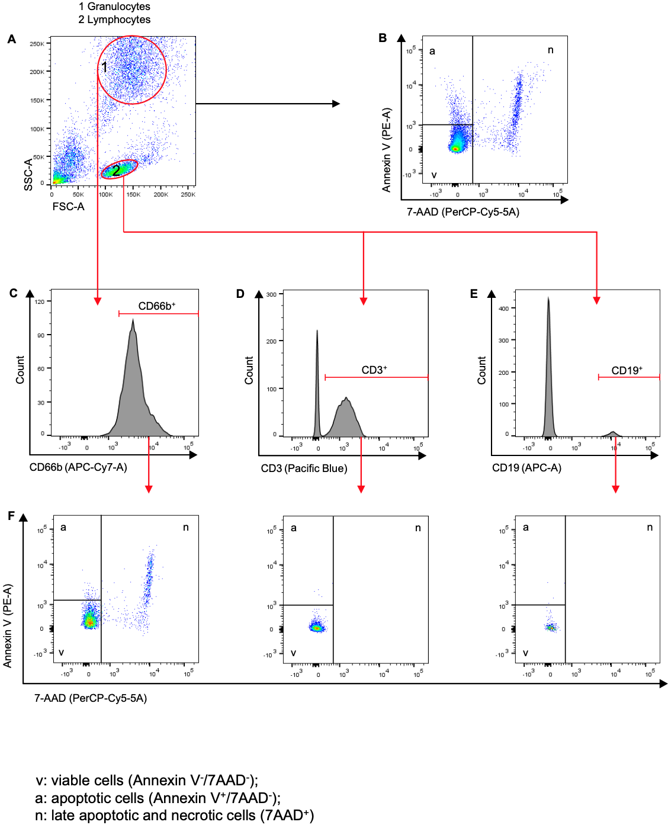
b
a
f
e
d
c

Fig. S3 Determination of cell death in circulating leukocytes: gating strategy.
(a) The raw data determined by the flow cytometer were plotted in FSC-A and SSC-A.
(b) To detect the cell death of all cells, the view was switched to Annexin V (PE-A) and 7-AAD (PerCPCy5-5A). Annexin V attaches to negatively charged phosphatidylserine, which is mainly found on the outer membrane of apoptotic cells (a).
7-Aminoactinomycin (7-AAD ) accumulates on the DNA of cells with loss of membrane integrity. These cells are then referred to as late apoptotic (Annexin V+) or necrotic cells (Annexin V-). We summarized these as necrotic cells (n).
Cells to which these two markers did not bind (Annexin V-/7AAD-) were considered viable cells (v).
(c) Cells in (a) that were in a location typical for granulocytes (1) were analyzed for expression of CD66b (APC-Cy7-A).
(d),(e) Cells in (a) that were in a location typical of lymphocytes (2) were analyzed for expression of CD3 (Pacific Blue) (d) and CD19 (APC-A) (e).
(f) Cells determined in (c), (d), and (e) (CD66b+, CD3+, and CD19+) were then divided into v, a, and n in analogy to the procedure described in (b).
This procedure was performed for all 30 patients and 10 controls and subsequently evaluated (Fig. S4).
APC, Allophycocyanin Conjugate; APC-Cy7, Allophycocyanin-Cyanine 7 Conjugate; CD, Cluster of Differentiation; FSC, forward scatter; PE, Phycoerythrin; PerCP-Cy5-5, Peridinin chlorophyll protein-Cyanine5.5; SSC, side scatter

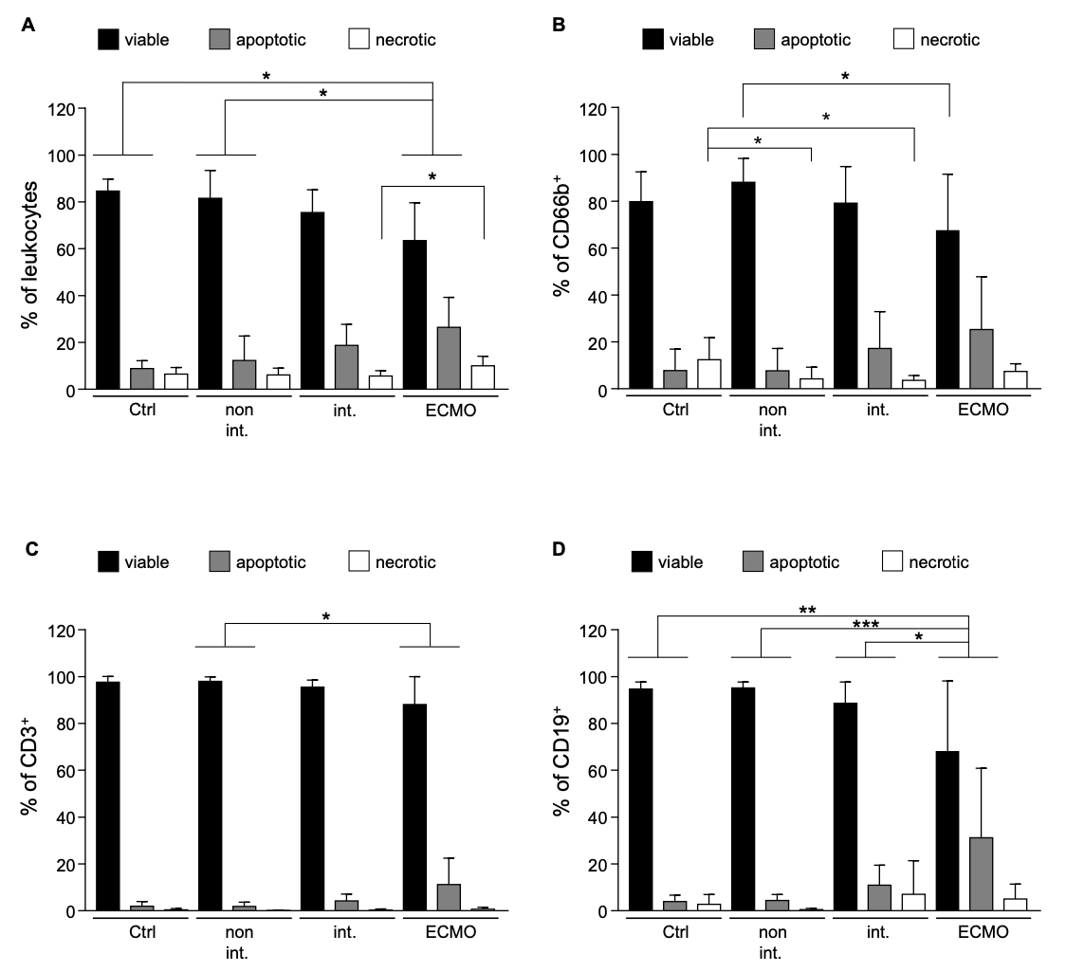
d
c
b
a

Fig. S4 Loss of viable leukocytes in critical COVID-19 patients. (a)-(d), Bar graphs show a quantitative summary of flow cytometric analysis. Cells were gated in viable cells (black), apoptotic cells (grey), and necrotic cells (white) according to the gating strategy (Fig. S3). Groups consisted of 10 healthy controls (Ctrl), 12 non-intubated (non int.), 12 intubated (int.), and 6 COVID-19 patients who required ECMO.
(a) All leukocytes were examined (viability: χ²=12.34, p=0.0063; apoptosis: χ²=11.75, p=0.0083; necrosis: F(3, 36)=3.206, p=0.0345). In (b) CD66b⁺ cells (viability: χ²=7.752, p=0.0514; apoptosis: χ²=9.668, p=0.0216; necrosis: χ²=13.5, p=0.0037), in (c) CD3⁺ cells (viability: χ²=10.25, p=0.0165; apoptosis: χ²=10.95, p=0.012; necrosis: χ²=5.549, p=0.1357), and in (d) CD19⁺ cells (viability: F(3, 36)=7.411, p=0.0005; apoptosis: F(3, 36)=7.744, p=0.0004; necrosis: F(3, 36)=1.262, p=0.3020) were taken into account.
Statistical differences and adjusted p-values (p_{adj}) were assessed using ANOVAs with Tukey’s post hoc test or the Kruskal-Wallis tests with Dunn’s post hoc test as appropriate (*p_{adj}<0.05; **p_{adj}<0.01; ***p_{adj}<0.001). Results are expressed as mean + SD
a
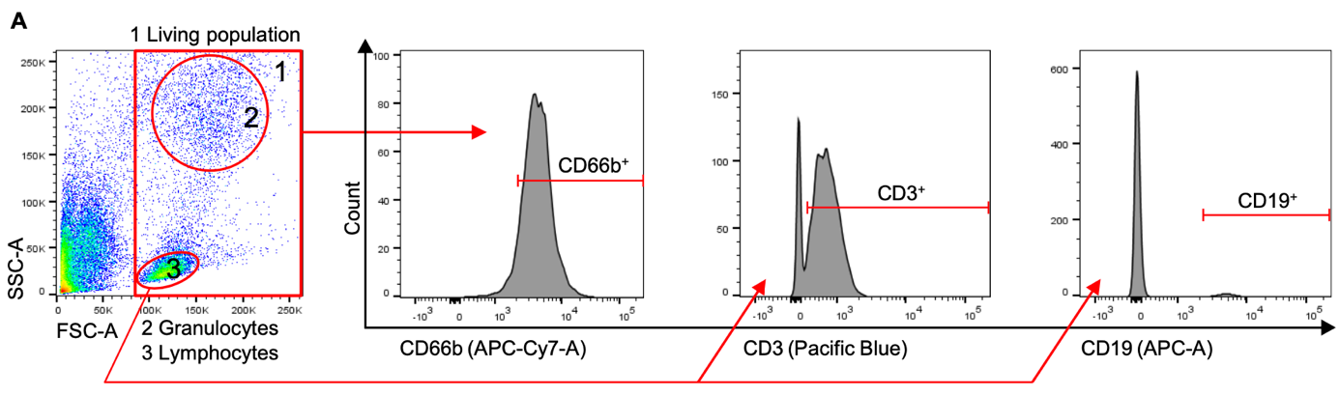

Fig. S5 Gating strategy for mtROS measurement. (a) Cells were measured by flow cytometry analysis and gated for living cells (1). The populations, already recognizable in the overview image (FSC-A and SSC-A) of the living population, in detail granulocytes (2) and lymphocytes (3), were gated and further distinguished into subgroups based on the expressed surface markers (CD66b+, CD3+, and CD19+).
APC, Allophycocyanin Conjugate; APC-Cy7, Allophycocyanin-Cyanine 7
Conjugate; CD, Cluster of Differentiation; FSC, forward scatter; SSC, side scatter

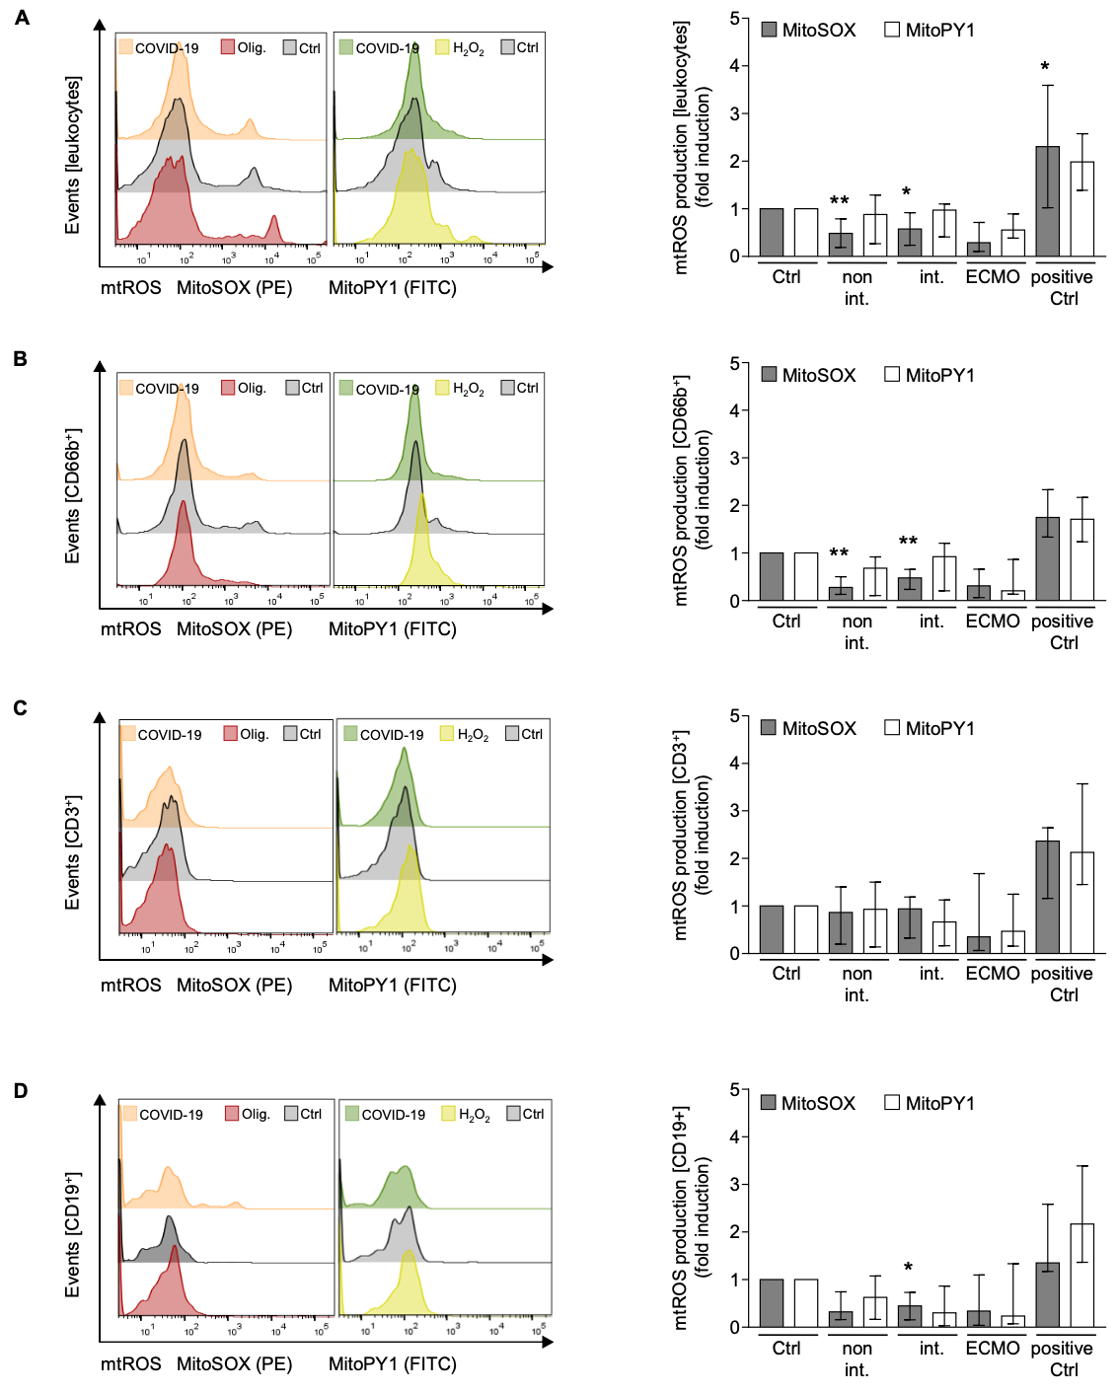
a
c
b
d
Fig. S6 Lower mtROS production in leukocytes of COVID-19 patients. In (a) leukocytes, in (b) CD66b⁺ cells, in (c) CD3⁺ cells and in (d) CD19⁺ cells were examined after gating (Fig. S5).
Left column: Fluorescence differences of PE (MitoSOX) and FITC (MitoPY1) were shown between a representative patient (COVID-19), a healthy control (Ctrl), and positive control for mtROS.
The positive control for MitoSOX was performed with 50 µM oligomycin A (Olig.) for 30 minutes and MitoPY1 with 200 µM H₂O₂ for 1 hour in separate control tubes.
Right column: Groups consisted of 10 healthy controls (Ctrl), 12 non-intubated (non int.), 11 intubated (int.), and 6 COVID-19 patients who required ECMO as well as positive controls (positive Ctrl).
Briefly, the fluorescence means of PE (MitoSOX) and FITC (MitoPY1) were analyzed for each measurement and an unstained raw value was subtracted. Fold induction was calculated by comparing the patients’ values with those of healthy controls measured in the same experiment. Statistical significances comparing each group with the healthy controls (set to 1) were determined by using the Wilcoxon signed-rank test and a Bonferroni correction for multiple comparisons (*p_{adj}<0.05; **p_{adj}<0.01).
Fold induction is expressed as median ± IQR.
CD, Cluster of Differentiation; FITC, Fluorescein; PE, Phycoerythrin

