Supplementary Online Content
Appendix 1. Search strategy for Cochrane library database
Appendix 2. basic information about included studies
Appendix 3. Jadad score in included studies
Appendix 4. Jadad score in excluded studies
Appendix 5. risk of bias in included studies
Appendix 6. Forest diagram of HAMD for acupuncture + antidepressants VS antidepressants in follow-up
Appendix 7. meta-regression with age, baseline HAMD-24, acupuncture session as single continuous covariate
Appendix 8. meta-regression with age, course of diseases, acupuncture session as single continuous covariate
Appendix 9. Sensitivity analyses of acupuncture versus sham-acupuncture for HAMD-24
Appendix 10. Sensitivity analyses of acupuncture versus antidepressants for HAMD-24
Appendix 11. Forest diagram of SDS for acupuncture VS sham-acupuncture
Appendix 12. Forest diagram of SDS for acupuncture VS antidepressants
Appendix 13. Funnel Chart of SDS for acupuncture VS antidepressants
Appendix 14. Forest diagram of SDS for acupuncture + antidepressants VS antidepressants
Appendix 15. meta-regression with course of diseases, age, baseline HAMD-24, acupuncture session as single continuous covariate
Appendix 16. Sensitivity analyses of acupuncture versus sham-acupuncture for SDS
Appendix 17. Forest diagram of adverse events for acupuncture VS antidepressants
Appendix 18. Forest diagram of adverse events for acupuncture + antidepressants VS antidepressants

Appendix 1. Search strategy for Cochrane library database
#1 | randomized controlled trial [All Text]
#2 | controlled clinical trial [All Text]
#3 | randomized [All Text]
#4 | randomised [All Text]
#5 | placebo [All Text]
#6 | randomly [All Text]
#7 | trial [All Text]
#8 | groups [All Text]
#9 | or/#1-#8
#10 | Depression [Title/Abstract/Keyword]
#11 | Depressive disorder [Title/Abstract/Keyword]
#12 | #10 or #11
#13 | Acupuncture [Title/Abstract/Keyword]
#14 | Electropuncture [Title/Abstract/Keyword]
#15 | Auricular acupuncture [Title/Abstract/Keyword]
#16 | Warm acupuncture [Title/Abstract/Keyword]
#17 | [Title/Abstract/Keyword]
#18 | Fire needle[Title/Abstract/Keyword]
#19 | Warm needle[Title/Abstract/Keyword]
#20 | Point embedding therapy[Title/Abstract/Keyword]
#21 | Electroacupuncture [Title/Abstract/Keyword]
#22 | Or/#13-#21
#23 | #9 and #12 and #22
This search strategy was modified to be suitable for other electronic databases.

Appendix 2 basic information about included studies
Study ID | Country | Diagnostic criteria | Treatment modality |  |  |  |  |  | Course | Sample sizes |  |  | Sex |  |  | Age |  |  | Course of disease |  |  | HAMD-24 |  |  | Adverse reactions |  |  | Follow-up
Study ID | Country | Diagnostic criteria | Experimental group |  | Control group |  | Control group
Study ID | Country | Diagnostic criteria | Therapeutics | Number of times | Therapeutics | Number of times | Therapeutics | Number of times | Course | Experimental group | Control group | Control group | Experimental group | Control group | Control group | Experimental group | Control group | Control group | Experimental group | Control group | Control group | Experimental group | Control group | Control group | Experimental group | Control group | Control group | Follow-up
Fan_2015¹ | China | ICD-10 | Acupuncture | 24Times | Sham-acupuncture | 24Times | Sham-acupuncture | 24Times | 12Weeks | 47 | 48 | 48 | 16 | 24 | 21 | 37.9 ± 14.3 | 40.4 ± 13.6 | 39.7 ± 12.1 | 27.2 ± 25.8 | 25.4 ± 24.4 | 32.0 ± 18.2 | 28.96 ± 3.52 | 28.62 ± 4.56 | 29.05 ± 3.61 | NA | NA | NA | NA
Zhang_2009² | China | DSM-V | Acupuncture + Antidepressants | 50Times | Sham-acupuncture + Antidepressants | 30Times | NA | NA | 6Weeks | 40 | 40 | NA | 12 | 15 | NA | 36.2 ± 11.7 | 35.5 ± 12.0 | NA | NA | NA | NA | 43.02 ± 7.53 | 43.93 ± 8.87 | NA | NA | NA | NA | NA
Almi_2018³ | India | DSM-V | Acupuncture + Antidepressants | 12Times | Sham-acupuncture + Antidepressants | 12Times | NA | NA | 4Weeks | 25 | 23 | NA | 4 | 3 | NA | 49.9 ± 11.66 | 48.2 ± 13.05 | NA | NA | NA | NA | 40.13 ± 4.54 | 38.68 ± 4.17 | NA | 11 | 0 | NA | NA
Jiang_2012⁴ | China | CCMD-3 | Acupuncture | 18Times | Sham-acupuncture | 18Times | Sham-acupuncture | 18Times | 6Weeks | 38 | 36 | 34 | 16 | 13 | 10 | 43.726 ± 11.381 | 37.585 ± 12.157 | 41.259 ± 9.362 | 1.952 ± 1.92 | 2.314 ± 2.195 | 1.523 ± 1.854 | 26.12±3.97 | 27.62±4.61 | 25.98±4.37 | 3 | 0 | 0 | 2Weeks
Jiang_2016⁵ | China | CCMD-3 | Acupuncture | 18Times | Sham-acupuncture | 18Times | Sham-acupuncture | 18Times | 6Weeks | 36 | 39 | 37 | 15 | 11 | 13 | 40.81 ± 11.00 | 42.03 ± 10.64 | 40.24 ± 10.52 | 13.19 ± 13.16 | 15.10 ± 13.15 | 12.39 ± 12.33 | 26.00±4.00 | 26.23±3.60 | 26.14±3.90 | NA | NA | NA | NA
Fan_2005⁶ | China | CCMD-2 | Acupuncture | 24Times | Fluose fine hydrochloride 20mg/d | NA | Sham-acupuncture | 24Times | 12Weeks | 28 | 24 | 25 | 16 | 11 | 12 | 30.2 ± 7.9 | 33.2 ± 9.7 | 34.2 ± 9.6 | 27.6 | 31.2 | 37.3 | 26.01±3.99 | 25.14±5.78 | 25.65±3.42 | 0 | 4 | 0 | NA
Fu_2008⁷ | China | CCMD-2 | Acupuncture | 24Times | Fluose fine hydrochloride 20mg/d | NA | Sham-acupuncture | 24Times | 12Weeks | 176 | 176 | 88 | 67 | 54 | 28 | 41.87 ± 12.29 | 39.88 ± 11.04 | 43.51 ± 11.43 | 55.08 ± 10.39 | 46.92 ± 8.24 | 55.08 ± 9.8 | 27.4±4.75 | 26.11±4.75 | 26.33±4.25 | NA | NA | NA | NA
Fu_2006⁸ | China | CCMD-2 | Acupuncture | 24Times | Fluose fine hydrochloride 20mg/d | NA | Sham-acupuncture | 24Times | 12Weeks | 78 | 82 | 41 | 26 | 27 | 19 | 41.8 ± 12.12 | 39.4 ± 10.8 | 40 ± 12.38 | 59.76 ± 10 | 59.16 ± 8.23 | 60.6 ± 12.33 | 28.22±4.95 | 26.72±5.28 | 26.44±4.5 | NA | NA | NA | NA
Cai_2014⁹ | China | ICD-10 | Acupuncture | 30Times | Fluose fine hydrochloride 20mg/d | NA | Acupuncture + Cognitive Therapy | 36Times | 6Weeks | 28 | 31 | 30 | NA | NA | NA | 40.53 ± 3.38 | 44.03 ± 3.42 | 42.01 ± 3.62 | 11.42 ± 6.33 | 12.02 ± 5.62 | 11.68 ± 6.42 | 28.24±3.73 | 27.34±3.43 | 29.03±4.08 | NA | NA | NA | NA
Li_2012¹⁰ | China | DSM-V | Acupuncture | 40Times | Sham-acupuncture | 40Times | NA | NA | 8Weeks | 48 | 41 | NA | 33 | 26 | NA | 36.3 ± 74 | 38.1 ± 8.1 | NA | 23.2 ± 6.7 | 25.3 ± 8.2 | NA | NA | NA | NA | 4 | 4 | NA | NA
Liu_2015¹¹ | China | CCMD-3 | Acupuncture | 10Times | Antidepressants | 10Times | NA | NA | 2Weeks | 32 | 32 | NA | 14 | 13 | NA | 36.27 ± 11.70 | 39.83 ± 9.76 | NA | NA | NA | NA | 23.43 ± 4.897 | 24.00 ± 4.275 | NA | NA | NA | NA | NA
Lu_2015¹² | China | CCMD-3 | Acupuncture | 10Times | Antidepressants | 10Times | NA | NA | 2Weeks | 30 | 30 | NA | 13 | 12 | NA | 41.43 ± 9.13 | 40.87 ± 9.21 | NA | 42.73 ± 31.23 | 40.87 ± 26.25 | NA | 19.47 ± 3.29 | 19.40 ± 2.76 | NA | 1 | 7 | NA | NA
Shou_2020¹³ | China | ICD-10 | Acupuncture | 18Times | Flupentixol and Melitracen Tablets | 18Times | NA | NA | 3Weeks | 30 | 30 | NA | 8 | 5 | NA | 44.53 ± 11.00 | 43.33 ± 10.43 | NA | 14.10 ± 6.42 | 14.00 ± 6.31 | NA | 27.67 ± 5.62 | 26.17 ± 5.67 | NA | NA | NA | NA | NA
Chen_2011¹⁴ | China | CCMD-3 | Acupuncture + Antidepressants | 18Times | Antidepressants | 6Weeks | NA | NA | 6Weeks | 64 | 63 | NA | 24 | 22 | NA | 46.17 ± 10.46 | 48.20 ± 10.63 | NA | NA | NA | NA | 41.97 ± 4.99 | 42.3 ± 6.0 | NA | 3 | 2 | NA | 4Weeks
Wu_2017¹⁵ | China | CCMD-3 | Acupuncture | 16Times | Paroxetine Hydrochloride20mg/d | NA | Sham-acupuncture | 16Times | 8Weeks | 32 | 28 | 28 | 10 | 9 | 13 | 47.88 ± 13.13 | 47.32 ± 13.15 | 45.93 ± 11.62 | 21.06 ± 12.14 | 22.18 ± 12.42 | 22.57 ± 9.29 | 27.86 ± 4.97 | 27.89 ± 4.38 | 31.06 ± 4.3 | 6 | 20 | 0 | 4Weeks
Li Haixing_2019¹⁶ | China | ICD-10 | Acupuncture | 16Times | Sertraline | NA | NA | NA | 4Weeks | 40 | 40 | NA | 19 | 17 | NA | 34.70 ± 11.82 | 37.75 ± 13.09 | NA | 34.63 ± 1.39 | 34.58 ± 1.97 | NA | 18.35 ± 2.14 | 18.20 ± 2.22 | NA | NA | NA | NA | NA
Liu_2018¹⁷ | China | ICD-11 | Acupuncture | 16Times | Sham-acupuncture | 16Times | NA | NA | 8Weeks | 21 | 21 | NA | NA | NA | NA | 44 ± 10 | 43 ± 9 | NA | 33.38 ± 7.7 | 36.90 ± 10.8 | NA | NA | NA | NA | 4 | 12 | NA | NA
Liu_2011¹⁸ | China | CCMD-3 | Acupuncture | 14Times | Fluose fine hydrochloride 20mg/d | NA | NA | NA | 2Weeks | 30 | 30 | NA | 7 | 6 | NA | 42.78 ± 10.39 | 41.54 ± 9.53 | NA | 27.36 ± 4.19 | 29.16 ± 4.02 | NA | 31.28 ± 1.76 | 30.12 ± 1.93 | NA | NA | NA | NA | NA
Chen_2007¹⁹ | China | CCMD-2 | Acupuncture | 36Times | Fluose fine hydrochloride 20mg/d | NA | NA | NA | 12Weeks | 30 | 30 | NA | 11 | 10 | NA | 40.45 ± 12.54 | 41.15 ± 13.83 | NA | NA | NA | NA | 26.60 ± 6.25 | 27.35 ± 6.87 | NA | 3 | 10 | NA | NA
Chen_2014²⁰ | China | ICD-10 | Acupuncture + Antidepressants | 18 | Paroxetine Hydrochloride20mg/d | NA | NA | NA | 6Weeks | 38 | 32 | NA | 13 | 12 | NA | 36.2 ± 11.7 | 35.0 ± 10.5 | NA | 13.0 ± 6.1 | 10.9 ± 8.9 | NA | 50.44 ± 6.86 | 45.73 ± 6.05 | NA | 20 | 29 | NA | NA
Si_2014²¹ | China | CCMD-3 | Acupuncture | 30Times | Escitalopram 10mg/d | NA | NA | NA | 6Weeks | 20 | 20 | NA | 7 | 5 | NA | 39.25 ± 11.52 | 39.15士11.14 | NA | 5.9士0.58 | 6.2 ± 0.63 | NA | NA | NA | NA | NA | NA | NA | NA
Wang_2007²² | China | CCMD-3 | Acupuncture | 24Times | Fluose fine hydrochloride 20mg/d | NA | NA | NA | 12Weeks | 30 | 30 | NA | 14 | 13 | NA | 39.73 ± 13.38 | 38.43 ± 12.23 | NA | 51.84 ± 2.04 | 39.96 ± 0.97 | NA | 30.75 ± 3.40 | 30.75 ± 3.08 | NA | 1 | 3 | NA | NA
Zou_2010²³ | China | CCMD-3 | Acupuncture | 56Times | Fluose fine hydrochloride 20mg/d | NA | NA | NA | 8Weeks | 53 | 52 | NA | 25 | 24 | NA | 45.17 ± 6.98 | 42.45 ± 8.16 | NA | 29.04 ± 4.57 | 27.12 ± 5.09 | NA | 58.14 ± 1.9 | 52.93 ± 3.48 | NA | NA | NA | NA | NA
Cai_2018²⁴ | China | DSM-V | Acupuncture + Antidepressants | 18Times | Antidepressants | NA | NA | NA | 6Weeks | 41 | 41 | NA | 13 | 14 | NA | 45.27 ± 13.3 | 46.23 ± 14.5 | NA | 23.51 ± 12.19 | 23.92 ± 14.52 | NA | 22.45 ± 8.24 | 22.78 ± 6.02 | NA | 0 | NA | NA | NA
Huang_2010²⁵ | China | CCMD-3 | Acupuncture + Antidepressants | 18Times | Antidepressants | NA | NA | NA | 6Weeks | 30 | 30 | NA | 13 | 10 | NA | 49.63 ± 15.12 | 50.17 ± 13.93 | NA | 7.21 ± 9.71 | 6.1 ± 7.94 | NA | 48.03 ± 4.1 | 47.42 ± 3.32 | NA | NA | NA | NA | NA
Kang_2013²⁶ | China | ICD-10 | Acupuncture | 20Times | Fluose fine hydrochloride 20mg/d | NA | NA | NA | 4Weeks | 61 | 61 | NA | 22 | 20 | NA | 45.7 ± 7.1 | 47 ± 7.9 | NA | NA | NA | NA | 24.9 ± 4.4 | 25.6 ± 4.6 | NA | NA | NA | NA | 4Weeks
Li Qiaojun_2019²⁷ | China | CCMD-3 | Acupuncture | 15Times | Fluose fine hydrochloride 20mg/d | NA | NA | NA | 4Weeks | 36 | 36 | NA | 9 | 11 | NA | 44.38 ± 12.8 | 43.13 ± 11.66 | NA | 6.19 ± 3.39 | 6.29 ± 3.56 | NA | 32.2 ± 7.6 | 32.3 ± 7.26 | NA | NA | NA | NA | NA
Lin Weirong_2012²⁸ | China | ICD-10 | Acupuncture + Antidepressants | 18Times | Paroxetine Hydrochloride20mg/d | NA | NA | NA | 6Weeks | 34 | 34 | 34 | 17 | 15 | 14 | 31.62 ± 8.9 | 34.26 ± 9.94 | 35.21 ± 11.49 | NA | NA | NA | 47.56 ± 7.35 | 47.87 ± 7.83 | 42.52 ± 5.89 | NA | NA | NA | 4Weeks
Lin Yanhogn_2012²⁹ | China | CCMD-3 | Acupuncture + Antidepressants | 18Times | Antidepressants | NA | NA | NA | 6Weeks | 46 | 44 | 54 | 14 | 13 | 15 | 47 ± 8 | 47 ± 10 | 8 ± 10 | (4.72 ± 2.4 | 4.24 ± 2.0 | 4.48 ± 2.7 | 45.26 ± 7.42 | 44.18 ± 5.2 | 42.23 ± 5.82 | NA | NA | NA | 4Weeks
Lin_2014³⁰ | China | CCMD-3 | Acupuncture + Antidepressants | 18Times | Fluose fine hydrochloride 20mg/d | NA | NA | NA | 6Weeks | 30 | 30 | NA | 10 | 7 | NA | 40.03 ± 9.96 | 42.17 ± 9.06 | NA | 23.57 ± 13.94 | 20.73 ± 12.00 | NA | 34.22 ± 4.63 | 35.07 ± 4.34 | NA | 3 | 13 | NA | NA
Liu_2019³¹ | China | CCMD-3 | Acupuncture | 30Times | Fluose fine hydrochloride 20mg/d | NA | NA | NA | 5Weeks | 30 | 31 | NA | 15 | 13 | NA | 40.43 ± 10.91 | 43.94 ± 11.2 | NA | NA | NA | NA | 30.17 ± 3.71 | 30.97 ± 2.33 | NA | NA | NA | NA | NA
Miao_2015³² | China | DSM-V | Acupuncture | 24Times | Fluose fine hydrochloride 20mg/d | NA | NA | NA | 8Weeks | 33 | 34 | NA | 13 | 15 | NA | 30 ± 4 | 30 ± 4 | NA | 3.2 ± 1.9 | 3.2 ± 1.9 | NA | 22.31 ± 4.23 | 26.47 ± 3.24 | NA | 2 | 4 | NA | NA
Shi_2015³³ | China | CCMD-3 | Acupuncture | 40Times | Acupuncture | 40Times | Fluose fine hydrochloride 20mg/d | NA | 8Weeks | 30 | 30 | 30 | 20 | 18 | 17 | 52.33 ± 9.93 | 48.46 ± 8.44 | 49.99 ± 9.41 | NA | NA | NA | 49.12 ± 7.22 | 48.63 ± 6.87 | 48.63 ± 6.74 | NA | NA | NA | NA
Teng_2010³⁴ | China | CCMD-3 | Acupuncture | 24Times | Acupuncture | 24Times | Antidepressants | NA | 4Weeks | 30 | 20 | 20 | 13 | 11 | 10 | 39.73 ± 13.38 | 38.43 ± 12.23 | 37.85 ± 13.14 | 4.31 ± 0.5 | 3.33 ± 0.28 | 3.33 ± 0.28 | NA | NA | NA | NA | NA | NA | NA
Wei_2021³⁵ | China | ICD-10 | Acupuncture | 24Times | Flupentixol and Melitracen Tablets | NA | NA | NA | 4Weeks | 32 | 33 | NA | 12 | 13 | NA | 37.4 ± 11.4 | 35.7 ± 12.2 | NA | 4.7 ± 3.1 | 3.9 ± 4.2 | NA | 27.71 ± 3.97 | 26.84 ± 4.32 | NA | 2 | 3 | NA | NA
Xiang_2016³⁶ | China | CCMD-3 | Acupuncture | 14Times | Acupuncture | 14Times | Paroxetine Hydrochloride20mg/d | NA | 4Weeks | 15 | 16 | 15 | 1 | 2 | 1 | 42.2 ± 11.8 | 38.2 ± 11.58 | 39.8 ± 11.56 | 27.3 ± 21.19 | 27.4 ± 24.2 | 32.1 ± 23.48 | 19.76 ± 5.97 | 20.12 ± 6.03 | 19.41 ± 5.44 | 1 | 0 | 1 | NA
Xing_2011³⁷ | China | CCMD-3 | Acupuncture | 42Times | Fluose fine hydrochloride 20mg/d | 42Times | NA | NA | 6Weeks | 120 | 120 | NA | 48 | 52 | NA | 36.2 ± 12.8 | 33.5 ± 11.4 | NA | 11.6 ± 7.3 | 10.5 ± 8.6 | NA | 26.36 ± 4.99 | 24.31 ± 5.03 | NA | NA | NA | NA | NA
Zhang_2019³⁸ | China | ICD-10 | Acupuncture | 15Times | Cognitive Therapy | NA | NA | NA | 5Weeks | 30 | 30 | NA | 14 | 13 | NA | NA | NA | NA | NA | NA | NA | 26.97 + 4.98 | 25.17 + 4.30 | NA | NA | NA | NA | NA
Zhang_2015³⁹ | China | CCMD-2 | Acupuncture | 8Times | Fluose fine hydrochloride 20mg/d | NA | NA | NA | 8Weeks | 30 | 30 | NA | 11 | 9 | NA | 39.77 ± 12.025 | 38.47 ± 11.744 | NA | 56.4 ± 6.51 | 51.24 ± 5.06 | NA | 29.43 ± 2.344 | 29.63 ± 2.428 | NA | NA | NA | NA | NA
Chen_2020⁴⁰ | China | ICD-10 | Acupuncture | 12Times | Acupuncture | 12Times | Fluose fine hydrochloride 20mg/d | NA | 4Weeks | 30 | 30 | 30 | 16 | 13 | 15 | 42.6 ± 10.46 | 45.63 ± 10.13 | 44.10 ± 10.40 | 10.50 ± 4.52 | 11.27 ± 3.74 | 11.4 ± 4.17 | 34.65 ± 4.21 | 35.67 ± 3.71 | 33.75 ± 2.78 | NA | NA | NA | NA
Zhou_2021⁴¹ | China | ICD-10 | Acupuncture | 28Times | Fluose fine hydrochloride 20mg/d | NA | Acupuncture + Antidepressants | NA | 8Weeks | 28 | 27 | 27 | 3 | 8 | 3 | 47 | 45 | 45 | 36 | 24 | 36 | 29.75 ± 4.97 | 30.46 ± 5.03 | 31.87 ± 5.02 | NA | NA | NA | NA
Dong_2013⁴² | China | CCMD-3 | Acupuncture | 30Times | Fluose fine hydrochloride 20mg/d | NA | NA | NA | 4Weeks | 29 | 29 | NA | 7 | 6 | NA | 42.78 ± 10.39 | 41.54 ± 9.53 | NA | 27.36 ± 4.19 | 29.16 ± 4.02 | NA | NA | NA | NA | NA | NA | NA | NA
Du_2005⁴³ | China | CCMD-3 | Acupuncture | 42Times | Acupuncture | 42Times | Fluose fine hydrochloride 20mg/d | NA | 6Weeks | 49 | 29 | 25 | 18 | 10 | 11 | 46.1 ± 14.5 | 42.8 ± 14.9 | 43.9 ± 15.2 | 11.2 ± 12.1 | 10.8 ± 11.3 | 9.7 ± 14.3 | 30.1 ± 5.9 | 28.72 ± 5.83 | 28.16 ± 6.21 | 0 | 0 | 2 | NA
Note: CCMD-2/3= the third edition of Chinese Classification of Mental Disorders; ICD-10/11= the International Statistical Classification of Diseases and Related Health Problems; DSM-II/III/III-R/IV/IV /V= the Diagnostic and Statistical Manual of Mental Disorders; NA= Not Applicable.

Appendix 3 Jadad score in included studies
Study ID | Random sequence generation | Allocation concealment | Blinding | Withdrawals and lost visits | Total
Fan_2015 | 2 | 2 | 2 | 1 | 7
Zhang_2009 | 2 | 1 | 1 | 1 | 5
Almi_2018 | 2 | 1 | 1 | 0 | 4
Jiang_2012 | 2 | 2 | 2 | 1 | 7
Jiang_2016 | 2 | 2 | 2 | 1 | 7
Fan_2005 | 2 | 2 | 2 | 1 | 7
Fu_2008 | 2 | 2 | 2 | 1 | 7
Fu_2006 | 2 | 2 | 2 | 1 | 7
Cai_2014 | 2 | 2 | 1 | 1 | 6
Li_2012 | 2 | 2 | 2 | 0 | 6
Liu_2015 | 2 | 2 | 1 | 1 | 6
Lu_2015 | 2 | 2 | 1 | 1 | 6
Shou_2020 | 2 | 2 | 1 | 1 | 6
Chen_2011 | 2 | 2 | 1 | 1 | 6
Wu_2017 | 2 | 2 | 1 | 1 | 6
Li Haixing_2019 | 2 | 2 | 0 | 1 | 5
Liu_2018 | 2 | 2 | 1 | 0 | 5
Liu_2011 | 2 | 1 | 2 | 0 | 5
Chen_2007 | 2 | 1 | 2 | 0 | 5
Chen_2014 | 2 | 2 | 0 | 1 | 5
Si_2014 | 2 | 1 | 1 | 1 | 5
Wang_2007 | 2 | 2 | 0 | 1 | 5
Zou_2010 | 2 | 2 | 0 | 0 | 4
Cai_2018 | 2 | 1 | 0 | 1 | 4
Huang_2010 | 2 | 1 | 0 | 1 | 4
Kang_2013 | 2 | 1 | 1 | 0 | 4
Li Qiaojun_2019 | 2 | 1 | 0 | 1 | 4
Lin_2014 | 2 | 1 | 1 | 0 | 4
Liu_2019 | 2 | 1 | 0 | 1 | 4
Miao_2015 | 2 | 1 | 0 | 1 | 4
Shi_2015 | 2 | 1 | 0 | 1 | 4
Teng_2010 | 2 | 1 | 0 | 1 | 4
Wei_2021 | 2 | 2 | 0 | 0 | 4
Xing_2011 | 2 | 1 | 0 | 1 | 4
Zhang_2019 | 2 | 1 | 0 | 1 | 4
Zhang_2015 | 2 | 2 | 0 | 0 | 4
Chen_2020 | 2 | 2 | 0 | 0 | 4
Zhou_2021 | 2 | 1 | 0 | 1 | 4
Dong_2013 | 2 | 1 | 1 | 0 | 4
Du_2005 | 2 | 1 | 0 | 1 | 4
Lin Weirong_2012 | 2 | 1 | 0 | 1 | 4
Lin Yanhong_2012 | 2 | 1 | 0 | 1 | 4
Xiang_2016 | 2 | 2 | 0 | 0 | 4

Appendix 4 Jadad score in excluded studies
Author | Title | Journal | Publication time | Random sequence generation | Allocation concealment | Blinding | Withdrawals and lost visits | Total
郭学泉, 高巍 | 解郁安神汤联合普通针刺治疗肝气郁结型郁证32例 | 中医研究 | 2019;32(07):19-20 | 2 | 1 | 0 | 0 | 3
郭颖, 孙颖哲, 周琛, et al | 经颅重复针刺法治疗抑郁症疗效观察 | 世界中西医结合杂志 | 2021;16(04):757-60 | 2 | 1 | 0 | 0 | 3
郭玉娟 | 艾司西酞普兰联合针刺治疗抑郁症效果分析 | 医药前沿 | 2019;9(23):121-22 | 2 | 1 | 0 | 0 | 3
郭芸倩, 张永光 | 脐针配合针刺治疗躯体化障碍临床观察 | 针灸临床杂志 | 2014(6) | 2 | 1 | 0 | 0 | 3
韩鹏, 胡新颖 | 调神养心针法治疗抑郁症的临床研究 | 针灸临床杂志 | 2010;26(08):20-21 | 2 | 1 | 0 | 0 | 3
毕研蒙, 温金峰, 刘媛, et al | 中西医集成方案治疗中、重度抑郁症的临床观察 | 广州中医药大学学报 | 2018;35(05):774-79 | 2 | 1 | 0 | 0 | 3
何鲜艳, 高晓峰, 金旭, et al | 补肾调肝汤结合五输穴透刺治疗老年期抑郁症临床观察 | 新中医 | 2016;48(10):48-51 | 2 | 1 | 0 | 0 | 3
何小东, 王欣君 | 针药结合治疗抑郁症54例疗效观察 | 中国临床研究 | 2010;23(07):628-29 | 2 | 1 | 0 | 0 | 3
洪娜, 闫丽华, 李义会 | 舒肝解郁胶囊联合针刺治疗抑郁症临床研究 | 新中医 | 2019;51(03):130-32 | 2 | 1 | 0 | 0 | 3
黄艳, 王欣君, 王玲玲, et al | 针刺疗法对选择性5-羟色胺再摄取抑制剂抗抑郁效应的影响 | 中国中西医结合杂志 | 2013;33(10):1341-44 | 2 | 1 | 0 | 0 | 3
康凤河 | 针灸调肝固本法治疗抑郁症的实用型临床研究 |  |  | 2 | 1 | 0 | 0 | 3
蔡姝娟 | 针刺加心理疏导治疗郁证的临床研究 | 中医学报 | 2012;27(07):915-16 | 2 | 1 | 0 | 0 | 3
李大信 | 头针结合背俞穴治疗青年抑郁症--肝气郁结型的临床研究 [硕士] | 黑龙江中医药大学, | 2010 | 2 | 1 | 0 | 0 | 3
李光海, 耿寅卯, 张素娟, et al | 头针配合药物治疗抑郁症的疗效观察 | 针灸临床杂志 | 2006(05):27-28 | 2 | 1 | 0 | 0 | 3
李海峰, 游惠, 甘露, et al | 针刺配合舒肝解郁胶囊治疗轻中度抑郁的临床观察 | 特别健康 | 2020(9):46 | 2 | 1 | 0 | 0 | 3
李佩琪 | 针刺“五志穴”结合西药治疗抑郁症的临床疗效观察 [硕士] | 广州中医药大学, | 2016 | 2 | 1 | 0 | 0 | 3
李青竹 | 养心安神针刺法治疗抑郁症16例 | 针灸临床杂志 | 2010;26(03):19-20 | 2 | 1 | 0 | 0 | 3
蔡小莉 | 针药结合治疗郁病30例疗效观察 | 新中医 | 2011;43(3) | 2 | 1 | 0 | 0 | 3
李岩, 冯垚 | 头针配合体针疗法治疗肝气郁结型抑郁症的临床疗效观察 | 针灸临床杂志 | 2013;29(07):31-32 | 2 | 1 | 0 | 0 | 3
李永丽 | 舒肝解郁胶囊联合针刺治疗老年抑郁症的临床观察 | 中国民间疗法 | 2020;28(09):62-63 | 2 | 1 | 0 | 0 | 3
林汉芳, 周少林, 朱志高 | 针药并用治疗抑郁症疗效观察 | 辽宁中医药大学学报 | 2013;15(02):187-88 | 2 | 1 | 0 | 0 | 3
凌宇, 郭小川, 符文彬 | 整合针灸方案对中老年抑郁患者生活质量的影响 | 中国老年学杂志 | 2018;38(09):2150-52 | 2 | 1 | 0 | 0 | 3
刘爱红, 郭华 | 针刺联合中医心理疗法治疗抑郁症疗效观察 | 临床心身疾病杂志 | 2017;23(3):119-20 | 2 | 1 | 0 | 0 | 3
刘二军, 张伟玲, 白亚平 | 针药联合治疗抑郁症临床疗效观察 | 中国针灸 | 2013;33(06):497-500 | 2 | 1 | 0 | 0 | 3
刘敏, 李梓香, 邓兴瑞, et al | 颅骨缝针刺法联合帕罗西汀治疗抑郁症患者的疗效观察 | 世界中西医结合杂志 | 2020;15(11):2121-24 + 29 | 2 | 1 | 0 | 0 | 3
刘鹏 | 针刺百会、内关治疗抑郁症的临床研究 [硕士] | 黑龙江中医药大学, | 2009 | 2 | 1 | 0 | 0 | 3
刘天红 | 西酞普兰合并针灸治疗抑郁症的临床疗效观察 | 中西医结合心血管病电子杂志 | 2017;5(08):80-81 | 2 | 1 | 0 | 0 | 3
刘显洁, 吉康生, 郭祥鸿, et al | 艾灸肝气郁结型郁证30例 | 江西中医药大学学报 | 2019;31(06):57-59 | 2 | 1 | 0 | 0 | 3
刘晓 | 舍曲林联合针刺治疗老年抑郁症的效果观察 | 四川精神卫生 | 2015;28(05):414-16 | 2 | 1 | 0 | 0 | 3
刘晓荣 | 针刺治疗混合性焦虑抑郁障碍的临床分析 | 陕西中医 | 2015;36(10):1412-13 | 2 | 1 | 0 | 0 | 3
刘义, 冯慧, 莫亚莉, et al | 针刺对SSRI类抗抑郁药治疗抑郁症的增效作用及调节TH1/TH2平衡的研究 | 中华中医药学刊 | 2014;32(08):1927-29 | 2 | 1 | 0 | 0 | 3
刘义, 冯慧, 莫亚莉, et al | 针刺联合SSRIs治疗抑郁障碍早期疗效及相关神经免疫学指标的影响 | 中国中西医结合杂志 | 2015;35(03):299-303 | 2 | 1 | 0 | 0 | 3
柳心 | 柴胡疏肝散联合针刺治疗抑郁症30例临床观察 | 浙江中医杂志 | 2021;56(06):425-26 | 2 | 1 | 0 | 0 | 3
陈白, 曹丽萍, 修春英, et al | 针刺疗法治疗轻中度抑郁症60例 | 亚太传统医药 | 2020;16(11):123-25 | 2 | 1 | 0 | 0 | 3
吕海波, 甘收云 | 头部穴位透刺为主治疗抑郁症30例临床观察 | 江苏中医药 | 2018;50(01):56-58 | 2 | 1 | 0 | 0 | 3
吕沛宛, 郑伟锋 | 针药并用疏肝解郁法治疗抑郁症的临床观察 | 中国中医基础医学杂志 | 2011;17(09):1010-11 | 2 | 1 | 0 | 0 | 3
马学红, 杨秀岩, 许珂, et al | 针刺联合西药治疗轻中度抑郁症患者88例临床观察 | 中医杂志 | 2014;55(06):493-96 | 2 | 1 | 0 | 0 | 3
马雪真, 盛国滨 | 针刺额区治疗抑郁症的临床疗效观察 | 黑龙江科技信息 | 2013(26):92 + 277 | 2 | 1 | 0 | 0 | 3
马阳, 马艳红, 穆春平, et al | 森林浴结合中医针灸、饮食对T2DM伴焦虑抑郁患者心理状态与生活质量的影响 | 中国疗养医学 | 2021;30(01):40-41 | 2 | 1 | 0 | 0 | 3
陈国丽, 裴睿杰, 李建平 | 体针联合头针治疗老年抑郁症的临床观察 | 中国民间疗法 | 2020;28(09):32-33 | 2 | 1 | 0 | 0 | 3
麦凤香, 姜宁宁 | 针刺加药物治疗老年性抑郁症的效果观察 | 宁夏医科大学学报 | 2020;42(11):1177-80 | 2 | 1 | 0 | 0 | 3
孟祥五, 郑祖艳, 吴冬艳, et al | 头穴丛刺治疗抑郁症的临床疗效观察 | 生物技术世界 | 2016(2) | 2 | 1 | 0 | 0 | 3
裴音, 张捷, 陈杰, et al | 针刺王氏五脏俞治疗抑郁症临床观察 | 中国中医药信息杂志 | 2006(06):62-63 | 2 | 1 | 0 | 0 | 3
朴芝仙 | 头针结合背俞穴治疗青年抑郁症心脾两虚型的临床研究 [硕士] | 黑龙江中医药大学, | 2011 | 2 | 1 | 0 | 0 | 3
乔德峰, 范彦荣, 赵刘乐, et al | 辨体、辨病、辨证诊疗模式下针刺治疗抑郁症160例 | 河南中医 | 2017;37(04):624-27 | 2 | 1 | 0 | 0 | 3
乔颖欣, 程为平 | 针刺“百会”、“神门”治疗抑郁症的临床研究 | 针灸临床杂志 | 2007(07):52-54 | 2 | 1 | 0 | 0 | 3
屈超超, 段可杰, 陈泽林, et al | 互动式疗法治疗肝气郁结型抑郁症短期疗效观察 | 辽宁中医杂志 | 2011;38(05):971-72 | 2 | 1 | 0 | 0 | 3
陈江 | 针药合用治疗抑郁症临床观察 | 中医学报 | 2011;26(10):1267-69 | 2 | 1 | 0 | 0 | 3
任彩连, 于晓飞 | 针刺联合艾司西酞普兰治疗重度抑郁症的临床疗效观察 | 东方药膳 | 2020(20):100 | 2 | 1 | 0 | 0 | 3
任建宁 | 针药并用治疗抑郁症疗效观察 | 上海针灸杂志 | 2016;35(01):21-22 | 2 | 1 | 0 | 0 | 3
任首臣 | “郁十针”治疗郁证（肝气郁结型）轻、中度抑郁的临床研究 [硕士] | 华北理工大学, | 2019 | 2 | 1 | 0 | 0 | 3
沈莉, 高雅, 周博, et al | 三位一体综合疗法治疗轻度抑郁症疗效观察 | 天津中医药 | 2016;33(11):651-53 | 2 | 1 | 0 | 0 | 3
石杰 | 艾灸疗法对抑郁症患者神经功能及认知功能的影响 | 中国中医药科技 | 2020;27(01):130-32 | 2 | 1 | 0 | 0 | 3
水淼 | 针刺结合保神汤治疗肝气郁结型抑郁症的临床观察 [硕士] | 辽宁中医药大学, | 2016 | 2 | 1 | 0 | 0 | 3
宋宝华, 戴红, 沈仲夏, et al | 解郁清心安神汤联合平腕立指针刺手法治疗抑郁症临床疗效及安全性观察 | 中华中医药学刊 | 2020;38(05):158-61 | 2 | 1 | 0 | 0 | 3
宋书昌, 卢智, 陈华, et al | 形神合治针法治疗抑郁症40例疗效观察 | 针灸临床杂志 | 2013;29(09):27-29 | 2 | 1 | 0 | 0 | 3
宋帅 | 隔药灸脐法对原发性甲状腺功能减退症患者抑郁状态影响的临床研究 [硕士] | 山东中医药大学, | 2018 | 2 | 1 | 0 | 0 | 3
孙悦童 | 针药综合治疗脾虚湿蕴型湿疹临床观察 | 山西中医 | 2019;35(2) | 1 | 0 | 2 | 0 | 3
唐颖, 张素娟, 赵蕊, et al | 通关利窍针刺法联合丁螺环酮片治疗复发性抑郁障碍伴轻度认知障碍疗效观察 | 上海针灸杂志 | 2021;40(01):26-31 | 2 | 1 | 0 | 0 | 3
陶泽民 | 呼吸补泻法联合盐酸帕罗西汀片治疗痰气郁结型中轻度抑郁症35例 | 中医研究 | 2018;31(08):15-18 | 2 | 1 | 0 | 0 | 3
田华张, 张春燕, 彭志贤 | 头针合背俞穴治疗抑郁症临床疗效观察 | 中国民族民间医药 | 2010;19(14):173-74 | 2 | 1 | 0 | 0 | 3
王浩宇 | 于太冲穴行透天凉手法配合常规针刺治疗气郁化火型抑郁症的临床观察 [硕士] | 黑龙江中医药大学, | 2019 | 2 | 1 | 0 | 0 | 3
王虹, 姚利艳 | 针灸治疗抑郁症的安全性和疗效 | 中国卫生标准管理 | 2018;9(14):99-101 | 2 | 1 | 0 | 0 | 3
王建文, 黄生辉, 樊树银, et al | 温通针刺疗法治疗痰瘀痹阻型多发性硬化临床研究 | 新中医 | 2016;48(05):129-31 | 2 | 1 | 0 | 0 | 3
王立志 | 复方益气化痰方加减合四关穴针刺治疗肝郁型抑郁症疗效观察 | 现代中西医结合杂志 | 2017;26(23):2594-96 | 2 | 1 | 0 | 0 | 3
王佩蓉, 杨春玉, 连中, et al | 基于DTI技术对针刺联合盐酸文拉法辛治疗抑郁症的疗效研究 | 中国针灸 | 2019;39(06):571-75 | 2 | 1 | 0 | 0 | 3
王佩蓉, 杨春玉, 连中, et al | 针刺联合盐酸文拉法辛治疗抑郁症的疗效观察及对5-HT、超敏C反应蛋白的影响 | 中国中医药科技 | 2020;27(02):167-69 + 82 | 2 | 1 | 0 | 0 | 3
王铁飞 | 疏肝解郁化痰法针刺治疗抑郁状态的临床研究 [硕士] | 长春中医药大学, | 2014 | 2 | 1 | 0 | 0 | 3
王伟, 张吉玲, 孙世成, et al | 古法针刺配合口服艾司西酞普兰(来士普)治疗抑郁症疗效观察 | 现代养生（下半月版） | 2017(5):121-22 | 1 | 0 | 1 | 1 | 3
王晓红, 水淼 | 针刺治疗肝气郁结型抑郁症60例临床观察 | 辽宁中医杂志 | 2015;42(07):1327-28 | 2 | 1 | 0 | 0 | 3
王妍文, 符文彬, 韩冠先, et al | 整合针灸方案治疗轻中度抑郁症临床研究 | 新中医 | 2019;51(10):249-52 | 2 | 1 | 0 | 0 | 3
文超, 余倩, 刘颖, et al | 脐针治疗医学难以解释症状的临床观察 | 中医药导报 | 2020;26(10) | 2 | 1 | 0 | 0 | 3
吴晓静 | 针刺迷走神经耳支结合抗抑郁药治疗抑郁症的临床研究 [硕士] | 南京中医药大学, | 2017 | 2 | 1 | 0 | 0 | 3
伍远菲, 丁国安, 徐琰 | 针灸联合加味逍遥汤对抑郁症患者Hcy、5-HT、细胞因子及疗效影响分析 | 世界中医药 | 2016;11(11):2408-10 + 14 | 2 | 1 | 0 | 0 | 3
夏青, 赵军 | 调神解郁针法治疗郁证疗效观察 | 上海针灸杂志 | 2013;32(05):352-53 | 2 | 1 | 0 | 0 | 3
谢宗远 | 针刺对台湾老年抑郁症患者抑郁症状和生存质量影响的临床研究 [硕士] | 广州中医药大学, | 2017 | 2 | 1 | 0 | 0 | 3
徐蕾 | 针刺、艾灸结合选择性5-羟色胺再摄取抑制剂治疗抑郁症的临床研究 [硕士] | 南京中医药大学, | 2012 | 2 | 1 | 0 | 0 | 3
徐薇 | “调神解郁”针刺法治疗肝气郁结型抑郁证的临床研究 [硕士] | 黑龙江中医药大学, | 2010 | 2 | 1 | 0 | 0 | 3
许金水, 许茜, 徐星凯, et al | 热敏化灸疗法治疗抑郁症40例 | 江西中医药大学学报 | 2015;27(02):68-70 | 2 | 1 | 0 | 0 | 3
杨洋, 张捷 | 针刺五脏俞加膈俞治疗抑郁症的随机对照临床研究 | 北京中医药 | 2015;34(01):14-17 | 2 | 1 | 0 | 0 | 3
姚春栉 | 基于疏肝健脾理论治疗肝郁脾虚型抑郁症的临床研究 [硕士] | 广西中医药大学, | 2020 | 2 | 1 | 0 | 0 | 3
姚岚 | 十三鬼穴配合常规针刺治疗躯体化障碍临床观察 | 上海针灸杂志 | 2018;37(12) | 2 | 1 | 0 | 0 | 3
叶育宏 | 盐酸舍曲林联合平衡针灸治疗抑郁障碍的疗效 | 中国民康医学 | 2019;31(03):84-85 | 2 | 1 | 0 | 0 | 3
余利霞, 徐裕, 张守亚, et al | 百会穴艾灸联合行为激活疗法对老年抑郁患者躯体化症状及压力知觉的影响 | 全科医学临床与教育 | 2020;18(11):1051-53 | 2 | 1 | 0 | 0 | 3
余永森 | 针刺捻转泻法为主治疗肝气郁结型抑郁症的临床疗效观察 [硕士] | 广州中医药大学, | 2012 | 2 | 1 | 0 | 0 | 3
岳媛媛, 祁继鹏, 潘振山 | 度洛西汀联合针刺治疗抑郁症对患者神经细胞递质及免疫功能的影响 | 实验与检验医学 | 2019;37(02):313-15 | 2 | 1 | 0 | 0 | 3
张洁, 李军, 黄新智, et al | 基于社区的针药结合治疗老年抑郁症疗效和影响因素研究 | 中外医疗 | 2017;36(4) | 2 | 1 | 0 | 0 | 3
张捷, 沈慧, 裴音, et al | 针刺五脏俞加膈俞对抑郁症患者躯体症状的影响 | 中医杂志 | 2013;54(23):2018-20 | 2 | 1 | 0 | 0 | 3
张魁魁, 刘莉, 韩雪燕 | 针刺额中线结合肝俞穴治疗肝气郁结型抑郁症的临床观察 | 针灸临床杂志 | 2012;28(01):23-25 | 2 | 1 | 0 | 0 | 3
张伟玲, 汪建平, 王建兵, et al | 针药联合经颅微电流刺激治疗抑郁症的临床观察 | 时珍国医国药 | 2014;25(6) | 2 | 1 | 0 | 0 | 3
赵佳辉, 桑鹏 | 针刺治疗抑郁性神经症60例临床观察 | 黑龙江中医药 | 2005(01):40-41 | 2 | 1 | 0 | 0 | 3
郑美, 林燕红, 张建斌, et al | 针刺联合抗抑郁药治疗抑郁症44例临床观察 | 中医杂志 | 2012;53(11):927-29 + 32 | 2 | 1 | 0 | 0 | 3
周秀芳, 胡捷, 张迎梅, et al | 附子逍遥散配合快速针刺法治疗抑郁症的临床观察 | 中国药房 | 2016;27(11):1515-17 | 2 | 1 | 0 | 0 | 3
周秀芳, 刘瑶, 李燕, et al | 五输穴透刺结合心理疗法治疗抑郁症的疗效观察 | 辽宁中医杂志 | 2010(1) | 2 | 1 | 0 | 0 | 3
朱凤英, 牛梦娣, 马燕, et al | 针灸温通法联合米氮平治疗难治性抑郁症临床评价 | 中国药业 | 2021;30(12):76-78 | 2 | 1 | 0 | 0 | 3
朱越琪, 郭鸿, 兰建华 | 舍曲林联合穴位刺激调控法治疗抑郁症的效果及安全性 | 中国医药导报 | 2014;11(14) | 2 | 1 | 0 | 0 | 3
朱志敏, 徐琰, 曾奕彬, et al | 针灸联合舍曲林治疗抑郁症疗效分析 | 实用中医药杂志 | 2018;34(02):175-76 | 2 | 1 | 0 | 0 | 3
程远 | 疏肝解郁化痰法针刺治疗抑郁发作的临床疗效评价研究 |  |  | 2 | 1 | 0 | 0 | 3
刁雅静 | 针刺董氏奇穴治疗混合性焦虑与抑郁障碍30例临床观察 | 湖南中医杂志 | 2020;36(02):70-72 | 2 | 1 | 0 | 0 | 3
房涛, 杜娟 | 针刺背俞穴联合解郁安神汤治疗肝郁脾虚型抑郁症临床观察 | 现代中医药 | 2019;39(06):20-22 | 2 | 1 | 0 | 0 | 3
傅海扬, 黄艳, 王玲玲 | 针刺麦粒灸结合药物治疗抑郁症30例临床观察 | 吉林中医药 | 2011;31(09):889-90 | 2 | 1 | 0 | 0 | 3
高晨 | 针刺治疗轻中度抑郁症的临床研究 [硕士] | 辽宁中医药大学, | 2011 | 2 | 1 | 0 | 0 | 3
柏巧玲, 马晓晶 | 针刺配合西药治疗抑郁症的临床观察 | 中国针灸 | 2004;24(S1):5-6 | 2 | 1 | 0 | 0 | 3
马洁 | 调督解郁法针刺治疗原发性抑郁症的临床随机对照研究 [硕士] | 上海中医药大学, | 2017 | 2 | 1 | 0 | 0 | 3
陈宁 | 针灸结合音乐疗法治疗抑郁症68例观察 | 新疆中医药 | 2016;34(04):29-30 | 2 | 1 | 0 | 0 | 3
吴娟, 宣丽华 | 针刺联合黛力新治疗轻中度抑郁症躯体症状临床研究 | 浙江中西医结合杂志 | 2016;26(11):1011-13 | 2 | 1 | 0 | 0 | 3
杨波 | 丛刺神庭穴为主治疗轻中度抑郁症的临床观察 [硕士] | 黑龙江中医药大学, | 2018 | 2 | 1 | 0 | 0 | 3
Wang Z, Wang X, Liu J, et al | Acupuncture treatment modulates the corticostriatal reward circuitry in major depressive disorder | Journal of psychiatric research | 2017;84:18-26. | 1 | 0 | 1 | 0 | 2
张晓林 | 常规针刺配合温针灸心俞、脾俞治疗心脾两虚型郁证的临床观察 [硕士] | 黑龙江中医药大学, | 2019 | 1 | 0 | 0 | 1 | 2
段冬梅, 图娅 | 不同联合方案治疗60例轻、中度抑郁症的疗效分析 | 中国药业 | 2007(21):45-46 | 1 | 0 | 0 | 1 | 2
高鹏, 王加亮 | 子午流注养子法针刺治疗抑郁症临床观察 | 光明中医 | 2020;35(09):1374-75 + 78 | 1 | 0 | 0 | 1 | 2
高鹏, 吴龙海 | 针灸疗法联合氟西汀治疗抑郁障碍的临床疗效观察 | 中国医药指南 | 2016;14(04):29 | 1 | 0 | 1 | 0 | 2
关婷尹 | 针刺配合药物治疗抑郁症的临床研究 [博士] | 广州中医药大学, | 2009 | 1 | 0 | 1 | 0 | 2
班维固 | 针刺十三鬼穴对抑郁症认知功能障碍的影响 | 中医学报 | 2020(S02) | 1 | 0 | 1 | 0 | 2
胡敏, 赵桂花, 罗佳佳 | 氢溴酸西酞普兰联合针刺治疗抑郁症临床疗效 | 现代医学与健康研究电子杂志 | 2018;2(18):20-21 | 1 | 0 | 0 | 1 | 2
胡蕊, 庞建民, 王志峰, et al | 帕罗西汀联合针灸对老年抑郁症认知功能的疗效观察 | 河北医药 | 2013;35(11):1624-26 | 1 | 0 | 0 | 1 | 2
胡阳, 高昆 | 针灸治疗抑郁症的临床效果分析 | 世界最新医学信息文摘 | 2015;15(95):156 + 61 | 1 | 0 | 1 | 0 | 2
姜浩, 王铁云, 李海燕, et al | 腹针疗法结合程氏三才针法治疗抑郁症临床研究 | 新中医 | 2019;51(08):218-20 | 1 | 0 | 1 | 0 | 2
姜劲峰, 刘兰英, 王俊, et al | 针药并用对抑郁症患者HAMD量表因子的影响 | 上海针灸杂志 | 2007(06):3-5 | 1 | 0 | 0 | 1 | 2
He Q, Zhang J, Tang Y | A controlled study on treatment of mental depression by acupuncture plus TCM medication | Journal of traditional Chinese medicine = Chung i tsa chih ying wen pan | 2007;27(3):166-9 | 1 | 0 | 0 | 0 | 1
Jiahui Z, Peng S | Clinical observation on acupuncture treatment of depressive neurosis in 30 cases | Journal of traditional Chinese medicine = Chung i tsa chih ying wen pan | 2006;26(3):191-2 | 1 | 0 | 0 | 0 | 1
Roschke J, Wolf C, Muller MJ, et al | The benefit from whole body acupuncture in major depression | Journal of affective disorders | 2000;57(1-3):73-81 | 1 | 0 | 0 | 0 | 1
Zhang GJ, Shi ZY, Liu S, et al | Clinical observation on treatment of depression by electro-acupuncture combined with Paroxetine | Chinese journal of integrative medicine | 2007;13(3):228-30 | 1 | 0 | 0 | 0 | 1
Ma S, Qu S, Huang Y, et al | Improvement in quality of life in depressed patients following verum acupuncture or electroacupuncture plus paroxetine: A randomized controlled study of 157 cases | Neural regeneration research |  | 1 | 0 | 0 | 0 | 1
Ma X, Zhang H, Jin L, et al | Effectiveness of Electro-acupuncture/Hand-acupuncture Combined with Paroxetine Hydrochloride on Depression: A Pragmatic Randomized Controlled Trial | Integrative medicine research | 2015;4(1):20-21 | 1 | 0 | 0 | 0 | 1
MacPherson H | Acupuncture for depression: state of the evidence | Acupuncture in medicine : journal of the British Medical Acupuncture Society | 2014;32(4):304-5 | 1 | 0 | 0 | 0 | 1
Macpherson H, Elliot B, Hopton A, et al | Acupuncture for Depression: Patterns of Diagnosis and Treatment within a Randomised Controlled Trial | Evidence-based complementary and alternative medicine : eCAM | 2013;2013:286048 | 1 | 0 | 0 | 0 | 1
MacPherson H, Richmond S, Bland M, et al | Acupuncture and counselling for depression in primary care: a randomised controlled trial | PLoS medicine | 2013;10(9):e1001518 | 1 | 0 | 0 | 0 | 1
Williams J, Graham C | Acupuncture for older adults with depression-a pilot study to assess acceptability and feasibility | Int J Geriatr Psychiatry | 2006;21(6):599-600 | 1 | 0 | 0 | 0 | 1
姜劲峰, 徐蕾, 林燕红, et al | 基于SSRIs药物治疗的针、灸抗抑郁效应研究 | 中国针灸 | 2012;32(03):219-23 | 1 | 0 | 0 | 0 | 1
姜劲峰, 徐蕾, 林燕红, et al | 基于SSRIs药物治疗的针、灸抗抑郁效应研究 | 中国针灸 | 2012;32(3) | 1 | 0 | 0 | 0 | 1
蒋沁蓓 | 对抑郁症针灸辅助治疗的临床探索 | 鄂州大学学报 | 2010;17(02):39-40 | 1 | 0 | 0 | 0 | 1
蓝丽康, 何伟娟, 张巧玲 | 针灸治疗抑郁症33例疗效观察 | 浙江实用医学 | 2006(02):123 + 39 | 1 | 0 | 0 | 0 | 1
雷洋 | 针灸推拿联合西药治疗抑郁症的临床观察 | 中国中医药现代远程教育 | 2018;16(11):115-16 | 1 | 0 | 0 | 0 | 1
李超 | 百会丛刺法治疗肝气郁结型抑郁症的临床疗效观察 [硕士] | 黑龙江中医药大学, | 2017 | 1 | 0 | 0 | 0 | 1
李桂平 | 调神疏肝针法治疗郁证的研究 [硕士] | 天津中医学院, | 2003 | 1 | 0 | 0 | 0 | 1
李桂平, 杜元灏, 颜红, et al | 调神疏肝针法治疗抑郁症的临床疗效观察 | 天津中医药 | 2004;21(5) | 1 | 0 | 0 | 0 | 1
李翔 | 针灸辅助治疗抑郁症的临床疗效 | 健康心理学杂志 | 2003(05):363-64 | 1 | 0 | 0 | 0 | 1
李晓宁, 高嵩, 吴磊, et al | 针刺配合帕罗西汀治疗肝气郁结型抑郁症临床观察 | 上海针灸杂志 | 2017;36(02):138-41 | 1 | 0 | 0 | 0 | 1
李岩, 秦亚冰 | 头皮针刺治疗抑郁症(心脾两虚型)的临床研究 | 中国中医药现代远程教育 | 2013;11(02):57-58 | 1 | 0 | 0 | 0 | 1
李彦霞, 焦永波, 王庆利, et al | 芪枣神衰胶囊配合针刺治疗老年抑郁症临床观察 | 辽宁中医杂志 | 2008(11):1739-40 | 1 | 0 | 0 | 0 | 1
练剑锋 | 针刺配合五行音乐治疗女性抑郁症的临床观察 | 中国保健营养 | 2019;29(22):65 | 1 | 0 | 0 | 0 | 1
梁家柱 | 度洛西汀联合针灸暗示疗法治疗躯体化障碍对照研究 | 临床心身疾病杂志 | 2015;21(5) | 1 | 0 | 0 | 0 | 1
林虹, 李根起, 周正保 | 针刺合并帕罗西汀治疗抑郁症临床观察 | 针灸临床杂志 | 2004(12):20-22 + 3 | 1 | 0 | 0 | 0 | 1
林虹, 李根起, 周正保, et al | 针药并用治疗抑郁症疗效观察 | 中国针灸 | 2005(01):31-33 | 1 | 0 | 0 | 0 | 1
曹爽, 刘波, 赵艳超, et al | 五行针灸治疗抑郁症50例临床观察 | 光明中医 | 2016;31(09):1281-83 | 1 | 0 | 0 | 0 | 1
刘成峰, 程博, 王先永 | 针刺十三鬼穴联合认知疗法治疗肝郁气滞型抑郁症的临床研究 | 现代中医药 | 2019;39(06):23-26 | 1 | 0 | 0 | 0 | 1
刘风杰 | 针刺联合抗抑郁药治疗抑郁症的临床效果 | 特别健康 | 2021(19):287 | 1 | 0 | 0 | 0 | 1
刘硕, 周正国 | “疏肝”法针刺治疗郁证的临床观察及辨症施治 | 中国社区医师(综合版) | 2006(12):45 | 1 | 0 | 0 | 0 | 1
艾春启, 陈生梅, 谢贵文 | 针灸治疗对抑郁症的影响 | 中国民康医学 | 2011;23(05):627 | 1 | 0 | 0 | 0 | 1
刘小军, 陈彦 | 草酸艾司西酞普兰联合针灸治疗抑郁症的疗效及安全性观察 | 按摩与康复医学 | 2014(10):27-28 | 1 | 0 | 0 | 0 | 1
刘瑶 | 灸百会治疗抑郁症250例的疗效观察 | 医药世界 | 2006(06):72-73 | 1 | 0 | 0 | 0 | 1
刘英江 | 针灸治疗抑郁症的应用效果与安全性研究 | 中国实用医药 | 2018;13(05):127-28 | 1 | 0 | 0 | 0 | 1
罗秋梅, 秦明芳, 黎凤仪 | 艾灸联合五音疗法在肝气郁结型抑郁症治疗中的应用研究 | 世界最新医学信息文摘 | 2021;21(49):138-39 | 1 | 0 | 0 | 0 | 1
罗应珍 | 针刺结合心理治疗在抑郁症中的应用效果分析 | 家庭心理医生 | 2014;10(11) | 1 | 0 | 0 | 0 | 1
吕梅 | 针刺结合SSRI_s类药物治疗抑郁症的研究 [博士] | 南京中医药大学, | 2004 | 1 | 0 | 0 | 0 | 1
马洁, 陶善平, 褚晓彦, et al | 调督解郁法针刺治疗原发性抑郁症的临床随机对照研究 | 辽宁中医杂志 | 2020;47(05):180-82 | 1 | 0 | 0 | 0 | 1
马玲 | 浅针配合盐酸舍曲林治疗心脾两虚型抑郁症的临床疗效观察 [硕士] | 福建中医药大学, | 2018 | 1 | 0 | 0 | 0 | 1
马霞 | 针刺合并舍曲林治疗抑郁症疗效观察 | 四川中医 | 2012;30(08):140-41 | 1 | 0 | 0 | 0 | 1
毛翔 | 原络相伍针法治疗抑郁症临床观察 | 上海针灸杂志 | 2015;34(10):976-77 | 1 | 0 | 0 | 0 | 1
潘莉萍 | 针药结合治疗抑郁症的疗效观察 | 湖北中医杂志 | 2007(05):46-47 | 1 | 0 | 0 | 0 | 1
潘永天, 陆克慧 | 针灸对抑郁性神经症治疗的应用 | 大健康 | 2021(21):14-15,18 | 1 | 0 | 0 | 0 | 1
潘玉印 | 穴位针刺联合氢溴酸西酞普兰治疗复发性抑郁症的对照研究 | 精神医学杂志 | 2014;27(01):24-26 | 1 | 0 | 0 | 0 | 1
裴广华 | 抑郁症采用针刺结合心理治疗之临床疗效观察 | 中国保健营养 | 2017;27(15):334 | 1 | 0 | 0 | 0 | 1
秦亚冰 | 头针配合体针治疗心脾两虚型抑郁症的临床观察 [硕士] | 黑龙江中医药大学, | 2013 | 1 | 0 | 0 | 0 | 1
屈小江, 尹长江, 严英 | 针刺联合抗抑郁药治疗抑郁症的临床效果 | 医药前沿 | 2016;6(21):347-48 | 1 | 0 | 0 | 0 | 1
任毅, 李学智, 吕发金, et al | 疏肝健脾针刺法治疗抑郁障碍的临床随机对照研究 | 辽宁中医杂志 | 2015;42(04):842-45 | 1 | 0 | 0 | 0 | 1
赛音朝克图 | 蒙医三根平衡针对首发抑郁症的疗效观察 | 中国中医药科技 | 2013(2) | 1 | 0 | 0 | 0 | 1
石志红, 石志福 | 调神针刺法结合蒙药槟榔十三味丸治疗抑郁症临床疗效观察 | 中国民族医药杂志 | 2017;23(09):1-3 | 1 | 0 | 0 | 0 | 1
宋美芹 | 艾灸疗法治疗抑郁症的临床研究 [硕士] | 山东中医药大学, | 2006 | 1 | 0 | 0 | 0 | 1
艾春启, 王钦波, 王熙, et al | 颅骨缝针刺法治疗抑郁症的临床疗效观察 | 针灸推拿医学（英文版） | 2018;16(3):161-66 | 1 | 0 | 0 | 0 | 1
陈理, 王欣君, 王玲玲 | 通督调神针法结合氟西汀治疗抑郁症30例临床观察 | 江苏中医药 | 2011;43(12):57-59 | 1 | 0 | 0 | 0 | 1
宋宇昕 | 针刺结合太子神悦胶囊治疗心脾两虚型郁证的临床疗效研究 [硕士] | 黑龙江中医药大学, | 2013 | 1 | 0 | 0 | 0 | 1
孙畅, 黄东勉, 曾令友 | 针刺治疗抑郁症64例临床观察 | 中国康复理论与实践 | 2007(12):1186 | 1 | 0 | 0 | 0 | 1
孙力 | 长针透刺调理督任法治疗抑郁症24例疗效观察 | 中华实用中西医杂志 | 2010;23(10) | 1 | 0 | 0 | 0 | 1
孙远征, 姜倩, 张茗 | 原络通经针法治疗中、轻度抑郁症疗效的临床观察 | 针灸临床杂志 | 2015;31(04):18-19 | 1 | 0 | 0 | 0 | 1
太鑫, 韩泰哲, 滕丽萍, et al | 针刺结合心理疗法治疗大学生抑郁症37例临床观察 | 中医药信息 | 2010;27(04):92-93 | 1 | 0 | 0 | 0 | 1
谭涛, 王金贵, 孙庆 | 中西医结合治疗抑郁症疗效观察 | 山西中医 | 2012;28(09):16-17 + 22 | 1 | 0 | 0 | 0 | 1
田绍侠, 田赛 | 中医三联疗法治疗抑郁症36例临床观察 | 世界中医药 | 2016;11(06):993-95 + 98 | 1 | 0 | 0 | 0 | 1
田欣, 郝玉杰, 马爱超, et al | 奥拉西坦联合针灸与生物反馈治疗抑郁患者的疗效分析 | 健康必读 | 2020(13):79-80 | 1 | 0 | 0 | 0 | 1
佟欣, 王晓彤, 索晴, et al | 针灸结合中医情志疗法改善酒精依赖患者抑郁症状的疗效观察 | 针灸临床杂志 | 2016;32(02):15-17 | 1 | 0 | 0 | 0 | 1
童伟隆, 吴景竹, 赵桂琴, et al | 柴胡疏肝散加减配合针灸对抑郁症疗效及相关指标的影响 | 中华中医药学刊 | 2019;37(01):227-29 | 1 | 0 | 0 | 0 | 1
童钟, 赵嫦莹, 陈瀚 | 赖氏“通元针法”治疗抑郁性神经症疗效分析 | 沈阳医学院学报 | 2016;18(04):251-52 + 55 | 1 | 0 | 0 | 0 | 1
涂新生, 彭懂承 | 针刺结合嘘气法治疗郁病100例的效观察 | 按摩与导引 | 2009(7) | 1 | 0 | 0 | 0 | 1
王存伟, 孙守刚, 秦秀红 | 孙思邈“十三鬼穴”治疗抑郁症临床观察 | 西部中医药 | 2012;25(2) | 1 | 0 | 0 | 0 | 1
王丹 | 原络配穴针刺联合心理疏导疗法治疗肝气郁结型抑郁症临床研究 [硕士] | 黑龙江中医药大学, | 2020 | 1 | 0 | 0 | 0 | 1
王贯民 | 针药结合与单纯药物治疗抑郁症疗效对比 | 天津中医药 | 2007;24(3) | 1 | 0 | 0 | 0 | 1
王红, 刘晓茹, 姜劲峰, et al | 耳皮内刺治疗抑郁症的临床观察 | 中国中医基础医学杂志 | 2020;26(04):526-28 | 1 | 0 | 0 | 0 | 1
王洪朋 | 针药合用治疗抑郁症的临床研究 [硕士] | 黑龙江中医药大学, | 2007 | 1 | 0 | 0 | 0 | 1
陈珑, 王挺 | 抑郁症患者应用针灸治疗的疗效及其安全性分析 | 家庭医药就医选药 | 2018(07):109-10 | 1 | 0 | 0 | 0 | 1
王树华 | 针药治疗抑郁症100例临床报告 | 临床医药文献电子杂志 | 2017;4(88):17382 | 1 | 0 | 0 | 0 | 1
王祥, 林忆平 | 针刺四神聪印堂内关治疗抑郁症 | 云南中医学院学报 | 2006(03):25-26 | 1 | 0 | 0 | 0 | 1
王晓红, 刘诗文, 袁敏哲 | 灸法治疗抑郁症临床疗效观察 | 辽宁中医杂志 | 2015;42(09):1759-60 | 1 | 0 | 0 | 0 | 1
王欣波 | 针刺治疗隐匿性抑郁症50例临床观察 | 中外医疗 | 2011;30(08):117 | 1 | 0 | 0 | 0 | 1
陈清, 廖燕 | 针药结合与单纯药物治疗抑郁症的临床疗效比较研究 | 中国实用医药 | 2020;15(6) | 1 | 0 | 0 | 0 | 1
王艳 | 针刺配合心理疗法治疗抑郁症60例 | 河南中医 | 2010;30(10):1010-12 | 1 | 0 | 0 | 0 | 1
陈庆, 龙伟芳, 庄子齐 | 通督调神法针刺治疗抑郁症临床疗效观察 | 内蒙古中医药 | 2011;30(24):35-36 | 1 | 0 | 0 | 0 | 1
吴继新, 李晶晶 | 针灸治疗抑郁症的临床效果分析 | 健康必读（中旬刊） | 2012;11(10):128-28 | 1 | 0 | 0 | 0 | 1
吴江, 朱俊杰, 姜丹, et al | 支持性心理联合针灸治疗对首发抑郁症患者生活质量的影响 | 环球中医药 | 2015;8(S1):70-71 | 1 | 0 | 0 | 0 | 1
陈庆, 庄子齐, 龙伟芳 | 针刺百会、神庭、神门为主治疗抑郁症30例疗效观察 | 新中医 | 2007(08):64-65 + 8 | 1 | 0 | 0 | 0 | 1
席玉红, 党中勤, 张玉峰, et al | 以艾灸为主的综合调护法治疗肝病抑郁焦虑症70例 | 河南中医 | 2011;31(12):1398-99 | 1 | 0 | 0 | 0 | 1
项柏冬, 韩春霞 | 针刺治疗老年抑郁症120例 | 中国老年学杂志 | 2013;33(10):2399-400 | 1 | 0 | 0 | 0 | 1
谢丹, 秦敏 | 头皮针结合腹针治疗抑郁症疗效观察 | 按摩与康复医学 | 2014(5):53-54,55 | 1 | 0 | 0 | 0 | 1
谢东娥 | 疏肝理气推拿法结合头针治疗抑郁症（肝郁气滞型）的临床研究 [硕士] | 长春中医药大学, | 2020 | 1 | 0 | 0 | 0 | 1
陈天安 | 针药心理综合疗法治疗抑郁症30例 | 中医药学刊 | 2005(05):923 | 1 | 0 | 0 | 0 | 1
徐凤鸣, 王奇, 刘晓磊 | 针刺治疗抑郁症的临床观察 | 针灸临床杂志 | 2009;25(09):27-28 | 1 | 0 | 0 | 0 | 1
徐小敏, 杨昆鹏 | 中西医结合治疗抑郁症临床观察 | 实用中医药杂志 | 2019;35(9) | 1 | 0 | 0 | 0 | 1
徐英妹, 黄文华, 陈炜 | 柴胡疏肝散联合针灸治疗原发性抑郁症疗效观察 | 辽宁中医杂志 | 2016;43(12):2590-92 | 1 | 0 | 0 | 0 | 1
艾霞, 高强强 | 针刺结合心理干预治疗青少年抑郁症32例 | 河南中医 | 2013;33(10):1758-59 | 1 | 0 | 0 | 0 | 1
陈晓玲 | 针刺治疗抑郁症的临床疗效观察 | 中国农村卫生 | 2014(z1):167 | 1 | 0 | 0 | 0 | 1
许红 | 针药结合治疗抑郁症临床研究 | 上海针灸杂志 | 2003;22(6) | 1 | 0 | 0 | 0 | 1
阳琼, 李爱凤, 黄俊东, et al | 针刺治疗难治性抑郁症增效作用的对照研究 | 新中医 | 2013;45(07):129-31 | 1 | 0 | 0 | 0 | 1
杨春艳, 张博, 时国臣 | 调原补俞法针刺治疗抑郁性神经症临床疗效观察 | 亚太传统医药 | 2016;12(08):105-06 | 1 | 0 | 0 | 0 | 1
杨沈秋 | 针刺治疗抑郁症48例临床观察 | 中医药信息 | 2006(04):44 | 1 | 0 | 0 | 0 | 1
陈燕云 | 薄氏腹针配合体针治疗轻中度抑郁症的临床研究 [博士] | 南方医科大学, | 2011 | 1 | 0 | 0 | 0 | 1
杨卓欣, 虢周科 | 针刺治疗抑郁症的临床疗效观察 | 针灸临床杂志 | 2003(08):30-31 | 1 | 0 | 0 | 0 | 1
姚成龙 | 针刺配合头面部推拿治疗肝郁气滞型抑郁症的临床研究 [硕士] | 长春中医药大学, | 2014 | 1 | 0 | 0 | 0 | 1
叶国传, 牛燕霞, 刘晓辉 | 针刺四肢穴治疗抑郁症疗效观察 | 上海针灸杂志 | 2012;31(07):464-66 | 1 | 0 | 0 | 0 | 1
袁瑷琳 | 针刺结合米氮平治疗抑郁的临床观察 | 内蒙古医学杂志 | 2012;44(10):1234-35 | 1 | 0 | 0 | 0 | 1
翟宏业, 项柏冬, 韩春霞 | 通经活络法针刺治疗老年抑郁症 | 长春中医药大学学报 | 2014;30(06):1118-19 | 1 | 0 | 0 | 0 | 1
翟茜 | 针刺结合药物治疗轻中度肝气郁结型郁病 [硕士] | 辽宁中医药大学, | 2014 | 1 | 0 | 0 | 0 | 1
陈燕云, 王艳杰, 黄泳 | 腹针配合体针对轻中度抑郁症患者HAMD和SDS评分的影响 | 上海针灸杂志 | 2011;30(03):151-52 | 1 | 0 | 0 | 0 | 1
张常科, 柳筱筱, 赵仁龙, et al | 针灸结合药物治疗抑郁障碍的对比观察 | 中国民康医学 | 2011;23(17):2193-94 | 1 | 0 | 0 | 0 | 1
张德利 | 甘麦大枣汤与针刺疗法合并文拉法辛治疗郁证的对照研究 | 光明中医 | 2011;26(08):1633-35 | 1 | 0 | 0 | 0 | 1
张桂铭, 赵虎 | 针刺结合艾司西酞普兰治疗抑郁症疗效的临床观察 | 中国民康医学 | 2014;26(10):11-12 + 15 | 1 | 0 | 0 | 0 | 1
陈燕云, 王艳杰, 黄泳, et al | 腹针结合体针治疗轻中度抑郁症的疗效观察(英文) | J Acupunct Tuina Sci | 2012;10(01):14-17 | 1 | 0 | 0 | 0 | 1
张晓霞, 陆洪虎, 孙玲莉, et al | 深刺五脏俞联合百乐眠胶囊治疗抑郁症临床观察 | 陕西中医 | 2017;38(11):1592-94 | 1 | 0 | 0 | 0 | 1
张烨 | 针刺对比抗抑郁药物在抑郁症患者治疗中的临床效果 | 中国保健营养 | 2016;26(25):109-10 | 1 | 0 | 0 | 0 | 1
赵建玲 | 针药结合治疗抑郁症疗效观察 | 针灸临床杂志 | 2002(12):13 | 1 | 0 | 0 | 0 | 1
赵献民, 仇红杰 | 中西医结合治疗抑郁症对照研究 | 中国医学创新 | 2009;6(29):24-25 | 1 | 0 | 0 | 0 | 1
郑改琴, 刘瞳瞳, 刘奕畅 | 针刺配合艾灸治疗抑郁症的疗效分析 | 科学养生 | 2021;24(11):176 | 1 | 0 | 0 | 0 | 1
郑新杰, 贾东佩, 任应国, et al | 针刺结合喜普妙治疗抑郁症113例 | 中国中医药现代远程教育 | 2012;10(17):61-62 | 1 | 0 | 0 | 0 | 1
郑照顺 | 抑郁症采用针刺结合心理治疗之临床疗效观察 [博士] | 广州中医药大学, | 2013 | 1 | 0 | 0 | 0 | 1
周剑利 | 针刺配合化痰解郁汤治疗抑郁症56例疗效观察 | 中医临床研究 | 2010;2(11):73,76 | 1 | 0 | 0 | 0 | 1
周金平 | 针灸治疗抑郁症的临床疗效及安全性评价 | 中国医刊 | 2013;48(02):90-91 | 1 | 0 | 0 | 0 | 1
周霞 | 针刺治疗抑郁症32例 | 湖南中医杂志 | 2011;27(05):53-54 | 1 | 0 | 0 | 0 | 1
艾霞, 张淑珍 | 针刺结合加减读书丸治疗青少年抑郁症临床观察 | 辽宁中医药大学学报 | 2013;15(09):89-90 | 1 | 0 | 0 | 0 | 1
程越珠 | 灵龟八法结合辨证取穴对抑郁症患者疗效及生活质量影响的临床研究 [硕士] | 长春中医药大学, | 2012 | 1 | 0 | 0 | 0 | 1
丛秀玲, 高峰 | 针灸解郁方治疗抑郁症的疗效研究 | 新中医 | 2016;48(08):50-51 | 1 | 0 | 0 | 0 | 1
董艳 | 针刺结合心理疗法治疗青少年抑郁症的临床疗效观察 | 唐山市中医医院 | 2016 | 1 | 0 | 0 | 0 | 1
敖特根 | 调神针刺法结合蒙药槟榔十三味丸治疗抑郁症临床疗效观察 | 心理月刊 | 2020;15(10):121 | 1 | 0 | 0 | 0 | 1
董艳, 黄玮宏, 张月, et al | 针刺结合心理疗法治疗抑郁症30例 | 河南中医 | 2016;36(08):1477-78 | 1 | 0 | 0 | 0 | 1
段松会 | 针灸治疗抑郁症的安全性和疗效分析 | 医学理论与实践 | 2017;30(09):1302-04 | 1 | 0 | 0 | 0 | 1
符文彬 | 针灸对抑郁性神经症的治疗作用 | 中国临床康复 | 2002(05):679 | 1 | 0 | 0 | 0 | 1
傅勇辉, 史奇, 万齐根 | 中西医结合治疗老年期抑郁症29例 | 中国中医药现代远程教育 | 2015;13(02):61-62 | 1 | 0 | 0 | 0 | 1
高红 | 针灸解郁方治疗抑郁症疗效分析 | 中国误诊学杂志 | 2008(34):8348-49 | 1 | 0 | 0 | 0 | 1
高连印, 刘晓艳 | 腹针调神理气健脾化痰法治疗抑郁症30例的临床观察 | 北京中医 | 2006(03):174-76 | 1 | 0 | 0 | 0 | 1
高玲 | 醒神解郁针法治疗抑郁症临床疗效观察 | 长春中医药大学学报 | 2011;27(4) | 1 | 0 | 0 | 0 | 1
高莹 | 针刺华佗夹脊穴治疗肝郁脾虚型抑郁症的临床疗效观察 [硕士] | 山东中医药大学, | 2013 | 1 | 0 | 0 | 0 | 1
古剑珂, 罗海龙, 张准, et al | 针灸联合SSRI西药治疗抑郁症及焦虑症的疗效评价 | 光明中医 | 2019;34(06):924-26 | 1 | 0 | 0 | 0 | 1
Araya） 苏BAC | 针刺结合推拿治疗肝气郁结型抑郁症临床疗效观察 [硕士] | 南京中医药大学, | 2018 | 1 | 0 | 0 | 0 | 1
口锁堂 | 针刺对青少年抑郁症患者抗抑郁药物服用剂量的影响 | 中医杂志 | 2016;57(08):682-85 | 1 | 0 | 0 | 0 | 1
罗仁瀚, 徐凯, 黄云声 | 针刺治疗抑郁症临床观察 | 上海针灸杂志 | 2009;28(02):69-71 | 1 | 0 | 0 | 0 | 1

Appendix 5 risk of bias in included studies
Study ID | Random sequence generation | Allocation concealment | Blinding of participants and investigators | Blinding of outcome assessment | Incomplete data | Selective reporting | other bias
Fan_2015 | Low | Low | Low | Low | Low | Unclear | Unclear
Zhang_2009 | Low | Unclear | Unclear | Unclear | Low | Unclear | Unclear
Almi_2018 | Low | Unclear | Low | Unclear | Low | Unclear | Unclear
Jiang_2012 | Low | Low | Low | Low | Low | Low | Unclear
Jiang_2016 | Low | Low | Low | Low | Unclear | Unclear | Unclear
Fan_2005 | Low | Low | Low | Low | Unclear | Unclear | Unclear
Fu_2008 | Low | Low | Low | Low | Low | Low | Low
Fu_2006 | Low | Low | Low | Low | Low | Low | Low
Cai_2014 | Low | Low | Unclear | Unclear | Low | Low | Unclear
Li_2012 | Low | Low | Low | Low | Unclear | Unclear | Unclear
Liu_2015 | Low | Low | Unclear | Unclear | Unclear | Unclear | High
Lu_2015 | Low | Low | Unclear | Unclear | Low | Low | Unclear
Shou_2020 | Low | Low | Unclear | Unclear | Low | Unclear | Unclear
Chen_2011 | Low | Low | Unclear | Unclear | Low | Low | Low
Wu_2017 | Low | Low | Unclear | Unclear | Low | Unclear | Unclear
Li Haixing_2019 | Low | Low | High | Unclear | Low | Unclear | Unclear
Liu_2018 | Low | Low | Unclear | Unclear | Low | Unclear | Unclear
Liu_2011 | Low | Unclear | Low | Low | Low | Unclear | High
Chen_2007 | Low | Unclear | Low | Low | Low | Low | Unclear
Chen_2014 | Low | Low | High | High | Low | Unclear | Unclear
Si_2014 | Low | Unclear | Unclear | High | Low | Unclear | High
Wang_2007 | Low | Low | High | High | Low | Unclear | Unclear
Zou_2010 | Low | Low | High | High | Low | Unclear | Unclear
Cai_2018 | Low | Unclear | High | High | Low | Unclear | Unclear
Huang_2010 | Low | Unclear | High | High | Low | Low | Unclear
Kang_2013 | Low | Unclear | Unclear | Unclear | Low | Low | Low
Li Qiaojun_2019 | Low | Unclear | High | High | Low | Unclear | Unclear
Lin_2014 | Low | Unclear | Unclear | Unclear | Low | Unclear | Unclear
Liu_2019 | Low | Unclear | High | Unclear | Low | Unclear | Unclear
Miao_2015 | Low | Unclear | High | Unclear | Low | Unclear | High
Shi_2015 | Low | Unclear | High | Unclear | Low | Unclear | Unclear
Teng_2010 | Low | Unclear | High | Unclear | Unclear | High | High
Wei_2021 | Low | Low | High | Unclear | Low | Unclear | Unclear
Xing_2011 | Low | Unclear | High | Unclear | Low | Unclear | Unclear
Zhang_2019 | Low | Unclear | High | Unclear | Low | Low | Unclear
Zhang_2015 | Low | Low | High | Unclear | Low | Unclear | Unclear
Chen_2020 | Low | Low | High | Unclear | Low | Low | Unclear
Zhou_2021 | Low | Unclear | High | Unclear | Low | Low | Unclear
Dong_2013 | Low | Unclear | Unclear | Unclear | Low | Unclear | Unclear
Du_2005 | Low | Unclear | High | Unclear | Low | Low | Unclear
Lin Weirong_2012 | Low | Unclear | High | High | Low | Low | Unclear
Lin Yanhong_2012 | Low | Unclear | High | High | Low | Unclear | Unclear
Xiang_2016 | Low | Low | High | Unclear | Low | Low | Unclear

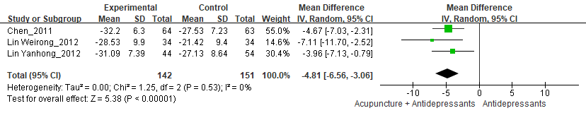
Appendix 6 Forest diagram of HAMD for acupuncture + antidepressants VS antidepressants in follow-up
Appendix 7 meta-regression with age, baseline HAMD-24, acupuncture session as single continuous covariate

Appendix 8 meta-regression with age, course of diseases, acupuncture session as single continuous covariate
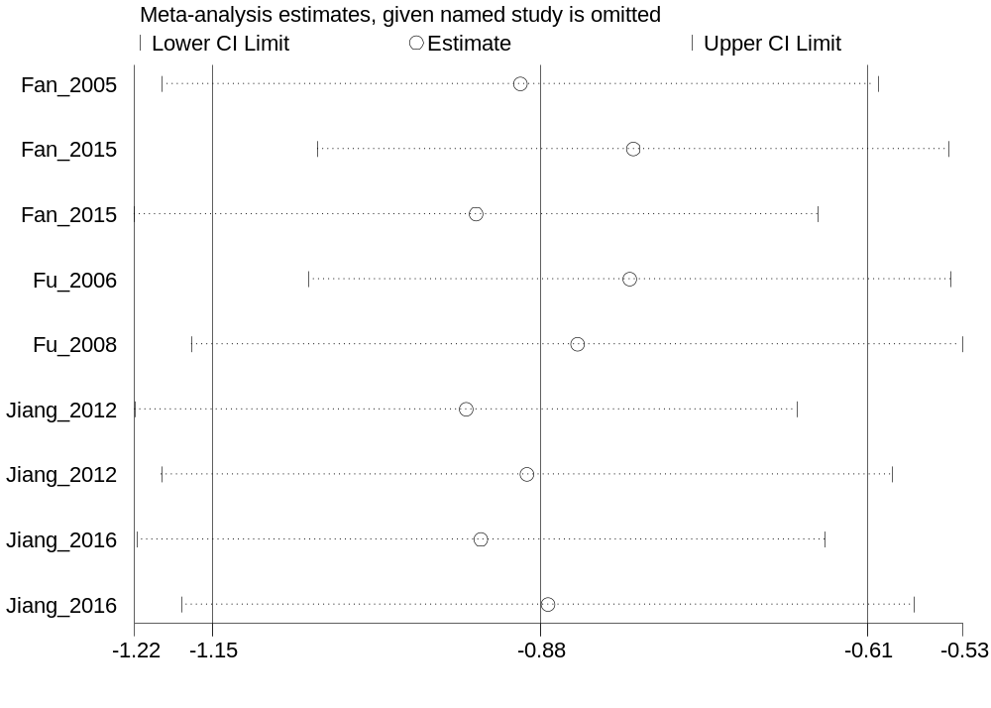
Appendix 9 Sensitivity analyses of acupuncture versus sham-acupuncture for HAMD-24

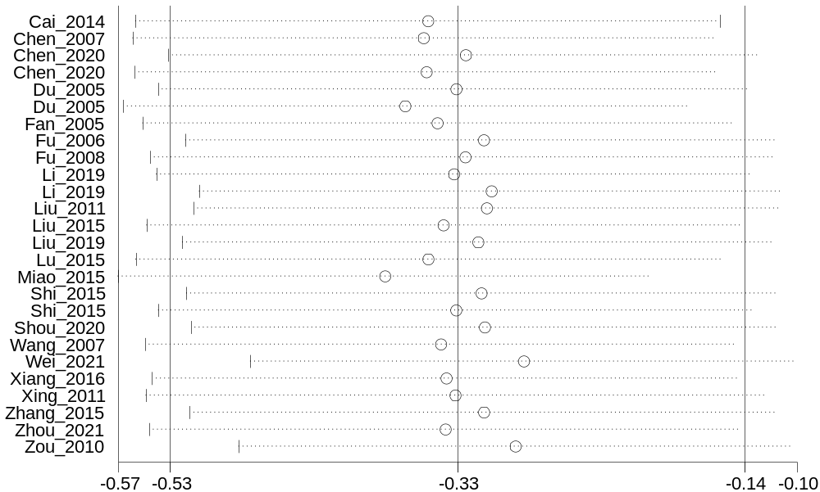
Appendix 10 Sensitivity analyses of acupuncture versus antidepressants for HAMD-24
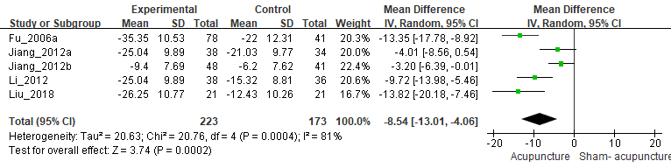
Appendix 11 Forest diagram of SDS for acupuncture VS sham-acupuncture

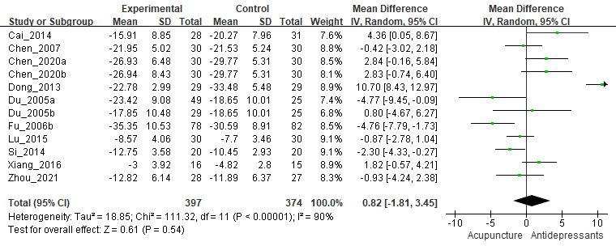
Appendix 12 Forest diagram of SDS for acupuncture VS antidepressants

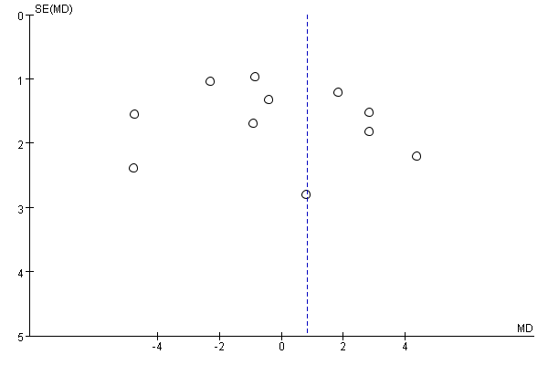
Appendix 13 Funnel Chart of SDS for acupuncture VS antidepressants

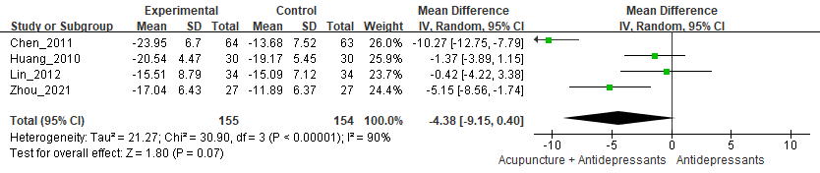
Appendix 14 Forest diagram of SDS for acupuncture + antidepressants VS antidepressants

Appendix 15 meta-regression with course of diseases, age, baseline HAMD-24, acupuncture session as single continuous covariate

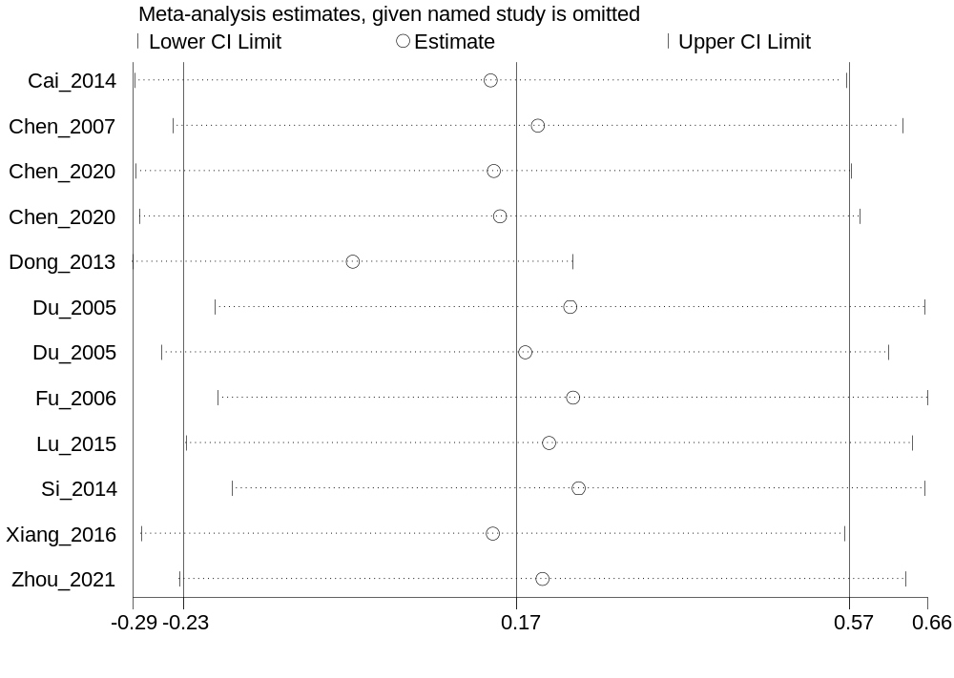
Appendix 16 Sensitivity analyses of acupuncture versus sham-acupuncture for SDS

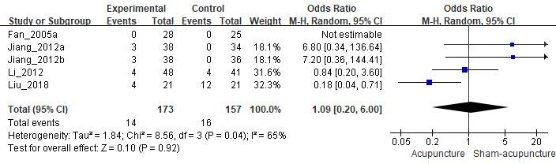
Appendix 17 Forest diagram of adverse events for acupuncture VS antidepressants

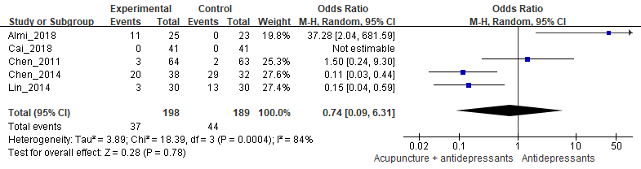

Appendix 18 Forest diagram of adverse events for acupuncture + antidepressants VS antidepressants

Reference:
1. Fan L, Gong J, Fu W, et al. Gender-Related Differences in Outcomes on Acupuncture and Moxibustion Treatment Among Depression Patients. Journal of alternative and complementary medicine (New York, NY) 2015;21(11):673-80. doi: 10.1089/acm.2015.0068 [published Online First: 2015/08/21]
2. Zhang WJ, Yang XB, Zhong BL. Combination of acupuncture and fluoxetine for depression: a randomized, double-blind, sham-controlled trial. Journal of alternative and complementary medicine (New York, NY) 2009;15(8):837-44. doi: 10.1089/acm.2008.0607 [published Online First: 2009/08/15]
3. Almi A, Mihardja H, Srilestari A, et al. Therapeutic effect of acupuncture combined with antidepressants on changes in the HAMD-17 score in major depressive disorder. Journal of Physics: Conference Series 2018;1073 doi: 10.1088/1742-6596/1073/6/062037
4. Li J. A Random i zed Control led Study on Acupuncture Treatment of Siguan" Points for Depression and the Ac-cAMP-PKA Postreceptor signal Transduction Mechan i sm [PhD]. Guangzhou University of Chinese Medicine, 2012.
5. Li J, Jianhua L, Jianpen H, et al. Influence of acupuncture in Compare with sham acupuncture on hamd Factors in Mild and moderate depression. Chinese Archives of Traditional Chinese Medicine 2016;34(08):1916-19.
6. Li F, Wen-bin F, Chang-rong M, et al. Effect of acupuncture at routine acupoint and non-acupoint on depressive neurosis evaluated with Hamilton depression scale. Chinese Journal of Clinical Rehabilitation 2005(28):14-16.
7. Wenbing F, Li F, Xiaoping Z, et al. Acupuncture for treatment of depressive neurosis a multi-center randomized controlled study. Chinese Acupuncture & Moxibustion 2008(01):3-6.
8. Wenbing F, Li F, Xiaoping Z, et al. Clinical Research on Acupuncture Treatment of Depressive Neurosis by Using Liver-function-regulating Method. Acupuncture Research 2006(06):355-58.
9. Meiyun C. The Clinical Study of Using Acupuncture Based on Combination of Yuan and Luo points Method and Cognitive Therapy on Depression of the Liver qi Stagnation Syndrome [PhD]. Nanjing University of Chinese Medicine, 2014.
10. Yi L, Baoliang Z, Zhuowei H, et al. Acupuncture Therapy for Depressive and Anxious Symptoms of Outpatients Receiving methadone maintenance treatment: a Randomized Controlled tria. Chinese journal of clinical psychology 2012;20(03):363-66.
11. Huan L. Clinical study of old ten-" to treat Comorbid anxiety and depression [Master]. Chengdu University of Chinese Medicine, 2015.
12. Chao L. The clinical research of comorbid anxiety and depression with acupuncture to regulate the heart and soothe the nerves [Master]. Chengdu University of Chinese Medicine, 2015.
13. Qianqian S. Clinical Study on Lingguibafa Combined with Music Therapy in the Treatment of the Depression of Liver and Qi Stagnation [Master]. Guangxi University of Chinese Medicine, 2020.
14. Lizhi C. The Observations on Long-Term Curative Effects of the Combination of Acupuncture and medication in Depression Treatments [Master]. Nanjing University of Chinese Medicine, 2011.
15. Guanghai W. Clinical Study on Improving the Quality of Life of Patients with mild to Moderate Depression by Acupuncture and Moxibustion [PhD]. Guangzhou University of Chinese Medicine, 2017.
16. Haixing L. Cl inical efficacy observation of acu-therapy of Bal anc ing and Adjust ing Ren and Du on mild to Moderate Depress ion patients with the syndrome of i iver-depress ion and spleen-deficiency [Master]. Guangzhou University of chinese Medicine, 2019.
17. Jian L, Aiai W, Guangning N, et al. Acupuncture for female depression a randomized controlled trial. Chinese Acupuncture & Moxibustion 2018;38(04):375-78.
18. Kexin L. THE CLINICAL OBSERVATION OF ACUPANETURE TREATMENT IN DEPRESSION [Master]. Heilongjiang University of Chinese Medicine, 2011.
19. Chuanwei C. Cl inical Observation on Treating Neurotic Depress ion between Fluoxetine and Acupuncture [Master]. Guangzhou University of Chinese Medicine, 2007.
20. Hai-dong C, Xiu-yan Y, Xue-hong M, et al. Effects of acupuncture in Patients with mild or Moderate depression treated with paroxetine hydrochloride. Chinese Journal of Information on Traditional Chinese Medicine 2014;21(08):35-38.
21. Ling S. Clinical efficacy of acupuncture combined with biofeedback therapy in the treatment of depression [Master]. Guiyang College of Traditional Chinese Medicine, 2014.
22. Chong W. Study of clinical effect and improvement of tcM syndromes of acupuncture for depression with I iver-qi stagnation syndrome [Master]. Guangzhou University of Chinese Medicine, 2007.
23. The Clinical Study of“Tiao Shen Jie Yu”Acupuncture Treatment on Depression of Liver Qi Stagnation. WCCU's 3rd Academic Conference on Chinese Medicine and Integrative Medicine in Geriatrics; 2010; Nanyang, Henan, China.
24. Junyi C, Guo'an D, Le H, et al. Clinical Study on acupuncture in Method of regulating mentality and Smoothing Liver Combined with SSRI. Journal of New Chinese Medicine 2018;50(12):191-93.
25. Yan H. A CLINICAL OBSERVATION OF COMBINED ACUPUNCTURE AND MEDICINAL TREATMENT IN DEPRESSION SYNDROME P300 EFFECTS [Master]. Nanjing University of Chinese Medicine, 2010.
26. Fenghe K, Hong L. 61 cases of depression treated with acupuncture. Chinese Journal of Gerontology 2013;33(10):2380-82.
27. Qiaojun L. Clinical therapeutic effect of ping wan li zhi acupuncture manipulation in the treatment of depression due to the deficiency of heart and spleen [Master]. Yunnan University of Chinese Medicine, 2019.
28. Weirong L, Yong H, Junqi C, et al. Global improvement in agitated depression treated with the alliance therapy of acupuncture and seroxat and the observation of the quality of life.
Chinese Acupuncture & Moxibustion 2012;32(12):1063-69.
29. Yanhong L. Clinical Comparative Study of Electro-Acupuncture and Manual Acupuncture in Treating Depression [Master]. Nanjing University of Chinese Medicine, 2012.
30. Yueqing L. The Clinical Research on the Combination of Shallow Insertion and Fluoxetine Hydrochloride in Treating Depression with Liver-qi Stagnation Type [Master]. Fujian University of Chinese Medicine, 2014.
31. Cheng L. a clinical study of synergy effect of acupuncture host points combined with local warm needling method in the treatment of depression of heart-spleen deficiency syndrome type [Master]. Yunnan University of Chinese Medicine, 2019.
32. Mengmeng M, Junmei W. Clinical observation of " Shugan Jianpi, Tongdu Tiaoxinacupuncture in the treatment of liver qi stagnation type depression. Clinical Journal of Traditional Chinese Medicine 2015;27(08):1115-17.
33. Yu S, Zhixiang W, Zheqi Z, et al. Clinical Study on Needling Method of Purging Liver and Tonifying Lungs in Treating Taiyin Cases with Depression. Journal of Nanjing University of Traditional Chinese Medicine 2015;31(2) [published Online First: 20161205]
34. Jinyan T. THE CLINICAL OBSERVATION ON THERAPEUTIC EFFECT OF REGULATING SPIRIT TO RELIEVE DEPRESSION ACUPUNCTURE THERAPY OF DEPRESSION (STAGNANCY OF LIVER QD) [Master]. Heilongjiang University of Chinese Medicine, 2010.
35. Lai W, Zuyan Z, Dan L, et al. RCTs of Fuyang Yiyin Acupuncture in Treating Depression. Journal of Clinical Acupuncture and Moxibustion 2021;37(08):30-34.
36. Juan X, Guo C, Lizhi O, et al. Clinical efficacy of acupuncture and moxibustion combined with gua sha in the treatment of depression evidence. Journal of Clinical Acupuncture and Moxibustion 2016;32(05):19-21.
37. Kai X. 120 cases of depression treated with acupuncture. Liaoning Journal of Traditional Chinese Medicine 2011;38(10):2060-62.
38. Aijia Z. Clinical Study on the Treatment of Mild and Moderate Depression with Acupuncture and Moxibustion for Warming Yang and Expelling Pathogenic Factors [Master]. Shanghai University of Chinese Medicine, 2019.
39. Run Z. Cl inical Study on the appl icat ion of tongyuan theory to acupuncture and acupoint catgut embedd ing therapy on Depressive neurosis [Master]. Guangzhou Un i ver s i ty of chinese Medicine, 2015.
40. Yijun C. Clinical observation on the Treatment of Mild and Moderate Depression by Zhuang heat-sensitive moxibustion acupuncture [Master]. Guangxi University of Chinese Medicine, 2020.
41. Jing Z, Yeqing D, Yuning W, et al. The efficacy of acupuncture and medicine in the treatment of mild to moderate depression. Shanghai Journal of Acupuncture and Moxibustion:1-6.
42. Yan D, Qing X. Clinical observation of 60 cases of depression treated with acupuncture. Medical Information 2013(16):616-16.
43. Yuanhao D, Guiping L, Hong Y, et al. Clinical study on needling method for regulating mental activities and soothing liver for treatment of melancholia. Chinese acupuncture & Moxibustion 2005(03):7-10.

