Table S1: Predictive performance of machine learning models in the external training set
Model | AUC | Sensitivity | Specificity | Accuracy | PPV | NPV | Brier | F1
Logistic | 0.795 | 0.705 | 0.740 | 0.730 | 0.508 | 0.868 | 0.151 | 0.591
RF | 0.799 | 0.687 | 0.743 | 0.727 | 0.505 | 0.861 | 0.149 | 0.582
XGBoost | 0.802 | 0.741 | 0.682 | 0.698 | 0.471 | 0.874 | 0.148 | 0.576
LightGBM | 0.800 | 0.669 | 0.765 | 0.739 | 0.521 | 0.858 | 0.149 | 0.586
CatBoost | 0.805 | 0.689 | 0.748 | 0.731 | 0.510 | 0.863 | 0.147 | 0.586
KNN | 0.794 | 0.677 | 0.745 | 0.727 | 0.504 | 0.858 | 0.151 | 0.578
SVM | 0.797 | 0.656 | 0.778 | 0.745 | 0.530 | 0.856 | 0.153 | 0.587
ANN | 0.797 | 0.678 | 0.760 | 0.738 | 0.519 | 0.861 | 0.150 | 0.588

Table S2: Predictive performance of machine learning models in the external test set
Model | AUC | Sensitivity | Specificity | Accuracy | PPV | NPV | Brier | F1
Logistic | 0.726 | 0.601 | 0.736 | 0.682 | 0.604 | 0.734 | 0.220 | 0.603
RF | 0.736 | 0.725 | 0.590 | 0.644 | 0.542 | 0.762 | 0.202 | 0.621
XGBoost | 0.737 | 0.628 | 0.716 | 0.681 | 0.598 | 0.742 | 0.204 | 0.613
LightGBM | 0.721 | 0.631 | 0.697 | 0.670 | 0.582 | 0.738 | 0.208 | 0.606
CatBoost | 0.736 | 0.606 | 0.733 | 0.682 | 0.603 | 0.735 | 0.211 | 0.605
KNN | 0.717 | 0.664 | 0.655 | 0.659 | 0.563 | 0.744 | 0.221 | 0.610
SVM | 0.729 | 0.621 | 0.734 | 0.689 | 0.610 | 0.743 | 0.209 | 0.615
ANN | 0.729 | 0.596 | 0.747 | 0.686 | 0.612 | 0.734 | 0.213 | 0.604

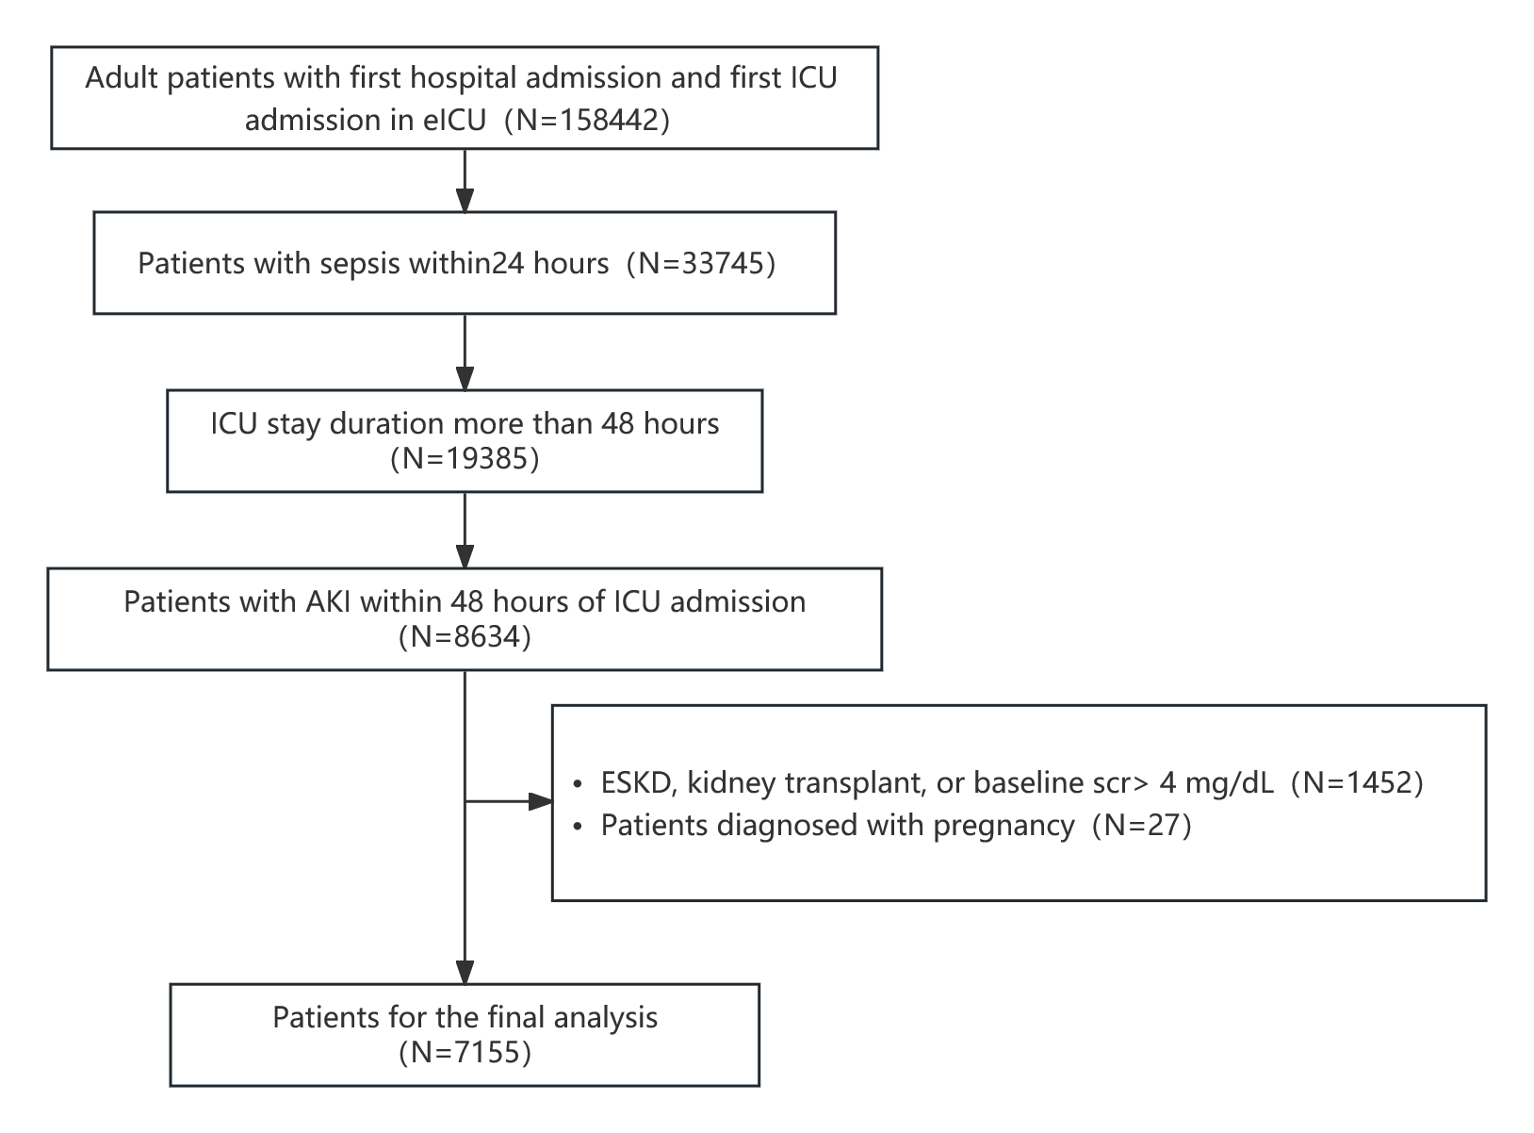
Fig. S1: Flow chart of participants included in the eICU dataset
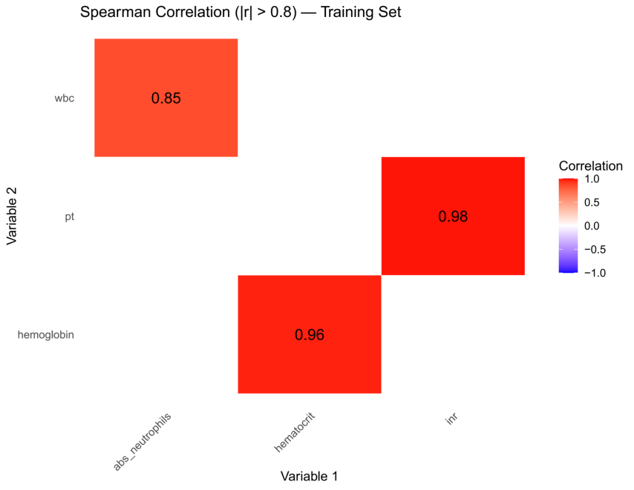
Fig. S2: Heatmap of high-correlation screening for feature variables

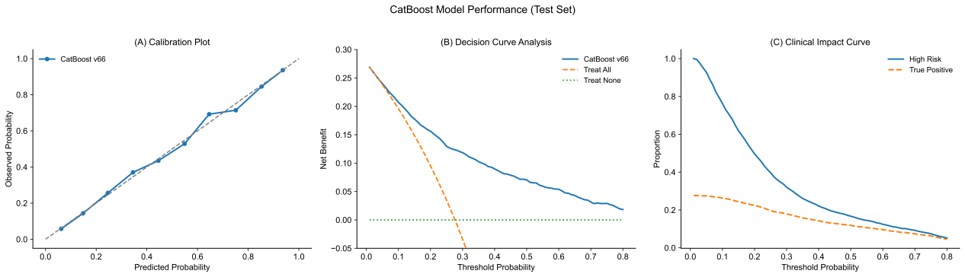
Fig. S3: Calibration curve, DCA, and CIC of the CatBoost model in the test set
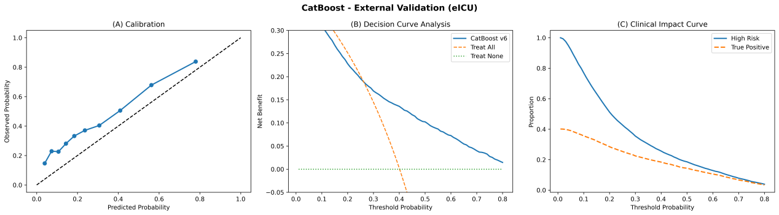
Fig. S4: Calibration curve, DCA, and CIC of the CatBoost model in the external validation cohort

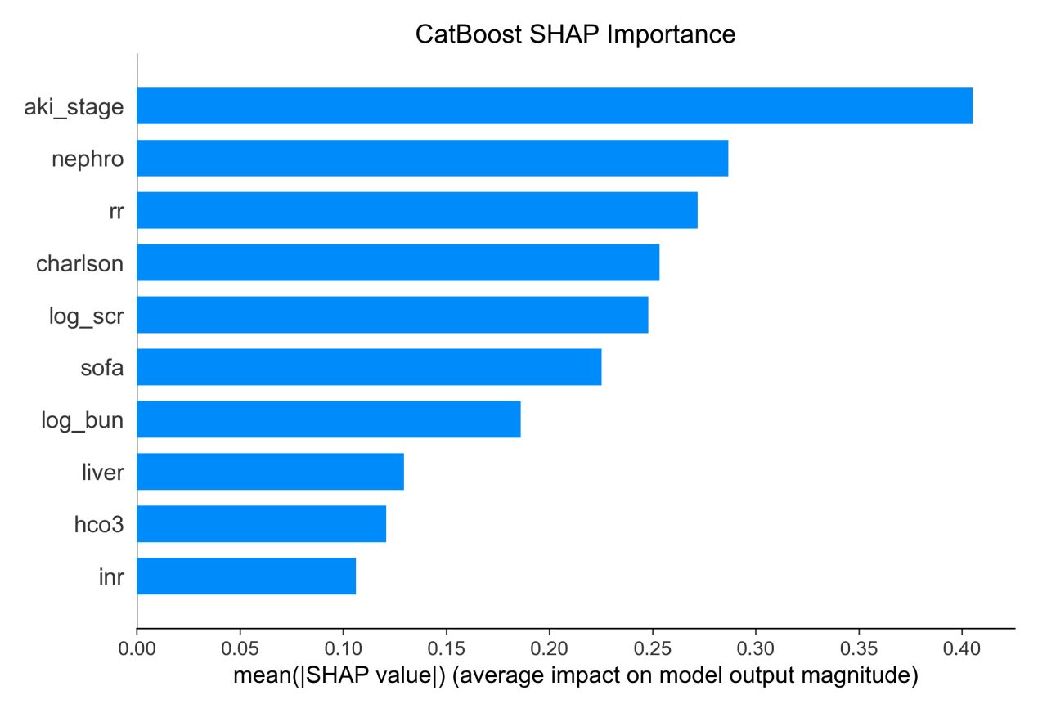
Fig. S5: SHAP feature importance based on mean absolute SHAP values

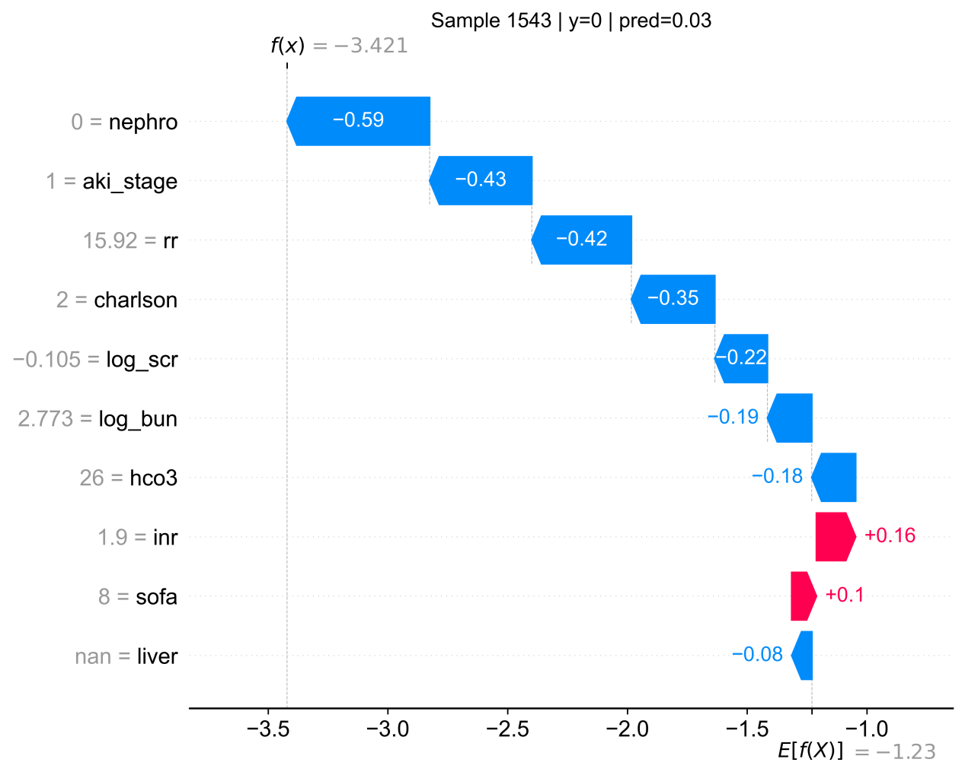
Fig. S6: SHAP waterfall plot for an individual patient without MAKE30

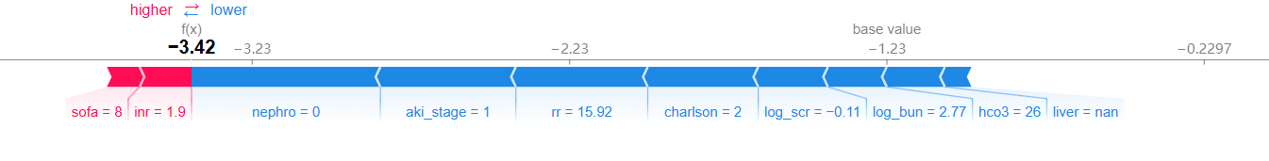
Fig. S7: SHAP force plot for an individual patient without MAKE30

