Supplementary Table 1 Conjugated antibodies used in flow cytometry evaluation
Antigen | clone | Fluorochrome
L/D | - | IR885
CD3 | HIT3a | FITC
CD16 | 3G8 | AF647
CD56 | HCD56 | PE dazzle
CD57 | HNK-1 | PE cy7
NKG2D | 1D11 | APC cyanine 7
CD226 (DNAM-1) | 11A8 | percp cy5.5
PD-1 | EH12.2H7 | BV510
DNAM-1: DNAX accessory molecule-1. PD-1: programmed death-1.
Supplementary Figure 1 Gating strategy for NK cell subtypes in peripheral blood under flow cytometry
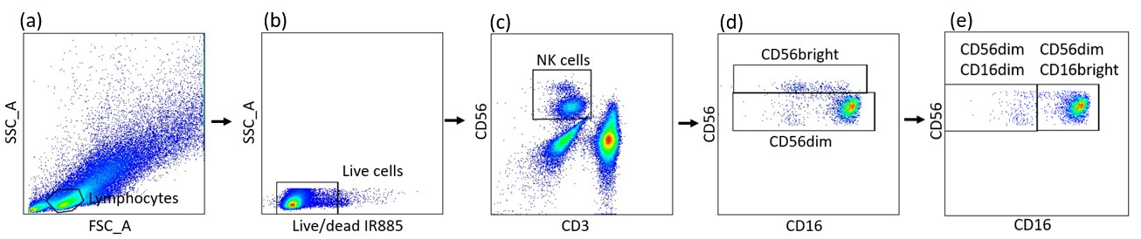
Thawed peripheral blood mononuclear cell (PBMC) were evaluated by forward scatter (FSC), side scatter (SSC), and IR885 for survival rate (a and b). Gated lymphocytes then were analyzed by CD3 and CD56 (c). NK cells (CD56⁺CD3⁻) can be gated into two subtypes: CD56^{bright} NK cells and CD56^{dim} NK cells through CD56 expression (d), and CD56^{dim} NK cells can be further separated into CD56^{dim}CD16^{bright} NK cells and CD56^{dim}CD16^{dim} NK cells by CD16 expression (e).

