Predicting the impacts of land management for sustainable development on depression risk in a Ugandan case study
Thomas Pienkowski^{a,1,}, Aidan Keane^{b}, Eugene Kinyanda^{c}, Caroline Asiimwe^{d}, and E.J. Milner-Gullandª
ª Department of Zoology, University of Oxford, Oxford, OX1 3SZ, UK
^{b} School of GeoSciences, University of Edinburgh, Edinburgh, EH9 3FF, UK
^{c} Medical Research Council/Uganda Virus Research Institute and London School of Hygiene & Tropical Medicine Uganda Research Unit, 51-59 Nakiwogo Street, Entebbe, Uganda
^{d} Budongo Conservation Field Station, Masindi, Uganda
¹ thomas.pienkowski@zoo.ox.ac.uk

Supplementary methods 1: Study site description
Since 1986, the Ugandan government has adopted a wide range of reforms to modernise the countries agricultural sector, leading to massive growth in cash crop production, including sugarcane¹. Contract sugarcane farming was promoted as a mechanism for inclusive development but increased inequalities in several parts of the country¹. For example, there has been an expansion of contract sugarcane farming around Budongo Forest to supply Kinyara Sugar Works. This expansion appears to have deepened inequitable land distributions, increasing incomes for wealthier landowners but worsening economic poverty, food insecurity, and subsequent psychological distress among small-scale farmers². This land redistribution appears to have occurred through several mechanisms, including voluntary selling or renting land to meet immediate needs and coercive or forced displacement².
Forest reserves are an essential part of Uganda’s protected areas network, which covers 16% of the country’s land surface³. Budongo Forest Reserve, which neighbours the smaller Rwensama Forest Reserve, was gazetted by the British in the 1930s and is managed by the National Forestry Authority⁴. The forest is a source of illegal timber, charcoal, and wild meat and legally harvested medicines, firewood, plants and mushrooms⁵. These sources of forest food and income appear to alleviate stressors causing psychological distress among poorer households².

Supplementary methods 2: Depression instrument
Total eight-item Patient Health Questionnaire (PHQ-8) scores were not used within the statistical analysis^{6,7}. Instead, the PHQ-8 was used to estimate latent depression risk. The dataset was split into training (2/3 of observations) and test (1/3 of observations) sets. Using the training set, parallel analysis using polychoric correlation and a weighted least squares estimator suggested extracting one factor using the ‘psych’ package⁸. Exploratory factor analysis with the training set suggested each item was reasonably well loaded on the one extracted factor, with good model fit using the ‘semTools’ package⁹. Confirmatory factor analysis using the test data yielded similar results, although with a poorer model fit (likely because of the small size of the test dataset). A one-factor graded response model using all data suggested was fit using the ‘mirt’ package¹⁰. This analysis indicated that the instrument had reasonable discriminatory power, although with some floor and ceiling effects. This model had a root mean square error of approximation (RMSEA) of 0.048 (95% confidence interval 0.033 - 0.065), comparative fit index (CFI) of 0.864, Tucker–Lewis index (TLI) of 0.810, and standardised root mean square residual (SRMR) of 0.044. One set of plausible values were extracted from a graded responses model run with each of the ten imputed datasets. Plausible values were used because the software used in the statistical model could not estimate factors from ordinal data.
The statements within the PHQ-8 were:
- Over the past two weeks, how many times were you disturbed by little interest or pleasure in doing things? Was it not at all, a few days, more than half the days, or nearly every day?
- Over the past two weeks, how many times were you disturbed by feeling down, unhappy, or like you cannot see a way forward? Was it not at all, a few days, more than half the days, or nearly every day?
- Over the past two weeks, how many times were you disturbed by trouble falling or staying asleep, or sleeping too much? Was it not at all, a few days, more than half the days, or nearly every day?
- Over the past two weeks, how many times were you disturbed by feeling tired or having little energy? Was it not at all, a few days, more than half the days, or nearly every day?
- Over the past two weeks, how many times were you disturbed by not wanting to eat or eating too much? Was it not at all, a few days, more than half the days, or nearly every day?
- Over the past two weeks, how many times were you disturbed by feeling bad about yourself, or you are a failure, or you have failed yourself or your family? Was it not at all, a few days, more than half the days, or nearly every day?
- Over the past two weeks, how many times were you disturbed by challenges putting your mind on what you are doing, like a church service or speaking with people? Was it not at all, a few days, more than half the days, or nearly every day?
- Over the past two weeks, how many times were you disturbed by moving or speaking so slowly that other people notice? Or in the opposite way, fidgeting so much that you move a lot more than how you used to do? Was it not at all, a few days, more than half the days, or nearly every day?
- Over the past two weeks, how many times were you disturbed by thinking to much or too many thoughts? Was it not at all, a few days, more than half the days, or nearly every day?
“Thinking too much” is a colloquial term used to indicate degrees of psychological distress in the study area¹¹. An additional variable corresponding to the format of the PHQ-8 was therefore included, asking respondents if they “think too much”. This variable was not used in the formal assessment of depression risk but was instead used to triangulate the study with the previous qualitative study results (see S12: Supplementary analysis 1).

Supplementary methods 3: Prior probability details
Table S1. The a priori hypothesised associations between exposure and outcome variables in the structural equation model, the distributional form and type of prior, the supporting evidence, and associated hyperparameters. Key: ‘+’ = positive association; ‘-’ = negative association; ‘?’ = uncertain direction of the association; N = normal distribution, and B = beta distribution.
Outcome variable | Expected association | Exposure variable | Distributional form of the priors | Type of prior | Prior evidence | Picture of plot | Hyperparameters
Depression | (+) | Food insecurity | Normal | Moderately informative | Food insecurity is a widely recognised and strong social determinant of common mental disorders, including depression¹²⁻¹⁵. Food insecurity also appears to be a prominent stressor associated with psychological distress in the study site and other parts of Uganda^{11,16}. | 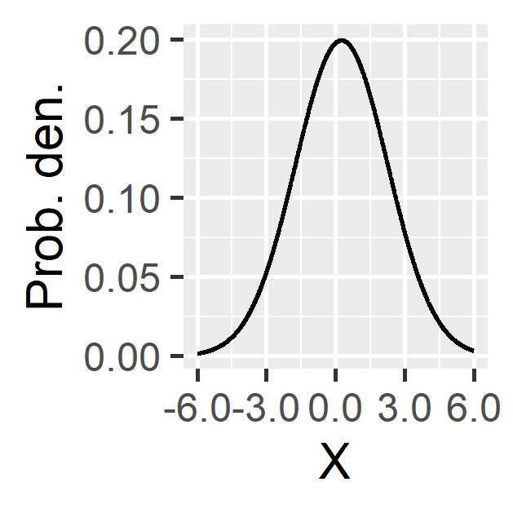 | $$N(0.25, 4)$$
Depression | (+) | Economic poverty | Normal | Moderately informative | Economic poverty is also a widely recognised and strong social determinant of common mental disorders, such as depression^{14,15,17}. Again, economic poverty also appears to be a prominent stressor associated with psychological distress in the study site and Uganda generally^{11,18}. |  | $$N(0.25, 4)$$
Food insecurity | (+) co-variance | Forest use | Beta | Moderately informative | Prior evidence from the study site suggests that legally and illegally harvested forest resources are an important source of food and income (used to purchase food) for some households, particularly in times of need¹¹. And so, food-insecure households appear more likely to be forest users, but forest use alleviates food insecurity. | 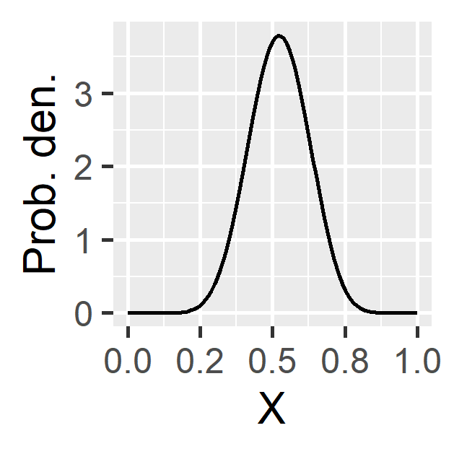 | $$B(12, 11)$$
Food insecurity | (-) | Farm size | Normal | Moderately informative | Multiple on-farm factors influence food security, including absolute farm size^{19,20}. Previous research found that small farm sizes were considered a major cause of food insecurity for residents¹¹. |  | $$N(-0.25, 4)$$
Food insecurity | (+) | Economic poverty | Normal | Moderately informative | In general, food insecurity and economic poverty are often closely tied and sometimes treated as sub-dimensions of general poverty (e.g., ¹⁵). Previous research within the study site suggests a strong association between food insecurity and economic poverty, with income often used to purchase food, especially in times of need¹¹. | 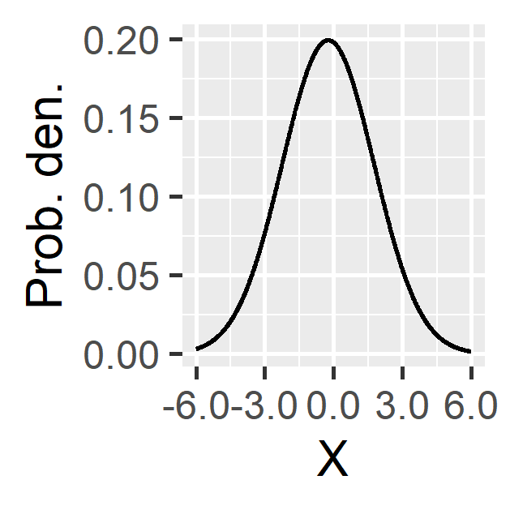 | $$N(0.25, 4)$$
Food insecurity | (-) | Distance for forest reserve | Normal | Moderately informative | Previous research suggests that crop-raiding may threaten food security in the study area and mostly occurs close to the forest edge^{11,21,22}. |  | $$N(-0.25, 4)$$
Economic poverty | (+) co-variance | Forest use | Beta | Moderately informative | Prior research in the study site suggests that legally and illegally harvested forest resources are to be an important source of income for some households; poor households are more likely to be forest users, but forest resource utilisation helps alleviate poverty¹¹. |  | $$B(12, 11)$$
Economic poverty | (-) co-variance | Farm size | Beta | Moderately informative | Most land outside the forest reserves within the study site has been cleared for agriculture, meaning there is little available land for agricultural expansion²³. Residents of the area reported rising land prices leading to increasingly inequitably distributed farm sizes between wealthier and poorer households¹¹. | 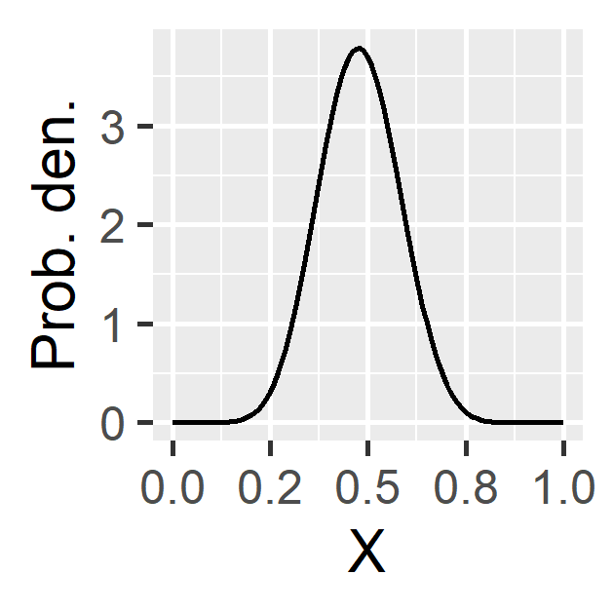 | $$B(11,12)$$
Depression | (+) | Age | Normal | Moderately informative | Although the association may not be linear, prior evidence suggests a general positive association between age and poor mental health in Uganda^{18,24}. |  | $$N(0.25, 4)$$
Depression | (+) | Gender | Normal | Moderately informative | Evidence from Uganda indicates women may be at higher risk of poor mental health than men ^{16,18}. Prior research in the case study suggests women might face greater threats to mental health due to having fewer assets and less income, greater childcare responsibilities, and other factors¹¹. |  | $$N(0.25, 4)$$
Depression | (-) | Education | Normal | Moderately informative | While the relationship between educational level and mental health can be complex¹⁴, educational attainment is often associated with socioeconomic status¹⁵. Some evidence for Uganda suggests higher levels of education are associated with better mental health¹⁸. |  | $$N(-0.25, 4)$$
Depression | (-) | Social support | Normal | Moderately informative | Significant evidence suggests those with less social support (from spouses, family, and friends) have worse mental health, including research in Uganda^{16,25,26}. |  | $$N(-0.25, 4)$$
Depression | (+/?) | Marital status: divorced or widowed | Normal | Moderately informative | Although married individuals tend to have better mental health, this relationship may be more complex is contexts where polygamy is common^{27,28}. Prior evidence from Uganda suggests those who are divorced or widowed are at around double the risk of depression than the general population in Uganda¹⁸. We adopt a strongly informative prior for ‘divorced or widowed’ but a weakly informative prior for ‘never married’. |  | $$N(0.25, 4)$$
Depression | (+/?) | Marital status: never married | Normal | Weakly informative |  | 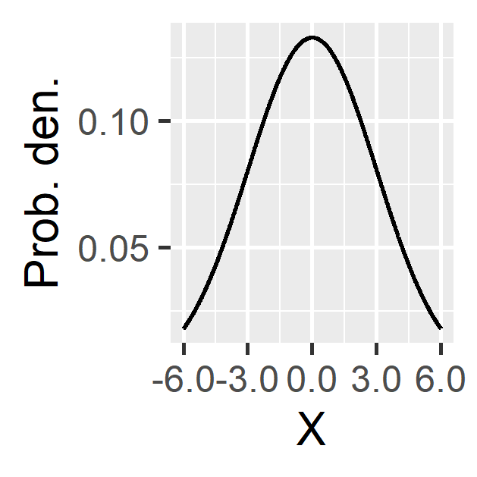 | $$N(0, 9)$$
Depression | (-) co-variance | General health | Beta | Moderately informative | A large amount of research describes bi-directional co-morbidity between mental and physical health²⁹. |  | $$B(2, 3)$$
Depression | (+) | Alcohol consumption | Normal | Moderately informative | Evidence suggests a positive association between drinking and depression risk, with the former tending to causally influence the latter³⁰. |  | $$N(0.25, 4)$$
Depression | (+) | Smoking | Normal | Moderately informative | Tobacco smoking is often positively associated with depression risk, although the direction of causality is uncertain³¹. Some evidence that smoking might be a risk factor in Uganda²⁴. | 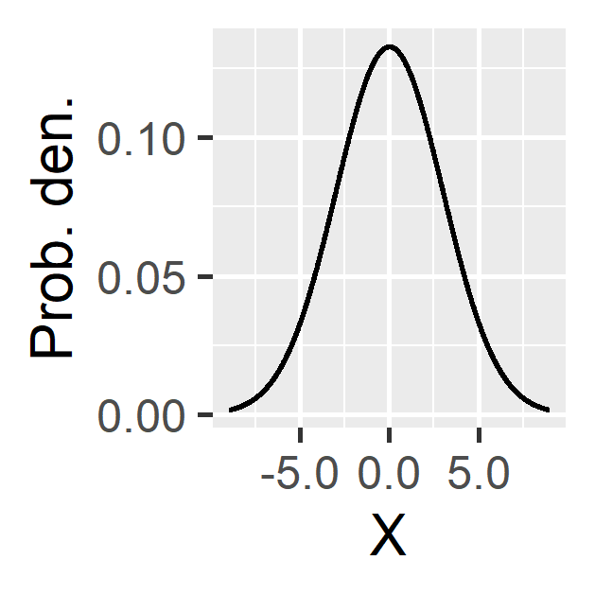 | $$N(0.25, 4)$$
Depression | (?) | Community name (all) | Normal | Weakly informative | Prior research within the study site suggests community-level differences in access to utilities, markets, and sources of employment¹¹. The inclusion of this variable controls for these differences. |  | $$N(0,9)$$

Supplementary methods 4: FIES instrument
The Food Insecurity Experience Scale (FIES) was used to estimate food insecurity. Rasch, two-parameter, and three-parameter logistic item response models were fit. The two-parameter model had 24.1 lower Akaike information criterion scores than the next best model, and so was chosen. This model had a RMSEA of 0.087 (95% CI 0.073 - 0.102), CFI = 0.971, TLI of 0.959, and SRMR of 0.051. Ten sets of plausible values were extracted, as above.
The statements within the FIES were:
- During the last 3 months, was there a time when you or others in your household worried about not having enough food to eat because of a lack of money or other resources?
- Still thinking about the last 3 months, was there a time when you or others in your household were unable to eat healthy and nutritious food because of a lack of money or other resources?
- Was there a time when you or others in your household ate only a few kinds of foods because of a lack of money or other resources?
- Was there a time when you or others in your household had to skip a meal because there was not enough money or other resources to get food?
- Still thinking about the last 3 months, was there a time when you or others in your household ate less than you thought you should because of a lack of money or other resources?
- Was there a time when your household ran out of food because of a lack of money or other resources?
- Was there a time when you or others in your household were hungry but did not eat because there was not enough money or other resources for food?
- Was there a time when you or others in your household went without eating for a whole day because of a lack of money or other resources?
- We would like to hear how you feel about some sayings. These sayings are going to be read to you. We would like you to tell us if you agree or disagree with these sayings using the answers given. Have you understood?

Supplementary methods 5: Asset index
A logistic principal component analysis was conducted with 21 household assets (Table S2). The number of principal components to estimate in the model was selected through an iterative process. This process involved repeating the logistic principal component analysis ten times, starting with extracting one component and ending with the extraction of ten. Out of these ten candidate models, we choose the one whose factor scores had the largest linear association with an external measure of subjective financial strain. This measure of financial strain is a single-item question recommended by the National Academy of Medicine^{,32,33}. This analysis suggested using nine principal components within the model (which explained 85.7% of the total variance). The first component was used as a proxy for economic poverty.
Table S2. Household assets that were include (‘Yes’) or excluded (‘No’) in a logistic principal component analysis to construct an asset index, used as a proxy for economic poverty.
Assets | Included
A gas cooker | No
At least two sets of clothes for every person in the household | Yes
Two goats | No
At least two meals per day | Yes
Mains electricity | No
A wooden bed (frame) | Yes
A big solar panel | Yes
At least two Jerry cans | Yes
One mattress or more | Yes
A television | No
Brick walls for your house | Yes
A motorbike | No
Two hoes | Yes
A blanket for every person in the household | Yes
A bank account | No
A bicycle | Yes
A water tank | No
A pair of shoes for every member of the household | Yes
Iron sheets on your roof | Yes
A radio | Yes
Three saucepans | Yes
Solar battery | No
A mobile phone | Yes
Two or more plastic chairs | Yes
A car | No
A fridge | No
A cement floor for your house | Yes
A member in a savings group | Yes
A sofa | Yes
Two or more wooden chairs | Yes
Soap | Yes

Supplementary methods 6: Forest instrument
We designed an instrument with seven Likert-scaled items to estimate forest use. Parallel analysis and exploratory factor analysis with the training data were performed, followed by confirmatory factor analysis with the test data. Parallel analysis with the training set suggested the extraction of two factors. Exploratory factor analysis suggested that four items were heavily loaded on the first factor, two items were cross-loaded, and the final item was heavily loaded on the second factor. Therefore, a two-factor graded response model was fit (Table S3). This model had an RMSEA of 0.087 (95% CI 0.068 - 0.106), CFI of 0.966, TLI of 0.941, and SRMR of 0.048. The four items heavily loaded on the first factor specifically related to food and income, while the three items heavily loaded on the second factor related to non-specific forest dependence. Therefore, one set of plausible values associated with the first dimension – deemed most relevant for this study – were extracted from each imputed dataset.
Table S3. Loadings within two-factor graded response model. Ten sets of plausible values of the first factor were extracted and used in the primary analysis.
Statement | First factor | Second factor
Your household gets things from the forest that help you a lot. |  | 0.787
Your household gets good money from things in the forest. | 0.860
The forest helps you buy things you need, like food, school fees, or medicine. | 0.888
It would be very bad for your household if you could not get things from the forest. | 0.261 | 0.638
Your household gets food from the forest. | 0.771
Getting things from the forest helps your household to survive. | 0.305 | 0.682
Your household would have no money or food if you could not go to the forest. | 0.744

Supplementary methods 7: Land instrument
We designed an instrument with six Likert-scaled items to estimate land size. Again, the same steps described to estimate latent depression symptom severity (S2: Depression instrument) were repeated. This analysis suggested the extraction of one factor, and so a one-factor graded response model was fit. This model had an RMSEA of 0.080 (95% CI 0.059 - 0.103), CFI of 0.970, TLI of 0.951, and SRMR of 0.057. As above, one set of plausible values were extracted from each of the imputed datasets.
The statements within the land instrument were:
- Your household’s farm is bigger than most others in this community.
- Your household’s farm is big enough for you to get the things you need, like food, school fees, or medicine.
- Your household struggles because you do not have enough land.
- Your household has enough land to live well.
- Your household gets good money from your farm.
- Your household’s farm is smaller than most others in this community.

Supplementary methods 8: Social support instrument
Social support was estimated using a modified version of the Multidimensional Scale of Perceived Social Support (MSPSS) ³⁴⁻³⁶. The MSPSS is used to estimate latent social support from three sources; friends, family, and significant others. The modification of the MSPSS involves using six of the 12-items, as indicated by Slavin, et al. ³⁷. We further simplified the instrument by reducing the number of response levels from seven to five to simplify. Furthermore, we also altered some of the phrases and changed from the first to the second person following piloting. For instance, one of the original statements is “I can count on my friends when things go wrong”, which we changed to “You know your friends will be around to help when trouble finds you.”
The modified version of the MSPSS was used to estimate latent social support, following steps similar to those described in the main text for estimating latent depression. The parallel analysis with the training data suggested the extraction of two factors. Subsequent exploratory factor analysis using all responses suggested three items were heavily loaded onto the first factor, one item was cross-loaded, and two items were loaded on a second factor (Table S4). This model had an RMSEA of 0.083 (95% CI 0.061 - 0.107), CFI of 0.970, TLI of 0.944, and SRMR of 0.057. The first factor related to social support from family or one’s partner, which was deemed more relevant than support from friends, and therefore ten sets of plausible values associated with the first factor were extracted.
Table S4. Loadings within two-factor graded response model. Ten sets of plausible values of the first factor were extracted and used in the primary analysis.
Statement | First factor | Second factor
There is a special person around you when you are in need. | 0.578
Your family tries to help you. | 0.864
You get the comfort and support you need from your family. | 0.902
You know your friends will be around to help when trouble finds you. |  | 0.819
You can talk about your problems with your friends. |  | 0.711
There is a special person with whom you can share joys and sorrows. | 0.327 | 0.440

Supplementary methods 9: Patterns of missing data
Approximately 0.2% of the data were missing (Figure S1). This missingness is partly attributed to one of the questions (indicated by ‘SOCJOY’) mistakenly not being asked in an early version of the survey. Additionally, several respondents did not wish to respond to questions about their land size (e.g., those questions staring with the indicator ‘LAND…’).
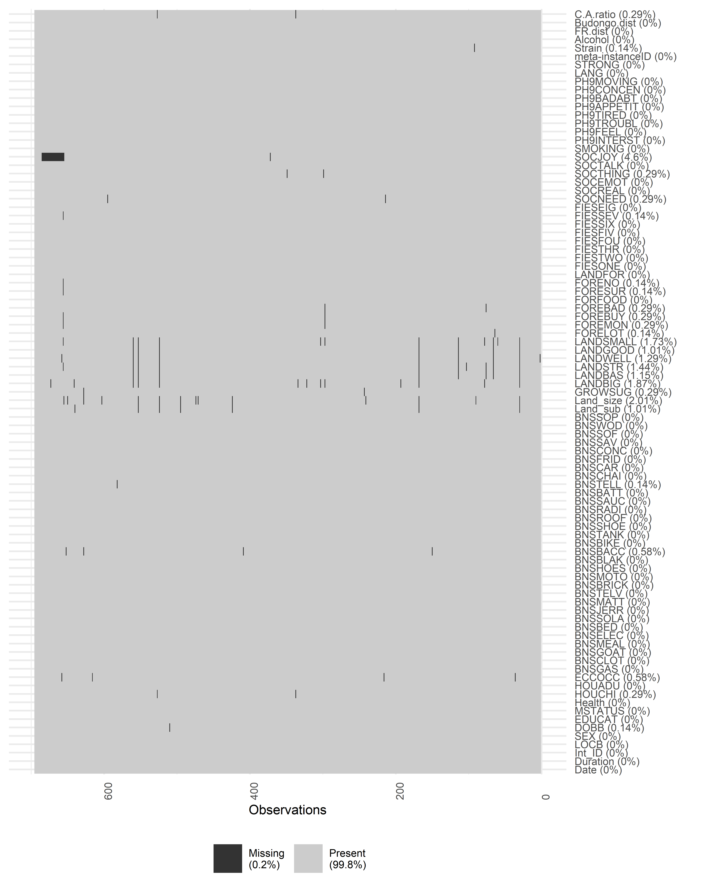
Figure S1. Patterns of missing data within our data.

Supplementary methods 10: MICE
Missing values were assumed to be missing at random in relation to the response variable and so were substituted with synthetic values through multivariate imputation by chained equations, using the ‘mice’ package³⁸. This imputation created ten datasets containing the imputed data. Ordinal variables were imputed using proportional odds models, numeric variables with predictive mean matching, and unordered categorical variables with polytomous logistic regression. The pre- and post-imputation distributions of these variables were consistent.

Supplementary methods 11: Model diagnostics
The models were evaluated according to the ten steps described in the When to worry and how to Avoid the Misuse of Bayesian Statistics (WAMBS)-Checklist³⁹.
- “Do you understand the priors?”: TP discussed the priors (shown in S3: Prior probability details) with EJMG and AK.
- “Does the trace-plot exhibit convergence?”: We inspected the trace-plots, potential scale reduction factor from the Gelman-Rubin Diagnostic, and the Geweke Diagnostic for the model run with the first of the ten imputed datasets. These diagnostics suggested the models had converged, with equality between the first and second half of iterations.
- “Does convergence remain after doubling the number of iterations?”: The number of pre- and post-burn-in iterations doubled to 8,000 each (16,000 in total), and trace plots, potential scale reduction factor, and Geweke Diagnostic were re-examined. These results suggested that local convergence was not an issue.
- “Does the histogram have enough information?”: We inspected the histograms of estimates in each iteration, and there appeared to be sufficient information to approximate the posterior, with a single clear peak and sloping sides for each parameter.
- “Do the chains exhibit a strong degree of autocorrelation?”: We found a small amount of autocorrelation, but it was not accompanied by convergence issues, so it was not concerning.
- “Does the posterior distribution make substantive sense?”: The posterior distributions were consistent with our hypothesis and a plausible mean and spread.
- “Do different specifications of the multivariate variance priors influence the results?” We re-run the model with a multivariate variance prior of “gamma(1, 0.05)”, which had no discernible effect on the posterior distribution.
- “Is there a notable effect of the prior when compared with noninformative priors?”. We repeated the analysis with the software’s default weakly informative priors, with no discernible effect on the posterior distribution.
- “Are the results stable from a sensitivity analysis?” We re-ran the analysis twice, first increasing all hyperparameters (e.g., shifting from N(0.25, 4) to N(0.50, 4)), then decreasing them (e.g., shifting from N(0.25, 4) to N(0.00, 4)). These changes had no discernible effect on the posterior distribution.
- “Is the Bayesian way of interpreting and reporting model results used?” We presented the median, 95% and 50% credibility intervals of the posterior distribution.

Supplementary methods 12: Supplementary analysis 1
We modelled the association between “thinking too much” (the outcome variable) and latent depressive symptom severity (using the raw PHQ-8 scores as the exposure variable) within a Bayesian ordinal regression. We used the software’s default weakly informative priors. The models were fitted with a logit link function and were run for 4000 burn-in and 4000 post-burn-in iterations across four Markov chains and using the Markov Chain Monte Carlo sampler. The analysis was repeated with all ten imputed datasets, and the prior distributions were pooled. PHQ-8 scores were strongly positively correlated with “thinking too much” (Table S5).
Table S5. The results of an ordinal logistic regression examining the association between “thinking too much” and Patient Health Questionnaire (PHQ-8) scores on the log-odds scale.
Variable | Estimate | Standard error | 95% CI
Threshold one (Not at all | Few days) | 1.08 | 1.19 | 0.77-1.53
Threshold two (Few days | More than half the days) | 9.46 | 1.21 | 6.49-13.89
Threshold three (More than half the days | Nearly every day) | 19.19 | 1.23 | 12.88-28.83
PHQ-8 score | 1.27 | 1.02 | 1.22-1.31

Supplementary methods 13: Supplementary analysis 2
We repeated the primary analysis but replaced depressive symptom severity with “thinking too much”. Assuming that responses to “thinking too much” were driven by an underlying latent variable, we scaled and centred the variable and treated it as continuous. The same priors, number of iterations and chains, seed, and sampling algorithm as used in the main analysis was also used here.
The results of this analysis were generally consistent with the primary analysis (Figure S2). However, in contrast with the primary analysis, age had a significant positive association with “thinking too much”, but gender and education did not. Further analysis would be needed to understand these differences. However, these results suggest that “thinking too much” and depression may affect slightly different demographic groups.
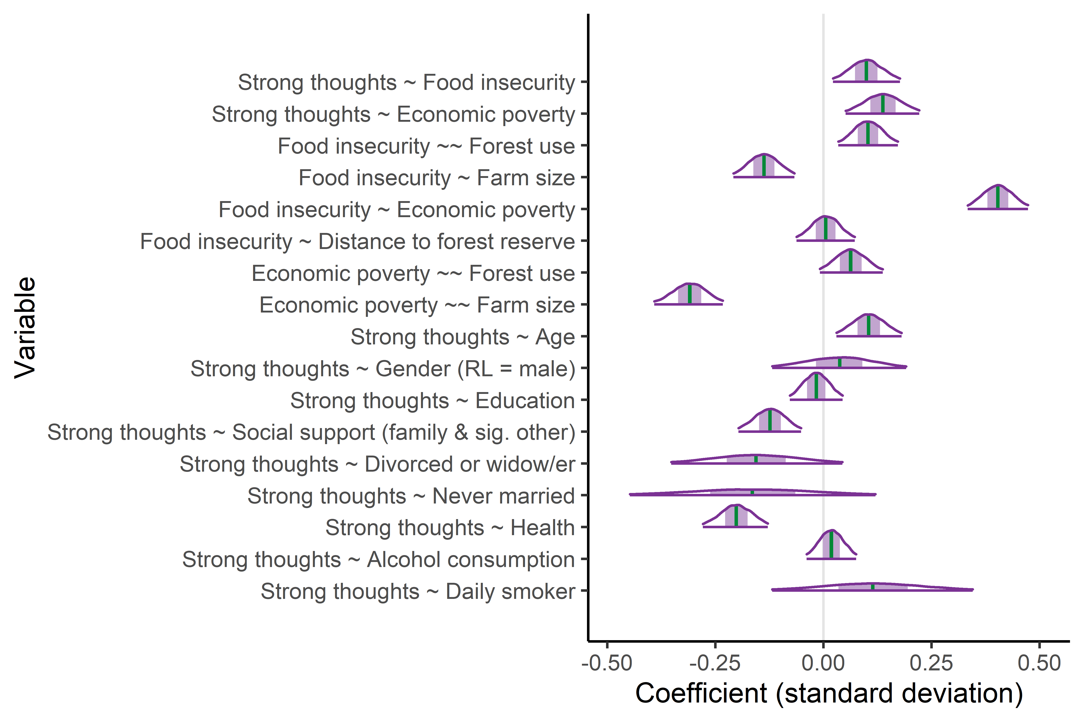
Figure S2. The coefficient estimates from the Bayesian structural equation model using data from 695 respondents. The vertical green line represents the point estimate (median of the posterior distribution), the dark purple line represents the 95% credibility interval, and the shaded area represents the 50% credibility interval. The estimated associations between depressive symptom severity and the community dummy variables are not shown. Coefficient estimates are presented in standard deviations.

References
1 Martiniello, G. Bitter sugarification: sugar frontier and contract farming in Uganda. Globalizations 18, 355-371, doi:10.1080/14747731.2020.1794564 (2021).
2 Pienkowski, T. et al. The role of nature conservation and commercial farming in psychological distress among rural Ugandans. bioRxiv, 2021.2006.2008.446718, doi:10.1101/2021.06.08.446718 (2021).
3 United Nations Environment World Conservation Monitoring Centre (UNEP-WCMC) & International Union for Conservation of Nature (IUCN). Protected Planet: The World Database on Protected Areas (WDPA), <https://www.protectedplanet.net/> (2020).
4 Paterson, J. D. The ecology and history of Uganda's Budongo forest. Forest & Conservation History 35, 179-187 (1991).
5 Babweteera, F. et al. in Conservation and Development in Uganda (eds C. Sandbrook, C. J. Cavanagh, & D. M. Tumusiime) 104-122 (Routledge, 2018).
6 Kroenke, K., Spitzer, R. L. & Williams, J. B. W. The PHQ-9: validity of a brief depression severity measure. Journal of General Internal Medicine 16, 606-613, doi:10.1046/j.1525-1497.2001.016009606.x (2001).
7 Wu, Y. et al. Equivalency of the diagnostic accuracy of the PHQ-8 and PHQ-9: a systematic review and individual participant data meta-analysis. Psychological Medicine 50, 1368-1380, doi:https://doi.org/10.1017/S0033291719001314 (2020).
8 psych: Procedures for psychological, psychometric, and personality research v. 1.9.12 (Northwestern University., Evanston, USA, 2019).
9 semTools: Useful tools for structural equation modeling v. 05-3 (https://CRAN.R-project.org/package=semTools, 2020).
10 Chalmers, R. P. mirt: A multidimensional Item Response Theory package for the R environment. Journal of Statistical Software 48, 1-29, doi:10.18637/jss.v048.i06 (2012).
11 Pienkowski, T. et al. The role of nature conservation and commercial farming in psychological distress among rural Ugandans. Land Use Policy (in review).
12 Weaver, L. J. & Hadley, C. Moving beyond hunger and nutrition: a systematic review of the evidence linking food insecurity and mental health in developing countries. Ecology of Food and Nutrition 48, 263–284, doi:10.1080/03670240903001167 (2009).
13 Jones, A. D. Food insecurity and mental health status: a global analysis of 149 countries. American Journal of Preventive Medicine 53, 264-273, doi:10.1016/j.amepre.2017.04.008 (2017).
14 Lund, C. et al. Social determinants of mental disorders and the Sustainable Development Goals: a systematic review of reviews. The Lancet Psychiatry 5, 357-369, doi:10.1016/s2215-0366(18)30060-9 (2018).
15 Lund, C. et al. Poverty and common mental disorders in low and middle income countries: a systematic review. Social Science & Medicine 71, 517-528, doi:10.1016/j.socscimed.2010.04.027 (2010).
16 Kinyanda, E. et al. Major depressive disorder and suicidality in early HIV infection and its association with risk factors and negative outcomes as seen in semi-urban and rural Uganda. Journal of Affective Disorders 212, 117-127, doi:10.1016/j.jad.2017.01.033 (2017).
17 Patel, V. & Kleinman, A. Poverty and common mental disorders in developing countries. Bulletin of the World Health Organization 81, 609-615 (2003).
18 Kinyanda, E. et al. Poverty, life events and the risk for depression in Uganda. Social Psychiatry and Psychiatric Epidemiology 46, 35-44, doi:10.1007/s00127-009-0164-8 (2011).
19 Otsuka, K. Food insecurity, income inequality, and the changing comparative advantage in world agriculture. Agricultural Economics 44, 7-18, doi:https://doi.org/10.1111/agec.12046 (2013).
20 Fraval, S. et al. Food access deficiencies in sub-Saharan Africa: prevalence and implications for agricultural interventions. 3, doi:10.3389/fsufs.2019.00104 (2019).
21 Tweheyo, M., Hill, C. M. & Obua, J. Patterns of crop raiding by primates around the Budongo Forest Reserve, Uganda. Wildlife Biology 11, 237-247, doi:10.2981/0909-6396(2005)11[237:Pocrbp]2.0.Co;2 (2005).
22 Hill, C. M. Perspectives of “conflict” at the wildlife–agriculture boundary: 10 Years On. Human Dimensions of Wildlife 20, 296-301, doi:10.1080/10871209.2015.1004143 (2015).
23 Babweteera, F. et al. in The ecological impact of long-term changes in Africa’s Rift valley (ed A. J. Plumptre) 31-53 (Nova Science, 2012).
24 Kinyanda, E., Waswa, L., Baisley, K. & Maher, D. Prevalence of severe mental distress and its correlates in a population-based study in rural south-west Uganda. BMC Psychiatry 11, 1-9, doi:10.1186/1471-244X-11-97 (2011).
25 Haber, M. G., Cohen, J. L., Lucas, T. & Baltes, B. B. The relationship between self-reported received and perceived social support: a meta-analytic review. American Journal of Community Psychology 39, 133-144, doi:10.1007/s10464-007-9100-9 (2007).
26 Garipy, G., Honkaniemi, H. & Quesnel-Valle, A. Social support and protection from depression: systematic review of current findings in western countries. British Journal of Psychiatry 209, 284-293, doi:10.1192/bjp.bp.115.169094 (2016).
27 Bove, R. & Valeggia, C. Polygyny and women's health in sub-Saharan Africa. Social Science & Medicine 68, 21-29, doi:https://doi.org/10.1016/j.socscimed.2008.09.045 (2009).
28 Coombs, R. H. Marital status and personal well-being: a literature review. Family Relations 40, 97-102, doi:10.2307/585665 (1991).
29 Firth, J. et al. The Lancet Psychiatry Commission: a blueprint for protecting physical health in people with mental illness. The Lancet Psychiatry 6, 675-712, doi:10.1016/S2215-0366(19)30132-4 (2019).
30 Boden, J. M. & Fergusson, D. M. Alcohol and depression. Addiction 106, 906-914, doi:10.1111/j.1360-0443.2010.03351.x (2011).
31 Fluharty, M., Taylor, A. E., Grabski, M. & Munaf. The association of cigarette smoking with depression and anxiety: A systematic review. Nicotine and Tobacco Research 19, 3--13, doi:10.1093/ntr/ntw140 (2017).
32 National Academy of Medicine. in Capturing Social and Behavioral Domains and Measures in Electronic Health Records: Phase 2 (ed Institute of Medicine (US). Committee on the Recommended Social and Behavioral Domains and Measures for Electronic Health Records) Ch. 4, 127-226 (National Academies Press, 2014).
33 Kahn, J. R. & Pearlin, L. I. Financial strain over the life course and health among older adults. Journal of Health and Social Behavior 47, 17-31 (2006).
34 Zimet, G. D., Powell, S. S., Farley, G. K., Werkman, S. & Berkoff, K. A. Psychometric characteristics of the Multidimensional Scale of Perceived Social Support. Journal of Personality Assessment 55, 610-617, doi:10.1080/00223891.1990.9674095 (1990).
35 Zimet, G. D., Dahlem, N. W., Zimet, S. G., Gordon, K. & Farley, G. K. The multidimensional scale of perceived social support the multidimensional scale of perceived social support. Journal of Personality Assessment 52, 37-41, doi:10.1207/s15327752jpa5201 (2010).
36 Shumaker, S. C., Frazier, S. K., Moser, D. K. & Chung, M. L. Psychometric properties of the Multidimensional Scale of Perceived Social Support in patients with heart failure. Journal of Nursing Measurement 25, 90-102, doi:10.1891/1061-3749.25.1.90 (2017).
37 Slavin, V., Creedy, D. K. & Gamble, J. Single item measure of social supports: evaluation of construct validity during pregnancy. Journal of Affective Disorders 272, 91-97, doi:https://doi.org/10.1016/j.jad.2020.03.109 (2020).
38 van Buuren S & K, G.-O. mice: multivariate imputation by chained equations in R. Journal of Statistical Software 45, 1-67, doi:10.18637/jss.v045.i03 (2011).
39 Depaoli, S. & Van de Schoot, R. Improving transparency and replication in Bayesian statistics: The WAMBS-Checklist. Psychological Methods 22, 240, doi:10.1037/met0000065 (2017).

“In the past month, how hard has it been for you to pay for the things you need the most like food, medicine, or clothing? Was it hard or not hard?” If hard: “Was it very hard, hard, or a bit hard?”

