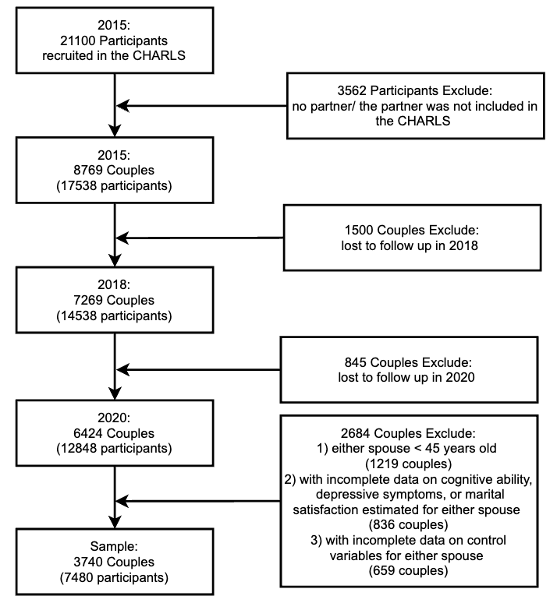
Supplementary Figure 1. Sample selection criteria and procedure.

Supplementary Table 1. Model fit indices and model comparisons of cognitive performance on depressive symptoms.
Models | Model Fits |  |  |  |  | Model comparisons
Models | χ²(df) | CFI | SRMR | RMSEA | Pairs | p | ∆CFI | ∆RMSEA
Model 1 | 0.000 | 1.000 | 0.000 | 0.000
Model 1a | 1.768(1) | 0.999 | 0.003 | 0.014 | 1a vs. 1 | 0.184 | 0.001 | 0.014
Model 1b | 0.071(1) | 1.000 | 0.001 | 0.000 | 1b vs. 1 | 0.789 | 0.000 | 0.000
Model 1c | 1.888(2) | 1.000 | 0.003 | 0.000 | 1c vs. 1 | 0.389 | 0.000 | 0.000
Notes: Model 1 = free model; Model 1a = model with constrained actor effects paths for husbands and wives; Model 1b = model with constrained partner effects paths for husbands and wives; Model 1c = model with constrained actor and partner effects paths for husbands and wives; χ²= Chi-Square Test, df = Degrees of Freedom, CFI= Comparative Fit Index, SRMR= Standardized Root Mean Square Residual, RMSEA= Root Mean Square Error of Approximation, Δ = change in parameter.

Supplementary Table 2. Simple results from actor–partner interdependence model of cognitive performance on depressive symptoms.
Pathways Estimate | β | SE | 95% CI | P Value
Actor Effect Coefficient
Wife’s CP₂₀₁₅ → Wife’s DS₂₀₂₀ | -0.083 | 0.018 | [-0.118, -0.048] | 0.000
Husband’s CP₂₀₁₅ → Husband’s DS₂₀₂₀ | -0.112 | 0.017 | [-0.145, -0.078] | 0.000
Partner Effect Coefficient
Wife’s CP₂₀₁₅ → Husband’s DS₂₀₂₀ | -0.046 | 0.015 | [-0.074, -0.017] | 0.002
Husband’s CP₂₀₁₅ → Wife’s DS₂₀₂₀ | -0.034 | 0.011 | [-0.056, -0.013] | 0.002
Notes: The parameters in Supplementary Table 2 correspond to Figure 1; The subscripts refer to the assessment year point; CP= cognitive performance; DS= depressive symptoms; β= Standardized Coefficient; SE= Standard Error; CI = confidence interval; The model includes control variables, as detailed in Supplementary Table 3.

Supplementary Table 3. Full parameter estimates from actor-partner interdependence model of cognitive performance on depressive symptoms.
 | Husband’s DS₂₀₂₀ | Wife’s DS₂₀₂₀
Husband’s CP₂₀₁₅ | -0.112***  (0.017) | -0.034**  (0.011)
Wife’s CP₂₀₁₅ | -0.046**  (0.015) | -0.083***  (0.018)
Husband’s Age | 0.023  (0.036) | -0.043  (0.036)
Wife’s Age | -0.050  (0.035) | 0.001  (0.035)
Husband’s Education | -0.047**  (0.018) | -0.033  (0.017)
Wife’s Education | 0.004  (0.018) | -0.066***  (0.018)
Husband’s Health | -0.213***  (0.016) | -0.063***  (0.016)
Wife’s Health | -0.044**  (0.016) | -0.247***  (0.015)
Husband’s ADL | -0.025  (0.016) | 0.008  (0.016)
Wife’s ADL | 0.004  (0.015) | 0.022  (0.015)
Husband’s Wealth | -0.072***  (0.018) | 0.003  (0.018)
Wife’s Wealth | -0.004  (0.018) | -0.068***  (0.019)
Children | 0.037***  (0.009) | 0.020*  (0.009)
Residence | -0.046**  (0.015) | -0.034**  (0.011)
Note: The parameters in Supplementary Table 3 correspond to Figure 1; The subscripts refer to the assessment year point; CP= cognitive performance; DS= depressive symptoms; Standard errors in parentheses; *p < .05. **p < .01. ***p < .001.

Supplementary Table 4. Simple results from actor–partner interdependence model of cognitive performance on depressive symptoms, with marital satisfaction as a mediating variable.
Pathways Estimate | β | SE | 95% CI | P Value
Mediating Pathways
Wife’s CP₂₀₁₅ →Wife’s MS₂₀₁₈ | -0.018 | 0.020 | [-0.057, 0.022] | 0.410
Wife’s CP₂₀₁₅ → Husband’s MS₂₀₁₈ | 0.077 | 0.019 | [0.041, 0.116] | 0.000
Husband’s CP₂₀₁₅ → Husband’s MS₂₀₁₈ | 0.019 | 0.019 | [-0.016, 0.060] | 0.327
Husband’s CP₂₀₁₅ → Wife’s MS₂₀₁₈ | 0.043 | 0.019 | [0.009, 0.085] | 0.020
Wife’s MS₂₀₁₈→ Wife’s DS₂₀₂₀ | -0.162 | 0.016 | [-0.192, -0.130] | 0.000
Wife’s MS₂₀₁₈→Husband’s DS₂₀₂₀ | -0.041 | 0.017 | [-0.073, -0.008] | 0.014
Husband’s MS₂₀₁₈ → Husband’s DS₂₀₂₀ | -0.114 | 0.017 | [-0.150, -0.082] | 0.000
Husband’s MS₂₀₁₈ →Wife’s DS₂₀₂₀ | -0.010 | 0.016 | [-0.039, 0.022] | 0.529
Actor Effect Coefficient
Wife’s CP₂₀₁₅ → Wife’s DS₂₀₂₀ | -0.085 | 0.018 | [-0.121, -0.052] | 0.000
Husband’s CP₂₀₁₅ → Husband’s DS₂₀₂₀ | -0.109 | 0.018 | [-0.143, -0.074] | 0.000
Partner Effect Coefficient
Wife’s CP₂₀₁₅ → Husband’s DS₂₀₂₀ | -0.038 | 0.015 | [-0.069, -0.009] | 0.012
Husband’s CP₂₀₁₅ → Wife’s DS₂₀₂₀ | -0.028 | 0.011 | [-0.051, -0.006] | 0.012
Notes: The parameters in Supplementary Table 4 correspond to Figure 2; The subscripts refer to the assessment year point; CP= cognitive performance; DS= depressive symptoms; MS= Marital Satisfaction; β= Standardized Coefficient; SE= Standard Error; CI = confidence interval; The model includes control variables, as detailed in Supplementary Table 5.

Supplementary Table 5. Full parameter estimates from actor-partner interdependence model of cognitive performance on depressive symptoms, with marital satisfaction as a mediating variable.
 | Husband’s DS₂₀₂₀ | Husband’s MS₂₀₁₈ | Wife’s DS₂₀₂₀ | Wife’s MS₂₀₁₈
Husband’s CP₂₀₁₅ | -0.109 ***  (0.018) | 0.019  (0.019) | -0.028*  (0.011) | 0.043 *  (0.019)
Wife’s CP₂₀₁₅ | -0.038 *  (0.015) | 0.077***  (0.019) | -0.085***  (0.018) | -0.018  (0.020)
Husband’s MS₂₀₁₈ | -0.114 ***  (0.017) |  | -0.010  (0.016)
Wife’s MS₂₀₁₈ | -0.041 *  (0.017) |  | -0.162***  (0.016)
Husband’s Age | 0.012  (0.036) | -0.075  (0.039) | -0.051  (0.035) | -0.044  (0.038)
Wife’s Age | -0.043  (0.036) | 0.045  (0.040) | 0.013  (0.033) | 0.070  (0.038)
Husband’s Education | -0.050 **  (0.018) | -0.032  (0.017) | -0.029  (0.016) | 0.030  (0.019)
Wife’s Education | -0.002  (0.018) | -0.032  (0.020) | -0.074***  (0.018) | -0.044  (0.019)
Husband’s Health | -0.201***  (0.016) | 0.107***  (0.018) | -0.053**  (0.016) | 0.058**  (0.018)
Wife’s Health | -0.032*  (0.016) | 0.063***  (0.017) | -0.229***  (0.015) | 0.123***  (0.016)
Husband’s ADL | -0.030  (0.016) | -0.032  (0.017) | 0.002  (0.016) | -0.030  (0.017)
Wife’s ADL | 0.001  (0.015) | -0.015  (0.016) | 0.018  (0.015) | -0.024  (0.016)
Husband’s Wealth | -0.075***  (0.018) | -0.025  (0.020) | 0.007  (0.018) | 0.026  (0.018)
Wife’s Wealth | -0.002  (0.018) | 0.020  (0.020) | -0.069***  (0.019) | -0.002  (0.021)
Children | 0.036***  (0.009) | -0.011  (0.010) | 0.018*  (0.008) | -0.012  (0.010)
Residence | 0.017  (0.016) | -0.018  (0.018) | 0.026  (0.017) | -0.015  (0.017)
Note: The parameters in Supplementary Table 5 correspond to Figure 2; The subscripts refer to the assessment year point; CP= cognitive performance; DS= depressive symptoms; Standard errors in parentheses; *p < .05. **p < .01. ***p < .001.

Supplementary Table 6. Model fit indices and model comparisons of cognitive performance on depressive symptoms for middle-aged and older adult couples.
Models | Model Fits |  |  |  |  | Model comparisons
Models | χ²(df) | CFI | SRMR | RMSEA | Pairs | p | ∆CFI | ∆RMSEA
Model 2 | 0 | 1.000 | 0.000 | 0.000
Model 2a | 0.264(1) | 1.000 | 0.002 | 0.000 | 2a vs. 2 | 0.607 | 0.000 | 0.000
Model 2b | 0.165(1) | 1.000 | 0.001 | 0.000 | 2b vs. 2 | 0.685 | 0.000 | 0.000
Model 2c | 0.725(2) | 1.000 | 0.003 | 0.000 | 2c vs. 2 | 0.696 | 0.000 | 0.000
Model 3 | 0 | 0.000 | 0.000 | 0.000
Model 3a | 5.884(1) | 0.993 | 0.007 | 0.049 | 3a vs. 3 | 0.015 | 0.007 | 0.049
Model 3b | 0.030(1) | 1.000 | 0.001 | 0.000 | 3b vs. 3 | 0.862 | 0.000 | 0.000
Model 3c | 6.657(2) | 0.994 | 0.008 | 0.034 | 3c vs. 3 | 0.036 | 0.006 | 0.034
Notes: Model 2 = free model for middle-aged couples; Model 2a = model with constrained actor effects paths for husbands and wives for middle-aged couples; Model 2b = model with constrained partner effects paths for husbands and wives for middle-aged couples; Model 2c = model with constrained actor and partner effects paths for husbands and wives for middle-aged couples; Model 3 = free model for older adult couples; Model 3a = model with constrained actor effects paths for husbands and wives for older adult couples; Model 3b = model with constrained partner effects paths for husbands and wives for older adult couples; Model 3c = model with constrained actor and partner effects paths for husbands and wives for older adult couples; χ²= Chi-Square Test, df = Degrees of Freedom, CFI= Comparative Fit Index, SRMR= Standardized Root Mean Square Residual, RMSEA= Root Mean Square Error of Approximation, Δ = change in parameter.

Supplementary Table 7. Results from actor–partner interdependence model of cognitive performance on depressive symptoms for middle-aged and older adult couples.
Pathways Estimate | β | SE | 95% CI | P Value
Middle-aged Couples
Actor Effect Coefficient
Wife’s CP₂₀₁₅ → Wife’s DS₂₀₂₀ | -0.110 | 0.020 | [-0.148, -0.072] | 0.000
Husband’s CP₂₀₁₅ → Husband’s DS₂₀₂₀ | -0.106 | 0.019 | [-0.144, -0.069] | 0.000
Partner Effect Coefficient
Wife’s CP₂₀₁₅ → Husband’s DS₂₀₂₀ | -0.035 | 0.021 | [-0.076, 0.006] | 0.096
Husband’s CP₂₀₁₅ → Wife’s DS₂₀₂₀ | -0.027 | 0.016 | [-0.052, 0.014] | 0.097
Older Adult Couples
Actor Effect Coefficient
Wife’s CP₂₀₁₅ → Wife’s DS₂₀₂₀ | -0.043 | 0.024 | [-0.090, 0.003] | 0.067
Husband’s CP₂₀₁₅ → Husband’s DS₂₀₂₀ | -0.124 | 0.023 | [-0.169, -0.079] | 0.000
Partner Effect Coefficient
Wife’s CP₂₀₁₅ → Husband’s DS₂₀₂₀ | -0.049 | 0.019 | [-0.087, -0.011] | 0.011
Husband’s CP₂₀₁₅ → Wife’s DS₂₀₂₀ | -0.037 | 0.015 | [-0.066, -0.009] | 0.011
Notes: The parameters in Supplementary Table 7 correspond to Figure 3; The subscripts refer to the assessment year point; CP= cognitive performance; DS= depressive symptoms; β= Standardized Coefficient; SE= Standard Error; CI = confidence interval; The model includes control variables.

Supplementary Table 8. Results from actor–partner interdependence model of cognitive performance on depressive symptoms, with marital satisfaction as a mediating variable，for middle-aged and older adult couples.
Pathways Estimate | β | SE | 95%CI | P Value
Middle-aged Couples
Mediating Pathways
Wife’s CP₂₀₁₅ →Wife’s MS₂₀₁₈ | -0.032 | 0.029 | [-0.089, 0.026] | 0.274
Wife’s CP₂₀₁₅ → Husband’s MS₂₀₁₈ | 0.092 | 0.028 | [0.042, 0.154] | 0.001
Husband’s CP₂₀₁₅ → Husband’s MS₂₀₁₈ | -0.022 | 0.026 | [-0.073, 0.028] | 0.400
Husband’s CP₂₀₁₅ → Wife’s MS₂₀₁₈ | 0.046 | 0.027 | [-0.016, 0.093] | 0.097
Wife’s MS₂₀₁₈→ Wife’s DS₂₀₂₀ | -0.177 | 0.024 | [-0.220, -0.127] | 0.000
Wife’s MS₂₀₁₈→Husband’s DS₂₀₂₀ | -0.045 | 0.023 | [-0.090, -0.002] | 0.053
Husband’s MS₂₀₁₈ → Husband’s DS₂₀₂₀ | -0.104 | 0.024 | [-0.142, -0.046] | 0.000
Husband’s MS₂₀₁₈ →Wife’s DS₂₀₂₀ | -0.018 | 0.024 | [-0.067, 0.027] | 0.463
Actor Effect Coefficient
Wife’s CP₂₀₁₅ → Wife’s DS₂₀₂₀ | -0.114 | 0.019 | [-0.150, -0.074] | 0.000
Husband’s CP₂₀₁₅ → Husband’s DS₂₀₂₀ | -0.110 | 0.019 | [-0.147, -0.071] | 0.000
Partner Effect Coefficient
Wife’s CP₂₀₁₅ → Husband’s DS₂₀₂₀ | -0.026 | 0.021 | [-0.071, 0.015] | 0.218
Husband’s CP₂₀₁₅ → Wife’s DS₂₀₂₀ | -0.020 | 0.016 | [-0.054, 0.011] | 0.216
Older Adult Couples
Mediating Pathways
Wife’s CP₂₀₁₅ →Wife’s MS₂₀₁₈ | -0.009 | 0.027 | [-0.059, 0.045] | 0.752
Wife’s CP₂₀₁₅ → Husband’s MS₂₀₁₈ | 0.058 | 0.025 | [0.009, 0.104] | 0.020
Husband’s CP₂₀₁₅ → Husband’s MS₂₀₁₈ | 0.049 | 0.027 | [-0.005, 0.098] | 0.069
Husband’s CP₂₀₁₅ → Wife’s MS₂₀₁₈ | 0.036 | 0.027 | [-0.016, 0.089] | 0.183
Wife’s MS₂₀₁₈→ Wife’s DS₂₀₂₀ | -0.153 | 0.022 | [-0.199, -0.110] | 0.000
Wife’s MS₂₀₁₈→Husband’s DS₂₀₂₀ | -0.037 | 0.023 | [-0.083, 0.006] | 0.105
Husband’s MS₂₀₁₈ → Husband’s DS₂₀₂₀ | -0.127 | 0.023 | [-0.173, -0.083] | 0.000
Husband’s MS₂₀₁₈ →Wife’s DS₂₀₂₀ | -0.005 | 0.022 | [-0.047, 0.037] | 0.820
Actor Effect Coefficient
Wife’s CP₂₀₁₅ → Wife’s DS₂₀₂₀ | -0.045 | 0.023 | [-0.092, 0.000] | 0.050
Husband’s CP₂₀₁₅ → Husband’s DS₂₀₂₀ | -0.118 | 0.023 | [-0.165, -0.072] | 0.000
Partner Effect Coefficient
Wife’s CP₂₀₁₅ → Husband’s DS₂₀₂₀ | -0.042 | 0.019 | [-0.083, -0.008] | 0.024
Husband’s CP₂₀₁₅ → Wife’s DS₂₀₂₀ | -0.032 | 0.014 | [-0.062, -0.006] | 0.024
Notes: The parameters in Supplementary Table 8 correspond to Figure 4; The subscripts refer to the assessment year point; CP= cognitive performance; DS= depressive symptoms; MS= Marital Satisfaction; β= Standardized Coefficient; SE= Standard Error; CI = confidence interval; The model includes control variables.

Supplementary Table 9. Model fit indices and model comparisons of cognitive performance on depressive symptoms for Urban and Rural couples.
Models | Model Fits |  |  |  |  | Model comparisons
Models | χ²(df) | CFI | SRMR | RMSEA | Pairs | p | ∆CFI | ∆RMSEA
Model 4 | 0 | 1.000 | 0.000 | 0.000
Model 4a | 0.142(1) | 1.000 | 0.002 | 0.000 | 4a vs. 4 | 0.706 | 0.000 | 0.000
Model 4b | 0.484(1) | 1.000 | 0.003 | 0.000 | 4b vs. 4 | 0.487 | 0.000 | 0.000
Model 4c | 0.481(2) | 1.000 | 0.003 | 0.000 | 4c vs. 4 | 0.786 | 0.000 | 0.000
Model 5 | 0 | 0.000 | 0.000 | 0.000
Model 5a | 1.879(1) | 0.999 | 0.004 | 0.018 | 5a vs. 5 | 0.171 | 0.001 | 0.018
Model 5b | 0.000(1) | 1.000 | 0.000 | 0.000 | 5b vs. 5 | 0.987 | 0.000 | 0.000
Model 5c | 2.337(2) | 1.000 | 0.004 | 0.008 | 5c vs. 5 | 0.311 | 0.000 | 0.008
Notes: Model 4 = free model for urban couples; Model 4a = model with constrained actor effects paths for husbands and wives for urban couples; Model 4b = model with constrained partner effects paths for husbands and wives for urban couples; Model 4c = model with constrained actor and partner effects paths for husbands and wives for urban couples; Model 5 = free model for rural couples; Model 5a = model with constrained actor effects paths for husbands and wives for rural couples; Model 5b = model with constrained partner effects paths for husbands and wives for rural couples; Model 5c = model with constrained actor and partner effects paths for husbands and wives for rural couples; χ²= Chi-Square Test, df = Degrees of Freedom, CFI= Comparative Fit Index, SRMR= Standardized Root Mean Square Residual, RMSEA= Root Mean Square Error of Approximation, Δ = change in parameter.

Supplementary Table 10. Results from actor–partner interdependence model of cognitive performance on depressive symptoms for urban and rural couples.
Pathways Estimate | β | SE | 95% CI | P Value
Urban Couples
Actor Effect Coefficient
Wife’s CP₂₀₁₅ → Wife’s DS₂₀₂₀ | -0.164 | 0.025 | [-0.214, -0.114] | 0.000
Husband’s CP₂₀₁₅ → Husband’s DS₂₀₂₀ | -0.158 | 0.024 | [-0.205, -0.111] | 0.000
Partner Effect Coefficient
Wife’s CP₂₀₁₅ → Husband’s DS₂₀₂₀ | -0.038 | 0.029 | [-0.095, 0.018] | 0.182
Husband’s CP₂₀₁₅ → Wife’s DS₂₀₂₀ | -0.027 | 0.020 | [-0.067, 0.013] | 0.183
Rural Couples
Actor Effect Coefficient
Wife’s CP₂₀₁₅ → Wife’s DS₂₀₂₀ | -0.077 | 0.015 | [-0.106, -0.048] | 0.000
Husband’s CP₂₀₁₅ → Husband’s DS₂₀₂₀ | -0.077 | 0.015 | [-0.106, -0.047] | 0.000
Partner Effect Coefficient
Wife’s CP₂₀₁₅ → Husband’s DS₂₀₂₀ | -0.048 | 0.016 | [-0.079, -0.016] | 0.003
Husband’s CP₂₀₁₅ → Wife’s DS₂₀₂₀ | -0.037 | 0.013 | [-0.062, -0.012] | 0.003
Notes: The parameters in Supplementary Table 10 correspond to Figure 3; The subscripts refer to the assessment year point; CP= cognitive performance; DS= depressive symptoms; β= Standardized Coefficient; SE= Standard Error; CI = confidence interval; The model includes control variables.

Supplementary Table 11. Results from actor–partner interdependence model of cognitive performance on depressive symptoms, with marital satisfaction as a mediating variable，for urban and rural couples.
Pathways Estimate | β | SE | 95% CI | P Value
Urban Couples
Mediating Pathways
Wife’s CP₂₀₁₅ →Wife’s MS₂₀₁₈ | -0.042 | 0.038 | [-0.118, 0.030] | 0.270
Wife’s CP₂₀₁₅ → Husband’s MS₂₀₁₈ | 0.067 | 0.038 | [-0.010, 0.141] | 0.082
Husband’s CP₂₀₁₅ → Husband’s MS₂₀₁₈ | -0.038 | 0.036 | [-0.108, 0.032] | 0.298
Husband’s CP₂₀₁₅ → Wife’s MS₂₀₁₈ | 0.051 | 0.036 | [-0.021, 0.124] | 0.165
Wife’s MS₂₀₁₈→ Wife’s DS₂₀₂₀ | -0.175 | 0.036 | [-0.243, -0.102] | 0.000
Wife’s MS₂₀₁₈→Husband’s DS₂₀₂₀ | -0.033 | 0.031 | [-0.091, 0.033] | 0.295
Husband’s MS₂₀₁₈ → Husband’s DS₂₀₂₀ | -0.145 | 0.034 | [-0.208, -0.072] | 0.000
Husband’s MS₂₀₁₈ →Wife’s DS₂₀₂₀ | -0.080 | 0.032 | [-0.143, -0.014] | 0.013
Actor Effect Coefficient
Wife’s CP₂₀₁₅ → Wife’s DS₂₀₂₀ | -0.169 | 0.025 | [-0.216, -0.120] | 0.000
Husband’s CP₂₀₁₅ → Husband’s DS₂₀₂₀ | -0.163 | 0.024 | [-0.207, -0.116] | 0.000
Partner Effect Coefficient
Wife’s CP₂₀₁₅ → Husband’s DS₂₀₂₀ | -0.031 | 0.030 | [-0.088,0.025] | 0.305
Husband’s CP₂₀₁₅ → Wife’s DS₂₀₂₀ | -0.022 | 0.021 | [-0.064,0.017] | 0.304
Rural Couples
Mediating Pathways
Wife’s CP₂₀₁₅ →Wife’s MS₂₀₁₈ | -0.013 | 0.022 | [-0.056, 0.029] | 0.538
Wife’s CP₂₀₁₅ → Husband’s MS₂₀₁₈ | 0.074 | 0.022 | [0.034, 0.120] | 0.001
Husband’s CP₂₀₁₅ → Husband’s MS₂₀₁₈ | 0.036 | 0.022 | [-0.005, 0.081] | 0.105
Husband’s CP₂₀₁₅ → Wife’s MS₂₀₁₈ | 0.039 | 0.021 | [0.000, 0.083] | 0.066
Wife’s MS₂₀₁₈→ Wife’s DS₂₀₂₀ | -0.158 | 0.019 | [-0.196, -0.118] | 0.000
Wife’s MS₂₀₁₈→Husband’s DS₂₀₂₀ | -0.043 | 0.019 | [-0.081, -0.004] | 0.023
Husband’s MS₂₀₁₈ → Husband’s DS₂₀₂₀ | -0.108 | 0.019 | [-0.146, -0.071] | 0.000
Husband’s MS₂₀₁₈ →Wife’s DS₂₀₂₀ | 0.014 | 0.018 | [-0.022, 0.049] | 0.456
Actor Effect Coefficient
Wife’s CP₂₀₁₅ → Wife’s DS₂₀₂₀ | -0.076 | 0.015 | [-0.104, -0.046] | 0.000
Husband’s CP₂₀₁₅ → Husband’s DS₂₀₂₀ | -0.076 | 0.015 | [-0.104, -0.046] | 0.000
Partner Effect Coefficient
Wife’s CP₂₀₁₅ → Husband’s DS₂₀₂₀ | -0.040 | 0.016 | [-0.072, -0.009] | 0.012
Husband’s CP₂₀₁₅ → Wife’s DS₂₀₂₀ | -0.031 | 0.013 | [-0.056, -0.007] | 0.012
Notes: The parameters in Supplementary Table 11 correspond to Figure 4; The subscripts refer to the assessment year point; CP= cognitive performance; DS= depressive symptoms; MS= Marital Satisfaction; β= Standardized Coefficient; SE= Standard Error; CI = confidence interval; The model includes control variables.

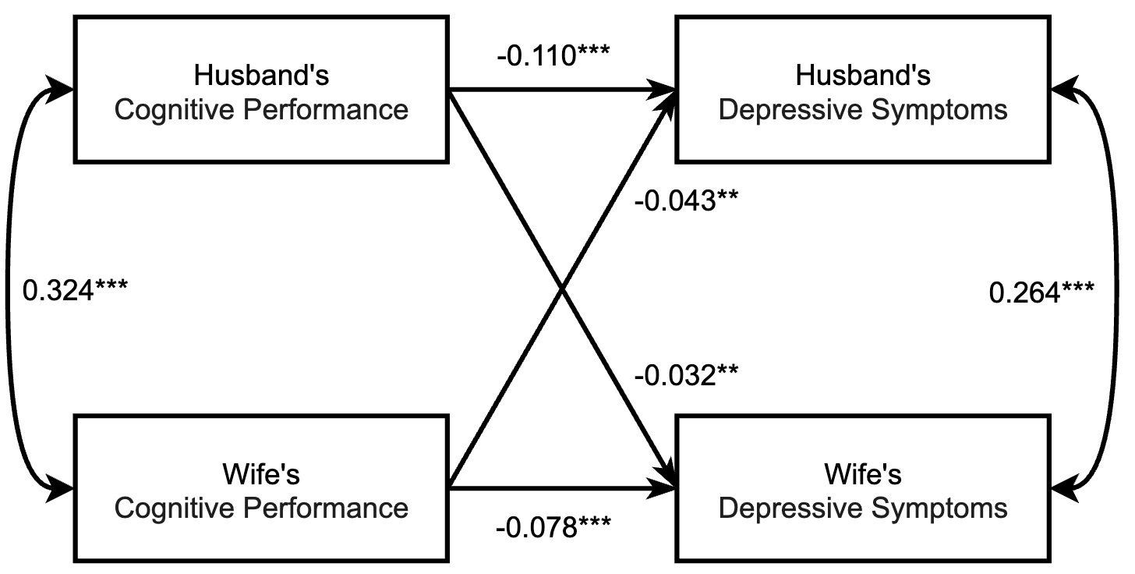
Supplementary Figure 2. Results from actor–partner interdependence model of cognitive performance on depressive symptoms.
Notes: The full line represents a significant path; the dashed line represents an insignificant path. Single-headed arrows represent regression paths. Double-headed arrows represent correlations. All path coefficients were labeled with significance: *p < .05. **p < .01. ***p < .001. The model includes control variables, as detailed in Supplementary Table 2 & 3.

Supplementary Table 12. Model fit indices and model comparisons of cognitive performance on depressive symptoms.
Models | Model Fits |  |  |  |  | Model comparisons
Models | χ²(df) | CFI | SRMR | RMSEA | Pairs | p | ∆CFI | ∆RMSEA
Model 6 | 0.000 | 1.000 | 0.000 | 0.000
Model 6a | 1.954(1) | 0.999 | 0.003 | 0.016 | 6a vs. 6 | 0.162 | 0.001 | 0.016
Model 6b | 0.018(1) | 1.000 | 0.000 | 0.000 | 6b vs. 6 | 0.894 | 0.000 | 0.000
Model 6c | 2.222(2) | 1.000 | 0.003 | 0.005 | 6c vs. 6 | 0.329 | 0.000 | 0.005
Notes: Model 6 = free model; Model 6a = model with constrained actor effects paths for husbands and wives; Model 6b = model with constrained partner effects paths for husbands and wives; Model 6c = model with constrained actor and partner effects paths for husbands and wives; χ²= Chi-Square Test, df = Degrees of Freedom, CFI= Comparative Fit Index, SRMR= Standardized Root Mean Square Residual, RMSEA= Root Mean Square Error of Approximation, Δ = change in parameter.

Supplementary Table 13. Simple results from actor–partner interdependence model of cognitive performance on depressive symptoms.
Pathways Estimate | β | SE | 95% CI | P Value
Actor Effect Coefficient
Wife’s CP₂₀₁₅ → Wife’s DS₂₀₂₀ | -0.078 | 0.018 | [-0.113, -0.043] | 0.000
Husband’s CP₂₀₁₅ → Husband’s DS₂₀₂₀ | -0.110 | 0.017 | [-0.144, -0.077] | 0.000
Partner Effect Coefficient
Wife’s CP₂₀₁₅ → Husband’s DS₂₀₂₀ | -0.043 | 0.015 | [-0.072, -0.014] | 0.003
Husband’s CP₂₀₁₅ → Wife’s DS₂₀₂₀ | -0.032 | 0.011 | [-0.054, -0.011] | 0.003
Notes: The parameters in Supplementary Table 13 correspond to Supplementary Figure 2; The subscripts refer to the assessment year point; CP= cognitive performance; DS= depressive symptoms; β= Standardized Coefficient; SE= Standard Error; CI = confidence interval; The model includes control variables, as detailed in Supplementary Table 3.

Supplementary Table 14. Full parameter estimates from actor-partner interdependence model of cognitive performance on depressive symptoms.
 | Husband’s DS₂₀₂₀ | Wife’s DS₂₀₂₀
Husband’s CP₂₀₁₅ | -0.110***  （0.017） | -0.032**  （0.011）
Wife’s CP₂₀₁₅ | -0.043**  （0.015） | -0.078***  （0.018）
Husband’s Age | 0.024  （0.035） | -0.039  （0.036）
Wife’s Age | -0.053  （0.035） | -0.004  （0.035）
Husband’s Education | -0.048**  （0.018） | -0.035*  （0.017）
Wife’s Education | 0.002  （0.018） | -0.068***  （0.018）
Husband’s Health | -0.213***  （0.016） | -0.063***  （0.016）
Wife’s Health | -0.044**  （0.016） | -0.246***  （0.015）
Husband’s ADL | -0.025  （0.016） | 0.009  （0.016）
Wife’s ADL | 0.002  （0.015） | 0.021  （0.015）
Husband’s Wealth | -0.072***  （0.018） | 0.001  （0.018）
Wife’s Wealth | -0.004  （0.018） | -0.065***  （0.019）
Children | 0.038***  （0.009） | 0.020*  （0.009）
Residence | 0.019  （0.016） | 0.029  （0.016）
Note: The parameters in Supplementary Table 14 correspond to Supplementary Figure 2; The subscripts refer to the assessment year point; CP= cognitive performance; DS= depressive symptoms; Standard errors in parentheses; *p < .05. **p < .01. ***p < .001.
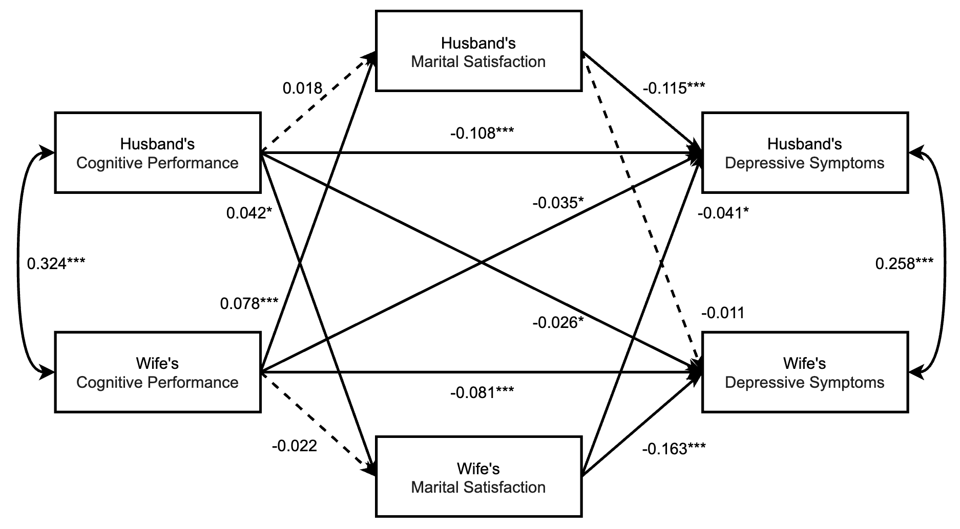
Supplementary Figure 3. Results from actor–partner interdependence model of cognitive performance on depressive symptoms, with marital satisfaction as a mediating variable.
Notes: The full line represents a significant path; the dashed line represents an insignificant path. Single-headed arrows represent regression paths. Double-headed arrows represent correlations. All path coefficients were labeled with significance: *p < .05. **p < .01. ***p < .001. The model includes control variables, as detailed in Supplementary Table 4 & 5.

Supplementary Table 15. Simple results from actor–partner interdependence model of cognitive performance on depressive symptoms, with marital satisfaction as a mediating variable.
Pathways Estimate | β | SE | 95% CI | P Value
Mediating Pathways
Wife’s CP2015 →Wife’s MS2018 | -0.022 | 0.020 | [-0.016, 0.062] | 0.262
Wife’s CP2015 → Husband’s MS2018 | 0.078 | 0.019 | [0.041, 0.118,] | 0.000
Husband’s CP2015 → Husband’s MS2018 | 0.018 | 0.019 | [-0.058, 0.019] | 0.344
Husband’s CP2015 → Wife’s MS2018 | 0.042 | 0.018 | [0.008, 0.080] | 0.023
Wife’s MS2018→ Wife’s DS2020 | -0.163 | 0.017 | [-0.198, -0.131] | 0.000
Wife’s MS2018→Husband’s DS2020 | -0.041 | 0.017 | [-0.073, -0.005] | 0.017
Husband’s MS2018 → Husband’s DS2020 | -0.115 | 0.017 | [-0.146, -0.081] | 0.000
Husband’s MS2018 →Wife’s DS2020 | -0.011 | 0.017 | [-0.043, -0.021] | 0.519
Actor Effect Coefficient
Wife’s CP2015 → Wife’s DS2020 | -0.081 | 0.018 | [-0.115, -0.045] | 0.000
Husband’s CP2015 → Husband’s DS2020 | -0.108 | 0.017 | [-0.149, -0.075] | 0.000
Partner Effect Coefficient
Wife’s CP2015 → Husband’s DS2020 | -0.035 | 0.015 | [-0.063, -0.003] | 0.018
Husband’s CP2015 → Wife’s DS2020 | -0.026 | 0.011 | [-0.047, -0.003] | 0.019

Notes: The parameters in Supplementary Table 15 correspond to Supplementary Figure 3; The subscripts refer to the assessment year point; CP= cognitive performance; DS= depressive symptoms; MS= Marital Satisfaction; β= Standardized Coefficient; SE= Standard Error; CI = confidence interval; The model includes control variables, as detailed in Supplementary Table 5.

Supplementary Table 16. Full parameter estimates from actor-partner interdependence model of cognitive performance on depressive symptoms, with marital satisfaction as a mediating variable.
 | Husband’s DS₂₀₂₀ | Husband’s MS₂₀₁₈ | Wife’s DS₂₀₂₀ | Wife’s MS₂₀₁₈
Husband’s CP₂₀₁₅ | -0.108***  （0.017） | 0.018  （0.019） | -0.026*  （0.011） | 0.042*  （0.018）
Wife’s CP₂₀₁₅ | -0.035*  （0.015） | 0.078***  （0.019） | -0.081***  （0.018） | -0.022  （0.020）
Husband’s MS₂₀₁₈ | -0.115***  （0.017） |  | -0.011  （0.017）
Wife’s MS₂₀₁₈ | -0.041*  （0.017） |  | -0.163***  （0.017）
Husband’s Age | 0.014  （0.035） | -0.079  （0.040） | -0.047  （0.035） | -0.043  （0.037）
Wife’s Age | -0.045  （0.034） | 0.048  （0.040） | 0.008  （0.034） | 0.067  （0.038）
Husband’s Education | -0.051**  （0.017） | -0.031  （0.018） | -0.031  （0.017） | 0.029  （0.018）
Wife’s Education | -0.004  （0.018） | -0.032  （0.020） | -0.077***  （0.017） | -0.043*  （0.018）
Husband’s Health | -0.201***  （0.016） | 0.107***  （0.017） | -0.053**  （0.016） | 0.058**  （0.018）
Wife’s Health | -0.032*  （0.016） | 0.061***  （0.017） | -0.228***  （0.015） | 0.125***  （0.015）
Husband’s ADL | -0.030  （0.016） | -0.034*  （0.016） | 0.004  （0.016） | -0.030  （0.017）
Wife’s ADL | 0.000  （0.015） | -0.015  （0.017） | 0.017  （0.015） | -0.023  （0.016）
Husband’s Wealth | -0.075***  （0.018） | -0.026  （0.020） | 0.005  （0.018） | 0.027  （0.019）
Wife’s Wealth | -0.002  （0.018） | 0.020  （0.019） | -0.066***  （0.019） | -0.005  （0.018）
Children | 0.037***  （0.009） | -0.011  （0.010） | 0.018*  （0.009） | -0.011  （0.009）
Urban vs. Rural | 0.016  （0.016） | -0.020  （0.018） | 0.026  （0.017） | -0.018  （0.017）
Note: The parameters in Supplementary Table 16 correspond to Supplementary Figure 3; The subscripts refer to the assessment year point; CP= cognitive performance; DS= depressive symptoms; Standard errors in parentheses; *p < .05. **p < .01. ***p < .001.
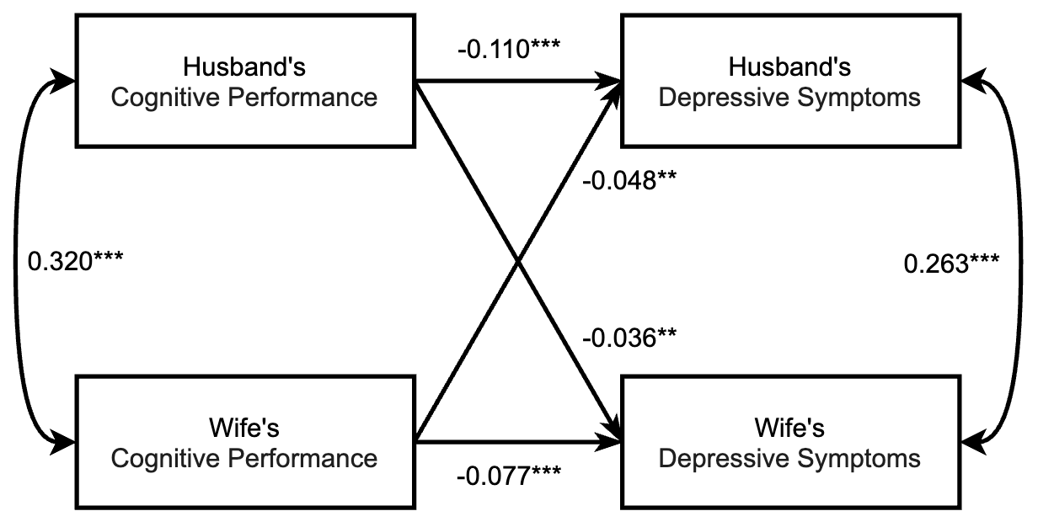
Supplementary Figure 4. Results from actor–partner interdependence model of cognitive performance on depressive symptoms.
Notes: The full line represents a significant path; the dashed line represents an insignificant path. Single-headed arrows represent regression paths. Double-headed arrows represent correlations. All path coefficients were labeled with significance: *p < .05. **p < .01. ***p < .001. The model includes control variables, as detailed in Supplementary Table 18 & 19.

Supplementary Table 17. Model fit indices and model comparisons of cognitive performance on depressive symptoms.
Models | Model Fits |  |  |  |  | Model comparisons
Models | χ²(df) | CFI | SRMR | RMSEA | Pairs | p | ∆CFI | ∆RMSEA
Model 7 | 0.000 | 1.000 | 0.000 | 0.000
Model 7a | 2.303(1) | 0.999 | 0.004 | 0.020 | 7a vs. 7 | 0.129 | 0.001 | 0.020
Model 7b | 0.229(1) | 1.000 | 0.001 | 0.000 | 7b vs. 7 | 0.632 | 0.000 | 0.000
Model 7c | 2.363(2) | 1.000 | 0.004 | 0.007 | 7c vs. 7 | 0.307 | 0.000 | 0.007
Notes: Model 7 = free model; Model 7a = model with constrained actor effects paths for husbands and wives; Model 7b = model with constrained partner effects paths for husbands and wives; Model 7c = model with constrained actor and partner effects paths for husbands and wives; χ²= Chi-Square Test, df = Degrees of Freedom, CFI= Comparative Fit Index, SRMR= Standardized Root Mean Square Residual, RMSEA= Root Mean Square Error of Approximation, Δ = change in parameter.

Supplementary Table 18. Simple results from actor–partner interdependence model of cognitive performance on depressive symptoms.
Pathways Estimate | β | SE | 95% CI | P Value
Actor Effect Coefficient
Wife’s CP₂₀₁₅ → Wife’s DS₂₀₂₀ | -0.077 | 0.019 | [-0.115, -0.040] | 0.000
Husband’s CP₂₀₁₅ → Husband’s DS₂₀₂₀ | -0.110 | 0.018 | [-0.146, -0.075] | 0.000
Partner Effect Coefficient
Wife’s CP₂₀₁₅ → Husband’s DS₂₀₂₀ | -0.048 | 0.015 | [-0.078, -0.018] | 0.002
Husband’s CP₂₀₁₅ → Wife’s DS₂₀₂₀ | -0.036 | 0.012 | [-0.059, -0.013] | 0.002
Notes: The parameters in Supplementary Table 18 correspond to Supplementary Figure 4; The subscripts refer to the assessment year point; CP= cognitive performance; DS= depressive symptoms; β= Standardized Coefficient; SE= Standard Error; CI = confidence interval; The model includes control variables, as detailed in Supplementary Table 19.

Supplementary Table 19. Full parameter estimates from actor-partner interdependence model of cognitive performance on depressive symptoms.
 | Husband’s DS₂₀₂₀ | Wife’s DS₂₀₂₀
Husband’s CP₂₀₁₅ | -0.110***  （0.018） | -0.036**  （0.012）
Wife’s CP₂₀₁₅ | -0.048**  （0.015） | -0.077***  （0.019）
Husband’s Age | 0.037  （0.048） | -0.046  （0.049）
Wife’s Age | -0.065  （0.048） | 0.005  （0.047）
Husband’s Education | -0.055**  （0.019） | -0.035  （0.018）
Wife’s Education | 0.004  （0.019） | -0.064**  （0.019）
Husband’s Health | -0.212***  （0.017） | -0.048**  （0.017）
Wife’s Health | -0.045**  （0.017） | -0.256***  （0.016）
Husband’s ADL | -0.027  （0.017） | 0.002  （0.017）
Wife’s ADL | 0.004  （0.016） | 0.038*  （0.016）
Husband’s Wealth | -0.083***  （0.019） | 0.004  （0.019）
Wife’s Wealth | 0.000  （0.019） | -0.068**  （0.020）
Children | 0.034***  （0.009） | 0.018  （0.009）
Residence | 0.017  （0.017） | 0.038*  （0.017）
Note: The parameters in Supplementary Table 19 correspond to Supplementary Figure 4; The subscripts refer to the assessment year point; CP= cognitive performance; DS= depressive symptoms; Standard errors in parentheses; *p < .05. **p < .01. ***p < .001.
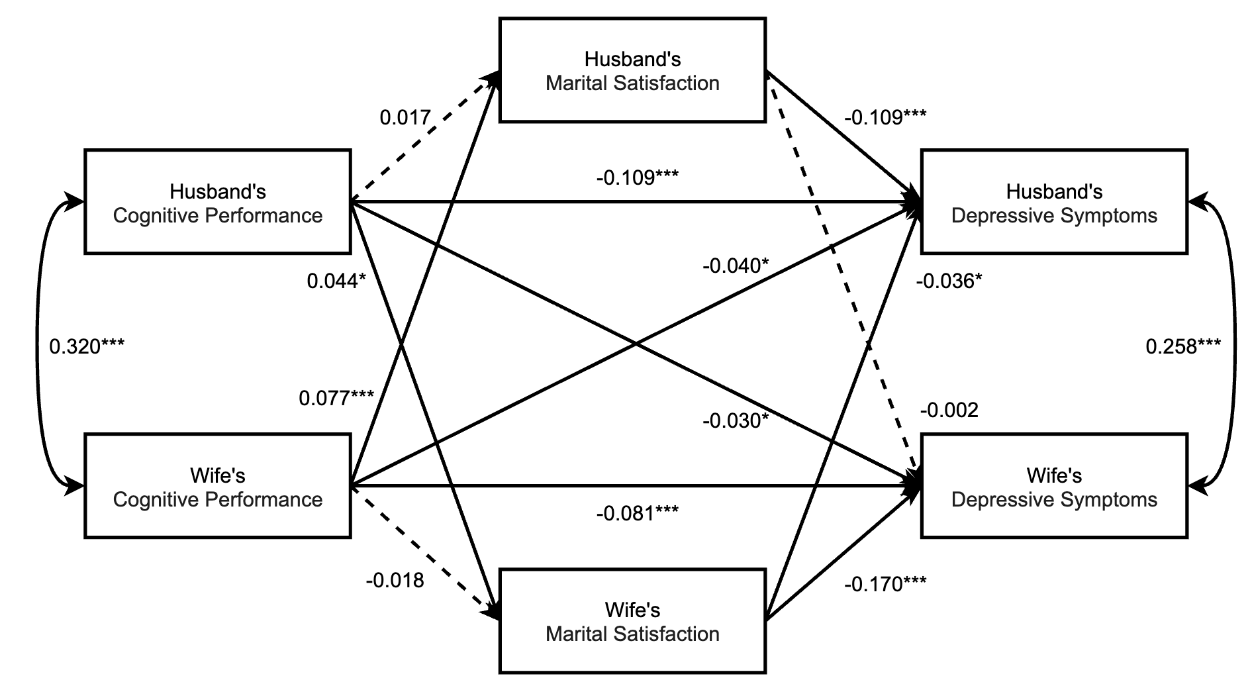
Supplementary Figure 5. Results from actor–partner interdependence model of cognitive performance on depressive symptoms, with marital satisfaction as a mediating variable.
Notes: The full line represents a significant path; the dashed line represents an insignificant path. Single-headed arrows represent regression paths. Double-headed arrows represent correlations. All path coefficients were labeled with significance: *p < .05. **p < .01. ***p < .001. The model includes control variables, as detailed in Supplementary Table 20 & 21.

Supplementary Table 20. Simple results from actor–partner interdependence model of cognitive performance on depressive symptoms, with marital satisfaction as a mediating variable.
Pathways Estimate | β | SE | 95% CI | P Value
Mediating Pathways
Wife’s CP₂₀₁₅ →Wife’s MS₂₀₁₈ | -0.018 | 0.021 | [-0.055, 0.023] | 0.382
Wife’s CP₂₀₁₅ → Husband’s MS₂₀₁₈ | 0.077 | 0.019 | [0.041, 0.118] | 0.000
Husband’s CP₂₀₁₅ → Husband’s MS₂₀₁₈ | 0.017 | 0.020 | [-0.023, 0.055] | 0.395
Husband’s CP₂₀₁₅ → Wife’s MS₂₀₁₈ | 0.044 | 0.020 | [0.004, 0.084] | 0.033
Wife’s MS₂₀₁₈→ Wife’s DS₂₀₂₀ | -0.170 | 0.017 | [-0.201, -0.134] | 0.000
Wife’s MS₂₀₁₈→Husband’s DS₂₀₂₀ | -0.036 | 0.017 | [-0.067, -0.001] | 0.038
Husband’s MS₂₀₁₈ → Husband’s DS₂₀₂₀ | -0.109 | 0.018 | [-0.143, -0.074] | 0.000
Husband’s MS₂₀₁₈ →Wife’s DS₂₀₂₀ | -0.002 | 0.017 | [-0.035, 0.031] | 0.890
Actor Effect Coefficient
Wife’s CP₂₀₁₅ → Wife’s DS₂₀₂₀ | -0.081 | 0.019 | [-0.116, -0.042] | 0.000
Husband’s CP₂₀₁₅ → Husband’s DS₂₀₂₀ | -0.109 | 0.019 | [-0.145, -0.073] | 0.000
Partner Effect Coefficient
Wife’s CP₂₀₁₅ → Husband’s DS₂₀₂₀ | -0.040 | 0.015 | [-0.070, -0.010] | 0.010
Husband’s CP₂₀₁₅ → Wife’s DS₂₀₂₀ | -0.030 | 0.012 | [-0.053, -0.008] | 0.010
Notes: The parameters in Supplementary Table 20 correspond to Supplementary Figure 5; The subscripts refer to the assessment year point; CP= cognitive performance; DS= depressive symptoms; MS= Marital Satisfaction; β= Standardized Coefficient; SE= Standard Error; CI = confidence interval; The model includes control variables, as detailed in Supplementary Table 21.

Supplementary Table 21. Full parameter estimates from actor-partner interdependence model of cognitive performance on depressive symptoms, with marital satisfaction as a mediating variable.
 | Husband’s DS₂₀₂₀ | Husband’s MS₂₀₁₈ | Wife’s DS₂₀₂₀ | Wife’s MS₂₀₁₈
Husband’s CP₂₀₁₅ | -0.109***  （0.019） | 0.017  （0.020） | -0.030*  （0.012） | 0.044*  （0.020）
Wife’s CP₂₀₁₅ | -0.040***  （0.015） | 0.077***  （0.019） | -0.081***  （0.019） | -0.018  （0.021）
Husband’s MS₂₀₁₈ | -0.109***  （0.018） |  | -0.002  （0.017）
Wife’s MS₂₀₁₈ | -0.036*  （0.017） |  | -0.170***  （0.017）
Covariates
Husband’s Age | 0.023  （0.048） | -0.108*  （0.051） | -0.060  （0.047） | -0.080  （0.053）
Wife’s Age | -0.054  （0.049） | 0.078  （0.052） | 0.023  （0.046） | 0.105*  （0.052）
Husband’s Education | -0.058**  （0.019） | -0.035  （0.019） | -0.029  （0.018） | 0.032  （0.019）
Wife’s Education | 0.000  （0.019） | -0.021  （0.020） | -0.071***  （0.019） | -0.041*  （0.019）
Husband’s Health | -0.201***  （0.017） | 0.118***  （0.019） | -0.040*  （0.017） | 0.052**  （0.020）
Wife’s Health | -0.035*  （0.017） | 0.057**  （0.017） | -0.237***  （0.016） | 0.124***  （0.017）
Husband’s ADL | -0.032  （0.017） | -0.037*  （0.018） | -0.003  （0.017） | -0.027  （0.018）
Wife’s ADL | 0.002  （0.017） | -0.017  （0.017） | 0.035*  （0.016） | -0.022  （0.018）
Husband’s Wealth | -0.087***  （0.020） | -0.031  （0.020） | 0.007  （0.020） | 0.018  （0.021）
Wife’s Wealth | 0.002  （0.019） | 0.020  （0.019） | -0.069***  （0.020） | -0.007  （0.021）
Children | 0.033***  （0.009） | -0.009  （0.010） | 0.016  （0.009） | -0.010  （0.011）
Residence | 0.014  （0.017） | -0.026  （0.019） | 0.036*  （0.017） | -0.017  （0.018）
Note: The parameters in Supplementary Table 21 correspond to Supplementary Figure 5; The subscripts refer to the assessment year point; CP= cognitive performance; DS= depressive symptoms; Standard errors in parentheses; *p < .05. **p < .01. ***p < .001.

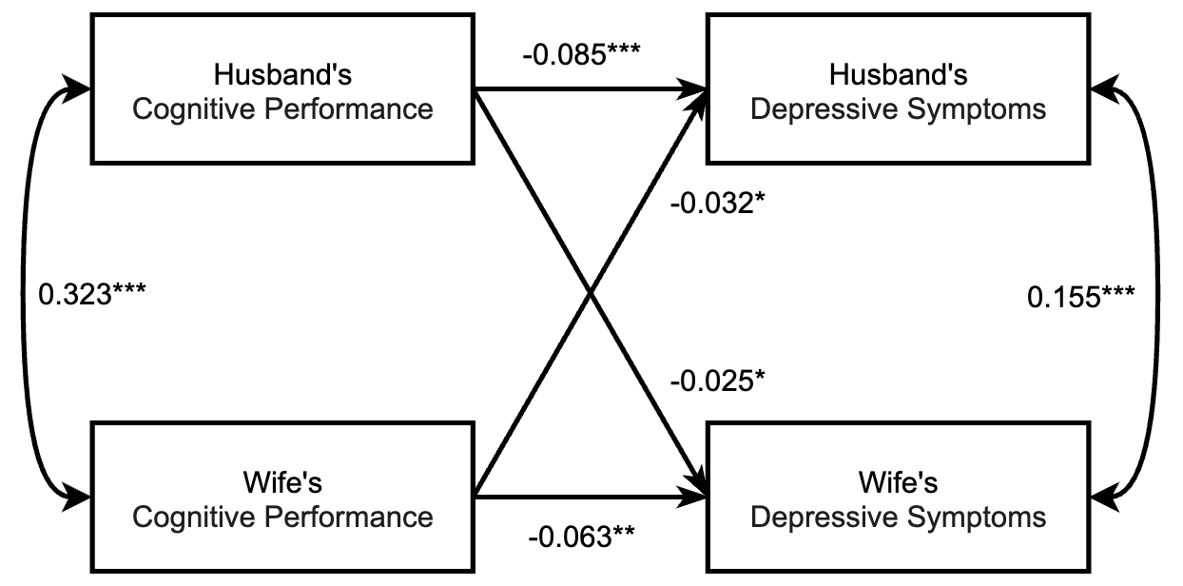
Supplementary Figure 6. Results from actor–partner interdependence model of cognitive performance on depressive symptoms.
Notes: The full line represents a significant path; the dashed line represents an insignificant path. Single-headed arrows represent regression paths. Double-headed arrows represent correlations. All path coefficients were labeled with significance: *p < .05. **p < .01. ***p < .001. The model includes control variables, as detailed in Supplementary Table 23 & 24.

Supplementary Table 22. Model fit indices and model comparisons of cognitive performance on depressive symptoms.
Models | Model Fits |  |  |  |  | Model comparisons
Models | χ²(df) | CFI | SRMR | RMSEA | Pairs | p | ∆CFI | ∆RMSEA
Model 8 | 0.000 | 1.000 | 0.000 | 0.000
Model 8a | 0.944(1) | 1.000 | 0.002 | 0.000 | 8a vs. 8 | 0.331 | 0.000 | 0.000
Model 8b | 0.052(1) | 1.000 | 0.001 | 0.000 | 8b vs. 8 | 0.818 | 0.000 | 0.000
Model 8c | 1.262(2) | 1.000 | 0.003 | 0.000 | 8c vs. 8 | 0.532 | 0.000 | 0.000
Notes: Model 6 = free model; Model 6a = model with constrained actor effects paths for husbands and wives; Model 6b = model with constrained partner effects paths for husbands and wives; Model 6c = model with constrained actor and partner effects paths for husbands and wives; χ²= Chi-Square Test, df = Degrees of Freedom, CFI= Comparative Fit Index, SRMR= Standardized Root Mean Square Residual, RMSEA= Root Mean Square Error of Approximation, Δ = change in parameter.

Supplementary Table 23. Simple results from actor–partner interdependence model of cognitive performance on depressive symptoms.
Pathways Estimate | β | SE | 95% CI | P Value
Actor Effect Coefficient
Wife’s CP₂₀₁₅ → Wife’s DS₂₀₂₀ | -0.063 | 0.018 | [-0.099, -0.027] | 0.001
Husband’s CP₂₀₁₅ → Husband’s DS₂₀₂₀ | -0.085 | 0.018 | [-0.120, -0.051] | 0.000
Partner Effect Coefficient
Wife’s CP₂₀₁₅ → Husband’s DS₂₀₂₀ | -0.032 | 0.015 | [-0.062, -0.003] | 0.031
Husband’s CP₂₀₁₅ → Wife’s DS₂₀₂₀ | -0.025 | 0.012 | [-0.048, -0.002] | 0.031
Notes: The parameters in Supplementary Table 23 correspond to Supplementary Figure 6; The subscripts refer to the assessment year point; CP= cognitive performance; DS= depressive symptoms; β= Standardized Coefficient; SE= Standard Error; CI = confidence interval; The model includes control variables, as detailed in Supplementary Table 24.

Supplementary Table 24. Full parameter estimates from actor-partner interdependence model of cognitive performance on depressive symptoms.
 | Husband’s DS₂₀₂₀ | Wife’s DS₂₀₂₀
Husband’s CP₂₀₁₅ | -0.085***  （0.018） | -0.025*  （0.012）
Wife’s CP₂₀₁₅ | -0.032*  （0.015） | -0.063**  （0.018）
Husband’s Age | 0.036  （0.039） | 0.000  （0.037）
Wife’s Age | -0.055  （0.039） | -0.031  （0.037）
Husband’s Education | -0.042*  （0.018） | -0.044*  （0.017）
Wife’s Education | 0.001  （0.018） | -0.050**  （0.019）
Husband’s Health | -0.174***  （0.016） | -0.053**  （0.016）
Wife’s Health | -0.045**  （0.016） | -0.199***  （0.016）
Husband’s ADL | -0.022  （0.016） | 0.014  （0.016）
Wife’s ADL | 0.017  （0.016） | 0.003  （0.016）
Husband’s Wealth | -0.047*  （0.019） | 0.015  （0.018）
Wife’s Wealth | -0.010  （0.019） | -0.078***  （0.018）
Children | 0.034***  （0.009） | 0.015  （0.009）
Residence | 0.022  （0.016） | 0.025  （0.017）
Note: The parameters in Supplementary Table 24 correspond to Supplementary Figure 6; The subscripts refer to the assessment year point; CP= cognitive performance; DS= depressive symptoms; Standard errors in parentheses; *p < .05. **p < .01. ***p < .001.
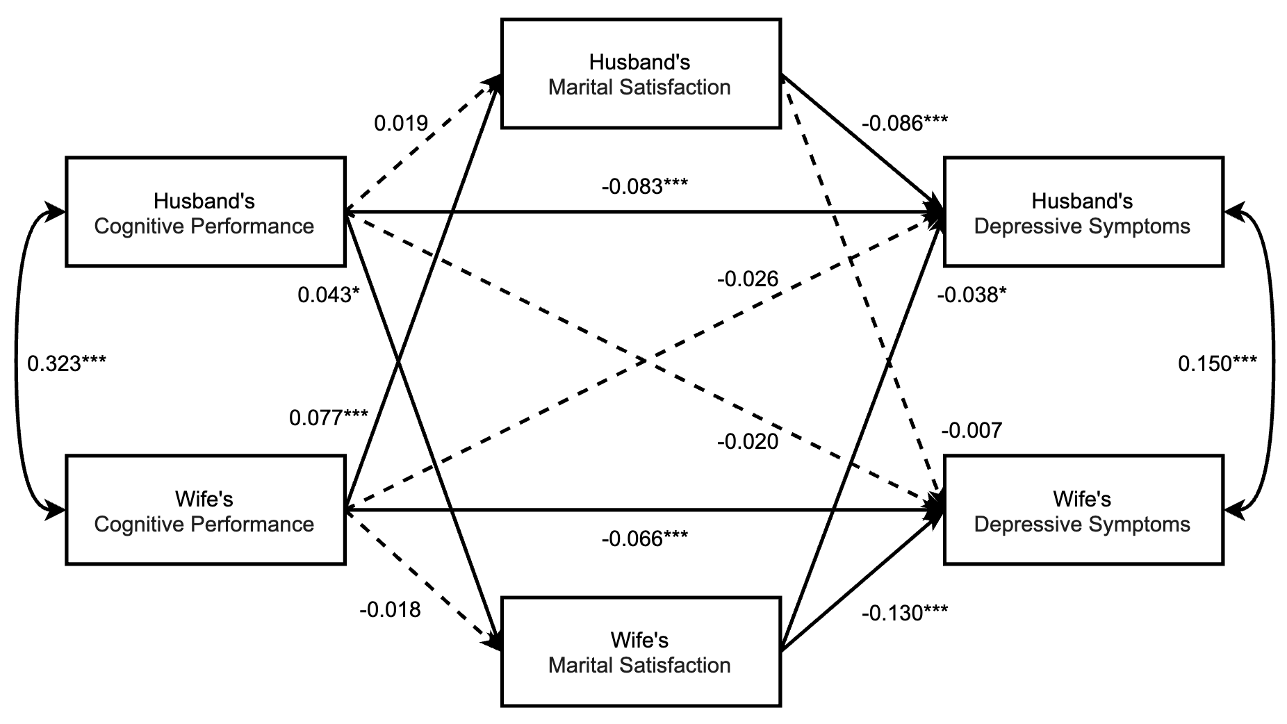
Supplementary Figure 7. Results from actor–partner interdependence model of cognitive performance on depressive symptoms, with marital satisfaction as a mediating variable.
Notes: The full line represents a significant path; the dashed line represents an insignificant path. Single-headed arrows represent regression paths. Double-headed arrows represent correlations. All path coefficients were labeled with significance: *p < .05. **p < .01. ***p < .001. The model includes control variables, as detailed in Supplementary Table 25 & 26.

Supplementary Table 25. Simple results from actor–partner interdependence model of cognitive performance on depressive symptoms, with marital satisfaction as a mediating variable.
Pathways Estimate | β | SE | 95% CI | P Value
Mediating Pathways
Wife’s CP₂₀₁₅ →Wife’s MS₂₀₁₈ | -0.018 | 0.020 | [0.040, 0.115] | 0.358
Wife’s CP₂₀₁₅ → Husband’s MS₂₀₁₈ | 0.077 | 0.019 | [0.040, 0.115] | 0.000
Husband’s CP₂₀₁₅ → Husband’s MS₂₀₁₈ | 0.019 | 0.019 | [0.016, 0.059] | 0.333
Husband’s CP₂₀₁₅ → Wife’s MS₂₀₁₈ | 0.043 | 0.019 | [-0.059, 0.020] | 0.025
Wife’s MS₂₀₁₈→ Wife’s DS₂₀₂₀ | -0.130 | 0.016 | [-0.161, -0.098] | 0.000
Wife’s MS₂₀₁₈→Husband’s DS₂₀₂₀ | -0.038 | 0.017 | [-0.071, -0.006] | 0.022
Husband’s MS₂₀₁₈ → Husband’s DS₂₀₂₀ | -0.086 | 0.017 | [-0.121, -0.054] | 0.000
Husband’s MS₂₀₁₈ →Wife’s DS₂₀₂₀ | 0.007 | 0.016 | [-0.024, 0.039] | 0.679
Actor Effect Coefficient
Wife’s CP₂₀₁₅ → Wife’s DS₂₀₂₀ | -0.066 | 0.018 | [-0.100, -0.029] | 0.000
Husband’s CP₂₀₁₅ → Husband’s DS₂₀₂₀ | -0.083 | 0.018 | [-0.120, -0.048] | 0.000
Partner Effect Coefficient
Wife’s CP₂₀₁₅ → Husband’s DS₂₀₂₀ | -0.026 | 0.015 | [-0.055, 0.002] | 0.082
Husband’s CP₂₀₁₅ → Wife’s DS₂₀₂₀ | -0.020 | 0.012 | [-0.043, 0.002] | 0.082

Notes: The parameters in Supplementary Table 15 correspond to Supplementary Figure 7; The subscripts refer to the assessment year point; CP= cognitive performance; DS= depressive symptoms; MS= Marital Satisfaction; β= Standardized Coefficient; SE= Standard Error; CI = confidence interval; The model includes control variables, as detailed in Supplementary Table 26.

Supplementary Table 26. Full parameter estimates from actor-partner interdependence model of cognitive performance on depressive symptoms, with marital satisfaction as a mediating variable.
 | Husband’s DS₂₀₂₀ | Husband’s MS₂₀₁₈ | Wife’s DS₂₀₂₀ | Wife’s MS₂₀₁₈
Husband’s CP₂₀₁₅ | -0.083***  （0.018） | 0.019  （0.019） | -0.020  （0.012） | 0.043*  （0.019）
Wife’s CP₂₀₁₅ | -0.026  （0.015） | 0.077***  （0.019） | -0.066***  （0.018） | -0.018  （0.020）
Husband’s MS₂₀₁₈ | -0.086***  （0.017） |  | 0.007  （0.016）
Wife’s MS₂₀₁₈ | -0.038*  （0.017） |  | -0.130***  （0.016）
Husband’s Age | 0.028  （0.041） | -0.076  （0.039） | -0.006  （0.037） | -0.044  （0.038）
Wife’s Age | -0.049  （0.040） | 0.045  （0.040） | -0.022  （0.036） | 0.070  （0.038）
Husband’s Education | -0.044*  （0.017） | -0.032  （0.017） | -0.041*  （0.017） | 0.030  （0.019）
Wife’s Education | -0.003  （0.019） | -0.033  （0.020） | -0.055**  （0.019） | -0.044*  （0.018）
Husband’s Health | -0.164***  （0.016） | 0.107***  （0.018） | -0.046**  （0.016） | 0.058**  （0.018）
Wife’s Health | -0.035*  （0.016） | 0.063***  （0.017） | -0.185***  （0.016） | 0.123***  （0.016）
Husband’s ADL | -0.026  （0.017） | -0.032  （0.017） | 0.010  （0.016） | -0.030  （0.017）
Wife’s ADL | 0.015  （0.016） | -0.015  （0.016） | 0.000  （0.015） | -0.024  （0.016）
Husband’s Wealth | -0.048**  （0.018） | -0.025  （0.020） | 0.018  （0.019） | 0.026  （0.018）
Wife’s Wealth | -0.009  （0.019） | 0.019  （0.020） | -0.079***  （0.019） | -0.002  （0.020）
Children | 0.033***  （0.009） | -0.011  （0.010） | 0.014  （0.009） | -0.012  （0.010）
Urban vs. Rural | 0.020  （0.016） | -0.021  （0.018） | 0.023  （0.017） | -0.015  （0.017）
Note: The parameters in Supplementary Table 26 correspond to Supplementary Figure 7; The subscripts refer to the assessment year point; CP= cognitive performance; DS= depressive symptoms; Standard errors in parentheses; *p < .05. **p < .01. ***p < .001.

