NISTmAb-Based Small-Scale RP-HPLC Screening for DAR Adjustment in Cysteine Antibody-Drug Conjugation
Yutaka Matsuda^{1,2}*, Monica Leung¹, Zhala Tawfiq¹, Veronica Robles¹, Yuichi Nakahara²*, Brian A. Mendelsohn¹
1: Ajinomoto Bio-Pharma Services, 11040 Roselle Street, San Diego, California 92121, United States
2: Ajinomoto Co., Inc., 1-1 Suzuki-cho, Kawasaki, Kanagawa 210-8681, Japan.

*Corresponding authors: Ajinomoto Co., Inc, 1-1 Suzuki-cho, Kawasaki, Kanagawa 210-8681, Japan. Tel +81 (44) 244-7470;
e-mail:
Y.M.: yutakamatsuda.official@gmail.com
Y. N.: yuichi.nakahara.s5k@asv.ajinomoto.com

Supplementary Method S1. Representative 1-mg preparation of the DAR ≈ 4 NISTmAb-MMAE model conjugate
An aliquot of the 13.3 mg/mL NISTmAb working stock (75.2 µL, corresponding to approximately 1.0 mg antibody) was diluted with conjugation buffer to an antibody concentration of 7.5 mg/mL. TCEP (1.0 mM stock solution) was added to 2.75 molar equivalents relative to antibody, and the mixture was incubated for 45 min at 37 °C. mc-vc-PABC-MMAE (10 mM in DMSO, 5.3 µL; 7.5 equivalents) was then added, followed by incubation for 1 h at 25 °C. Excess maleimide-containing linker-payload was quenched by addition of NAC (50 mM, 6.7 µL; 50 equivalents), followed by incubation for 15 min at 25 °C. The resulting conjugate was analyzed by reduced RP-HPLC as described in the main manuscript and gave an RP-HPLC-estimated DAR of 4.1.

Table S1. Reduced RP-HPLC gradient program and operating conditions
Time (min) | A (%) | B (%)
0.0 | 68 | 32
2.0 | 68 | 32
27.0 | 52 | 48
27.5 | 5 | 95
30.5 | 5 | 95
31.0 | 68 | 32
33.0 | 68 | 32
Mobile phase A: 0.1% formic acid and 0.01% trifluoroacetic acid in 2% acetonitrile. Mobile phase B: 0.1% formic acid and 0.01% trifluoroacetic acid in 99.9% acetonitrile. Column: Agilent AdvanceBio RP-mAb Diphenyl (2.1 × 100 mm, 3.5 µm). Flow rate: 0.3 mL/min. Column temperature: 70 °C. Injection volume: 20 µL. Detection: 280 nm.

Table S2. Full TCEP-equivalent screening dataset
Conditions: mc-vc-PABC-MMAE 10 eq, conjugation at 25 °C for 1 h after TCEP reduction at 37 °C for 3 h. Each condition was evaluated once (n = 1).
Sample | NISTmAb concentration (mg/mL) | TCEP (eq) | RP-HPLC-estimated DAR
A1 | 10.0 | 1.50 | 2.40
A2 | 10.0 | 1.75 | 2.72
A3 | 10.0 | 2.00 | 3.06
A4 | 10.0 | 2.25 | 3.66
A5 | 10.0 | 2.50 | 3.71
A6 | 10.0 | 2.75 | 4.12
A7 | 10.0 | 3.00 | 4.50
B1 | 7.5 | 1.50 | 2.30
B2 | 7.5 | 1.75 | 2.64
B3 | 7.5 | 2.00 | 3.03
B4 | 7.5 | 2.25 | 3.42
B5 | 7.5 | 2.50 | 3.75
B6 | 7.5 | 2.75 | 4.12
B7 | 7.5 | 3.00 | 4.40
C1 | 5.0 | 1.50 | 2.30
C2 | 5.0 | 1.75 | 2.79
C3 | 5.0 | 2.00 | 3.06
C4 | 5.0 | 2.25 | 3.23
C5 | 5.0 | 2.50 | 3.88
C6 | 5.0 | 2.75 | 4.11
C7 | 5.0 | 3.00 | 4.38

Table S3. mc-vc-PABC-MMAE-equivalent screening dataset
Conditions: NISTmAb 7.5 mg/mL, TCEP 2.75 eq, reduction 3 h at 37 °C, conjugation 1 h at 25 °C. Each condition was evaluated once (n = 1).
mc-vc-PABC-MMAE (eq) | RP-HPLC-estimated DAR
4 | 3.1
5 | 3.9
7.5 | 4.1
10 | 4.1
15 | 4.1

Table S4. Reduction-time screening dataset
Conditions: NISTmAb 7.5 mg/mL, TCEP 2.75 eq at 37 °C, followed by mc-vc-PABC-MMAE 7.5 eq for 1 h at 25 °C. Values are reported at the precision used for Fig. 4; each time point was evaluated once (n = 1).
Reduction time (min) | RP-HPLC-estimated DAR
15 | 2.3
30 | 3.9
45 | 4.1
60 | 4.1
75 | 4.1
90 | 4.1
120 | 4.1
180 | 4.1

Table S5. Representative peak-integration data used for RP-HPLC-estimated DAR calculation for the selected NISTmAb-vcMMAE model conjugate
Provisional peak assignment | Retention time (min) | Integrated area (mAU·min) | Assigned drug load | Relative area within chain group (%) | Weighted area contribution (%)
LC0 | 7.93 | 2.91 | 0 | 37.6 | 0
LC1 | 10.7 | 4.84 | 1 | 62.5 | 62.5
HC0 | 13.1 | 1.24 | 0 | 19.2 | 0
HC1 | 14.8 | 2.49 | 1 | 38.6 | 38.6
HC2 | 17.6 | 1.60 | 2 | 24.8 | 49.7
HC3 | 20.1 | 1.13 | 3 | 17.5 | 52.4
Weighted area contribution was calculated as assigned drug load × relative peak area within the corresponding chain group. The resulting RP-HPLC-estimated DAR was calculated as 2 × (62.5/100) + 2 × [(38.6 + 49.7 + 52.4)/100] = 4.06, reported as DAR = 4.1. Peak assignments are provisional; see Supplementary Note S1.

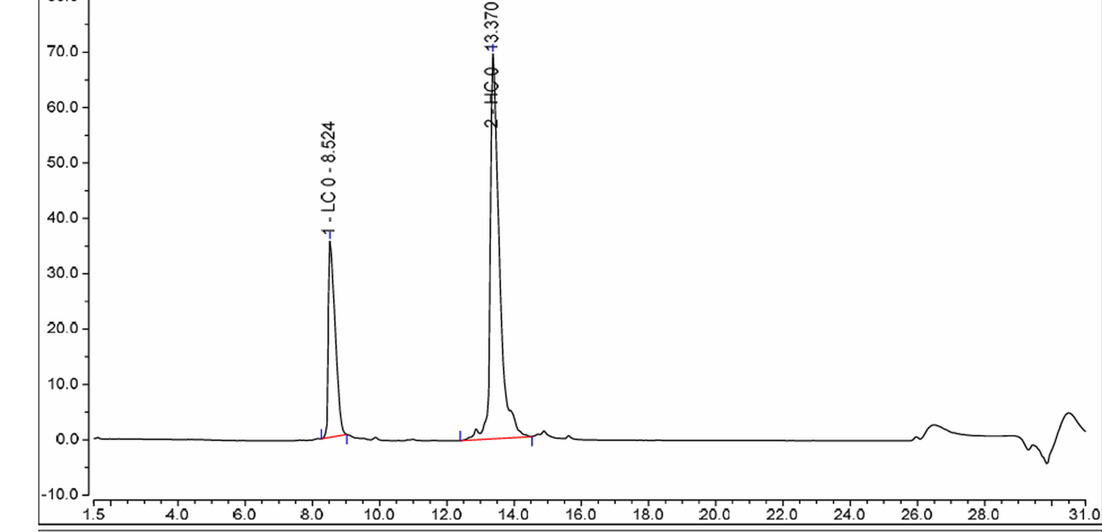
Figure. S1 Original data-system export for the unconjugated Sartorius-supplied NISTmAb working stock. The reduced RP-HPLC profile shows the major light-chain (LC0) and heavy-chain (HC0) peaks used as retention anchors for provisional assignment of drug-loaded chain species in the conjugated sample

Supplementary Note S1. Basis and limitation of peak assignments
The unconjugated starting-antibody chromatogram in Fig. S1 provided retention-time anchors for LC0 and HC0. In the conjugated samples, later-eluting peaks within the corresponding light- and heavy-chain regions were provisionally assigned to progressively drug-loaded species based on the starting-material retention profile and the expected increase in reversed-phase retention associated with vcMMAE conjugation. These assignments were used solely for screening-level DAR estimation. Individual LC1 and HC1–HC3 peak identities were not independently confirmed by mass spectrometry or another orthogonal method. Accordingly, the values reported in the manuscript are designated RP-HPLC-estimated DAR rather than orthogonally confirmed absolute DAR.

