Supplementary material
Multi-cation irrigation water composition affects strawberry growth, yield and fruit quality beyond SAR-based sodicity assessment
Supplementary Fig. S1. Relationship between fresh and dry fruit weight used to estimate fresh fruit mass from dry fruit measurements.
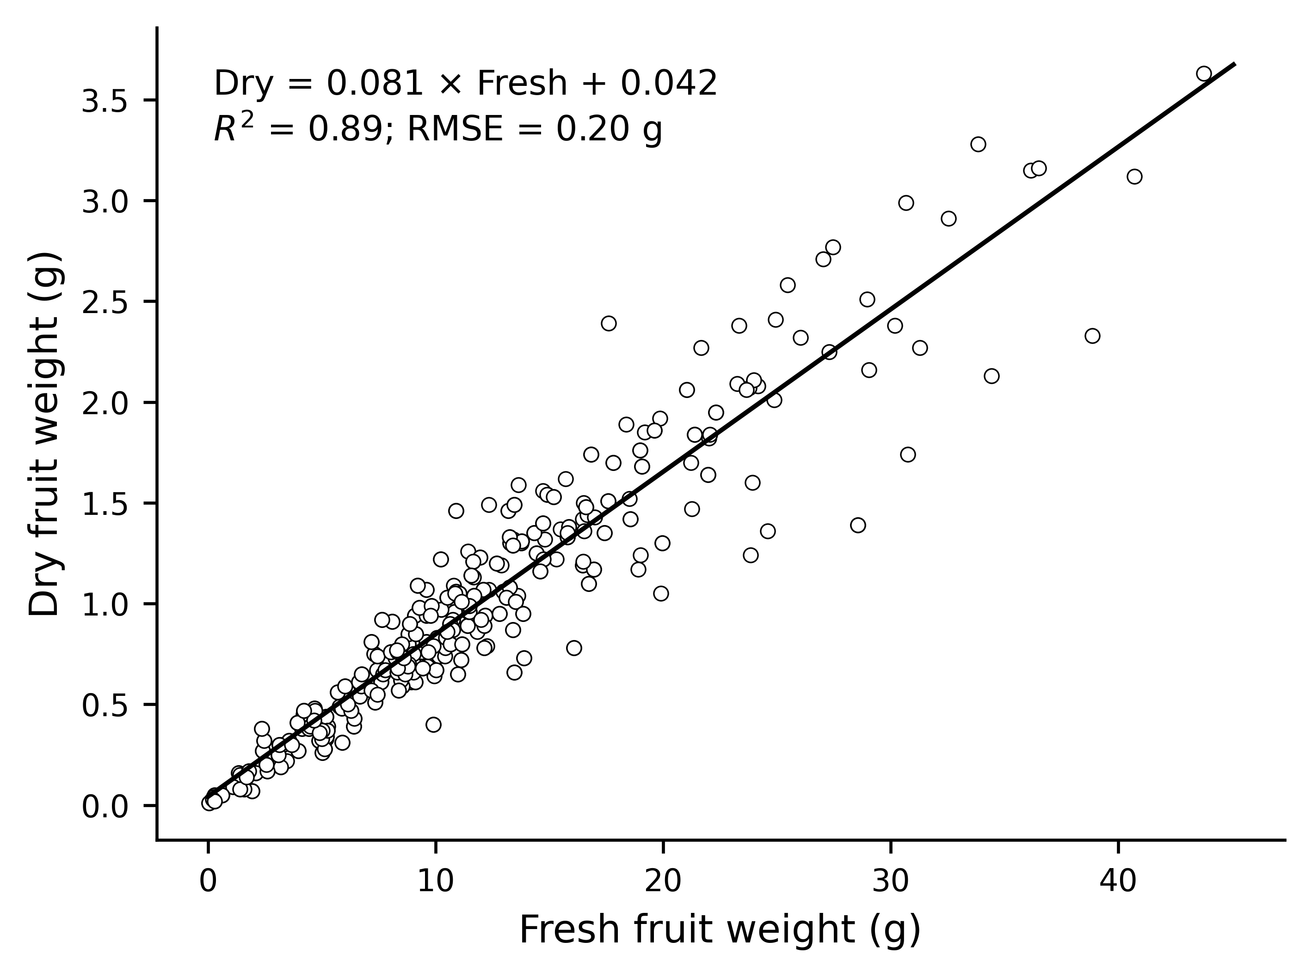
Supplementary Fig. S2. Irrigation schedule during the 40-week greenhouse experiment. The black step line shows daily irrigation volume per plant and the grey line shows approximate cumulative irrigation per plant. The dashed vertical line marks the increase in pulse volume after week 22.
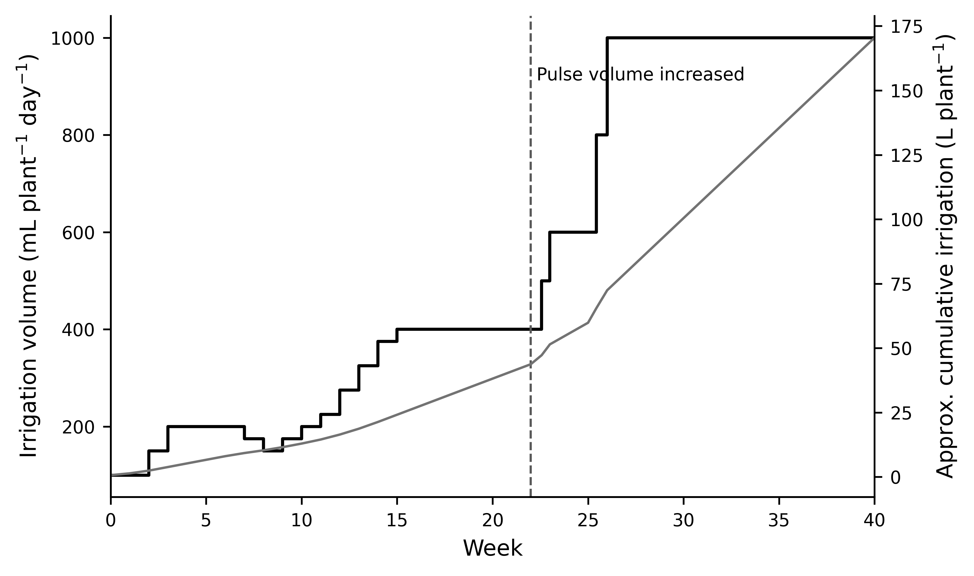
Supplementary Table S1. Yield, fruit quality and final biomass by irrigation treatment.
Estimated fresh fruit weight was calculated from the fresh-dry fruit weight relationship. The late-season period corresponds to weeks 30-40. Values are means ± SD on a per-plant basis.
Treatment | Group | Total yield (g plant-1) | Marketable yield (g plant-1) | Late marketable yield (g plant-1) | SSC (°Brix) | Fresh biomass (g plant-1) | Dry biomass (g plant-1)
T0 | T0 (Ca control) | 395.1 ± 311.9 | 310.8 ± 265.8 | 67.7 ± 75.4 | 7.09 ± 1.13 | 594.7 ± 156.9 | 190.6 ± 32.3
T1 | T1 (Na extreme) | 279.7 ± 222.0 | 214.9 ± 198.8 | 19.7 ± 22.0 | 9.57 ± 1.98 | 229.2 ± 104.7 | 82.2 ± 27.9
T2 | SAR 9.8 | 256.7 ± 205.7 | 168.7 ± 142.1 | 43.1 ± 56.6 | 8.86 ± 1.43 | 429.8 ± 103.1 | 143.2 ± 31.1
T3 | SAR 9.8 | 90.9 ± 61.6 | 21.6 ± 20.5 | 17.9 ± 22.4 | 7.97 ± 0.91 | 320.3 ± 204.6 | 111.7 ± 69.8
T4 | SAR 9.8 | 89.8 ± 99.0 | 29.6 ± 28.3 | 22.5 ± 29.8 | 7.54 ± 0.96 | 431.7 ± 169.0 | 149.5 ± 66.7
T5 | SAR 4.9 | 190.3 ± 30.8 | 75.1 ± 21.4 | 75.1 ± 21.4 | 7.26 ± 1.52 | 520.5 ± 139.2 | 175.0 ± 40.5
T6 | SAR 4.9 | 185.6 ± 134.2 | 79.2 ± 63.1 | 79.2 ± 63.1 | 7.71 ± 1.39 | 432.2 ± 164.5 | 159.2 ± 49.2
T7 | SAR 4.9 | 73.2 ± 56.2 | 19.1 ± 24.2 | 19.1 ± 24.2 | 9.06 ± 0.80 | 314.3 ± 129.6 | 128.5 ± 53.0
T8 | K-group | 191.0 ± 91.4 | 92.0 ± 78.2 | 92.0 ± 78.2 | 7.54 ± 1.04 | 437.9 ± 112.9 | 160.3 ± 28.7
T9 | K-group | 192.8 ± 130.7 | 81.9 ± 58.7 | 81.9 ± 58.7 | 7.83 ± 1.35 | 455.4 ± 226.6 | 159.0 ± 64.8
T10 | K-group | 204.9 ± 106.2 | 82.4 ± 69.0 | 82.4 ± 69.0 | 7.06 ± 1.44 | 496.3 ± 133.3 | 183.3 ± 43.0

Supplementary Table S2A. ANOVA summary for crop-response variables, fruit soluble solids, biomass and shoot ion accumulation.
For yield and biomass variables, tests were calculated from treatment means ± SD using n=4 block-level observations. Fruit soluble solids and shoot ion variables were analysed from available raw observations. p values <0.05 indicate significant treatment effects.
Variable | Unit | df treatment | df error | F | p value | Data basis
Total yield | g plant-1 estimated FW | 10 | 33 | 1.48 | 0.190 | treatment means ± SD; n=4 block-level observations
Marketable yield | g plant-1 estimated FW | 10 | 33 | 2.37 | 0.031 | treatment means ± SD; n=4 block-level observations
Late-season total yield | g plant-1 estimated FW | 10 | 33 | 1.87 | 0.087 | treatment means ± SD; n=4 block-level observations
Late-season marketable yield | g plant-1 estimated FW | 10 | 33 | 1.33 | 0.256 | treatment means ± SD; n=4 block-level observations
Total yield dry weight | g plant-1 DW | 10 | 33 | 1.49 | 0.188 | treatment means ± SD; n=4 block-level observations
Final fresh biomass | g plant-1 FW | 10 | 33 | 1.78 | 0.104 | treatment means ± SD; n=4 block-level observations
Final dry biomass | g plant-1 DW | 10 | 33 | 1.74 | 0.113 | treatment means ± SD; n=4 block-level observations
Fruit soluble solids | °Brix | 10 | 66 | 2.9 | 0.005 | raw observations; n varies by treatment
Shoot Na | % DW | 10 | 22 | 53.82 | <0.001 | raw block-level tissue observations; n=3 per treatment
Shoot K | % DW | 10 | 22 | 56.86 | <0.001 | raw block-level tissue observations; n=3 per treatment
Shoot Ca | % DW | 10 | 22 | 27.87 | <0.001 | raw block-level tissue observations; n=3 per treatment
Shoot Mg | % DW | 10 | 22 | 12.58 | <0.001 | raw block-level tissue observations; n=3 per treatment
Shoot Cl | % DW | 10 | 22 | 26.6 | <0.001 | raw block-level tissue observations; n=3 per treatment

Supplementary Table S2B. Treatment means and Tukey groupings for selected crop-response variables.
Treatments sharing at least one letter are not significantly different according to Tukey’s HSD test at p < 0.05. Variables are shown in the units indicated in Supplementary Table S2A.
Variable | Treatment | Mean ± SD | n | Tukey group
Total yield | T0 | 395.09 ± 311.86 | 4 | A
Total yield | T1 | 279.70 ± 221.97 | 4 | A
Total yield | T2 | 256.68 ± 205.73 | 4 | A
Total yield | T3 | 90.88 ± 61.60 | 4 | A
Total yield | T4 | 89.77 ± 98.95 | 4 | A
Total yield | T5 | 190.35 ± 30.83 | 4 | A
Total yield | T6 | 185.64 ± 134.23 | 4 | A
Total yield | T7 | 73.16 ± 56.22 | 4 | A
Total yield | T8 | 190.98 ± 91.37 | 4 | A
Total yield | T9 | 192.75 ± 130.66 | 4 | A
Total yield | T10 | 204.92 ± 106.24 | 4 | A
Marketable yield | T0 | 310.80 ± 265.75 | 4 | A
Marketable yield | T1 | 214.93 ± 198.81 | 4 | A
Marketable yield | T2 | 168.69 ± 142.07 | 4 | A
Marketable yield | T3 | 21.65 ± 20.49 | 4 | B
Marketable yield | T4 | 29.59 ± 28.26 | 4 | A
Marketable yield | T5 | 75.06 ± 21.44 | 4 | A
Marketable yield | T6 | 79.23 ± 63.09 | 4 | A
Marketable yield | T7 | 19.14 ± 24.22 | 4 | B
Marketable yield | T8 | 91.97 ± 78.23 | 4 | A
Marketable yield | T9 | 81.92 ± 58.73 | 4 | A
Marketable yield | T10 | 82.42 ± 68.96 | 4 | A
Late-season total yield | T0 | 128.94 ± 132.85 | 4 | A
Late-season total yield | T1 | 32.36 ± 40.35 | 4 | A
Late-season total yield | T2 | 84.83 ± 106.18 | 4 | A
Late-season total yield | T3 | 56.23 ± 70.68 | 4 | A
Late-season total yield | T4 | 69.64 ± 94.39 | 4 | A
Late-season total yield | T5 | 190.35 ± 30.83 | 4 | A
Late-season total yield | T6 | 185.64 ± 134.23 | 4 | A
Late-season total yield | T7 | 73.16 ± 56.22 | 4 | A
Late-season total yield | T8 | 190.98 ± 91.37 | 4 | A
Late-season total yield | T9 | 192.75 ± 130.66 | 4 | A
Late-season total yield | T10 | 204.92 ± 106.24 | 4 | A
Late-season marketable yield | T0 | 67.73 ± 75.39 | 4 | A
Late-season marketable yield | T1 | 19.72 ± 22.00 | 4 | A
Late-season marketable yield | T2 | 43.15 ± 56.65 | 4 | A
Late-season marketable yield | T3 | 17.90 ± 22.43 | 4 | A
Late-season marketable yield | T4 | 22.48 ± 29.78 | 4 | A
Late-season marketable yield | T5 | 75.06 ± 21.44 | 4 | A
Late-season marketable yield | T6 | 79.23 ± 63.09 | 4 | A
Late-season marketable yield | T7 | 19.14 ± 24.22 | 4 | A
Late-season marketable yield | T8 | 91.97 ± 78.23 | 4 | A
Late-season marketable yield | T9 | 81.92 ± 58.73 | 4 | A
Late-season marketable yield | T10 | 82.42 ± 68.96 | 4 | A
Total yield dry weight | T0 | 32.28 ± 25.48 | 4 | A
Total yield dry weight | T1 | 23.02 ± 18.22 | 4 | A
Total yield dry weight | T2 | 21.13 ± 16.88 | 4 | A
Total yield dry weight | T3 | 7.48 ± 5.03 | 4 | A
Total yield dry weight | T4 | 7.36 ± 8.09 | 4 | A
Total yield dry weight | T5 | 15.53 ± 2.50 | 4 | A
Total yield dry weight | T6 | 15.13 ± 10.87 | 4 | A
Total yield dry weight | T7 | 6.02 ± 4.58 | 4 | A
Total yield dry weight | T8 | 15.58 ± 7.38 | 4 | A
Total yield dry weight | T9 | 15.71 ± 10.56 | 4 | A
Total yield dry weight | T10 | 16.70 ± 8.58 | 4 | A
Final fresh biomass | T0 | 594.70 ± 156.92 | 4 | A
Final fresh biomass | T1 | 229.15 ± 104.73 | 4 | A
Final fresh biomass | T2 | 429.78 ± 103.09 | 4 | A
Final fresh biomass | T3 | 320.32 ± 204.56 | 4 | A
Final fresh biomass | T4 | 431.70 ± 169.02 | 4 | A
Final fresh biomass | T5 | 520.55 ± 139.16 | 4 | A
Final fresh biomass | T6 | 432.22 ± 164.46 | 4 | A
Final fresh biomass | T7 | 314.30 ± 129.56 | 4 | A
Final fresh biomass | T8 | 437.95 ± 112.87 | 4 | A
Final fresh biomass | T9 | 455.42 ± 226.60 | 4 | A
Final fresh biomass | T10 | 496.28 ± 133.35 | 4 | A
Final dry biomass | T0 | 190.62 ± 32.32 | 4 | A
Final dry biomass | T1 | 82.20 ± 27.92 | 4 | A
Final dry biomass | T2 | 143.22 ± 31.11 | 4 | A
Final dry biomass | T3 | 111.68 ± 69.83 | 4 | A
Final dry biomass | T4 | 149.50 ± 66.73 | 4 | A
Final dry biomass | T5 | 174.98 ± 40.51 | 4 | A
Final dry biomass | T6 | 159.15 ± 49.25 | 4 | A
Final dry biomass | T7 | 128.50 ± 52.97 | 4 | A
Final dry biomass | T8 | 160.32 ± 28.71 | 4 | A
Final dry biomass | T9 | 159.00 ± 64.80 | 4 | A
Final dry biomass | T10 | 183.30 ± 42.97 | 4 | A
Fruit soluble solids | T0 | 7.09 ± 1.13 | 7 | B
Fruit soluble solids | T1 | 9.57 ± 1.98 | 7 | A
Fruit soluble solids | T10 | 7.06 ± 1.44 | 7 | B
Fruit soluble solids | T2 | 8.86 ± 1.43 | 7 | A
Fruit soluble solids | T3 | 7.97 ± 0.91 | 7 | A
Fruit soluble solids | T4 | 7.54 ± 0.96 | 7 | A
Fruit soluble solids | T5 | 7.26 ± 1.52 | 7 | A
Fruit soluble solids | T6 | 7.71 ± 1.39 | 7 | A
Fruit soluble solids | T7 | 9.06 ± 0.80 | 7 | A
Fruit soluble solids | T8 | 7.54 ± 1.04 | 7 | A
Fruit soluble solids | T9 | 7.83 ± 1.35 | 7 | A
Shoot Na | T0 | 0.02 ± 0.00 | 3 | D
Shoot Na | T1 | 2.14 ± 0.24 | 3 | A
Shoot Na | T10 | 0.02 ± 0.01 | 3 | D
Shoot Na | T2 | 1.14 ± 0.20 | 3 | B
Shoot Na | T3 | 1.22 ± 0.07 | 3 | B
Shoot Na | T4 | 1.32 ± 0.38 | 3 | B
Shoot Na | T5 | 0.45 ± 0.01 | 3 | C
Shoot Na | T6 | 0.38 ± 0.10 | 3 | C
Shoot Na | T7 | 0.65 ± 0.21 | 3 | C
Shoot Na | T8 | 0.03 ± 0.01 | 3 | D
Shoot Na | T9 | 0.02 ± 0.01 | 3 | D
Shoot K | T0 | 1.86 ± 0.04 | 3 | C
Shoot K | T1 | 1.01 ± 0.22 | 3 | D
Shoot K | T10 | 4.00 ± 0.61 | 3 | A
Shoot K | T2 | 1.57 ± 0.18 | 3 | C
Shoot K | T3 | 1.32 ± 0.04 | 3 | C
Shoot K | T4 | 1.15 ± 0.26 | 3 | C
Shoot K | T5 | 2.84 ± 0.23 | 3 | B
Shoot K | T6 | 2.63 ± 0.15 | 3 | B
Shoot K | T7 | 3.02 ± 0.22 | 3 | B
Shoot K | T8 | 4.18 ± 0.08 | 3 | A
Shoot K | T9 | 3.90 ± 0.42 | 3 | A
Shoot Ca | T0 | 2.40 ± 0.34 | 3 | A
Shoot Ca | T1 | 1.18 ± 0.15 | 3 | C
Shoot Ca | T10 | 0.76 ± 0.11 | 3 | C
Shoot Ca | T2 | 1.80 ± 0.12 | 3 | B
Shoot Ca | T3 | 1.40 ± 0.13 | 3 | B
Shoot Ca | T4 | 0.92 ± 0.23 | 3 | C
Shoot Ca | T5 | 1.53 ± 0.12 | 3 | B
Shoot Ca | T6 | 1.22 ± 0.06 | 3 | C
Shoot Ca | T7 | 0.79 ± 0.06 | 3 | C
Shoot Ca | T8 | 1.36 ± 0.07 | 3 | B
Shoot Ca | T9 | 1.09 ± 0.10 | 3 | C
Shoot Mg | T0 | 0.50 ± 0.04 | 3 | B
Shoot Mg | T1 | 0.58 ± 0.05 | 3 | B
Shoot Mg | T10 | 0.71 ± 0.05 | 3 | A
Shoot Mg | T2 | 0.56 ± 0.02 | 3 | B
Shoot Mg | T3 | 0.67 ± 0.06 | 3 | A
Shoot Mg | T4 | 0.83 ± 0.09 | 3 | A
Shoot Mg | T5 | 0.57 ± 0.06 | 3 | B
Shoot Mg | T6 | 0.65 ± 0.08 | 3 | B
Shoot Mg | T7 | 0.76 ± 0.05 | 3 | A
Shoot Mg | T8 | 0.46 ± 0.02 | 3 | C
Shoot Mg | T9 | 0.59 ± 0.05 | 3 | B
Shoot Cl | T0 | 0.18 ± 0.04 | 3 | C
Shoot Cl | T1 | 3.36 ± 0.31 | 3 | A
Shoot Cl | T10 | 2.42 ± 0.41 | 3 | B
Shoot Cl | T2 | 3.39 ± 0.13 | 3 | A
Shoot Cl | T3 | 2.95 ± 0.21 | 3 | A
Shoot Cl | T4 | 2.79 ± 0.43 | 3 | A
Shoot Cl | T5 | 2.90 ± 0.26 | 3 | A
Shoot Cl | T6 | 2.69 ± 0.27 | 3 | A
Shoot Cl | T7 | 3.02 ± 0.48 | 3 | A
Shoot Cl | T8 | 3.18 ± 0.12 | 3 | A
Shoot Cl | T9 | 2.63 ± 0.26 | 3 | A

