Figures.

Fig. 1. The microstructure of the carbon
matrix wall. Overgrowing pore.

Initial carbon sample | carbon matrix after pyrolysis
Fig. 2. Program execution results
modeling the pyrolysis process. White - pores, red re-settled
carbon particles, black - original coal
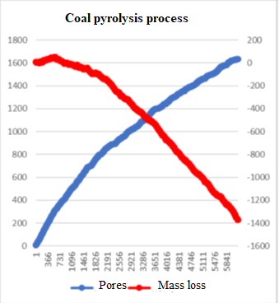
Fig. 3. Mass loss graph (red)
and the number of pores (blue).
Fig.4. STA diagram of coal pyrolysis.
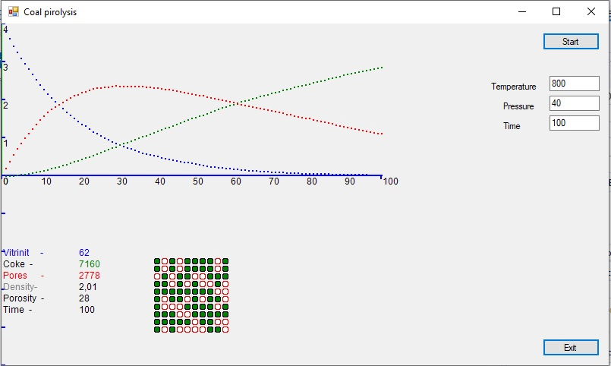

Fig. 5. User interface of the pyrolysis process simulation program.

