Target Journal: Journal of Regional Environmental Change
Climate-Driven Changes in Habitat Suitability and Landscape Structure of Red Panda (Ailurus fulgens) in Eastern Nepal
Naresh SHRESTHA*, Ritodhi CHAKRABORTY, Sonam Tashi LAMA, Damber BISTA, Helen DE KLERK
* Centre for Geospatial and Computing Studies, Faculty of Environment, Society and Design, Te Whare Wānaka o Aoraki Lincoln University, Lincoln, Christchurch 7647, Canterbury, Aotearoa New Zealand; Naresh.Shrestha@lincolnuni.ac.nz
Supplementary Information (Appendix S1)
Table S1 Normality test statistics for 31 environmental variables extracted at red panda presence locations (n=342) and background points (n=43,890). Normality was assessed using the Shapiro-Wilk (SW) test and Kolmogorov-Smirnov (KS) test. Variables meeting the normality assumption at α = 0.05 under the SW test are indicated as “YES”. Distribution categories are classified as: Approx Normal (|skewness|<0.5, passes at least one normality test), Moderate Skew (0.5≤|skewness|<1.0), and High Skew (|skewness|≥1.0). Given that the majority of variables violated the assumption of normality in both groups, Spearman’s rank correlation was subsequently used for collinearity assessment during variable selection. Bio = WorldClim bioclimatic variable; Elev = elevation; NDVI = Normalized Difference Vegetation Index (Amp = amplitude, Max = maximum, Mean = mean, Min = minimum, SD = standard deviation); RiverED = Euclidean distance to water sources; RoadED = Euclidean distance to roads; SetlED = Euclidean Distance to settlements and TreeHt = Tree Height.
Group | Variable | N | Skewness | Kurtosis | SW_statistic | SW_p_value | KS_statistic | KS_p_value | Normal_SW0.05 | Distribution
Presence | Asp | 342 | -0.12 | -0.91 | 0.98 | 1e-04 | 0.05 | 0.35 | NO | Approx normal
Presence | Bio10 | 342 | -0.22 | 0.06 | 0.99 | 0.0649 | 0.04 | 0.57 | YES | Approx normal
Presence | Bio11 | 342 | -0.34 | 0.05 | 0.99 | 0.0021 | 0.04 | 0.51 | NO | Approx normal
Presence | Bio12 | 342 | -0.47 | 0.48 | 0.97 | 0 | 0.09 | 0 | NO | Approx normal
Presence | Bio13 | 342 | 0.16 | 0.21 | 0.98 | 0 | 0.08 | 0.02 | NO | Approx normal
Presence | Bio14 | 342 | 1.49 | 3.58 | 0.77 | 0 | 0.28 | 0 | NO | High skew
Presence | Bio15 | 342 | 0.16 | -0.32 | 0.99 | 0.07 | 0.05 | 0.36 | YES | Approx normal
Presence | Bio16 | 342 | -0.05 | 0.04 | 0.99 | 0 | 0.08 | 0.02 | NO | Approx normal
Presence | Bio17 | 342 | 0.09 | 0.10 | 0.97 | 0 | 0.14 | 0 | NO | Approx normal
Presence | Bio18 | 342 | -0.05 | 0.04 | 0.99 | 0 | 0.08 | 0.02 | NO | Approx normal
Presence | Bio19 | 342 | -0.78 | 0.64 | 0.95 | 0 | 0.13 | 0 | NO | Moderate skew
Presence | Bio1 | 342 | -0.27 | 0.03 | 0.99 | 0.02 | 0.05 | 0.36 | NO | Approx normal
Presence | Bio2 | 342 | 0.36 | -0.91 | 0.96 | 0 | 0.13 | 0 | NO | Approx normal
Presence | Bio3 | 342 | 0.72 | -0.49 | 0.92 | 0 | 0.17 | 0 | NO | Moderate skew
Presence | Bio4 | 342 | -0.26 | -0.68 | 0.97 | 0 | 0.10 | 0 | NO | Approx normal
Presence | Bio5 | 342 | -0.11 | -0.13 | 0.99 | 0.06 | 0.05 | 0.31 | YES | Approx normal
Presence | Bio6 | 342 | -0.49 | 0.36 | 0.99 | 0 | 0.05 | 0.29 | NO | Approx normal
Presence | Bio7 | 342 | 0.83 | 2.21 | 0.95 | 0 | 0.11 | 0.01 | NO | Moderate skew
Presence | Bio8 | 342 | -0.22 | 0.06 | 0.99 | 0.06 | 0.04 | 0.57 | YES | Approx normal
Presence | Bio9 | 342 | -0.28 | -0.06 | 0.99 | 0.01 | 0.05 | 0.37 | NO | Approx normal
Presence | Elev | 342 | 0.03 | -0.57 | 0.99 | 0.17 | 0.04 | 0.78 | YES | Approx normal
Presence | NDVI_Amp | 342 | 1.06 | 1.28 | 0.93 | 0 | 0.10 | 0.01 | NO | High skew
Presence | NDVI_Max | 342 | -1.07 | 1.47 | 0.94 | 0 | 0.10 | 0.01 | NO | High skew
Presence | NDVI_Mean | 342 | -0.96 | 0.71 | 0.93 | 0 | 0.09 | 0.01 | NO | Moderate skew
Presence | NDVI_Min | 342 | -0.94 | 0.85 | 0.94 | 0 | 0.07 | 0.07 | NO | Moderate skew
Presence | NDVI_SD | 342 | 0.92 | 0.61 | 0.94 | 0 | 0.11 | 0 | NO | Moderate skew
Presence | RiverED | 342 | 0.56 | -0.20 | 0.97 | 0 | 0.08 | 0.04 | NO | Moderate skew
Presence | RoadED | 342 | 1.63 | 2.55 | 0.83 | 0 | 0.18 | 0 | NO | High skew
Presence | SetlED | 342 | 2.17 | 4.12 | 0.69 | 0 | 0.22 | 0 | NO | High skew
Presence | Slope | 342 | -0.07 | -0.31 | 0.99 | 0.77 | 0.03 | 0.95 | YES | Approx normal
Presence | TreeHt | 342 | -0.41 | -0.45 | 0.97 | 0 | 0.05 | 0.39 | NO | Approx normal
Background | Asp | 43890 | -0.01 | -0.80 | 0.99 | 0 | 0.03 | 0 | NO | Approx normal
Background | Bio10 | 43890 | -0.49 | -1.02 | 0.92 | 0 | 0.10 | 0 | NO | Approx normal
Background | Bio11 | 43890 | -0.64 | -0.83 | 0.91 | 0 | 0.13 | 0 | NO | Moderate skew
Background | Bio12 | 43890 | -0.31 | -1.19 | 0.92 | 0 | 0.11 | 0 | NO | Approx normal
Background | Bio13 | 43890 | 0.12 | -1.11 | 0.93 | 0 | 0.12 | 0 | NO | Approx normal
Background | Bio14 | 43890 | 0.32 | 0.32 | 0.96 | 0 | 0.16 | 0 | NO | Approx normal
Background | Bio15 | 43890 | -0.22 | -0.95 | 0.96 | 0 | 0.07 | 0 | NO | Approx normal
Background | Bio16 | 43890 | -0.05 | -1.20 | 0.93 | 0 | 0.12 | 0 | NO | Approx normal
Background | Bio17 | 43890 | 0.25 | -0.55 | 0.98 | 0 | 0.08 | 0 | NO | Approx normal
Background | Bio18 | 43890 | -0.06 | -1.18 | 0.93 | 0 | 0.12 | 0 | NO | Approx normal
Background | Bio19 | 43890 | 0.71 | -0.56 | 0.92 | 0 | 0.13 | 0 | NO | Moderate skew
Background | Bio1 | 43890 | -0.55 | -0.95 | 0.92 | 0 | 0.11 | 0 | NO | Moderate skew
Background | Bio2 | 43890 | 0.36 | -0.49 | 0.98 | 0 | 0.07 | 0 | NO | Approx normal
Background | Bio3 | 43890 | -0.34 | 1.79 | 0.95 | 0 | 0.11 | 0 | NO | Approx normal
Background | Bio4 | 43890 | 1.42 | 1.08 | 0.80 | 0 | 0.25 | 0 | NO | High skew
Background | Bio5 | 43890 | -0.49 | -0.97 | 0.93 | 0 | 0.11 | 0 | NO | Approx normal
Background | Bio6 | 43890 | -0.68 | -0.89 | 0.88 | 0 | 0.15 | 0 | NO | Moderate skew
Background | Bio7 | 43890 | 1.03 | -0.09 | 0.86 | 0 | 0.19 | 0 | NO | High skew
Background | Bio8 | 43890 | -0.49 | -1.01 | 0.93 | 0 | 0.10 | 0 | NO | Approx normal
Background | Bio9 | 43890 | -0.53 | -1.05 | 0.91 | 0 | 0.12 | 0 | NO | Moderate skew
Background | Elev | 43890 | 0.45 | -0.95 | 0.94 | 0 | 0.10 | 0 | NO | Approx normal
Background | NDVI_Amp | 43890 | 1.29 | 3.61 | 0.92 | 0 | 0.08 | 0 | NO | High skew
Background | NDVI_Max | 43890 | -1.06 | -0.28 | 0.82 | 0 | 0.19 | 0 | NO | High skew
Background | NDVI_Mean | 43890 | -0.89 | -0.56 | 0.85 | 0 | 0.17 | 0 | NO | Moderate skew
Background | NDVI_Min | 43890 | -0.69 | -0.81 | 0.90 | 0 | 0.14 | 0 | NO | Moderate skew
Background | NDVI_SD | 43890 | 1.30 | 3.52 | 0.93 | 0 | 0.08 | 0 | NO | High skew
Background | RiverED | 43890 | 1.52 | 1.76 | 0.79 | 0 | 0.19 | 0 | NO | High skew
Background | RoadED | 43890 | 1.04 | -0.13 | 0.84 | 0 | 0.17 | 0 | NO | High skew
Background | SetlED | 43890 | 1.79 | 3.39 | 0.76 | 0 | 0.22 | 0 | NO | High skew
Background | Slope | 43890 | -0.05 | 0.16 | 0.99 | 0 | 0.03 | 0 | NO | Approx normal
Background | TreeHt | 43890 | 0.50 | -1.22 | 0.83 | 0 | 0.24 | 0 | NO | Moderate skew
Table S2 Spearman’s rank correlation matrix for 31 environmental variables assessed at red panda presence locations (n=342). Values represent Spearman’s correlation coefficients (r) between each pair of variables. Cells highlighted in red indicate variable pairs with |r|≥0.70, the threshold used to identify and exclude collinear predictors during variable selection. Bio = WorldClim bioclimatic variable; Asp = aspect; Elev = elevation; NDVI = Normalized Difference Vegetation Index (Amp = amplitude, Max = maximum, Mean = mean, Min = minimum, SD = standard deviation).
Variable | Asp | Bio10 | Bio11 | Bio12 | Bio13 | Bio14 | Bio15 | Bio16 | Bio17 | Bio18 | Bio19 | Bio1 | Bio2 | Bio3 | Bio4 | Bio5 | Bio6 | Bio7 | Bio8 | Bio9 | Elev
Asp | 1.00 | -0.02 | -0.02 | -0.02 | -0.03 | 0.03 | -0.04 | -0.02 | 0.03 | -0.02 | 0.03 | -0.02 | 0.05 | 0.02 | 0.02 | -0.02 | -0.02 | 0.03 | -0.02 | -0.02 | 0.04
Bio10 | -0.02 | 1.00 | 1.00 | 0.78 | 0.83 | -0.35 | 0.76 | 0.81 | -0.16 | 0.80 | -0.54 | 1.00 | -0.54 | 0.10 | -0.61 | 1.00 | 1.00 | -0.57 | 1.00 | 1.00 | -1.00
Bio11 | -0.02 | 1.00 | 1.00 | 0.79 | 0.84 | -0.35 | 0.75 | 0.81 | -0.15 | 0.80 | -0.54 | 1.00 | -0.52 | 0.12 | -0.63 | 1.00 | 1.00 | -0.58 | 1.00 | 1.00 | -1.00
Bio12 | -0.02 | 0.78 | 0.79 | 1.00 | 0.99 | -0.22 | 0.77 | 1.00 | 0.09 | 0.99 | -0.21 | 0.78 | -0.55 | 0.24 | -0.80 | 0.77 | 0.79 | -0.76 | 0.78 | 0.80 | -0.79
Bio13 | -0.03 | 0.83 | 0.84 | 0.99 | 1.00 | -0.30 | 0.84 | 1.00 | -0.01 | 0.99 | -0.32 | 0.83 | -0.60 | 0.16 | -0.75 | 0.82 | 0.84 | -0.74 | 0.83 | 0.84 | -0.83
Bio14 | 0.03 | -0.35 | -0.35 | -0.22 | -0.30 | 1.00 | -0.63 | -0.26 | 0.75 | -0.25 | 0.77 | -0.35 | 0.50 | 0.59 | -0.01 | -0.34 | -0.35 | 0.11 | -0.35 | -0.36 | 0.35
Bio15 | -0.04 | 0.76 | 0.75 | 0.77 | 0.84 | -0.63 | 1.00 | 0.81 | -0.39 | 0.81 | -0.67 | 0.76 | -0.71 | -0.26 | -0.48 | 0.74 | 0.76 | -0.55 | 0.76 | 0.76 | -0.75
Bio16 | -0.02 | 0.81 | 0.81 | 1.00 | 1.00 | -0.26 | 0.81 | 1.00 | 0.05 | 1.00 | -0.27 | 0.81 | -0.58 | 0.19 | -0.77 | 0.80 | 0.81 | -0.76 | 0.81 | 0.82 | -0.81
Bio17 | 0.03 | -0.16 | -0.15 | 0.09 | -0.01 | 0.75 | -0.39 | 0.05 | 1.00 | 0.06 | 0.88 | -0.16 | 0.13 | 0.70 | -0.41 | -0.14 | -0.15 | -0.37 | -0.16 | -0.15 | 0.15
Bio18 | -0.02 | 0.80 | 0.80 | 0.99 | 0.99 | -0.25 | 0.81 | 1.00 | 0.06 | 1.00 | -0.26 | 0.80 | -0.59 | 0.19 | -0.78 | 0.79 | 0.81 | -0.77 | 0.80 | 0.81 | -0.80
Bio19 | 0.03 | -0.54 | -0.54 | -0.21 | -0.32 | 0.77 | -0.67 | -0.27 | 0.88 | -0.26 | 1.00 | -0.54 | 0.41 | 0.62 | -0.09 | -0.53 | -0.53 | -0.03 | -0.54 | -0.53 | 0.53
Bio1 | -0.02 | 1.00 | 1.00 | 0.78 | 0.83 | -0.35 | 0.76 | 0.81 | -0.16 | 0.80 | -0.54 | 1.00 | -0.53 | 0.10 | -0.62 | 1.00 | 1.00 | -0.58 | 1.00 | 1.00 | -1.00
Bio2 | 0.05 | -0.54 | -0.52 | -0.55 | -0.60 | 0.50 | -0.71 | -0.58 | 0.13 | -0.59 | 0.41 | -0.53 | 1.00 | 0.43 | 0.37 | -0.51 | -0.53 | 0.73 | -0.54 | -0.53 | 0.52
Bio3 | 0.02 | 0.10 | 0.12 | 0.24 | 0.16 | 0.59 | -0.26 | 0.19 | 0.70 | 0.19 | 0.62 | 0.10 | 0.43 | 1.00 | -0.54 | 0.12 | 0.11 | -0.18 | 0.09 | 0.12 | -0.11
Bio4 | 0.02 | -0.61 | -0.63 | -0.80 | -0.75 | -0.01 | -0.48 | -0.77 | -0.41 | -0.78 | -0.09 | -0.62 | 0.37 | -0.54 | 1.00 | -0.62 | -0.64 | 0.82 | -0.61 | -0.64 | 0.63
Bio5 | -0.02 | 1.00 | 1.00 | 0.77 | 0.82 | -0.34 | 0.74 | 0.80 | -0.14 | 0.79 | -0.53 | 1.00 | -0.51 | 0.12 | -0.62 | 1.00 | 1.00 | -0.56 | 1.00 | 1.00 | -1.00
Bio6 | -0.02 | 1.00 | 1.00 | 0.79 | 0.84 | -0.35 | 0.76 | 0.81 | -0.15 | 0.81 | -0.53 | 1.00 | -0.53 | 0.11 | -0.64 | 1.00 | 1.00 | -0.59 | 1.00 | 1.00 | -0.99
Bio7 | 0.03 | -0.57 | -0.58 | -0.76 | -0.74 | 0.11 | -0.55 | -0.76 | -0.37 | -0.77 | . | -0.58 | 0.73 | -0.18 | 0.82 | -0.56 | -0.59 | 1.00 | -0.57 | -0.58 | 0.57
Bio8 | -0.02 | 1.00 | 1.00 | 0.78 | 0.83 | -0.35 | 0.76 | 0.81 | -0.16 | 0.80 | -0.54 | 1.00 | -0.54 | 0.09 | -0.61 | 1.00 | 1.00 | -0.57 | 1.00 | 1.00 | -1.00
Bio9 | -0.02 | 1.00 | 1.00 | 0.80 | 0.84 | -0.36 | 0.76 | 0.82 | -0.15 | 0.81 | -0.53 | 1.00 | -0.53 | 0.12 | -0.64 | 1.00 | 1.00 | -0.58 | 1.00 | 1.00 | -0.99
Elev | 0.04 | -1.00 | -1.00 | -0.79 | -0.83 | 0.35 | -0.75 | -0.81 | 0.15 | -0.80 | 0.53 | -1.00 | 0.52 | -0.11 | 0.63 | -1.00 | -0.99 | 0.57 | -1.00 | -0.99 | 1.00
NDVI Amp | 0.04 | 0.34 | 0.33 | 0.18 | 0.20 | 0.13 | 0.05 | 0.19 | 0.11 | 0.18 | -0.02 | 0.34 | -0.02 | 0.23 | -0.15 | 0.34 | 0.33 | -0.11 | 0.34 | 0.33 | -0.33
Max NDVI | -0.01 | 0.52 | 0.52 | 0.68 | 0.66 | 0.03 | 0.44 | 0.68 | 0.45 | 0.68 | 0.12 | 0.52 | -0.52 | 0.29 | -0.70 | 0.51 | 0.52 | -0.79 | 0.52 | 0.52 | -0.52
NDVI Mean | -0.02 | 0.52 | 0.52 | 0.68 | 0.66 | 0.02 | 0.45 | 0.68 | 0.44 | 0.69 | 0.12 | 0.52 | -0.53 | 0.28 | -0.71 | 0.51 | 0.52 | -0.80 | 0.52 | 0.52 | -0.52
Min NDVI | -0.03 | 0.51 | 0.51 | 0.68 | 0.66 | 0.01 | 0.44 | 0.68 | 0.43 | 0.68 | 0.13 | 0.51 | -0.51 | 0.30 | -0.71 | 0.50 | 0.51 | -0.79 | 0.51 | 0.51 | -0.51
NDVI SD | 0.04 | 0.33 | 0.33 | 0.17 | 0.19 | 0.12 | 0.06 | 0.18 | 0.09 | 0.18 | -0.04 | 0.33 | -0.02 | 0.22 | -0.14 | 0.34 | 0.33 | -0.09 | 0.33 | 0.33 | -0.33
Distance to Water Sources | -0.04 | -0.29 | -0.30 | -0.31 | -0.31 | -0.02 | -0.15 | -0.30 | -0.12 | -0.31 | 0.01 | -0.29 | 0.09 | -0.24 | 0.41 | -0.29 | -0.31 | 0.31 | -0.29 | -0.30 | 0.31
Distance to Roads | 0.01 | -0.76 | -0.76 | -0.68 | -0.71 | 0.20 | -0.60 | -0.70 | -0.11 | -0.70 | 0.27 | -0.76 | 0.58 | -0.15 | 0.67 | -0.76 | -0.77 | 0.73 | -0.76 | -0.76 | 0.75
Distance to Settlements | -0.02 | -0.51 | -0.52 | -0.49 | -0.51 | 0.17 | -0.45 | -0.51 | -0.08 | -0.52 | 0.20 | -0.52 | 0.43 | -0.11 | 0.58 | -0.51 | -0.53 | 0.59 | -0.51 | -0.53 | 0.52
Slope | 0.05 | -0.38 | -0.38 | -0.28 | -0.31 | 0.26 | -0.35 | -0.30 | 0.34 | -0.29 | 0.43 | -0.38 | 0.16 | 0.16 | 0.07 | -0.38 | -0.38 | 0.05 | -0.38 | -0.38 | 0.38
Tree Height | 0.02 | 0.47 | 0.48 | 0.46 | 0.46 | 0.05 | 0.34 | 0.47 | 0.31 | 0.47 | 0.01 | 0.47 | -0.33 | 0.29 | -0.57 | 0.48 | 0.48 | -0.54 | 0.47 | 0.47 | -0.47

Variable | NDVI Amp | Max NDVI | NDVI Mean | Min NDVI | NDVI SD | Distance to Water Sources | Distance to Roads | Distance to Settlements | Slope | Tree Height
Asp | 0.04 | -0.01 | -0.02 | -0.03 | 0.04 | -0.04 | 0.01 | -0.02 | 0.05 | 0.02
Bio10 | 0.34 | 0.52 | 0.52 | 0.51 | 0.33 | -0.29 | -0.76 | -0.51 | -0.38 | 0.47
Bio11 | 0.33 | 0.52 | 0.52 | 0.51 | 0.33 | -0.30 | -0.76 | -0.52 | -0.38 | 0.48
Bio12 | 0.18 | 0.68 | 0.68 | 0.68 | 0.17 | -0.31 | -0.68 | -0.49 | -0.28 | 0.46
Bio13 | 0.20 | 0.66 | 0.66 | 0.66 | 0.19 | -0.31 | -0.71 | -0.51 | -0.31 | 0.46
Bio14 | 0.13 | 0.03 | 0.02 | 0.01 | 0.12 | -0.02 | 0.20 | 0.17 | 0.26 | 0.05
Bio15 | 0.05 | 0.44 | 0.45 | 0.44 | 0.06 | -0.15 | -0.60 | -0.45 | -0.35 | 0.34
Bio16 | 0.19 | 0.68 | 0.68 | 0.68 | 0.18 | -0.30 | -0.70 | -0.51 | -0.30 | 0.47
Bio17 | 0.11 | 0.45 | 0.44 | 0.43 | 0.09 | -0.12 | -0.11 | -0.08 | 0.34 | 0.31
Bio18 | 0.18 | 0.68 | 0.69 | 0.68 | 0.18 | -0.31 | -0.70 | -0.52 | -0.29 | 0.47
Bio19 | -0.02 | 0.12 | 0.12 | 0.13 | -0.04 | 0.01 | 0.27 | 0.20 | 0.43 | 0.01
Bio1 | 0.34 | 0.52 | 0.52 | 0.51 | 0.33 | -0.29 | -0.76 | -0.52 | -0.38 | 0.47
Bio2 | -0.02 | -0.52 | -0.53 | -0.51 | -0.02 | 0.09 | 0.58 | 0.43 | 0.16 | -0.33
Bio3 | 0.23 | 0.29 | 0.28 | 0.30 | 0.22 | -0.24 | -0.15 | -0.11 | 0.16 | 0.29
Bio4 | -0.15 | -0.70 | -0.71 | -0.71 | -0.14 | 0.41 | 0.67 | 0.58 | 0.07 | -0.57
Bio5 | 0.34 | 0.51 | 0.51 | 0.50 | 0.34 | -0.29 | -0.76 | -0.51 | -0.38 | 0.48
Bio6 | 0.33 | 0.52 | 0.52 | 0.51 | 0.33 | -0.31 | -0.77 | -0.53 | -0.38 | 0.48
Bio7 | -0.11 | -0.79 | -0.80 | -0.79 | -0.09 | 0.31 | 0.73 | 0.59 | 0.05 | -0.54
Bio8 | 0.34 | 0.52 | 0.52 | 0.51 | 0.33 | -0.29 | -0.76 | -0.51 | -0.38 | 0.47
Bio9 | 0.33 | 0.52 | 0.52 | 0.51 | 0.33 | -0.30 | -0.76 | -0.53 | -0.38 | 0.47
Elev | -0.33 | -0.52 | -0.52 | -0.51 | -0.33 | 0.31 | 0.75 | 0.52 | 0.38 | -0.47
NDVI Amp | 1.00 | 0.09 | -0.03 | -0.14 | 0.98 | -0.11 | -0.23 | -0.12 | -0.09 | 0.11
Max NDVI | 0.09 | 1.00 | 0.98 | 0.94 | 0.07 | -0.25 | -0.60 | -0.45 | 0.00 | 0.60
NDVI Mean | -0.03 | 0.98 | 1.00 | 0.98 | -0.05 | -0.26 | -0.61 | -0.46 | 0.00 | 0.61
Min NDVI | -0.14 | 0.94 | 0.98 | 1.00 | -0.16 | -0.27 | -0.59 | -0.46 | -0.01 | 0.60
NDVI SD | 0.98 | 0.07 | -0.05 | -0.16 | 1.00 | -0.11 | -0.23 | -0.12 | -0.10 | 0.10
Distance to Water Sources | -0.11 | -0.25 | -0.26 | -0.27 | -0.11 | 1.00 | 0.56 | 0.73 | -0.01 | -0.41
Distance to Roads | -0.23 | -0.60 | -0.61 | -0.59 | -0.23 | 0.56 | 1.00 | 0.84 | 0.20 | -0.56
Distance to Settlements | -0.12 | -0.45 | -0.46 | -0.46 | -0.12 | 0.73 | 0.84 | 1.00 | 0.11 | -0.53
Slope | -0.09 | 0.00 | 0.00 | -0.01 | -0.10 | -0.01 | 0.20 | 0.11 | 1.00 | -0.02
Tree Height | 0.11 | 0.60 | 0.61 | 0.60 | 0.10 | -0.41 | -0.56 | -0.53 | -0.02 | 1.00

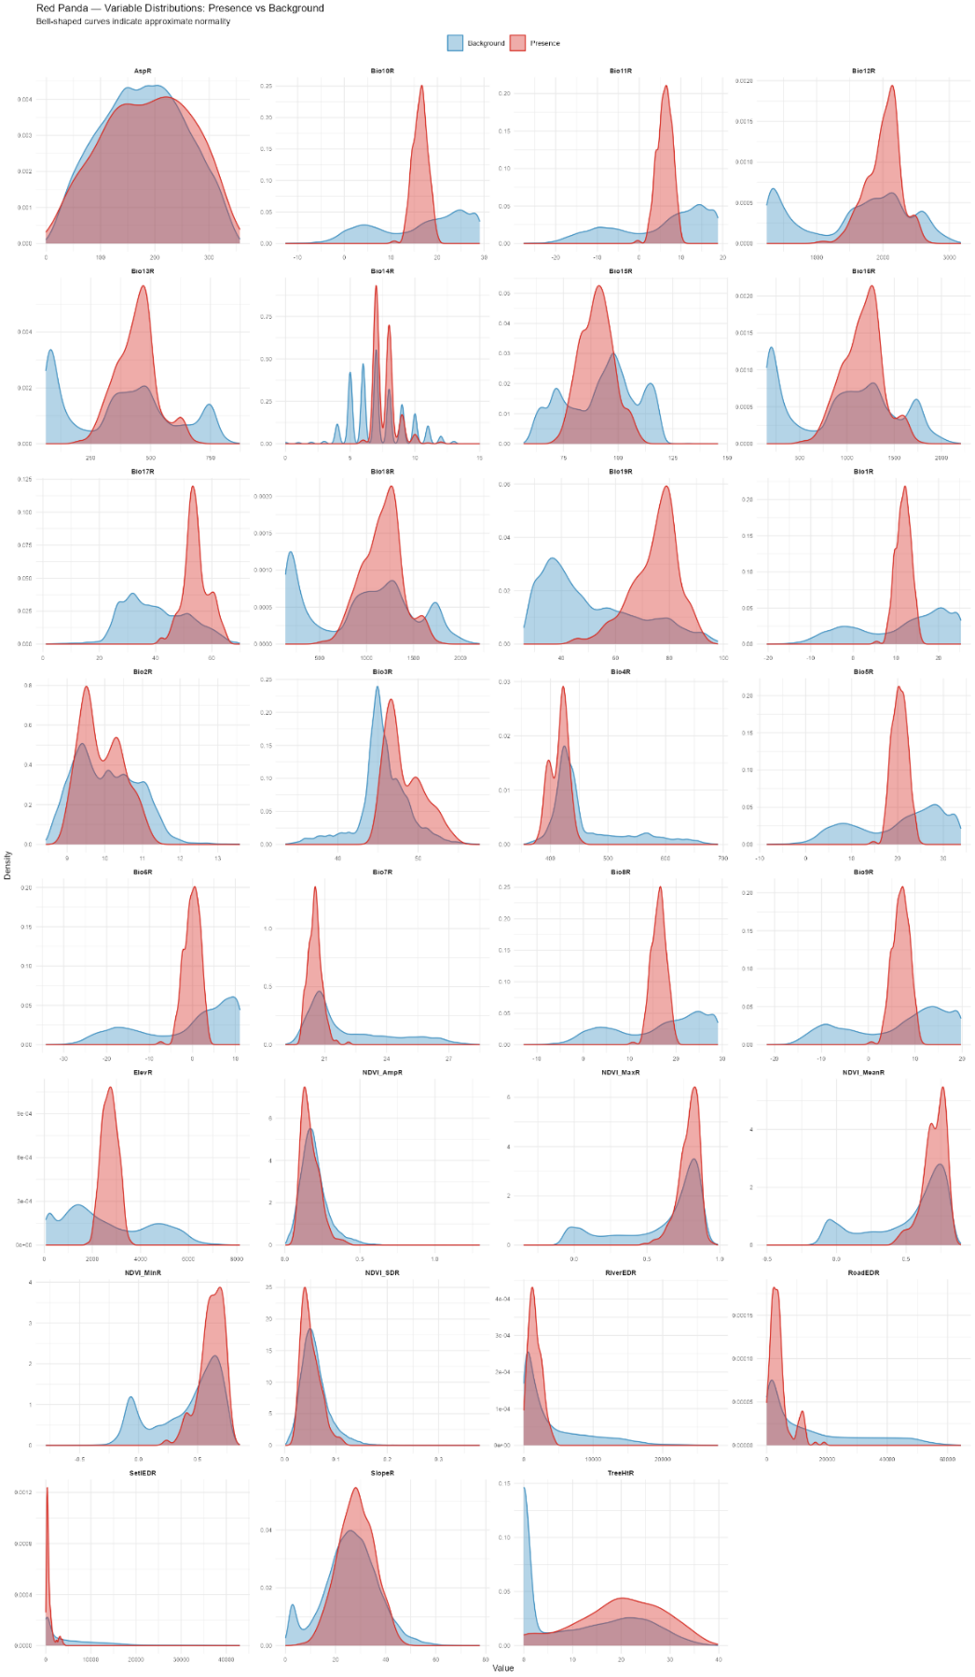
Fig. S1 Density plots comparing the distributions of 31 environmental predictor variables between red panda presence cells (n = 342, red) and background cells (n = 43,890, blue) across the study extent in the PIT region

Fig. S2 Boxplots comparing the distribution of 31 environmental predictor variables between Red Panda presence cells (n = 342) and background cells (n = 43,890) across the study extent in the PIT region.

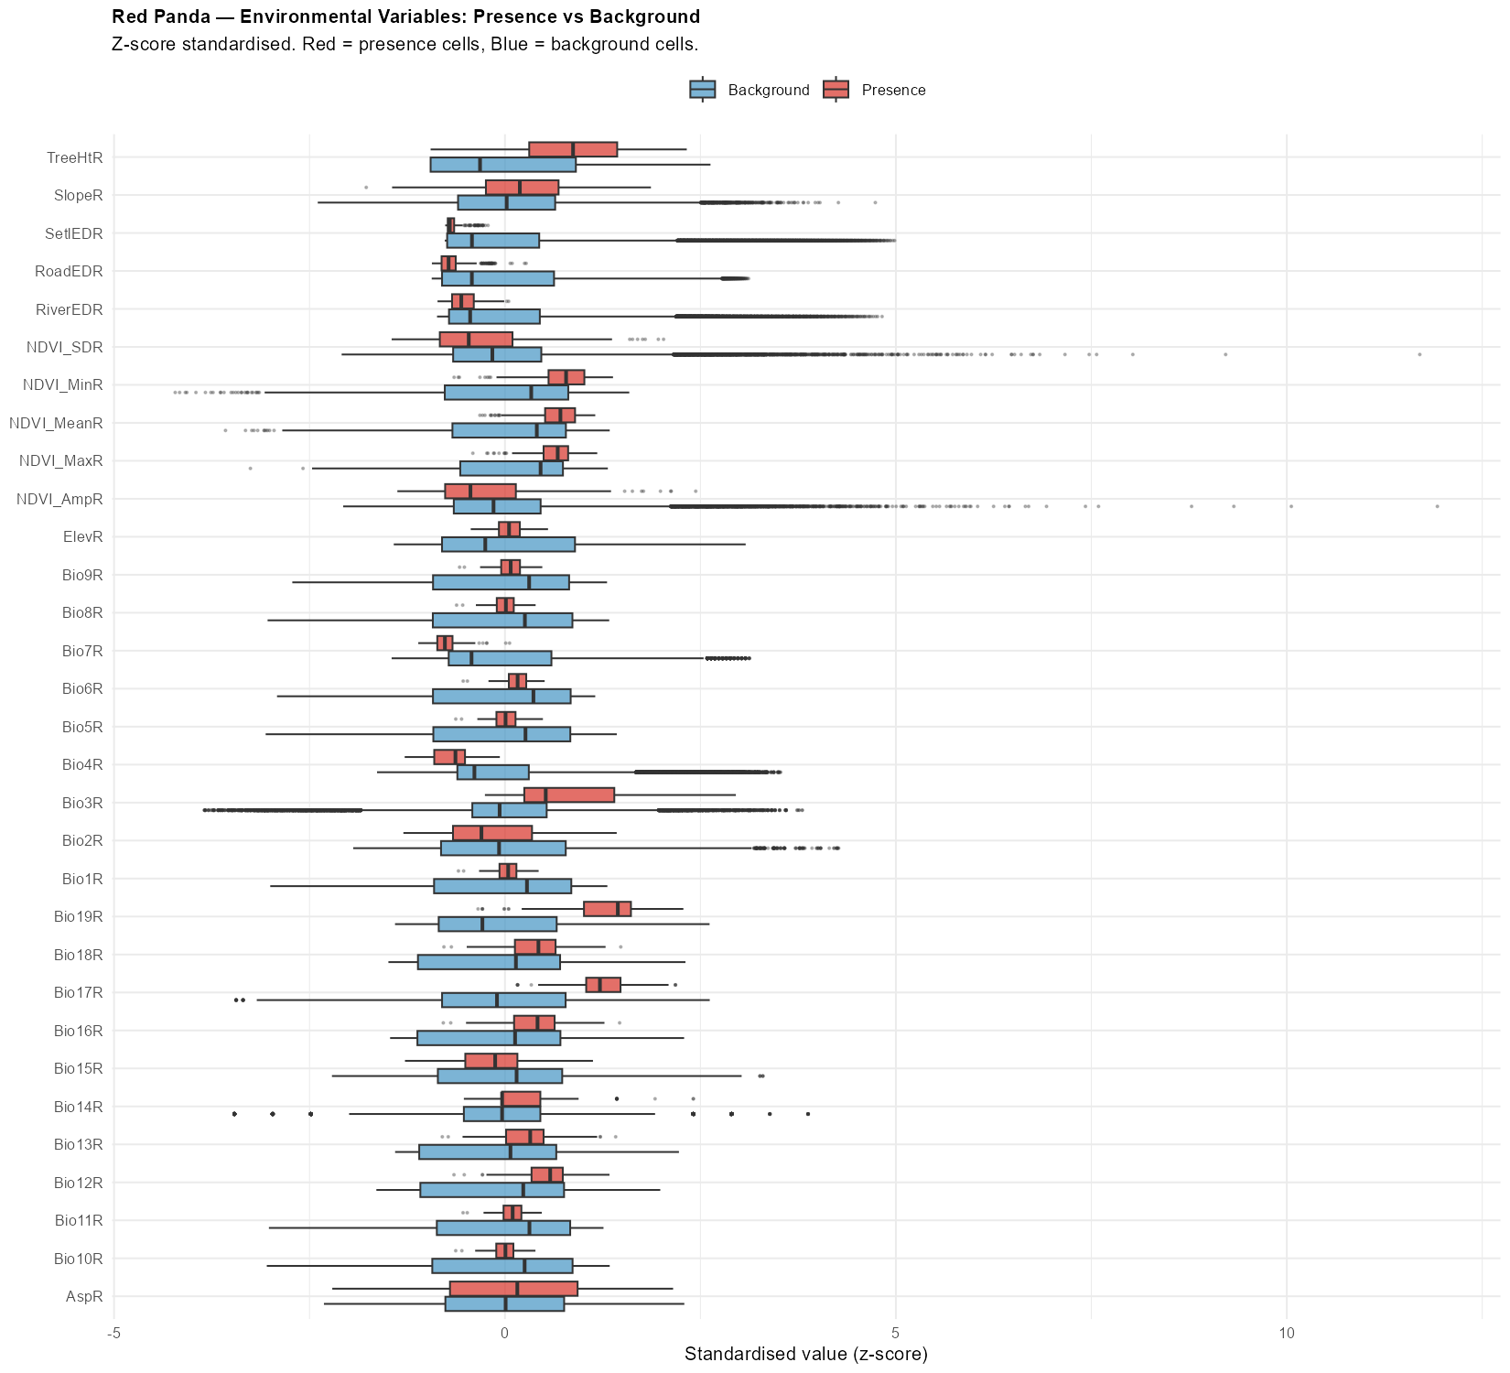

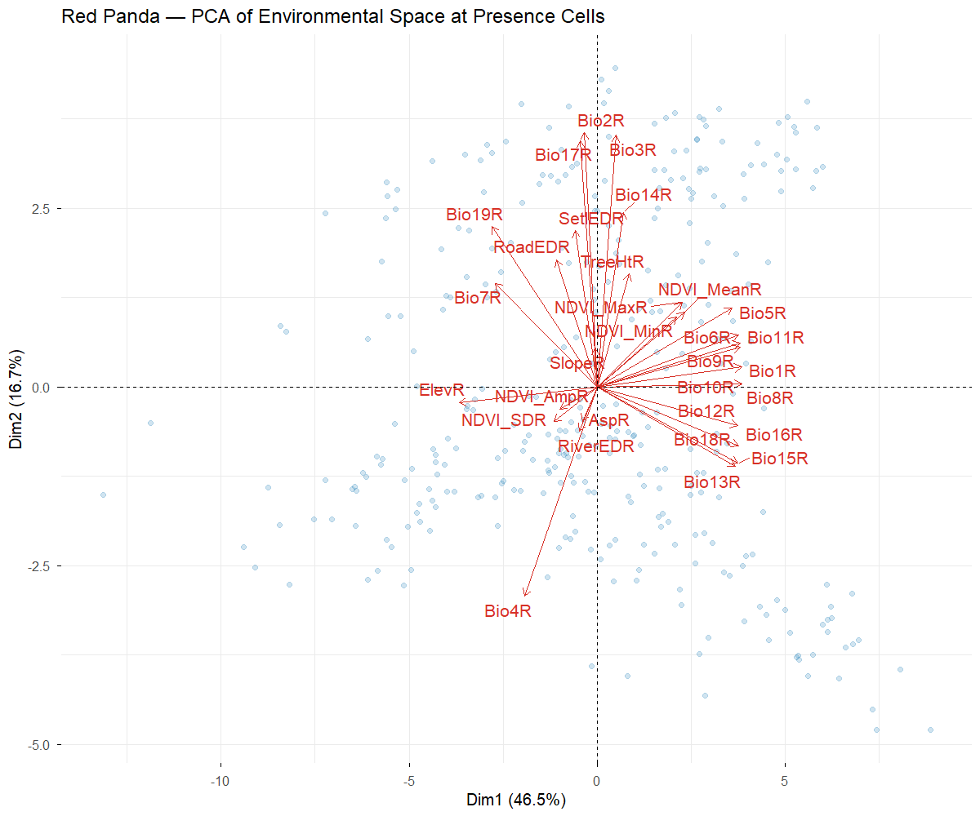
Fig. S3 Principal component analysis (PCA) biplot of 31 environmental predictor variables extracted at Red Panda presence cells (n = 342) across the study extent in the PIT Region
Table S3 Variance Inflation Factor (VIF) values for the selected environmental predictor variables retained after iterative Spearman’s correlation-based variable selection. A threshold of VIF<10 was applied to identify problematic multicollinearity. All multicollinearity in the final predictor set used for MaxEnt habitat suitability modelling. Bio3 = isothermality; Bio6 = minimum temperature of coldest month; Bio19 = precipitation of coldest quarter; NDVI = Normalized Difference Vegetation Index (Mean = mean annual NDVI, SD = standard deviation of NDVI)
Variable | VIF
Bio3 | 7.57
Bio6 | 8.13
Bio19 | 4.64
NDVI_Mean | 1.69
NDVI_SD | 1.42
Slope | 1.14
Distance to Settlements | 1.53
Distance to Water Sources | 1.10
Distance to Roads | 1.68
Tree Height | 1.25
Table S4 Model tuning results for MaxEnt habitat suitability modelling of red panda across combinations of feature classes (L = Linear, Q = Quadratic, H = Hinge, LQ = Linear-Quadratic, LH = Linear-Hinge, QH = Quadratic-Hinge, LQH = Linear-Quadratic-Hinge) and regularization multipliers (0.5, 1, 2, 3, 4, 5). Model performance was assessed using the Akaike Information Criterion corrected for small sample sizes (AICc), delta AICc (∆AICc), training AUC, and the mean and standard deviation of validation AUC across cross-validation folds. The optimal model configuration was selected based on the lowest AICc value (∆AICc = 0), corresponding to the LQ feature class combination with a regularization multiplier of 0.5 (AICc = 5837.113; training AUC = 0.9688; mean validation AUC = 0.9658). Bold row indicate the best-performing model configuration.
Feature Class | Regularization Multiplier | AICc | ∆AICc | AUC (train) | AUC  (Val. Avg.) | AUC  (Val. SD) | Remarks
L | 0.5 | 6019.07 | 181.95 | 0.96 | 0.95 | 0.01
Q | 0.5 | 5965.66 | 128.55 | 0.96 | 0.96 | 0.01
H | 0.5 | 6033.73 | 196.62 | 0.98 | 0.97 | 0.01
LQ | 0.5 | 5837.11 | 0.00 | 0.97 | 0.97 | 0.01 | Best
LH | 0.5 | 6021.40 | 184.29 | 0.98 | 0.97 | 0.01
QH | 0.5 | 6043.25 | 206.13 | 0.98 | 0.97 | 0.01
LQH | 0.5 | 6067.44 | 230.33 | 0.98 | 0.97 | 0.01
L | 1 | 6027.49 | 190.37 | 0.96 | 0.95 | 0.01
Q | 1 | 5994.84 | 157.73 | 0.96 | 0.96 | 0.01
H | 1 | 5988.04 | 150.93 | 0.98 | 0.97 | 0.01
LQ | 1 | 5873.69 | 36.58 | 0.97 | 0.96 | 0.01
LH | 1 | 5987.99 | 150.87 | 0.98 | 0.97 | 0.01
QH | 1 | 5956.37 | 119.26 | 0.98 | 0.97 | 0.01
LQH | 1 | 5946.94 | 109.83 | 0.98 | 0.97 | 0.01
L | 2 | 6027.60 | 190.49 | 0.96 | 0.95 | 0.01
Q | 2 | 6044.44 | 207.33 | 0.96 | 0.95 | 0.01
H | 2 | 5926.01 | 88.90 | 0.97 | 0.97 | 0.01
LQ | 2 | 5921.31 | 84.19 | 0.96 | 0.96 | 0.01
LH | 2 | 5929.19 | 92.08 | 0.97 | 0.97 | 0.01
QH | 2 | 5910.04 | 72.92 | 0.97 | 0.97 | 0.01
LQH | 2 | 5925.04 | 87.92 | 0.97 | 0.97 | 0.01
L | 3 | 6033.44 | 196.33 | 0.95 | 0.95 | 0.01
Q | 3 | 6093.63 | 256.52 | 0.95 | 0.95 | 0.01
H | 3 | 5963.11 | 126.00 | 0.97 | 0.97 | 0.01
LQ | 3 | 5961.65 | 124.54 | 0.96 | 0.96 | 0.01
LH | 3 | 5928.51 | 91.40 | 0.97 | 0.97 | 0.01
QH | 3 | 5946.11 | 109.00 | 0.97 | 0.97 | 0.01
LQH | 3 | 5905.79 | 68.68 | 0.97 | 0.97 | 0.01
L | 4 | 6041.13 | 204.02 | 0.95 | 0.95 | 0.01
Q | 4 | 6136.63 | 299.51 | 0.95 | 0.95 | 0.01
H | 4 | 5948.04 | 110.92 | 0.97 | 0.97 | 0.01
LQ | 4 | 6002.74 | 165.63 | 0.96 | 0.96 | 0.01
LH | 4 | 5937.37 | 100.26 | 0.97 | 0.97 | 0.01
QH | 4 | 5968.14 | 131.03 | 0.97 | 0.97 | 0.01
LQH | 4 | 5936.29 | 99.18 | 0.97 | 0.97 | 0.01
L | 5 | 6049.67 | 212.56 | 0.95 | 0.95 | 0.01
Q | 5 | 6174.23 | 337.12 | 0.95 | 0.95 | 0.01
H | 5 | 5966.27 | 129.16 | 0.97 | 0.97 | 0.01
LQ | 5 | 6041.40 | 204.29 | 0.95 | 0.95 | 0.01
LH | 5 | 5929.93 | 92.82 | 0.97 | 0.97 | 0.01
QH | 5 | 5953.57 | 116.45 | 0.97 | 0.97 | 0.01
LQH | 5 | 5929.92 | 92.81 | 0.97 | 0.97 | 0.01

Table S5 Total area in sq. km and percentage of total suitable habitat within the protected area and each district within the PIT region.
Area/district | Area (km²) | Percentage of total suitable habitat
Kangchenjungha Conservation Area (KCA) | 260.65 | 78.78%
Outside protected area | 967.68 | 21.22%
Taplejung district | 823.38 | 67.03%
Panchthar district | 282.57 | 23.01%
Ilam district | 122.38 | 9.96%

Table S6 Pairwise comparison of landscape metrics between current and future climate scenarios (SSP2-4.5 and SSP5-8.5 for 2050 and 2070) for red panda habitat patches. Metrics include the Largest Patch Index (LPI), Edge Density (ED), Aggregation Index (AI), and Division Index (DIVISION). Statistical differences between scenarios were assessed using the Wilcoxon rank-sum test, with effect size estimated using Pearson’s r. Significant codes: *** p < 0.001, ** p < 0.01, ns = not significant. Delta values represent the absolute difference between current and future scenario means; percentage change is relative to the current scenario mean. Effect size interpretation follows Cohen (1977): negligible (|r| < 0.1), small (0.1 ≤ |r| < 0.3), medium (0.3 ≤ |r| <0.5), large (|r| ≥ 0.5). SSP = Shared Socioeconomic Pathway; LPI = proportion of the landscape occupied by the largest patch (%); ED = total edge length per unit area (m/ha); AI = degree of patch aggregation (0-100); DIVISION = probability that two randomly selected cells belong to different patches (0-1). Bold rows represent the landscape metrics that differed significantly relative to the metrics calculated for current climate scenario.
Metric | Comparison | Scen1 (mean) | Scen2 (mean) | Delta | % Change | Direction | P value | Sig | Effect r | Effect Size
LPI | Current vs SSP2-4.5 (2050) | 96.03 | 95.77 | -0.26 | -0.27% | More fragmented | 2.57E-08 | *** | -0.03 | Negligible
LPI | Current vs SSP5-8.5 (2050) | 96.03 | 95.77 | -0.26 | -0.27% | More fragmented | 3.93E-08 | *** | -0.03 | Negligible
LPI | Current vs SSP2-4.5 (2070) | 96.03 | 95.80 | -0.22 | -0.23% | More fragmented | 1.41E-07 | *** | -0.02 | Negligible
LPI | Current vs SSP5-8.5 (2070) | 96.03 | 95.78 | -0.24 | -0.25% | More fragmented | 1.17E-07 | *** | -0.03 | Negligible
ED | Current vs SSP2-4.5 (2050) | 0.98 | 1.04 | 0.06 | 6.08% | More fragmented | 0.0037 | ** | -0.01 | Negligible
ED | Current vs SSP5-8.5 (2050) | 0.98 | 1.05 | 0.08 | 7.91% | More fragmented | 1.23E-05 | *** | -0.02 | Negligible
ED | Current vs SSP2-4.5 (2070) | 0.98 | 1.02 | 0.04 | 4.13% | More fragmented | 0.0006 | *** | -0.02 | Negligible
ED | Current vs SSP5-8.5 (2070) | 0.98 | 1.00 | 0.03 | 2.69% | More fragmented | 0.0987 | ns | -0.01 | Negligible
AI | Current vs SSP2-4.5 (2050) | 98.27 | 98.18 | -0.09 | -0.09% | More fragmented | 0.1828 | ns | -0.01 | Negligible
AI | Current vs SSP5-8.5 (2050) | 98.27 | 98.12 | -0.16 | -0.16% | More fragmented | 4.24E-05 | *** | -0.02 | Negligible
AI | Current vs SSP2-4.5 (2070) | 98.27 | 98.29 | 0.02 | 0.02% | Less fragmented | 0.6805 | ns | 0.00 | Negligible
AI | Current vs SSP5-8.5 (2070) | 98.27 | 98.35 | 0.08 | 0.08% | Less fragmented | 0.0035 | ** | -0.01 | Negligible
DIVISION | Current vs SSP2-4.5 (2050) | 0.06 | 0.06 | 0.00 | 6.93% | More fragmented | 4.05E-09 | *** | -0.03 | Negligible
DIVISION | Current vs SSP5-8.5 (2050) | 0.06 | 0.06 | 0.00 | 7.19% | More fragmented | 1.63E-09 | *** | -0.03 | Negligible
DIVISION | Current vs SSP2-4.5 (2070) | 0.06 | 0.06 | 0.00 | 6.76% | More fragmented | 7.39E-12 | *** | -0.03 | Negligible
DIVISION | Current vs SSP5-8.5 (2070) | 0.06 | 0.06 | 0.00 | 7.19% | More fragmented | 1.75E-11 | *** | -0.03 | Negligible

