Supplement file

Table S1. The definition of physical, psychological and cognitive disorder
Table S2. The definition of drinking and smoking status
Table S3. Association between physical-psychological-cognitive multimorbidity status and falls using GEE-logit models
Table S4. Baseline characteristics of participants after excluding baseline
Table S5. Association between physical-psychological-cognitive multimorbidity status and falls after excluding baseline fallers
Table S6. Lagged association between physical-psychological-cognitive multimorbidity status and subsequent falls
Table S7. Associations between the number of physical-psychological-cognitive multimorbidity and falls

Figure S1. Association between physical morbidity and falls stratified by different factors.
Figure S2. Association between psychological morbidity and falls stratified by different factors.
Figure S3. Association between cognitive morbidity and falls stratified by different factors
Figure S4. Association between physical and psychological morbidity and falls stratified by different factors
Figure S5. Association between physical and cognitive morbidity and falls stratified by different factors
Figure S6. Association between psychological and cognitive morbidity and falls stratified by different factors

Table S1. The definition of physical, psychological and cognitive disorder
 |  | HRS  (2010-2018) | ELSA  (2014-2018) | CHARLS  (2011-2018) | MHAS  (2012-2018)
Physical disorder | Yes | hypertension, diabetes, stroke, heart problem, arthritis, lung disease, cancer
 | No | Did not report above mentioned physical chronic condition.
Psychological disorder | Yes | A CESD-8 score of greater than 3^{[1]} | A CESD-8 score of greater than 3 | Total CES-D10 score>=10^{[2,3]} | MHAS screening questionnaire total score of ≥5 points ^{[4]}
 | No | <4 | <4 | <10 | <5
Cognitive disorder | Yes | The Harmonized Cognitive Assessment Protocol (HCAP) of 10 or below^{[5]} | A TICS score of 11 or less ^{[6]} | A TICS score of 11 or less ^{[7]} | CCCE (Cross-Cultural Cognitive Examination) 1.5 SD below the mean of sum score
 | No | Otherwise | Otherwise | Otherwise | Otherwise

Table S2. The definition of drinking and smoking status.
Dataset | Drinking | Smoking
HRS | Whether the respondent has ever consumed alcoholic beverages. | Whether the respondent currently smokes.
MHAS | Whether the respondent has ever consumed alcoholic beverages. | Whether the respondent currently smokes.
CHARLS | Whether the respondent has consumed alcoholic beverages in the past. | Whether the respondent currently smokes, only asked if they report ever smoking.
ELSA | Whether the respondent ever drinks any alcohol. | Whether the respondent currently smokes.

Table S3. Association between physical-psychological-cognitive multimorbidity status and falls using GEE-logit models
 | Multimorbidity status | Model 1 OR (95% CI) | Model 2 OR (95% CI) | Model 3 OR (95% CI) | Model 4 OR (95% CI) | Model 5 OR (95% CI)
CHARLS (n = 7,686) | None | 1.00 (ref) | 1.00 (ref) | 1.00 (ref) | 1.00 (ref) | 1.00 (ref)
 | Phy | 1.22 (1.02, 1.47) | 1.17 (0.97, 1.41) | 1.17 (0.97, 1.42) | 1.19 (0.99, 1.44) | 1.05 (0.87, 1.27)
 | Psy | 1.28 (0.91, 1.80) | 1.24 (0.88, 1.74) | 1.21 (0.86, 1.70) | 1.20 (0.86, 1.69) | 1.07 (0.76, 1.50)
 | Cog | 1.15 (0.87, 1.52) | 1.06 (0.80, 1.41) | 1.03 (0.78, 1.37) | 1.03 (0.78, 1.37) | 1.01 (0.76, 1.35)
 | Phy + Psy | 2.25 (1.84, 2.74) | 2.09 (1.71, 2.56) | 2.07 (1.69, 2.53) | 2.10 (1.72, 2.57) | 1.52 (1.23, 1.88)
 | Phy + Cog | 1.54 (1.25, 1.91) | 1.35 (1.09, 1.67) | 1.32 (1.07, 1.64) | 1.34 (1.08, 1.66) | 1.13 (0.91, 1.41)
 | Psy + Cog | 2.16 (1.58, 2.95) | 1.92 (1.40, 2.63) | 1.86 (1.36, 2.54) | 1.86 (1.36, 2.55) | 1.48 (1.07, 2.04)
 | Phy + Psy + Cog | 2.54 (2.07, 3.11) | 2.20 (1.79, 2.70) | 2.12 (1.72, 2.61) | 2.15 (1.75, 2.65) | 1.46 (1.17, 1.82)
HRS (n = 14,392) | None | 1.00 (ref) | 1.00 (ref) | 1.00 (ref) | 1.00 (ref) | 1.00 (ref)
 | Phy | 1.60 (1.44, 1.78) | 1.45 (1.30, 1.61) | 1.45 (1.30, 1.61) | 1.41 (1.27, 1.57) | 1.19 (1.06, 1.32)
 | Psy | 1.33 (0.90, 1.98) | 1.27 (0.86, 1.89) | 1.28 (0.86, 1.90) | 1.25 (0.85, 1.85) | 1.03 (0.70, 1.53)
 | Cog | 0.88 (0.68, 1.13) | 0.75 (0.58, 0.96) | 0.76 (0.59, 0.97) | 0.75 (0.58, 0.96) | 0.70 (0.54, 0.90)
 | Phy + Psy | 2.64 (2.34, 2.99) | 2.37 (2.10, 2.69) | 2.39 (2.11, 2.70) | 2.31 (2.04, 2.61) | 1.55 (1.36, 1.77)
 | Phy + Cog | 1.98 (1.76, 2.22) | 1.60 (1.43, 1.80) | 1.63 (1.45, 1.84) | 1.58 (1.41, 1.78) | 1.26 (1.11, 1.42)
 | Psy + Cog | 2.36 (1.54, 3.62) | 2.02 (1.31, 3.12) | 2.07 (1.34, 3.20) | 2.03 (1.31, 3.14) | 1.55 (0.98, 2.45)
 | Phy + Psy + Cog | 3.51 (3.07, 4.03) | 2.89 (2.52, 3.32) | 2.97 (2.58, 3.42) | 2.86 (2.48, 3.29) | 1.80 (1.55, 2.08)
ELSA (n = 5,547) | None | 1.00 (ref) | 1.00 (ref) | 1.00 (ref) | 1.00 (ref) | 1.00 (ref)
 | Phy | 1.51 (1.32, 1.73) | 1.36 (1.19, 1.55) | 1.35 (1.18, 1.54) | 1.35 (1.18, 1.55) | 1.17 (1.01, 1.34)
 | Psy | 1.62 (1.01, 2.59) | 1.57 (0.97, 2.53) | 1.57 (0.97, 2.55) | 1.55 (0.96, 2.51) | 1.34 (0.84, 2.16)
 | Cog | 1.07 (0.68, 1.70) | 0.89 (0.57, 1.39) | 0.89 (0.56, 1.40) | 0.90 (0.57, 1.42) | 0.89 (0.56, 1.41)
 | Phy + Psy | 2.64 (2.21, 3.16) | 2.23 (1.86, 2.68) | 2.19 (1.82, 2.64) | 2.14 (1.78, 2.58) | 1.45 (1.19, 1.76)
 | Phy + Cog | 2.08 (1.71, 2.53) | 1.58 (1.29, 1.93) | 1.57 (1.28, 1.92) | 1.56 (1.27, 1.91) | 1.28 (1.04, 1.58)
 | Psy + Cog | 3.30 (1.29, 8.45) | 2.78 (1.03, 7.53) | 2.69 (0.98, 7.40) | 2.66 (0.97, 7.29) | 2.13 (0.80, 5.66)
 | Phy + Psy + Cog | 4.76 (3.41, 6.66) | 3.53 (2.50, 4.99) | 3.45 (2.44, 4.88) | 3.38 (2.38, 4.78) | 2.31 (1.61, 3.31)
MHAS (n = 9,894) | None | 1.00 (ref) | 1.00 (ref) | 1.00 (ref) | 1.00 (ref) | 1.00 (ref)
 | Phy | 1.54 (1.40, 1.70) | 1.39 (1.26, 1.53) | 1.38 (1.25, 1.53) | 1.38 (1.25, 1.53) | 1.27 (1.15, 1.41)
 | Psy | 1.58 (1.30, 1.92) | 1.49 (1.23, 1.82) | 1.48 (1.21, 1.80) | 1.49 (1.22, 1.81) | 1.35 (1.11, 1.65)
 | Cog | 1.38 (1.10, 1.73) | 1.24 (0.99, 1.57) | 1.22 (0.97, 1.54) | 1.22 (0.97, 1.54) | 1.21 (0.96, 1.52)
 | Phy + Psy | 2.73 (2.45, 3.03) | 2.32 (2.08, 2.58) | 2.29 (2.05, 2.55) | 2.29 (2.06, 2.56) | 1.84 (1.64, 2.06)
 | Phy + Cog | 1.96 (1.71, 2.25) | 1.60 (1.38, 1.84) | 1.57 (1.36, 1.81) | 1.57 (1.36, 1.82) | 1.41 (1.21, 1.63)
 | Psy + Cog | 2.05 (1.51, 2.79) | 1.80 (1.32, 2.46) | 1.76 (1.29, 2.41) | 1.77 (1.29, 2.41) | 1.59 (1.16, 2.17)
 | Phy + Psy + Cog | 3.33 (2.89, 3.84) | 2.60 (2.24, 3.01) | 2.55 (2.20, 2.96) | 2.56 (2.21, 2.97) | 2.01 (1.73, 2.35)

Table S4. Baseline characteristics of participants after excluding baseline
Variables | CHARLS | HRS | ELSA | MHAS | P value
Participants | 6,175 | 9,365 | 4,086 | 5,468
Age, mean (SD) | 70.2 (5.1) | 72.0 (7.1) | 71.5 (6.3) | 71.0 (6.3) | <0.001
Age group, n (%) |  |  |  |  | <0.001
65-69 | 3,458 (56.0%) | 4,421 (47.2%) | 2,041 (50.0%) | 3,027 (55.4%)
70-74 | 1,507 (24.4%) | 2,024 (21.6%) | 844 (20.7%) | 1,065 (19.5%)
75+ | 1,210 (19.6%) | 2,920 (31.2%) | 1,201 (29.4%) | 1,376 (25.2%)
Sex, n (%) |  |  |  |  | <0.001
Male | 3,608 (58.4%) | 4,039 (43.1%) | 2,039 (49.9%) | 2,860 (52.3%)
Female | 2,567 (41.6%) | 5,326 (56.9%) | 2,047 (50.1%) | 2,608 (47.7%)
Marital status, n (%) |  |  |  |  | <0.001
Married or partnered | 4,800 (77.7%) | 5,529 (59.0%) | 2,943 (72.0%) | 3,595 (65.7%)
Other marital status | 1,375 (22.3%) | 3,836 (41.0%) | 1,143 (28.0%) | 1,873 (34.3%)
Education, n (%) |  |  |  |  | <0.001
Low | 5,617 (91.0%) | 1,851 (19.8%) | 1,142 (27.9%) | 4,796 (87.7%)
Middle | 397 (6.4%) | 5,009 (53.5%) | 2,144 (52.5%) | 144 (2.6%)
High | 161 (2.6%) | 2,505 (26.7%) | 800 (19.6%) | 528 (9.7%)
Currently working, n (%) |  |  |  |  | <0.001
No | 3,340 (54.1%) | 6,909 (73.8%) | 3,436 (84.1%) | 3,795 (69.4%)
Yes | 2,835 (45.9%) | 2,456 (26.2%) | 650 (15.9%) | 1,673 (30.6%)
Wealth quartile, n (%) |  |  |  |  | <0.001
Q1 lowest | 1,001 (16.2%) | 1,701 (18.2%) | 812 (19.9%) | 1,269 (23.2%)
Q2 | 1,875 (30.4%) | 2,227 (23.8%) | 976 (23.9%) | 1,317 (24.1%)
Q3 | 1,663 (26.9%) | 2,617 (27.9%) | 1,114 (27.3%) | 1,382 (25.3%)
Q4 highest | 1,636 (26.5%) | 2,820 (30.1%) | 1,184 (29.0%) | 1,500 (27.4%)
Current smoking, n (%) |  |  |  |  | <0.001
No | 4,278 (69.3%) | 8,413 (89.8%) | 3,751 (91.8%) | 4,902 (89.6%)
Yes | 1,897 (30.7%) | 952 (10.2%) | 335 (8.2%) | 566 (10.4%)
Current drinking, n (%) |  |  |  |  | <0.001
No | 4,101 (66.4%) | 4,467 (47.7%) | 541 (13.2%) | 4,243 (77.6%)
Yes | 2,074 (33.6%) | 4,898 (52.3%) | 3,545 (86.8%) | 1,225 (22.4%)
Self-rated health, n (%) |  |  |  |  | <0.001
Excellent | 530 (8.6%) | 916 (9.8%) | 445 (10.9%) | 135 (2.5%)
Very good | 835 (13.5%) | 3,150 (33.6%) | 1,296 (31.7%) | 232 (4.2%)
Good | 3,256 (52.7%) | 3,238 (34.6%) | 1,431 (35.0%) | 1,606 (29.4%)
Fair | 1,255 (20.3%) | 1,640 (17.5%) | 725 (17.7%) | 2,839 (51.9%)
Poor | 299 (4.8%) | 421 (4.5%) | 189 (4.6%) | 656 (12.0%)
ADL limitation, n (%) |  |  |  |  | <0.001
No | 5,028 (81.4%) | 8,229 (87.9%) | 3,536 (86.5%) | 4,672 (85.4%)
Yes | 1,147 (18.6%) | 1,136 (12.1%) | 550 (13.5%) | 796 (14.6%)
Multimorbidity, n (%) |  |  |  |  | <0.001
None | 856 (13.9%) | 805 (8.6%) | 834 (20.4%) | 1,039 (19.0%)
Phy | 2,128 (34.5%) | 6,206 (66.3%) | 2,606 (63.8%) | 2,603 (47.6%)
Psy | 205 (3.3%) | 37 (0.4%) | 40 (1.0%) | 164 (3.0%)
Cog | 413 (6.7%) | 127 (1.4%) | 48 (1.2%) | 102 (1.9%)
Phy + Psy | 840 (13.6%) | 615 (6.6%) | 276 (6.8%) | 1,021 (18.7%)
Phy + Cog | 839 (13.6%) | 1,302 (13.9%) | 237 (5.8%) | 291 (5.3%)
Psy + Cog | 187 (3.0%) | 14 (0.1%) | 7 (0.2%) | 40 (0.7%)
Phy + Psy + Cog | 707 (11.4%) | 259 (2.8%) | 38 (0.9%) | 208 (3.8%)

Table S5. Association between physical-psychological-cognitive multimorbidity status and falls after excluding baseline fallers
 | Multimorbidity status | Model 1 RR (95% CI) | Model 2 RR (95% CI) | Model 3 RR (95% CI) | Model 4 RR (95% CI) | Model 5 RR (95% CI)
CHARLS (n = 6,175) | None | 1.00 (ref) | 1.00 (ref) | 1.00 (ref) | 1.00 (ref) | 1.00 (ref)
 | Phy | 1.56 (1.02, 2.39) | 1.15 (0.76, 1.75) | 1.15 (0.76, 1.76) | 1.19 (0.78, 1.80) | 1.07 (0.70, 1.64)
 | Psy | 1.35 (0.63, 2.90) | 1.39 (0.66, 2.95) | 1.38 (0.65, 2.93) | 1.37 (0.64, 2.90) | 1.30 (0.62, 2.73)
 | Cog | 1.07 (0.53, 2.14) | 0.87 (0.44, 1.73) | 0.87 (0.44, 1.71) | 0.90 (0.46, 1.78) | 0.93 (0.47, 1.84)
 | Phy + Psy | 2.54 (1.62, 3.98) | 1.85 (1.19, 2.88) | 1.84 (1.18, 2.85) | 1.89 (1.22, 2.93) | 1.46 (0.92, 2.31)
 | Phy + Cog | 2.31 (1.46, 3.65) | 1.44 (0.91, 2.29) | 1.44 (0.91, 2.28) | 1.46 (0.92, 2.30) | 1.27 (0.80, 2.03)
 | Psy + Cog | 1.34 (0.59, 3.08) | 1.35 (0.59, 3.06) | 1.35 (0.59, 3.05) | 1.37 (0.61, 3.11) | 1.16 (0.51, 2.67)
 | Phy + Psy + Cog | 2.75 (1.74, 4.35) | 1.71 (1.08, 2.72) | 1.68 (1.06, 2.67) | 1.70 (1.07, 2.70) | 1.24 (0.77, 2.00)
HRS (n = 9,365) | None | 1.00 (ref) | 1.00 (ref) | 1.00 (ref) | 1.00 (ref) | 1.00 (ref)
 | Phy | 1.63 (1.40, 1.90) | 1.39 (1.20, 1.61) | 1.40 (1.20, 1.62) | 1.36 (1.18, 1.58) | 1.18 (1.02, 1.37)
 | Psy | 1.29 (0.73, 2.30) | 1.24 (0.72, 2.14) | 1.26 (0.73, 2.17) | 1.25 (0.72, 2.16) | 1.10 (0.64, 1.89)
 | Cog | 0.86 (0.59, 1.25) | 0.75 (0.53, 1.07) | 0.77 (0.54, 1.10) | 0.76 (0.53, 1.08) | 0.72 (0.51, 1.02)
 | Phy + Psy | 2.54 (2.16, 3.00) | 2.05 (1.75, 2.41) | 2.08 (1.77, 2.44) | 2.03 (1.72, 2.38) | 1.46 (1.23, 1.72)
 | Phy + Cog | 1.98 (1.69, 2.32) | 1.40 (1.19, 1.64) | 1.45 (1.23, 1.70) | 1.41 (1.20, 1.65) | 1.18 (1.00, 1.38)
 | Psy + Cog | 1.56 (0.88, 2.77) | 1.14 (0.65, 2.00) | 1.19 (0.68, 2.09) | 1.18 (0.67, 2.07) | 0.94 (0.54, 1.64)
 | Phy + Psy + Cog | 2.96 (2.48, 3.53) | 2.04 (1.71, 2.43) | 2.14 (1.79, 2.56) | 2.08 (1.74, 2.48) | 1.44 (1.20, 1.73)
ELSA (n = 4,086) | None | 1.00 (ref) | 1.00 (ref) | 1.00 (ref) | 1.00 (ref) | 1.00 (ref)
 | Phy | 1.51 (1.26, 1.81) | 1.27 (1.05, 1.52) | 1.26 (1.05, 1.52) | 1.26 (1.05, 1.51) | 1.18 (0.98, 1.43)
 | Psy | 1.36 (0.66, 2.79) | 1.57 (0.78, 3.14) | 1.59 (0.79, 3.20) | 1.61 (0.81, 3.23) | 1.50 (0.76, 2.98)
 | Cog | 0.69 (0.30, 1.56) | 0.54 (0.25, 1.16) | 0.53 (0.25, 1.15) | 0.54 (0.25, 1.17) | 0.53 (0.24, 1.16)
 | Phy + Psy | 2.19 (1.72, 2.78) | 1.70 (1.34, 2.17) | 1.69 (1.32, 2.15) | 1.67 (1.31, 2.12) | 1.40 (1.08, 1.80)
 | Phy + Cog | 1.87 (1.44, 2.44) | 1.19 (0.91, 1.56) | 1.18 (0.90, 1.55) | 1.18 (0.90, 1.54) | 1.07 (0.81, 1.41)
 | Psy + Cog | 2.29 (0.73, 7.23) | 2.19 (0.73, 6.57) | 2.18 (0.71, 6.69) | 2.25 (0.73, 6.89) | 2.03 (0.63, 6.55)
 | Phy + Psy + Cog | 2.45 (1.50, 4.00) | 1.39 (0.85, 2.26) | 1.36 (0.83, 2.22) | 1.36 (0.83, 2.23) | 1.10 (0.68, 1.80)
MHAS (n = 5,468) | None | 1.00 (ref) | 1.00 (ref) | 1.00 (ref) | 1.00 (ref) | 1.00 (ref)
 | Phy | 1.50 (1.31, 1.72) | 1.21 (1.06, 1.39) | 1.21 (1.06, 1.39) | 1.21 (1.06, 1.39) | 1.16 (1.01, 1.33)
 | Psy | 1.15 (0.85, 1.55) | 1.09 (0.83, 1.44) | 1.10 (0.83, 1.45) | 1.10 (0.83, 1.45) | 1.05 (0.79, 1.39)
 | Cog | 1.09 (0.75, 1.57) | 0.84 (0.59, 1.20) | 0.85 (0.59, 1.21) | 0.84 (0.59, 1.21) | 0.86 (0.60, 1.23)
 | Phy + Psy | 2.11 (1.83, 2.43) | 1.63 (1.41, 1.87) | 1.63 (1.42, 1.88) | 1.64 (1.42, 1.88) | 1.43 (1.24, 1.66)
 | Phy + Cog | 2.00 (1.67, 2.39) | 1.18 (0.99, 1.41) | 1.19 (0.99, 1.42) | 1.19 (0.99, 1.42) | 1.11 (0.93, 1.33)
 | Psy + Cog | 1.88 (1.29, 2.76) | 1.38 (0.95, 2.02) | 1.40 (0.96, 2.04) | 1.40 (0.96, 2.05) | 1.33 (0.92, 1.92)
 | Phy + Psy + Cog | 2.78 (2.34, 3.29) | 1.59 (1.34, 1.89) | 1.60 (1.34, 1.90) | 1.60 (1.35, 1.91) | 1.40 (1.18, 1.68)

Table S6. Lagged association between physical-psychological-cognitive multimorbidity status and subsequent falls
 | Multimorbidity status | Model 1 RR (95% CI) | Model 2 RR (95% CI) | Model 3 RR (95% CI) | Model 4 RR (95% CI) | Model 5 RR (95% CI)
CHARLS (n = 2,066) | None | 1.00 (ref) | 1.00 (ref) | 1.00 (ref) | 1.00 (ref) | 1.00 (ref)
 | Phy | 1.37 (1.02, 1.83) | 1.34 (1.00, 1.79) | 1.34 (1.00, 1.79) | 1.37 (1.02, 1.83) | 1.26 (0.94, 1.69)
 | Psy | 1.65 (1.04, 2.60) | 1.57 (0.99, 2.49) | 1.56 (0.98, 2.47) | 1.53 (0.96, 2.45) | 1.39 (0.87, 2.24)
 | Cog | 1.28 (0.80, 2.04) | 1.20 (0.75, 1.92) | 1.16 (0.73, 1.86) | 1.15 (0.72, 1.84) | 1.14 (0.71, 1.82)
 | Phy + Psy | 1.87 (1.38, 2.54) | 1.75 (1.29, 2.37) | 1.72 (1.27, 2.33) | 1.75 (1.29, 2.36) | 1.43 (1.04, 1.95)
 | Phy + Cog | 1.87 (1.35, 2.60) | 1.72 (1.23, 2.40) | 1.67 (1.20, 2.33) | 1.70 (1.22, 2.37) | 1.52 (1.09, 2.12)
 | Psy + Cog | 1.79 (0.98, 3.27) | 1.59 (0.87, 2.92) | 1.53 (0.83, 2.82) | 1.52 (0.82, 2.81) | 1.33 (0.71, 2.46)
 | Phy + Psy + Cog | 2.29 (1.65, 3.18) | 2.03 (1.46, 2.82) | 1.96 (1.41, 2.73) | 2.00 (1.44, 2.77) | 1.65 (1.17, 2.31)
HRS (n = 11,643) | None | 1.00 (ref) | 1.00 (ref) | 1.00 (ref) | 1.00 (ref) | 1.00 (ref)
 | Phy | 1.48 (1.34, 1.64) | 1.41 (1.27, 1.56) | 1.41 (1.27, 1.56) | 1.39 (1.25, 1.54) | 1.23 (1.11, 1.36)
 | Psy | 1.54 (1.17, 2.03) | 1.51 (1.15, 1.99) | 1.51 (1.14, 1.99) | 1.50 (1.14, 1.98) | 1.30 (0.99, 1.69)
 | Cog | 1.07 (0.84, 1.35) | 0.96 (0.76, 1.21) | 0.97 (0.77, 1.23) | 0.96 (0.76, 1.21) | 0.93 (0.75, 1.17)
 | Phy + Psy | 2.09 (1.88, 2.33) | 1.98 (1.78, 2.21) | 1.99 (1.78, 2.21) | 1.95 (1.75, 2.18) | 1.47 (1.31, 1.64)
 | Phy + Cog | 1.58 (1.42, 1.76) | 1.40 (1.26, 1.56) | 1.42 (1.28, 1.59) | 1.40 (1.25, 1.56) | 1.19 (1.07, 1.33)
 | Psy + Cog | 1.41 (0.90, 2.21) | 1.29 (0.82, 2.01) | 1.30 (0.83, 2.04) | 1.29 (0.82, 2.02) | 1.04 (0.66, 1.64)
 | Phy + Psy + Cog | 2.36 (2.10, 2.64) | 2.12 (1.90, 2.38) | 2.17 (1.93, 2.43) | 2.12 (1.89, 2.38) | 1.52 (1.35, 1.71)
ELSA (n = 3,898) | None | 1.00 (ref) | 1.00 (ref) | 1.00 (ref) | 1.00 (ref) | 1.00 (ref)
 | Phy | 1.33 (1.17, 1.51) | 1.25 (1.10, 1.42) | 1.23 (1.08, 1.39) | 1.23 (1.08, 1.40) | 1.12 (0.98, 1.28)
 | Psy | 0.78 (0.40, 1.53) | 0.77 (0.39, 1.51) | 0.77 (0.40, 1.51) | 0.77 (0.40, 1.49) | 0.69 (0.36, 1.34)
 | Cog | 1.25 (0.77, 2.02) | 1.12 (0.69, 1.83) | 1.08 (0.66, 1.76) | 1.08 (0.66, 1.76) | 1.06 (0.64, 1.74)
 | Phy + Psy | 1.84 (1.56, 2.18) | 1.64 (1.38, 1.94) | 1.56 (1.32, 1.85) | 1.54 (1.29, 1.82) | 1.20 (1.00, 1.45)
 | Phy + Cog | 1.52 (1.24, 1.87) | 1.29 (1.04, 1.59) | 1.24 (1.00, 1.53) | 1.23 (1.00, 1.52) | 1.09 (0.88, 1.35)
 | Psy + Cog | 1.98 (0.72, 5.46) | 2.04 (0.74, 5.57) | 1.87 (0.71, 4.93) | 1.86 (0.70, 4.90) | 1.57 (0.73, 3.38)
 | Phy + Psy + Cog | 2.26 (1.63, 3.13) | 1.92 (1.38, 2.67) | 1.80 (1.29, 2.50) | 1.78 (1.28, 2.47) | 1.42 (1.03, 1.96)
MHAS (n = 6,920) | None | 1.00 (ref) | 1.00 (ref) | 1.00 (ref) | 1.00 (ref) | 1.00 (ref)
 | Phy | 1.31 (1.21, 1.42) | 1.24 (1.15, 1.34) | 1.24 (1.15, 1.34) | 1.25 (1.15, 1.35) | 1.20 (1.11, 1.30)
 | Psy | 1.33 (1.15, 1.53) | 1.26 (1.10, 1.45) | 1.26 (1.10, 1.45) | 1.26 (1.10, 1.45) | 1.21 (1.05, 1.39)
 | Cog | 1.09 (0.88, 1.35) | 1.02 (0.83, 1.26) | 1.02 (0.83, 1.26) | 1.02 (0.83, 1.26) | 1.02 (0.82, 1.26)
 | Phy + Psy | 1.71 (1.58, 1.85) | 1.54 (1.42, 1.67) | 1.54 (1.42, 1.67) | 1.55 (1.43, 1.68) | 1.41 (1.30, 1.54)
 | Phy + Cog | 1.40 (1.25, 1.57) | 1.24 (1.10, 1.39) | 1.24 (1.10, 1.39) | 1.24 (1.11, 1.39) | 1.19 (1.06, 1.33)
 | Psy + Cog | 1.35 (1.06, 1.72) | 1.25 (0.98, 1.59) | 1.24 (0.97, 1.59) | 1.25 (0.98, 1.60) | 1.19 (0.93, 1.51)
 | Phy + Psy + Cog | 1.80 (1.62, 1.99) | 1.53 (1.38, 1.70) | 1.52 (1.37, 1.69) | 1.53 (1.38, 1.70) | 1.39 (1.25, 1.55)

Table S7. Associations between the number of physical-psychological-cognitive multimorbidity and falls
 | Number of morbidity domains | Model 1 RR (95% CI) | Model 2 RR (95% CI) | Model 3 RR (95% CI) | Model 4 RR (95% CI) | Model 5 RR (95% CI)
CHARLS (n = 7,686) | 0 domains | 1.00 (ref) | 1.00 (ref) | 1.00 (ref) | 1.00 (ref) | 1.00 (ref)
 | 1 domain | 1.21 (1.03-1.42) | 1.17 (1.00-1.37) | 1.16 (0.99-1.36) | 1.17 (1.00-1.37) | 1.06 (0.90-1.24)
 | 2 domains | 1.76 (1.51-2.06) | 1.62 (1.39-1.90) | 1.61 (1.37-1.88) | 1.62 (1.38-1.90) | 1.29 (1.10-1.52)
 | 3 domains | 2.17 (1.84-2.56) | 1.93 (1.63-2.29) | 1.88 (1.59-2.23) | 1.90 (1.61-2.26) | 1.35 (1.13-1.62)
HRS (n = 14,392) | 0 domains | 1.00 (ref) | 1.00 (ref) | 1.00 (ref) | 1.00 (ref) | 1.00 (ref)
 | 1 domain | 1.43 (1.31-1.56) | 1.36 (1.25-1.49) | 1.37 (1.25-1.50) | 1.34 (1.23-1.47) | 1.16 (1.06-1.27)
 | 2 domains | 1.83 (1.67-2.00) | 1.66 (1.52-1.82) | 1.71 (1.56-1.87) | 1.66 (1.52-1.82) | 1.27 (1.16-1.40)
 | 3 domains | 2.46 (2.23-2.71) | 2.21 (2.00-2.44) | 2.32 (2.10-2.56) | 2.24 (2.03-2.48) | 1.47 (1.33-1.62)
ELSA (n = 5,547) | 0 domains | 1.00 (ref) | 1.00 (ref) | 1.00 (ref) | 1.00 (ref) | 1.00 (ref)
 | 1 domain | 1.36 (1.22-1.52) | 1.27 (1.14-1.42) | 1.26 (1.13-1.41) | 1.26 (1.13-1.41) | 1.13 (1.01-1.26)
 | 2 domains | 1.93 (1.71-2.17) | 1.65 (1.46-1.87) | 1.63 (1.44-1.84) | 1.61 (1.42-1.82) | 1.25 (1.10-1.43)
 | 3 domains | 2.89 (2.43-3.44) | 2.31 (1.93-2.77) | 2.27 (1.90-2.72) | 2.24 (1.86-2.68) | 1.61 (1.34-1.95)
MHAS (n = 9,894) | 0 domains | 1.00 (ref) | 1.00 (ref) | 1.00 (ref) | 1.00 (ref) | 1.00 (ref)
 | 1 domain | 1.33 (1.25-1.42) | 1.26 (1.18-1.34) | 1.25 (1.17-1.34) | 1.25 (1.17-1.34) | 1.19 (1.12-1.27)
 | 2 domains | 1.76 (1.65-1.88) | 1.59 (1.49-1.70) | 1.58 (1.48-1.69) | 1.58 (1.48-1.69) | 1.40 (1.31-1.50)
 | 3 domains | 1.99 (1.85-2.15) | 1.73 (1.60-1.87) | 1.71 (1.58-1.85) | 1.71 (1.59-1.85) | 1.47 (1.36-1.60)

Figure

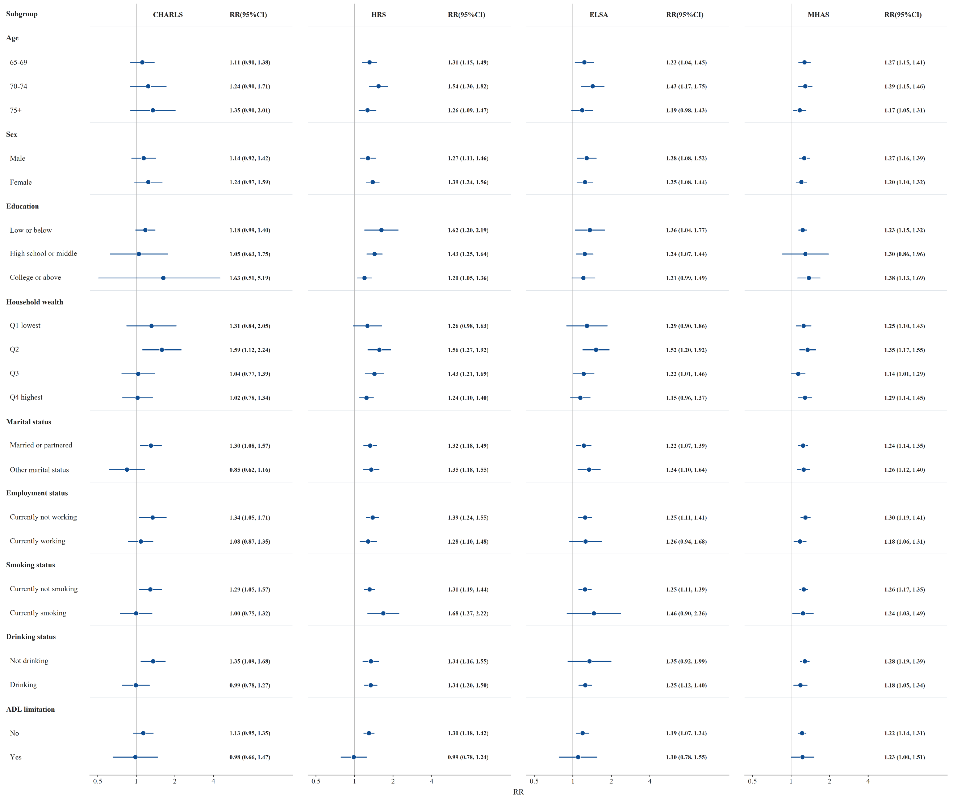
Figure S1. Association between physical morbidity and falls stratified by different factors.

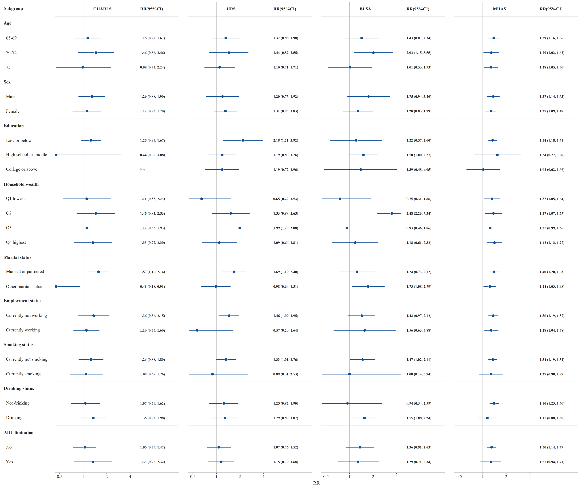
Figure S2. Association between psychological morbidity and falls stratified by different factors.

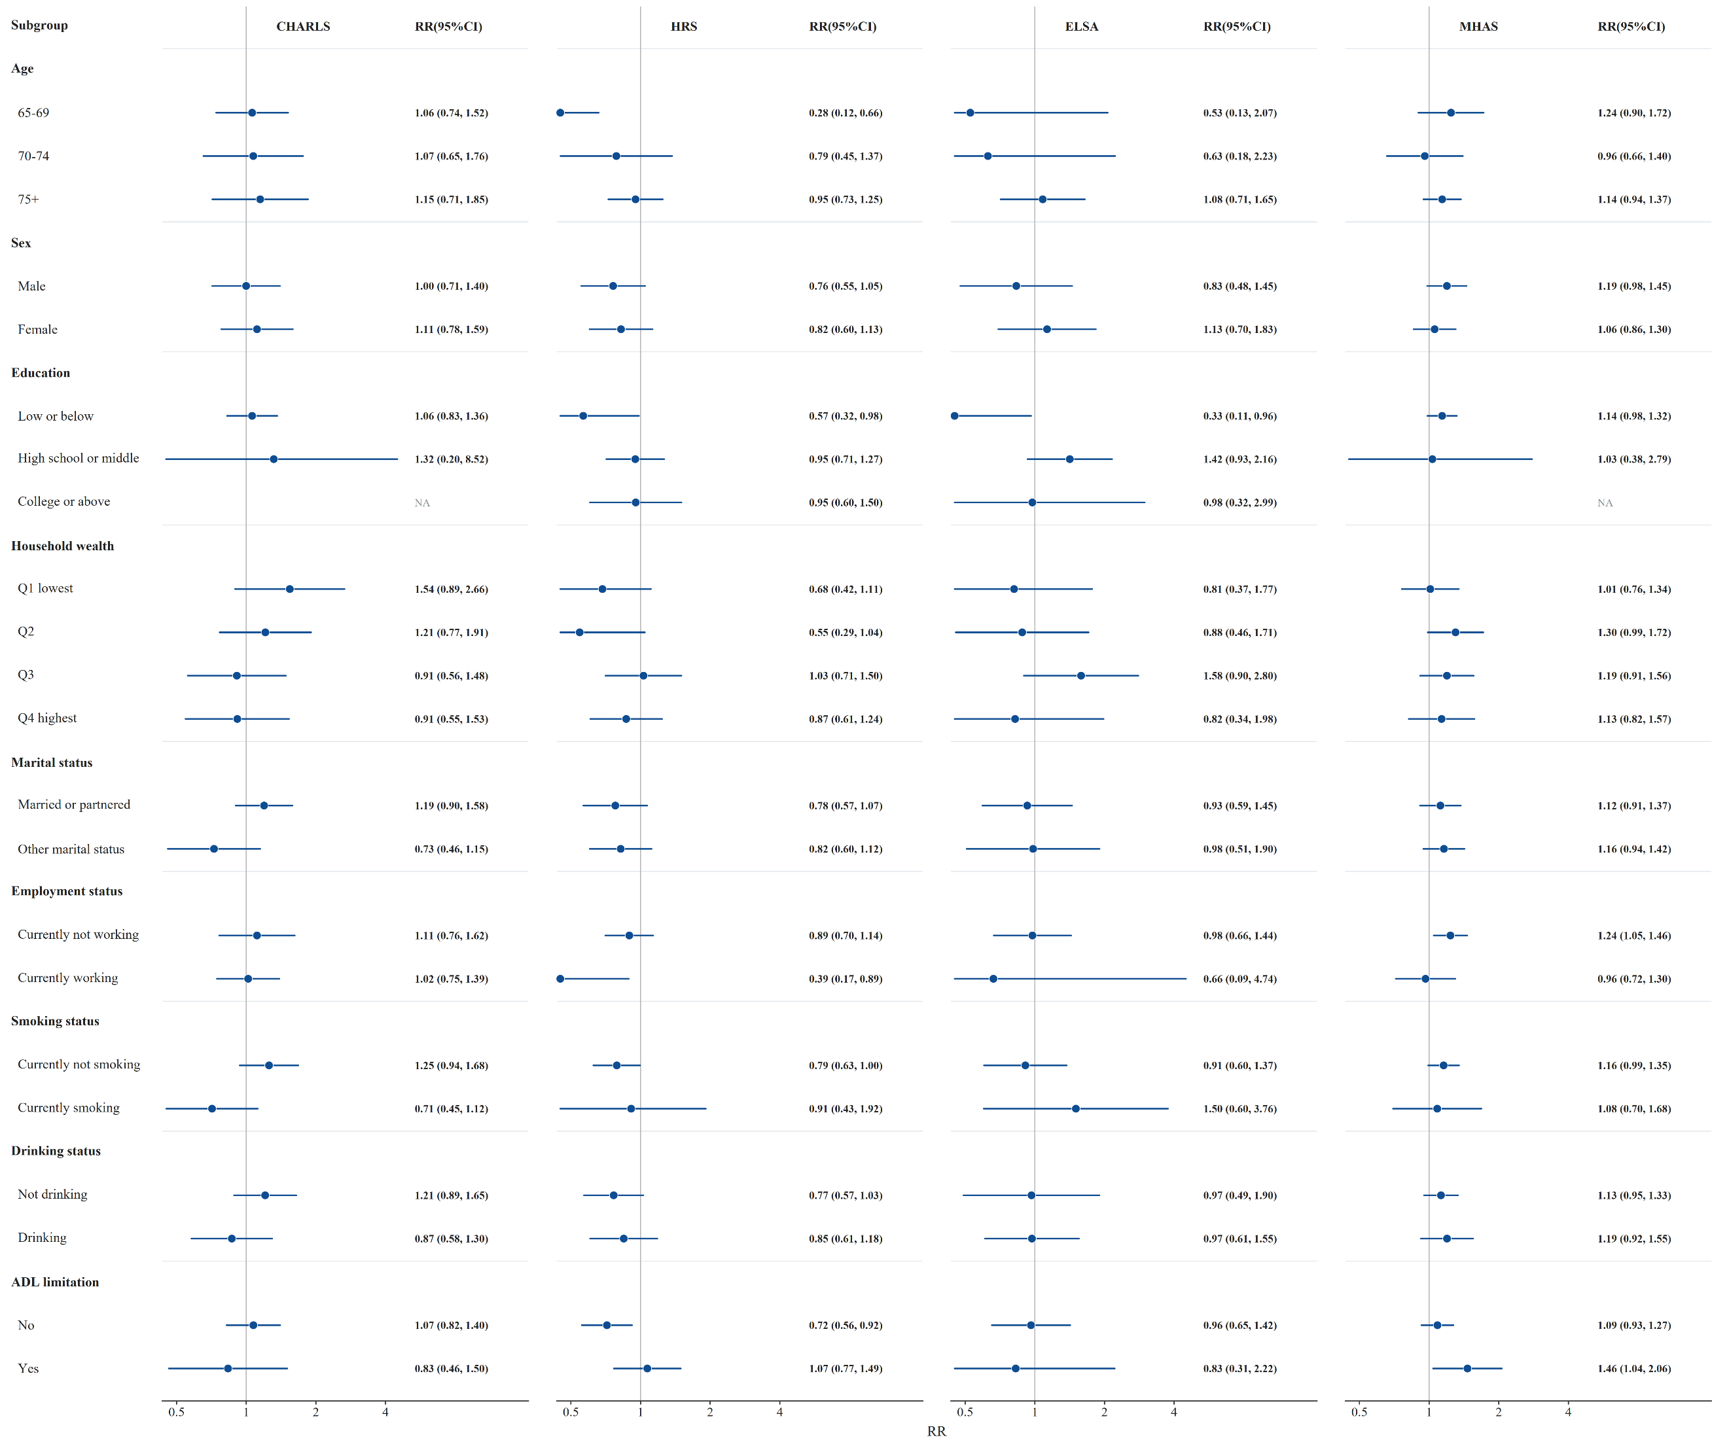
Figure S3. Association between cognitive morbidity and falls stratified by different factors

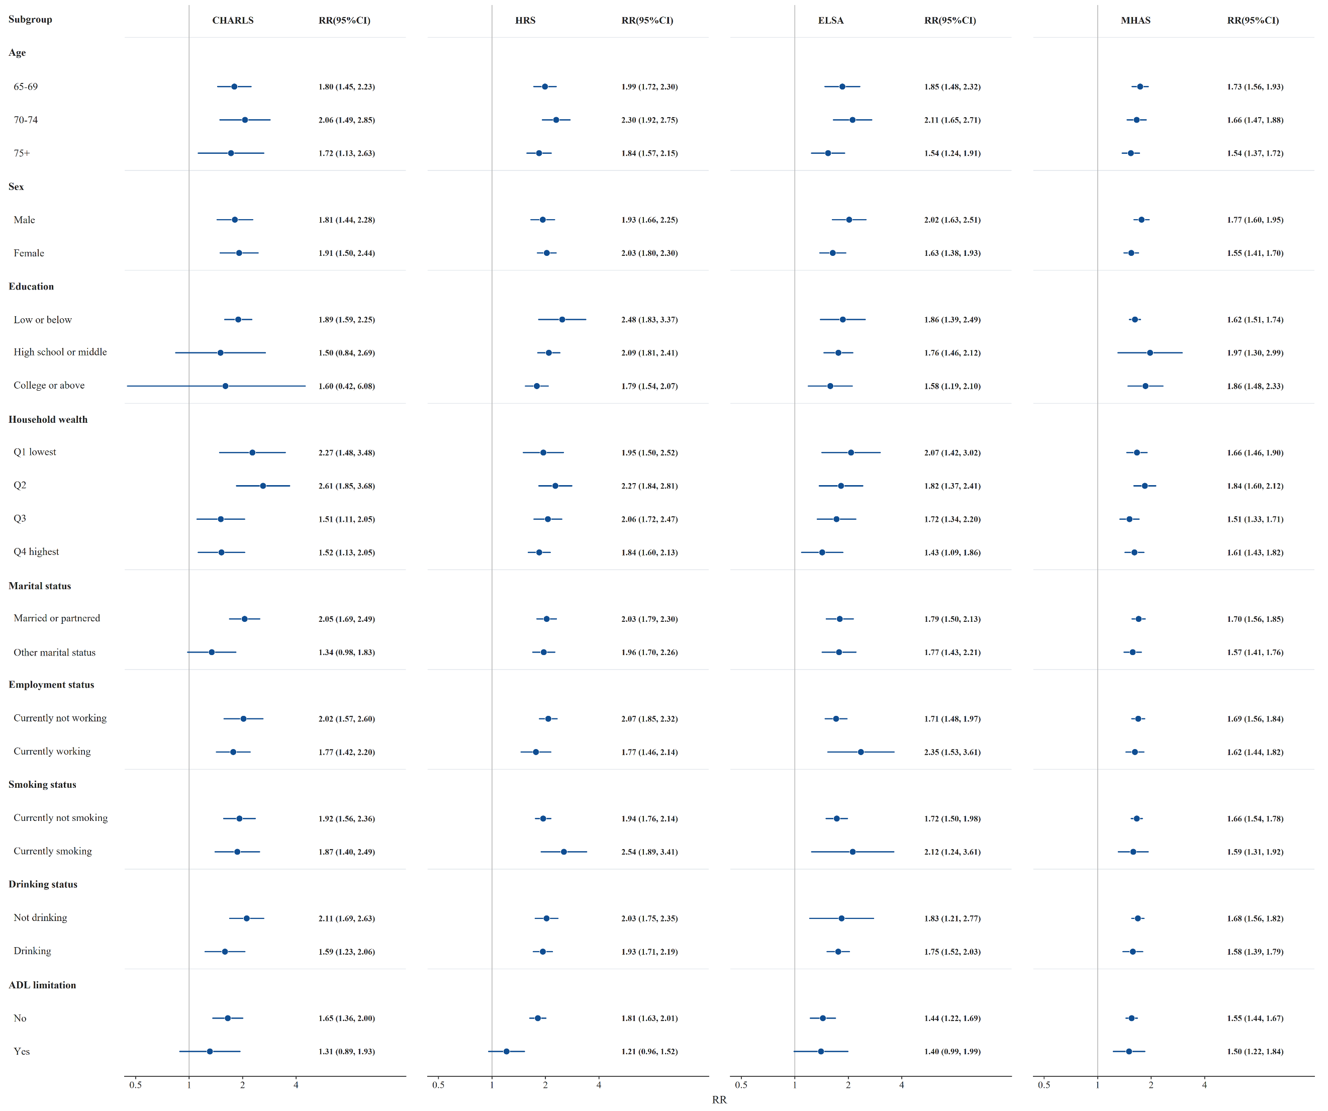
Figure S4. Association between physical and psychological morbidity and falls stratified by different factors

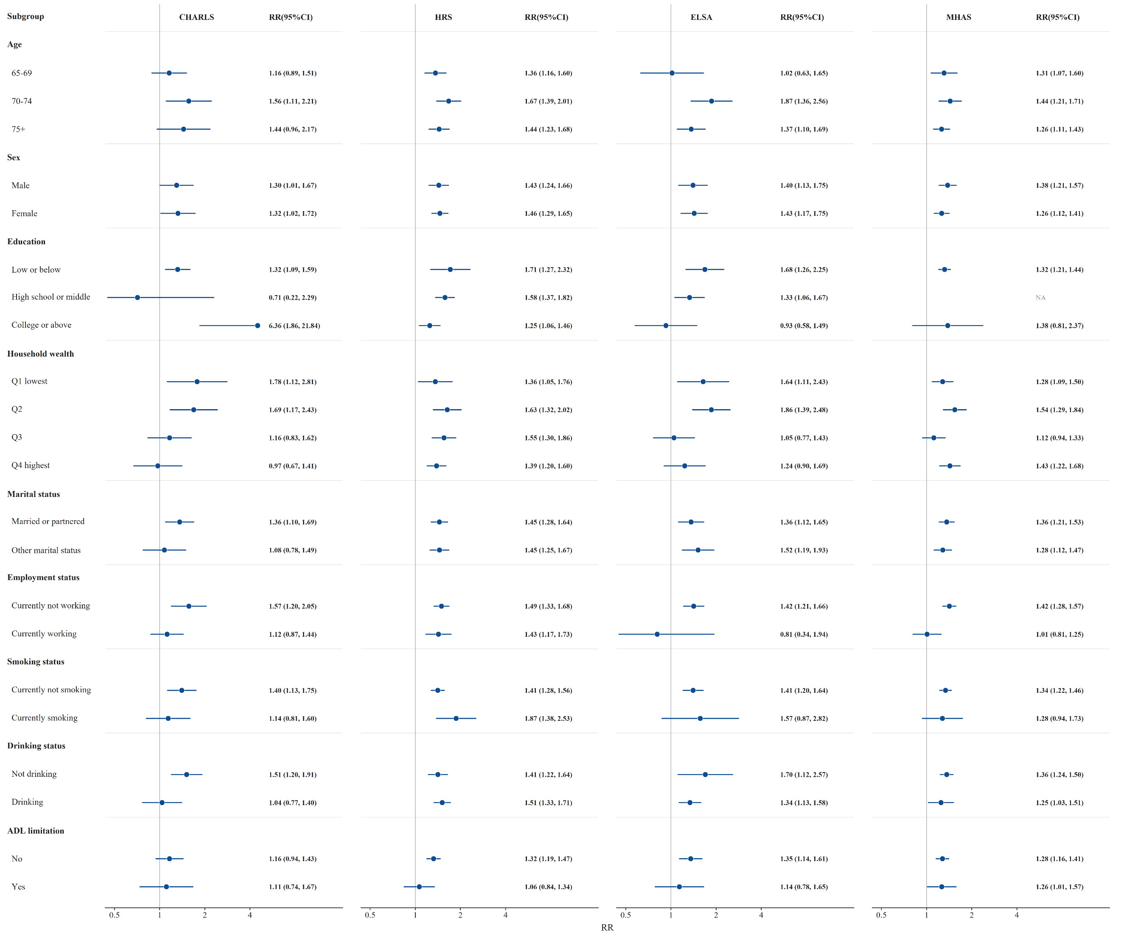
Figure S5. Association between physical and cognitive morbidity and falls stratified by different factors

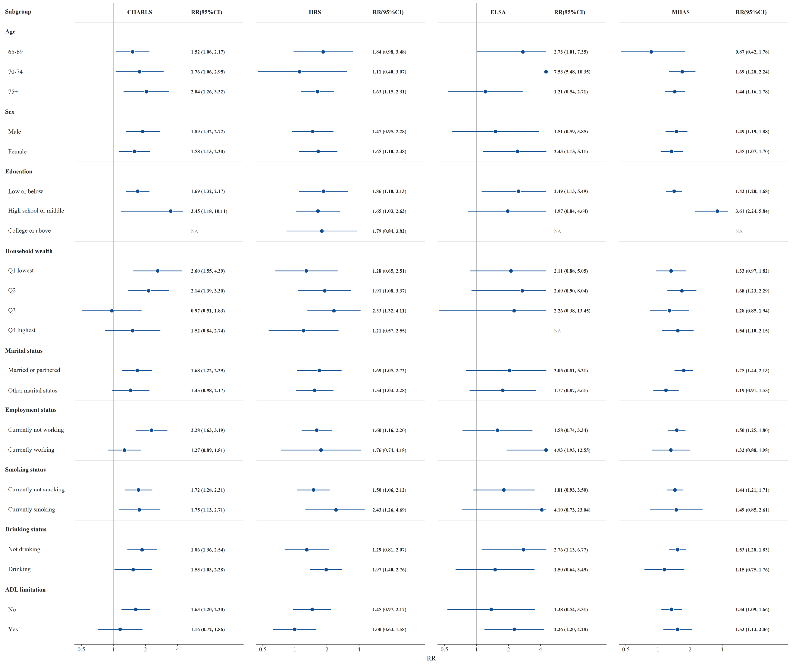
Figure S6. Association between psychological and cognitive morbidity and falls stratified by different factors

Reference
[1] Kozlov E, Dong X, Kelley A S, et al. The Epidemiology of Depressive Symptoms in the Last Year of Life[J]. Journal of the American Geriatrics Society, 2020, 68(2): 321-328.
[2] Yang X, Pan A, Gong J, et al. Prospective associations between depressive symptoms and cognitive functions in middle-aged and elderly Chinese adults[J]. Journal of Affective Disorders, 2020, 263: 692-697.
[3] Zhou L, Ma X, Wang W. Relationship between Cognitive Performance and Depressive Symptoms in Chinese Older Adults: The China Health and Retirement Longitudinal Study (CHARLS)[J]. Journal of Affective Disorders, 2021, 281: 454-458.
[4] Castellanos-Perilla N, Borda M G, Fernández-Quilez Á, et al. Factors associated with functional loss among community-dwelling Mexican older adults[J]. Biomédica, 2020, 40(3): 546-556.
[5] Sutin A R, Luchetti M, Stephan Y, et al. Meaning in Life and Risk of Cognitive Impairment: A 9-Year Prospective Study in 14 Countries[J]. Archives of gerontology and geriatrics, 2020, 88: 104033.
[6] Williams B D, Pendleton N, Chandola T. Cognitively stimulating activities and risk of probable dementia or cognitive impairment in the English Longitudinal Study of Ageing[J]. SSM - Population Health, 2020, 12: 100656.
[7] Zhou S, Song S, Jin Y, et al. Prospective association between social engagement and cognitive impairment among middle-aged and older adults: evidence from the China Health and Retirement Longitudinal Study[J]. BMJ Open, 2020, 10(11): e040936.

