Supplementary Information
Mapping Muscle Stiffness: Shear-Wave Elastography Endovaginal Ultrasound of the Puborectalis in Defecation Disorders
Sandip Maiti-Bera, Giulio A Santoro, Hugo Cuellar-Gomez
Supplementary Tables
SUPPLEMENTARY TABLE S1. Pairwise comparisons of puborectalis stiffness (Mann-Whitney U with Bonferroni correction)
Zone | ODS vs. HC  P value | ODS vs. FC  P value | FC vs. HC  P value
Zone 1  (left insertion) | 0.007 | 0.158 | 0.478
Zone 2  (left sling) | < 0.001 | 0.025 | 0.449
Zone 3  (U-shaped body) | 0.002 | 0.012 | 0.699
Zone 4  (right sling) | < 0.001 | 0.044 | 0.236
Zone 5  (right insertion) | 0.001 | 0.083 | 0.923
Global mean | < 0.001 | 0.010 | 0.612
Bonferroni correction; significance threshold P < 0.017. FC, functional constipation; HC, healthy controls; ODS, obstructed defecation syndrome.

SUPPLEMENTARY TABLE S2. Structural pelvic floor findings by group
Finding | ODS (n = 62) | HC (n = 46)
Levator ani avulsion, n (%) | 7 (11.3) | 0 (0.0)
Multicompartmental prolapse, n (%) | 31 (50.0) | 0 (0.0)
FC group not included due to small sample size (n = 16). HC, healthy controls; ODS, obstructed defecation syndrome.
*Levator ani avulsion ODS vs. HC: P = 0.020 (Fisher’s exact test).
Multicompartmental prolapse ODS vs. HC: P < 0.001 (Fisher’s exact test).

Supplementary Figures
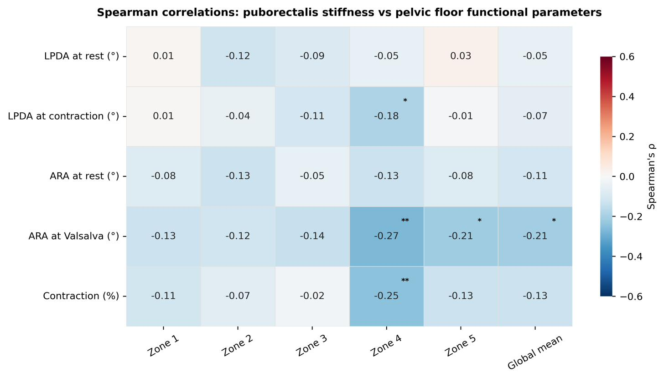
Supplementary Figure S1. Spearman correlation heatmap between puborectalis Young’s modulus (Zones 1–5 and global mean) and pelvic floor functional parameters: LPDA at rest and during contraction (°), ARA at rest and during Valsalva (°), and percentage of levator contraction (%). Colour intensity: −0.6 to +0.6. ARA, anorectal angle; LPDA, levator plate descent angle. *P<0.05; **P<0.01; ***P<0.001.
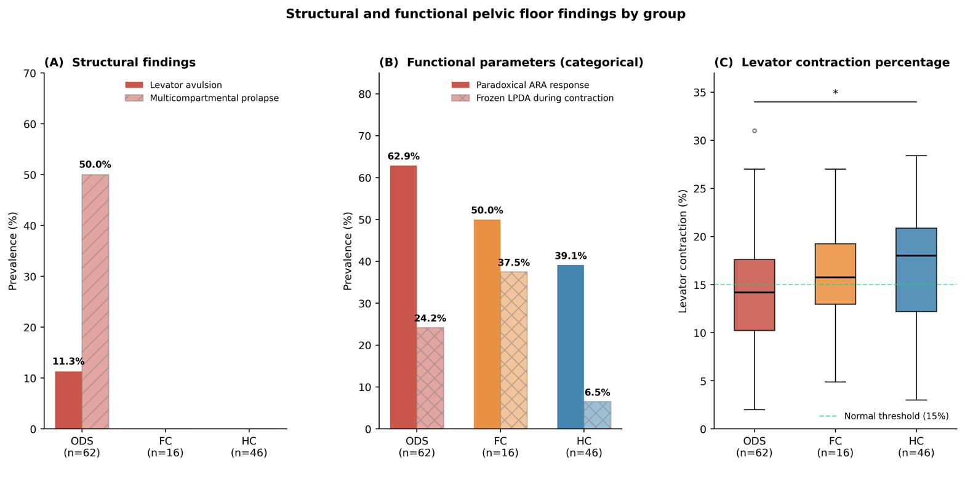
Supplementary Figure S2. Combined structural and functional pelvic floor findings by group. (A) Prevalence (%) of levator ani avulsion and multicompartmental prolapse in ODS, FC, and HC. (B) Prevalence (%) of paradoxical ARA response and frozen LPDA pattern during contraction by group. (C) Levator contraction percentage by group (box-and-whisker plots); dashed line indicates the validated normal threshold (15%, per Volløyhaug et al.¹⁴). ARA, anorectal angle; FC, functional constipation; HC, healthy controls; LPDA, levator plate descent angle; ODS, obstructed defecation syndrome. *P<0.05; ns, not significant.
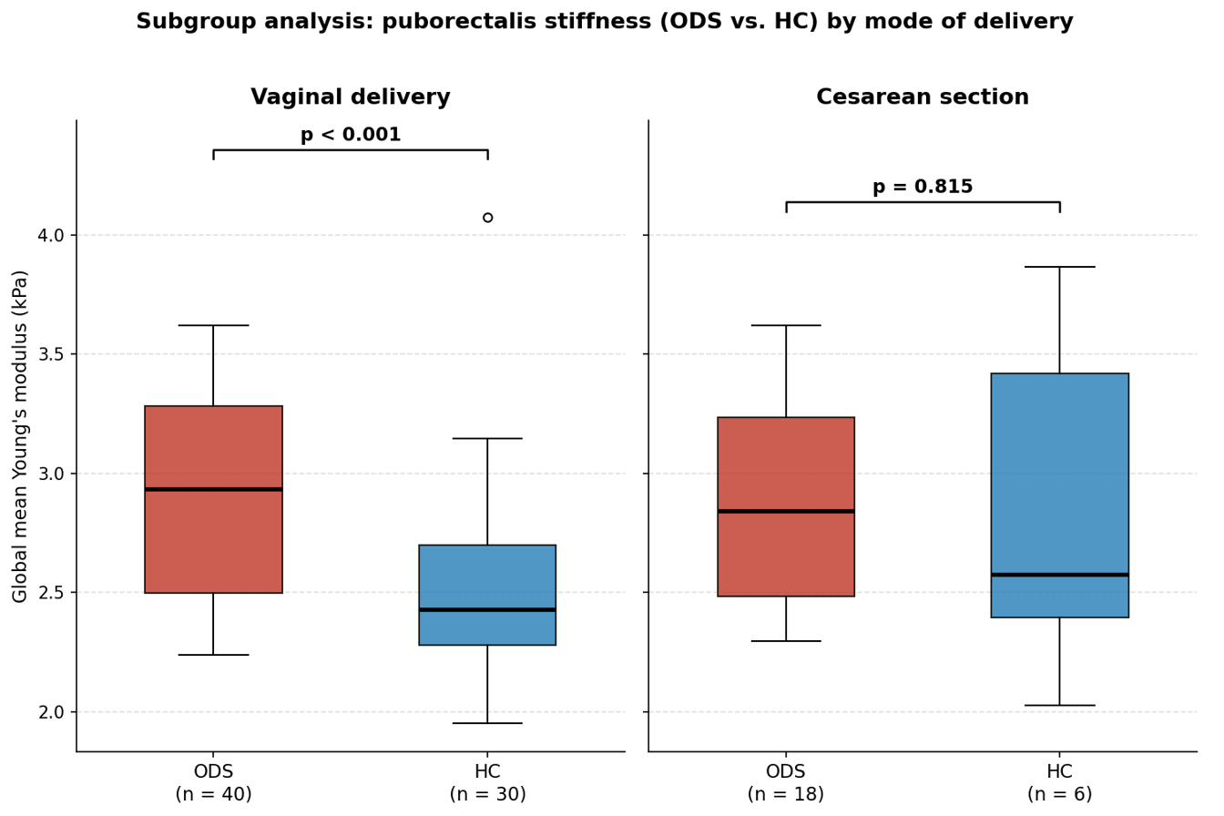
Supplementary Figure S3. Subgroup analysis: global mean puborectalis stiffness (kPa) in ODS vs. HC by mode of delivery. Left panel: vaginal delivery subgroup (ODS n = 40 vs. HC n = 30; P<0.001). Right panel: cesarean section subgroup (ODS n = 18 vs. HC n = 6; P=0.815). HC, healthy controls; ODS, obstructed defecation syndrome.

