Supplementary Table S1. All primers used in this study.
Primers | Sequence (5’-3’) | Used in
Red1 | GTGTGTCCATGGCCTCCTCCGAGAAC | To amplify the DsRed2 gene
Red2 | TACAGGAACAGGTGGTGGC | To amplify the DsRed2 gene
GmUbi1 | GTGTGAATTCTCCACTTGCAACGGGGT | To amplify the GmUbi promoter
GmUbi2 | ACACACCCATGGTGTCGAGTCAACAATCAC AGATA | To amplify the GmUbi promoter

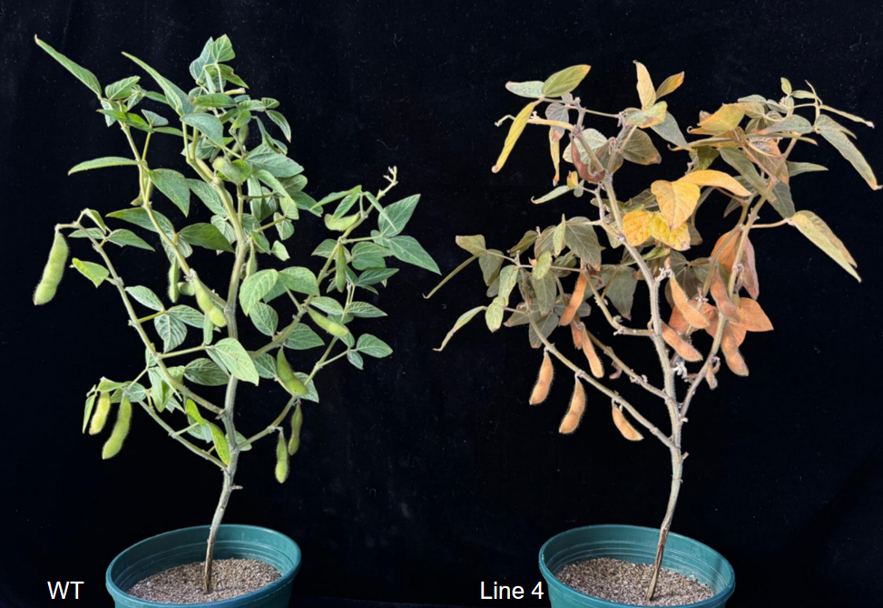
Supplimentary Fig. 1 Wild-type (WT) and transgenic soybean (Line 4) at the podding stage.

