Supplementary Materials for: Integrating laboratory-based secondary precipitation thresholds with ocean biogeochemistry models to advance ocean alkalinity enhancement decision-making

Authors: Allison M. Savoie^{1*}, Kyle E. Hinson¹, Ashley Bird¹, Mallory Ringham², Emma Scott¹, Chinmayee Subban^{1,3}, Jessica Cross¹, Alexa K. Labossiere⁴, Rémi Pagès⁵, Jilian Xiong⁶, Zhaoqing Yang¹, Nicholas D. Ward^{1,7}

- Pacific Northwest National Laboratory, Coastal Sciences Division, Sequim, WA
- Ebb Carbon, Inc., South San Francisco, CA
- Department of Materials Science and Engineering, University of Washington, Seattle, WA
- Virginia Institute of Marine Science, William & Mary, Gloucester Point, VA
- International Arctic Research Center, University of Alaska Fairbanks, Fairbanks, AK
- Woods Hole Oceanographic Institution, Woods Hole, MA
- University of Washington, School of Oceanography, Seattle, WA

*Corresponding Author – Allison M. Savoie can be contacted at allison.savoie@pnnl.gov

SM1. YSI data across Experiment 1. Data has been filtered for outliers using methods detailed in Section 2.4.
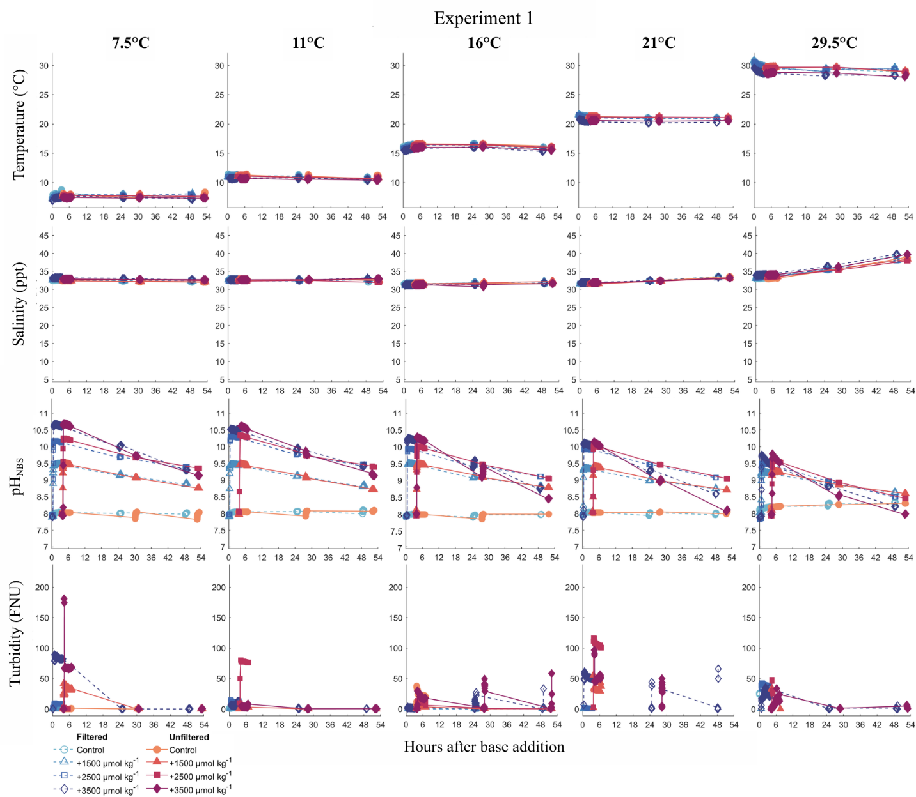

SM2. YSI data across Experiment 2. Data has been filtered for outliers using methods detailed in Section 2.4
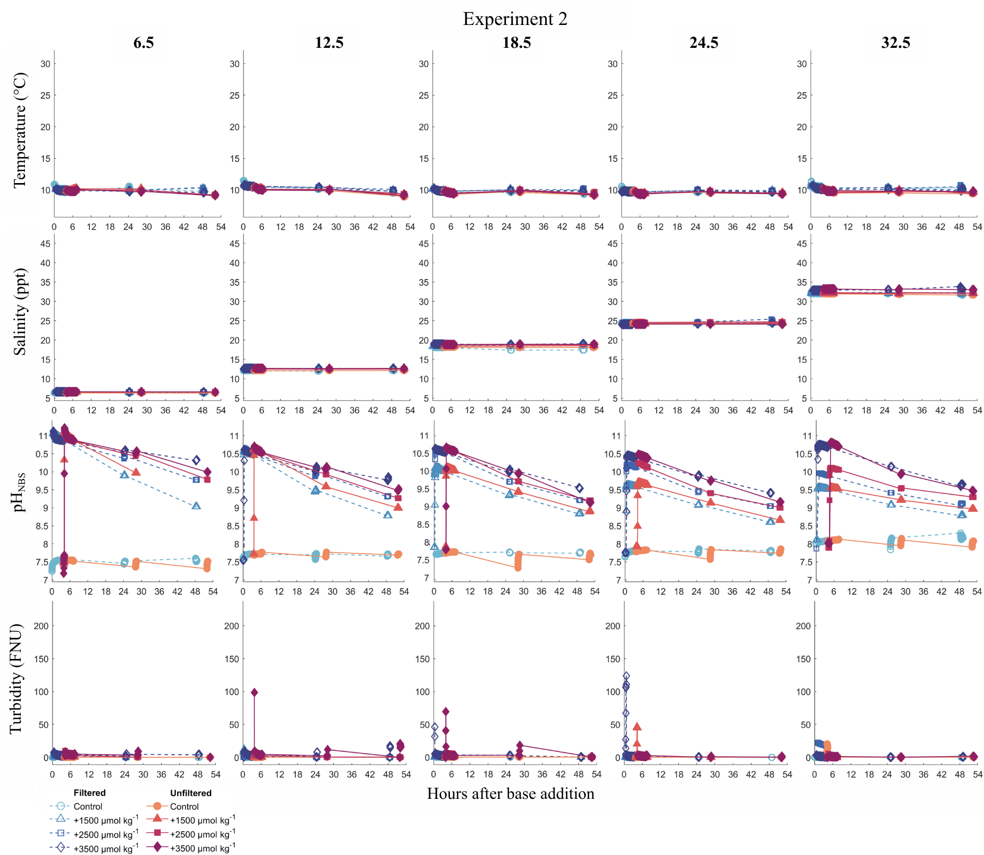

SM3. Precipitate sample identification and analysis performed for mineral characterization.
Sample ID | Exp | Tank | Time | Salinity | Temperature | XRD | SEM | EDS Spec | EDS Mapping
2 | 1 | 4 | 24 | 32 | 16 | X
3 | 1 | 8 | 24 | 32 | 16 | X
4 | 1 | 4 | 48 | 32 | 16 | X
5 | 1 | 4 | EOE | 32 | 16 | X
6 | 1 | 8 | 48 | 32 | 16 | X
7 | 1 | 8 | EOE | 32 | 16 | X
8 | 1 | 4 | 24 | 32 | 21 | X
10 | 1 | 4 | 48 | 32 | 21 | X
11 | 1 | 8 | 48 | 32 | 21 | X
14 | 1 | 4 | 3 | 32 | 30 | X | X | X | X
15 | 1 | 8 | 3 | 32 | 30 | X | X
16 | 1 | 4 | 24 | 32 | 30 | X | X | X | X
17 | 1 | 8 | 24 | 32 | 30 | X | X | X | X
18 | 1 | 4 | 48 | 32 | 30 | X | X | X | X
19 | 1 | 8 | 48 | 32 | 30 | X | X
20 | 1 | 4 | EOE | 32 | 30 | X
21 | 1 | 8 | EOE | 32 | 30 | X
23 | 2 | 4 | 3 | 6 | 10 | X | X | X | X
24 | 2 | 8 | 3 | 6 | 10 | X | X
25 | 2 | 4 | 24 | 6 | 10 | X | X | X | X
26 | 2 | 8 | 24 | 6 | 10 | X | X | X | X
27 | 2 | 4 | 48 | 6 | 10 | X | X | X | X
28 | 2 | 8 | 48 | 6 | 10 | X | X
29 | 2 | 4 | 24 | 12 | 10 | X | X
30 | 2 | 8 | 24 | 12 | 10 | X
31 | 2 | 4 | 48 | 12 | 10 | X | X
32 | 2 | 8 | 48 | 12 | 10 | X
39 | 2 | 4 | 24 | 24 | 10 | X
40 | 2 | 4 | 48 | 24 | 10 | X
41 | 2 | 8 | 48 | 24 | 10 | X

SM4. Results of error uncertainty analysis for experimentally-derived logistical precipitation threshold equation. Peak Ω_{ar} values from each experiment are plotted along with the temperature and salinity data as individual data points on each graph. Experiment 1 point are circles, 2 are squares, 3 are triangles, and 4 are inverted triangles. Experiment 3 & 4 are mesocosm and microcosm data, respectively, from Ringham et al. (2024). Red points are those that precipitated and blue are those that did not. (A) Three-dimensional plot of Ω_{th} (at T=9.97°C & S=32.35ppt) across temperature, salinity, & peak Ω_{ar} values during the experiments. (B) Uncertainty map of standard error of the Ω_{th} equation across temperatures and salinities. (C) Ω_{th} calculated across temperatures at S = 32.35 ppt (Sref or average across Experiment 1). (D) Ω_{th} calculated across salinities at T = 9.97°C (Tref or average across Experiment 2).
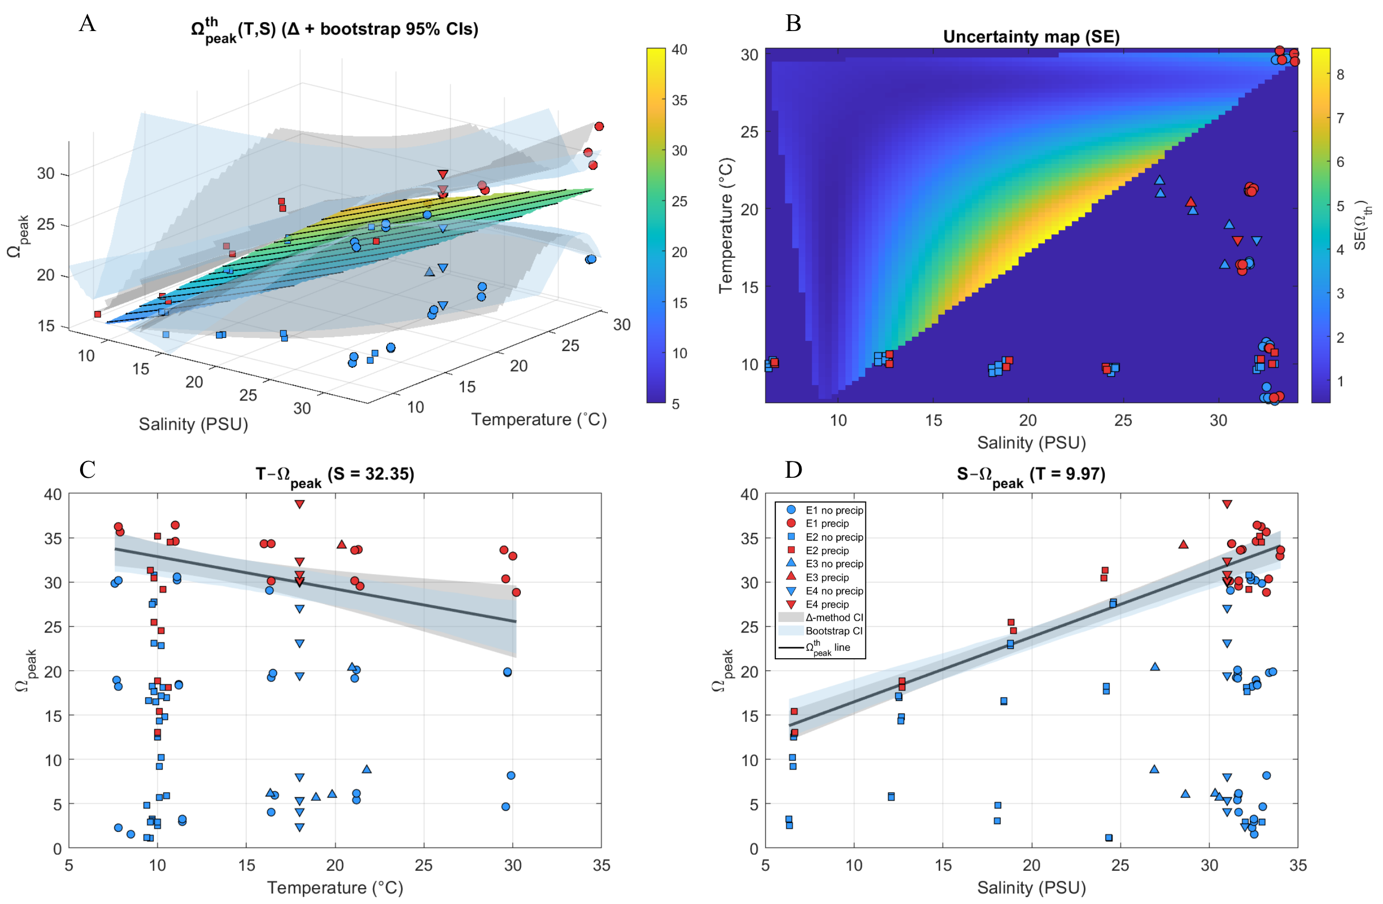

SM5. XRD data of solid precipitate samples collected across experiment 1 & 2. All data are from the +3500 µmol kg⁻¹ treatments. Experiment 1 data (left) include spectra from samples collected during the 16°C and 29.5°C groups. Experiment 2 data (right) include spectra from samples collected during the 6.5, 12.5 and 24.5 salinity groups. Filtered data are dashed lines with the blue gradient indicating time progression over the experiment (darker = longer after base addition), also labeled by t₃, t₂₄, and t₄₈. Unfiltered data are solid lines with the pink gradient (darker = longer after base addition). Reference spectrum are on the bottom of each XRD for brucite (Desgranges et al. (1996) ), aragonite (Jarosch and Heger (1986)), and calcite (Caspi et al. (2005)).
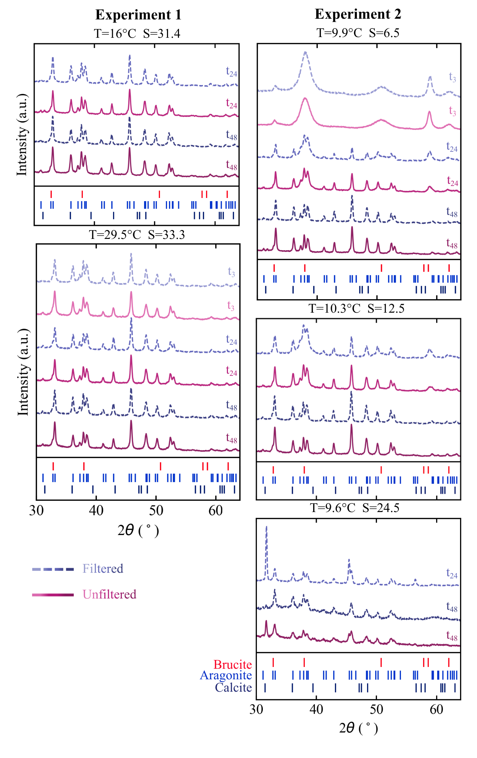

SM6. SEM photos of solid precipitate samples comparing abiotic and biotic tanks across Experiment 1, Round 5 (T=29.5°C) at 3 hours (T3), 24 hours (T24), and 48 hours (T48) after base addition. Scale is 30 µm.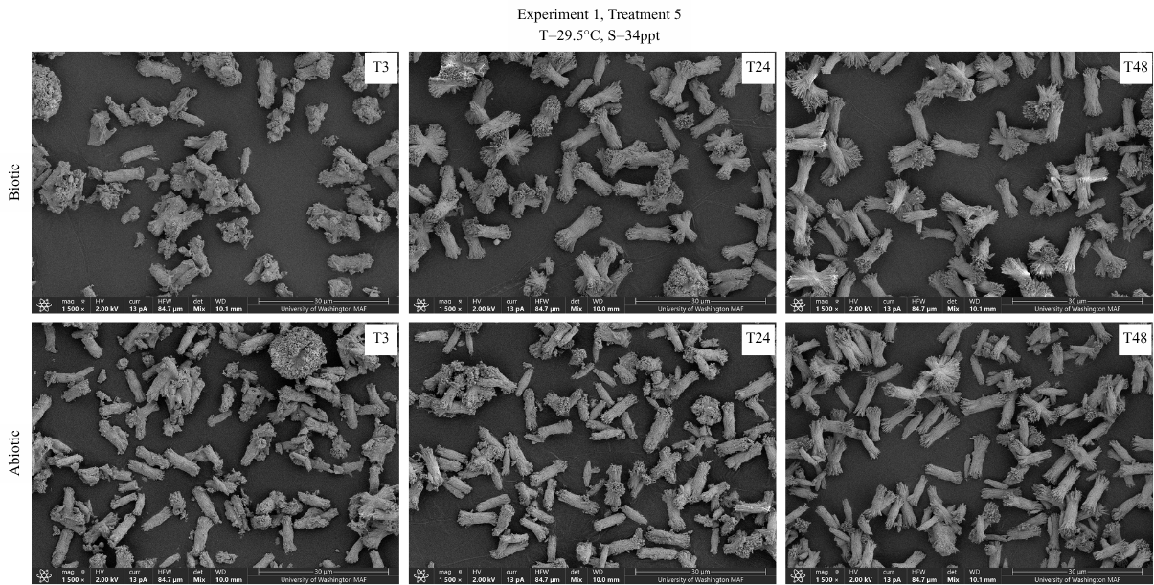
SM7. SEM photos of solid precipitate samples comparing abiotic and biotic tanks across Experiment 2, Round 1 (S=6.5ppt) at 3 hours (T3), 24 hours (T24), and 48 hours (T48) after base addition. Scale is 30 µm.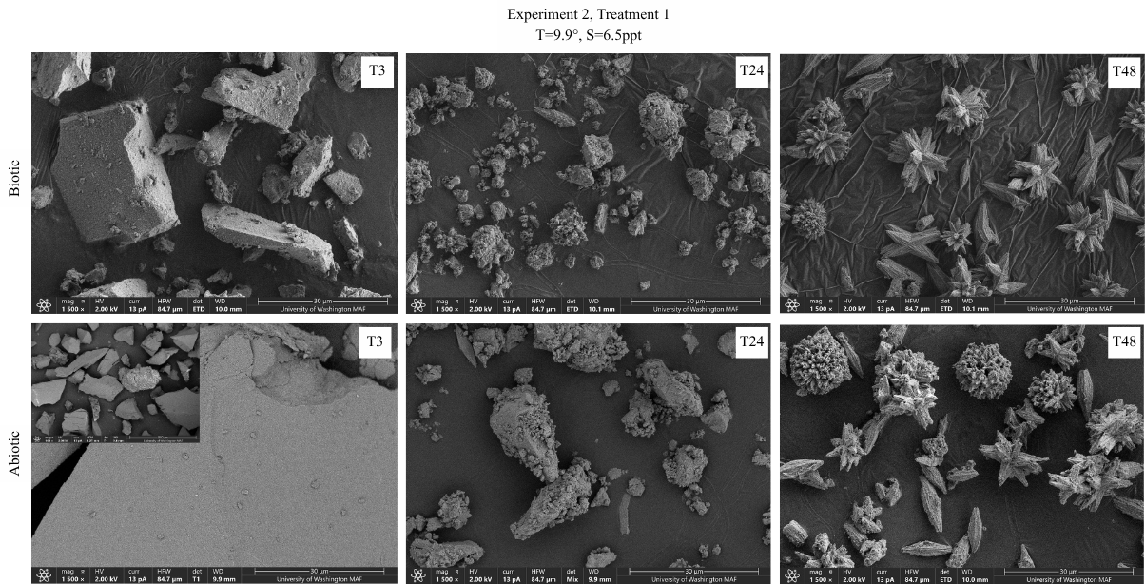

SM8. Total alkalinity (meq m⁻³) surface data from the day of release at the northern oligohaline Baltimore Harbor release site in January. Top row is without the precipitation module enabled and the bottom row is with the precipitation module.
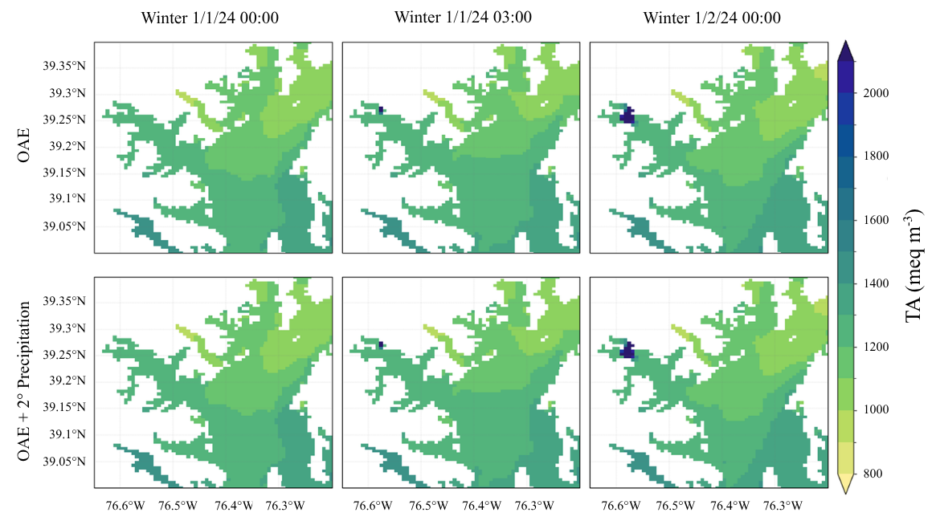
SM9. Total alkalinity (meq m⁻³) surface data from the day of release at the northern oligohaline Baltimore Harbor release site in June. Top row is without the precipitation module enabled and the bottom row is with the precipitation module.
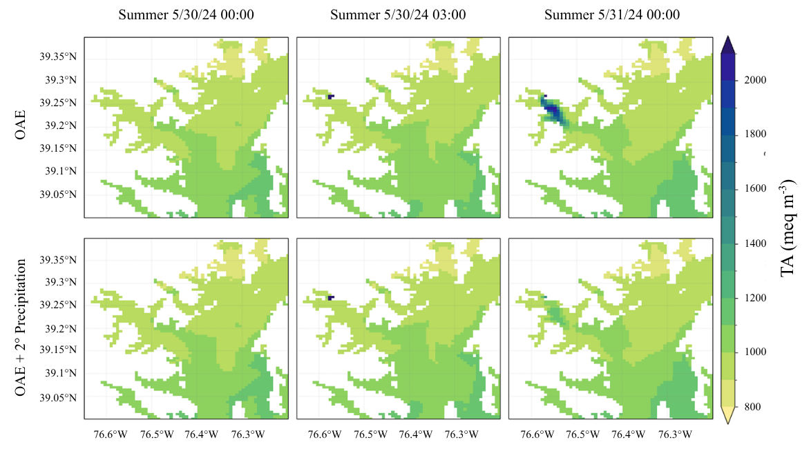
SM10. Total alkalinity (meq m⁻³) surface data from the day of release at the southern mesohaline Southern Bay release site in January. Top row is without the precipitation module enabled and the bottom row is with the precipitation module.
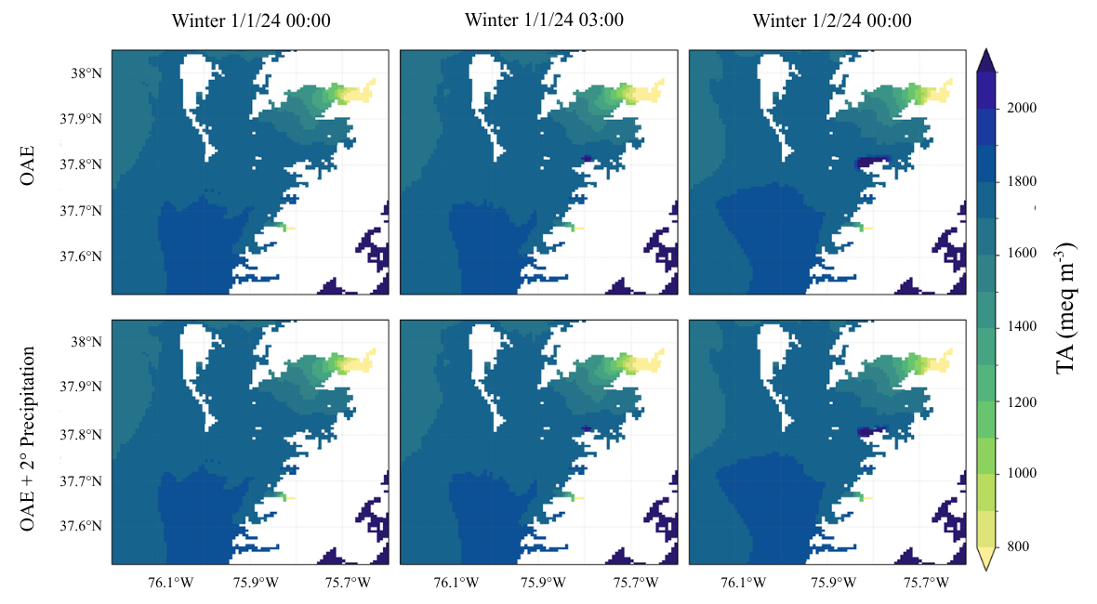
SM11. Total alkalinity (meq m⁻³) surface data from the day of release at the southern mesohaline Southern Bay release site in June. Top row is without the precipitation module enabled and the bottom row is with the precipitation module.
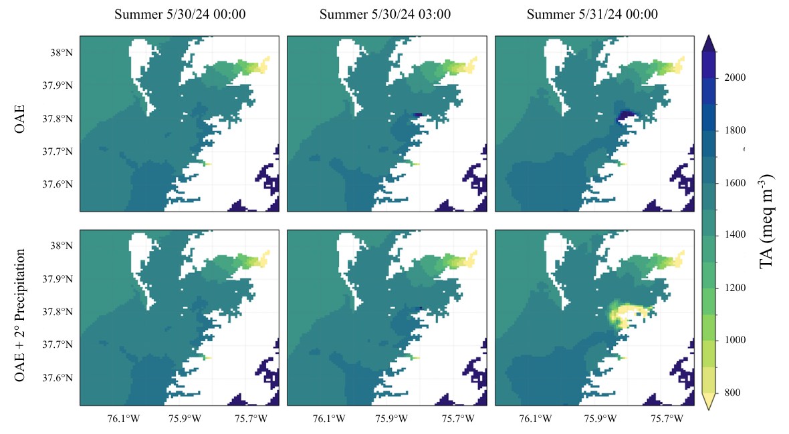
SM12. Dissolved inorganic carbon (mmolC m⁻³) surface data from the day of release at the northern oligohaline Baltimore Harbor release site in January. Top row is without the precipitation module enabled and the bottom row is with the precipitation module.
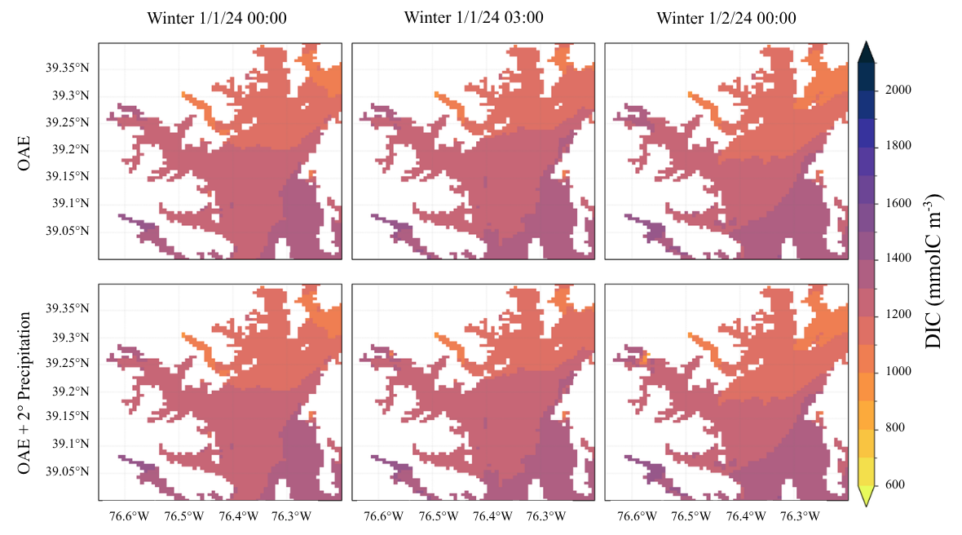
SM13. Dissolved inorganic carbon (mmolC m⁻³) surface data from the day of release at the northern oligohaline Baltimore Harbor release site in June. Top row is without the precipitation module enabled and the bottom row is with the precipitation module.
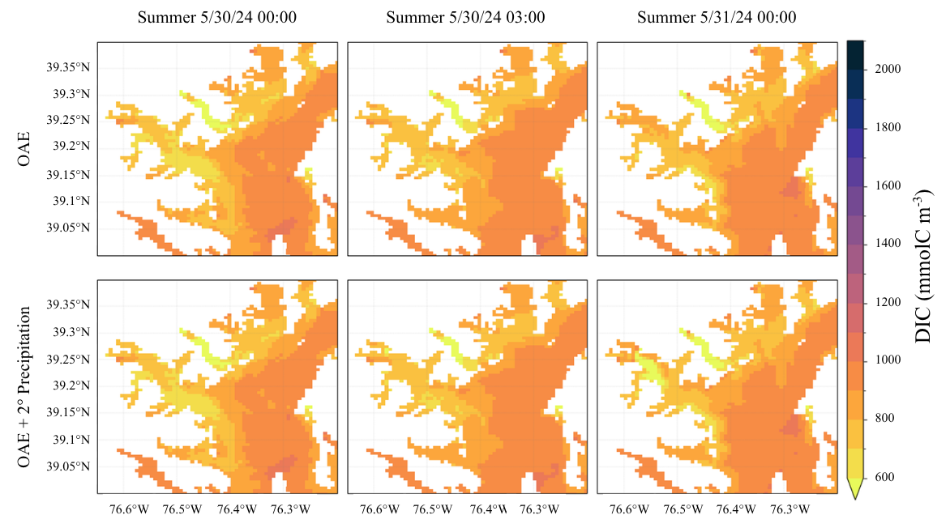
SM14. Dissolved inorganic carbon (mmolC m⁻³) surface data from the day of release at the southern mesohaline Southern Bay release site in January. Top row is without the precipitation module enabled and the bottom row is with the precipitation module.
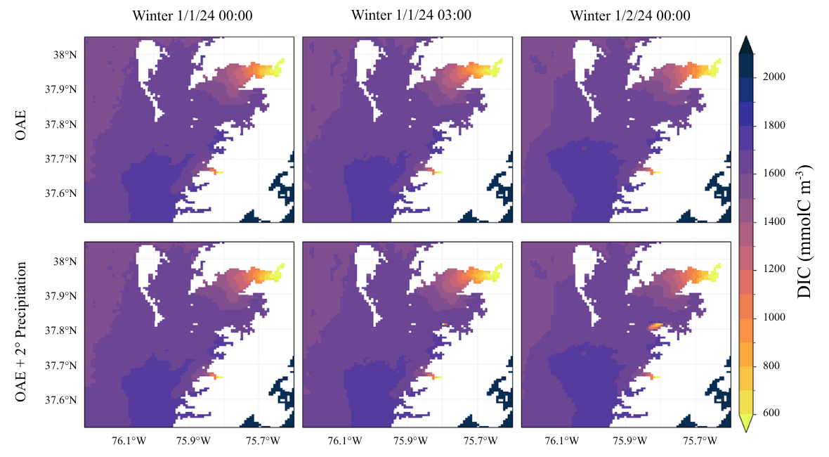
SM15. Dissolved inorganic carbon (mmolC m⁻³) surface data from the day of release at the southern mesohaline Southern Bay release site in June. Top row is without the precipitation module enabled and the bottom row is with the precipitation module.
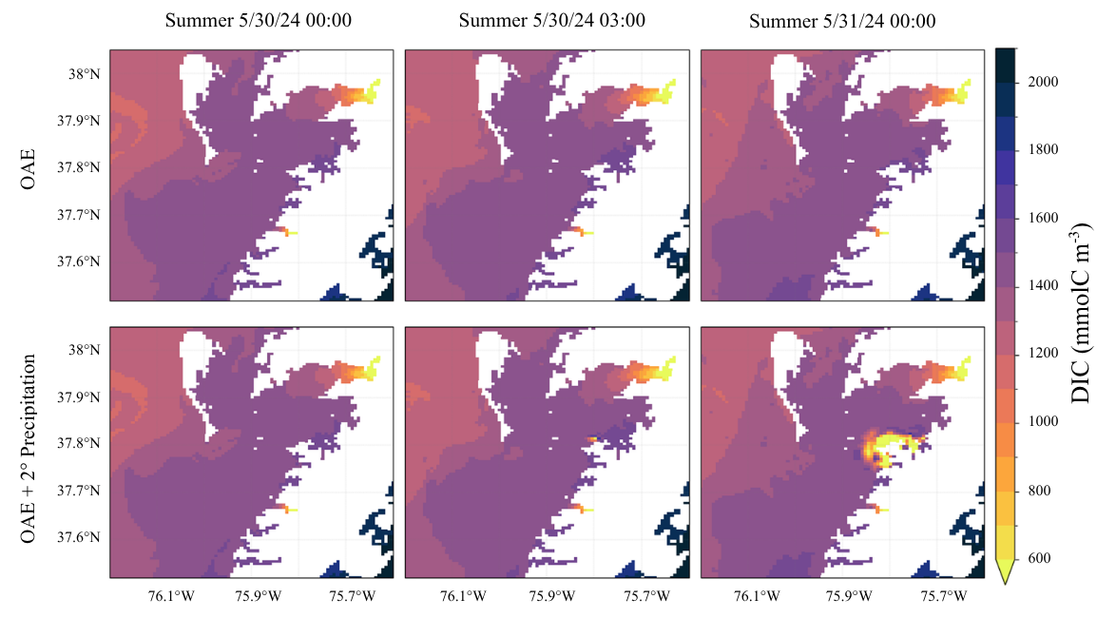
SM16. Ω_{ar} surface data from the day of release at the northern oligohaline Baltimore Harbor release site in January. Top row is without the precipitation module enabled and the bottom row is with the precipitation module.
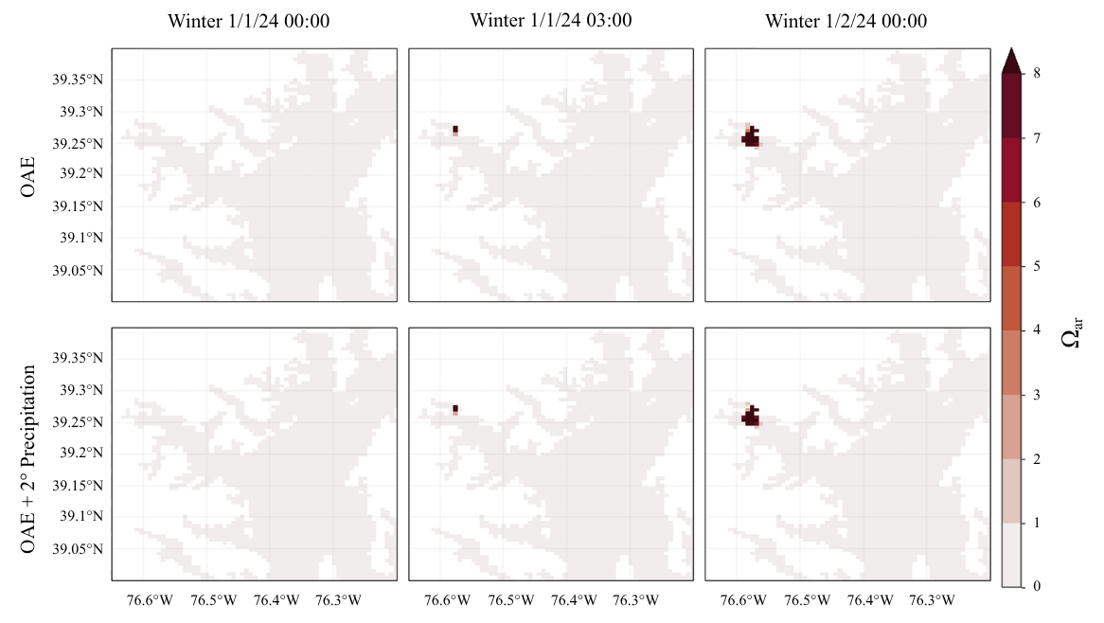
SM17. Ω_{ar} surface data from the day of release at the northern oligohaline Baltimore Harbor release site in June. Top row is without the precipitation module enabled and the bottom row is with the precipitation module.
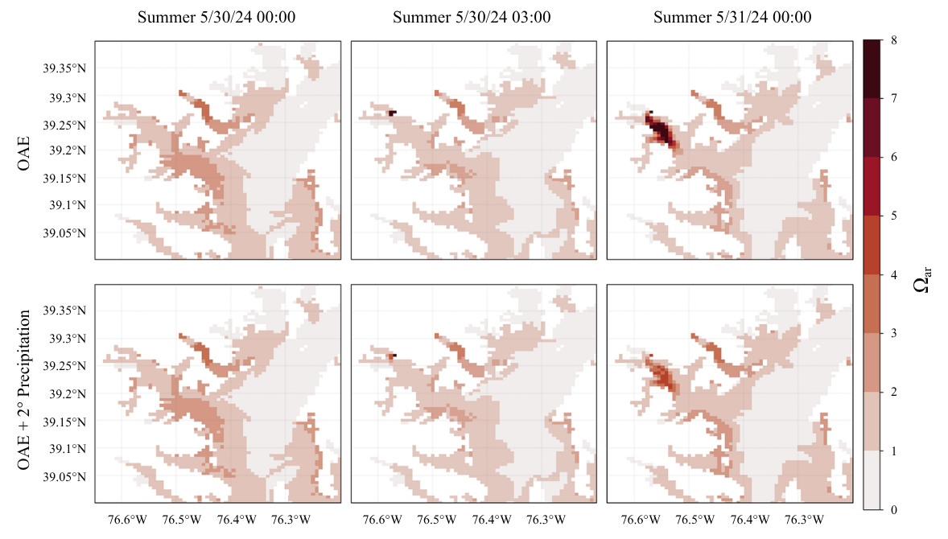
SM18. Ω_{ar} surface data from the day of release at the southern mesohaline Southern Bay release site in January. Top row is without the precipitation module enabled and the bottom row is with the precipitation module.
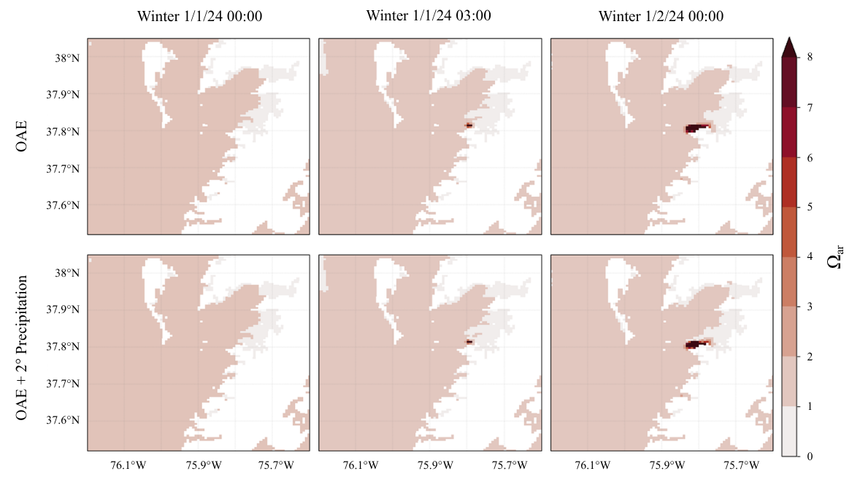
SM19. Ω_{ar} surface data from the day of release at the southern mesohaline Southern Bay release site in June. Top row is without the precipitation module enabled and the bottom row is with the precipitation module.
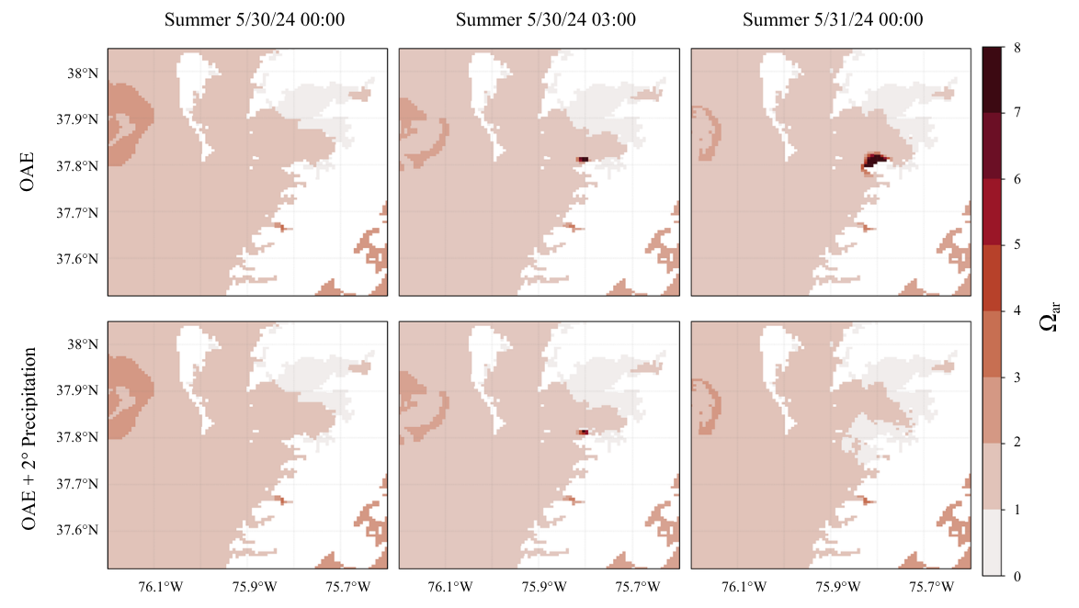
SM20. SEM results of solid precipitate samples collected from abiotic tanks in Experiment 2 during the salinity 6 treatment. (A-C) SEM photos of precipitate samples collected from Experiment 2 during the salinity 6 treatment. Time increases from left to right where (A) is 3 hours, (B) is 24 hours, and (C) is 48 hours after base addition. All images are at the 5 µm scale.
