Extended data figures and tables
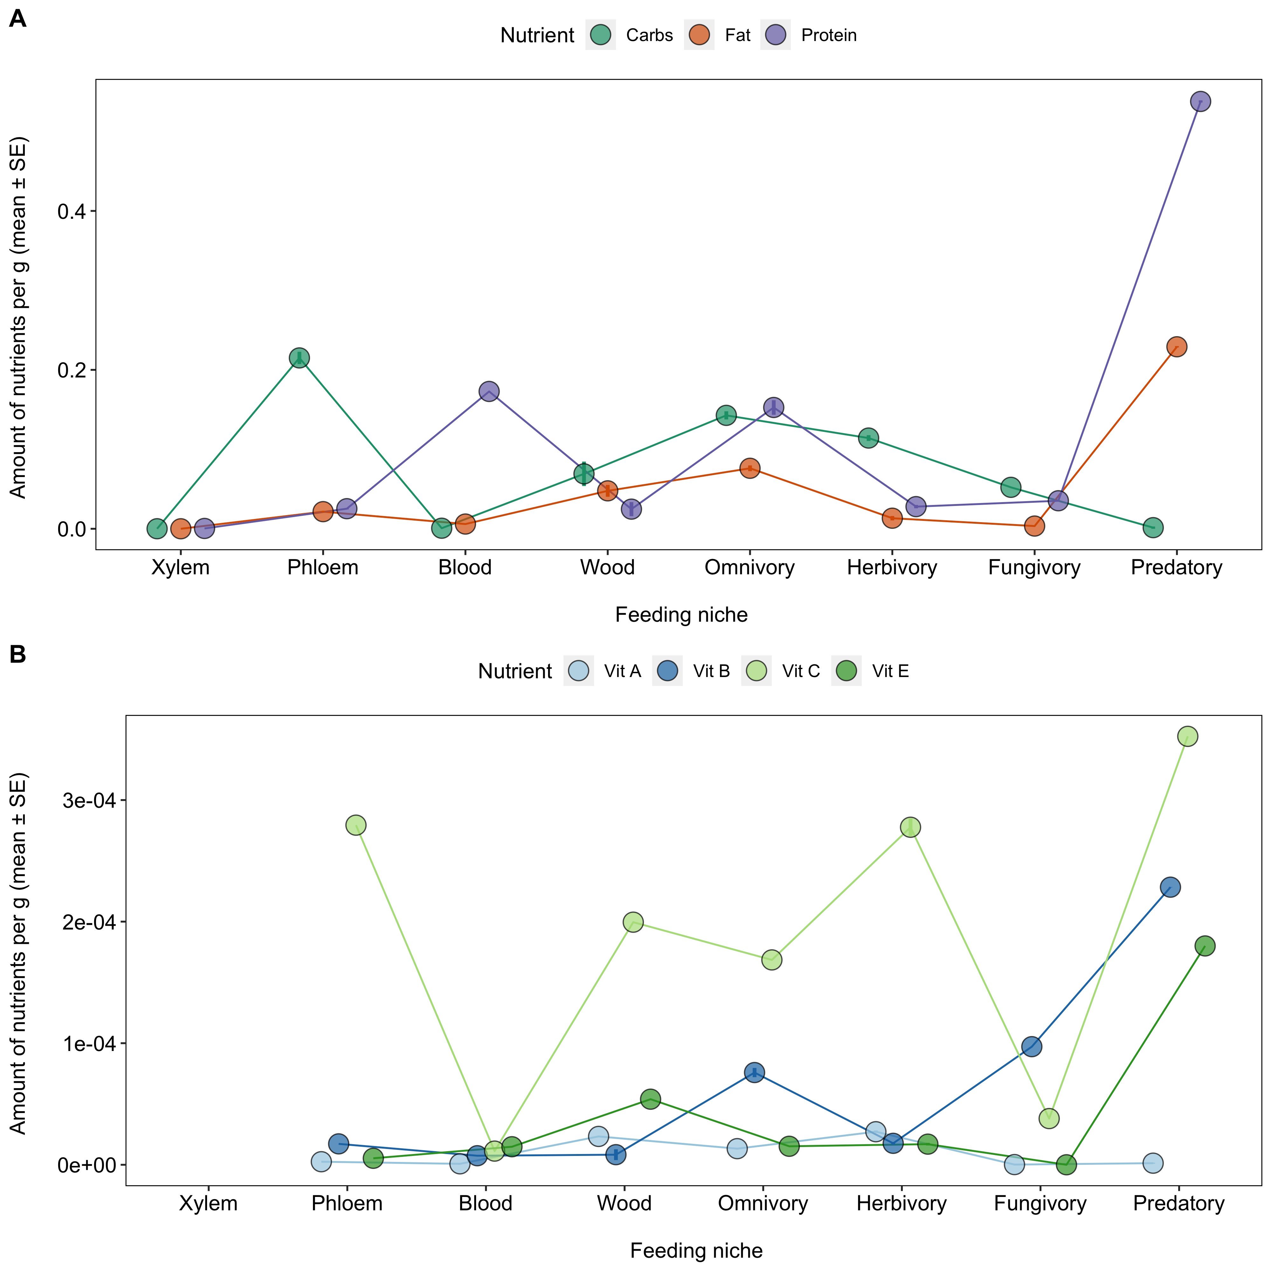
Extended Data Fig.1: Nutritional composition of different feeding niches. (A) The amount of macronutrients (carbohydrate, protein, fat) varied across feeding niches, but only protein in the diets of insects feeding on phloem and wood was significantly lower than the average across all diets (Table S8). (B) The amount of vitamins in diets of insects with different feeding niches. Only vitamin B was found to be significantly lower in insects feeding on blood, phloem and wood, all of which were associated with high rates of obligate symbiosis. Note no micronutrients were reported for xylem.
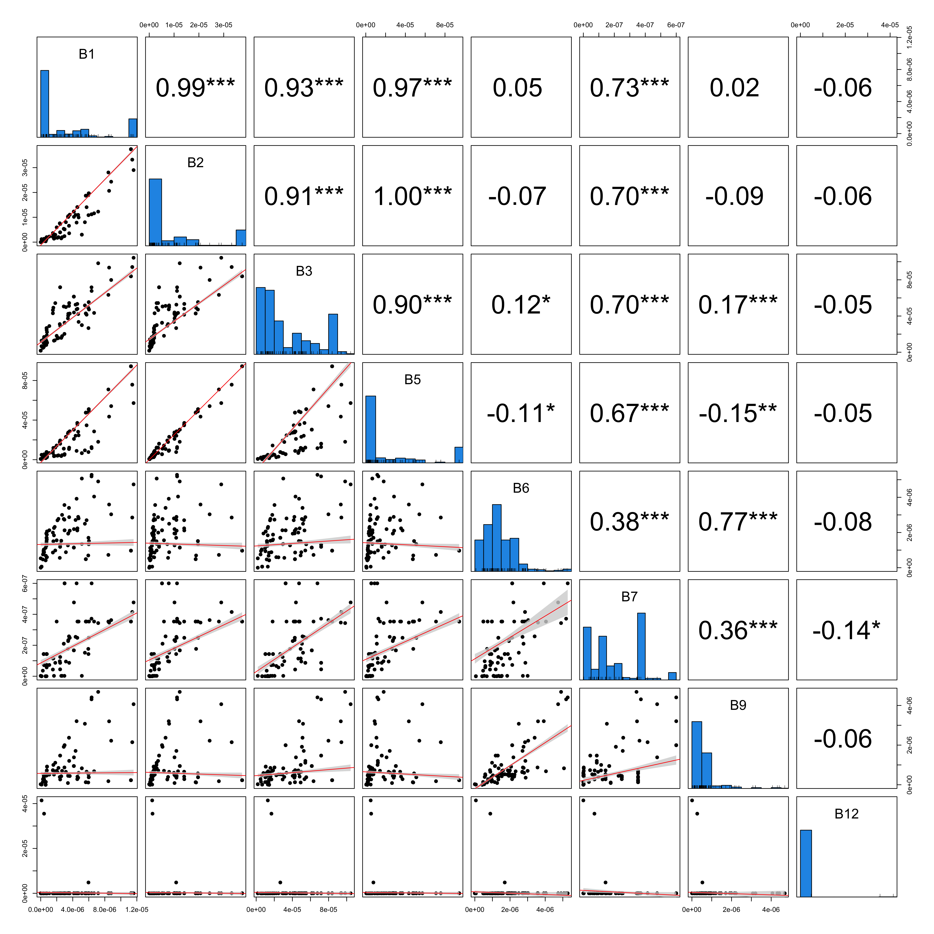
Extended Data Fig.2: The relationship between different B vitamins across diets. Frequency distributions are plotted on the diagonals. Scatter plots of the correlation between different B vitamins are plotted below the diagonal where each point represents one insect family and lines represent linear fits with 95% confidence intervals. Pearson correlation coefficients with significance values (* p<0.05,** p<0.01,*** p<0.001) are plotted above the diagonal.
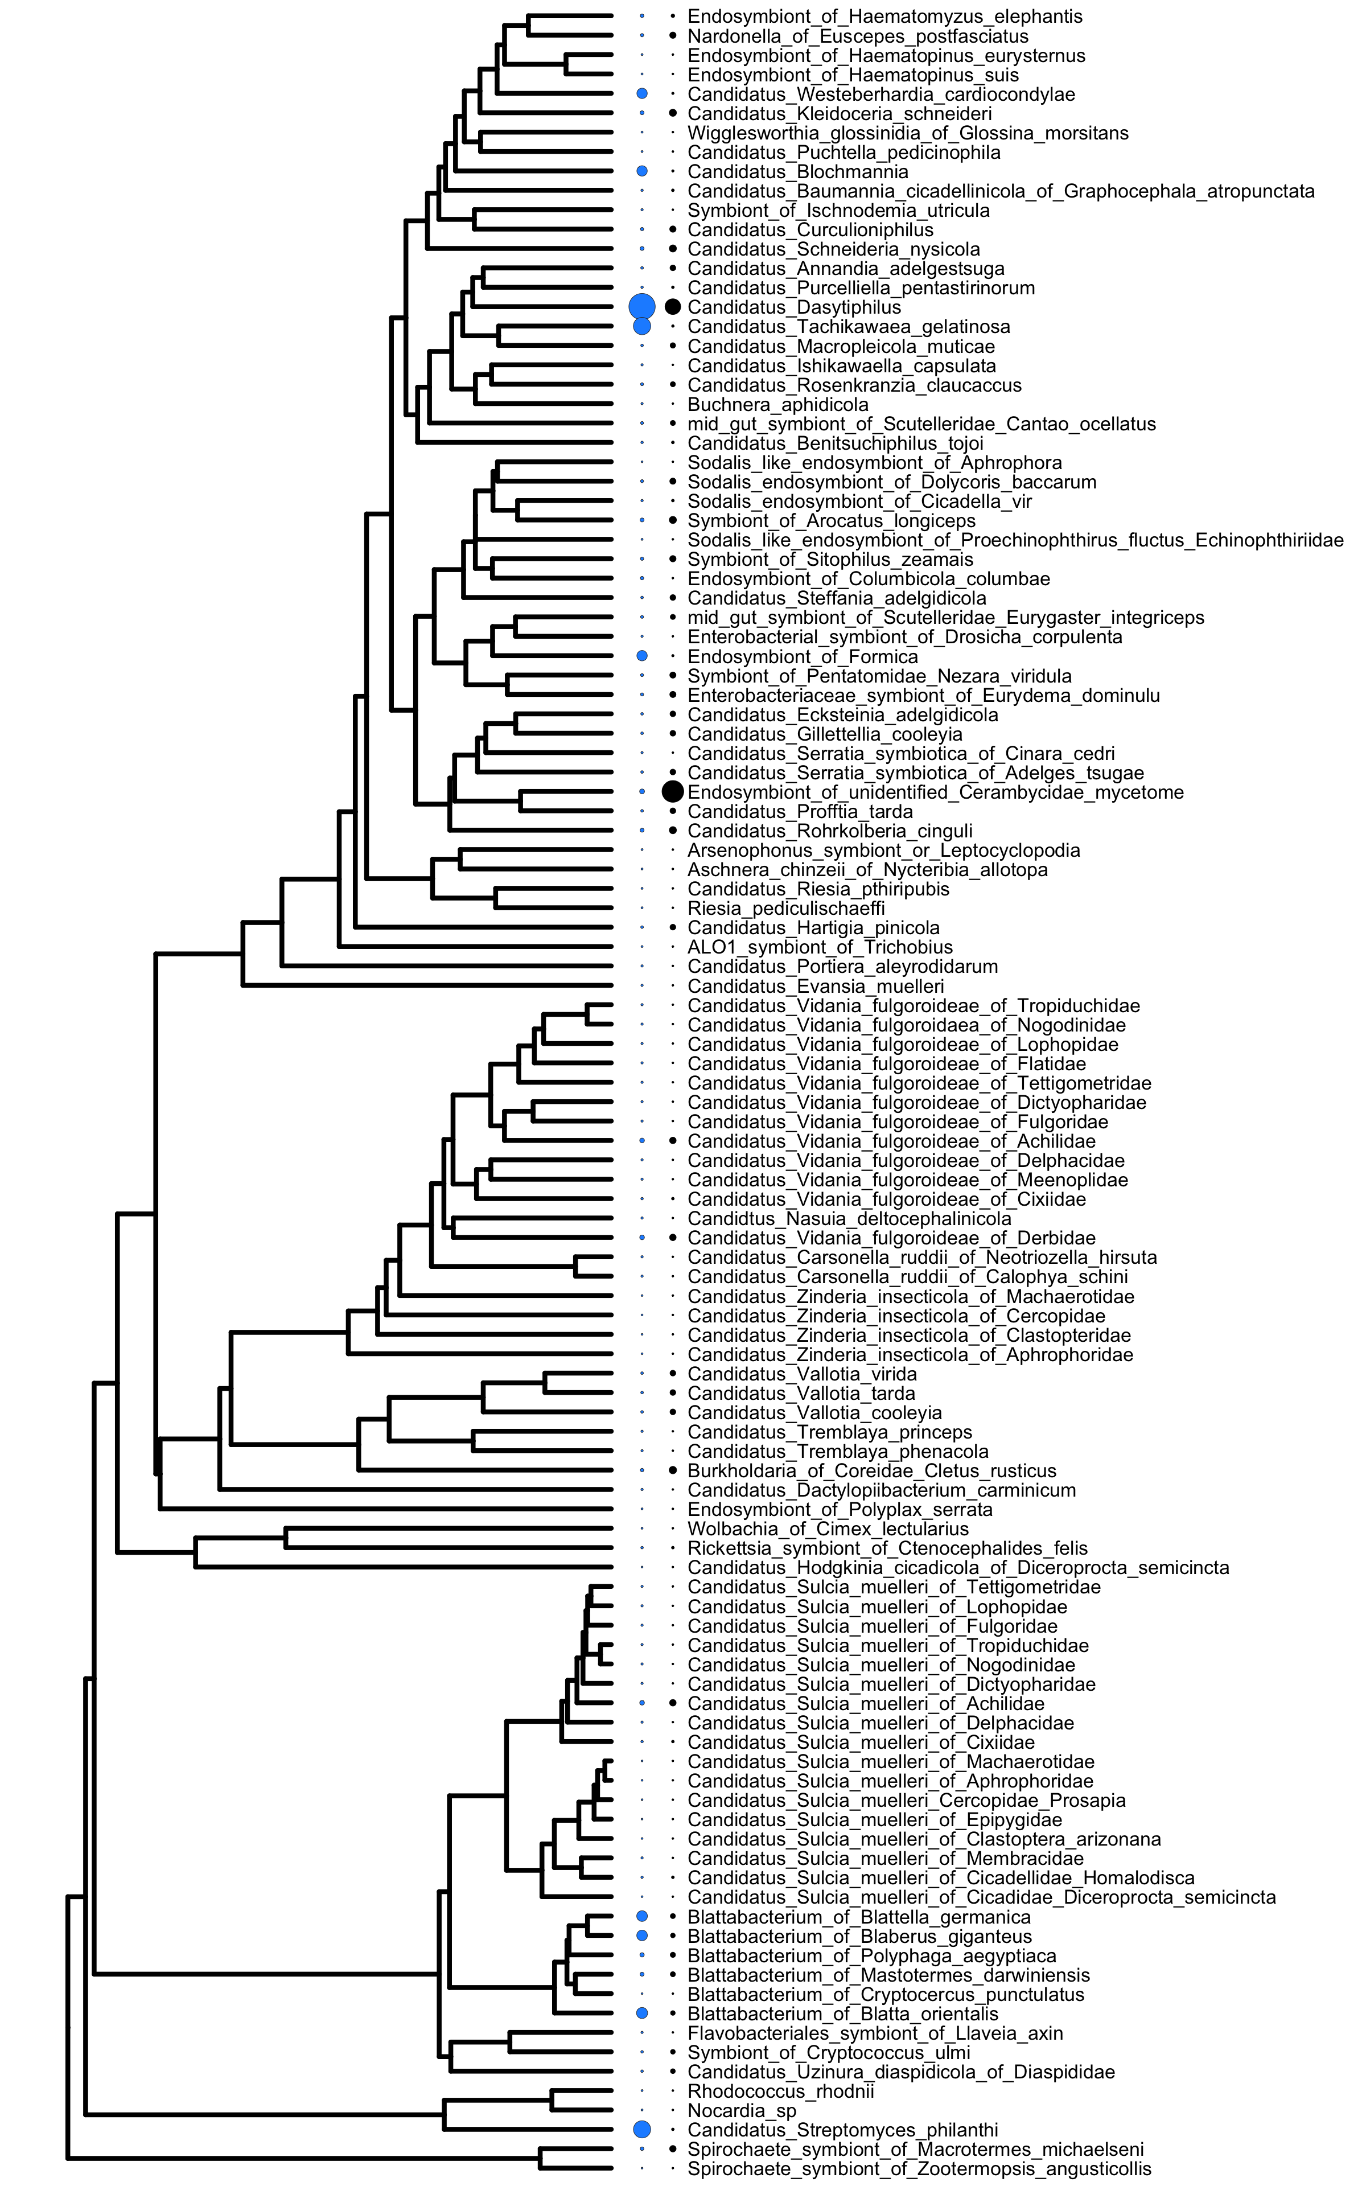
Extended Data Fig.3: Levels of B vitamins in host diets in relation to symbiont phylogenetic history. B5 vitamins are presented in blue and B9 in black and the size of the circles indicates the amount of B5 and B9 vitamins in the diets of insect hosts.
Extended Data Fig.4: The relationship between nutrients in adult and juvenile diets. Frequency distributions are plotted on the diagonals. Scatter plots of the correlation between different nutrients during adult and juvenile life stages are plotted below the diagonal where each point represents one insect family and lines represent linear fits with 95% confidence intervals. Pearson correlation coefficients with significance values (* p<0.05,** p<0.01,*** p<0.001) are plotted above the diagonal.

Extended Data Fig.5: The relationship between the number of species within families and net diversification rates. Net diversfication rates were calculated using the method-of-moments estimator for stem-group ages of using the ‘bd.ms’ function in the R package geiger with different extinction fractions (0 = div0, 0.5 = div0.5, 0.9 = div0.9). Different estimates of diversification rates were highly correlated, but diversification rates were only weakly correlated to species richness. Pearson correlation coefficients with significance values (* p<0.05,** p<0.01,*** p<0.001) are plotted above the diagonal.

Extended Data Fig.6: The phylogenetic distribution of obligate symbionts across insect families and their feeding niches (Figure 1 of the main manuscript plotted with tip labels). Turquiose tips and branches indicate obligate symbionts and different coloured dots represent different feeding niches. Ancestral feeding niches and states obligate symbiosis were estimated using SCM (Supplementary Table 5).

