Supplementary Information for “Integrated Polygenic Risk Scores: Composite and Ensemble Learning Approaches for Precision Medicine”

Junming Guan^{1#}, Song Zhai^{2#}, Wujuan Zhong², Devan V. Mehrotra³, Judong Shen^{2*}
¹Department of Statistics, University of Chicago, Chicago, IL 60637, USA
²Biostatistics and Research Decision Sciences, Merck & Co., Inc., Rahway, NJ 07065, USA
³Biostatistics and Research Decision Sciences, Merck & Co., Inc., North Wales, PA
19454, USA
#These authors contributed equally to this work
* To whom correspondence should be addressed
Correspondence: judong.shen@merck.com

This file includes:
Supplementary Methods
Supplementary Figures: Figure S1 to S5
Supplementary Tables: Table S1

Supplementary Methods

Derivation of theoretical $R^{2}$
We posit the following model for drug response (with covariates regressed out) in the target cohort:
$$ΔY=β_{0}+β_{T}T+g^{⊤}β+T×g^{⊤}γα+ϵ,$$
where $g∈R^{m}$ is the vector of genotypes; $β∈R^{m}$ is the vector of prognostic effect; $α∈R^{m}$ is the vector of predictive effect, $γ>0$ is a parameter controlling the scale difference between the two effects; $ϵ$ is independent mean 0 Gaussian noise with variance
$$σ^{2}=\frac{1-h_{D}^{2}}{h_{D}^{2}}Var\left(g^{⊤}β+\left(g^{⊤}α^{*}\right)T\right)-\operatorname{Var}\left(β_{T}T\right),$$
where $h_{D}^{2}$ is the total heritability of drug response; $β_{0}$ is an intercept term, $β_{t}$ is the treatment effect, and $T$ is the treatment assignment, assumed to be random and independent of any environmental or genetic component. More precisely, we have
$$T⟂g, T⟂β, T⟂α, T⟂ϵ.$$
We denote $p_{i}∈(0,1)$ as the allele frequency of SNP $i$. Note that we have $p_{i}^{2}{\left(1-p_{i}\right)}^{2}≤\frac{1}{16}$ for all $i$.
Let $μ∈R^{m}$ be the vector of prognostic effect sizes in the disease GWAS cohort, and $b,a∈R^{m}$ be the vectors of prognostic and predictive effect sizes in the PGx-T GWAS cohort. As noted in the main text, we assume that for SNP $i$:
$$\left({\begin{matrix}μ_{i} \\ b_{i} \\ a_{i}\end{matrix} \atop \begin{aligned}β_{i} \\ α_{i}\end{aligned}}\right)\sim \left(1-p_{causal}\right)⋅δ_{0}+p_{causal}⋅MVN\left(0,Σ\right), Σ=\frac{h_{T}^{2}}{mp_{causal}}Ω,$$
with the correlation matrix defined as
$Ω=\left[\begin{matrix}1 & ρ_{Y} & ρ_{Y}⋅ρ_{E} & ρ_{Y}⋅ρ_{C} & ρ_{Y}⋅ρ_{C}⋅ρ_{E} \\ ρ_{Y} & 1 & ρ_{E} & ρ_{C} & ρ_{E}⋅ρ_{C} \\ ρ_{Y}⋅ρ_{E} & ρ_{E} & 1 & ρ_{E}⋅ρ_{C} & ρ_{C} \\ ρ_{Y}⋅ρ_{C} & ρ_{C} & ρ_{E}⋅ρ_{C} & 1 & ρ_{E} \\ ρ_{Y}⋅ρ_{C}⋅ρ_{E} & ρ_{E}⋅ρ_{C} & ρ_{C} & ρ_{E} & 1\end{matrix}\right]$,
and $h_{T}^{2}$ is the total variance of each genetic component.

Preparation
We first derive some intermediate results that will be useful later. Suppose we have two random vectors of effect sizes $ξ$ and $η$ (which could be $β$ and $α$) that are independent of the genotypes and environmental factors. Furthermore, they are distributed as follows:
$$\left[\begin{matrix}ξ_{i} \\ η_{i}\end{matrix}\right]∼(1-p_{causal})δ_{0}+p_{causal}\frac{h_{T}^{2}}{mp_{causal}}N\left(0,\left[\begin{matrix}1 & ρ_{ξ,η} \\ ρ_{ξ,η} & 1\end{matrix}\right]\right).$$
Assume that the number of SNPs $m$ is large (we take $m$ to infinity), we aim to derive the limiting variance and covariance of the genetic components, as functions of $ρ_{ξ,η}$, $h_{T}^{2}$, $p_{causal}$ and treatment-to-placebo ratio $q≔P[T=1]$. To this end, we have
Var(g⊤η∣η)=i=1m2pi(1-pi)ηi2+2i<i'​Cov(gi,gi')ηiηi',
and, since $η_{i}⟂η_{i^{'}}$ for $i≠i^{'}$,
$$\begin{aligned}\text{Var}(\text{Var}(g^{⊤}η∣η))&=\sum_{i=1}^{m}{4}p_{i}^{2}(1-p_{i})^{2}\text{Var}(η_{i}^{2}) \\ &=\sum_{i=1}^{m}{4}p_{i}^{2}(1-p_{i})^{2}\frac{h_{T}^{4}}{m^{2}p_{causal}^{2}}p_{causal}(3-p_{causal}) \\ &≤\frac{1}{4}\frac{h_{T}^{4}(3-p_{causal})}{mp_{causal}}=O\left(\frac{1}{m}\right).\end{aligned}$$
Since the variance converges to 0 as $m→∞$, we can use Chebychev’s Inequality to conclude that
$$\text{Var}(g^{⊤}η∣η)\overset{p}{→}E[\text{Var}(g^{⊤}η∣η)]=\frac{h_{T}^{2}}{m}\sum_{i=1}^{m}{2}p_{i}(1-p_{i}).$$
Similarly, we have
$$\text{Var}(g^{⊤}ξ∣ξ)\overset{p}{→}E[\text{Var}(g^{⊤}ξ∣ξ)]=\frac{h_{T}^{2}}{m}\sum_{i=1}^{m}{2}p_{i}(1-p_{i}).$$
Next,
Cov(g⊤η,g⊤ξ∣η,ξ)=i=1m2pi(1-pi)ηiξi+i≠i'​Cov(gi,gi')ηiξi'
with
$$\text{Var}(\text{Cov}(g^{⊤}η,g^{⊤}ξ∣η,ξ))=\sum_{i=1}^{m}{4}p_{i}^{2}(1-p_{i})^{2}\text{Var}(η_{i}ξ_{i}).$$
Now, let $R_{i}:=1\{(η_{i},ξ_{i})∼N\}$, i.e., $P[R_{i}=1]=p_{causal}$; by Isserli’s Theorem,
$$\begin{aligned}\text{Var}(η_{i}ξ_{i})&=E[\text{Var}(η_{i}ξ_{i}∣R_{i})]+\text{Var}(E[η_{i}ξ_{i}∣R_{i}]) \\ &=p_{causal}\text{Var}(η_{i}ξ_{i}∣R_{i}=1)+ρ_{ηξ}^{2}\frac{h_{T}^{4}}{m^{2}p_{causal}^{2}}\text{Var}(1_{\{R_{i}=1\}}) \\ &=p_{causal}\text{Var}(η_{i}ξ_{i}∣R_{i}=1)+ρ_{ηξ}^{2}\frac{h_{T}^{4}(1-p_{causal})}{m^{2}p_{causal}} \\ &=p_{causal}\left(E[η_{i}^{2}ξ_{i}^{2}∣R_{i}=1]-E[η_{i}ξ_{i}∣R_{i}=1]^{2}\right)+ρ_{ηξ}^{2}\frac{h_{T}^{4}(1-p_{causal})}{m^{2}p_{causal}} \\ &=E[η_{i}^{2}ξ_{i}^{2}∣R_{i}=1]p_{causal}-E[η_{i}ξ_{i}∣R_{i}=1]^{2}p_{causal}+ρ_{ηξ}^{2}\frac{h_{T}^{4}(1-p_{causal})}{m^{2}p_{causal}} \\ &=E[η_{i}^{2}∣R_{i}=1]E[ξ_{i}^{2}∣R_{i}=1]p_{causal}+E[η_{i}ξ_{i}∣R_{i}=1]^{2}p_{causal}+ρ_{ηξ}^{2}\frac{h_{T}^{4}(1-p_{causal})}{m^{2}p_{causal}} \\ &=\frac{h_{T}^{4}}{m^{2}p_{causal}}+ρ_{ηξ}^{2}\frac{h_{T}^{4}}{m^{2}p_{causal}}+ρ_{ηξ}^{2}\frac{h_{T}^{4}(1-p_{causal})}{m^{2}p_{causal}}=\frac{h_{T}^{4}}{m^{2}p_{causal}}(1+ρ_{ηξ}^{2}(2-p_{causal})).\end{aligned}$$
So, we have
$$\text{Var}(\text{Cov}(g^{⊤}η,g^{⊤}ξ∣η,ξ))=\frac{h_{T}^{4}}{m^{2}p_{causal}}(1+ρ_{ηξ}^{2}(2-p_{causal}))\sum_{i=1}^{m}{4}p_{i}^{2}(1-p_{i})^{2}≤\frac{1}{4}\frac{h_{T}^{4}}{mp_{causal}}(1+ρ_{ηξ}^{2}(2-p_{causal}))=O\left(\frac{1}{m}\right).$$
Again, by Chebychev’s Inequality, we have
$$\text{Cov}(g^{⊤}η,g^{⊤}ξ∣η,ξ)\overset{p}{→}E[\text{Cov}(g^{⊤}η,g^{⊤}ξ∣η,ξ)]=ρ_{ηξ}\frac{h_{T}^{2}}{m}\sum_{i=1}^{m}{2}p_{i}(1-p_{i}).$$
Similar procedures yield
$$\text{Cov}(g^{⊤}η,T×g^{⊤}ξ∣η,ξ)\overset{p}{→}E[\text{Cov}(g^{⊤}η,T×g^{⊤}ξ∣η,ξ)]=qρ_{ηξ}\frac{h_{T}^{2}}{m}\sum_{i=1}^{m}{2}p_{i}(1-p_{i}),$$
$$\text{Cov}(T×g^{⊤}η,g^{⊤}ξ∣η,ξ)\overset{p}{→}E[\text{Cov}(T×g^{⊤}η,g^{⊤}ξ∣η,ξ)]=qρ_{ηξ}\frac{h_{T}^{2}}{m}\sum_{i=1}^{m}{2}p_{i}(1-p_{i}),$$
$$\text{Cov}(T×g^{⊤}η,T×g^{⊤}ξ∣η,ξ)\overset{p}{→}E[\text{Cov}(T×g^{⊤}η,T×g^{⊤}ξ∣η,ξ)]=qρ_{ηξ}\frac{h_{T}^{2}}{m}\sum_{i=1}^{m}{2}p_{i}(1-p_{i}),$$
$$\text{Cov}(T×g^{⊤}η,T∣η,ξ)\overset{p}{→}E[\text{Cov}(T×g^{⊤}η,T∣η,ξ)]=0,$$
and
$$\text{Cov}(T,T×g^{⊤}ξ∣η,ξ)\overset{p}{→}E[\text{Cov}(T,T×g^{⊤}ξ∣η,ξ)]=0.$$

For the derivations below, we consider the residual after regressing out $T$:
$$\overline{ΔY}:=ΔY-\frac{\text{Cov}(ΔY,T)}{\text{Var}(T)}T=g^{⊤}β+T×g^{⊤}γα+ϵ,$$
where
$$ϵ∼N\left(0,\frac{1-h_{D}^{2}}{h_{D}^{2}}\text{Var}\left(g^{⊤}β+T_{j}×g^{⊤}γα\right)\right).$$

Theoretical $R^{2}$ of PRS-Dis
We consider the estimator
$$\hat{ΔY}=g^{⊤}β_{dis}+T×g^{⊤}β_{dis}=(1+T)×g^{⊤}β_{dis}$$
where $β_{dis}=μ$. Then, we have
$$\begin{aligned}\text{Cov}(\hat{ΔY},\overline{ΔY})&\overset{p}{→}\text{Cov}( g^{⊤}β_{dis}+T×g^{⊤}β_{dis},g^{⊤}β+T×g^{⊤}γα+ϵ) \\ & =\frac{h_{T}^{2}}{m}ρ_{Y}ρ_{C}\sum_{i=1}^{m}{2}p_{i}(1-p_{i})+γ\frac{h_{T}^{2}}{m}ρ_{Y}ρ_{C}ρ_{E}q\sum_{i=1}^{m}{2p_{i}(1-p_{i})} \\ & +\frac{h_{T}^{2}}{m}ρ_{Y}ρ_{C}q\sum_{i=1}^{m}{2p_{i}(1-p_{i})}+γ\frac{h_{T}^{2}}{m}ρ_{Y}ρ_{C}ρ_{E}q\sum_{i=1}^{m}{2p_{i}(1-p_{i})} \\ &=\left(ρ_{Y}ρ_{C}+qρ_{Y}ρ_{C}+2γqρ_{Y}ρ_{C}ρ_{E}\right)\frac{h_{T}^{2}}{m}\sum_{i=1}^{m}{2}p_{i}\left(1-p_{i}\right),\end{aligned}$$
$$\begin{aligned}\text{Var}(\hat{ΔY})&\overset{p}{→}\text{Var}(g^{⊤}β_{dis})+\text{Var}(T×g^{⊤}β_{dis})+2\text{Cov}(T×g^{⊤}β_{dis},g^{⊤}β_{dis}) \\ &=\left(1+3q\right)\frac{h_{T}^{2}}{m}\sum_{i=1}^{m}{2p_{i}\left(1-p_{i}\right)},\end{aligned}$$
and
$$\begin{aligned}\text{Var}(\overline{ΔY})&\overset{p}{→}\frac{1}{h_{D}^{2}}\text{Var}(g^{⊤}β+T×g^{⊤}γα)-\text{Var}(β_{t}T) \\ &=\frac{1}{h_{D}^{2}}\left\{\frac{h_{T}^{2}}{m}\sum_{i=1}^{m}{2p_{i}(1-p_{i})}+γ^{2}q\frac{h_{T}^{2}}{m}\sum_{i=1}^{m}{2p_{i}(1-p_{i})}+γq\frac{h_{T}^{2}}{m}2ρ_{E}\sum_{i=1}^{m}{2p_{i}(1-p_{i})}\right\}-\text{Var}(β_{t}T) \\ &=\frac{h_{T}^{2}}{mh_{D}^{2}}\sum_{i=1}^{m}{2p_{i}(1-p_{i})}\left(1 +γ^{2}q+2γqρ_{E}\right)-β_{t}^{2}q(1-q).\end{aligned}$$
Take $C=\frac{1}{m}\sum_{i=1}^{m}{2p_{i}(1-p_{i})}$ and $q=\frac{1}{2}$, we have
$$\begin{matrix}R^{2}\overset{p}{→}\frac{Ch_{T}^{2}ρ_{Y}^{2}ρ_{C}^{2}(\frac{3}{2}+γρ_{E})^{2}}{\frac{5}{2}\left(C\frac{h_{T}^{2}}{h_{D}^{2}}(1+\frac{γ^{2}}{2}+γρ_{E})-\frac{1}{4}β_{t}^{2}\right)}.\end{matrix}$$
Take $β_{t}≈0$ and $γ=1$, we have
$$\begin{matrix}R^{2}\overset{p}{→}\frac{2}{5}h_{D}^{2}ρ_{Y}^{2}ρ_{C}^{2}\left(\frac{3}{2}+ρ_{E}\right).\end{matrix}$$

Theoretical $R^{2}$ of PRS-PGx-T
The PRS-PGx-T estimator is
$$\hat{ΔY}=g^{⊤}β_{PGx}+T×g^{⊤}β_{PGx}=g^{⊤}(b+a)+T×g^{⊤}(b+a).$$
Then
$$\begin{aligned}\text{Cov}(\hat{ΔY},\overline{ΔY})&\overset{p}{→}\text{Cov}(g^{⊤}(b+a)+T×g^{⊤}(b+a),g^{⊤}β+T×g^{⊤}γα+ϵ) \\ &=\frac{h_{T}^{2}}{m}ρ_{C}(1+ρ_{E})\sum_{i=1}^{m}{2}p_{i}(1-p_{i})+γ\frac{h_{T}^{2}}{m}ρ_{C}(1+ρ_{E})q\sum_{i=1}^{m}{2}p_{i}(1-p_{i}) \\ & +\frac{h_{T}^{2}}{m}ρ_{C}(1+ρ_{E})q\sum_{i=1}^{m}{2}p_{i}(1-p_{i})+γ\frac{h_{T}^{2}}{m}ρ_{C}(1+ρ_{E})q\sum_{i=1}^{m}{2}p_{i}(1-p_{i}) \\ &=ρ_{C}\left(1+ρ_{E}\right)\left(1+\left(2γ+1\right)q\right)\frac{h_{T}^{2}}{m}\sum_{i=1}^{m}{2}p_{i}\left(1-p_{i}\right),\end{aligned}$$
and
$$\begin{aligned}\text{Var}(\hat{ΔY})&\overset{p}{→}\text{Var}(g^{⊤}(b+a))+\text{Var}(T×g^{⊤}(b+a))+2\text{Cov}(g^{⊤}(b+a),T×g^{⊤}(b+a)) \\ &=(2+2ρ_{E}+6q+6qρ_{E})\frac{h_{T}^{2}}{m}∑2p_{i}(1-p_{i}).\end{aligned}$$
Take $C=\frac{1}{m}\sum_{i=1}^{m}{2}p_{i}(1-p_{i})$ and $q=\frac{1}{2}$, we have
$$\begin{matrix}R^{2}\overset{p}{→}\frac{(\frac{3}{2}+γ)^{2}Ch_{T}^{2}ρ_{C}^{2}(1+ρ_{E})}{5\left(C\frac{h_{T}^{2}}{h_{D}^{2}}(1+\frac{γ^{2}}{2}+γρ_{E})-\frac{1}{4}β_{t}^{2}\right)}.\end{matrix}$$
Take $β_{t}≈0$ and $γ=1$, we have
$$\begin{matrix}R^{2}\overset{p}{→}\frac{5}{4}h_{D}^{2}ρ_{C}^{2}\frac{1+ρ_{E}}{\frac{3}{2}+ρ_{E}}.\end{matrix}$$

Theoretical $R^{2}$ of PRS-DisPGx-C and PRS-DisPGx-C1
The PRS-DisPGx-C estimator is
$$\hat{ΔY}=g^{⊤}β_{dis}+T×g^{⊤}(β_{PGx}-β_{dis}),$$
where $β_{PGx}=b+a$ and $β_{dis}=μ$. So we have
$$\begin{aligned}\text{Cov}(\hat{ΔY},\overline{ΔY})&\overset{p}{→}\text{Cov}((1-T)×g^{⊤}β_{dis}+T×g^{⊤}β_{PGx},g^{⊤}β+T×g^{⊤}γα+ϵ) \\ &=(1-q)\frac{h_{T}^{2}}{m}ρ_{Y}ρ_{C}\sum_{i=1}^{m}{2}p_{i}(1-p_{i}) \\ & +\frac{h_{T}^{2}}{m}ρ_{C}(1+ρ_{E})q\sum_{i=1}^{m}{2}p_{i}(1-p_{i}) \\ & +γ\frac{h_{T}^{2}}{m}ρ_{C}(1+ρ_{E})q\sum_{i=1}^{m}{2}p_{i}(1-p_{i}) \\ &=(1+γ)\frac{h_{T}^{2}}{m}ρ_{C}(1+ρ_{E})q\sum_{i=1}^{m}{2}p_{i}(1-p_{i})+(1-q)\frac{h_{T}^{2}}{m}ρ_{Y}ρ_{C}\sum_{i=1}^{m}{2}p_{i}(1-p_{i}),\end{aligned}.$$
and
$$\begin{aligned}\text{Var}(\hat{ΔY})&\overset{p}{→}\text{Var}((1-T)×g^{⊤}β_{dis})+\text{Var}(T×g^{⊤}β_{PGx}) \\ &=(1-q)\frac{h_{T}^{2}}{m}\sum_{i=1}^{m}{2}p_{i}(1-p_{i})+2q\frac{h_{T}^{2}}{m}\sum_{i=1}^{m}{2}p_{i}(1-p_{i})+2qρ_{E}\frac{h_{T}^{2}}{m}\sum_{i=1}^{m}{2}p_{i}(1-p_{i}) \\ &=\frac{h_{T}^{2}}{m}\sum_{i=1}^{m}{2}p_{i}(1-p_{i})\left(1+q+2qρ_{E}\right).\end{aligned}$$
Take $q=\frac{1}{2}$ and denote $C=\frac{1}{m}\sum_{i=1}^{m}{2}p_{i}(1-p_{i})$, we have
$$R^{2}\overset{p}{→}\frac{Ch_{T}^{2}{\left(\frac{1+γ}{2}ρ_{C}\left(1+ρ_{E}\right)+\frac{1}{2}ρ_{Y}ρ_{C}\right)}^{2}}{(\frac{3}{2}+ρ_{E})(C\frac{h_{T}^{2}}{h_{D}^{2}}(1+\frac{γ^{2}}{2}+γρ_{E})-\frac{1}{4}β_{t}^{2})}=\frac{Ch_{T}^{2}ρ_{C}^{2}((1+γ)(1+ρ_{E})+ρ_{Y})^{2}}{4(\frac{3}{2}+ρ_{E})(C\frac{h_{T}^{2}}{h_{D}^{2}}(1+\frac{γ^{2}}{2}+γρ_{E})-\frac{1}{4}β_{t}^{2})}.$$
Suppose $β_{t}≈0$ and $γ=1$. Then
$$R^{2}\overset{p}{→}\frac{h_{D}^{2}ρ_{C}^{2}{\left(1+ρ_{E}+\frac{1}{2}ρ_{Y}\right)}^{2}}{{\left(\frac{3}{2}+ρ_{E}\right)}^{2}}.$$

The PRS-DisPGx-C1 estimator is
$$\hat{ΔY}=-g^{⊤}β_{dis}+T×g^{⊤}(β_{PGx}+β_{dis}),$$
where $β_{PGx}=b+a$ and $β_{dis}=μ$. We have
$$\begin{aligned}\text{Cov}(\hat{ΔY},\overline{ΔY})&\overset{p}{→}\text{Cov}((T-1)×g^{⊤}β_{dis}+T×g^{⊤}β_{PGx},g^{⊤}β+T×g^{⊤}γα+ϵ) \\ &=(q-1)\frac{h_{T}^{2}}{m}ρ_{Y}ρ_{C}\sum_{i=1}^{m}{2}p_{i}(1-p_{i}) \\ & +\frac{h_{T}^{2}}{m}ρ_{C}(1+ρ_{E})q\sum_{i=1}^{m}{2}p_{i}(1-p_{i}) \\ & +γ\frac{h_{T}^{2}}{m}ρ_{C}(1+ρ_{E})q\sum_{i=1}^{m}{2}p_{i}(1-p_{i}) \\ &=(1+γ)\frac{h_{T}^{2}}{m}ρ_{C}(1+ρ_{E})q\sum_{i=1}^{m}{2}p_{i}(1-p_{i})+(q-1)\frac{h_{T}^{2}}{m}ρ_{Y}ρ_{C}\sum_{i=1}^{m}{2}p_{i}(1-p_{i}),\end{aligned}$$
and
$$\begin{aligned}\text{Var}(\hat{ΔY})&\overset{p}{→}\text{Var}((T-1)×g^{⊤}β_{dis})+\text{Var}(T×g^{⊤}β_{PGx}) \\ &=(1-q)\frac{h_{T}^{2}}{m}\sum_{i=1}^{m}{2}p_{i}(1-p_{i})+2q\frac{h_{T}^{2}}{m}\sum_{i=1}^{m}{2}p_{i}(1-p_{i})+2qρ_{E}\frac{h_{T}^{2}}{m}\sum_{i=1}^{m}{2}p_{i}(1-p_{i}) \\ &=\frac{h_{T}^{2}}{m}\sum_{i=1}^{m}{2}p_{i}(1-p_{i})\left(1+q+2qρ_{E}\right).\end{aligned}$$
Take $q=\frac{1}{2}$ and denote $C=\frac{1}{m}\sum_{i=1}^{m}{2}p_{i}(1-p_{i})$, we have
$$R^{2}\overset{p}{→}\frac{Ch_{T}^{2}{\left(\frac{1+γ}{2}ρ_{C}\left(1+ρ_{E}\right)-\frac{1}{2}ρ_{Y}ρ_{C}\right)}^{2}}{(\frac{3}{2}+ρ_{E})(C\frac{h_{T}^{2}}{h_{D}^{2}}(1+\frac{γ^{2}}{2}+γρ_{E})-\frac{1}{4}β_{t}^{2})}=\frac{Ch_{T}^{2}ρ_{C}^{2}(\left(1+γ\right)\left(1+ρ_{E}\right)-ρ_{Y})^{2}}{4(\frac{3}{2}+ρ_{E})(C\frac{h_{T}^{2}}{h_{D}^{2}}(1+\frac{γ^{2}}{2}+γρ_{E})-\frac{1}{4}β_{t}^{2})}.$$
Suppose $β_{t}≈0$ and $γ=1$. Then
$$R^{2}\overset{p}{→}\frac{h_{D}^{2}ρ_{C}^{2}{\left(1+ρ_{E}-\frac{1}{2}ρ_{Y}\right)}^{2}}{{\left(\frac{3}{2}+ρ_{E}\right)}^{2}}.$$

Supplementary Figures
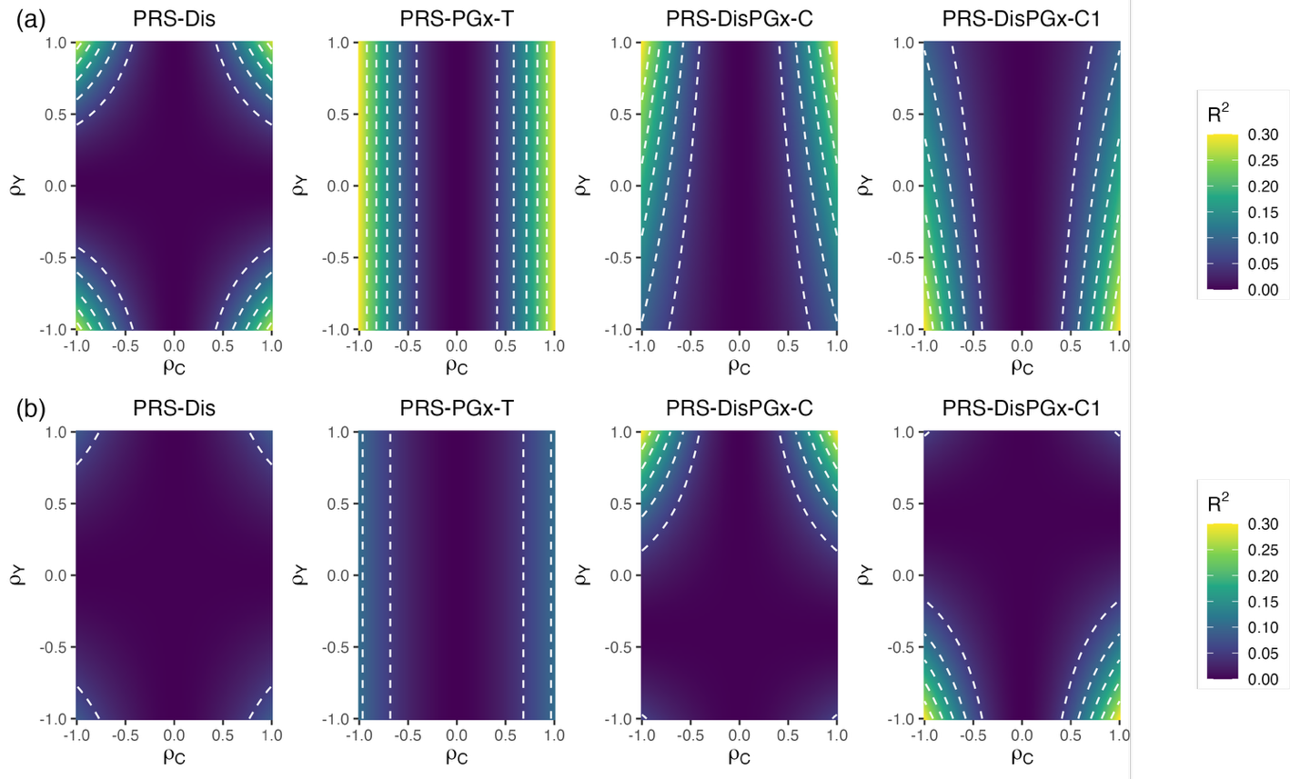

Figure S1. Theoretical prediction performance of PRS-Dis, PRS-PGx-T, PRS-DisPGx-C and PRS-DisPGx-C1 with fixed $ρ_{E}$. Theoretical drug response prediction accuracy (R²) of PRS-Dis, PRS-PGx-T, PRS-DisPGx-C and PRS-DisPGx-C1 as a function of $ρ_{Y}$ and $ρ_{C}$, with $h_{D}^{2}=0.3$ and (a) $ρ_{E}=0.8$, with $\max_{\left\{ρ_{Y}, ρ_{C}\right\}}{R^{2}}=0.276$ for PRS-Dis, $\max_{\left\{ρ_{Y}, ρ_{C}\right\}}{R^{2}}=0.293$ for PRS-PGx-T, and $\max_{\left\{ρ_{Y}, ρ_{C}\right\}}{R^{2}}=0.3$ for PRS-DisPGx-C, or (b) $ρ_{E}=-0.8$, with$\max_{\left\{ρ_{Y}, ρ_{C}\right\}}{R^{2}}=0.084$ for PRS-Dis, $\max_{\left\{ρ_{Y}, ρ_{C}\right\}}{R^{2}}=0.107$ for PRS-PGx-T, and $\max_{\left\{ρ_{Y}, ρ_{C}\right\}}{R^{2}}=0.3$ for PRS-DisPGx-C and PRS-DisPGx-C1.

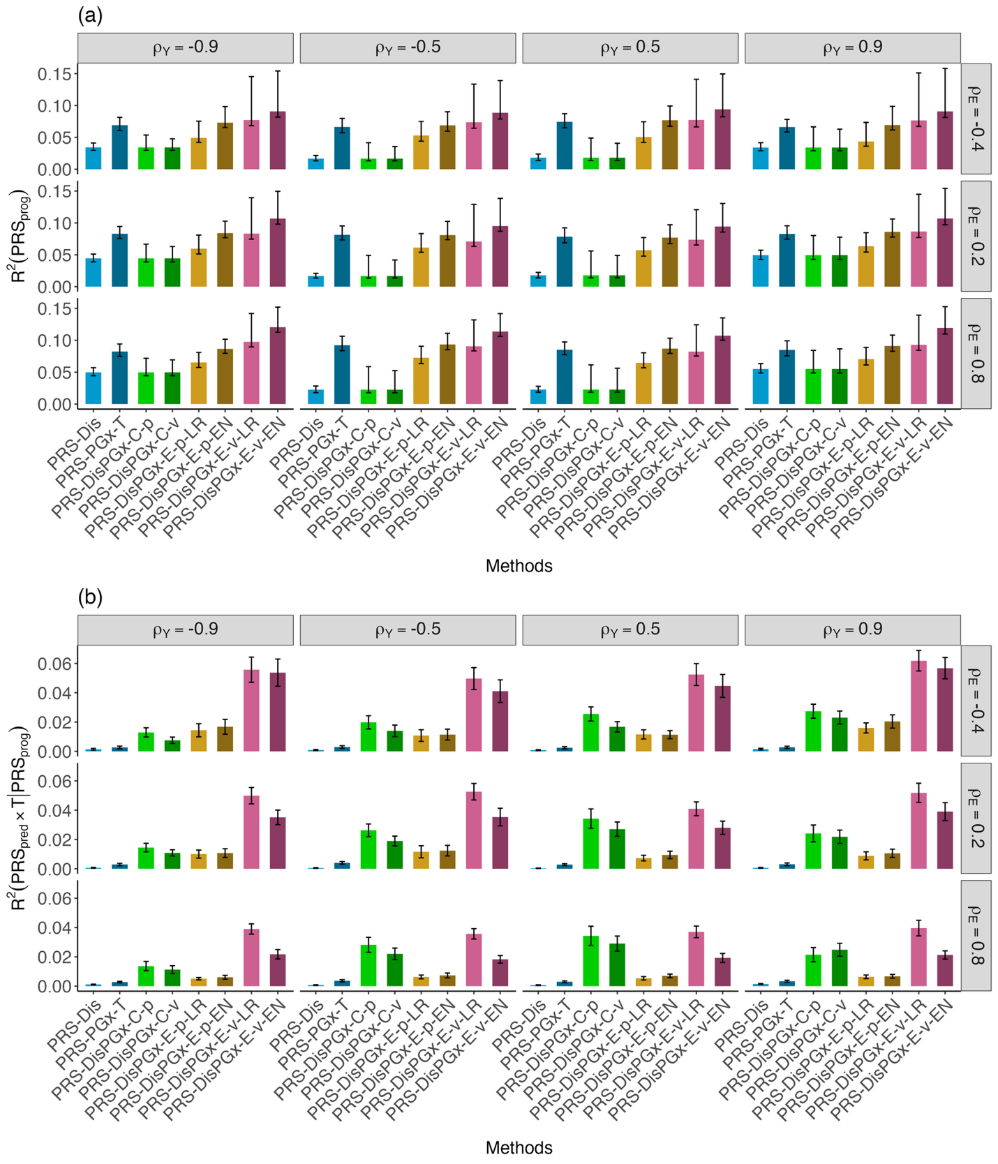

Figure S2. Method comparisons in terms of (a) $R^{2}(PRS_{prog})$: prognostic PRS R²; (b) $R^{2}(PRS_{pred}×T∣PRS_{prog})$: predictive PRS R², under different combinations of $ρ_{E}$ and $ρ_{Y}$ based on simulations. $ρ_{Y}∈\{-0.9, -0.5, 0.5, 0.9\}$, $ρ_{E}∈\{-0.4, 0.2, 0.8\}$, $p_{causal}=0.001$, $γ=1$, $h_{D}^{2}=0.3$, and $ρ_{C}=1$. The estimated PRS were computed from 18447 SNPs, and the presented statistics on the y-axis were obtained from regressions over 4000 target/testing samples (see subsections ‘Performance evaluation’ and ‘Simulation studies’ in the Methods section and Table 3 in the main text for more details). Error bars represent 95% confidence intervals derived from z-tests over 100 replications.

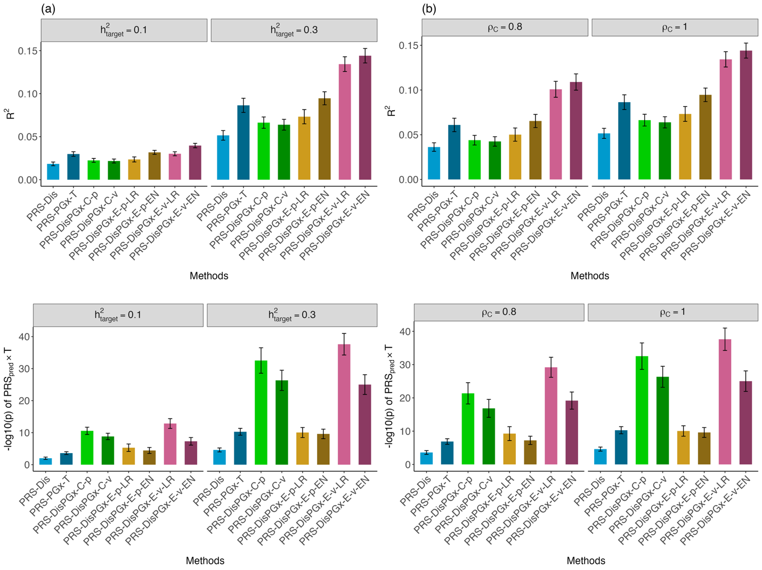
Figure S3 Sensitivity analyses on heritability of target cohort, $h_{D}^{2}$, and cohort-level genetic correlation, $ρ_{C}$. (a) $R^{2}$ and predictive p-value (-log10 scale) when $h_{D}^{2}=0.1$ versus $h_{D}^{2}=0.3$; $ρ_{C}=1$. (b) $R^{2}$ and predictive p-value (-log10 scale) when $ρ_{C}=0.8$ versus $ρ_{c}=1$; $h_{D}^{2}=0.3$. Other parameters are fixed to be $p_{causal}=0.001, ρ_{Y}=-0.9, ρ_{E}=0.8, γ=1$. For PRS-DisPGx-E, the ensemble weights were optimized in validation sets of 1000 samples. For Elastic-Net-based ensemble methods (PRS-DisPGx-E-p-EN and PRS-DisPGx-E-v-EN), the penalty term was selected via cross-validation in the validation sets. Data are presented as mean values +/− standard deviations (error bars) with 100 replications, where results were calculated from the testing sets of 4000 samples.

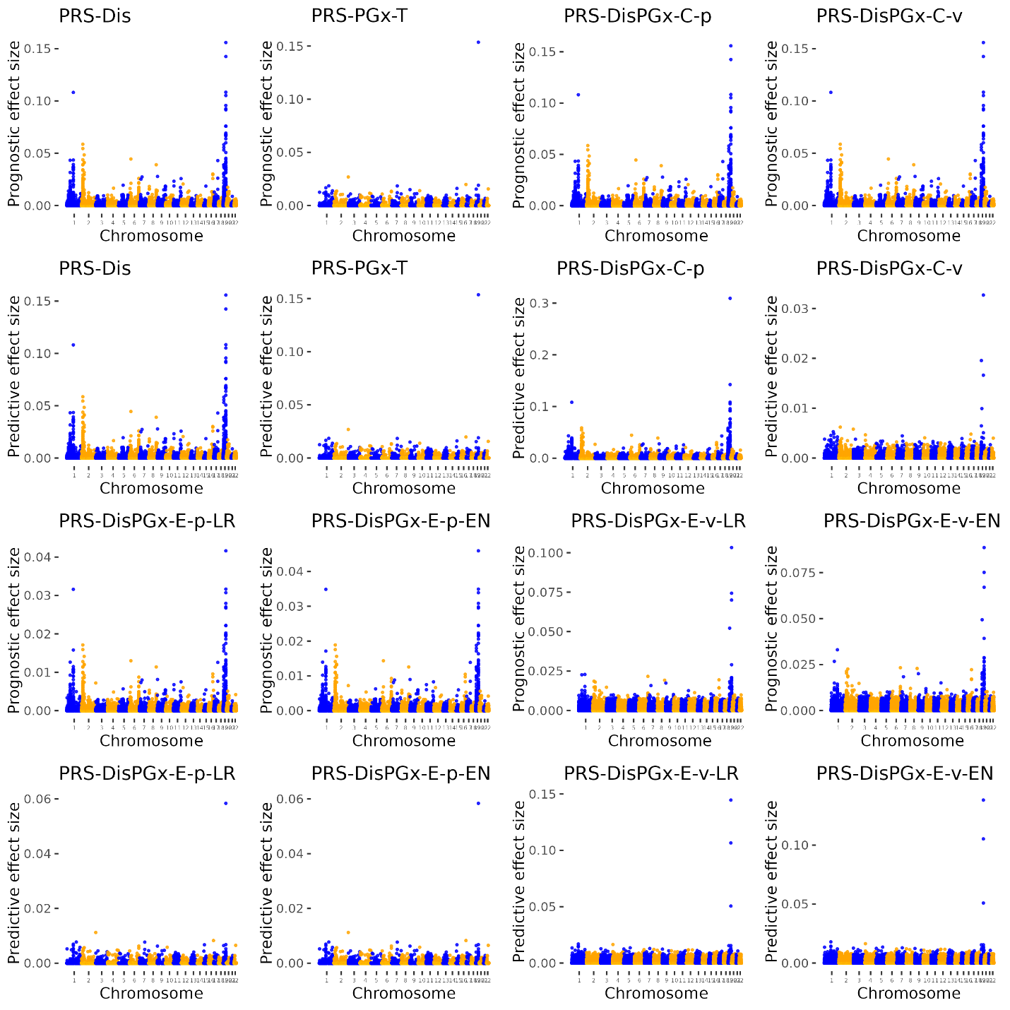
Figure S4. Prognostic and predictive effect size estimates across the whole genome in the PRS analysis of the IMPROVE-IT PGx GWAS dataset. The absolute values of the estimated prognostic/predictive effect sizes were presented. The prognostic and predictive effect sizes are the same for PRS-Dis and PRS-PGx-T, respectively, but differ for other methods.

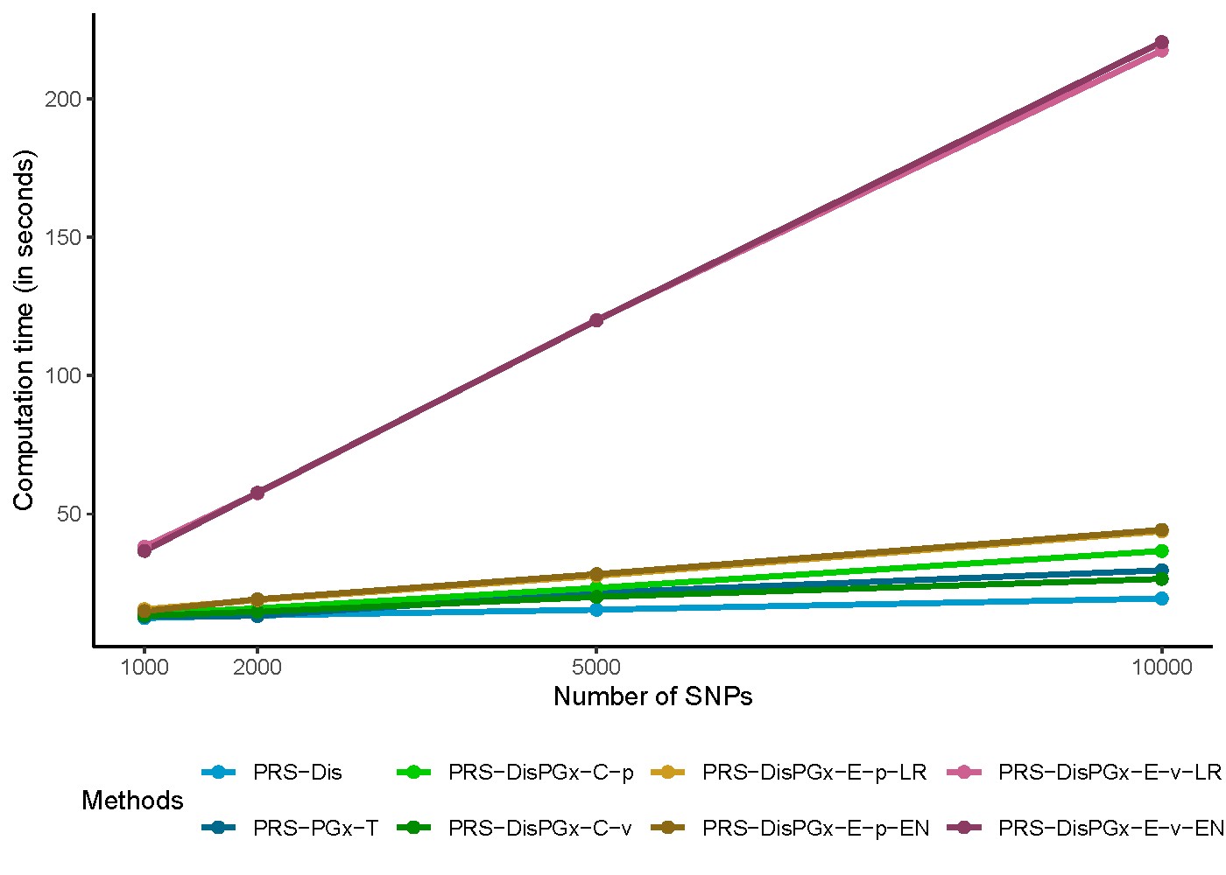
Figure S5. Computation time comparisons across eight PRS methods. The simulation was performed for 1000, 2000, 5000, or 10000 randomly selected SNPs from Chromosome 19. Simulation parameters are $h_{D}^{2}=0.3$, $p_{causal}=0.001$, $ρ_{Y}=0.9$, $ρ_{C}=1$, $ρ_{E}=0.8$, $γ=1$. Other simulation setup is the same as that in Table 2 in the main text.

Supplementary Tables

Table S1. Top 10 SNPs with largest (in magnitude) predictive effect sizes in the PRS analysis of the IMPROVE-IT PGx GWAS data. For PRS-Dis and PRS-PGx-T, the prognostic (prog) and predictive effects (pred) are the same, respectively. For PRS-DisPGx-C-v and PRS-DisPGx-E-vEN, the orders were determined by magnitudes of predictive effect sizes.
PRS-Dis (prog and pred) |  |  | PRS-PGx-T (prog and pred) |  |  | PRS-DisPGx-C-v (pred) |  |  | PRS-DisPGx-E-v-EN (pred)
CHR | SNP | Gene | CHR | SNP | Gene | CHR | SNP | Gene | CHR | SNP | Gene
19 | rs7412 | APOE | 19 | rs7412 | APOE | 19 | rs7412 | APOE | 19 | rs7412 | APOE
19 | rs405509 | APOE | 2 | rs4538195 |  | 19 | rs6511720 | LDLR | 19 | rs405509 | APOE
19 | rs157582 | TOMM40 | 16 | rs2247470 |  | 19 | rs4420638 | APOC1 | 19 | rs2075649
1 | rs17035630 |  | 19 | rs445925 |  | 19 | rs10401969 | SUGP1 | 19 | rs6859 | NECTIN2
19 | rs2075649 |  | 1 | rs16831518 |  | 19 | rs11668477 |  | 19 | rs769450 | APOE
19 | rs1160985 | TOMM40 | 7 | rs813379 |  | 2 | rs1367117 |  | 19 | rs1160985 | TOMM40
19 | rs769450 | APOE | 1 | rs11583007 |  | 2 | rs4538195 |  | 19 | rs8105340
19 | rs8105340 |  | 15 | rs12909871 |  | 1 | rs267733 |  | 19 | rs10401969 | SUGP1
19 | rs12610605 |  | 22 | rs5758756 |  | 19 | rs395908 |  | 1 | rs17035630
19 | rs8106922 | TOMM40 | 19 | rs1044250 |  | 1 | rs16831518 |  | 19 | rs12610605

