Supplementary information
Exosome derived from traumatic brain injury patients accelerates fracture healing via SMAD7 signaling regulation
Yuan Xiong^{1,2#}, Ze Lin^{1,2#}, Hang Xue^{1,2#}, Yiqiang Hu^{1,2}, Tao Yu³, Lang Chen^{1,2}, Adriana C. Panayi⁴, Wu Zhou^{1,2}, Yun Sun⁵, Faqi Cao^{1,2}, Ruiyin Zeng^{1,2}, Guodong Liu⁶, Bobin Mi^{1,2*}, Guohui Liu^{1,2*}

¹Department of Orthopaedics, Union Hospital, Tongji Medical College, Huazhong University of Science and Technology, Wuhan 430022, P. R. China
²Hubei Province Key Laboratory of Oral and Maxillofacial Development and Regeneration, Wuhan 430022, China
³Department of Orthopedic Surgery, Tongji Hospital, Tongji University School of Medicine, Shanghai 200065, China
⁴Department of Plastic Surgery, Brigham and Women’s Hospital, Harvard Medical School, Boston, MA 02152, USA
⁵Department of Neurosurgery, Union Hospital, Tongji Medical College, Huazhong University of Science and Technology, Wuhan 430022, P. R. China
⁶Medical Center of Trauma and War Injuries, Daping Hospital, Army Medical University, Chongqing 400042, P. R. China

Correspondence to: mibobin@hust.edu.cn (Bobin Mi), liuguohui@hust.edu.cn (Guohui Liu)

Yuan Xiong, Ze Lin and Hang Xue contributed equally to this work.

A B
Figure S1. The statistical results of CD31 (A) and Ki67 (B) analysis in the different groups.

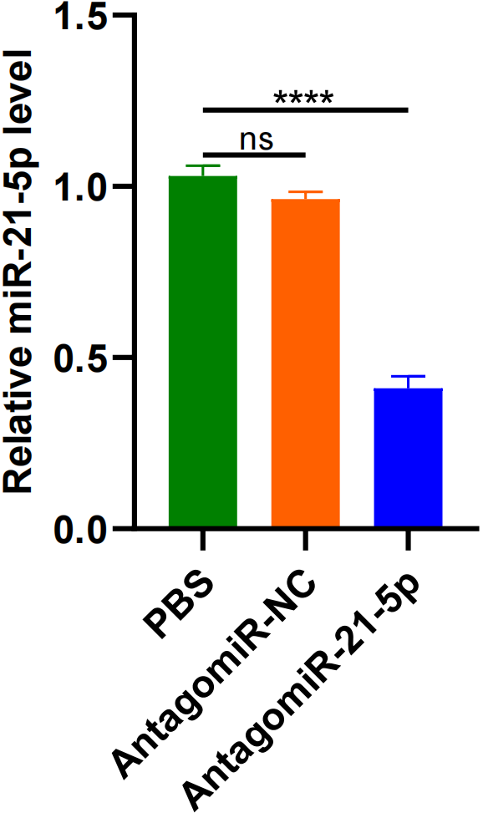
Figure S2. Relative miR-21-5p level of hBMSCs in the different groups was measured by qRT-PCR analysis.

A B
Figure S3. The statistical results of CD31 (A) and Ki67 (B) analysis in the different groups.

