Supplementary 1:
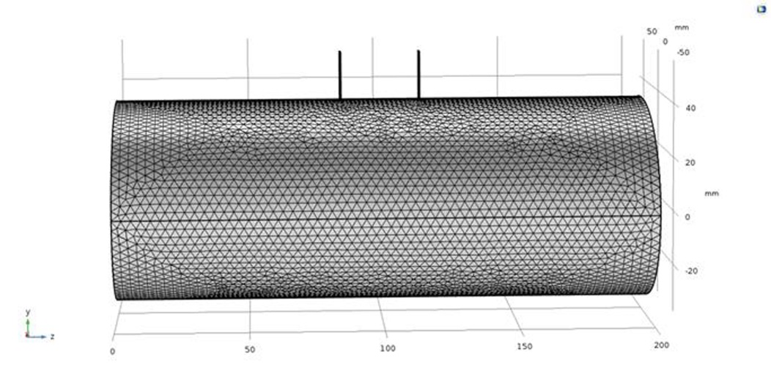
3-Dimensional Forearm Model

Supplementary 2:
Material | Electrical conductivity (σ)(S/m) | Electrical permittivity(ε)
Skin | 0.0025 | 8000
Fat | 0.01 | 20000
Blood | 0.7 | 5197
Muscle | 1 | 100000
Bone | 0.083 | 613
Nerve | 0.6 | 100000
Tissue material constants: σ, specific conductivity; ε, relative permeability

Supplementary 3:
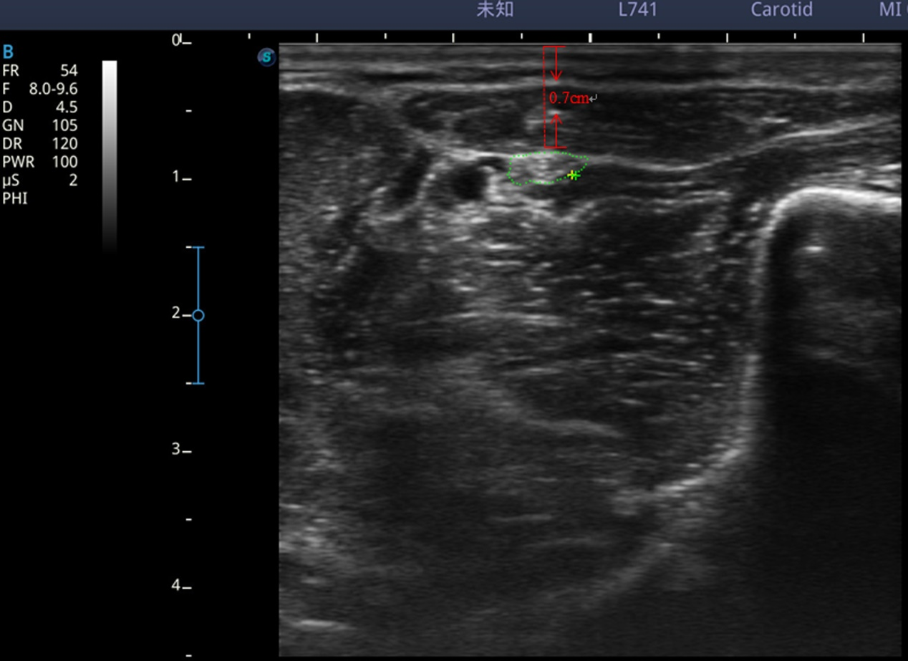
The image of ultrasound
The dotted green line is the cross-section of the median nerve; the red dotted line represents the distance from skin to nerve. An individualized depth plan was developed for each patient.
Supplementary 4:
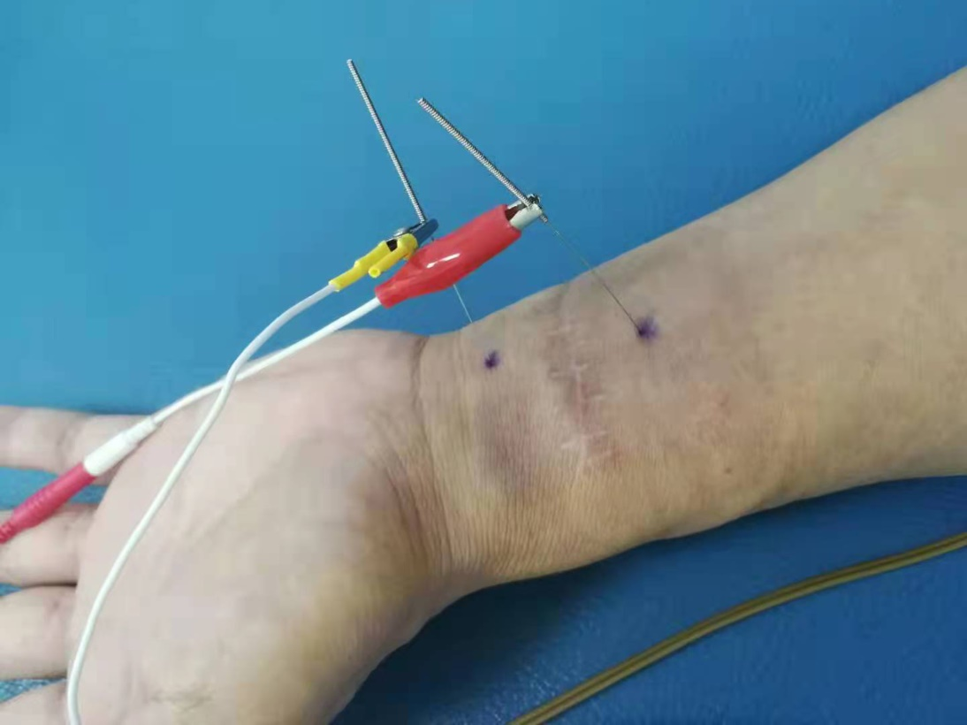
Percutaneous nerve stimulation
Supplementary 5:
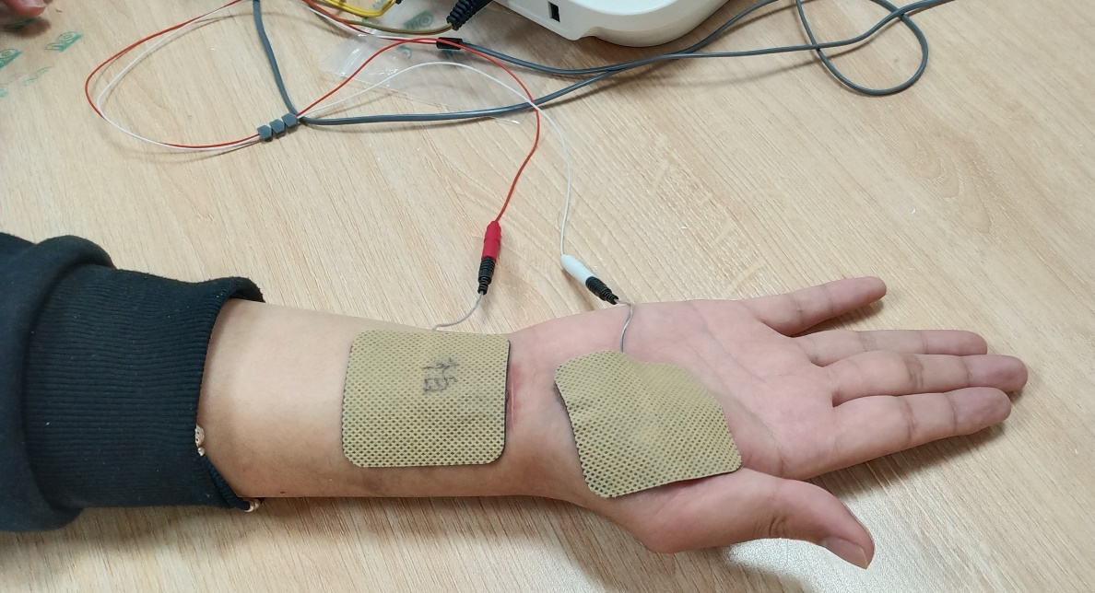
Transcutaneous electrical nerve stimulation
Supplementary 6:

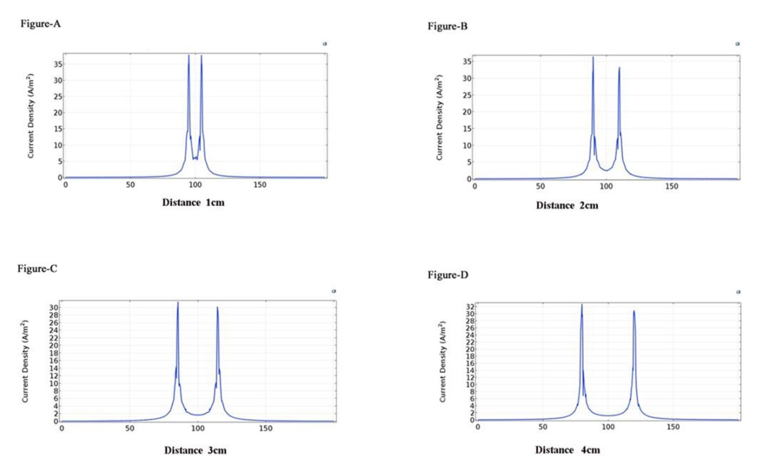
Current Density Distributions under Electrode at Different Distance

Supplementary 7:
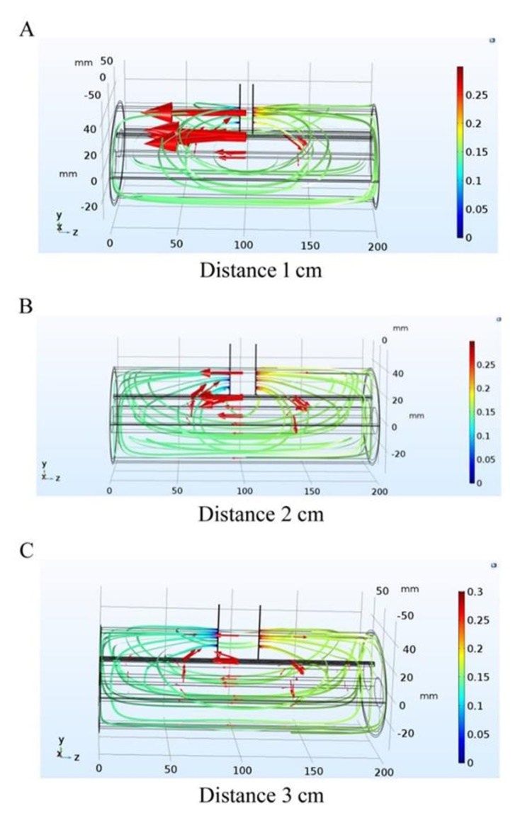
Current Distributions at Different Needle Distance
A: Electric potential distribution at 1cm distance between two needles; B: Electric potential distribution at 2cm distance between two needles; C: Electric potential distribution at 3cm distance between two needles.
Supplementary 8:

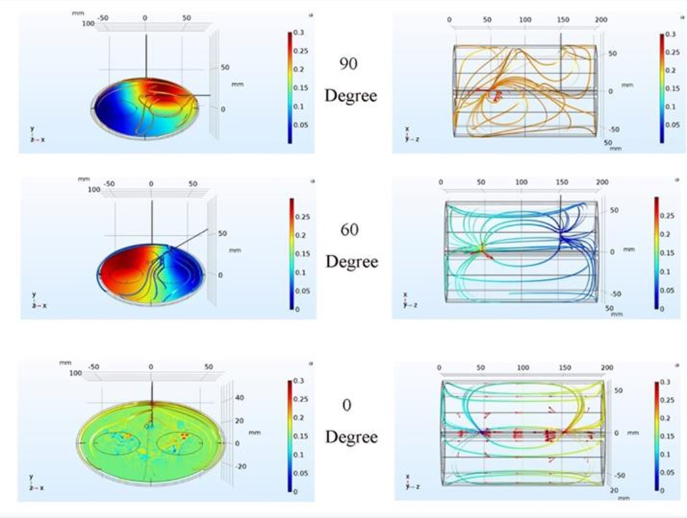
Current Density Distribution Diagram
Ultimately, we calculate percutaneous nerve stimulation optimal parameters by finite element modeling: parallel to each other, electrical needles are located at both ends of the injury nerve with a distance of 3 cm.

