Supplementary Materials
Beyond 30%: strategic strict protection delivers disproportionate biodiversity gains
Kaixuan Pan^{1,2✉️}, Jacobus C. Biesmeijer^{1,2}, Dylan Verheul³, Niels Raes¹ & Leon Marshall¹

1 Naturalis Biodiversity Center, Leiden, The Netherlands
2 Institute of Environmental Sciences, Leiden University, Leiden, The Netherlands
3 Stichting Observation International, Leiden, The Netherlands
✉️Corresponding author: kaixuan.pan@naturalis.nl (K.P)
Other co-authors’ emails: leon.marshall@naturalis.nl (L.M), dylan@observation.org (D.V), niels.raes@naturalis.nl (N.R), and koos.biesmeijer@naturalis.nl (J.C.B)

Table of contents:
Supplementary Table 1. Biodiversity conservation features and associated targets used in the prioritisation analysis.
Supplementary Table 2. Overview of systematic conservation planning scenarios designed in this study.
Supplementary Figure 1. Coverage of national species diversity in the observation dataset.
Supplementary Figure 2. Distribution of protected areas across the Netherlands.
Supplementary Figure 3. Distribution of strictly protected areas across the Netherlands.

Supplementary Table 1. Biodiversity conservation features and associated targets used in the prioritisation analysis. Targets reflect international and EU biodiversity frameworks. A 30% target is applied to most features in line with the EU Biodiversity Strategy for 2030 and the Kunming-Montreal Global Biodiversity Framework, while irreplaceable areas such as Key Biodiversity Areas and primary forests are assigned a 100% protection target.
Biodiversity Feature | Target (%) | Rationale and Source
Habitat Directive species | 30 | EU Biodiversity Strategy for 2030; O'Connor et al., 2024
Bird Directive species | 30 | EU Biodiversity Strategy for 2030; O'Connor et al., 2024
Key Biodiversity Areas (KBAs) | 100 | GBF Target 3; Plumptre et al., 2024; KeyBiodiversityAreas.org
Primary forests | 100 | EU 2030 target for strict protection of old-growth forests; European Commission Biodiversity Tracker
Habitat Directive habitats | 30 | EU Biodiversity Strategy for 2030; O'Connor et al., 2024
Red List species richness | 30 | In line with EU and GBF 2030 biodiversity targets
Total species richness (hotspots) | 30 | Proxy for overall biodiversity; aligned with EU/GBF 2030 conservation targets
Redlisted species proportion (RLSP) | 30 | Indicates ecosystem-level threat levels; target set in line with EU/GBF priorities

Supplementary Table 2. Overview of systematic conservation planning scenarios designed in this study. Each scenario includes different combinations of biodiversity features and optionally uses the current protected area (PA) network as a baseline constraint. All scenarios apply the conservation targets defined in Table 1. “X” indicates the inclusion of a biodiversity feature or planning constraint in the prioritisation analysis.
Scenario | Habitat Directive species | Bird Directive species | KBAs | Primary forests | Red List species richness | Total species richness | Redlisted species proportion (RLSP) | Current PAs as baseline
Baseline |  |  |  |  |  |  |  | X
Scenario 1a | X | X
Scenario 1b | X | X |  |  |  |  |  | X
Scenario 2a | X | X | X | X | X | X
Scenario 2b | X | X | X | X | X | X |  | X
Scenario 3a | X | X | X | X |  |  | X
Scenario 3b | X | X | X | X |  |  | X | X
Scenario 4a | X | X | X | X | X | X | X
Scenario 4b | X | X | X | X | X | X | X | X

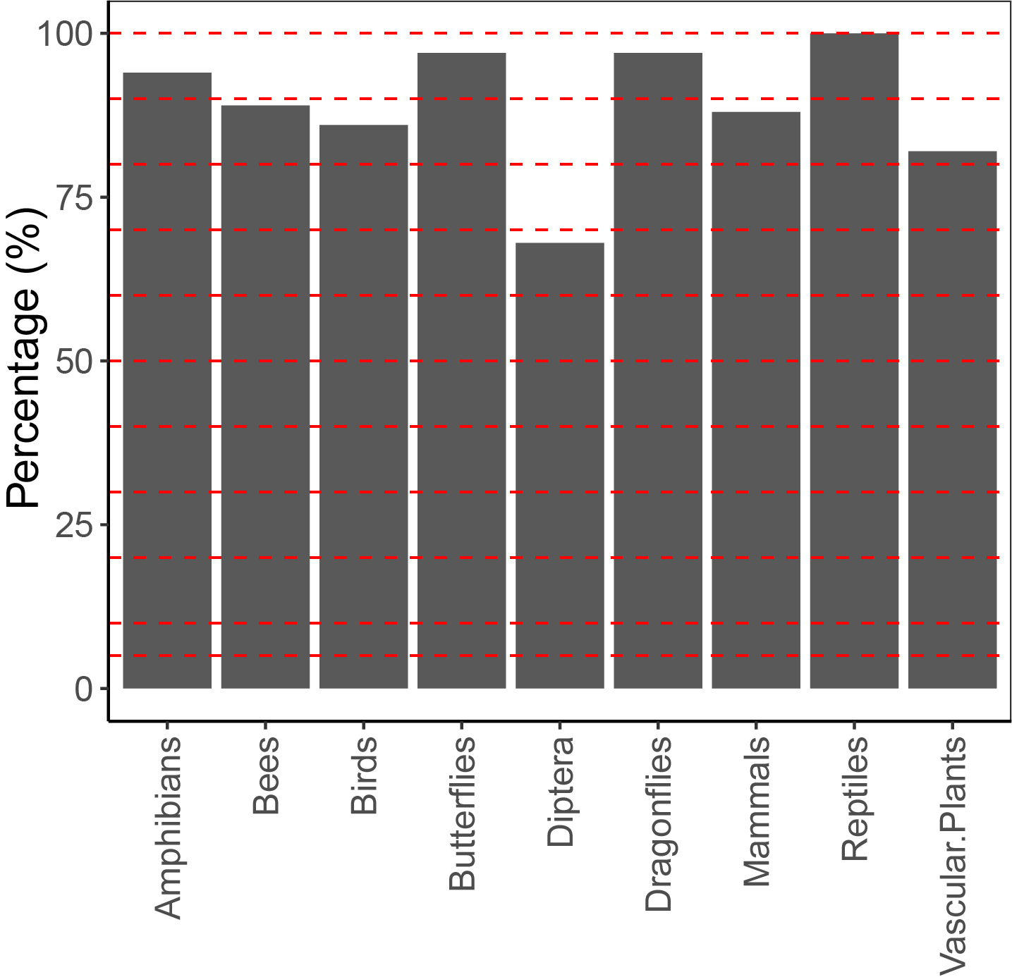
Supplementary Figure 1. Coverage of national species diversity in the observation dataset. Percentage of native species recorded in waarneming.nl relative to the total number of species listed in the Dutch Species Register, shown by taxonomic group.

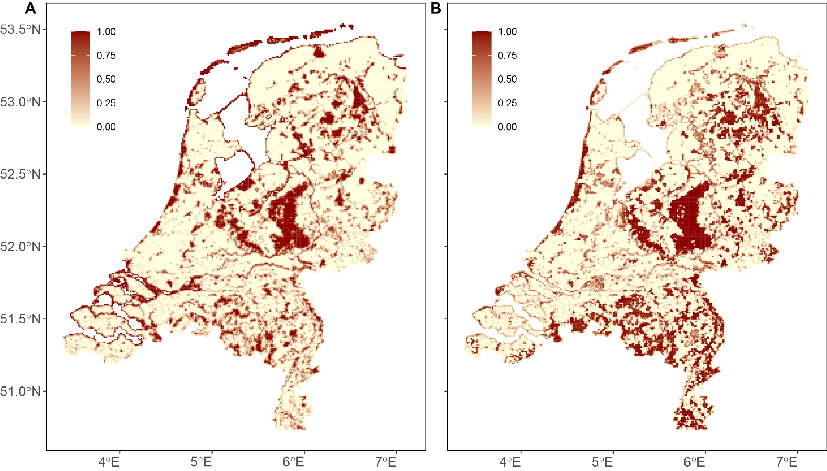

Supplementary Figure 2. Distribution of protected areas across the Netherlands. The red colour gradient indicates the percentage of protected area within each 1 km × 1 km grid cell, with darker shades representing higher coverage.

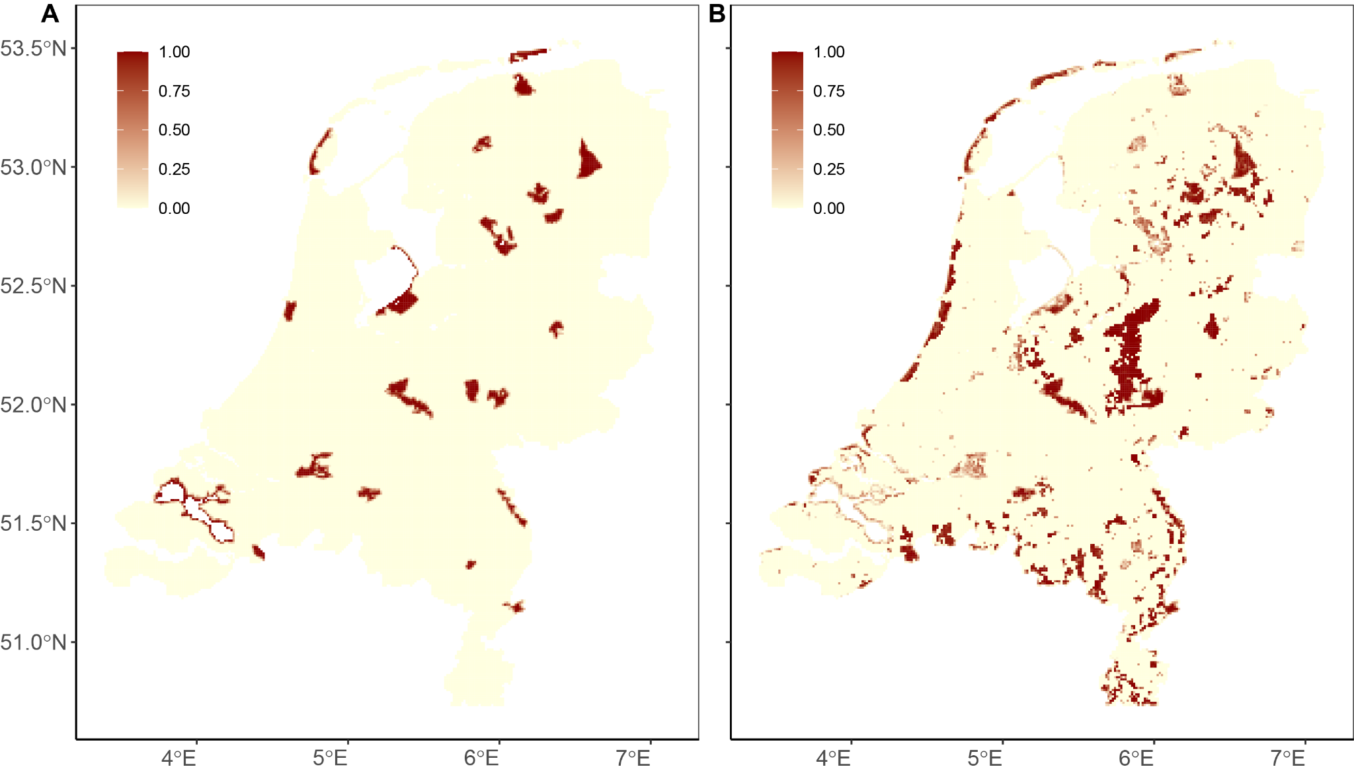
Supplementary Figure 3. Distribution of strictly protected areas across the Netherlands. The red colour gradient indicates the percentage of strictly protected area within each 1 km × 1 km grid cell, with darker shades representing higher coverage.

References
O'Connor, L.; Visconti, P.; Beher, J. (2024): Approaches to identify terrestrial priority areas for achieving the 30% and 10% protection target in the EU. (ETC BE Report 2024/4): European Topic Centre on Biodiversity and Ecosystems. Available online at https://pure.iiasa.ac.at/id/eprint/20359/.
Plumptre, Andy; Hayes, Jack; Baisero, Daniele; Rose, Rob; Holness, S.; Staden, Lize von; Smith, Robert J. (2024): Strengths and complementarity of systematic conservation planning and key biodiversity area approaches for spatial planning. In Conservation Biology, e14400. DOI: 10.1111/cobi.14400.

