Appendix A. 2021 UK Census Ethnicity Breakdown
Our analysis gains further salience when contextualized demographically. While Black players constitute approximately 40% of English Premier League rosters, the UK Census (2021) reports that only about 5.3% of the population identifies as Black or Black/mixed. This significant overrepresentation in professional soccer reflects both high levels of talent and historical pathways into professional soccer in the UK, but it also makes questions of structural bias and institutional inclusion more pressing. Simulating the impact of exclusionary selection not only illustrates potential losses in team performance but also underscores the broader social costs of limiting access to elite sports participation. Further insights on the ethnicity distribution in England and Wales are available in Table A1 below.
Table A1. Ethnicity in England and Wales, UK Census 2021
Ethnicity | Population | Percentage (%)
Black | 2,409,283 | 4.0
Black African | 1,488,387 | 2.5
Black Caribbean | 623,115 | 1.0
Black other | 297,781 | 0.5
Asian | 5,515,455 | 9.3
Bangladeshi | 644,900 | 1.1
Chinese | 445,646 | 0.7
Indian | 1,864,304 | 3.1
Pakistani | 1,587,822 | 2.7
Asian other | 972,783 | 1.6
Mixed | 1,717,977 | 2.9
Mixed White/Asian | 488,228 | 0.8
Mixed White/Black African | 249,593 | 0.4
Mixed White/Black Caribbean | 513,040 | 0.9
Mixed other | 467,116 | 0.8
White | 48,699,231 | 81.7
White British | 44,355,044 | 74.4
White Irish | 507,473 | 0.9
White Gypsy/Traveller | 67,757 | 0.1
White other | 3,667,993 | 6.2
White Roma | 100,964 | 0.2
Other | 1,255,632 | 2.1
Arab | 331,856 | 0.6
Any other | 923,776 | 1.6
All | 59,597,578 | 100.0
Notes: This table reports the ethnic composition of England and Wales based on the 2021 UK Census. Categories reflect the official Census classification, with subgroups listed under broader ethnic groups. Percentages are based on the total population and may not sum exactly to 100 due to rounding.

Appendix B. Competitive Tournaments: Sample Breakdown
Table A2. Sample Frequency Distribution of International Soccer Matches by Competition Type (n = 3,380)
Competition Name | n(Matches) | Percentage of Total
FIFA World Cup qualification | 837 | 24.76%
UEFA Nations League | 652 | 19.29%
African Cup of Nations qualification | 548 | 16.21%
UEFA Euro qualification | 501 | 14.82%
African Cup of Nations | 186 | 5.50%
UEFA Euro | 153 | 4.53%
FIFA World Cup | 128 | 3.79%
Copa America | 118 | 3.49%
Gold Cup | 118 | 3.49%
AFC Asian Cup | 99 | 2.93%
AFC Asian Cup qualification | 40 | 1.18%
Total | 3,380 | 100.00%

Appendix C. Top 15 English Right-Wingers by Transfermarkt Valuation in 2024
Table A3. Top 15 English Right-Wingers (2024) by TM Valuations
Overall Order | Player Name | TM Valuation (mln. €) | Preferred Foot
1 | Bukayo Saka | 150 | Left
2 | Phil Foden | 130 | Left
3 | Ethan Nwaneri | 55 | Left
4 | Jarrod Bowen | 45 | Left
5 | Noni Madueke | 40 | Left
6 | Mason Greenwood | 35 | Both
7 | Tyler Dibling | 25 | Left
8 | Reiss Nelson | 18 | Right
9 | Jacob Murphy | 16 | Right
10 | Jack Harrison | 16 | Left
11 | Marcus Edwards | 15 | Left
12 | Raheem Sterling | 15 | Right
13 | Romain Esse | 12 | Left
14 | Morgan Whittaker | 11 | Left
15 | Solly March | 8 | Left

Appendix D. Minutes-Weighted Counterfactual Estimation
This appendix presents a robustness check of the main counterfactual analysis by incorporating actual minutes played into the construction of team-level market valuations. Whereas the baseline estimates implicitly rely on a starting-eleven framework, match outcomes in international football may be influenced by substitutions, as we mention in the main body of the paper. The minutes-weighted approach explicitly accounts for these features while preserving comparability with the main results.
For each match, individual player valuations are weighted by the share of regulation time the player was on the pitch. Formally, the minutes-weighted valuation contribution of player $i$ in match $t$ is defined as:
$$V_{it}^{\text{min}} = V_{it}×\frac{{\text{Minutes}}_{it}}{90},$$
where $V_{it}$ denotes the player’s market valuation (or counterfactual valuation where applicable), and ${\text{Minutes}}_{it}$ represents the number of minutes played in regulation time. This calibration ensures that substitutes contribute proportionally less to the team’s cumulative valuation, while starters who are substituted early are correspondingly down-weighted. Match-level team valuations are then obtained by summing $V_{it}^{\text{min}}$ across all players who appeared in the match. The resulting measure can be interpreted as a 90-minute-equivalent cumulative team valuation.
In Table A4, we report summary statistics for England’s cumulative team valuation under the actual roster and three counterfactual scenarios using minutes-weighted valuations. The relative ordering of scenarios and the magnitude of valuation gaps closely mirror those obtained under the starting-eleven assumption. In particular, counterfactual scenarios involving the exclusion or replacement of specific player groups continue to exhibit economically meaningful reductions in cumulative valuation relative to the actual roster, indicating that the baseline results are not driven by assumptions about full-match participation.
Table A4. Summary Statistics: Minutes-Weighted Cumulative Team Valuations for England Under Actual and Three Counterfactual Scenarios ($n$ = 80 matches – England matches only)
Scenario | Mean (mln. €) | Median (mln. €) | St. Dev. (mln. €) | Min. (mln. €) | Max. (mln. €) | % Change in Mean
“Actual” England | 618.613 | 618.417 | 128.003 | 231.167 | 938.089 | —
“Non-Black England” | 464.689 | 463.747 | 101.281 | 182.250 | 640.044 | -24.88%
“Black-Only England” | 447.585 | 439.169 | 110.521 | 135.861 | 729.800 | -27.64%
“Black-Only (Except Goalkeeper) England” | 469.988 | 471.594 | 110.276 | 148.611 | 748.000 | -24.04%
Notes: This table reports cumulative market valuations (in millions of euros) for England’s national team, weighted by minutes played ($\text{Min}/90$), under the actual roster and three counterfactual scenarios. The “Non-Black England” scenario replaces Black players with the next-highest-valued non-Black English players. The “Black-Only England” scenario includes only Black players, while the “Black-Only (Except Goalkeeper)” variant retains the actual goalkeeper valuation. Percentage changes reflect differences in mean valuation relative to the minutes-weighted actual roster.
Using the minutes-weighted valuations, predicted win probabilities are re-estimated for each match under the same structural mapping from valuation ratios to outcome probabilities as in the main analysis. In Table A5, we report pairwise comparisons of mean predicted win probabilities across scenarios, along with paired t-tests conducted at the match level.
Consistent with the valuation results, the minutes-weighted estimates yield changes in expected win probabilities that are quantitatively similar to those obtained under the baseline specification. Differences between the actual roster and counterfactual team compositions remain statistically significant in nearly all pairwise comparisons. The findings that we present in this appendix indicate that the counterfactual effects documented in the main text are robust to accounting for substitutions and unequal playing time.
Table A5. Minutes-Weighted Differences in England’s Expected Win Probability Under Counterfactual Team Compositions
Scenario Pairs | Mean Win Probability (1st) | Mean Win Probability (2nd) | Mean Difference | 95% Conf. Interval | p-value
Actual vs. Non-Black England | 0.738 | 0.708 | 0.030 | (0.026, 0.034) | 0.0000
Actual vs. Black-Only England | 0.738 | 0.703 | 0.036 | (0.032, 0.040) | 0.0000
Actual vs. Black-Only (Except Goalkeeper) England | 0.738 | 0.708 | 0.030 | (0.027, 0.034) | 0.0000
Non-Black vs. Black-Only England | 0.708 | 0.703 | 0.005 | (0.001, 0.010) | 0.0156
Non-Black vs. Black-Only (Except Goalkeeper) England | 0.708 | 0.708 | -0.000 | (-0.004, 0.004) | 0.8760
Black-Only vs. Black-Only (Except Goalkeeper) England | 0.703 | 0.708 | -0.006 | (-0.006, -0.005) | 0.0000
Notes: This table reports pairwise comparisons of England’s mean predicted win probabilities under the actual roster and three counterfactual team compositions, using minutes-weighted cumulative team valuations that account for substitutions and unequal playing time. The second and third columns present the average predicted win probability for each scenario, while the fourth column reports the mean difference between paired match-level predictions. Confidence intervals and p-values are based on paired t-tests, with each match serving as its own control.

Appendix E. Graphical Distribution of Transfermarkt Player Valuations by Year
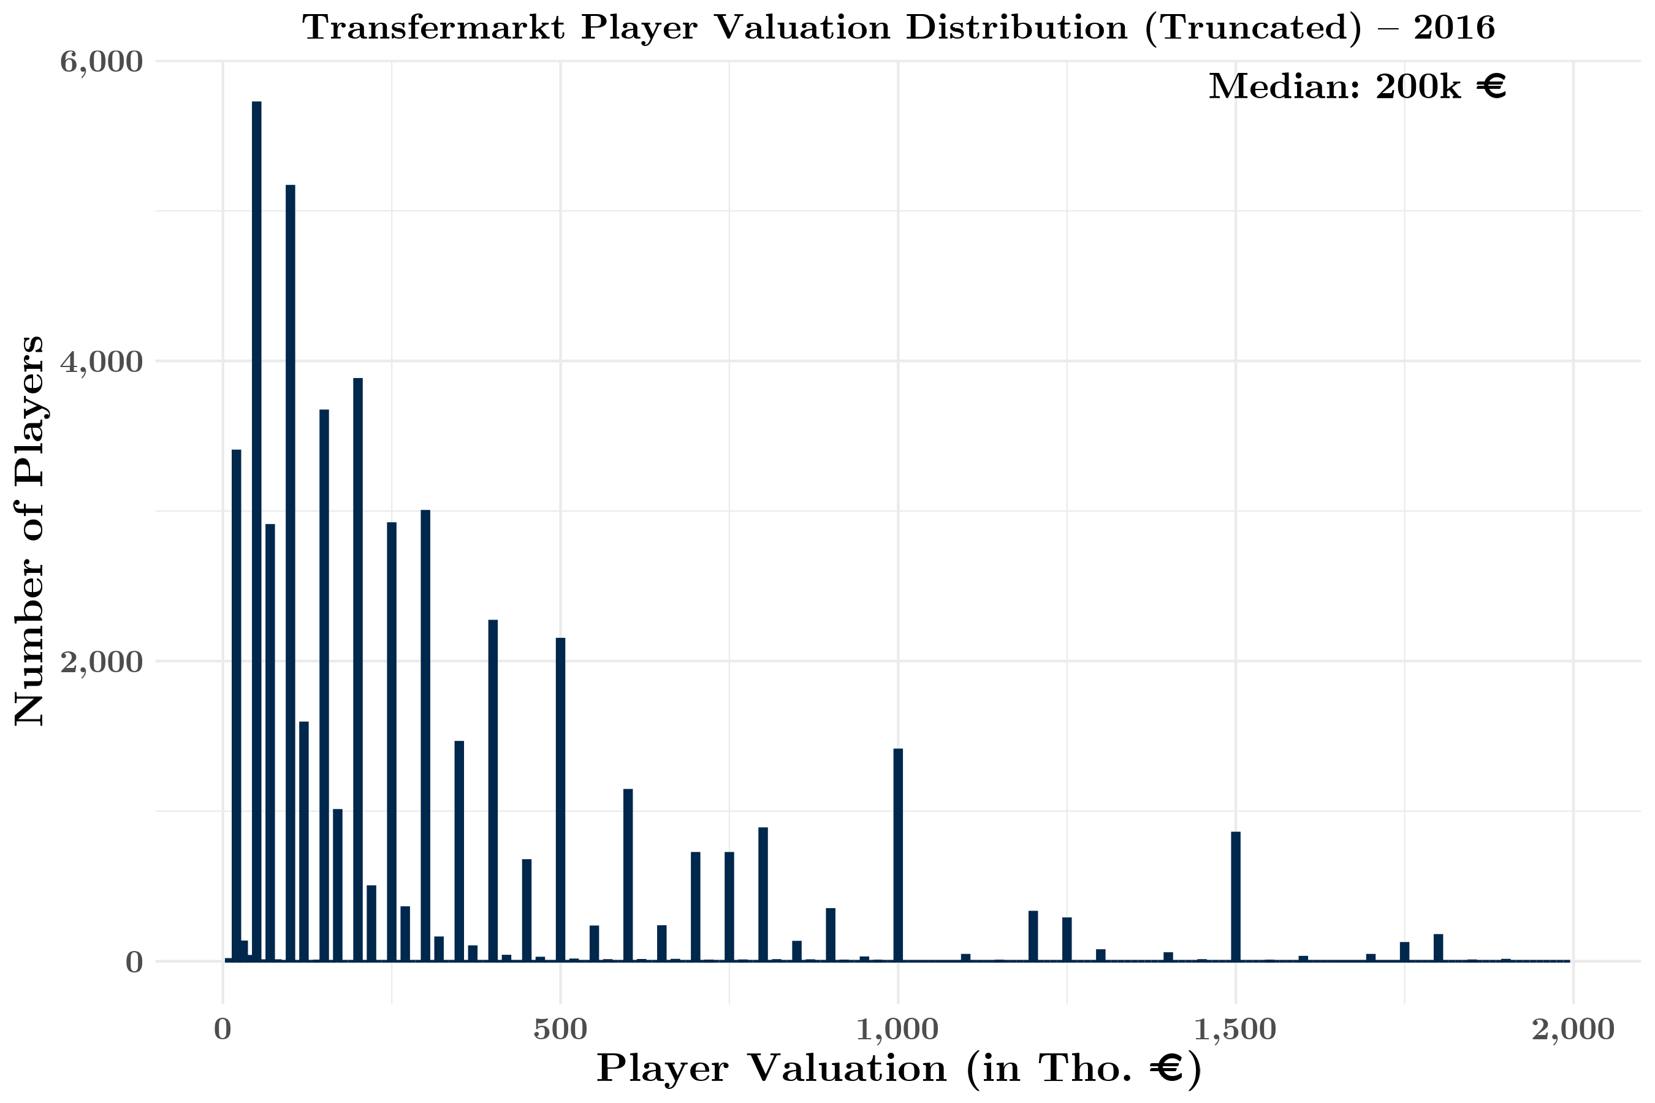
Figure A1. Histogram (Truncated at €2 mln.) of Transfermarkt Player Valuations for 2016–17 Season (n = 52,702)
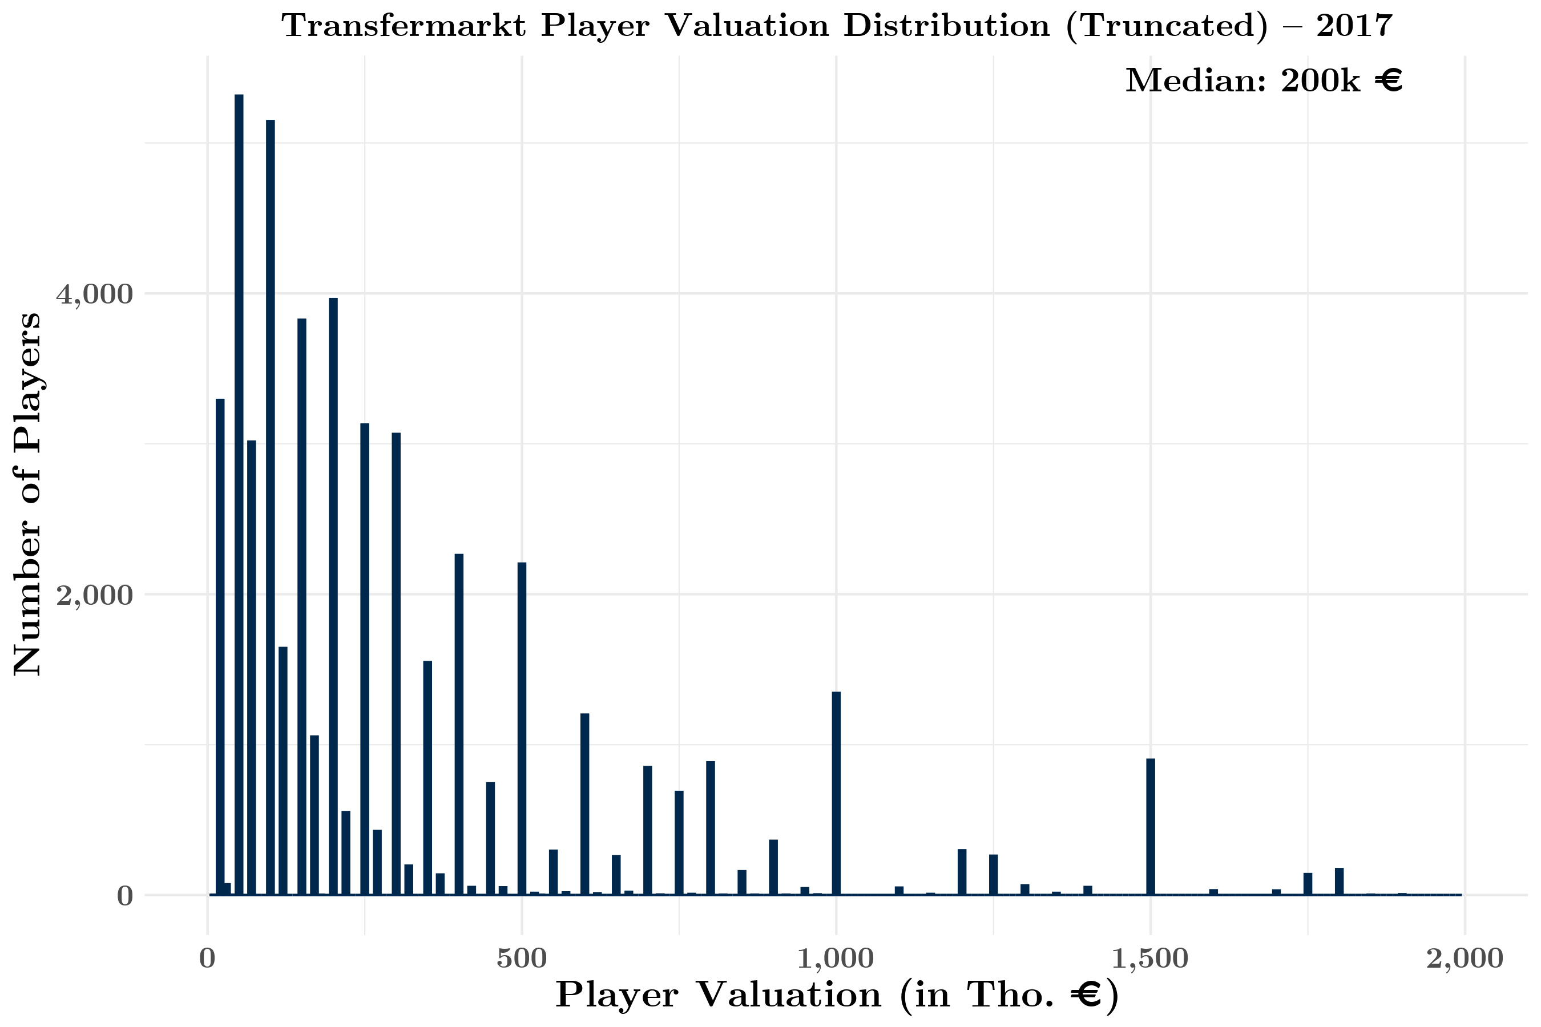
Figure A2. Histogram (Truncated at €2 mln.) of Transfermarkt Player Valuations for 2017–18 Season (n = 53,708)
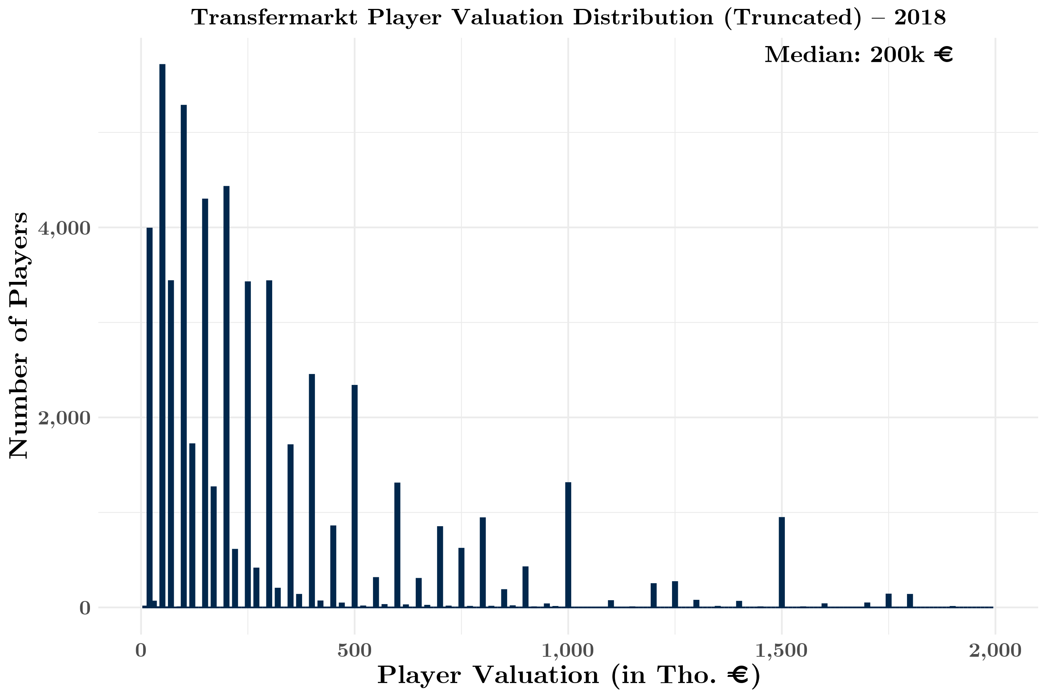
Figure A3. Histogram (Truncated at €2 mln.) of Transfermarkt Player Valuations for 2018–19 Season (n = 58,391)
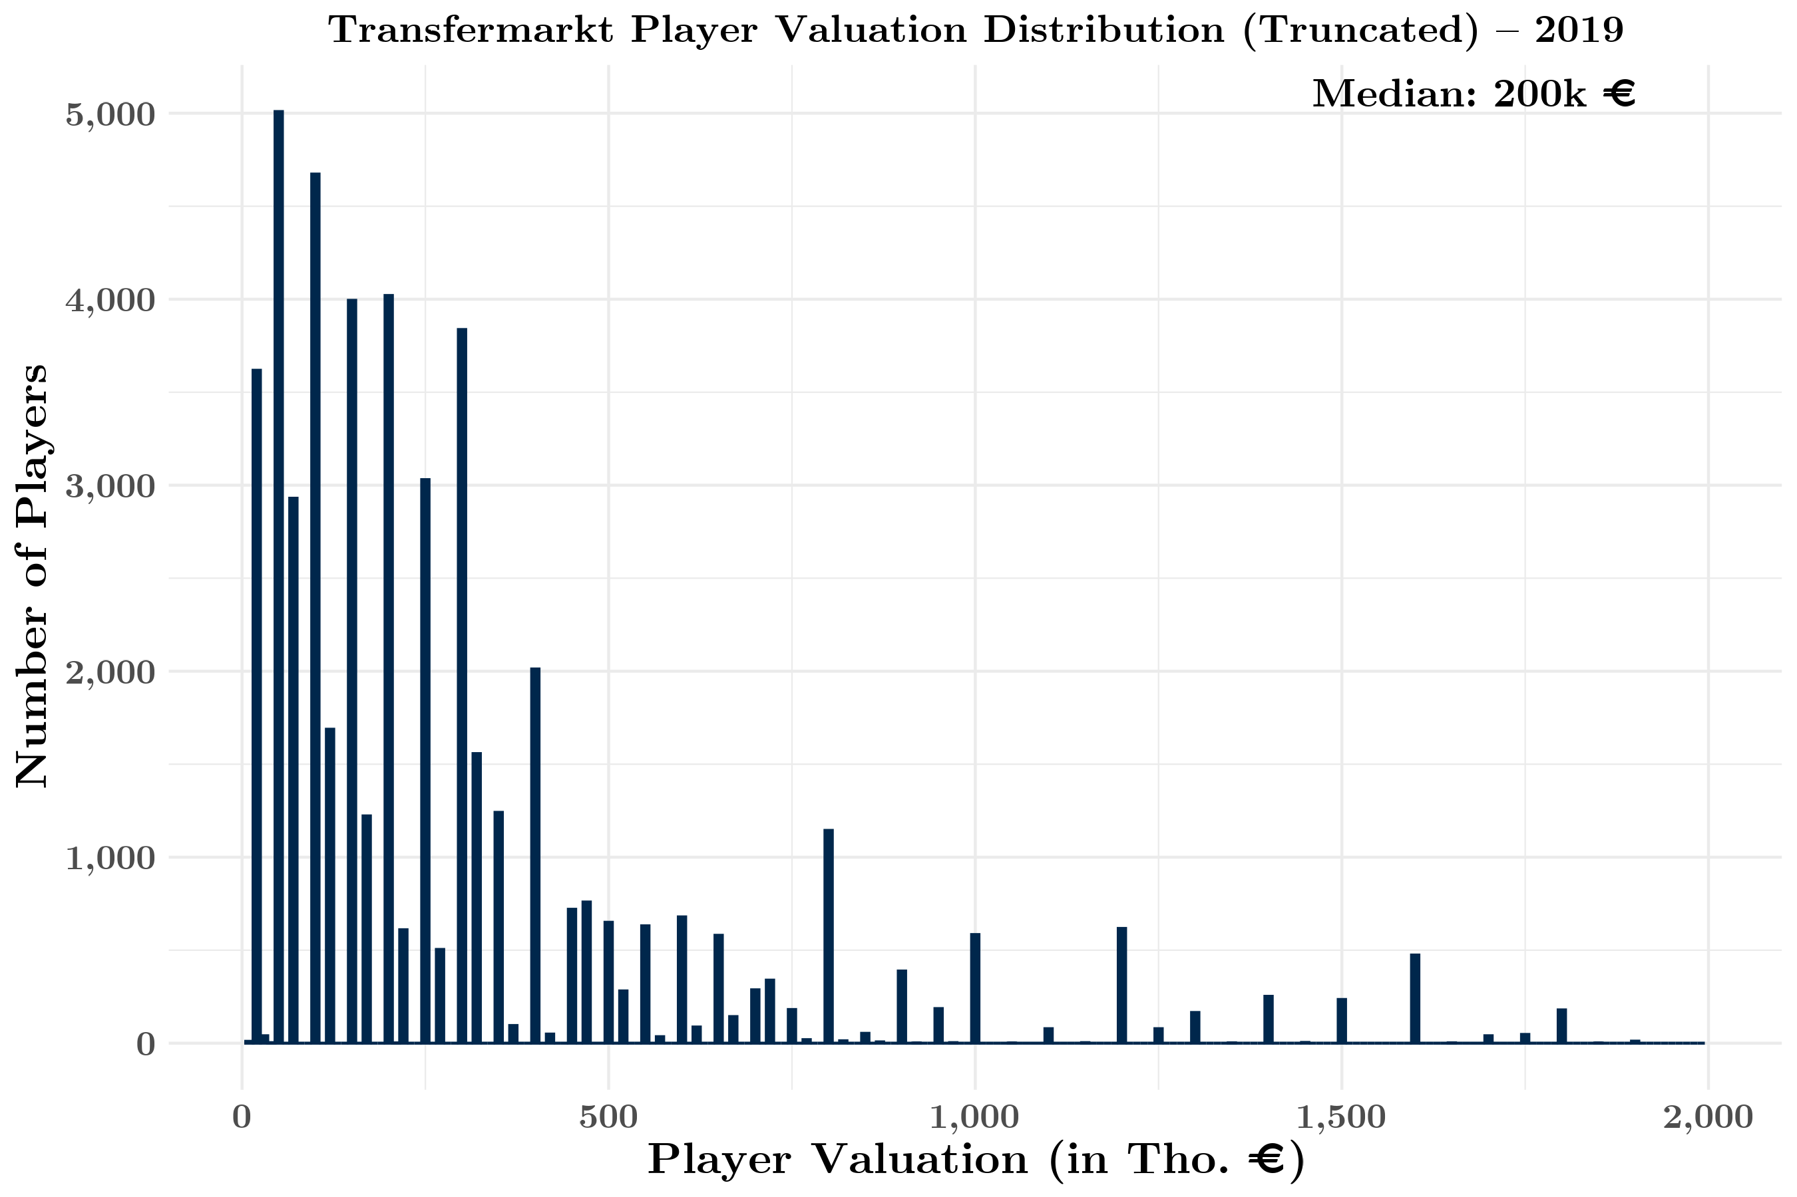
Figure A4. Histogram (Truncated at €2 mln.) of Transfermarkt Player Valuations for 2019–20 Season (n = 54,285)
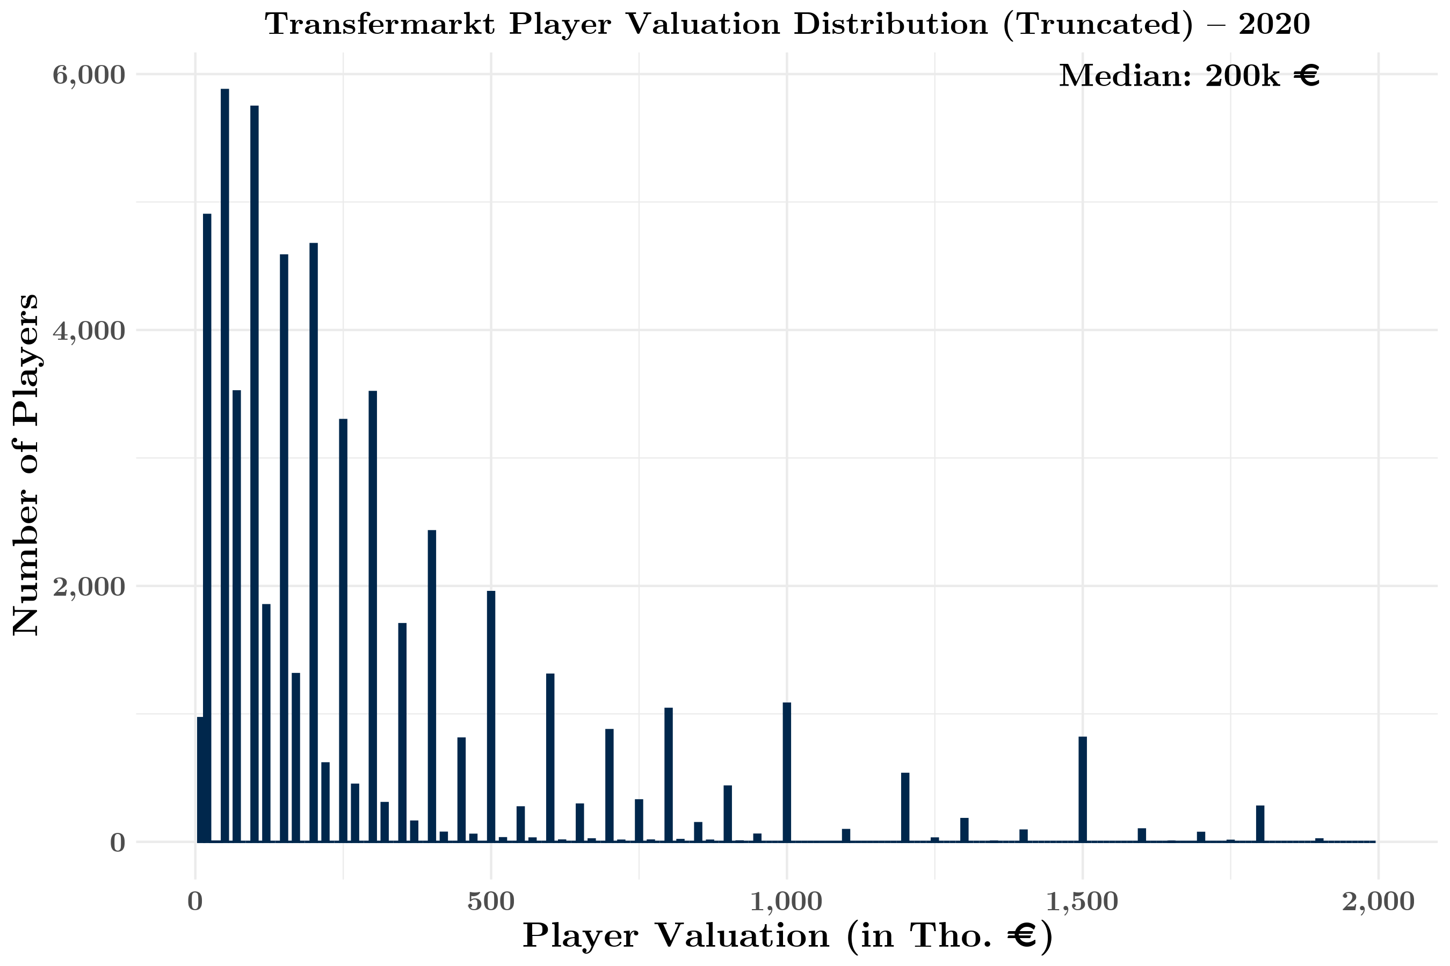
Figure A5. Histogram (Truncated at €2 mln.) of Transfermarkt Player Valuations for 2020–21 Season (n = 61,578)
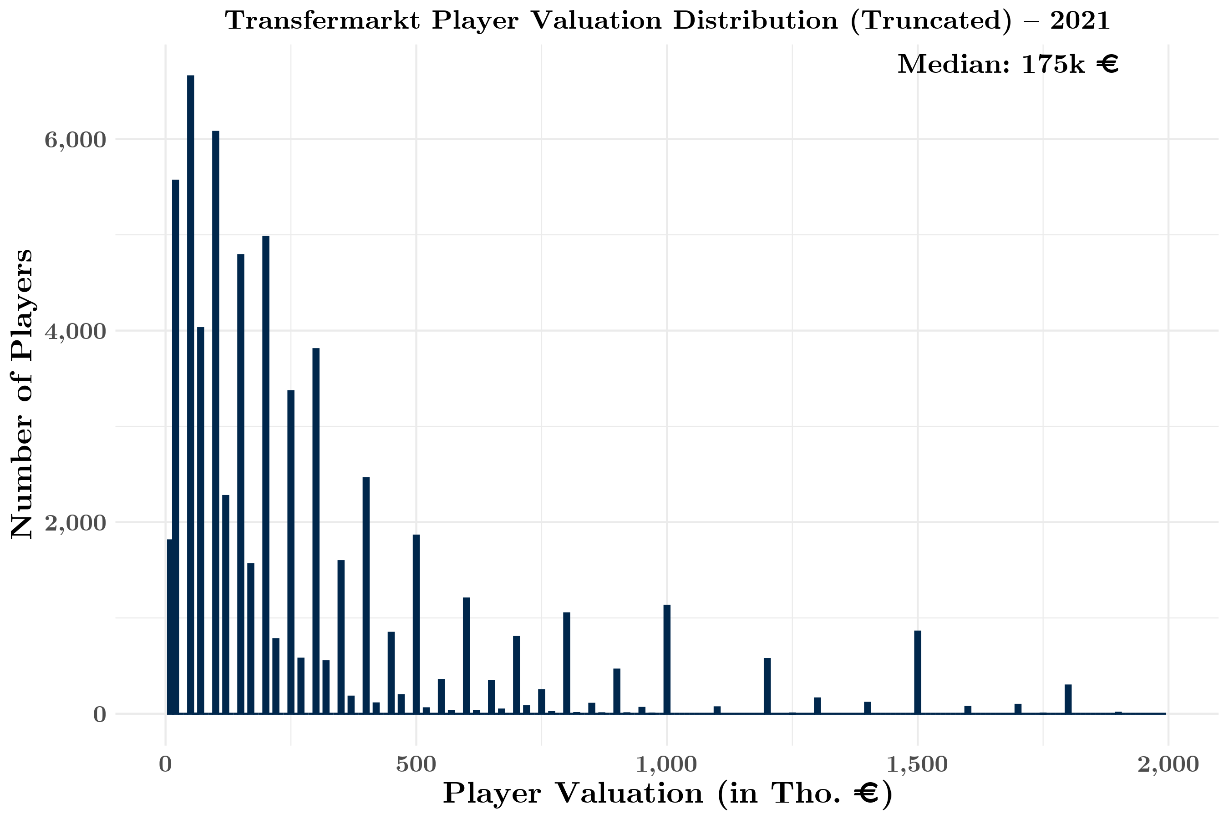
Figure A6. Histogram (Truncated at €2 mln.) of Transfermarkt Player Valuations for 2021–22 Season (n = 67,214)
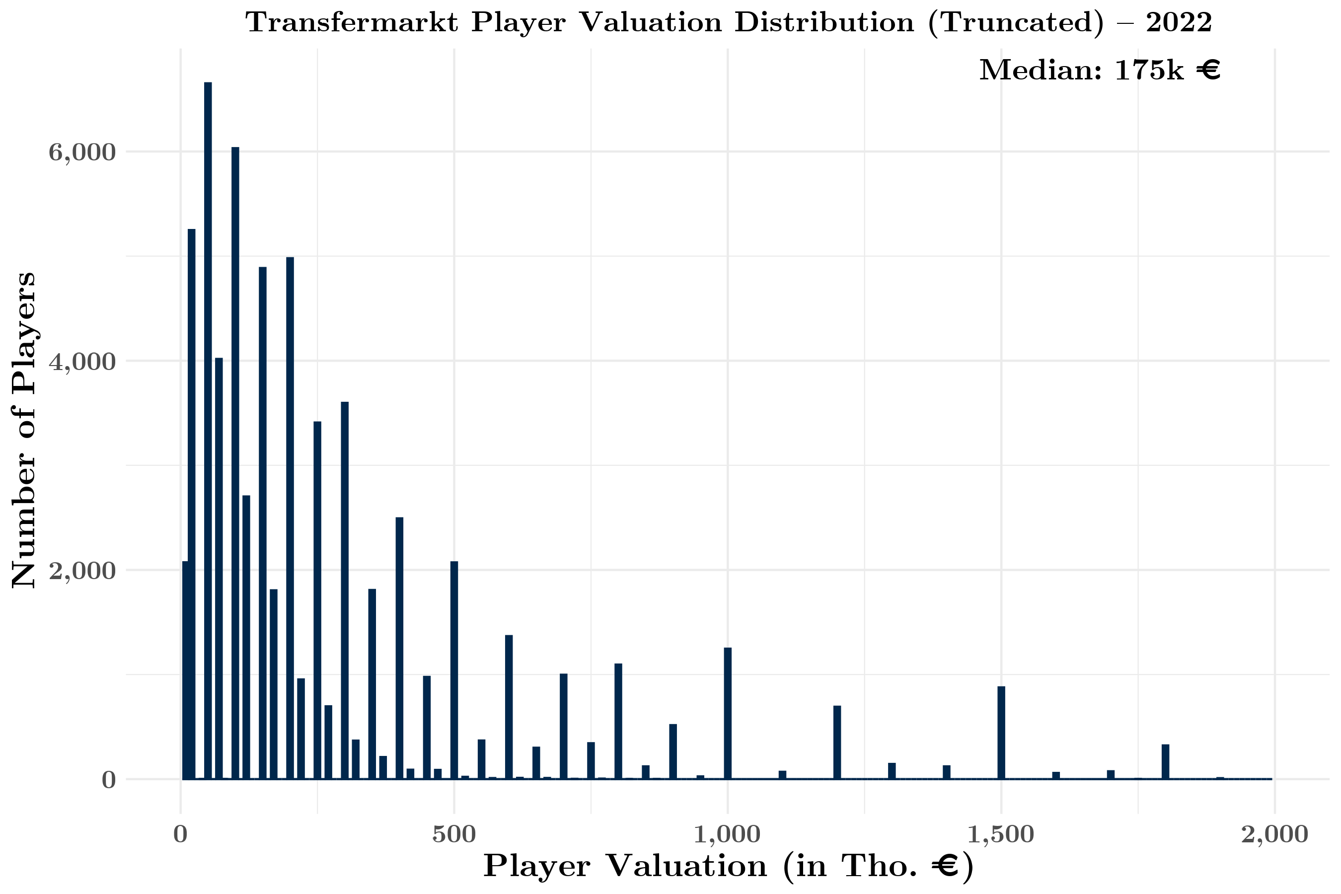
Figure A7. Histogram (Truncated at €2 mln.) of Transfermarkt Player Valuations for 2022–23 Season (n = 69,279)
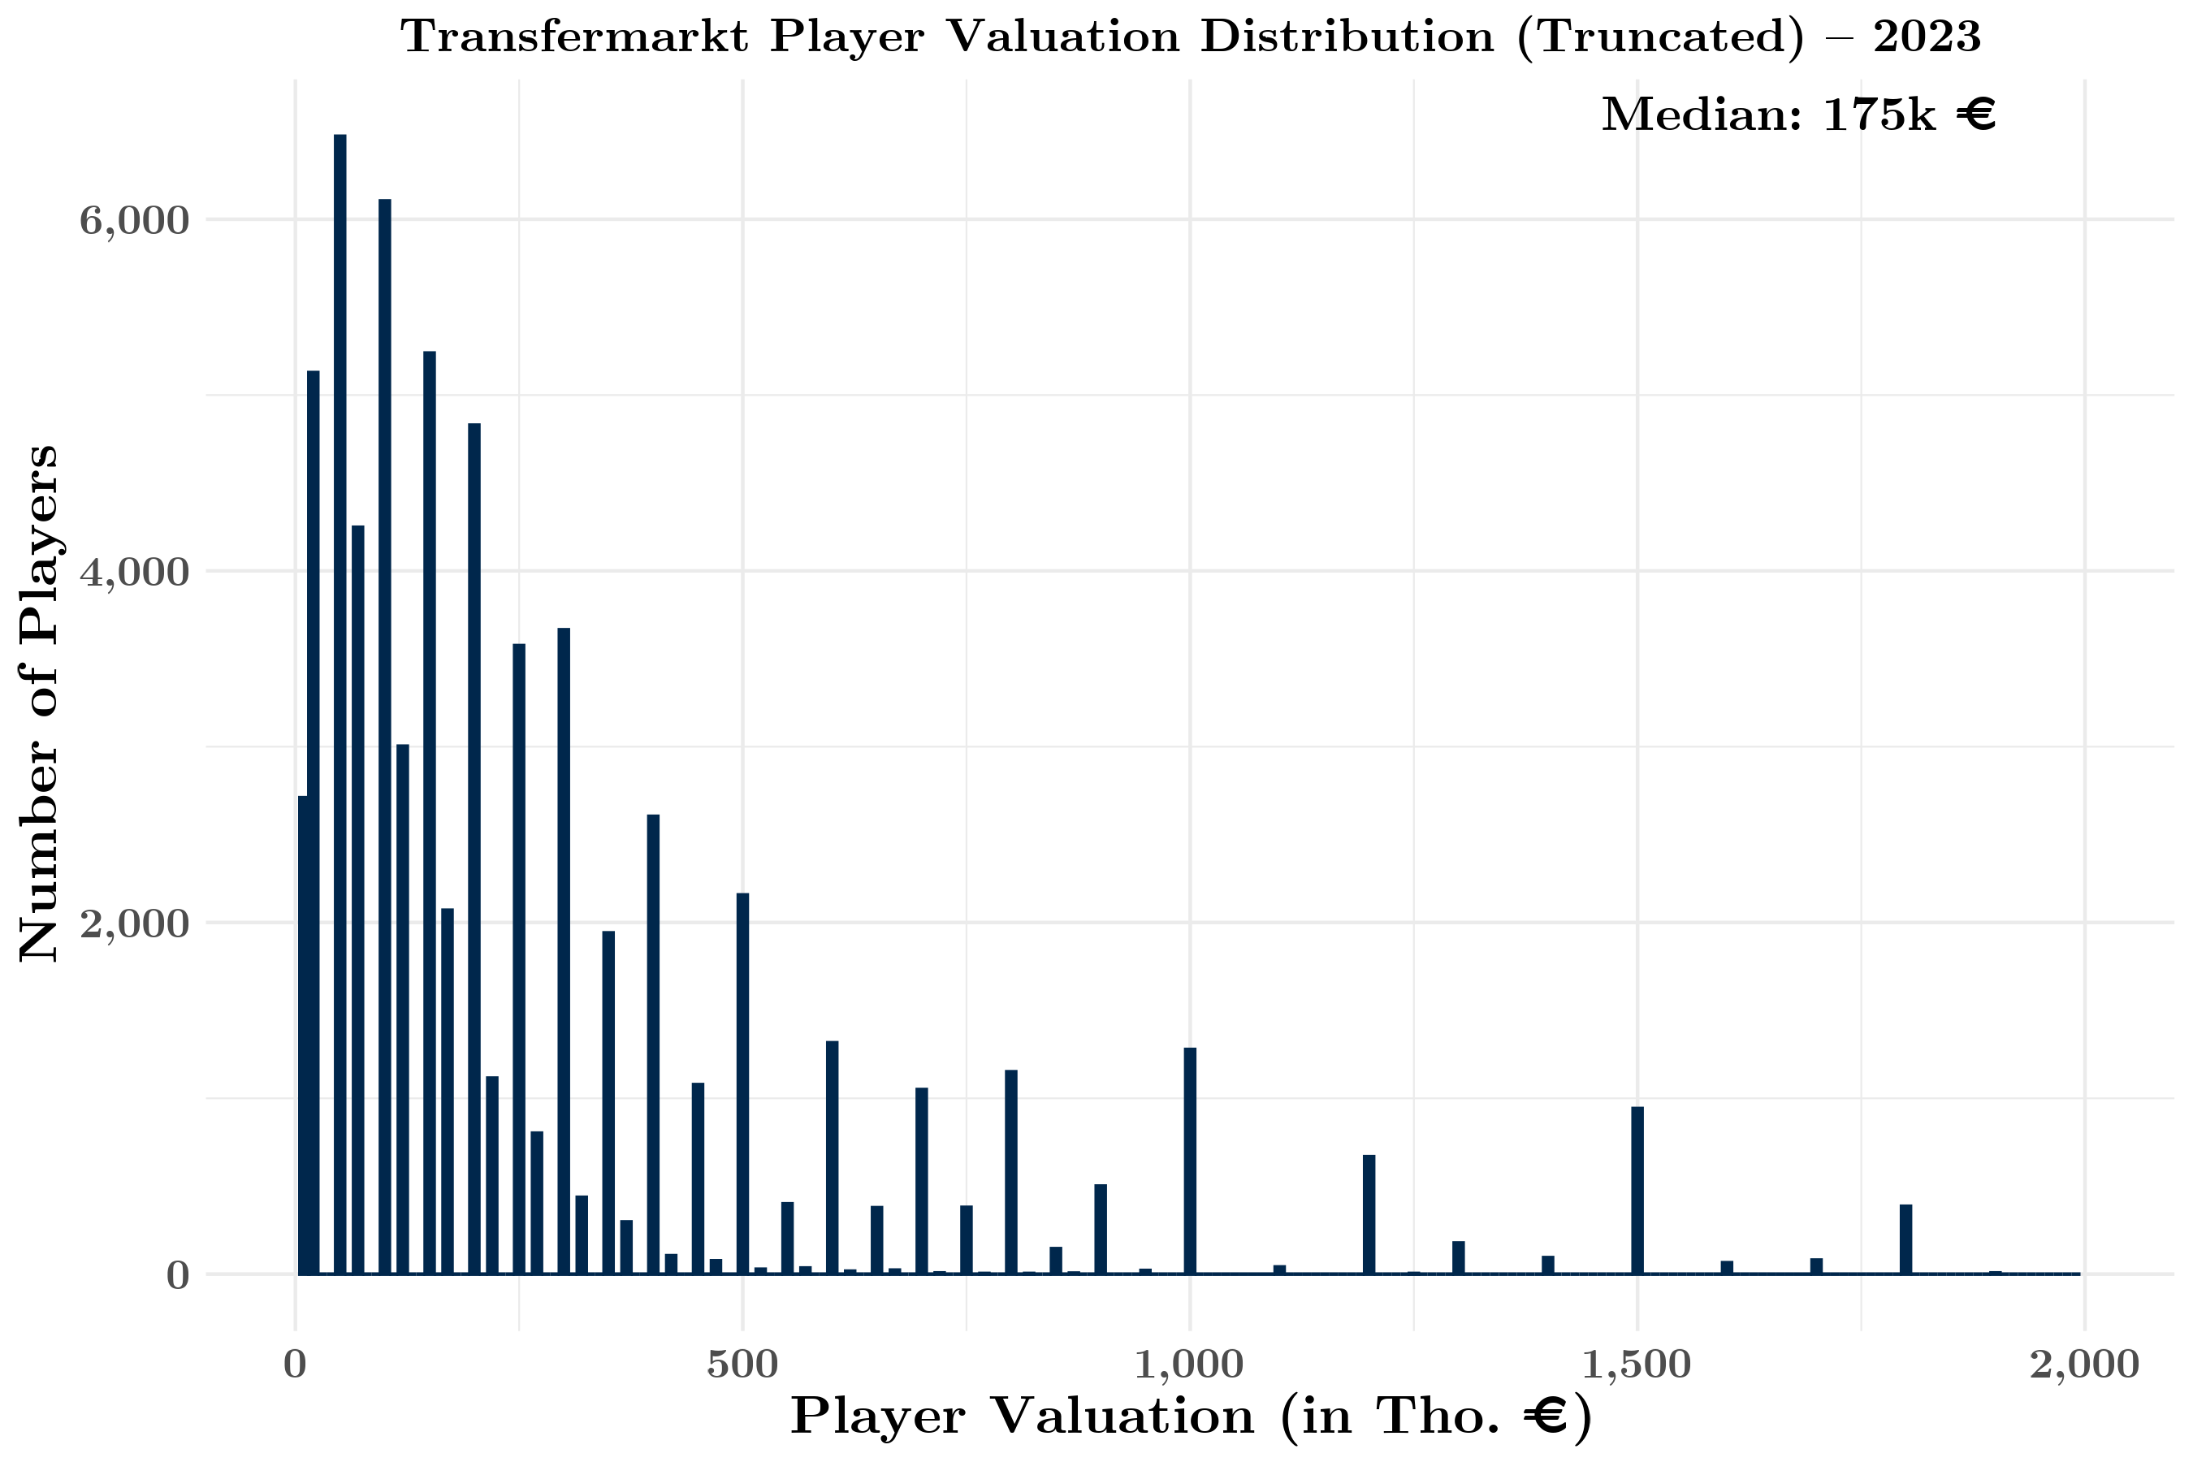
Figure A8. Histogram (Truncated at €2 mln.) of Transfermarkt Player Valuations for 2023–24 Season (n = 72,694)
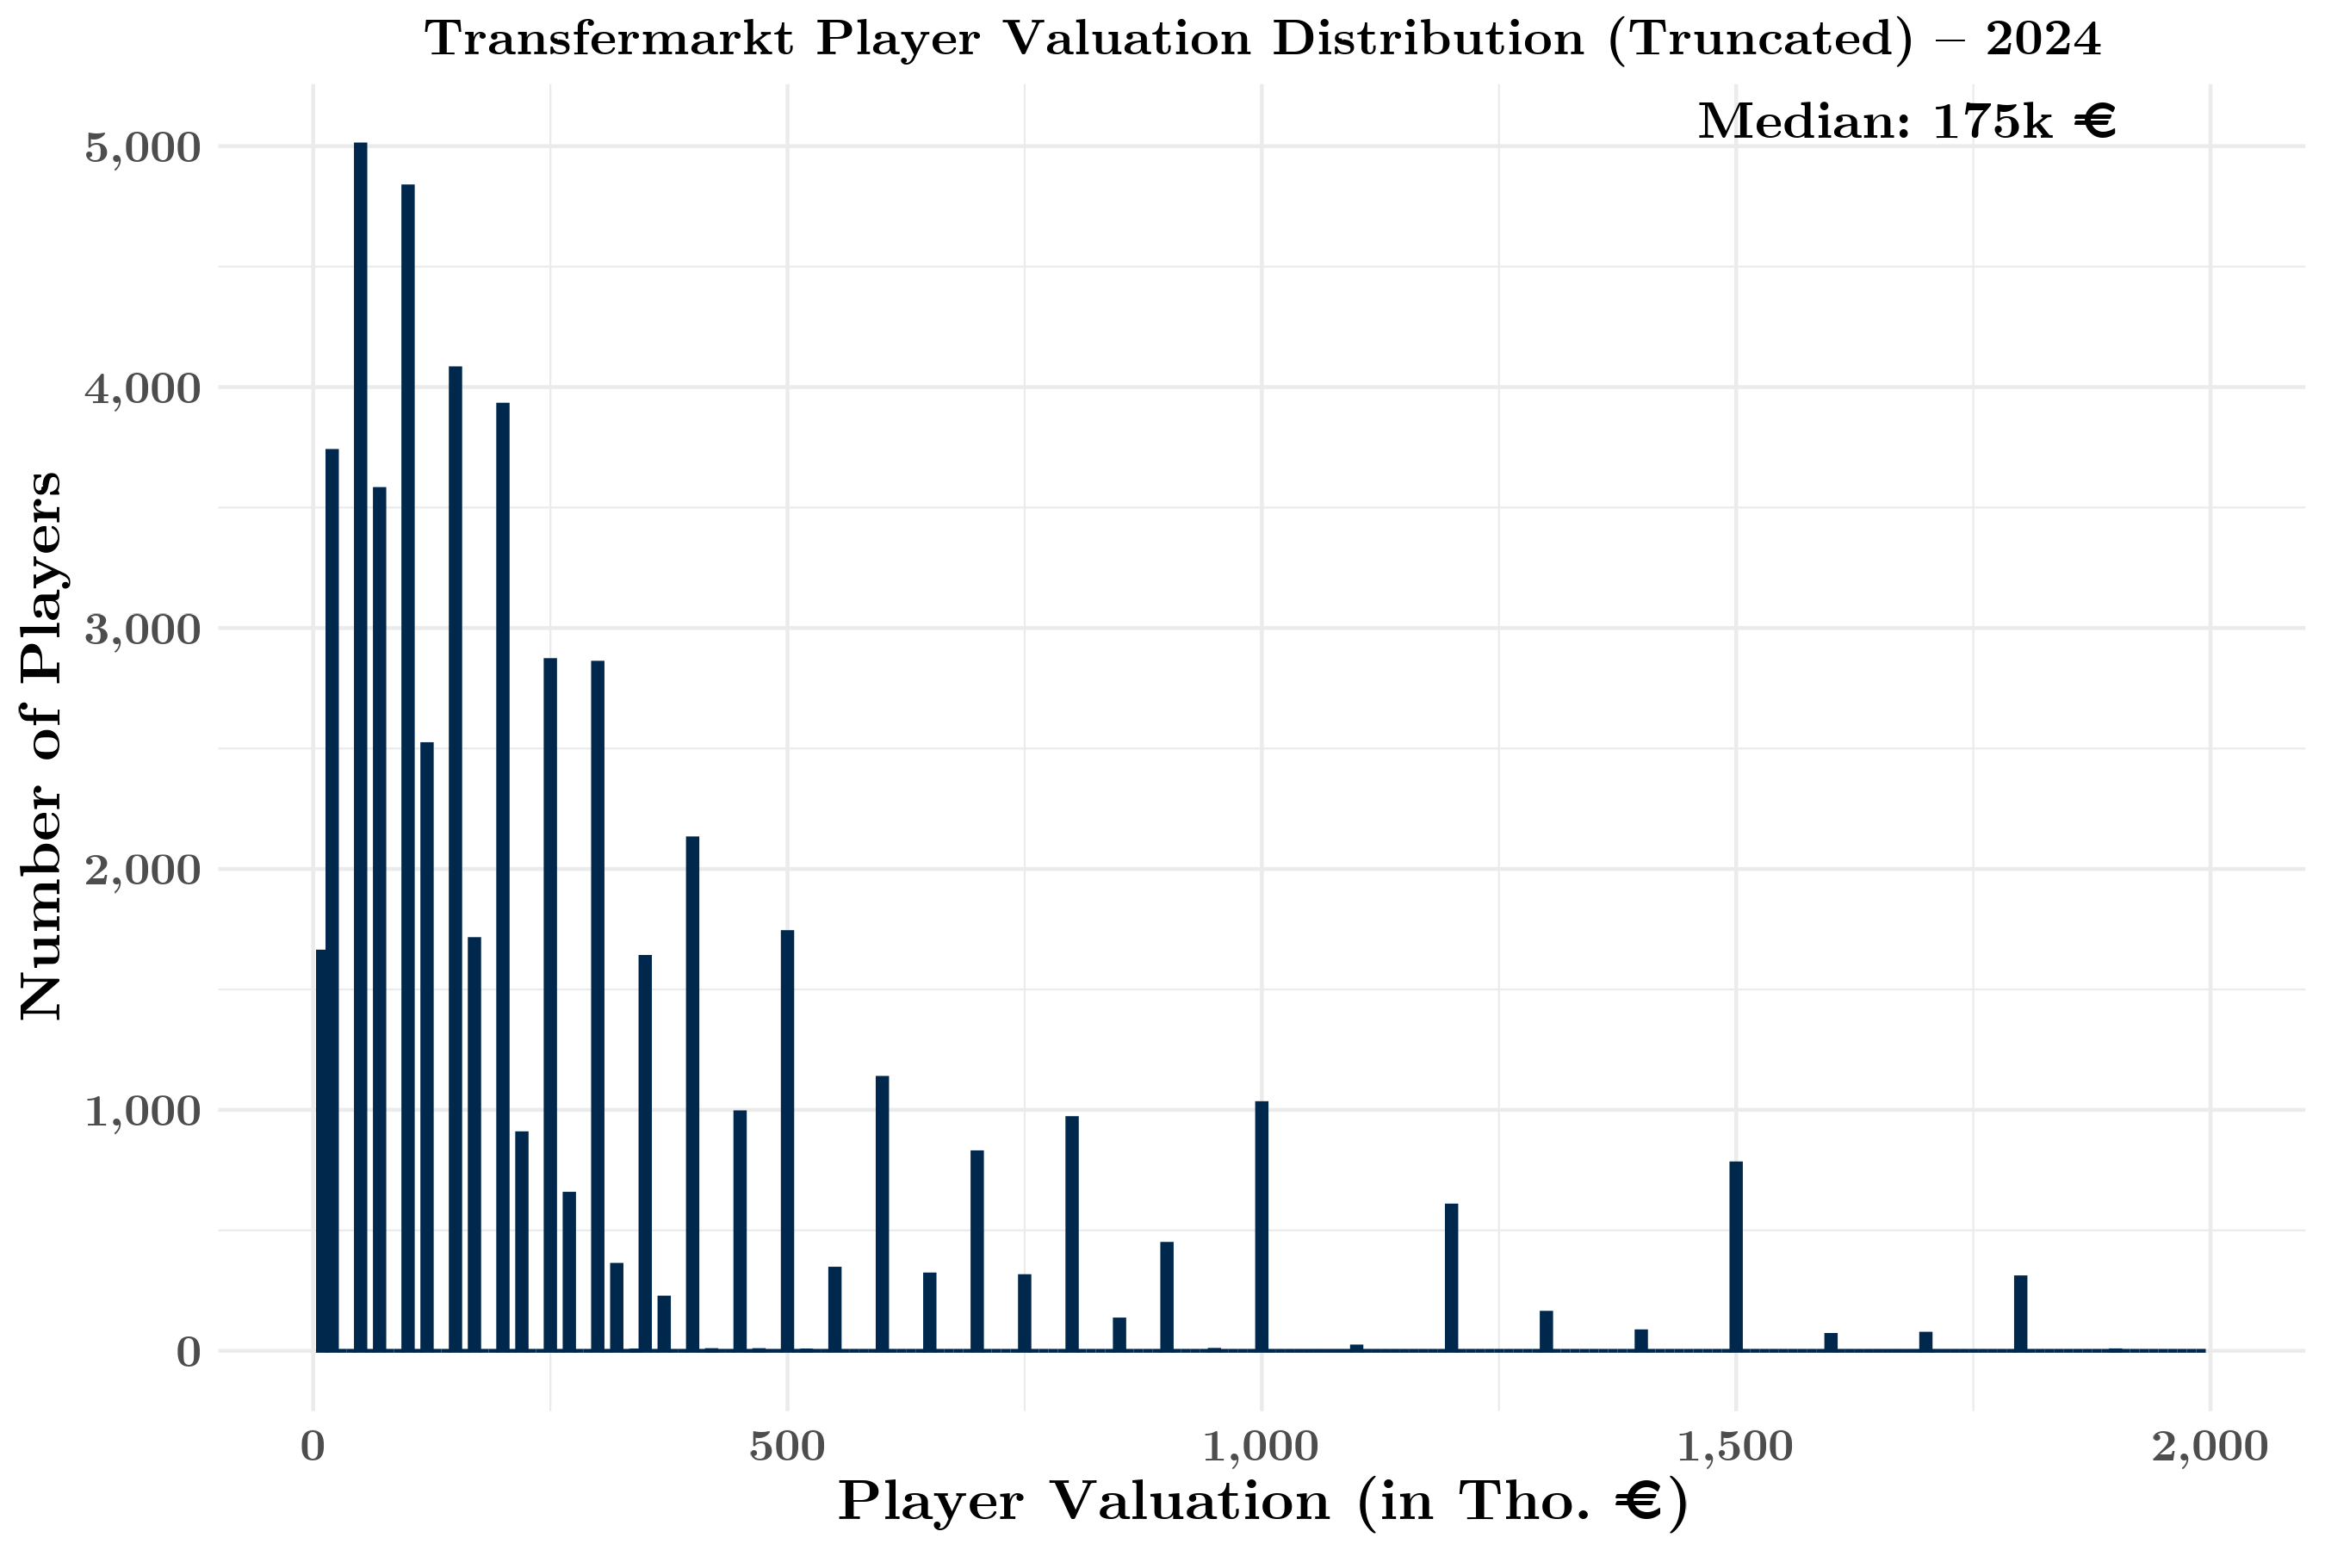
Figure A9. Histogram (Truncated at €2 mln.) of Transfermarkt Player Valuations for 2024–25 Season (n = 58,029)

Appendix F. Model Validation and Robustness Checks for Section 4.3
This appendix provides additional validation of the ordered logistic regression framework and documents the robustness checks underlying the counterfactual results reported in the main body of our paper. In Section 4.3, while we assess predictive accuracy based on the most likely outcome, such measures do not evaluate the quality of the full probability distribution. We therefore compute multi-class Brier scores, a proper scoring rule that penalizes deviations between predicted probabilities and realized outcomes across all possible result categories.
For each match $i$ and outcome $k∈\{\text{home win},\text{draw},\text{away win}\}$, we define the Brier score as
Brier=1Ni=1Nk​(pik-yik)2,
where $p_{ik}$ denotes the predicted probability assigned to outcome $k$ and $y_{ik}$ is a one-hot indicator equal to one for the realized outcome and zero otherwise.
We compute Brier scores separately for the bookmaker-implied probabilities (after normalization for the overround) and for the probabilities generated by the ordered logistic regression model. To facilitate comparison, we also report the Brier Skill Score (BSS),
$$\text{BSS}=1-\frac{{\text{Brier}}^{\text{Model}}}{{\text{Brier}}^{\text{Bookmaker}}},$$
which measures relative performance against the betting-market benchmark. Positive values indicate improved calibration relative to bookmakers, while negative values indicate underperformance. We report the results in Table A6 below.
Table A6. Probabilistic Calibration: Brier Scores for Bookmaker and TM-Based Models
Sample | Brier Score | Brier Score | Brier Skill
 | (Bookmaker) | (TM Model) | Score
Whole Sample | 0.487 | 0.515 | -0.056
England Matches Only | 0.497 | 0.498 | -0.003
Notes: This table reports multi-class Brier scores comparing bookmaker-implied probabilities and probabilities predicted by the ordered logistic regression model based on TM roster valuations. The Brier score is a proper scoring rule that measures the mean squared deviation between predicted probabilities and realized outcomes across home win, draw, and away win categories, with lower values indicating better calibration. Negative values indicate underperformance relative to bookmakers. Whole-sample results are based on 3,340 matches; England-only results are based on 80 matches.
The Brier score results indicate that bookmaker probabilities remain better calibrated than the Transfermarkt-based model in the full international sample, as reflected by a negative Brier Skill Score of –0.056. This is consistent with the role of betting markets as strong aggregators of diverse information sources beyond roster valuations alone. Importantly, however, calibration differences narrow substantially in the England-only subsample, where the Brier Skill Score is close to zero (–0.003). This near-parity suggests that, in settings where roster valuation information is especially rich and salient – such as in the case of English national team – the Transfermarkt-based model performs comparably to bookmaker probabilities in terms of probabilistic accuracy.
As an additional economic validation, we implement a simple betting back-test to assess whether the model contains information not fully reflected in bookmaker odds. For each match and outcome, we compare the model-implied probability to the bookmaker-implied probability and place a unit-stake wager only when the model indicates a positive expected value, i.e.,
$$p_{ik}^{\text{Model}}⋅o_{ik}>1,$$
where $o_{ik}$ denotes decimal odds for outcome $k$.
We summarize the number of bets placed, the average implied edge, and the realized return on investment (ROI). This exercise is not intended to propose a trading strategy, but rather to evaluate whether the valuation-based model captures systematic information beyond that embedded in the odds market. We report the results of this exercise in Table A7 below.
Table A7. Economic Validation: Betting Back-Test Based on Model-Implied Expected Value
Sample | Matches | Bets | Total Profit | ROI per Bet | Win Rate | Avg. Edge
Whole Sample | 3,340 | 3,026 | -510.00 | -0.169 | 0.300 | 0.104
England Matches | 80 | 76 | -3.37 | -0.044 | 0.224 | 0.052
Notes: This table reports the results of a unit-stake betting back-test used as an economic diagnostic of the valuation-based model. For each match, at most one wager is placed on the outcome with the highest model-implied expected value, provided that $p_{ik}^{\text{Model}} o_{ik}>1$, where $o_{ik}$ denotes decimal odds (converted from American odds). Total Profit is net profit in stake units. ROI per bet is defined as total net profit divided by the number of bets placed. Avg. Edge is the mean difference between model-implied and bookmaker-implied probabilities among placed bets.
In the full international sample, the valuation-based model places bets in the large majority of matches under the positive expected value rule (3,026 bets across 3,340 matches), yet generates a negative realized return of -510 units, corresponding to an average ROI of -0.169 per bet. This pattern is consistent with the probabilistic calibration evidence from the Brier scores, indicating that bookmaker probabilities remain better calibrated in the aggregate. Notably, the model-selected wagers exhibit a positive average implied edge relative to bookmakers (0.104), suggesting that the model frequently assigns higher probabilities to selected outcomes than the betting market, but that these differences do not translate into profitable signals once market odds are taken as the payoff-relevant benchmark.
Results are more favorable in the England-only subsample. Although the model again identifies a large share of matches as positive expected value opportunities (76 bets across 80 matches), the realized losses are small (-3.37 units), yielding an average ROI of -0.044 per bet. The implied edge in this subsample is approximately half the full-sample magnitude (0.052). Overall, the robustness-check test reinforces that while the Transfermarkt-based model captures meaningful information about relative team strength – particularly in the England context central to our counterfactual simulations – it does not systematically outperform betting markets and should therefore be interpreted as an informational validation rather than evidence of exploitable inefficiencies.

Appendix G. Aggregate Valuation Results with “Black-Only (Except Goalkeeper) England" Scenario Added
Table A8. Summary Statistics: Cumulative Team Valuations for England Under Actual and Three Counterfactual Scenarios ($n$ = 80 matches – for England only)
Scenario | Mean (mln. €) | Median (mln. €) | St. Dev. (mln. €) | Min. (mln. €) | Max. (mln. €) | % Change in Mean
“Actual” England | 604.590 | 615.010 | 135.549 | 219.000 | 985.000 | —
“Non-Black England” | 465.885 | 474.750 | 103.761 | 190.500 | 660.000 | -22.942%
“Black-Only England” | 448.791 | 444.850 | 113.011 | 125.750 | 780.800 | -25.769%
“Black-Only (Except Goalkeeper) England” | 471.194 | 474.000 | 112.963 | 138.500 | 799.000 | -22.064%
Notes: This table reports cumulative market valuations (in millions of euros) for England’s national team under the actual roster and three counterfactual scenarios. The “Non-Black England” scenario replaces Black players with the next-highest-valued non-Black English players, while the “Black-Only England” scenario includes only Black players. The “Black-Only (Except Goalkeeper)” variant retains the actual goalkeeper. Percentage changes reflect the difference in mean valuation relative to the actual roster.

