SUPPLEMENTARY INFORMATION

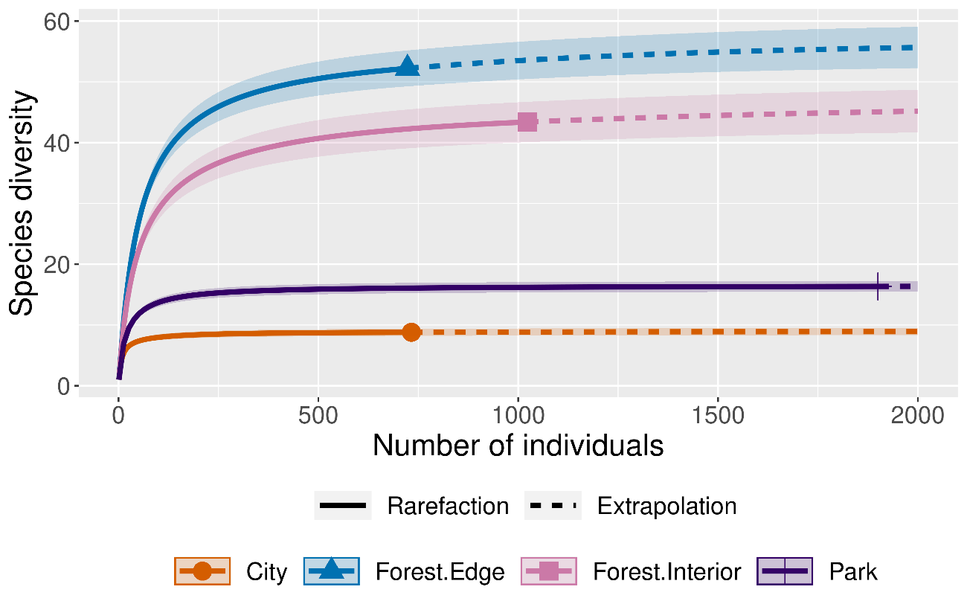
Fig 1. Rarefaction and Extrapolation curve of the four habitat types

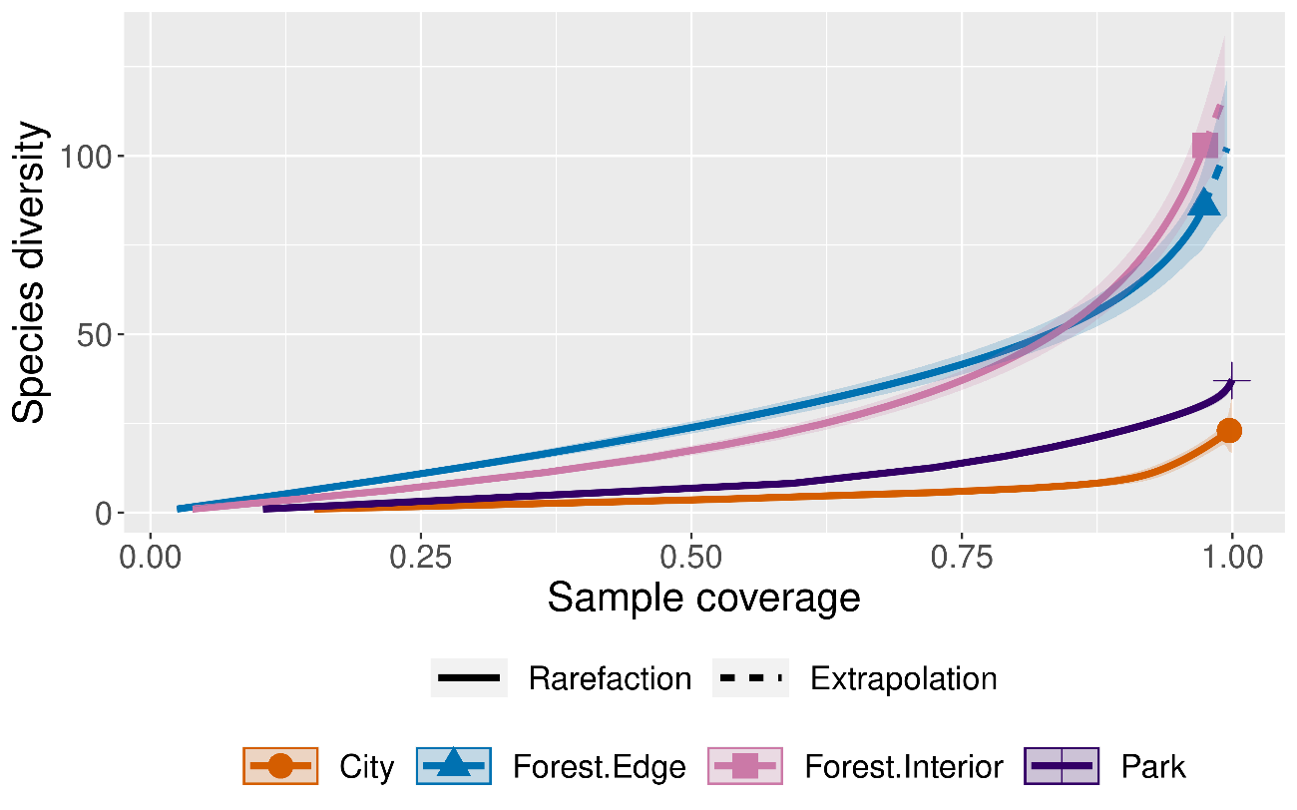
Fig 2. Sampling Coverage (SC) of the four habitat types

Table 1: P-Value of Post-Hoc Tests between Habitat Types and Significant Indices
Habitat | P Value
Habitat | Species Richness | Shannon  Diversity | FDiv | FD RaQ
Forest Edge - City | 0.01 | 0.01 | 0.01 | 0.39
Forest Interior - City | 0.01 | 0.01 | 0.10 | 0.09
Park - City | 0.06 | 0.03 | 0.75 | 0.94
Forest Interior - Forest Edge | 0.45 | 0.91 | 0.47 | 0.70
Park - Forest Edge | 0.03 | 0.01 | 0.05 | 0.19
Park - Forest Interior | 0.01 | 0.04 | 0.39 | 0.04

Table 2: Number of species shared between the habitat types
 | Forest Interior | Forest Edge | Park | City
Forest Interior | 103 | 68 | 16 | 10
Forest Edge |  | 86 | 24 | 15
Park |  |  | 37 | 22
City |  |  |  | 23

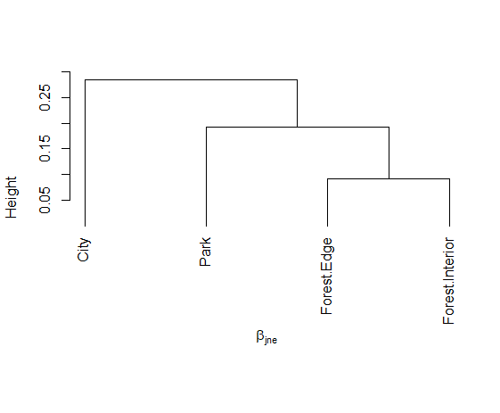

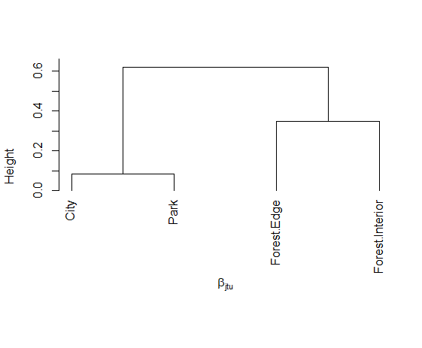
Fig. 3: Taxonomic Beta Diversity of habitat types (a) Nestedness component (Beta.JNE), and (b) Turnover component (Beta.JTU), using Jaccard’s dissimilarity

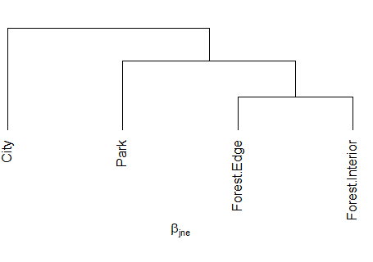
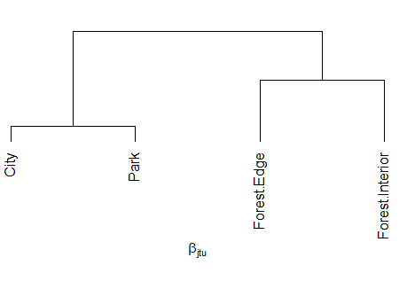

Fig. 4: Functional Beta Diversity of habitat types (a) Nestedness component (Func.Beta.JNE) and (b) Turnover component (Func.Beta.JTU) using Jaccard’s dissimilarity

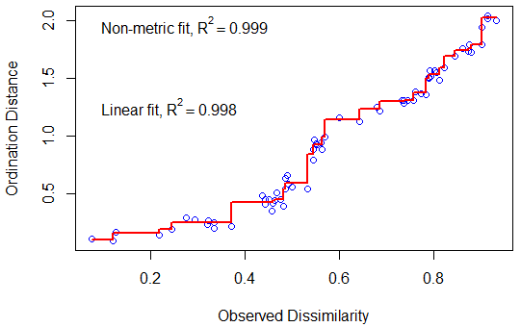

Fig. 5: Taxonomic NMDS Stress Plot

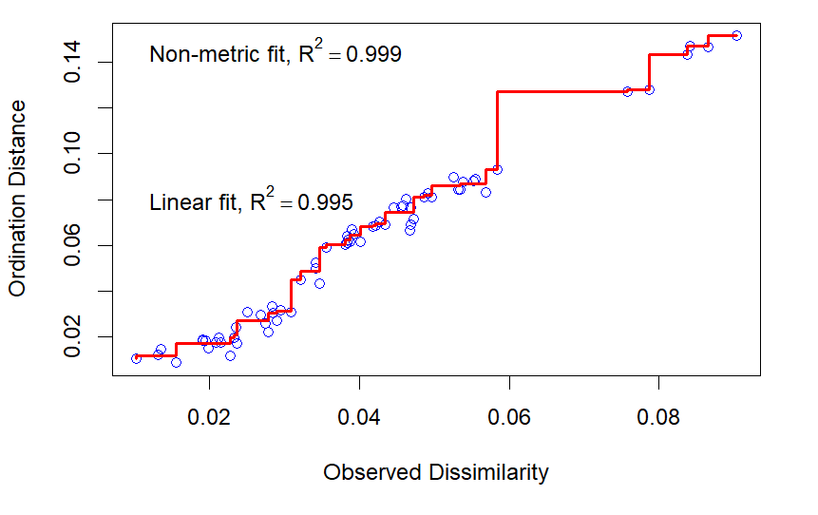
Fig. 6: Functional NMDS Stress Plot

Table 3: Global and Pairwise Taxonomic PERMANOVA Statistics

Habitat Pair | F.Model | R² | p-value
Global (all habitats) | 9.84 | 0.787 | 0.001 ***
City vs Park | 9.67 | 0.707 | 0.1
City vs Forest Edge | 11.26 | 0.738 | 0.1
City vs Forest Interior | 15.5 | 0.795 | 0.1
Park vs Forest Edge | 9.46 | 0.703 | 0.1
Park vs Forest Interior | 15.69 | 0.797 | 0.1
Forest Edge vs Interior | 1.72 | 0.301 | 0.1

Table 4: Global and Pairwise Functional PERMANOVA Statistics

Habitat Pair | F.Model | R² | p-value
Global (all habitats) | 6.96 | 0.72 | 0.013
City vs Park | 1.02 | 0.2 | 0.5
City vs Forest Edge | 6.18 | 0.61 | 0.1
City vs Forest Interior | 10.65 | 0.73 | 0.1
Park vs Forest Edge | 9.76 | 0.71 | 0.1
Park vs Forest Interior | 18.89 | 0.83 | 0.1
Forest Edge vs Interior | –0.08 | –0.02 | 1

Table 5: Spearman’s Correlation Coefficient and P Values of 11 continuous traits

 |  | Beak Length Culmen | Beak Length Nares | Beak Width | Beak Depth | Tarsus Length | Wing Length | Kipps Distance | Secondary1 | Hand Wing Index | Tail Length
Beak Length  Nares | Coefficient | 0.95
Beak Length  Nares | P Value | 0.01
Beak Width | Coefficient | 0.76 | 0.80
Beak Width | P Value | 0.01 | 0.01
Beak Depth | Coefficient | 0.79 | 0.81 | 0.94
Beak Depth | P Value | 0.01 | 0.01 | 0.01
Tarsus Length | Coefficient | 0.70 | 0.59 | 0.48 | 0.62
Tarsus Length | P Value | 0.01 | 0.01 | 0.01 | 0.01
Wing Length | Coefficient | 0.81 | 0.71 | 0.74 | 0.79 | 0.71
Wing Length | P Value | 0.01 | 0.01 | 0.01 | 0.01 | 0.01
Kipps Distance | Coefficient | 0.58 | 0.50 | 0.60 | 0.59 | 0.42 | 0.87
Kipps Distance | P Value | 0.01 | 0.01 | 0.01 | 0.01 | 0.01 | 0.01
Secondary1 | Coefficient | 0.86 | 0.76 | 0.74 | 0.82 | 0.83 | 0.95 | 0.70
Secondary1 | P Value | 0.01 | 0.01 | 0.01 | 0.01 | 0.01 | 0.01 | 0.01
Hand Wing  Index | Coefficient | 0.21 | 0.17 | 0.30 | 0.24 | 0.03 | 0.52 | 0.85 | 0.28
Hand Wing  Index | P Value | 0.02 | 0.05 | 0.05 | 0.05 | 0.74 | 0.01 | 0.01 | 0.01
Tail Length | Coefficient | 0.69 | 0.61 | 0.66 | 0.67 | 0.61 | 0.82 | 0.62 | 0.82 | 0.27
Tail Length | P Value | 0.01 | 0.01 | 0.01 | 0.01 | 0.01 | 0.01 | 0.01 | 0.01 | 0.01
Mass | Coefficient | 0.82 | 0.73 | 0.73 | 0.83 | 0.79 | 0.94 | 0.74 | 0.95 | 0.36 | 0.74
Mass | P Value | 0.01 | 0.01 | 0.01 | 0.01 | 0.01 | 0.01 | 0.01 | 0.01 | 0.01 | 0.01

Table 6: Values of Dunn’s Post Hoc Test for Hand-Wing Index

Habitat | Hand-Wing Index
Habitat | Z Value | P Value
City - Forest Interior | 2.74 | 0.01
City - Forest Edge | 2.79 | 0.01
Forest Interior - Park | -2.80 | 0.01
Forest Edge - Park | -2.85 | 0.01
Forest Edge - Forest Interior | -0.16 | 0.87
City - Park | 0.36 | 0.72

