Supplementary Information

Port’s criticality in international trade and global supply-chains

Verschuur et al.

Supplementary Figures

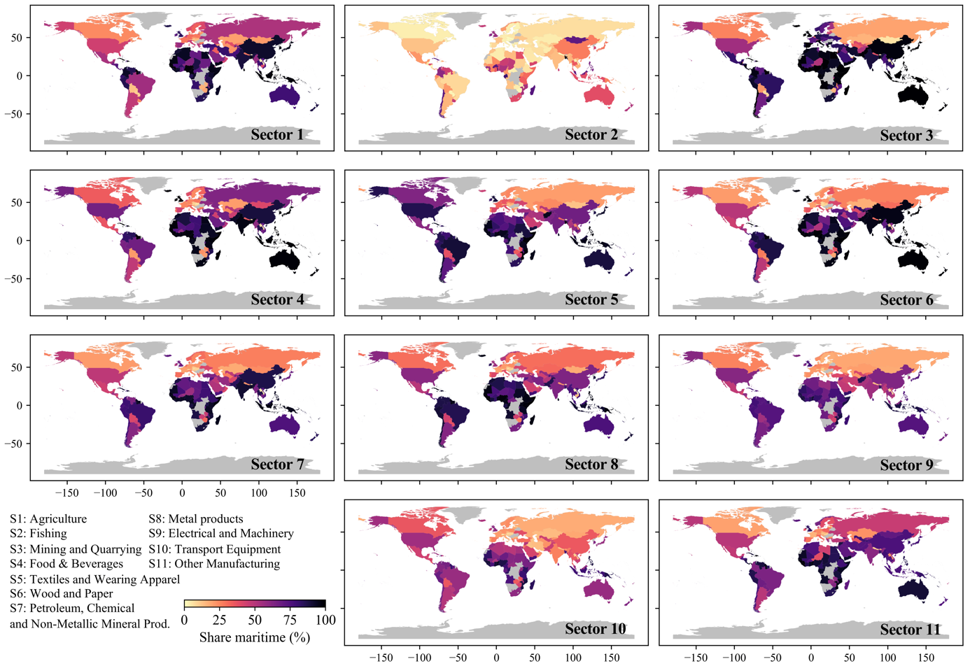

Supplementary Fig. 1 | Share of maritime trade in country imports. The share of maritime transport in total imports for the 2015 trade network. Each panel shows the percentages for a particular economic sector. Grey indicates no data.

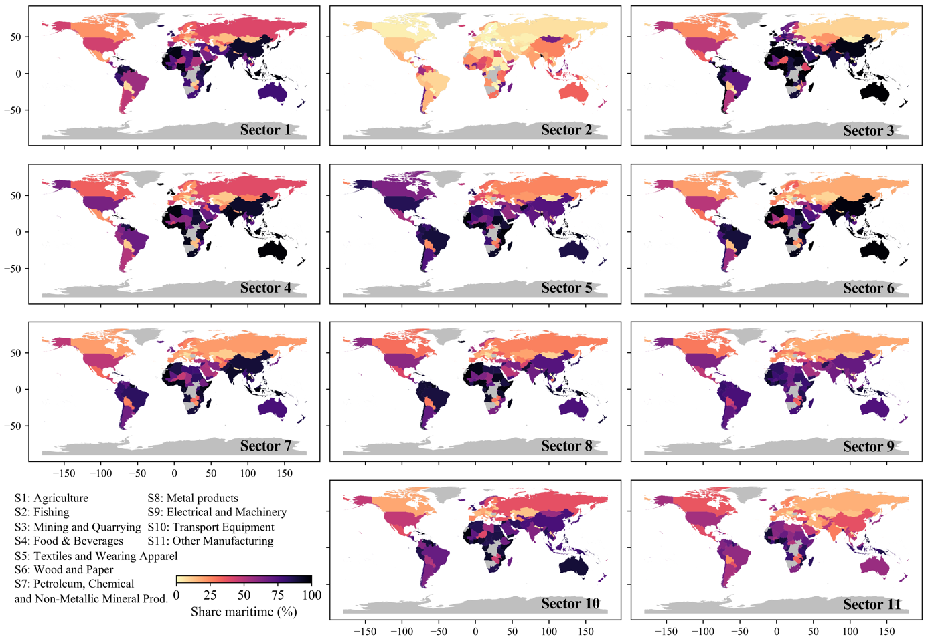

Supplementary Fig. 2 | Share of maritime trade in country exports. The share of maritime transport in total exports for the 2015 trade network. Each panel shows the percentages for a particular economic sector. Grey indicates no data.

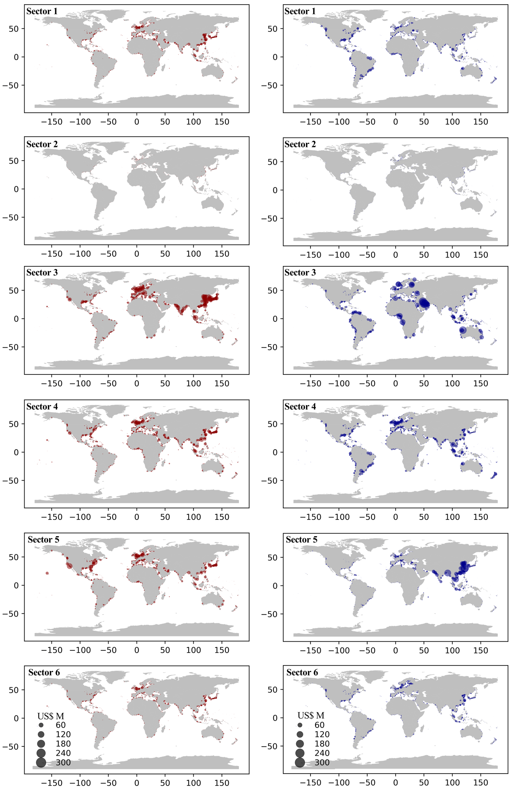
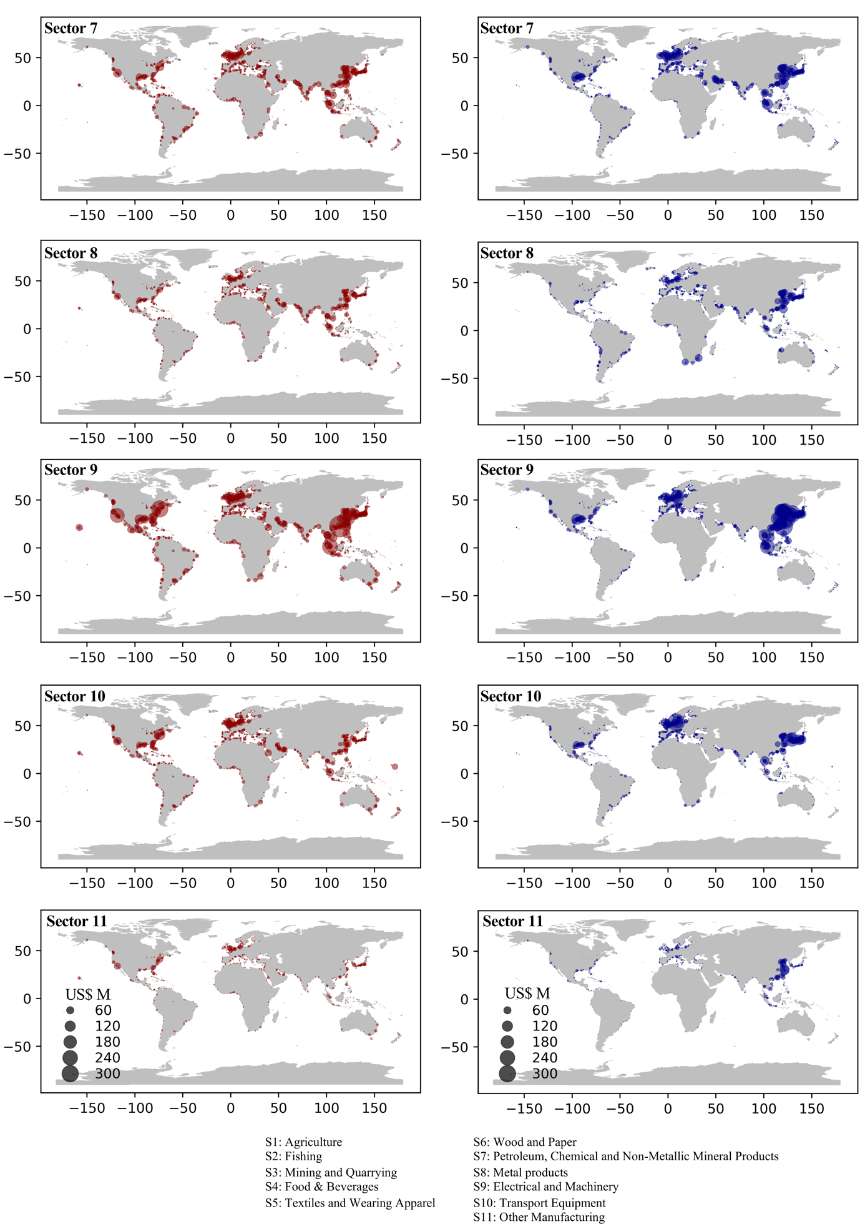

Supplementary Fig. 3 | The geographical location of port-level trade flows. The port-level imports (red, left) and exports (blue, right) per economic sector.
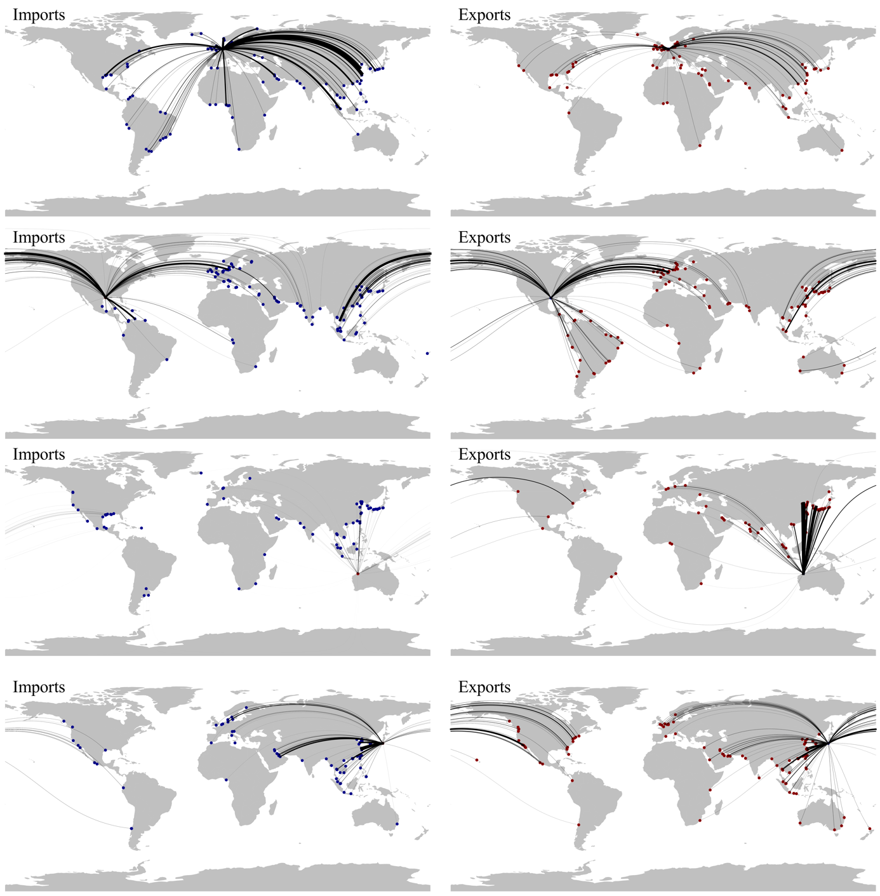

Supplementary Fig. 4 | Examples of port-level trade network. The top 200 largest importing (blue, left) and exporting (red, right) trade flows to and from a port, including the location of the origin/destination port. Four example ports: Rotterdam, Houston, Port Hedland, Yokohama.

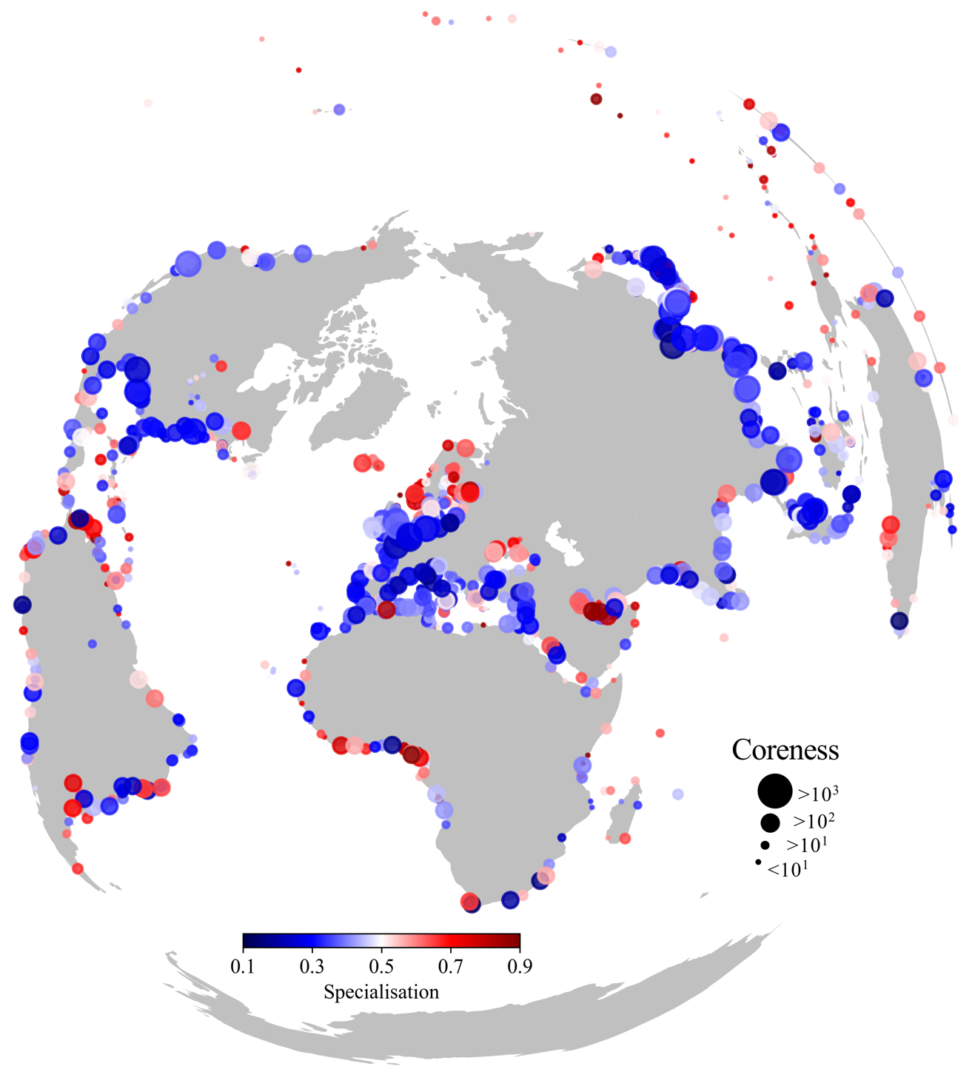

Supplementary Fig. 5 | Geographical distribution of coreness and specialisation in port-level trade. The geographical location of ports with their associated coreness and specialisation value. Coreness is based on a core-periphery detection method applied to the port-to-port trade network (see Methods) whereas the specialisation is based on the Gini-coefficient¹ of sector-level trade flows through ports.

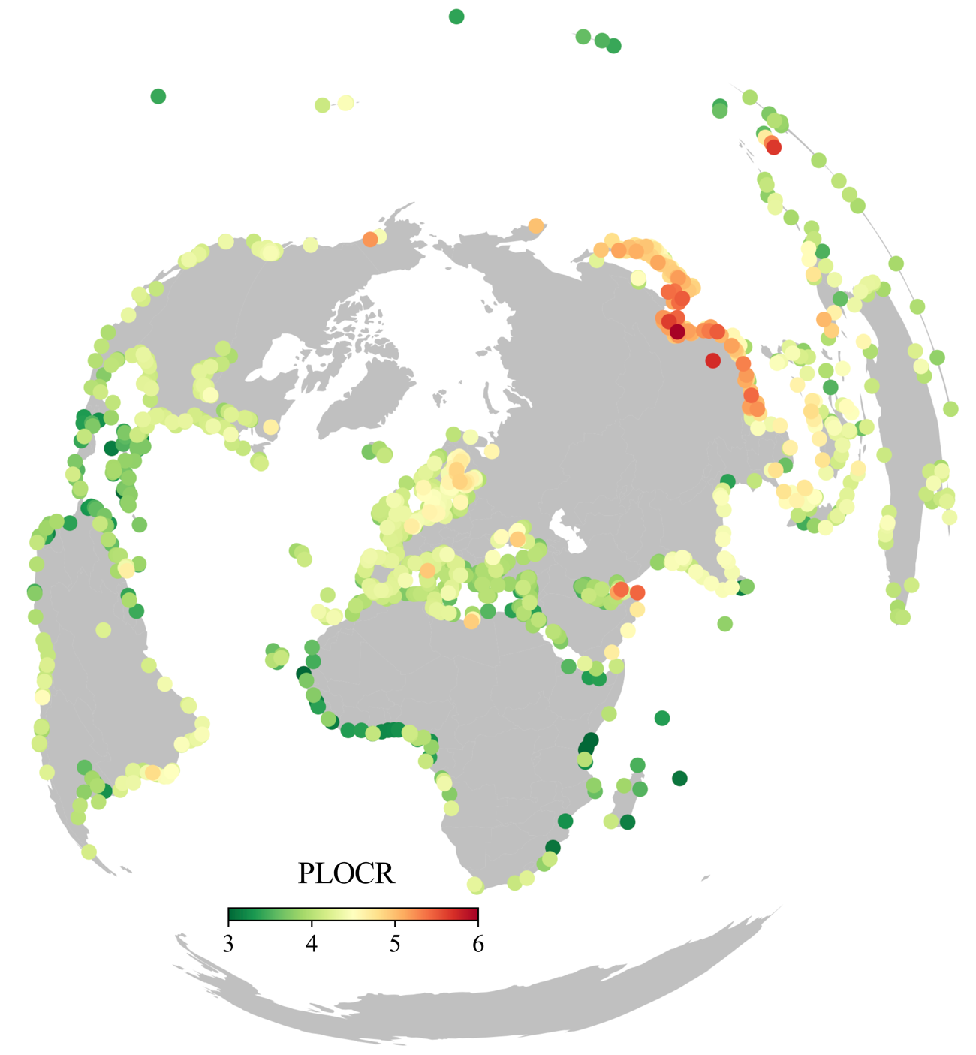

Supplementary Fig. 6 | Geographical distribution of PLOCR values. The geographical location of ports with their associated relative port-level output coefficient (PLOCR), indicating the amount of industry output embedded in every dollar trade flow going through a port.

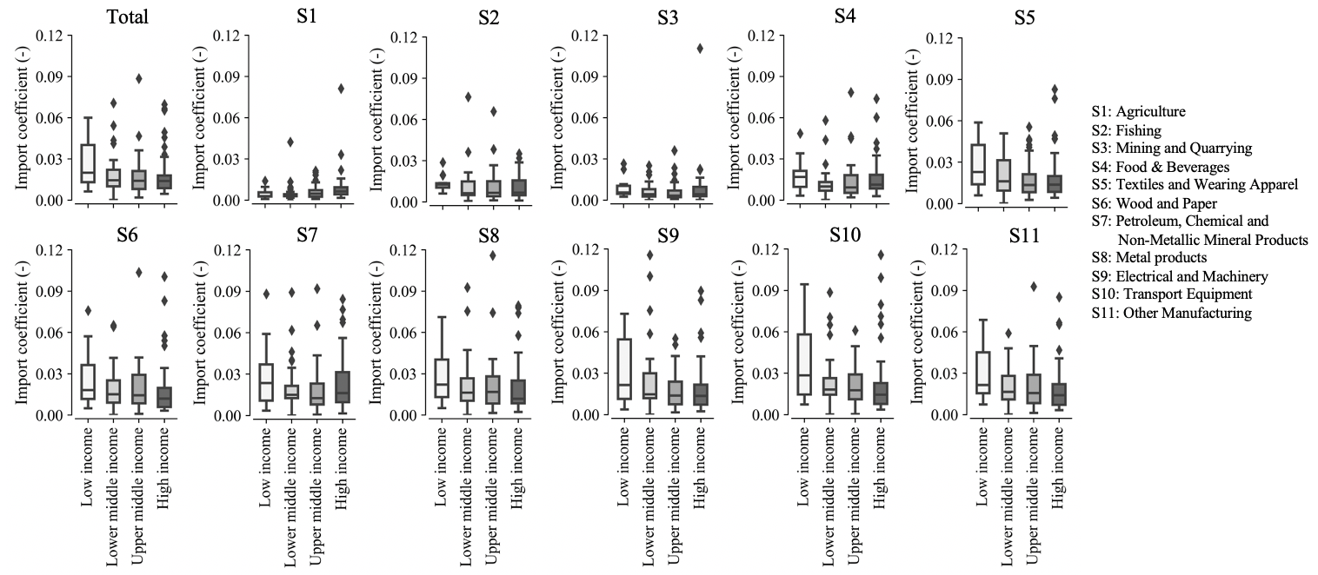
Supplementary Fig. 7 | Sector-level PLIC values on a country-level. The import coefficient on a sector and country-level, indicating the increase in imports necessary for every dollar increase in final demand for a sector.

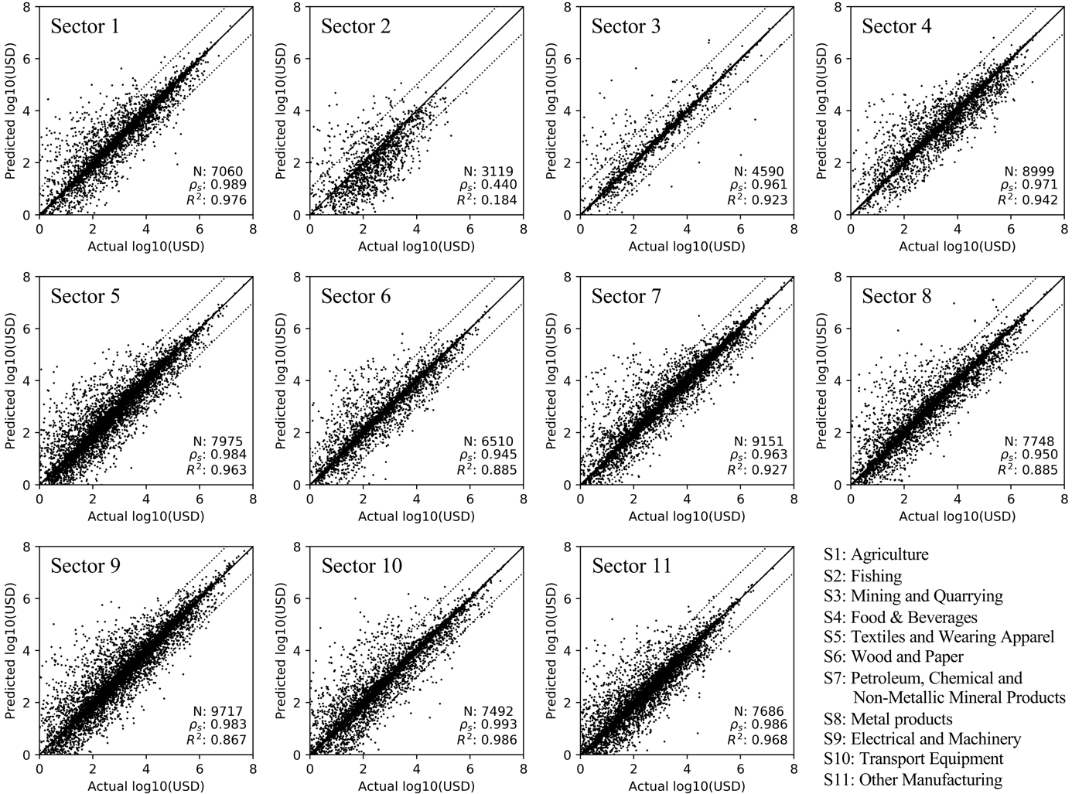

Supplementary Fig. 8 | Validation mode prediction model. Validation plots showing the actual maritime trade flows based on UN Comtrade data² and predicted maritime trade flows using the mode prediction model. Per figure, we include the number of data points (N), the correlation coefficient and the R-squared value.

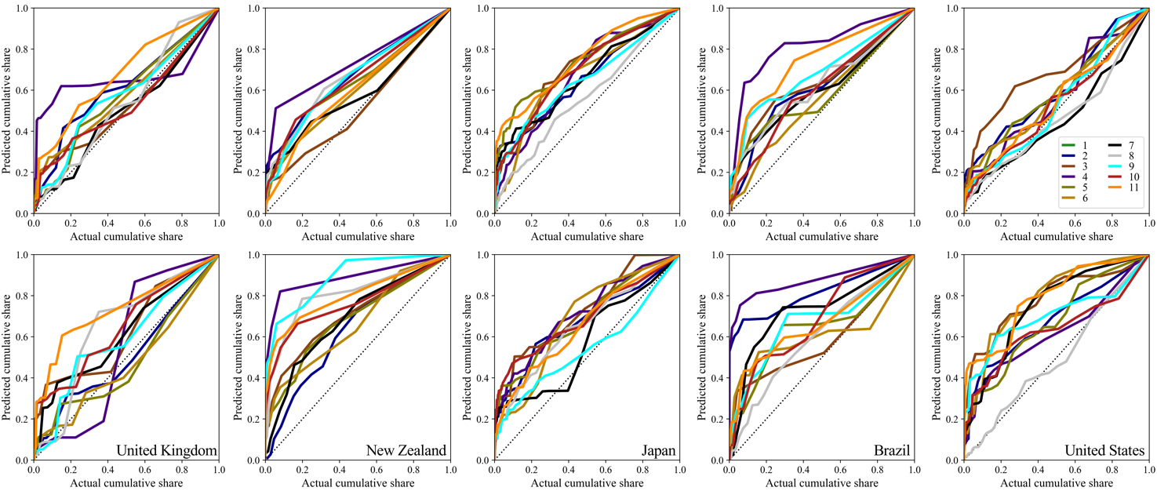

Supplementary Fig. 9 | Validation trade allocation algorithm. Validation plots showing the actual distribution of trade over the ports in a country and the predicted distribution based on the trade allocation algorithm. This is based on detailed port-level, sector-specific, trade flows which were available for five countries; United Kingdom, New Zealand, Japan, Brazil, United States. The top panel represent imports, whereas the bottom panel represent exports.

Supplementary Tables

Supplementary Table 1 | Overview of economic sectors used in this study.

Sector number | Description
1 | Agriculture
2 | Fishing
3 | Mining and Quarrying
4 | Food & Beverages
5 | Textiles and Wearing Apparel
6 | Wood and Paper
7 | Petroleum, Chemical and Non-Metallic Mineral Products
8 | Metal Products
9 | Electrical and Machinery
10 | Transport Equipment
11 | Other Manufacturing

Supplementary Table 2 | Overview of the trade inequality in port-level trade, representing the number of ports (out of the 1176 ports) that contribute to 10%, 50% and 90% of trade (imports and exports).

 | Import |  |  |  | Export
Sector | 90% | 50% | 10% |  | 90% | 50% | 10%
1 | 289 | 56 | 5 |  | 241 | 43 | 4
2 | 203 | 30 | 2 |  | 202 | 28 | 2
3 | 191 | 39 | 3 |  | 140 | 20 | 2
4 | 342 | 64 | 5 |  | 276 | 55 | 4
5 | 185 | 33 | 2 |  | 90 | 7 | 1
6 | 306 | 56 | 4 |  | 238 | 39 | 2
7 | 342 | 63 | 5 |  | 238 | 36 | 3
8 | 326 | 59 | 5 |  | 266 | 37 | 2
9 | 237 | 32 | 2 |  | 134 | 14 | 1
10 | 306 | 54 | 4 |  | 185 | 22 | 1
11 | 170 | 25 | 1 |  | 90 | 6 | 1
Total | 400 | 74 | 4 |  | 338 | 57 | 4

Supplementary Table 3 | Modelling assumptions adopted in the modal split model.

Mode | Parameter | Group 1 countries | Group 2 countries
Air | Dwell time (h) | 4 | 48
 | Speed (km/h) | 750 | 750
 | Transhipment (h) | 18 | 18
Road | Speed primary road | 80 | 70
 | Speed secondary road | 65 | 55
 | Speed beltway/national road | 40 | 30
 | Speed tracks/unpaved roads | 10 | 5
Maritime | Transhipment (h) | 48 | 48
 | Dwell time | 48 | 96

Note: Group 1 countries include European countries, Japan, Australia, Canada and United States. Group 2 countries include the rest of the world.

Supplementary Table 4 | The distance and time costs used in this study after a sensitivity analysis of a range of values.

Mode | Parameter | Value
Air | Distance costs (USD/km/tonnes) | 0.175
 | Time costs (USD/day/tonnes) | 3520
Road | Distance costs (USD/km/tonnes) | 0.057
 | Time costs (USD/day/tonnes) | 3.3
Maritime | Distance costs (USD/km/tonnes) | 0.006
 | Time costs (USD/day/tonnes) | 1.65

Supplementary Table 5 | The results of the regression model to estimate the modal splits per trade flow.

2 mode alternatives (maritime/air)
Sector | β₁ | β₂ | β₃ | β₄ |  | β₅ |  | β₆ |  | MSC
1 | 0.563*** | -0.023*** | -0.670*** | 2.538*** |  | 0.359*** |  | 0.278* |  | -8.230***
2 | -0.314** | -0.043*** | -0.624*** | 2.340*** |  | 0.374*** |  | -1.568*** |  | -4.671***
3 | -1.430*** | 0.000 | -0.816*** | 0.990*** |  | 0.236*** |  | 0.743*** |  | -2.010***
4 | -0.316*** | 0.004*** | -0.507*** | 1.795*** |  | 0.159*** |  | 0.137*** |  | -5.412***
5 | -3.351*** | 0.040*** | -1.478*** | 1.660*** |  | 0.344*** |  | 0.260*** |  | 1.347***
6 | -1.746*** | 0.011*** | -1.099*** | 1.879*** |  | 0.226*** |  | 0.468*** |  | -2.051***
7 | -2.454*** | 0.006*** | -0.944*** | 2.219*** |  | 0.197*** |  | 0.492*** |  | -0.888***
8 | -2.447*** | -0.009*** | -1.111*** | 1.859*** |  | 0.242*** |  | 0.718*** |  | -1.158***
9 | -1.930*** | -0.013*** | -1.235*** | 2.042*** |  | 0.257*** |  | 0.085 |  | -2.494***
10 | -2.092*** | 0.004** | -1.195*** | 1.743*** |  | 0.216*** |  | 0.640*** |  | -1.257***
11 | -2.071*** | -0.001 | -0.967*** | 2.099*** |  | 0.272*** |  | 0.696*** |  | -1.761***
3 mode alternatives (road/maritime/air)
Sector | β₁ | β₂ | β₃ | β₄ |  | β₅ |  | β₆ |  | MSC
1 | -1.589*** | -0.026*** | -0.644*** | 0.762*** |  | 0.757*** |  | 1.268*** |  | 0.352***
2 | -0.502*** | -0.017*** | -0.442*** | 1.067*** |  | 0.345*** |  | 0.219*** |  | 1.918
3 | -2.228*** | -0.030*** | -1.116*** | 0.037 |  | 1.027*** |  | 2.175*** |  | -0.045
4 | -1.944*** | -0.040*** | -0.489*** | 0.626*** |  | 0.820*** |  | 0.805*** |  | 0.790***
5 | -1.617*** | -0.020*** | -0.865*** | 0.744*** |  | 0.704*** |  | 0.307*** |  | 1.031
6 | -2.194*** | -0.033*** | -0.778*** | 0.760*** |  | 0.985*** |  | 1.143*** |  | -0.071***
7 | -2.428*** | -0.028*** | -0.769*** | 0.863*** |  | 0.834*** |  | 0.555*** |  | 1.453***
8 | -2.336*** | -0.025*** | -0.784*** | 0.537*** |  | 0.878*** |  | 0.589*** |  | 1.071***
9 | -2.172*** | -0.017*** | -0.785*** | 0.926*** |  | 0.738*** |  | 0.432*** |  | 1.005***
10 | -2.451*** | -0.023*** | -0.808*** | 0.647*** |  | 0.765*** |  | 0.677*** |  | 1.899***
11 | -1.793*** | -0.020*** | -0.569*** | 1.024*** |  | 0.648*** |  | 0.373*** |  | 1.337***

*p < 0.1, **p < 0.05, ***p < 0.01

Supplementary Table 6 | Validation of the derived maritime trade shares for European Union countries.

 | Exports |  |  | Imports
Country | Model prediction | Eurostat data |  | Model prediction | Eurostat data
AUT | 42.6 | 40.6 |  | 40.8 | 24.4
BEL | 43.3 | 48.3 |  | 56.0 | 58.7
BGR | 45.5 | 48.7 |  | 62.6 | 52.4
HRV | 30.1 | 25.2 |  | 58.6 | 43.2
CYP | 62.2 | 43.4 |  | 85.1 | 48.0
CZE | 39.4 | 24.3 |  | 58.6 | 0.2
DNK | 43.8 | 47.0 |  | 58.4 | 54.9
EST | 35.4 | 48.5 |  | 43.2 | 37.1
FIN | 50.2 | 60.8 |  | 40.3 | 64.1
FRA | 45.3 | 38.4 |  | 58.9 | 56.1
DEU | 53.4 | 49.8 |  | 56.7 | 46.0
GRC | 57.6 | 78.9 |  | 79.0 | 83.8
HUN | 47.6 | 23.7 |  | 59.1 | 23.1
IRL | 24.6 | 19.9 |  | 47.2 | 26.3
ITA | 55.1 | 53.3 |  | 70.8 | 68.3
LVA | 41.1 | 23.3 |  | 29.9 | 21.9
LTU | 34.4 | 29.9 |  | 39.5 | 65.3
MLT | 39.8 | 47.9 |  | 83.6 | 66.7
NLD | 52.4 | 48.2 |  | 68.6 | 64.3
POL | 43.1 | 33.7 |  | 60.8 | 53.0
PRT | 71.7 | 76.4 |  | 82.8 | 83.6
SVK | 52.8 | 51.6 |  | 67.9 | 47.8
SVN | 33.1 | 27.5 |  | 53.3 | 61.5
ESP | 65.4 | 73.0 |  | 76.6 | 78.7
SWE | 47.9 | 46.2 |  | 47.1 | 55.9
GBR | 52.7 | 41.9 |  | 73.4 | 48.0

Supplementary Note 1: Alternative model specifications

The final model formulation included in this study to estimate the % of maritime trade for trade flow n of goods within sector s given the mode alternatives i
$$LN\left(\frac{1}{\%_{ns,mar}}-1\right)=β_{1}\left(C_{ns,air}-C_{ns,mar}+C_{ns,road}-C_{ns,mar}\right)+β_{2}\left(t_{ns,air}-t_{ns,mar}+t_{ns,road}-t_{ns,mar}\right)+β_{3}Weight+β_{4}Value+β_{5}GDPcap+Neighb+γ_{s}+ C$$
with $C_{ns,i}$ the generalised cost function:
$$C_{ns,i}=\left(d_{ns,i}T_{i}+t_{ns,i}V_{i}\right)$$
In this formulation, $d_{ns,i}$ is the mode-specific distance in km, $T_{i}$ the mode-specific transport costs per tonnes per km, $t_{ins}$ the mode-specific transit time, $V_{i}$ the mode-specific value of time per tonnes per hour, $Weight$ the total transported weight in tonnes, $Value$the value per tonnes of the good in US$, $GDPcap$ the GDP/capita of the importing country, $Neighb$ is a dummy variable set to 1 if the countries are neighbours, $γ_{s}$ a dummy for commodity type (based on HS2 code) and $C$ a constant.
However, we have tested various formulations and picked the formulation that performs best given its complexity. The most extensive model (Model 1) is the extending the formulation adopted with an additional dummy parameter per continent pair (21 dummies). Model 2 has dummy variables for continent pairs, but not for the commodity type. Model 3 is the model formulation we adopted in the paper. Model 4 is similar to Model 3, but without the extra time component (β₂). Model 5 is a variation of Model 4, but without the continent dummy. At last, Model 6 is similar as Model 3, but with an alternative formulation of the parameters for β₁ and β₂ by including the value of the product in the cost function:
$$LN\left(\frac{1}{\%_{ns,mar}}-1\right)=β_{1}\left(D_{ns,air}-D_{ns,mar}+D_{ns,road}-D_{ns,mar}\right)+β_{2}\left(t_{ns,air}-t_{ns,mar}+t_{ns,road}-t_{ns,mar}\right)Value+β_{3}Weight+β_{4}Value+β_{5}GDPcap+Neighb+γ_{s}+ C$$
with $D_{ns,i}$ the generalised cost function:
$$D_{ns,i}=\left(d_{ns,i}T_{i}\right)$$

In the end, Model 3 outperformed all other formulations in reducing the Mean Square Error (MSE) (factor 1.62-2.20 better) and is adopted. We should note that more formulations were tested (including adding a GDPcap component for the exporting country and testing alternative cost function), but these were the main six models tested.

Supplementary Note 2: Validation modal split model

Apart from the internal validation process, we perform an external validation of the results for countries for which we could find modal share data.
For New Zealand, we find that maritime transport accounted for 81.8% of imports and 91.7% of exports in 2015, whereas the official data (average of 2005-2015) showed that these shares were 77% and 88%, respectively. For the United States, we find maritime import and export shares of 57.5% and 41.6%, respectively, which are in line with the number provided by the United States Department of Transportation who estimated these shares to be 53% and 38% in 2011. The overestimation can be caused by different years as reference and the fact that we use capital cities as centroids, thereby estimating higher transport costs for road transport if the distance between capital cities of neighbouring countries is large (e.g. USA-Mexico, USA-Canada). For the European Union (EU) countries, the share of maritime transport in extra-EU trade was 55% for imports and 47% for exports in 2019. Our model prediction estimates these shares to be 63% for imports and 50% for exports in 2015. Moreover, we can estimate the accuracy per country for the EU28 countries. The results are included in Supplementary Table 6. The prediction is well, with correlation coefficients of 0.77 (exports) and 0.50 (imports) and R² values of 0.60 (exports) and 0.25 (imports) (all with N = 26). The imports tend to be overpredicted to some extent, which can explained by the different base years (2015 versus 2019), the definition of mode of transport (not clear) and inclusion of alternative modes (in particular rail transport from Asia).

Supplementary References
1. Brown, M. C. Using gini-style indices to evaluate the spatial patterns of health practitioners: Theoretical considerations and an application based on Alberta data. Soc. Sci. Med. 38, 1243–1256 (1994).
2. United Nations Statistical Division. UN Comtrade database. UN Comtrade database (2020). Available at: https://comtrade.un.org. (Accessed: 1st February 2020)
3. Lenzen, M., Kanemoto, K., Moran, D. & Geschke, A. Mapping the structure of the world economy. Environ. Sci. Technol. 46, 8374–8381 (2012).

http://archive.stats.govt.nz/browse_for_stats/industry_sectors/imports_and_exports/overseas-merchandise-trade/Methods-transporting-imported-and-exported-goods.aspx#gsc.tab=0
https://www.bts.gov/archive/publications/by_the_numbers/maritime_trade_and_transportation/index
https://ec.europa.eu/eurostat/statistics explained/index.php/International_trade_in_goods_by_mode_of_transport

