Supplementary material
Divergent trends in child undernutrition in Bangladesh, 2012-2025: falling stunting alongside rising wasting in three nationally representative surveys
Table S1. Reproduction of published survey estimates
Every estimate we produce for 2025 that also appears in the Bangladesh MICS 2025 preliminary report is listed below against the published value. This is reported because an analysis of public microdata that cannot reproduce the survey's own published figures should not be relied upon for anything further. The report publishes stunting and wasting rounded to whole numbers and overweight and severe wasting to one decimal place, so agreement is assessed at the precision published.
Group | Category | Indicator | Published (%) | This analysis (%) | Difference (pp) | Agrees
National | National | Stunting | 24.0 | 24.01 | +0.01 | Yes
National | National | Wasting | 13.0 | 12.88 | -0.12 | Yes
National | National | Overweight | 1.7 | 1.74 | +0.04 | Yes
National | National | Severe wasting | 2.5 | 2.52 | +0.02 | Yes
Division | Barishal | Stunting | 26.0 | 25.54 | -0.46 | Yes
Division | Chattogram | Stunting | 26.0 | 25.66 | -0.34 | Yes
Division | Dhaka | Stunting | 22.0 | 21.72 | -0.28 | Yes
Division | Khulna | Stunting | 21.0 | 20.90 | -0.10 | Yes
Division | Mymensingh | Stunting | 25.0 | 24.95 | -0.05 | Yes
Division | Rajshahi | Stunting | 23.0 | 23.21 | +0.21 | Yes
Division | Rangpur | Stunting | 23.0 | 23.39 | +0.39 | Yes
Division | Sylhet | Stunting | 32.0 | 31.95 | -0.05 | Yes
Division | Barishal | Wasting | 13.0 | 12.85 | -0.15 | Yes
Division | Chattogram | Wasting | 14.0 | 13.63 | -0.37 | Yes
Division | Dhaka | Wasting | 11.0 | 11.20 | +0.20 | Yes
Division | Khulna | Wasting | 13.0 | 12.75 | -0.25 | Yes
Division | Mymensingh | Wasting | 12.0 | 11.88 | -0.12 | Yes
Division | Rajshahi | Wasting | 15.0 | 14.79 | -0.21 | Yes
Division | Rangpur | Wasting | 14.0 | 13.49 | -0.51 | No
Division | Sylhet | Wasting | 14.0 | 13.62 | -0.38 | Yes
Division | Barishal | Overweight | 1.4 | 1.35 | -0.05 | Yes
Division | Chattogram | Overweight | 1.2 | 1.20 | +0.00 | Yes
Division | Dhaka | Overweight | 3.4 | 3.42 | +0.02 | Yes
Division | Khulna | Overweight | 1.1 | 1.08 | -0.02 | Yes
Division | Mymensingh | Overweight | 1.3 | 1.33 | +0.03 | Yes
Division | Rajshahi | Overweight | 1.2 | 1.25 | +0.05 | Yes
Division | Rangpur | Overweight | 0.9 | 0.86 | -0.04 | Yes
Division | Sylhet | Overweight | 1.6 | 1.62 | +0.02 | Yes
Division | Barishal | Severe wasting | 2.4 | 2.36 | -0.04 | Yes
Division | Chattogram | Severe wasting | 3.2 | 3.18 | -0.02 | Yes
Division | Dhaka | Severe wasting | 2.4 | 2.41 | +0.01 | Yes
Division | Khulna | Severe wasting | 2.0 | 2.02 | +0.02 | Yes
Division | Mymensingh | Severe wasting | 2.5 | 2.51 | +0.01 | Yes
Division | Rajshahi | Severe wasting | 2.1 | 2.10 | -0.00 | Yes
Division | Rangpur | Severe wasting | 2.5 | 2.46 | -0.04 | Yes
Division | Sylhet | Severe wasting | 2.3 | 2.27 | -0.03 | Yes
Residence | Urban | Stunting | 22.0 | 21.70 | -0.30 | Yes
Residence | Rural | Stunting | 25.0 | 24.95 | -0.05 | Yes
Residence | Urban | Wasting | 12.0 | 11.98 | -0.02 | Yes
Residence | Rural | Wasting | 13.0 | 13.25 | +0.25 | Yes
Wealth | Poorest | Stunting | 32.0 | 32.28 | +0.28 | Yes
Wealth | Richest | Stunting | 16.0 | 16.11 | +0.11 | Yes
Wealth | Second | Wasting | 15.0 | 14.92 | -0.08 | Yes
Wealth | Richest | Wasting | 10.0 | 9.64 | -0.36 | Yes
Child age | 6-11 | Wasting | 12.0 | 11.88 | -0.12 | Yes
Child age | 48-59 | Wasting | 14.0 | 14.15 | +0.15 | Yes
45 of 46 estimates agree at the published precision. The exception is wasting in Rangpur, where we obtain 13.49% against a published 14%. Since the report rounds to whole numbers, its unrounded value must have been at least 13.5%; ours is 13.49%. The difference is half a percentage point and well within sampling variation, but it is reported here rather than omitted.
Table S2. Wealth-related inequality, with design-based intervals
Indicator | Round | Prevalence (%) | Concentration index | Erreygers index (95% CI) | Gap (pp) | Ratio
Stunting | 2012-13 | 42.00 | -0.120 | -0.201 (-0.223 to -0.180) | 25.7 | 1.95
Stunting | 2019 | 27.96 | -0.131 | -0.147 (-0.164 to -0.130) | 18.3 | 1.92
Stunting | 2025 | 24.01 | -0.126 | -0.121 (-0.136 to -0.106) | 16.2 | 2.00
Underweight | 2012-13 | 31.93 | -0.145 | -0.186 (-0.204 to -0.167) | - | -
Underweight | 2019 | 22.60 | -0.139 | -0.126 (-0.141 to -0.111) | - | -
Underweight | 2025 | 23.03 | -0.121 | -0.111 (-0.126 to -0.096) | - | -
Wasting | 2012-13 | 9.65 | -0.103 | -0.040 (-0.053 to -0.027) | 5.0 | 1.77
Wasting | 2019 | 9.83 | -0.088 | -0.035 (-0.046 to -0.023) | 3.7 | 1.47
Wasting | 2025 | 12.88 | -0.073 | -0.038 (-0.049 to -0.026) | 4.8 | 1.49
Overweight | 2012-13 | 1.59 | 0.280 | 0.018 (0.011 to 0.025) | - | -
Overweight | 2019 | 2.43 | 0.284 | 0.028 (0.021 to 0.035) | - | -
Overweight | 2025 | 1.74 | 0.191 | 0.013 (0.008 to 0.018) | - | -
A negative index means the burden falls disproportionately on poorer children and a positive index that it falls on wealthier children. Intervals are design-based, obtained by fitting the convenient covariance regression within the survey design. The gap and ratio are between the poorest and richest quintiles and are given for stunting and wasting only.
Table S3. Determinants of wasting in each survey round
Group | Category | 2012-13 | 2019 | 2025
Child age (ref: 0-5 months) | 6-11 months | 1.02 (0.78-1.34) | 1.07 (0.86-1.34) | 0.91 (0.73-1.12)
Child age (ref: 0-5 months) | 12-23 months | 1.32 (1.06-1.64)* | 1.13 (0.94-1.36) | 0.94 (0.78-1.12)
Child age (ref: 0-5 months) | 24-35 months | 0.91 (0.71-1.16) | 0.92 (0.76-1.12) | 0.96 (0.80-1.15)
Child age (ref: 0-5 months) | 36-47 months | 0.73 (0.58-0.92)** | 0.85 (0.70-1.03) | 1.00 (0.83-1.20)
Child age (ref: 0-5 months) | 48-59 months | 0.86 (0.68-1.08) | 1.12 (0.93-1.35) | 1.08 (0.90-1.29)
Sex (ref: male) | Female | 0.83 (0.73-0.94)** | 0.87 (0.78-0.96)** | 0.83 (0.75-0.90)***
Residence (ref: urban) | Rural | 0.85 (0.69-1.05) | 1.02 (0.86-1.20) | 0.98 (0.88-1.10)
Division (ref: Barishal) | Chattogram | 0.85 (0.67-1.07) | 1.08 (0.90-1.31) | 1.18 (0.97-1.42)
Division (ref: Barishal) | Dhaka | 0.85 (0.68-1.06) | 0.91 (0.74-1.12) | 0.96 (0.80-1.17)
Division (ref: Barishal) | Khulna | 0.92 (0.73-1.15) | 0.95 (0.77-1.18) | 1.03 (0.85-1.26)
Division (ref: Barishal) | Rajshahi | 0.79 (0.62-1.02) | 0.91 (0.73-1.13) | 1.20 (0.98-1.48)
Division (ref: Barishal) | Rangpur | 0.73 (0.57-0.92)** | 1.01 (0.82-1.25) | 1.05 (0.85-1.29)
Division (ref: Barishal) | Sylhet | 1.24 (0.98-1.56) | 1.07 (0.83-1.38) | 1.12 (0.89-1.41)
Wealth quintile (ref: poorest) | Second | 0.99 (0.86-1.15) | 1.04 (0.90-1.20) | 1.05 (0.91-1.21)
Wealth quintile (ref: poorest) | Middle | 0.82 (0.69-0.99)* | 0.83 (0.70-0.97)* | 0.86 (0.74-1.00)
Wealth quintile (ref: poorest) | Fourth | 0.71 (0.58-0.88)** | 0.76 (0.64-0.91)** | 0.89 (0.76-1.04)
Wealth quintile (ref: poorest) | Richest | 0.52 (0.39-0.69)*** | 0.73 (0.59-0.90)** | 0.65 (0.55-0.77)***
Mother's education (ref: none or pre-primary) | Primary | 0.93 (0.80-1.09) | 0.89 (0.75-1.06) | 1.01 (0.82-1.25)
Mother's education (ref: none or pre-primary) | Secondary or higher | 0.90 (0.76-1.06) | 0.77 (0.65-0.90)** | 0.93 (0.76-1.14)
Division (ref: Barishal) | Mymensingh | - | 0.84 (0.66-1.06) | 0.90 (0.70-1.15)
Survey-weighted logistic regression fitted separately within each round with all listed covariates entered simultaneously. *p<0.05, **p<0.01, ***p<0.001. Mymensingh has no 2012-13 estimate because the division was created in 2015. Neither the wealth gradient (F(8, 8802) = 0.79, p = 0.61) nor the education gradient (F(4, 8802) = 0.75, p = 0.56) changed across rounds.
Table S4. Stunting and wasting by district, 2025
District | Children measured | Stunting % (95% CI) | Wasting % (95% CI)
Sylhet | 389 | 37.3 (32.1-42.9) | 12.0 (8.6-16.4)
Sunamganj | 435 | 36.3 (31.1-41.9) | 12.0 (9.0-15.9)
Bhola | 401 | 32.0 (27.2-37.3) | 11.6 (8.8-15.3)
Cox's Bazar | 508 | 30.6 (26.9-34.6) | 13.9 (10.9-17.6)
Shariatpur | 333 | 30.6 (25.7-35.9) | 14.2 (10.1-19.7)
Netrokona | 334 | 30.1 (25.1-35.5) | 12.4 (8.9-17.2)
Noakhali | 472 | 28.5 (24.2-33.4) | 10.9 (8.1-14.6)
Rangpur | 303 | 28.3 (22.2-35.4) | 11.5 (8.2-15.9)
Gopalganj | 369 | 28.2 (24.5-32.3) | 9.7 (6.8-13.5)
Patuakhali | 283 | 27.8 (21.8-34.8) | 14.1 (9.7-20.0)
Naogaon | 208 | 27.7 (20.5-36.3) | 20.0 (14.6-26.9)
Brahamanbaria | 405 | 27.3 (21.8-33.6) | 11.4 (8.5-15.2)
Barguna | 291 | 26.6 (21.5-32.3) | 13.6 (10.0-18.3)
Bagerhat | 275 | 26.4 (20.5-33.3) | 14.4 (10.4-19.6)
Munshiganj | 286 | 26.4 (21.6-31.8) | 8.2 (5.8-11.4)
Manikganj | 266 | 26.3 (21.0-32.3) | 6.3 (3.8-10.3)
Chattogram | 742 | 26.1 (22.1-30.4) | 17.6 (14.8-20.6)
Moulvibazar | 316 | 26.0 (21.1-31.4) | 16.1 (11.7-21.7)
Cumilla | 410 | 25.8 (21.8-30.4) | 12.0 (9.1-15.7)
Feni | 428 | 25.8 (21.8-30.4) | 15.2 (12.3-18.7)
Jamalpur | 342 | 25.6 (21.2-30.6) | 11.9 (8.6-16.1)
Sherpur | 315 | 25.4 (21.1-30.2) | 14.8 (11.2-19.2)
Habiganj | 401 | 25.1 (20.8-30.0) | 15.6 (12.2-19.7)
Magura | 329 | 24.6 (19.5-30.6) | 11.1 (8.1-15.1)
Kishoreganj | 381 | 24.4 (19.7-29.8) | 12.7 (9.2-17.2)
Kurigram | 329 | 24.0 (19.5-29.2) | 13.1 (9.9-17.2)
Pabna | 298 | 24.0 (18.1-31.2) | 11.2 (7.8-15.9)
Sirajganj | 319 | 23.7 (19.2-28.8) | 13.6 (9.8-18.5)
Jashore | 268 | 23.5 (19.0-28.7) | 13.9 (10.4-18.3)
Bogura | 294 | 23.3 (18.4-28.9) | 11.7 (8.6-15.9)
Narsingdi | 367 | 23.1 (19.1-27.6) | 12.5 (9.6-16.0)
Nawabganj | 317 | 23.1 (19.0-27.7) | 13.1 (10.3-16.6)
Mymensingh | 335 | 23.0 (18.6-28.0) | 11.1 (8.2-14.7)
Panchagarh | 351 | 23.0 (18.7-27.8) | 12.5 (9.2-16.7)
Jhalokati | 306 | 22.9 (17.3-29.7) | 12.7 (9.0-17.7)
Bandarban | 408 | 22.8 (17.5-29.1) | 16.3 (12.1-21.7)
Dinajpur | 320 | 22.6 (17.6-28.5) | 12.9 (9.1-18.1)
Natore | 275 | 22.6 (16.9-29.5) | 15.2 (11.3-20.1)
Madaripur | 356 | 22.3 (17.0-28.6) | 12.3 (9.0-16.6)
Tangail | 264 | 22.2 (16.3-29.5) | 14.2 (10.8-18.5)
Nilphamari | 376 | 22.1 (17.2-28.0) | 16.5 (12.8-20.9)
Faridpur | 328 | 22.0 (18.1-26.4) | 16.5 (12.7-21.3)
Khulna | 283 | 21.9 (17.4-27.2) | 15.0 (11.5-19.3)
Gaibandha | 299 | 21.7 (16.5-28.0) | 13.8 (9.3-19.9)
Rajbari | 301 | 21.7 (16.7-27.7) | 9.4 (6.6-13.2)
Lalmonirhat | 378 | 21.6 (18.2-25.5) | 12.3 (8.6-17.3)
Rangamati | 326 | 21.5 (16.5-27.5) | 14.0 (9.7-19.7)
Thakurgaon | 356 | 21.0 (16.6-26.2) | 16.1 (12.1-21.0)
Barishal | 313 | 20.6 (16.6-25.3) | 14.0 (10.0-19.1)
Chandpur | 403 | 20.4 (16.5-25.0) | 14.5 (11.1-18.7)
Khagrachhari | 361 | 20.4 (16.5-24.9) | 10.3 (7.6-13.8)
Rajshahi | 285 | 20.3 (15.2-26.6) | 19.6 (15.0-25.3)
Satkhira | 279 | 20.2 (15.2-26.4) | 10.4 (7.1-15.0)
Dhaka | 835 | 19.9 (16.7-23.6) | 9.3 (7.4-11.5)
Narail | 368 | 19.9 (16.0-24.5) | 12.4 (9.0-16.8)
Pirojpur | 306 | 19.5 (15.5-24.3) | 11.0 (7.5-15.8)
Chuadanga | 316 | 19.3 (15.0-24.5) | 16.6 (12.2-22.2)
Joypurhat | 265 | 19.3 (14.8-24.6) | 18.5 (15.0-22.8)
Meherpur | 249 | 19.1 (14.6-24.6) | 9.2 (6.3-13.2)
Gazipur | 299 | 18.8 (13.7-25.2) | 10.8 (7.5-15.2)
Lakshmipur | 448 | 18.5 (15.3-22.1) | 10.5 (7.5-14.4)
Narayanganj | 304 | 18.1 (14.3-22.6) | 11.9 (9.0-15.5)
Jhenaidah | 307 | 17.2 (12.8-22.7) | 11.2 (8.2-15.0)
Kushtia | 306 | 17.0 (12.9-21.9) | 10.9 (7.6-15.3)
Districts ordered by stunting prevalence. Confidence intervals are wider than at divisional level because each district contributes roughly 300 to 500 measured children, so the ordering should be read as indicative. The three largest city corporations, reported separately in the 2025 round only, are folded back into their parent districts so that a district means the same thing in every round.
Figure S1. Concentration curves for stunting
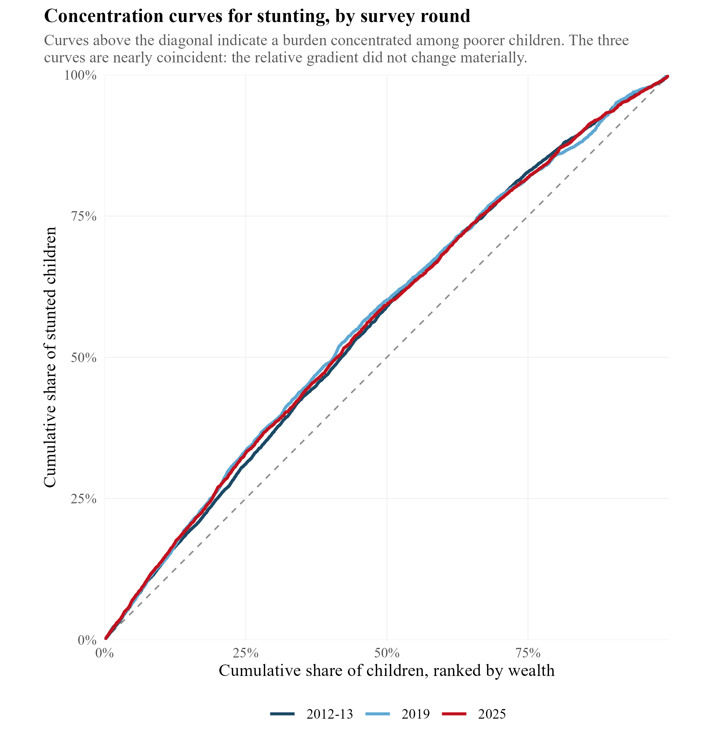
Cumulative share of stunted children against the cumulative share of children ranked by household wealth. A curve above the diagonal indicates a burden concentrated among poorer children. The three curves are nearly coincident, which is the correct result: the relative wealth gradient did not change materially across the three rounds. The summary indices in table S2 and figure 4 of the main text quantify this.
Figure S2. Stunting by division and survey round
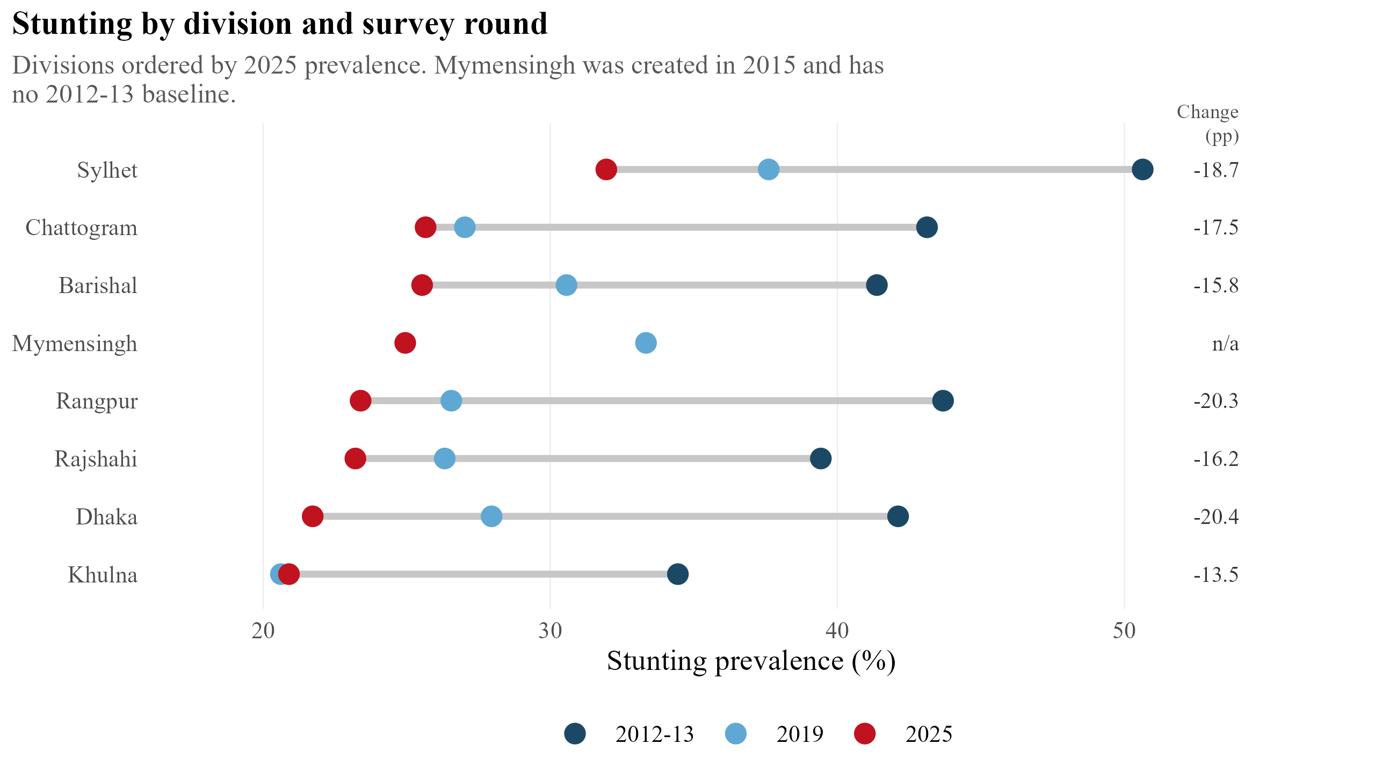
Divisions ordered by 2025 prevalence, with the change over the period at the right. Divisional estimates are more precise than the district estimates in figure 3 of the main text (median 95% confidence interval width 4 against 10 percentage points), so the over-time comparison is made at this level. Mymensingh was created in 2015 and has no 2012-13 baseline.
Note S1. Harmonisation decisions across survey rounds
Measurement flags. Each round supplies flag variables marking biologically implausible z-scores. Flagged values were set to missing before the thresholds were applied. Applying the flag as an additional condition alongside the threshold, which is the more natural way to write the expression, causes flagged children to be counted as not stunted rather than excluded and understates prevalence by roughly one percentage point.
Zero-weight records. In every round the wealth index takes an unlabelled value of zero for a group of children. This coincides exactly with a child sampling weight of zero and a missing height-for-age z-score, and identifies children whose under-five questionnaire was not completed. These records were dropped rather than treated as a sixth wealth category.
Residence labels. Urban and rural are recorded in upper case in the 2019 round and in title case in the other two, which yields four residence categories rather than two unless harmonised.
Maternal education. The 2012-13 round combines completed secondary schooling with all higher levels into one category, so secondary and higher cannot be separated in that round. The finest scheme comparable across all three rounds is three levels: none or pre-primary, primary, and secondary or higher. The published survey report uses a finer scheme for 2025, which is why its 'higher' category and our 'secondary or higher' category differ and are not compared in table S1.
Water and sanitation. The MICS questionnaire was renumbered between the fifth and sixth rounds. The question code that records the type of toilet facility in 2012-13 records the reason water was unavailable in 2019 and 2025. Harmonising these variables would require a hand-built per-round mapping, and they were omitted rather than risk a silent mis-mapping.
Maternal anthropometry. Height and weight of women are not measured in any Bangladesh MICS round, so the household-level double burden of malnutrition cannot be examined in these data.
Administrative geography. Rangpur division was created in 2010 and Mymensingh in 2015. At district level, the 2025 round reports Dhaka North, Dhaka South and Chattogram city corporations as separate units, which the earlier rounds do not; these were folded back into their parent districts. Four districts are spelled differently between rounds. After harmonisation the count is 64 districts in every round.
Note S2. The 2006 round
Bangladesh has conducted four MICS rounds: 2006, 2012-13, 2019 and 2025. The 2006 round was inspected and excluded because it contains no anthropometry module: no height or weight measurements, no derived z-scores and no measurement flags. The analysis therefore covers the three rounds that measured children.

