Supplementary Information
Coupled Homogeneous-Heterogeneous Oxidation of Tetracycline by Natural Pyrite and H₂O₂: The Roles of Fe(II) Release and Sulfur Transformation
Runchang Su^{a,b}, Yuhang Liu^{a,b}, Mei Zhang^{a,b}, Min Guo^{a,b,}∗
ªState Key Laboratory of Advanced Metallurgy, University of Science and Technology Beijing, Beijing 100083, P. R. China
^{b}School of Metallurgical and Ecological Engineering, University of Science and Technology Beijing, Beijing 100083, China

1. Chemical Composition and Microstructure of Natural Pyrite
Table S1 Chemical composition and content of natural pyrite by XRF (wt %)
element | Fe | S | Si | Al | Ca | Zn | Pb | Cu | K | Mn
content | 47.93 | 45.80 | 2.63 | 1.14 | 0.99 | 0.49 | 0.40 | 0.23 | 0.16 | 0.12

2. H₂O₂ Concentration and Absorbance Fitting Curve
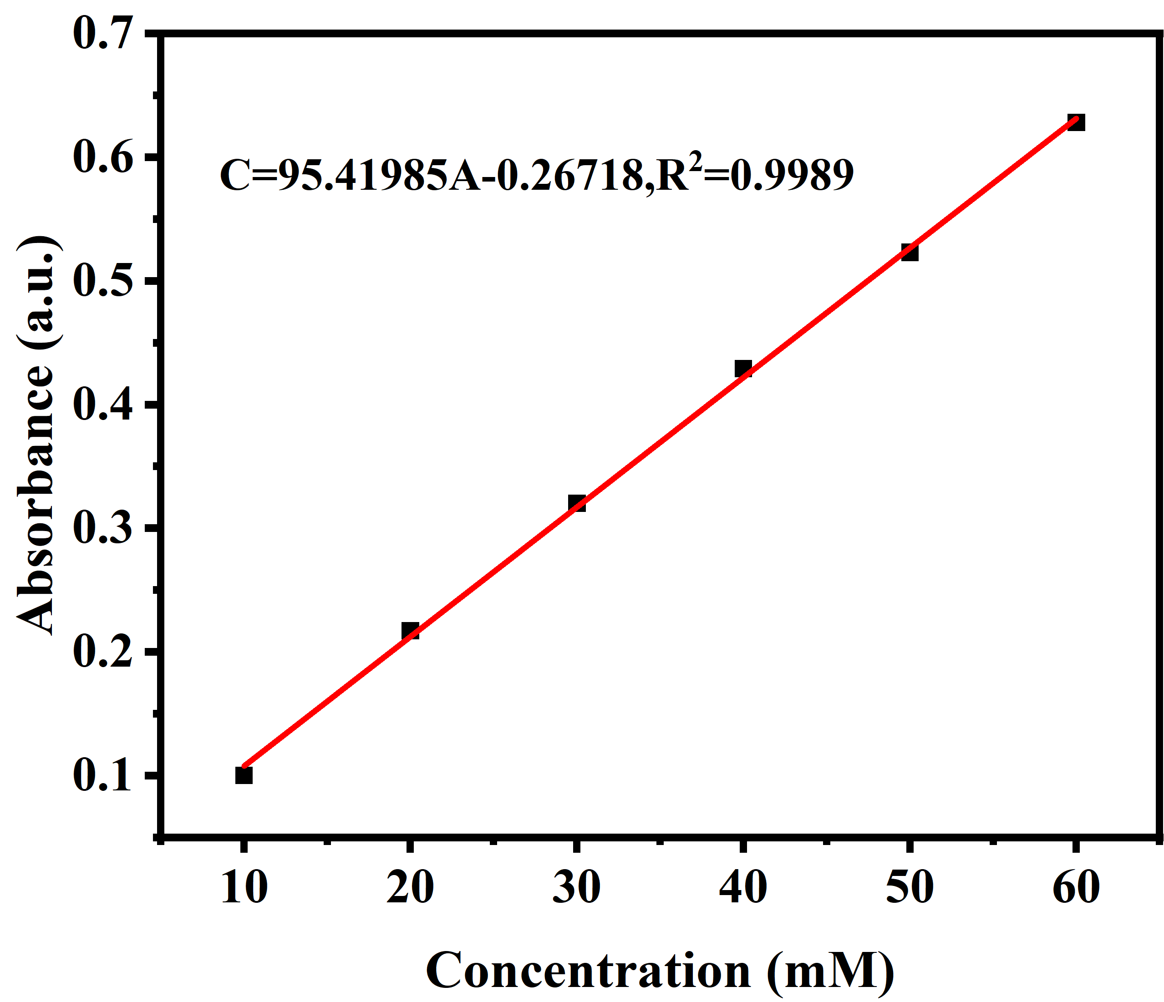
Figure. S1. H₂O₂ concentration and absorbance fitting curve.
The concentration of H₂O₂ in aqueous solution was determined by titanium potassium oxalate spectrophotometry. The reaction principle is as follows. In the medium acidity of Ti⁴⁺ salt solution, adding H₂O₂ will generate orange complex ( [TiO(H₂O₂)²⁺] ). 68 mL of concentrated sulfuric acid was slowly poured into 75 mL of deionized water several times. 8.85 g of potassium titanium oxalate dihydrate was added to the obtained sulfuric acid solution, stirred to dissolve, and then the solution was diluted to 250 mL to obtain potassium titanium oxalate solution. 0.25 mL of potassium titanyl oxalate solution and 0.25 mL of different concentrations of H₂O₂ (0 ~ 70 mM ) solution were mixed in a 25 mL colorimetric tube and diluted to 25 mL. After reacting for 10 min, the absorbance of the mixed solution at λ = 400 nm was measured, and the relationship curve between H₂O₂ concentration and absorbance was drawn.
3. SEM Images of Pyrite Catalysts
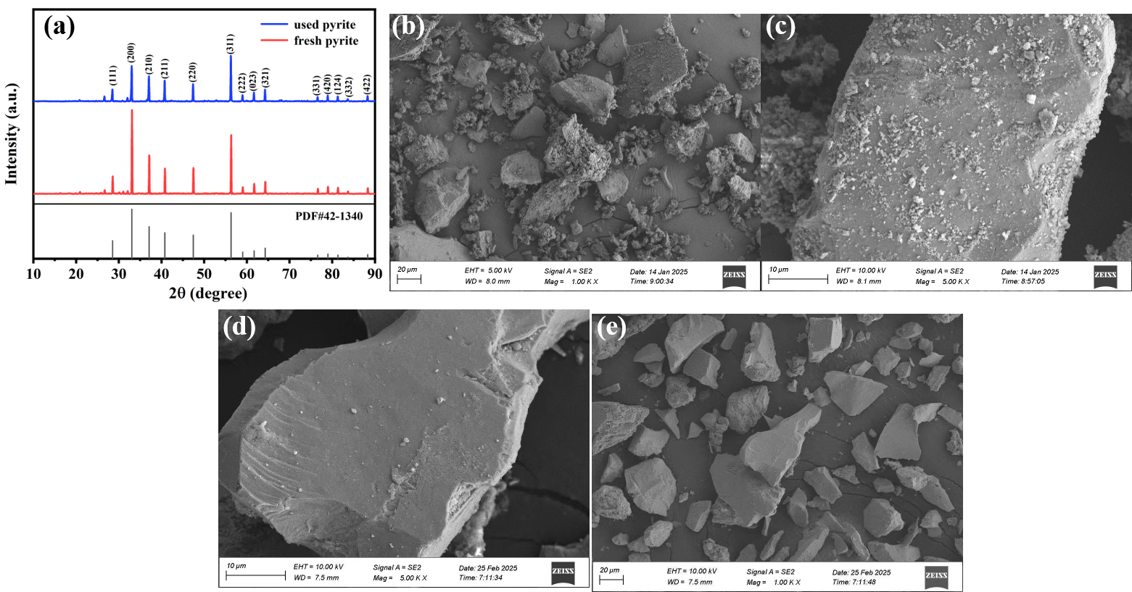
Figure. S2. (a) XRD pattern of pyrite before and after five degrading cycles; SEM images of pyrite catalysts before (b, c) and after (d, f) tetracycline degrading cycles.

4 The Ion Concentration and Solution Phenomenon After Adsorption
Figure. S3. (a) Ion concentrations in the solution after 20 min adsorption, (b)The color change of solution when Fe³⁺ is tested by potassium thiocyanate.
5. DFT Calculation Method
5.1 Computational details of Fukui Function
In this study, the Fukui functions (f⁺、f⁻ and f⁰) employed to predict local reactivity are rooted in conceptual density functional theory (CDFT) and were calculated using the Multiwfn. To eliminate the effects of geometric relaxation, all calculations were performed within the framework of the vertical approximation. Specifically, the single-point energy and wavefunction calculations for the N-1, N and N+1 systems strictly utilized the optimized geometric coordinates of the neutral tetracycline molecule. The wavefunctions of these three states, generated by ORCA, were subsequently imported into Multiwfn to compute both the 3D real-space Fukui function distributions and the condensed Fukui functions. The mathematical definitions of the three Fukui functions corresponding to nucleophilic, electrophilic, and radical attacks are expressed as follows:
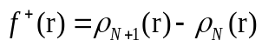 (S1)
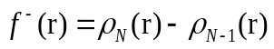 (S2)
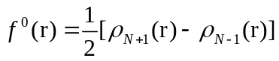 (S3)
Where ρ_{N+1}、ρ_{N} and ρ_{N-1} represent the electron density distributions of the anionic, neutral, and cationic systems, respectively. For 3D isosurface visualization, the spatial grid spacing was set to approximately 0.10 Bohr and rendered within the software. To obtain quantitative condensed atomic Fukui function values, the Hirshfeld population analysis scheme was adopted in Multiwfn to determine the net atomic charges under each electronic state ^{[70,71]}.
5.2 Computational details of the bond dual descriptor
To quantitatively evaluate the intrinsic reactivity of specific chemical bonds within the tetracycline molecular skeleton and their susceptibility to radical attacks, the bond dual descriptor (BDD) was calculated utilizing the Multiwfn. As a further extension of CDFT, this descriptor substitutes traditional atomic charges with interatomic bond orders, thereby providing a more direct reflection of the dynamic variations in bond strength during electron transfer processes ^{[72]}. Within the framework of the vertical approximation, the calculations strictly utilized the optimized geometric coordinates of the neutral molecule to extract the wavefunctions of the N-1, N and N+1 states. The condensed Fukui functions of the chemical bond between atoms h and k were determined via the finite difference approximation:
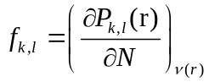 (S4)
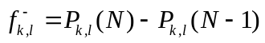 (S5)
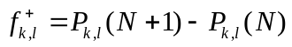 (S6)
Accordingly, the BDD (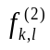) is defined as the difference between the nucleophilic and electrophilic bond Fukui functions:
(S7)
Chemical bonds with negative BDD values (<0) possess strong intrinsic nucleophilicity and are highly vulnerable to electrophilic addition (e.g., by·OH or ¹O₂）). On the contrary, those characterized by positive BDD values (>0) display significant electrophilic traits, serving as priority sites for attacks by nucleophilic radicals like ·O²⁻.
5.3 Computational Details of Molecular Electrostatic Potential Analysis
In order to elucidate the molecular charge distribution, intermolecular electrostatic interactions, and susceptible reactive sites of tetracycline, molecular ESP mapping was conducted via Multiwfn ^{[62]}. The electrostatic potential V(r) at any given spatial point r, arising from the collective contributions of both atomic nuclei and electrons, is mathematically expressed as follows:
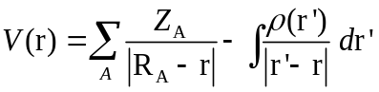 (S8)
Where 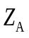 represents the nuclear charge of atom A located at position 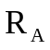 and 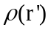 denotes the electron density function of the molecule. Following the internationally accepted standard proposed by Bader et al., the electrostatic potential in this work was mapped onto the molecular van der Waals (vdW) surface, which is defined by a total electron density isosurface of 0.001 a.u.
Table S2 The Fukui function of tetracycline
Atom | q(N) | q(N+1) | q(N-1) | f- | f+ | f0 | CDD
1(C ) | 0.1307 | 0.0814 | 0.1304 | -0.0003 | 0.0492 | 0.0245 | 0.0495
10(C ) | -0.0644 | -0.0813 | 0.0016 | 0.066 | 0.0169 | 0.0415 | -0.0491
11(C ) | -0.0307 | -0.0674 | 0.0018 | 0.0325 | 0.0367 | 0.0346 | 0.0042
12(C ) | -0.0632 | -0.0856 | -0.015 | 0.0482 | 0.0224 | 0.0353 | -0.0258
13(C ) | 0.0933 | 0.0753 | 0.1341 | 0.0408 | 0.0179 | 0.0294 | -0.0229
14(C ) | -0.0463 | -0.0492 | -0.0142 | 0.0322 | 0.0029 | 0.0175 | -0.0293
15(C ) | 0.1275 | 0.0811 | 0.1349 | 0.0074 | 0.0464 | 0.0269 | 0.0391
16(C ) | -0.056 | -0.0756 | -0.0277 | 0.0283 | 0.0196 | 0.0239 | -0.0087
17(C ) | 0.0908 | 0.0633 | 0.1188 | 0.028 | 0.0275 | 0.0278 | -0.0005
18(C ) | 0.0713 | 0.0594 | 0.0746 | 0.0033 | 0.0118 | 0.0076 | 0.0085
19(C ) | 0.1718 | 0.0934 | 0.1823 | 0.0105 | 0.0784 | 0.0445 | 0.068
2(C ) | -0.1006 | -0.115 | -0.0958 | 0.0048 | 0.0144 | 0.0096 | 0.0096
20(O ) | -0.2486 | -0.3319 | -0.2241 | 0.0245 | 0.0833 | 0.0539 | 0.0588
21(N ) | 0.0056 | -0.0172 | 0.0124 | 0.0068 | 0.0228 | 0.0148 | 0.016
22(O ) | -0.2406 | -0.2927 | -0.218 | 0.0226 | 0.0521 | 0.0374 | 0.0295
23(O ) | -0.2225 | -0.2736 | -0.2083 | 0.0142 | 0.0511 | 0.0326 | 0.0369
24(C ) | -0.0934 | -0.0978 | -0.0882 | 0.0051 | 0.0044 | 0.0048 | -0.0007
25(O ) | -0.2146 | -0.2437 | -0.205 | 0.0096 | 0.0291 | 0.0194 | 0.0195
26(O ) | -0.1813 | -0.2073 | -0.1433 | 0.038 | 0.026 | 0.032 | -0.0121
27(O ) | -0.2095 | -0.2356 | -0.124 | 0.0855 | 0.0261 | 0.0558 | -0.0594
28(O ) | -0.2213 | -0.2317 | -0.213 | 0.0084 | 0.0104 | 0.0094 | 0.0021
29(O ) | -0.2553 | -0.2937 | -0.2451 | 0.0103 | 0.0384 | 0.0243 | 0.0282
3(C ) | 0.1302 | 0.1101 | 0.1311 | 0.0009 | 0.0201 | 0.0105 | 0.0192
30(N ) | -0.095 | -0.0973 | -0.0133 | 0.0817 | 0.0023 | 0.042 | -0.0793
31(C ) | -0.0417 | -0.0449 | -0.0256 | 0.0161 | 0.0032 | 0.0097 | -0.0129
32(C ) | -0.0378 | -0.0429 | -0.0206 | 0.0172 | 0.0051 | 0.0111 | -0.0121
33(H ) | 0.0309 | 0.0255 | 0.0363 | 0.0053 | 0.0054 | 0.0054 | 0.0001
34(H ) | 0.0275 | 0.0194 | 0.0357 | 0.0082 | 0.0082 | 0.0082 | 0
35(H ) | 0.0413 | 0.0337 | 0.0503 | 0.009 | 0.0076 | 0.0083 | -0.0014
36(H ) | 0.025 | 0.0151 | 0.0284 | 0.0035 | 0.0099 | 0.0067 | 0.0065
37(H ) | 0.0266 | 0.0204 | 0.0329 | 0.0062 | 0.0062 | 0.0062 | 0
38(H ) | 0.0362 | 0.0232 | 0.0622 | 0.026 | 0.013 | 0.0195 | -0.013
39(H ) | 0.0455 | 0.0251 | 0.0701 | 0.0246 | 0.0203 | 0.0225 | -0.0043
4(C ) | 0.0187 | 0.0147 | 0.0266 | 0.0079 | 0.004 | 0.006 | -0.0039

Atom | q(N) | q(N+1) | q(N-1) | f- | f+ | f0 | CDD
40(H ) | 0.0472 | 0.0303 | 0.0738 | 0.0266 | 0.0169 | 0.0217 | -0.0096
41(H ) | 0.1774 | 0.1499 | 0.1855 | 0.008 | 0.0275 | 0.0178 | 0.0195
42(H ) | 0.1781 | 0.1465 | 0.1869 | 0.0088 | 0.0316 | 0.0202 | 0.0228
43(H ) | 0.0363 | 0.0353 | 0.0402 | 0.004 | 0.001 | 0.0025 | -0.003
44(H ) | 0.0352 | 0.0242 | 0.0442 | 0.009 | 0.011 | 0.01 | 0.0021
45(H ) | 0.0273 | 0.0204 | 0.0381 | 0.0108 | 0.007 | 0.0089 | -0.0039
46(H ) | 0.1689 | 0.1567 | 0.1777 | 0.0088 | 0.0122 | 0.0105 | 0.0034
47(H ) | 0.125 | 0.115 | 0.136 | 0.011 | 0.01 | 0.0105 | -0.001
48(H ) | 0.128 | 0.1198 | 0.1458 | 0.0179 | 0.0081 | 0.013 | -0.0097
49(H ) | 0.1546 | 0.1472 | 0.1641 | 0.0094 | 0.0074 | 0.0084 | -0.002
5(C ) | -0.026 | -0.028 | -0.0199 | 0.0061 | 0.002 | 0.0041 | -0.0041
50(H ) | 0.121 | 0.1088 | 0.1254 | 0.0044 | 0.0121 | 0.0083 | 0.0078
51(H ) | 0.0354 | 0.0233 | 0.0554 | 0.02 | 0.0121 | 0.016 | -0.0079
52(H ) | 0.0192 | 0.0153 | 0.0399 | 0.0207 | 0.0039 | 0.0123 | -0.0168
53(H ) | 0.0302 | 0.0305 | 0.0446 | 0.0144 | -0.0003 | 0.0071 | -0.0146
54(H ) | 0.0158 | 0.011 | 0.0378 | 0.0221 | 0.0048 | 0.0134 | -0.0173
55(H ) | 0.033 | 0.021 | 0.0548 | 0.0218 | 0.0121 | 0.0169 | -0.0097
56(H ) | 0.0372 | 0.0325 | 0.0525 | 0.0154 | 0.0047 | 0.01 | -0.0107
6(C ) | -0.0575 | -0.0622 | -0.0553 | 0.0022 | 0.0047 | 0.0035 | 0.0025
7(C ) | -0.0265 | -0.0288 | -0.0227 | 0.0039 | 0.0023 | 0.0031 | -0.0016
8(C ) | 0.0876 | 0.0863 | 0.0889 | 0.0012 | 0.0014 | 0.0013 | 0.0001
9(C ) | 0.0026 | -0.0113 | 0.0228 | 0.0202 | 0.0139 | 0.0171 | -0.0063

5. Intermediate Product Summary
Table S3 Tetracycline identification of intermediate product summary
 | Reaction Time  (min) | Accurate Mass [M+H]⁺  (Da) | Theoretical mass [M+H]+  (Da) | Molecular Formula [M+H]+  (Da) | Proposed Structures
1 | 6.76 | 445.1593 | 445.1533 | C₂₂H₂₅N₂O₈ | 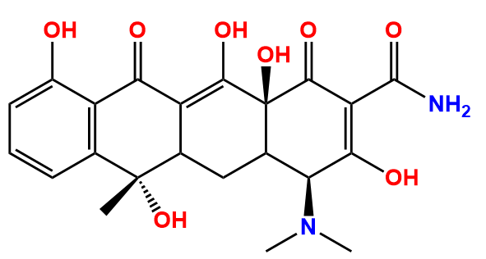
2 | 6.65 | 431.1436 | 431.1376 | C₂₁H₂₃N₂O₈ | 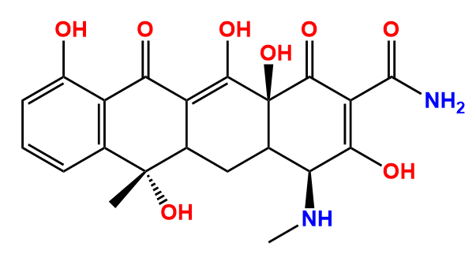
3 | 6.76 8.11 | 427.1491 | 427.1427 | C₂₂H₂₃N₂O₇ | 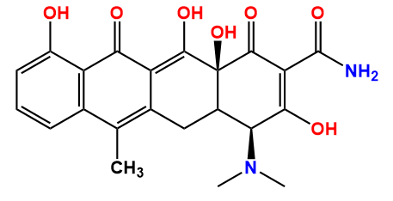
4 | 7.86 | 433.1593 | 433.1533 | C₂₁H₂₅N₂O₈ | 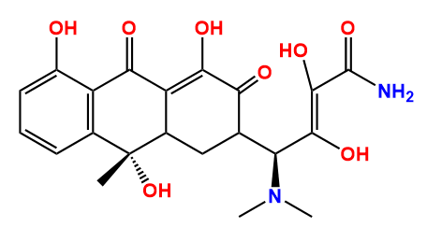
5 | 6.65 | 413.1322 | 413.1271 | C₂₁H₂₁N₂O₇ | 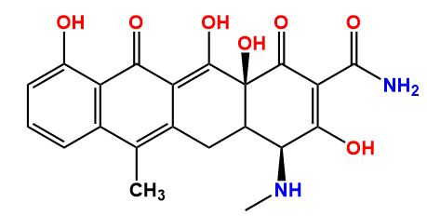
6 | 6.62 | 392.1322 | 392.1634 | C₂₀H₂₆NO₇ | 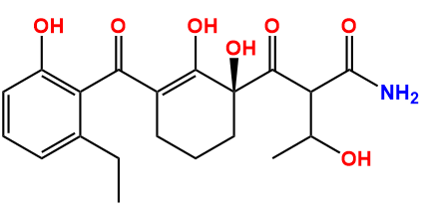
7 | 15.01 | 371.1009 | 371.1053 | C₂₀H₁₉O₇ | 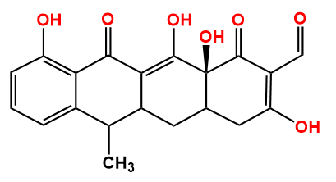
8 | 7.42 | 219.1223 | 219.1307 | C₁₄H₁₉O₂ | 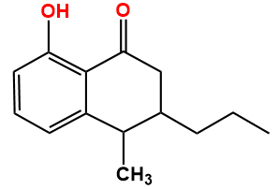
9 | 7.76 | 241.1353 | 241.0998 | C₁₂H₁₇O₅ | 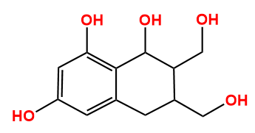
10 | 6.13 | 321.1304 | 321.126 | C₁₇H₂₁O₆ | 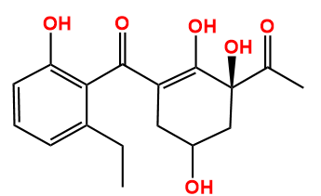
11 | 9.22 | 165.0909 | 165.0837 | C₁₀H₁₃O₂ | 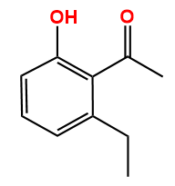
12 | 3.14 | 322.1607 | 322.1212 | C₁₆H₂₀N₁O₆ | 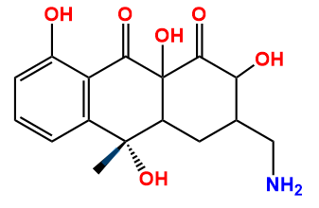
13 | 7.76 | 175.096 | 175.0681 | C₁₁H₁₁O₂ | 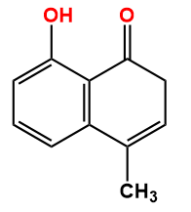

*Corresponding author: Tel/fax: +86 10 62334926, E-mail address: guomin@ustb.edu.cn

